Weekly Educational Options From the Ministère
secondary v
Week of June 1, 2020
Table of Contents
Survive and Thrive: Social Isolation and Global Awareness 2
Un défilé griffé hors du commun 4
Annexe 1 : Options 6
Annexe 2 : Références 7
The Mole Hole 8
Appendix A – The Mole Hole 10
The Conference 12
Appendix B – The Conference 13
Oh Snap, Elastic Potential Energy 15
Appendix A – Spring Experiment 16
Appendix B – Extension 17
Appendix C – Solutions 18
The Importance of Mindfulness 19
Appreciation Activity on Peace 20
Advertisement Awareness 23
Appendix – Advertisement Awareness 24

English Language Arts

Survive and Thrive: Social Isolation and Global Awareness

Information for students
The current crisis has isolated us and kept people apart. Despite this, it has also made many of us more aware of what is happening globally. Maybe you watch the news more, or surf the internet differently, and have acquired a new understanding of issues such as the environment, world events, politics, etc. Globally, young people like you have had to make many changes to the way they stay informed, socialize, study, and even exercise during this time of social distancing. You are growing up with the ability to thrive and becoming even more aware of the bigger picture than before.
- Think about how your way of life has changed since the beginning of the period of social isolation. What do you miss most? What do you not miss at all?
- Click on the link and watch the PBS Newshour report entitled “You're not alone: How teenagers are dealing with social distancing”: https://safeyoutube.net/w/bvvH
As you watch the video, think about the following questions:
what is the message the video is trying to deliver?
how do different teens present their ideas?
do you agree with the ideas presented? Which ones and why?
- Next, think about the strategies that you have developed to:
interact with friends and family
pursue hobbies and activities
grow as an individual
keep up with school assignments
stay informed
- What has the situation taught you about ways to interact within a global context? Explore the issues that affect other people, cultures, and countries
- Choose one or more aspects of the ideas and issues you identified and create a message where you share your views and tips for surviving and thriving and becoming more globally engaged in this era. What advice can you give to other teens who find themselves in the same situation as you? Teens in different contexts? Craft your message as a spoken, written or media text and share it with others. It could take the form of an article, a social media post, a podcast, a video, or other mode of communication

Materials required
Paper, pen, phone
Device with Internet access
English Language Arts

Information for parents

About the activity
Chidren will:
- learn about how other teens are coping with social distancing and isolation
- create a text for a specific and familiar audience
Parents can:
- engage their teen in conversation about the topic
- ask their teen to share their ideas and their final text with them

French as a Second Language

Un défilé griffé hors du commun

Information for students
Les grands événements culturels et sportifs ont été annulés dans les derniers mois et ce, partout sur la planète afin de protéger la population de la Covid-19. Têtus, certains organisateurs ont décidé de s’armer de créativité et de maintenir leurs activités dans le respect des règles en vigueur. À nous, disent-ils, de rivaliser d’ingéniosité! En temps de confinement, il est primordial que la population puisse se divertir, sans quoi, il est difficile de garder le moral.

Mise en situation
L’organisateur d’un défilé de mode auquel devaient prendre part les plus grands designers et couturiers du Québec (Marie Saint Pierre, Matt & Natt, Frank & Oak) décide d’aller de l’avant avec son Mode.qc. Il a convaincu en mars dernier tous ces grands couturiers de créer une collection ÉTÉ inspirée par cette pandémie, question d’influencer le plus grand nombre de Québécois à adopter des comportements responsables cet été en matière de protection.

Instructions
Lis tout d’abord l’article suivant : Déconfinement: oui, mais avec un masque, dit une experte
https://www.lapresse.ca/covid-19/202005/18/01-5274078-deconfinement-oui-mais-avec-un-masque-dit-une-experte.php.
Choisis ensuite une option parmi les quatre proposées (voir Annexe 1 : Options).
Pour réussir cette tâche, assure-toi de consulter l’annexe suivante (Annexe 2 : Références) laquelle te permettra d’aller chercher des informations pertinentes pour ta production.
Renseigne-toi auprès de ton enseignant/e afin de connaître les points grammaticaux ou toute autre modalité qui seront à prendre en considération pour ce travail.

Materials required
Papier, internet, caméra, enregistreur ou tout appareil/logiciel pertinent
French as a Second Language

Information for parents

About the activity
Children should:
- search for any other websites to help them with the task or use articles published in newspapers and magazines (if available) to get more information about their topic
- choose a topic that does not involve the use of the Internet if they do not have access to it

French as a Second Language

Annexe 1 : Options
Pour cette situation de production, quatre options s’offrent à toi:
- La publication d’un prospectus (papier ou pdf)
Tu es l’agent de promotion/marketing de ce défilé. Produis le dépliant que l’organisateur de ce défilé t’a mandaté d’envoyer aux créateurs afin de les convaincre de participer à cet événement.
- Parle des mesures que l’organisation compte prendre ou faire respecter pour les protéger, eux et leurs équipes : mannequins, maquilleurs, coiffeurs, etc.
- Aborde la ligne directrice (thème et particularités) qui devrait être suivie pour la création de cette collection Été 2020.
- Souligne les autres mesures que l’organisation compte mettre en place ou faire respecter afin d’assurer la protection du public.
- La création d’une légende fantastique (document audio)
Tu es écrivain-conteur. On fait appel à tes services afin de donner une touche « fantastique » à ce défilé. Une mise en scène est prévue en introduction : des acteurs déambuleront sur la scène afin de permettre au public d’entrer dans l’imaginaire de ce défilé hors de l’ordinaire.
- Ton récit doit être narré à la 3e personne (narrateur omniscient/dieu).
- Aucun dialogue n’est permis puisque les acteurs n’auront droit de parole.
- Le masque et les mesures de protection doivent jouer un rôle clé.
- La création d’un documentaire (vidéo, pwpt, prezzi, etc.)
Tu es historien, engagé par l’organisateur de ce défilé. Crée un documentaire de quelques minutes retraçant l’histoire du masque et des tendances vestimentaires dites de protection (d’hier à aujourd’hui). Ce documentaire sera présenté à l’entracte.
- La création d’un site web (fictif)
Tu es spécialiste du web. On t’engage pour créer une plateforme sur laquelle tu pourras faire la promotion de la nouvelle collection Été 2020 du/de la designer __________.
- Présente au moins trois nouveaux vêtements de ce/cette créateur/trice.
- Explique en quoi chacun d’entre eux est tendance et respecte socialement et écologiquement les valeurs des jeunes d’aujourd’hui en ce contexte de pandémie mondiale.
- Use de stratégies incitatives (idées, arguments, slogans, images, caractères, vocabulaire employé, etc.) pour amener le public à s’intéresser à cette nouvelle collection.

French as a Second Language

Annexe 2 : Références

Mesures contre la Covid-19
Festivals, événements culturels et événements sportifs dans le contexte de la Covid-19
https://www.quebec.ca/sante/problemes-de-sante/a-z/coronavirus-2019/festivals-evenements-culturels-sportifs-covid19/
Rassemblements dans le contexte de la Covid-19
https://www.quebec.ca/sante/problemes-de-sante/a-z/coronavirus-2019/rassemblements-evenements-covid19/

Histoire du masque…
L’histoire du masque de la peste noire, ancêtre du masque du Coronavirus Covid-19 (vidéo)
https://safeYouTube.net/w/WQ6G
Le masque médical : de la protection contre les odeurs à celle contre les pathogènes (audio)
https://ici.radio-canada.ca/premiere/emissions/les-annees-lumiere/segments/chronique/165154/masques-medicaux-histoire-utilisation-medecine-covid-peste

Tendances…
Les gants et les masques dans l’histoire
http://mitsoumagazine.com/mode/tendances/mode-les-gants-et-les-masques-dans-lhistoire/
Le masque, ce nouvel accessoire de mode (audio)
https://ici.radio-canada.ca/premiere/emissions/le-15-18/segments/chronique/167293/design-couvre-visage-coronavirus-covid-19

Créateurs québécois
https://www1.tonpetitlook.com/20-createurs-de-mode-quebecois-a-surveiller/

https://www.lapresse.ca/vivre/mode-quebecoise/201511/06/01-4918206-faits-ici-pour-lui.php

Mathematics - Science Option

The Mole Hole

Information for students
The Mole Hole
A mole has dug an underground tunnel, as shown in the graph below
The tunnel has two possible entrances at ground level
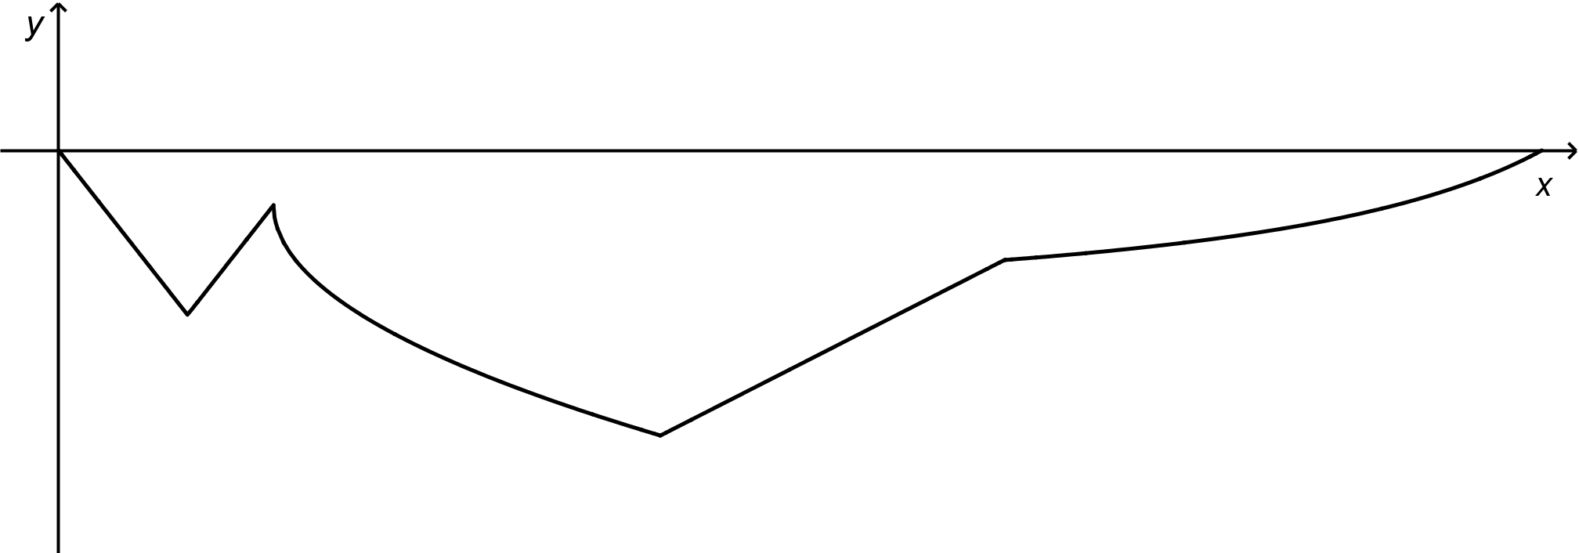
The function rule below describes the trajectory of the tunnel.
In addition:
f (0) = 0
f (9) = − 4.75
What is the horizontal distance between the two entrances of the tunnel?

Materials required
Calculator, graph paper, writing and drawing materials
Mathematics - Science Option

Information for parents

About the activity
Children could:
explain the problems-solving steps
Parents should:
read the instructions to their child, if necessary
discuss the task with their child, outlining what steps need to be carried out
go over the task with their child once it is completed by using the answer key provided in Appendix A

Mathematics – Science Option

Appendix A – The Mole Hole

Solution
- RULE OF THE ABSOLUTE VALUE PIECE OF THE PIECEWISE FUNCTION f

Using (0, 0); 0 = ${\text{a}}_{\text{1}}\left|\text{0} \text{-} \text{3}\right| \text{-} \text{3.75}$
3.75 = ${\text{a}}_{\text{1}}\left|\text{3}\right|$ → 3.75 = ${\text{a}}_{\text{1}}$ (3) → 1.25 = ${\text{a}}_{\text{1}}$
The rule of the absolute value piece of function f is f (x) = 1.25 │x – 3 │− 3.75

- RULE OF THE SQUARE ROOT PIECE OF THE PIECEWISE FUNCTION f
Solving for x = 5, the end point of first piece and the vertex of the second piece:
f (5) = 1.25 │5 – 3 │− 3.75 → f (5) = 1.25 │2 │− 3.75
f (5) = 1.25 (2) – 3.75 = 2.50 – 3.75 → f (5) = −1.25. So k = −1.25
f (x) = ${\text{a}}_{\text{2}}\sqrt{\text{x} \text{-} \text{5}} \text{-} \text{1.25}$ and using the point (9, −4.75):
−4.75 = ${\text{a}}_{\text{2}}\sqrt{\text{9} \text{-} \text{5}} \text{-} \text{1.25}$ → −4.75 = ${\text{a}}_{\text{2}}\sqrt{\text{4} } \text{-} \text{1.25}$
−3.50 = ${\text{a}}_{\text{2}}$ (2) → −1.75 = ${\text{a}}_{\text{2}}$
The rule of the square root piece of function f is f (x) = −1.75 $\sqrt{\text{x} \text{-} \text{5}} \text{-} \text{1.25}$.

- RULE OF THE LINEAR PIECE OF THE PIECEWISE FUNCTION f

Solving for x = 14, the end point of second piece and the starting point of the third piece:
f (14) = −1.75 $\sqrt{\text{14} \text{-} \text{5}} \text{-} \text{1.25}$ → f (14) = −1.75 $\sqrt{\text{9} } \text{-} \text{1.25}$
f (14) = −1.75 (3) $\text{-} \text{1.25}$ → f (14) = −6.50
f (x) = 0.5x + b and using (14, −6.5):
−6.5 = 0.5 (14) + b → −6.5 = 7 + b
−13.5 = b The rule of the linear piece of function f is f (x) = 0.5x –13.5.

- RULE OF THE RATIONAL PIECE OF THE PIECEWISE FUNCTION f

Solving for x = 22, the end point of third piece and the starting point of the fourth piece:
f (22) = 0.5(22) – 12.5 → f (22) = 11 – 13.5 = −2.5
f (x) = $\frac{{\text{a}}_{\text{3}}}{\text{x} \text{- 42}} \text{-} \text{4}$ and using the point (22, −2.5):
−2.5 = $\frac{{\text{a}}_{\text{3}}}{\text{22} \text{- 42}}$ – 4 → 1.5 = $\frac{{\text{a}}_{\text{3}}}{\text{- 20}}$ → −30 = ${\text{a}}_{\text{3}}$
The rule of the rational piece of function f is f (x) = $\frac{\text{-30}}{\text{x}\text{ - 42}} \text{- 4}$.

Mathematics – Science Option

- HORIZONTAL DISTANCE BETWEEN THE TWO ENTRANCES OF THE TUNNEL

Solving for t when f (t) = 0, we have: 0 = $\frac{\text{-30}}{\text{x}\text{ - 42}} \text{- 4}$.
4 = $\frac{\text{-30}}{\text{x}\text{ - 42}}$ → 4 (x – 42) = − 30 → x – 42 = $\frac{\text{-30}}{\text{4}}$
x = 42 – 7.5 = 34.5 Horizontal distance: 34.5 – 0 = 34.5

CONCLUSION
The horizontal distance between the two entrances of the tunnel is 34.5 u.

Mathematics – Cultural, Social and Technical Option

The Conference

Information for students
Conference attendees were given a choice of topics for next year's meeting in London.
The topics are Artificial Intelligence, World Economy and Social Media.
All 940 attendees responded to the survey.
The results are indicated in the table below.
 | 40% of the conference attendees | 329 conference attendees | $\frac{\text{1}}{\text{4}}$ of the conference attendees
1st Choice | World Economy | Social Media | Artificial Intelligence
2nd Choice | Artificial Intelligence | Artificial Intelligence | Social Media
3rd Choice | Social Media | World Economy | World Economy
The conference manager analyzed the data collected from the conference attendees, using plurality voting, the Borda count, the elimination method and the Condorcet method.
The manager will choose the topic that wins the most.
Which topic was chosen for next year’s meeting?

Materials required
Calculator, writing and drawing materials

Information for parents

About the activity
Children could:
explain the problems solving steps
Parents should:
read the instructions to their child, if necessary
discuss the task with their child, outlining what steps need to be carried out
go over the task with their child once it is completed by using the answer key provided in Appendix B

Mathematics Cultural, Social and Technical Option

Appendix B – The Conference

Solution
- Number of voters in each result column

Column 1: 40% of 940 = 0.40$\frac{1}{3}$ × 940 = 376 attendees
Column 3: $\frac{\text{1}}{\text{4}}$ of 940 = $\frac{\text{1}}{\text{4}}$ × 940 = 235 attendees
or 940 – (329 + 376) = 235 attendees
- Results of the vote using plurality voting
Number of votes for the 1st choice.
Topic | Number of votes for the 1st choice
World Economy (WE) | 376 | Highest value
Social Media (SM) | 329
Artificial intelligence (AI) | 235
World Economy wins using plurality voting.
- Results of the vote using the Borda count
Topic | Number of points
World Economy (WE) | (376 × 3) + (329 × 1) + (235 × 1) = 1692 points
Artificial intelligence (AI) | (376 × 2) + (329 × 2) + (235 × 3) = 2115 points
Social Media (SM) | (376 × 1) + (329 × 3) + (235 × 2) = 1833 points
Artificial Intelligence wins using the Borda count.

- Results of the vote using the elimination method
Round  Topic | 1st round | 2nd round
World Economy (WE) | 376 | 376
Social Media (SM) | 329 | 329 + 235 = 564
Artificial intelligence (AI) | 235 | ----
AI is eliminated. Its votes are given to SM.
Social Media wins using the elimination method.

Mathematics Cultural, Social and Technical Option

- Results of the vote using the Condorcet method

WE vs AI | WE vs SM | AI vs SM
WE: 376 | WE: 376 | AI: 376 + 235 = 611
AI: 329 + 235 = 564 | SM: 329 + 235 = 564 | SM: 329
Artificial Intelligence wins | Social Media wins | Artificial Intelligence wins
Artificial Intelligence wins using the Condorcet method with 2 wins.

Conclusion
The topic chosen for next year’s meeting was Artificial Intelligence (2 wins).

Physics

Oh Snap, Elastic Potential Energy

Information for students
Have you ever stood on a trampoline? What does a person have to do to create enough energy to start jumping? What has to happen to increase the height of a jump? This is an example of elastic potential energy (EPE). There is stored energy, or potential energy, in the stretched springs supporting the trampoline.
To explore EPE, you are going to need a ruler, an elastic and something to mark the spot where the elastic lands (e.g. chalk, tape, token). If possible, recruit a helper. Make sure no one is in front of the launch site when you perform the procedure in Appendix B.
Elastics bands have stored energy when they are stretched. What do you predict will happen when you pull an elastic band back and release? Describe the change between Elastic Potential Energy (EPE) and Kinetic Energy (KE) as the elastic is released.

Materials required
30 cm ruler or meter stick
Measuring tape
Elastic band (you can sometimes find an elastic band around the green onions or celery in your refrigerator)
A helper, if possible

Information for parents

About the activity
Students might need a helper to measure the launch distance

Physics

Appendix A – Spring Experiment

Prediction
What do you think the relationship is between the distance the elastic is pulled back before it is released and the launch distance?

Procedure
- Place the ruler on the ground with an object, for example a book, underneath the front edge of the ruler to create an upward angle. Prepare the elastic by placing it on the front end of the ruler and bringing it back, but without stretching it (at rest)
- Stretch the elastic band 5 cm from rest. Each launch must be lined up in the same direction and at the same angle
- Launch the elastic and mark where the elastic lands (first touch); this is your launch distance
- Repeat 4 times
- Take the average distance as your result for this trial
Repeat the procedure, stretching the elastic back 10 cm, 15 cm, 20 cm and, if possible, 25 cm.
Distance elastic band is stretched  from rest | Launch distance (cm)  Average of 5 attempts
5 cm
10 cm
15 cm
20 cm

Results
Graph your results and describe the relationship.
Was your prediction correct?
What would happen if you used an elastic band that is more “stretchy” or an elastic band that is less “stretchy”?
Physics

Appendix B – Extension

Conservation of Energy
When the elastic band is released, the elastic potential energy is converted to kinetic energy.
EPE (prior to release) = KE (immediately after release)
k = spring constant, or how stretchy/stiff the elastic band is
(every elastic will have its own spring constant) (N/m)

x = the distance that the elastic band is stretched from rest (m)

m = mass of the elastic band (kg)

v = velocity of the elastic band (m/s)
EPE = $\frac{1}{2}kx^{2}$

KE = $\frac{1}{2}{mv}^{2}$

$$\frac{1}{2}kx^{2}=\frac{1}{2}{mv}^{2}$$
Can you think of a way to calculate?
The velocity of the elastic band when it is released?
The spring constant “k” of the elastic?
Explore masses and springs @ https://phet.colorado.edu/en/simulation/mass-spring-lab

Physics

Appendix C – Solutions

Results for the Spring Experiment:
The relationship of the graph should be linear.

Possible Solutions for the Extension:
Can you think of a way to calculate the velocity of the elastic band when it is released?
Horizontal projectile motion:
Vertical motion
Launch the elastic band at 0o, horizontally, from a table, for example.
The initial velocity (vertical) = 0 m/s
$∆d = v_{1}t+\frac{1}{2} \left(9.8\frac{m}{s^{2}}\right)t^{2}$ $v_{1}=0$ m/s $∆d=height of table$
Solve for t
Horizontal motion
The initial velocity is completely horizontal. Solve for v.
$$v=\frac{d(launch distance)}{t (solved above)}$$
Can you think of a way to calculate the spring constant “k” of your elastic?
k = spring constant, or how stretchy/stiff the elastic is.
(every elastic will have its own spring constant) (N/m)

x = the distance that the elastic band is stretched from rest (m)

m = mass of the elastic band (kg)

v = velocity of the elastic band (m/s) (from above)
Solve for k

$\frac{1}{2}kx^{2}=\frac{1}{2}{mv}^{2}$

Physical Education and Health

The Importance of Mindfulness

Information for students
Activity 1: Practicing mindfulness
Watch the following video to learn about the importance of Mindfulness:
- video: Why Mindfulness is the New Superpower – Featuring Dan Harris
Read through the following infographic for daily mindfulness practices:
- infographic: Making Mindfulness a Way of Life and Work
What did you learn from the video? Why is it important to practice mindfulness? Do you think you could find one thing to be mindful about during your day? What would that be?
Discuss what you learned about mindfulness with a member of your family
Activity 2: Yoga for mindfulness
Try the exercises in the following video:
- video: 10 Minute Morning Yoga for All Levels
- If necessary, adapt the movements to your abilities

Materials required
Device with Internet access

Information for parents

About the activity
Children should:
learn about the importance of mindfulness
practice mindfulness
try the yoga workout
Parents could:
support their children by asking them what they have learned about mindfulness
support their children by practicing mindfulness with them
support their children by doing the workout with them or encourage them be more autonomous during the activity

Arts

Appreciation Activity on Peace

Information for students
This arts appreciation activity features three works of art from the Montreal Museum of Fine Art’s EducArt platform. The theme of the activity is peace. You will observe three works then answer a few questions. Following each work, you will be given a short challenge to create or perform.

Follow the instructions below.
Work 1: Man Size by Richard Mosse (Theme: Child soldiers)
- Click on the link below. Observe the work of art quietly for one minute
- Read the description (if you want, watch the video featuring Monique Mujawamariya)
- Learning how to look: Do an artwork analysis
- Observe: look at colours, textures, use of space
- Situate: get behind the camera, get behind the scene
- Acquire: how does it make you feel? What does it remind you of?
- Complete the Guiding Questions section. It would be a good idea for you to perform the recommended task since completing activities helps knowledge sink in
Man size link: https://educart.ca/en/theme/peace/#/man-size/cartel
Work 2: Cactus Man No. 1 by Julio González (Theme: Resist)
- Click on the link below. Observe the work of art quietly for one minute
- Read the description (if you haven’t already watched Monique Mujawamariya’s video, feel free to do so.)
- Learning how to look: Do an artwork analysis
- Observe: look at forms, textures, balance, use of space
- Situate: get behind the artist’s eyes, what was he thinking? Feeling?
- Acquire: how does it make you feel? What does it remind you of?
- Complete the Guiding Questions section. It would be a good idea for you to perform the recommended task of a musical composition. Go crazy!
Cactus Man No.1 link: https://educart.ca/en/theme/peace/#/cactus-man-no-1/cartel

Arts

Work 3: Peace and Justice by Pompeo Batoni (Theme: Peace and justice)
- Click on the link below. Observe the work of art quietly for one minute
- Read the description
- Learning how to look: Do an artwork analysis
- Observe: look at the characters. Their gaze, positions, levels, shadows, light, etc.
- Situate: determine when in time and space?
- Acquire: how does it make you feel? What does it remind you of?
- Complete the Guiding Questions section. It would be a good idea for you to write that allegory
If you still haven’t watched the video featuring Monique Mujawamariya, now would be the time!
Peace and Justice link: https://educart.ca/en/theme/peace/#/peace-and-justice/cartel
WORK 4: Your turn to create!
After watching https://educart.ca/en/theme/peace/#/video-capsule-monique-mujawamariya/cartel, answer the following questions:
What did you learn about issues surrounding peace?
Under each issue, consider the following questions and draw up a plan of how you would represent the theme.

Child soldiers
If you want to show the viewer (or listener) the negativity and seriousness of child soldiers, how would you represent this theme in a work of art?
Would you use photography? Painting? Poetry? Music? Dance?

Resist
What do you think about Julio Gonzalez’s statue? If it were alive, how do you think it would move or sound?
Consider creating a story around this defensive main character.
What about media? Would you write a dramatic scene or monologue? Create a dance? Cinema? Something else?

Peace and justice
Monique Mujawamariya says without justice there can’t be peace. Do you share this belief?
Are there other ideas you can think about where one depends on the other like peace and justice? What about media? How would you personify Peace and Justice?
Like Batoni, would you use painting to represent the theme? How would you communicate your message?

Materials required
Access to EducArt’s online platform
Any artistic medium you wish to use for expression
Arts

Information for parents

About the activity
Student can take as much time as necessary to explore the theme.
Parents could engage in conversation on the theme with the student. If the student is interested in a conversation, allow them to lead the discussion.

Financial Education

Advertisement Awareness

Information for students
Advertisements are intended to influence consumers to buy products or take action. The four main goals of advertising are to inform, to develop awareness, to modify behaviour and to create needs. The goal of this activity is to gain awareness of the techniques used by companies to influence our actions.

Instructions
Read the description of the goals of advertising in the Appendix.
As you watch television, browse your social media or look at magazines, find an example of each of the four goals of advertising.
Think about these questions as you watch or read the advertisement:
- How did you feel when you watched the commercial or ad?
- How did the producers convince or influence you? Did they appeal to your emotions or your logic? Did they use humour or facts and statistics?
- Have you ever been influenced by an ad or a commercial in the past? Did you buy the product or take action?

Materials required
Useful resources, depending on personal preferences and availability:
digital device with an Internet connection
writing materials (paper, pencil, etc.)
magazines

Information for parents

About the activity
Children could:
discuss different ads with their classmates and friends by video call. Vote on the best and the worst ads
Parents should:
help their child develop awareness of the influence that media and advertising have on the decisions and choices we make as consumers. Watch a commercial or ad with your child and discuss how companies try to influence consumers

Financial Education

Appendix – Advertisement Awareness

Information for students
Goals in advertising:
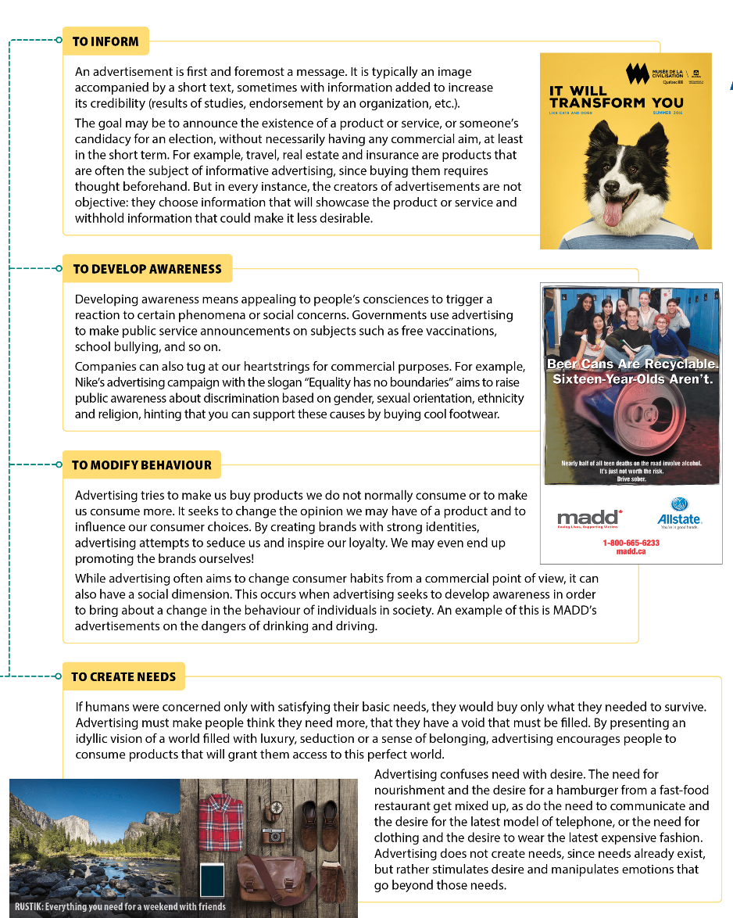
Source: Nadia Choquette-Bernier et al., Making Sense of Finance, Secondary V (Montréal: Chenelière Éducation, 2018), student textbook, 31.

