Weekly Educational Options From the Ministère
secondary v
Week of May 25, 2020
Table of Contents
“The Great Realisation”: Media and the Message 2
Se préoccuper de sa santé mentale… vraiment?! 4
Annexe 1 : Liens internet 6
Annexe 2 : Tableau de consignation 7
Annexe 3 : Liste de vérification 8
The Painter 10
Appendix – The Painter: Solutions 12
Chemistry ‘What If’? 13
Appendix A – What If? 14
Collisions 15
Appendix A – The Car Accident Problem 17
Design a Poster 18
Yin-Yang: A Symbol of Balance 19
Buying Online 21
Appendix – Buying Online 22
Discrimination Against Muslims in India: New Citizenship Policy and the Coronavirus Crisis 24

English Language Arts

“The Great Realisation”: Media and the Message

Information for students
Students will view a media text and think critically about the message that is being conveyed before adopting a stance and commenting on the video’s message.

Read/view and explore
Watch the video entitled “The Great Realisation” http://www.probablytomfoolery.com/
Consider these key media literacy questions as you think about the video:
Who created this message?
What techniques are used to attract the viewer’s attention?
How might different people understand this message differently?
What lifestyles, values and points of view are represented in this message?
What lifestyles, values and points of view are omitted from this message?
Why was this message created?
All texts, including media texts, are constructs. They have been created to serve a particular purpose, or to deliver a specific message. Some media texts have social and political implications. Watch this Media Smarts video to learn more.

Write/produce
This video has gone viral. Why do you think it has become popular? Do people agree with and wish to share his message? If you were to see this video through social media, what comment would you make?
Social media platforms have been the source of much information over the past few months, not all of it reliable. Using a critical literacy approach helps to filter through all of the messages. Though this video is presented initially as an innocent bedtime story, it is in fact delivering a powerful message you may, or may not, agree with about the pandemic.
The writing task:
If you were to share this video on social media, what post would you write to encourage your friends to view it through a critical lens? Create a post that introduces the video to a known audience.

Materials required
Computer with Internet access.

English Language Arts

Information for parents
Students should:
view the video and discuss their ideas with peers and family members.
Parents could:
- encourage their teen to talk about their initial reaction to the video and share their own ideas with them.

French as a Second Language

Se préoccuper de sa santé mentale… vraiment?!

Information for students
Imagine que tu es journaliste à la pige. En raison de la pandémie actuelle, on te demande d’écrire un article (Base : 250 mots / Enrichi : 350 mots) et/ou de produire une balado* d’une durée 2 à 3 minutes pour le magazine web Les mots pour le dire.
*La balado est une excellente façon de pratiquer sa diction.

Contexte
Tu es journaliste à la pige. On te demande en cette période de pandémie et de confinement d’offrir quelques conseils en santé mentale aux adolescents du Québec.

Sujet
Se préoccuper de sa santé mentale… vraiment?!

Destinataires
Les lectrices et lecteurs du magazine web pour adolescents Les mots pour le dire

Intention de communication
Inciter à agir

Consignes
Produire un texte écrit et/ou oral dans lequel vous…
- présentez deux suggestions aux lectrices et lecteurs leur permettant de conserver une bonne santé mentale en cette période de pandémie ;
- illustrez chacune de ces suggestions par un fait ou un exemple (FLS de base) ou par deux faits ou deux exemples (FLSE).

Materials required
Internet, papier, enregistreur audio (optionnel)
Liens internet (annexe 1) / Tableau de consignation (annexe 2) / Liste de vérification (annexe 3)

French as a Second Language

Information for parents
Children should:
revise their sentence structure, vocabulary and grammatical agreement (nouns, adjectives, verbs) before recording or finalizing their text

French as a Second Language

Annexe 1 : Liens internet
Voici quelques ressources intéressantes pouvant t’aider à titre de journaliste à
1. prendre position
2. offrir des conseils judicieux aux adolescents en matière de santé mentale

Articles :

https://www.lapresse.ca/actualites/sante/201812/05/01-5206814-hausse-des-problemes-de-sante-mentale-chez-les-jeunes.php

https://www.lapresse.ca/societe/202005/06/01-5272394-un-ami-virtuel-pour-survivre-a-la-pandemie.php

https://www.lapresse.ca/xtra/202004/08/01-5268600-covid-19-comment-proteger-la-sante-mentale-de-nos-jeunes.php

Balados :

https://www.mouvementunis.org/unisbienetre/balado/ (santé mentale)

Vidéos :

https://safeYouTube.net/w/ZGTD (le confinement, reportage radio-canada)

https://safeYouTube.net/w/YUTD (l’humour, reportage RDI)

https://safeYouTube.net/w/W6LD (robot Aido, chien intelligent de Sony)

French as a Second Language

Annexe 2 : Tableau de consignation
Thème : Se préoccuper de sa santé mentale… vraiment?!
- Opinion défendue: ______________________________________________
Voici un exemple de tableau pour t’aider à consigner tes arguments
Arguments | Stratégies incitatives
 | Injustice | Envie | Peur
Faits

Statistiques
Exemples
Grandes Vérités (proverbes, locutions latines, etc.)
Questions ou phrases-choc

French as a Second Language

Annexe 3 : Liste de vérification
Observe (avant, pendant et après ta production) la liste de vérification ci-proposée pour t’assurer de respecter la structure propre au texte incitatif.

Le texte incitatif

Structure du texte :

Introduction
J’introduis mon sujet et présente clairement ma position.
Je propose deux actions en santé mentale pour soutenir ma position.

Développement
Paragraphe 1
- J’introduis mon premier paragraphe de développement de façon habile (exemple : emploi d’un organisateur textuel + action clairement énoncée).
- J’énonce clairement mes arguments et les développe (1 en FLS Base)
- Argument 1;
- Argument 2.
- J’emploie des phrase(s) incitative(s) au cœur même de mon paragraphe et/ou en guise de clôture.
- J’emploie une/des stratégie(s) incitative(s) : laquelle ou lesquelles?
Peur Envie Injustice
Paragraphe 2
- J’introduis mon deuxième paragraphe de développement de façon habile (exemple : emploi d’un organisateur textuel + action clairement énoncée).
- J’énonce clairement mes arguments et les développe (1 en FLS Base)
- Argument 1;
- Argument 2
- J’emploie des phrase(s) incitative(s) au cœur même de mon paragraphe et/ou en guise de clôture.
- J’emploie une/des stratégie(s) incitative(s) : laquelle ou lesquelles?
Peur Envie Injustice

French as a Second Language

Conclusion
J’introduis ma conclusion de façon habile (exemple : emploi d’un organisateur textuel en début de conclusion).
Je fais un retour sur les deux actions proposées.
J’ai recours à une phrase incitative en guise de clôture.

Mathematics

The Painter

Information for students
Maybritt is trying to make it as a full-time artist. She paints small and large paintings.
It takes her an average of 6 hours to complete a small painting and an average of 12 hours to complete a large painting. Because she still needs to work 60 hours a month part time, she can spend only a maximum of 120 hours a month on her art.
Polygon of constraints ABCDE below represents the possible combinations of small paintings and large paintings that Maybritt can paint in a month.
Number of paintings that maybritt can paint per month

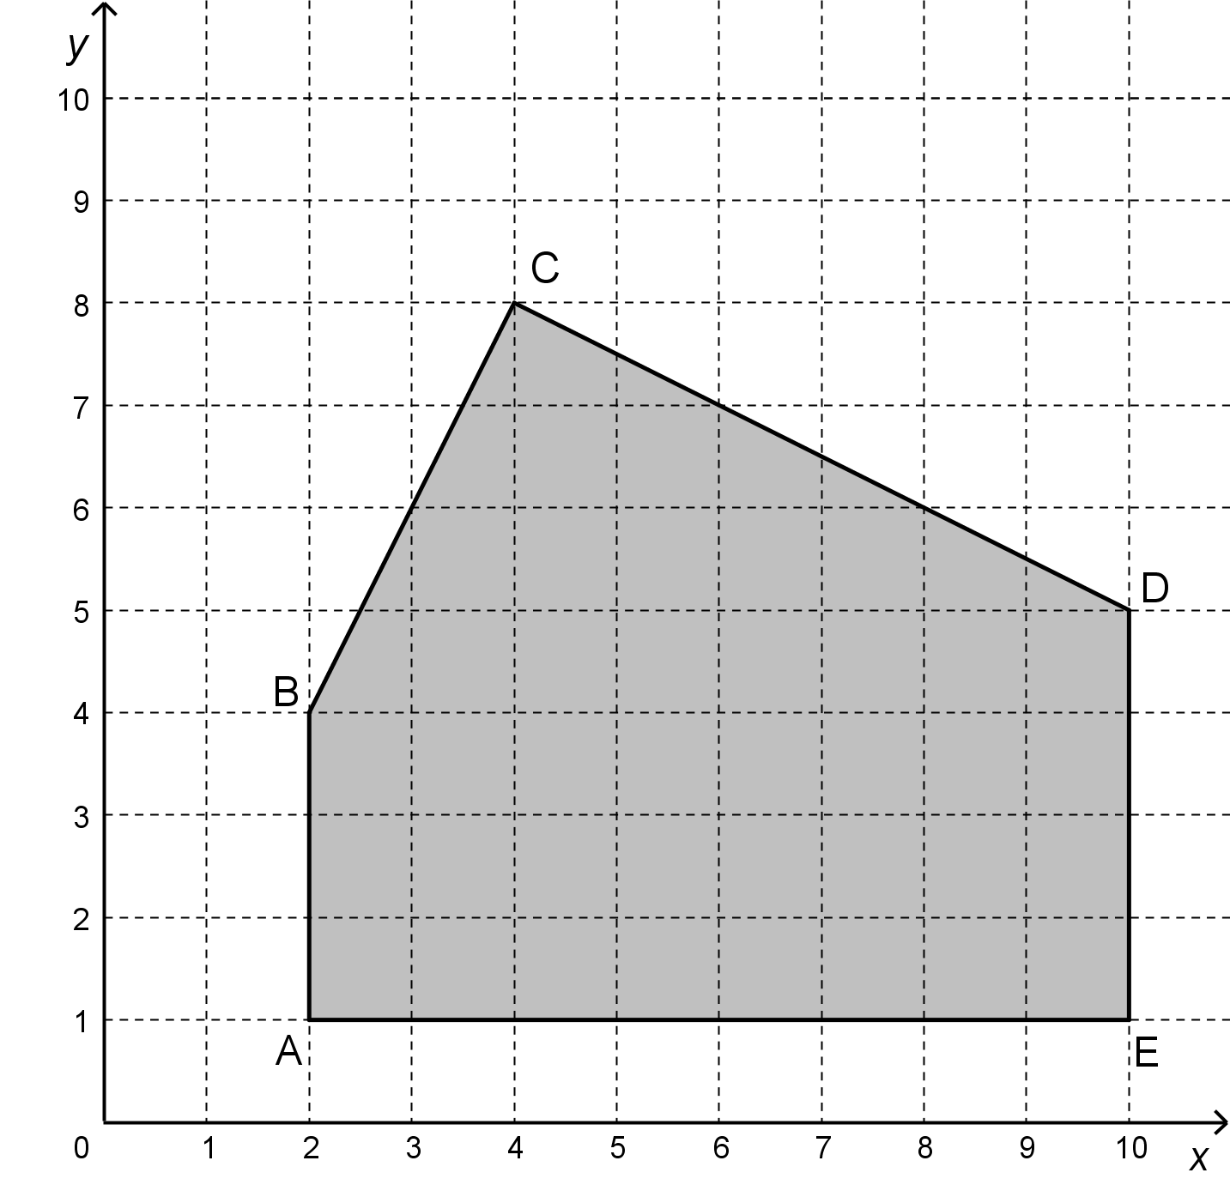 | Coordinates of the vertices of the polygon of constraints  A (2, 1)  B (2, 4)  C (4, 8)  D (10, 5)  E (10, 1)  Inequalities  6x + 12y ≤ 120  y ≤ 2x  x ≥ 2  x ≤10  y ≥ 1
where x: number of small paintings per month
y: number of large paintings per month
Maybritt earns an average income of $200 for a small painting and an average income of $450 for a large painting. She also makes $30 an hour at her part-time job.
After a few months of earning the maximum possible income from her art, she decides she would like to quit her part-time job. This will allow her to spend an extra 60 hours a month painting.

Mathematics

Will Maybritt’s maximum possible monthly income increase or decrease after she quits her part-time job to focus on painting?
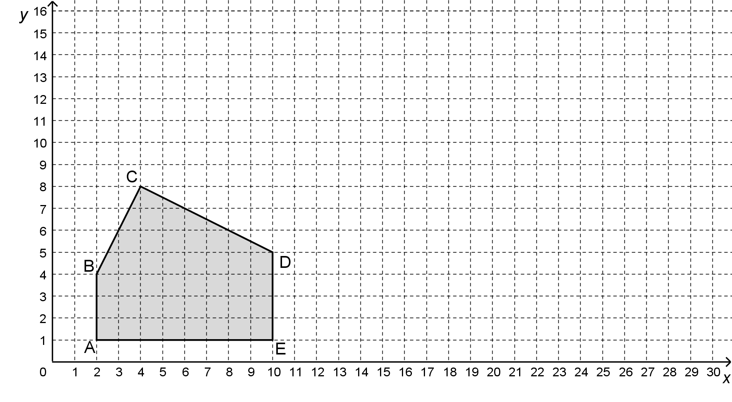

Materials required
Calculator, graph paper, writing and drawing materials

Information for parents

About the activity
Children could:
explain how this concept relates to businesses
Parents should:
read the instructions to their child, if necessary
discuss the task with their child, outlining what steps need to be carried out
go over the task with their child once it is completed by using the answer key provided in Appendix A

Mathematics

Appendix – The Painter: Solutions

Answer Key
MAXIMUM MONTHLY INCOME WHILE HAVING A PART-TIME JOB
Function rule: R = 200x + 450y + 60 × 30
VERTEX | INCOME:  200x + 450y + 1800
A (2, 1) | $2650
B (2, 4) | $4000
C (4, 8) | $6200 | Maximum
D (10, 5) | $6050
E (10, 1) | $4250

The maximum monthly income while having a part-time job is $6200.
NEW POLYGON OF CONSTRAINTS WITH THE NEW CONSTRAINT
The new constraint as a result of working full-time on painting is associated with the inequality  6x + 12y ≤ 180.  Polygon ABFGE on the right represents the possible combinations of small and large paintings with the new constraint.  - MAXIMUM INCOME  VERTEX INCOME: 200x + 450y  A (2, 1) $850  B (2, 4) $2200  F (5, 12) $6600  G (10, 10) $6500  E (10, 1) $2450 | - 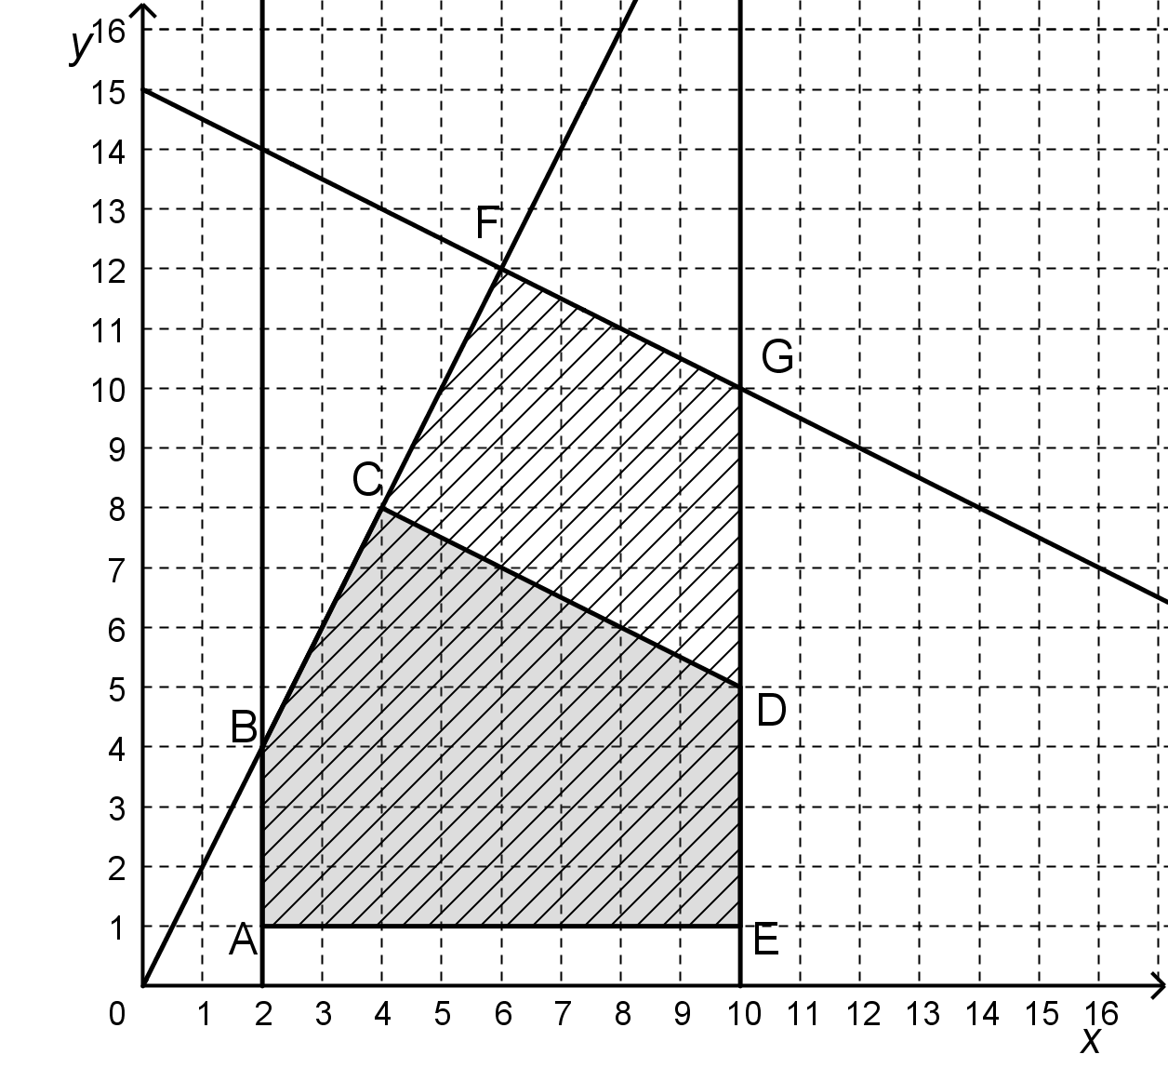
The new maximum possible income is now $6600. This is greater than $6200 by $400.

CONCLUSION
Maybritt’s maximum possible monthly income will increase by $400.

Chemistry

Chemistry ‘What If’?

Information for students
“Half of Science is asking the right questions” – Roger Bacon
We are so accustomed to answering questions that have precise answers. Let’s change that!
In this activity, you will choose at least 1 of the 3 “What If” questions presented in Appendix A to explore. You will have to make lots of assumptions and estimates and use your knowledge of mathematics, possibly physics and of course chemistry.

Materials required
Internet access to conduct research (don’t get sidetracked).
Calculator
Paper and pencil
Chemistry notes, text or reference tables may help

Information for parents

About the activity
Parents could:
listen to their child’s creative and unbelievable (but possibly true) explanations
click on https://what-if.xkcd.com/4/ for an example of a similar thought process on the mole question from Randall Munroe’s book What If?

Chemistry

Appendix A – What If?

Information for students
Choose at least 1 of the 3 options.
Option A
What if the Earth was composed of only moles (the furry animal)? How many moles (the unit of measure, 6.02 x 10²³ ) of moles (the furry animal) would be needed?

Option B
What if all the air in your house/apartment was placed in a small box? How much would it weigh?

Option C
What if we all travelled around using personal blimps/balloons? How big would they have to be?

Examples of questions to ask yourself
How much does a mole (the animal) weigh?
How much volume does a mole (the animal) occupy?
What is the composition of air?
What is the volume of air in my house?
What gas would be in the blimp?
How much buoyant force can a balloon generate?

Physics

Collisions

Information for students
In Physics, we learn about a special and useful quantity called energy. Energy is special because it can be used to keep track of an object’s ability to do “work” (e.g. the more energy we give an object, the more it can move).
A particularly interesting thing about energy is that in a closed system, it is conserved. This means that the amount of energy the system starts with is the same amount of energy it ends up with (since we are not adding new energy to the system and energy cannot be created or destroyed).
$$E_{start}=E_{end}$$
Where:
$E_{start}$ is the energy the system starts with
$E_{end}$ is the energy the system ends up with
For mechanical systems (systems having only mechanical energy), we can focus on potential and kinetic energy of the form:
$$E_{potential}=mgh$$
$$E_{kinetic}=½mv^{2}$$
Where:
$E_{potential}$ is the potential energy of the system
$E_{kinetic}$ is the kinetic energy of the system
$m$is the mass of the object, in kg
$h$is the height of the object, in m
$g$is the gravitational force, in N (1 N = 1 $\frac{kg∙m}{s^{2}}$)
$v$is the velocity of the object, in $\frac{m}{s}$
Therefore, an object sliding down a ramp (without friction) will always have a constant total energy given by the formula:
$E_{total}=mgh+½mv^{2}$**
Another quantity that is conserved (i.e. stays the same as the moving system changes over time) is momentum ($P$). Momentum is used when objects collide. An object’s momentum (P) is its mass ($m$) multiplied by its velocity ($v$):
$$P=mv$$

Physics

When 2 objects collide “elastically,” the total momentum between them stays the same:
$P_{total}=P_{1}+P_{2}=m_{1}v_{1}+m_{2}v_{2}$**
Furthermore, the initial and final velocities follow this rule:
$v_{1 initial}+v_{1 final}=v_{2 initial}+v_{2 final}$**
Watch these videos to learn more (optional):
https://www.youtube.com/watch?v=8OB8eIPgEkQ
https://www.youtube.com/watch?v=CFbo_nBdBco
https://www.youtube.com/watch?v=8ko3qy9vgLQ
https://www.youtube.com/watch?v=2E9fY8H6O1g
Click here to see simulations of collisions (optional):
what can you say about the relationship between the speeds and masses of the carts?
how can you get one cart to stop and the other cart to move after a collision?
is there a way to make both carts move in the same direction after a collision?
- use the information above to solve the car accident problem presented in Appendix A.

Materials required
Pencil, Paper, Calculator
Toy cars (or other rolling objects) and cardboard (or other material to build a ramp), (optional)
Device with Internet access (optional)

Information for parents

About the activity
Children should:
follow the links to watch explanatory YouTube videos
follow the links to online simulations
research the topic online or in encyclopedias
Parents could:
discuss the questions with their children and explore the topic of collision physics
help read the questions, if necessary
help navigate to the desired web pages
discuss the importance of car/driving safety

Physics

Appendix A – The Car Accident Problem

Information for students
Use the information on the first page to analyze the following car accident.
The starred (**) equations are especially useful, and you may need to solve a system of 2 linear equations.
An SUV (large car) parked at the top of a hill 30 meters high accidentally starts to roll down. It hits another parked car at the bottom of the hill. Assuming it was a perfectly elastic collision with no friction, and given the following information, at what velocity does the second car (the one parked at the bottom of the hill) start to roll?
Information:
Mass of the SUV: 1600 kg
Mass of the second car: 1200 kg
SUV
1600 kg

30 m
SUV
1600Kg
Car
1200Kg

30 m
Car
1200 kg

Draw a free body diagram before, during and after the car accident.
Can you model this collision using toy cars and a cardboard ramp?
In “real life,” collisions are never perfectly elastic. Describe where some of the energy gets dissipated and how that affects the system over time.

Arts

Design a Poster

Information for students
This project is about designing a poster for your favorite musical group or artist. Posters often express a mood or feeling, in the same way as the music of your favorite artist does. A poster is designed to get attention from a distance and provide information about the subject. Think of movie posters, bus stop posters, etc. You are free to use any medium or technique you like when creating your poster, such as painting, collage, photography, computer programs, etc. The only requirement for your poster is that you must incorporate some type into the piece. If you have access to the Internet, take the time to look at poster designs online and view the attached optional video on how to design a poster. The process is important. Don’t forget to play your artist’s music for inspiration!
Instructions
- Select your subject, make some sketches of your ideas on paper.
- Think of an image you would like to use.
- Select where on the poster you would like to incorporate the type and information.
- Create a poster that expresses the mood created by the music of the artist you have choosen.
- If possible, use a computer to create your poster. If you do not have access to a computer, make a poster using the supplies you have. Some of the best graphics in art history were drawn by hand.

Materials required
Paper, pencils, markers, paint, collage, tape or glue (optional)

Information for parents

About the activity
Children should:
Research online, if possible, by looking at their favorite movie posters. Think of their favorite movie and try to remember what the poster looked like.
Parents could:
Watch the attached video, if possible, and discuss the project with the student.
- https://youtu.be/7esXHJhrtZY

Ethics and Religious Culture

Yin-Yang: A Symbol of Balance

Information for students
You have probably seen the yin-yang symbol before, and maybe even know that it comes from an Eastern religious tradition, Taoism. But what does it actually mean? What is the relationship between the dark part and the light part? Watch this short video about the hidden meanings of this common symbol: https://ed.ted.com/lessons/the-hidden-meanings-of-yin-and-yang-john-bellaimey.
Look around the room and list the yin-yang relationships that you can see
Consider this poem by Anna Bridges: •
The flame is yang and the heat is yin.
The wick is yang and the flame is yin.
The heat is yang and the aroma is yin.
The wax is yang and the aroma is yin.
The glass is yang and the wax is yin.
My hand is yang and the glass is yin.
My brain is yang and my hand is yin.
The Wax is yang and the aroma is yin.
The glass is yang and the wax is yin.
Draw the yin-yang symbol with personal images representing the yin and the yang, inspired by the images in the video.
Consider reading further on Taoist philosophy here: Taoist Beliefs, Practices and Deities.

Materials required
Device with internet access
Paper, drawing materials

Ethics and Religious Culture

Information for parents

About the activity
Children could:
Watch the video to deepen their understanding of Taoism and the importance of balance
Reflect on the presence of yin-yang in their environment and in their lives
Draw the yin-yang symbol with personal images representing the yin and the yang, inspired by the images in the video
Consider reading further on Taoist philosophy here: Taoist Beliefs, Practices and Deities
Parents should:
Watch the video
Discuss the different interpretations of good and evil from a Western religious perspective
Compare this perspective with the philosophy of Taoism, in which good and evil are linked
Consider reading further on Taoist philosophy here: Taoist Beliefs, Practices and Deities

Financial Education

Buying Online

Information for students
In this activity you will learn about potential risks and guidelines to help you buy on online safely.

Instructions
Read pages 84, 103 and 104 of your textbook Making Sense of Finance, or consult the documents in the Appendix. Take note of the following:
- three rights that you have as a consumer
- three potential risks associated with buying online
- three signs to watch for before purchasing items online
The Educaloi site explains various laws and provides information about your rights and responsibilities as a citizen. Consult the Consumers section of the site and discover the guidelines for online shopping.
Once you’ve made your list of rights, risks and signs to watch for and you’ve explored the resources, take this quiz to test your knowledge of how to protect yourself.

Materials required
Useful resources, depending on personal preferences and availability:
Device with Internet access
Writing materials (paper, pencil, etc.)
Textbook

Information for parents

About the activity
Students could:
consult the Educaloi site to find out more about the Consumer Protection Act and consumer rights
Parents should:
help their child become an educated consumer with respect to online shopping and access the Educaloi website for more information

Financial Education

Appendix – Buying Online
Reference documents:
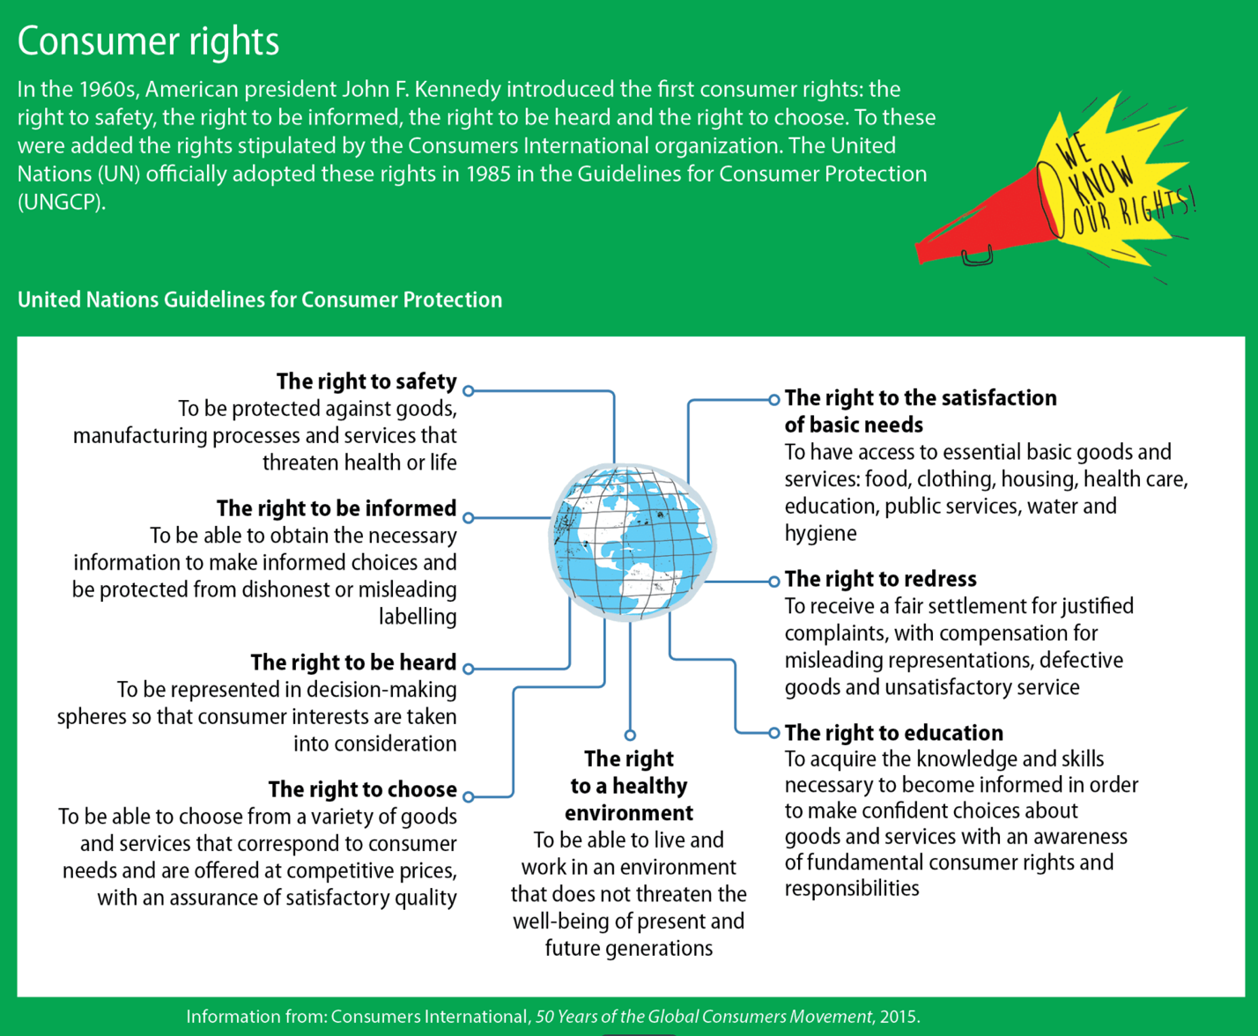

Source: Nadia Choquette-Bernier et al., Making Sense of Finance, Secondary V (Montréal: Chenelière Éducation, 2018), student textbook, 84.

Financial Education

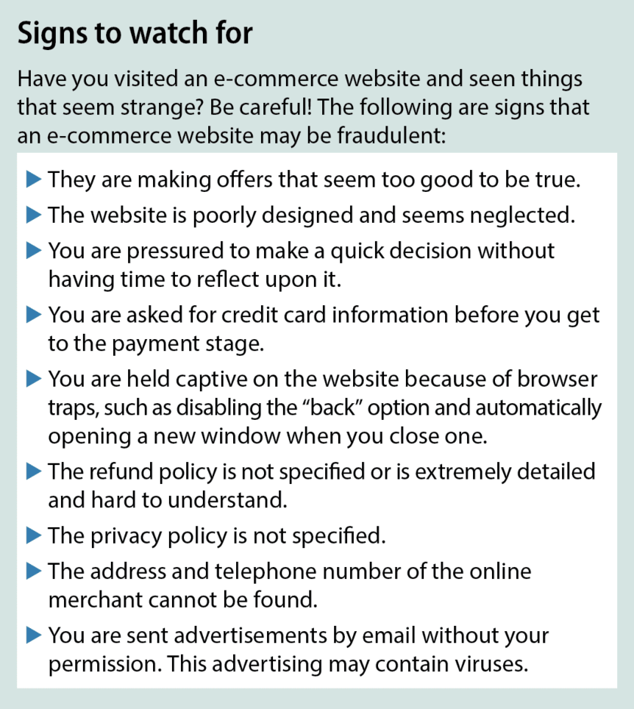
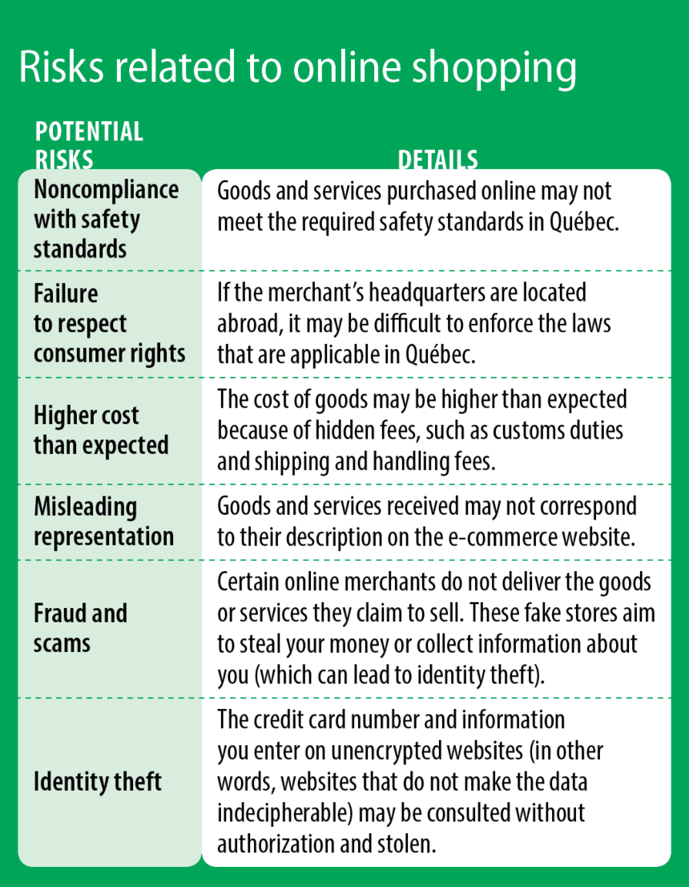

Source: Nadia Choquette-Bernier et al., Making Sense of Finance, Secondary V (Montréal: Chenelière Éducation, 2018), student textbook, 103.

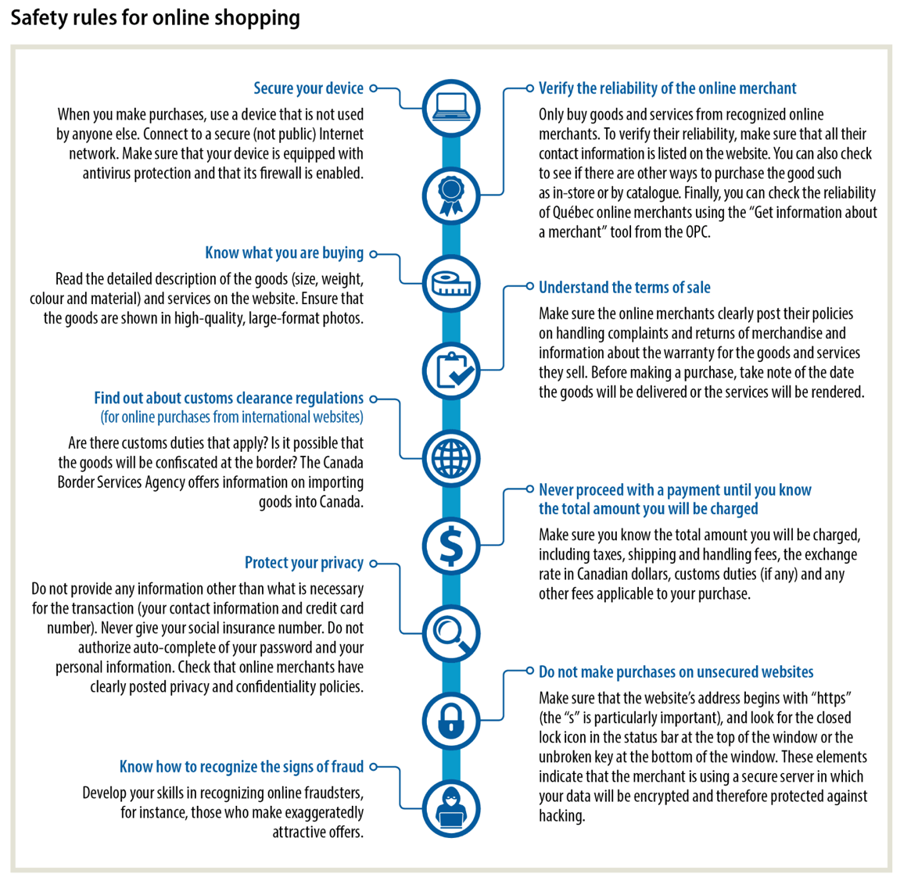
Source: Nadia Choquette-Bernier et al., Making Sense of Finance, Secondary V (Montréal: Chenelière Éducation, 2018), student textbook, 104.

Contemporary World

Discrimination Against Muslims in India: New Citizenship Policy and the Coronavirus Crisis

Information for students
In your Contemporary World class, you have likely explored the theme of Tensions and Conflicts. Some of the topics include:
- Rights, freedoms and cultural identity (ethnicity, religion, etc.)
- Diplomatic crisis and armed conflicts
- Intervention of third states or international institutions and humanitarian assistance
Most tensions and conflicts arise out of explicit demands, which take different forms, and may involve questions about rights, territory, the control of resources or political autonomy. In addition to explicit demands, there may be deeper causes, such as previous tensions and conflicts or deeply rooted ideological differences. These underlying social and economic factors could lead to grave consequences, including genocide: the systemic and deliberate murder of a national, racial, political or cultural group of people.
- Note: If the topic of genocide has not been covered in your Contemporary World course, you can activate your prior knowledge by thinking about books you might have read or movies you might have watched, or simply do some research on the subject.
As the number of coronavirus cases in India keeps rising, violent attacks on Muslims continue to occur, a result of the Hindu nationalist ideology of the ruling Bharatiya Janata Party (BJP) and its affiliated groups. In power since 2014, the BJP government has denounced Muslim refugees who fled an ethnic cleansing campaign in Myanmar and deported some of them, violating international laws.
In a new report (April 2020), Human Rights Watch found that, ‘’India’s discriminatory new citizenship law and proposed policies have spurred further violence against Muslims. The Citizenship Amendment Act, for the first time in India, makes religion the basis for granting citizenship . . .” The HRW, an international non-governmental organization, now fears that Indian Muslims could be stripped of their citizenship rights and identified as illegal migrants or infiltrators by their government.
While the planet is paralyzed by an ongoing pandemic, violence against Indian Muslims keeps raging and is threatening the effort to enforce a lockdown in a country that has nearly 18% of the total world population and some of the most densely populated cities. In addition, television channels and political leaders have falsely suggested that Islamic groups in India are responsible for the propagation of the coronavirus, leaving them even more vulnerable to violence.

Contemporary World

With the United Nations Human Rights Agency seeking to join a case in India’s Supreme Court against the new citizenship law and Amnesty International raising concerns over the fate of excluded Islamic groups, the situation is becoming urgent. Some world leaders have used the word genocide to describe what is taking place in the country.
Genocide is a human phenomenon that can be analyzed and understood. It is a process that develops in ten stages, or steps, according to Dr. Gregory H. Stanton, Founder and President of Genocide Watch:
- 1. Classification / 2. Symbolization / 3. Discrimination / 4. Dehumanization / 5. Organization / 6. Polarization / 7. Preparation / 8. Persecution / 9. Extermination / 10. Denial
- You will find a description of the ten stages and prevention measures that can be taken at each stage on the website of the Montreal Holocaust Museum: https://museeholocauste.ca/en/resources-training/ten-stages-genocide/
In light of what you’ve read about the present situation in India and with your prior knowledge:
- What could prevent a genocide from happening there? How would the situation be different from other genocides in history (the Armenian Genocide, the Holocaust, the Rwandan Genocide, etc.)?
- Keeping in mind that the stages of genocide do not necessarily follow a linear progression, what stage, in your opinion, is representative of the current situation in India? Explain.
- How do you think the coronavirus crisis could influence the course of events? Discuss and provide supporting arguments.

Materials required
Useful resources, depending on personal preferences and availability:
Device with Internet access
Writing materials (paper, pencil, etc.)

Information for parents
Students could:
remember that the goal is not to have the right answer but to reflect on the issues of discrimination, tensions and conflicts, and genocides
Parents should:
discuss the information and the questions with their child and share their own thoughts with them; parents could encourage their child to contact a classmate if their child has more questions or wants to chat with a peer

Adapted from: Randall Muroe “What if? Serious Scientific Answers to Absurd Hypothetical Questions,” (New York: Houghton Miffin Harcourt Publishing, 2011)
Rear End Collision Free Icon, n.d., SVG, Flaticon.com, https://www.flaticon.com/free-icon/rear-end-collision_66139?term=collision&page=1&position=80
https://www.hrw.org/news/2020/04/18/indias-steps-contain-covid-19-have-failed-curb-anti-muslim-rhetoric

