Weekly Educational Options From the Ministère
secondary v
Week of May 18, 2020
Table of Contents
Preparing a Defence! 2
La Terre aux soins intensifs? 3
Spending a Fortune 5
Appendix A – Required Information for Student Council 7
Appendix B – Formula Sheet 8
Appendix C – Answer Key 10
The Chemistry of the Bombardier Beetle 12
Appendix – Chemistry of the Bombardier Beetle 15
Roller Coaster Physics 16
Appendix A: Solutions 20
Reflect on Beauty Standards and Get Moving! 21
Your Visual Identity and Branding Your Art 23
Buying Online 24
Appendix – Buying Online 25
Refugees 27

English Language Arts

Preparing a Defence!

Information for students
Canada Reads: One Book That Brings Canada Into Focus
Canada Reads is an annual "battle of the books" competition organized and broadcast by Canada’s public broadcaster, the CBC. During the competition, five Canadian personalities champion five different books. This year’s theme is “bringing Canada into focus.” Each book will represent one view of Canada or one personal experience of our vast country. Find out more about Canada Reads 2020 here: Canada Reads. You can also listen to a special spotlight episode where the author discusses their book. Make notes as you read or listen.
Prepare a Canada Reads Defence
Watch this highlight video from Canada Reads 2019. Notice the types of arguments used to defend the book.
Use your notes and ideas from reading and listening or viewing to produce a short defence of one of the Canada Reads 2020 books. Write down and/or make a video or audio recording of your defence.

Material required
Paper, pen, phone, tablet or computer.

Information for parents
Above all, activity is designed to be simple. We hope it will appeal to your child. The best things your child can do are:
Read every day.
Write every day.
Talk every day.

French as a Second Language

La Terre aux soins intensifs?

Information for students
La Journée mondiale de l’environnement, le 5 juin, approche à grands pas. Profitons du temps qui nous est alloué pendant cette pandémie pour réfléchir à ce sujet qui a été récemment mis à l’écart. L’attention médiatique suscitée par la jeune militante Greta Thunberg et la Marche pour le climat en septembre dernier sont des moments charnières qui guideront, sans doute, nos actions futures en tant que société.

Dialogue entre la Terre et toi…
Imagine que ton amie, La Terre, est hospitalisée. Compose un dialogue entre elle et toi.
- Avant de commencer à écrire, regarde la vidéo et lis l’article suivants :
Greta Thunberg, qui est-elle vraiment? https://www.dailymotion.com/video/x7q1tpi
La Terre respire, mais pour combien de temps ? https://ici.radio-canada.ca/nouvelle/1695993/jour-terre-pandemie-covid-societe-habitudes-environnement-nature
- Consulte la page web suivante et suis les indications sur l’écriture d’une séquence dialogale : http://www.alloprof.qc.ca/BV/pages/f1022.aspx
Regarde cet exemple tiré du site web :
Phase d'ouverture:
Marjolaine téléphone à Pascal pour le prévenir qu'elle allait être en retard.
-Pascal, c'est moi. Je vais arriver quelques minutes en retard au restaurant.
Phase d'interaction:
​-Pas de problème. Je prendrai un café en t'attendant.
-Super! Tu demanderas à la serveuse de nous asseoir à une banquette, d'accord? demanda-t-elle.
-Oui, chef!
-Arrête de m'agacer...
Phase de clôture:
-Bon, on se voit tantôt, Marjolaine.
-D'accord, salut.
Les deux amis raccrochent et se préparent pour leur sortie.
- Fais l’activité de réflexion et l’activité de création s’intitulant Alerte Météo* : https://www.editionsmagriffe.ca/uploads/4/0/7/6/40767431/alerte_m%C3%A9t%C3%A9o_lire_interagir_produire.pdf
- Maintenant, écris la conversation que tu auras avec ton amie, la Terre, lors de ta visite aux soins intensifs. Ton texte doit compter entre 250 et 350 mots. Tu peux toujours écrire plus si ça te tente. Voici un aide-mémoire tiré de l’activité Alerte Météo.
- Que te dit-elle ? Que lui dis-tu ?
- Comment sont vos échanges ? Chaleureux, froids, empreints de tristesse, de colère, d’espoir ?
- Comment se termine votre discussion ? En bons ou mauvais termes ?

French as a Second Language
Porte une attention particulière aux éléments suivants lors de l’écriture de ton dialogue :
La présence des phases d’ouverture, d’interaction et de clôture dans l’écriture de ton dialogue.
La présence de tirets ou de guillemets (les uns ou les autres, mais évite le mélange des deux systèmes).
Un registre de langue approprié.
La ponctuation.
Si ton accès à Internet est limité et que tu désires bien te préparer à ta tâche d’écriture, n’hésite pas à discuter d’écologie avec ton entourage, soit réfléchir aux impacts que cette pandémie a sur l’environnement.
Pour aller plus loin
Crée une bande-dessinée de ta conversation avec la Terre.
Visionne un ou plusieurs documentaires en français à propos de l’environnement. Voir la section Information for parents pour connaître des titres de documentaires intéressants.

Materials required
Appareil avec accès Internet
Papier, crayon

Information for parents
Children should:
watch the documentaries Océans (2009), Avant le deluge (2016), Terra (2016) or Une suite qui dérange (2017) in French if they want to learn more about the environment.
Parents could:
help their child find online resources
brainstorm conversational dialogue with their child in French, if possible
*Nous avons eu l’autorisation de l’autrice/Les éditions M@griffe de reproduire en tout ou en partie cette activité.

Mathematics

Spending a Fortune

Information for students
A few years ago, Maurice Richard High School received a generous donation from an anonymous donor. The staff, students and parents decided to invest the money and spend the interest earned at a later date. Because the interest rate on the investment will fall by 2% next year, the school decided that this year, it would spend the interest earned on something that the students would like. The Student Council must decide what to do with this money.
The Student Council must answer the following questions:
- How long did it take for the initial investment to double in value?
- How much money did the school make in interest?
- At the new interest rate of 5%, how long would it have taken for the initial investment to double in value?
- The Sec. V members of the Student Council who are taking the CST math course will organize a vote to see what the students want to do with the money.
    - The following voting methods must be used: the Borda count, the Condorcet method and the elimination method.
    - The item that gets the most votes according to two out of the three methods will be the winner.
- The Sec. V members of the Student Council who are taking the SN math course will be organizing a fireworks show involving drones on the football field. One drone will be flying in a circle, while the other will take off from the ground and follow a parabolic trajectory. More than once during the show, the two drones will have to be at different altitudes to avoid colliding with each other. The students need to determine the locations in the sky where this must be the case.

Materials required
Appendix A: Required Information for the Student Council
Appendix B: Formula Sheet
Appendix C: Answer Sheet

Mathematics

Information for parents

About the activity
Read the instructions to your child, if necessary.
ALL students should answer the questions about the investment and the interest rate AND
- Students taking the CST math course should answer the question about voting methods.
- Students taking the SN math course should answer the question about the show with fireworks and drones.
Discuss the task together with your child, outlining what steps they need to carry out.
Once the task is completed, you and your child can go over the task with the answer key provided (Appendix C)
Your child may obtain answers that could be slightly different from the answer key, depending on how they round off their results. Being off by a few tenths is fine. There is no need to worry about inconsistencies in rounding off the results. The important thing is that your child is able to show that they can solve the problem.

Mathematics

Appendix A – Required Information for Student Council

Information for students
The original donation to the school was $10 000. At an interest rate of 7%, this investment has finally more than doubled in value.
- The student council needs to figure out how long it took for the initial investment to double in value.
- How much money did the school make in interest?
- At the new interest rate of 5%, how long would it have taken for the initial investment to double in value?

Vote Breakdown (CST Students)
 | ¼ of the students | 15% of students | 2/5 of the students | The rest of the students
1st Choice | Outdoor Garden | Hire a Band | Lounge Area | Outdoor Garden
2nd Choice | Lounge Area | Lounge Area | Hire a Band | Hire a Band
3rd Choice | Hire a Band | Outdoor Garden | Outdoor Garden | Lounge Area
There are 1000 students at Maurice Richard High School

Fireworks display (SN Students)
The council would like to celebrate by having two drones fly around while shooting fireworks.
One drone will take off from the field and fly further down the field by following a parabolic trajectory.
Another drone will be flying around in a circle at the same time.
This is represented in the diagram on the right.
The drone flying in a parabolic trajectory will reach a height of 36 metres and fly 24 metres across the field.
The drone flying in a circle will be at a minimum altitude of 8 metres and a maximum altitude of 32 metres above the ground.
The council needs to know the locations in the sky where the drones must be at different altitudes to avoid colliding (x-coordinates = distance flown down the field by the drone in the parabolic trajectory; y-coordinates = altitude of that drone).

Mathematics

Appendix B – Formula Sheet

Voting Methods (for CST portion)

Borda Count
ICE CREAM VOTE
Rank your favourites from 1-4 (1 being the best, 4 being the worst)
Chocolate | 1
Gum ‘n Nuts | 4
Strawberry | 3
Vanilla | 2
In a Borda count, people are asked to rank all the possible options. The ones with the higher ranking get more points compared to the lower ranked ones on the same ballot.
For example, a ballot (as shown on the left) is used to determine the favourite flavour of ice cream. The voter ranks them. The pick that gets the highest rank gets 4 points, the next highest 3 points, etc. The points are then used to determine the winner.
In this example, chocolate is given 4 points, vanilla is given 3 points, strawberry gets 2 points and gum ‘n nuts gets 1 point.
The rule for the Borda count is that the maximum number of points (n) is equal to the number of choices. In the above example, because there are four choices, the maximum number of points is 4.

Condorcet Method
The Condorcet method examines people’s secondary choice along with their top preference by doing a head-to-head comparison.

Number of votes based on rankings | 46 | 22 | 10 | 9
1st choice | Unicorn | Goat | Phoenix | Phoenix
2nd choice | Phoenix | Phoenix | Goat | Unicorn
3rd choice | Goat | Unicorn | Unicorn | Goat

Using the Condorcet method, we have to compare the following: Unicorn vs. Goat
Phoenix vs. Goat
Unicorn vs. Phoenix

Elimination Method
The elimination method can be used if there is no majority winner based on everyone’s first choice. In this case, the option in last place is eliminated and the votes are recalculated to see if there is a majority winner. The elimination process continues no matter how many options there are; you need to get a majority winner.

Mathematics

Logarithms

power = base^{exponent} for example: 8 = 2³

log_{base}(power) = exponent for example: log₂8 = 3

Conics Section (for SN portion)

Formula for a Second-Degree Function

y = a(x – h) + k

Formula for a Circle

(x – h)² + (y – k)² = r²

Mathematics

Appendix C – Answer Key

Analyzing the Investment

Time it took for the donation to double in value
$\frac{\text{10 000 x }{\text{1.07}}^{\text{x}}}{\text{10 000}}$= $\frac{\text{20 000}}{\text{10 000}}$

1.07^{x} = 2

$\frac{\text{log2}}{\text{log1.07}}$ = 10.2448 years

It took 11 years

Total amount of interest earned
10 000 x 1.07¹¹ = 21 048.52
21 048.52 – 10 000 = 11 048.52

Amount of time it would have taken for the initial investment to double in value at 5% interest
$\frac{\text{10 000 x }{\text{1.0}\text{5}}^{\text{x}}}{\text{10 000}}$= $\frac{\text{20 000}}{\text{10 000}}$

1.05^{x} = 2

$\frac{\text{log2}}{\text{log1.0}\text{5}}$ = 14.2067 years

It would have taken 15 years to double in value.

Mathematics

Student Vote
 | 250 students | 150 students | 400 students | 200 students
1st Choice | Outdoor Garden | Hire a Band | Lounge Area | Outdoor Garden
2nd Choice | Lounge Area | Lounge Area | Hire a Band | Hire a Band
3rd Choice | Hire a Band | Outdoor Garden | Outdoor Garden | Lounge Area
Borda count
- Outdoor garden: 3(250) + 1(150) + 1 (400) + 3(200) = 1900
- Lounge Area: 2(250) + 2(150) + 3(400) + 1(200) = 2200
- Hire a Band: 1(250) + 3(150) + 2(400) + 2(200) = 1900

Condorcet Method
- Outdoor Garden vs. Lounge Area = 450 < 550
- Lounge Area vs. Hire a Band = 650 > 350
- Hire a Band vs. Outdoor Garden = 450 < 550

Results inconclusive since it’s a three-way tie

Elimination Method
- 1st Round: Outdoor Garden (450), Lounge Area (400), Hire a Band (150)
- 2nd Round: Lounge Area (550), Outdoor Garden (450)

Final Results: Lounge Area is chosen
(It won according to the Borda count and the elimination method)

Fireworks Display
Equation of the circle : (x – 12)² + (y – 20)² = 144

Equation of the parabola : y = -(0.5x – 6)² + 36

Points of intersection (2.37, 12.83), (7.6, 31.17), (16.4, 31.17), (21.63, 12.83)

The drone following a parabolic trajectory will cross the path of the circle at the following points:
- 2.37 m down the field (12.83 m up in the air)
- 7.6 m down the field (31.17 m up in the air)
- 16.4 m down the field (31.17 m in the air)
- 21.63 m down the field (12.83 m in the air)

Chemistry

The Chemistry of the Bombardier Beetle

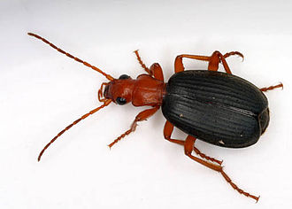
Information for students
The Bombardier Beetle gets its name from how it defends itself. When threatened, this beetle releases a toxic mixture that is produced by an explosive reaction inside its abdomen.
Read about the Bombardier Beetle’s defense mechanism below and then answer the questions to explain the chemistry behind this phenomenon.

The Bombardier Beetle’s Defense Mechanism
Scientists have been curious about how this defense mechanism works and are still learning about it. Below is a simplified description of some of the chemistry behind one of the ways in which the Bombardier Beetle may defend itself from attackers.
Two glands and a reaction chamber inside the abdomen of the beetle are involved in this defense mechanism.
When the contents of the glands are emptied into the reaction chamber, an extremely fast reaction occurs.
Below is a simplified model of the glands and the reaction chamber.

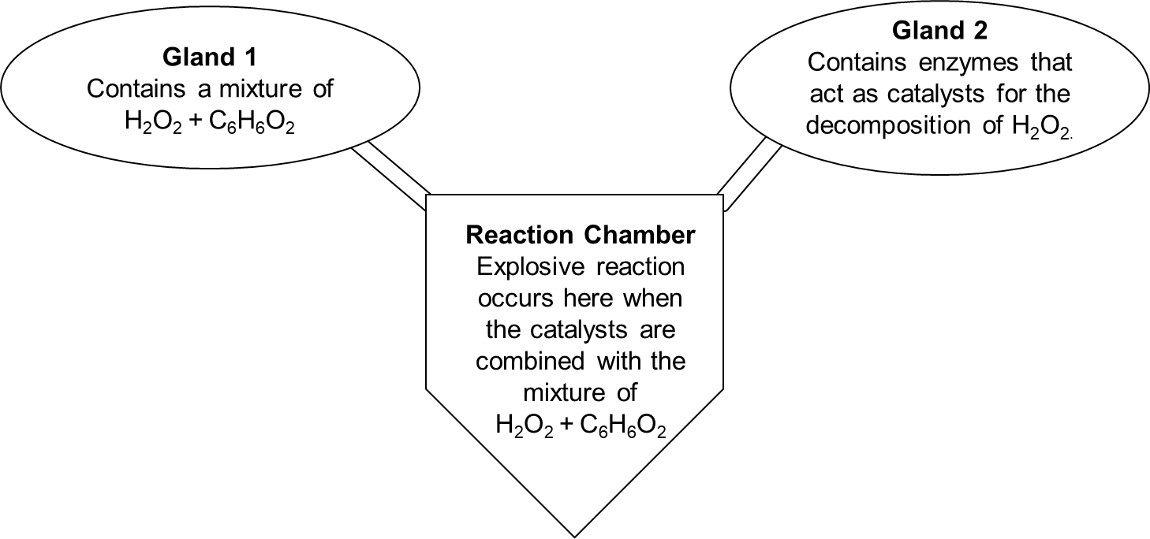
Chemistry
Gland 1 contains a mixture of hydrogen peroxide (H2O2), and hydroquinone (C6H6O2).
- This mixture is relatively stable.
- Hydrogen peroxide can decompose to produce oxygen and water. This reaction occurs very slowly in the gland.
Gland 2 contains a mixtures of enzymes.
- These enzymes are catalysts for the decomposition of hydrogen peroxide.

In the Reaction Chamber:
When the contents of the glands combine in the reaction chamber, an explosive reaction occurs and a mixture of water and benzoquinone is produced. Benzoquinone is the toxic chemical that irritates the beetle’s attackers. This reaction happens in two steps:
- The enzyme mixture catalyzes the decomposition of hydrogen peroxide (H₂O₂ ), rapidly producing water and oxygen gas: hydrogen peroxide → water + oxygen gas
- Then, the oxygen gas produced reacts with the hydroquinone, to produce benzoquinone.
As the reactions occur:
- Valves seal off the ducts between the glands and the reaction chamber.
- The mixture in the reaction chamber heats up and can reach temperatures as high as 100 °C.
- The pressure in the reaction chamber increases and, as a result, the mixture of water and benzoquinone is expelled out of the chamber and onto the beetle’s attackers.
You can see a Bombardier Beetle in action by watching this video.

Questions
Answers are provided in the Appendix.
1. Is the reaction that occurs in the reaction chamber endothermic or exothermic? Explain.

2. Explain why the decomposition of hydrogen peroxide (H₂O₂), occurs very slowly in Gland 1 but very quickly in the reaction chamber.

3. Draw and compare the energy diagrams for the decomposition of hydrogen peroxide (H₂O₂) in gland 1 and in the reaction chamber. Include a comparison of the activation energy and the change in enthalpy for the reactions in each location.

4. Why do you think the pressure builds up in the reaction chamber? Explain your answer.

Chemistry

Materials required
Paper and writing materials
Device with Internet access (optional)

Information for parents
Children should:
apply their chemistry knowledge to explain the chemistry behind a natural phenomena
Parents could:
read the task to their child if necessary
discuss the task with their child

Chemistry

Appendix – Chemistry of the Bombardier Beetle

Answers

1. The reaction that occurs in the reaction chamber is exothermic. The temperature in the reaction chamber increases during the reaction, which means the reaction releases heat. (Exothermic reactions release heat.)
2. The reaction rate depends on the number of effective collisions between reactants (with correct orientation, sufficient energy). The decomposition of hydrogen peroxide is slower in Gland 1 because there are relatively fewer effective collisions per unit of time than in the Reaction Chamber.
3. The decomposition of hydrogen peroxide is faster in the Reaction Chamber because there are more effective collisions between reactants per unit of time. This can be explained by the presence of the catalysts (from Gland 2) in the Reaction Chamber. A catalyst lowers the activation energy of the reaction. As such, a greater number of reactant particles have sufficient energy to react.
4. The comparison of your energy diagrams should illustrate the following characteristics:
- The reaction is exothermic (energy of reactants is greater than the energy of the products
- The change in enthalpy is the same for both reactions
- The activation energy is lower for the catalyzed reaction in the reaction chamber.
5. One of the possible explanations for the increase in pressure in the reaction chamber is that oxygen gas is produced when the hydrogen peroxide decomposes. An increase in the quantity of gas in the vessel increases the pressure (assuming that the volume of the Reaction Chamber is constant). The increase in temperature can also contribute to the increase in pressure.

Physics

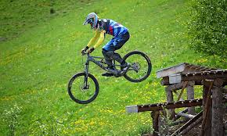
Roller Coaster Physics
Imagine you are on your bike and you are:
A) at the bottom of a very steep hill.
B) at the top of a very steep hill.
What factors affect:
velocity
the amount of effort/energy required to
- pedal
- break

Research
Describe in your own words what conservation of mechanical energy means
Identify one way you can increase potential energy
Identify one way you can increase kinetic energy
Click on the link below to Energy in a Roller Coaster Ride and choose the “STEP” option. Describe what happens at each position in terms of
height and velocity
potential and kinetic energy
Link to Energy in a Roller Coaster Ride: https://www.pbslearningmedia.org/resource/hew06.sci.phys.maf.rollercoaster/energy-in-a-roller-coaster-ride/

Information for students
The formula for conservation of mechanical energy (disregard friction)

$${PE}_{1}+{KE}_{1}={PE}_{2}+{KE}_{2}$$
Where:
$PE= mgh$
$KE=\frac{1}{2}mv^{2}$
$m=mass \left(kg\right)$
$h=height (m)$
$v=velocity (m/s)$
$g=acceleration due to gravity on earth= 9.8 m/s^{2}$
Physics

Problem 1
Most roller coasters use an electric winch to pull the cars up to the top of the first high point. In the example below, the roller coaster is pulled to the top of the hill where the speed of the rollercoaster is 2 m/s (point A). The mass of the roller coaster is 1000 kg.
A) Identify the potential energy, kinetic energy, total energy and the velocity at points A, B, C, D and complete Table 1.
B) What is the maximum height the roller coaster reaches when it stops (point E)?
( $v=0 m/s$ )

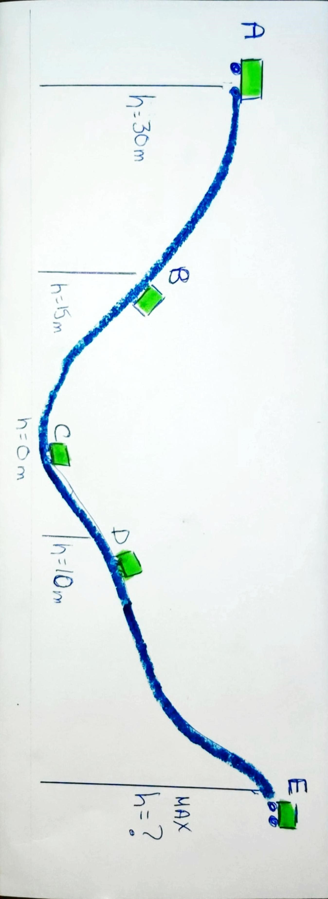
v = 2 m/s

Table 1

 | Point A | Point B | Point C | Point D | Point E
Height (m) | 30 | 15 | 0 | 10 | ?
Mass (kg)
Potential Energy (J)
Kinetic Energy (J)
Total Energy (J)
Velocity (m/s)

Physics

Problem 2
Design a new track for the same roller coaster (m = 1000 kg).
The roller coaster must have 4 hills and each hill must be a different height
The speed of your roller coaster should not exceed 100 km/hr
Air breaks will be used at the end of the ride, once it is at ground level (height = 0 m)
Complete Table 2

Table 2
 | Hill A | Hill B | Hill C | Hill D | End - before the breaks are applied
Height (m) |  |  |  |  | 0
Velocity (m/s)

Mass (Kg)

Potential Energy (J)
Kinetic Energy (J)
Total Energy (J)

Physics

Materials required:
Calculator
Internet device (optional)

Information for parents
Answer key to Table 1 can be found in the Appendix
Helpful link: https://www.khanacademy.org/science/physics/work-and-energy/work-and-energy-tutorial/v/conservation-of-energy

Physics

Appendix A: Solutions

Answer Key for Table 1
 | Point A | Point B | Point C | Point D | Point E
Height (m) | 30 | 15 | 0 | 10 | PE - mgh  $$296 000= 1000(9.8)h$$  30.2
Mass (kg) | 1000 | 1000 | 1000 | 1000 | 1000
Potential Energy (J)  $$PE= mgh$$ | 294 000 | 147 000 | 0 | 98 000 | 296 000
Kinetic Energy (J)  $$KE=\frac{1}{2}mv^{2}$$ | 2 000 | 296000 – 147000=  149 000 | 296000 – 0 =  296 000 | 296000 – 98000 =  198 000 | 0
Total Energy (J) | 296 000 | 296 000 | 296 000 | 296 000 | 296 000
Velocity (m/s)  $$KE=\frac{1}{2}mv^{2}$$ | 2 | 149 000=$\frac{1}{2}1000v^{2}$  17.26 | 296 000=$\frac{1}{2}1000v^{2}$  24.33 | 198 000=$\frac{1}{2}1000v^{2}$  19.90 | 0

Physical Education and Health

Reflect on Beauty Standards and Get Moving!

Information for students:
Activity 1: “I’ve had it with . . .”
- Watch this video (58 seconds). While the video is in French, the message is equally relevant in English.
- What are your thoughts after watching the video? What aspects of society’s beauty standards frustrate you? What strategies do you use to navigate the messages that society and mass media often promote about physical appearance?
- Discuss the topic with a friend or family member.
Activity 2: High Intensity Interval Training (HIIT)
- What do you know about High Intensity Interval Training? Watch the first 4 minutes of this video to learn more about HIIT and the proven benefits of this type of exercise.
Based on your current level of personal fitness, complete one of the following HIIT workouts:
- Beginner
- Intermediate
- Advanced
Remember that technique comes before intensity. Practise the movement first to make sure you can do them with the proper technique. In addition, stop the repetitions if you feel that you are too tired to complete the movements with proper technique.
To view these activities in a Google Slide format in French, consult the Reste actif! website.

Physical Education and Health

Materials required
None

Information for parents

About the activity
Children should:
reflect on society’s beauty standards
learn about High Intensity Interval Training (HIIT) and complete a HIIT workout
Parents could:
discuss stereotypes in sports with their children
learn how to juggle together with their children

Arts

Your Visual Identity and Branding Your Art

If your artwork or creations escaped from your sketchbook or phone, how would they want to be presented to others?
This week, we’ll dive into how we present what we make to others online. We will also consider the visual storytelling around our creations.
- You’ve heard of brands. What do you personally want to communicate about some of the art you’ve created since you started high school?
- Branding is about connecting with those that view your art and communicating with them. The goal is to have your audience recognize you.
Take a pencil and paper and without overthinking it, write down your answer to the following question: What do you want your creations to be remembered for? Simplify the idea and create your visuals based on that.
- Use the 10 steps found on this site to build the visuals. Focus on branding and brainstorming symbols. https://www.canva.com/learn/personal-branding/
- If you’ve already written an artist’s statement in class, going back to it could help you remember some key ideas about who you are as an artist and the work you create. Example: Artist's statement from Learnquebec

Materials required
Internet
Pencil and paper

Information for parents

About the activity
Children should:
Build on the work they had already done at school this year and in past years. Explore sharing their work.
Parents could:
Encourage their children to share or promote their artwork or artistic creations.

Financial Education

Buying Online

Information for students
In this activity you will learn about potential risks and guidelines to help you buy on online safely.
Instructions
Read pages 84, 103 and 104 of your textbook Making Sense of Finance, or consult the documents in the Appendix. Take note of the following:
- three rights that you have as a consumer
- three potential risks associated with buying online
- three signs to watch for before purchasing items online
The Educaloi site explains various laws and provides information about your rights and responsibilities as a citizen. Consult the Consumers section of the site and discover the guidelines for online shopping.
Once you’ve made your list of rights, risks and signs to watch for and you’ve explored the resources, take this quiz to test your knowledge of how to protect yourself.

Materials required
Useful resources, depending on personal preferences and availability:
Device with Internet access
Writing materials (paper, pencil, etc.)
Textbook

Information for parents

About the activity
Students could:
consult the Educaloi site to find out more about the Consumer Protection Act and consumer rights
Parents should:
help their child become an educated consumer with respect to online shopping and access the Educaloi website for more information

Financial Education

Appendix – Buying Online
Reference documents:
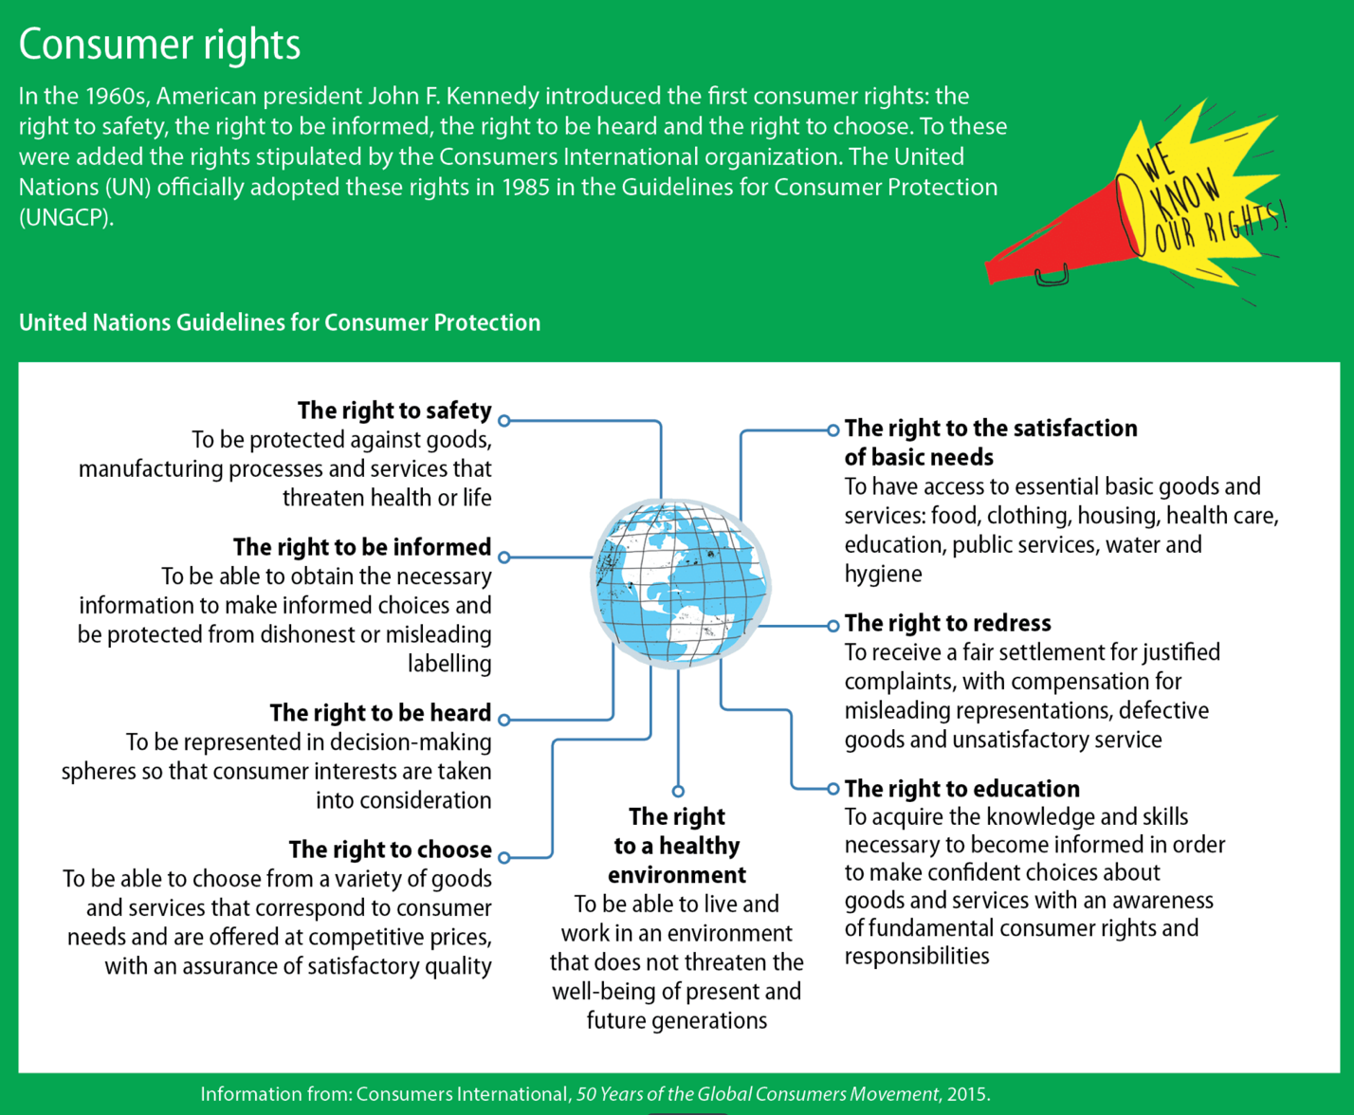

Source : Nadia Choquette-Bernier et al., Making Sense of Finance, Secondary V (Montréal: Chenelière Éducation, 2018), student textbook, 84.

Financial Education

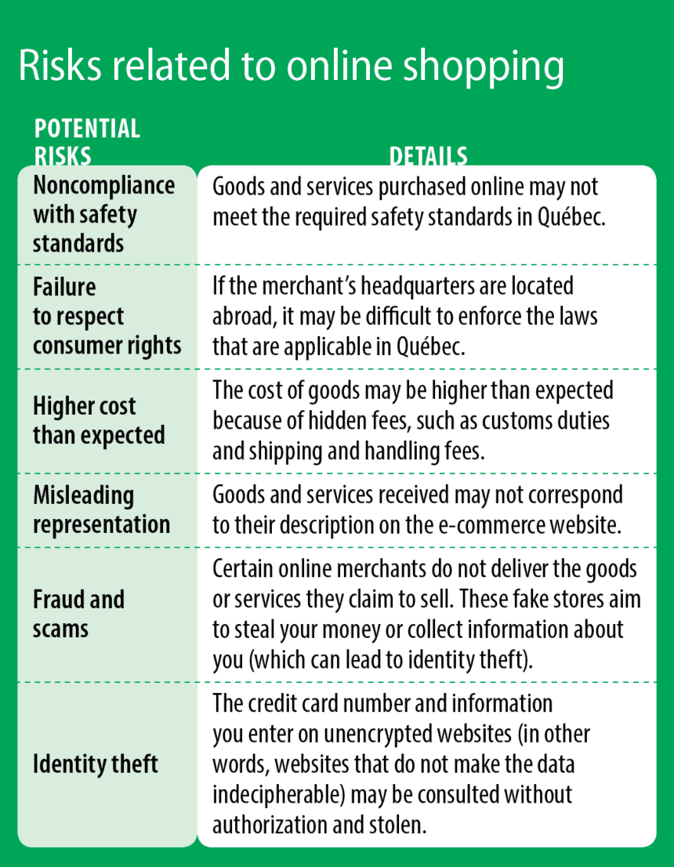

Source: Nadia Choquette-Bernier et al., Making Sense of Finance, Secondary V (Montréal: Chenelière Éducation, 2018), student textbook, 103.

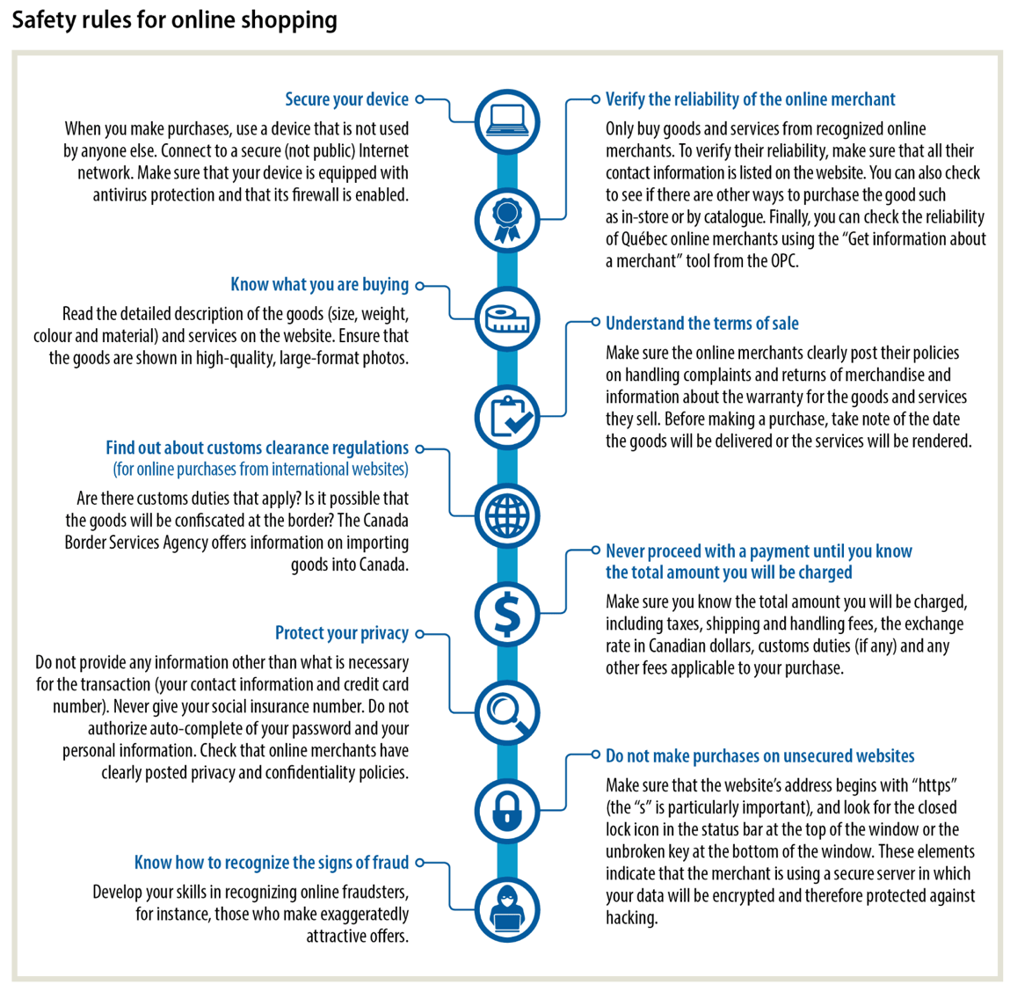
Source : Nadia Choquette-Bernier et al., Making Sense of Finance, Secondary V (Montréal: Chenelière Éducation, 2018), student textbook, 104.

Contemporary World

Refugees

Information for students
A key theme in your Contemporary World course is Tensions and Conflicts. Increasingly, refugees are seeking asylum in countries around the world as a result of war, famine and other global issues.
Instructions
Read the online stories Diary of a Teenage Refugee and 5 Surprising Facts About the Refugee Crisis. Use the “Read aloud” option if needed.
Watch the video Carol Off’s Journey to Save a Source
As you explore these resources (readings and video), answer the following questions and write down your thoughts:
- Why do refugees leave their home and native countries?
- Should Canada and other countries accept refugees? Why or why not?
- What was/is life like for refuges before, during and after seeking asylum?

Materials required
Useful resources, depending on personal preferences and availability:
Device with Internet access
Writing materials (paper, pencil, etc.)

Information for parents

About the activity
Students could:
remember that the goal is not to have the right answer but to reflect on the issue of tensions and conflict and how these impact people around the world. Discuss what you have read with a friend or classmate. Brainstorm together to think of things government agencies can do to help refugees.
Parents should:
help their child explore the various points of view and encourage them to explain their ideas and thoughts.

Image: Patrick Coin, 2006. Bombardier Beetle, Brachininae sp., Orange County, North Carolina, United States. Length 13 mm. CC BY-SA 2.5, https://en.wikipedia.org/wiki/Bombardier_beetle#/media/File:Brachinus_spPCCA20060328-2821B.jpg. Accessed 5/8/2020. References: Muzzi, M., & Di Giulio, A. (2019). The ant nest “bomber”: explosive defensive system of the flanged bombardier beetle paussus favieri (coleoptera, carabidae). Arthropod Structure and Development, 50, 24–42. Plumb, R. C., & Erickson, K. L. (1972). The bombardier beetle. Journal of Chemical Education, 49(10), 705–705. Schwarcz,J. (2017). Do Not Mess With a Bombardier Beetle, McGill Office for Science and Society, https://www.mcgill.ca/oss/article/environment/do-not-mess-bombardier-beetle. Accessed 5/8/2020.
Image from: https://www.piqsels.com/en/public-domain-photo-fjkzp, retrieved on May 11, 2020

