secondary v
Week of June 15, 2020
Table of Contents
Food: Other Places, Other Times 2
Mes vacances à Balconville 4
When Two Functions Meet 6
Appendix A – Answer Key 7
The Food Truck 9
Appendix A – The Food Truck 11
Sulfur Hexafluoride (SF₆): The Wonder Gas 12
Appendix A – SF₆ Activity 14
Appendix B – SF₆ Solutions 16
Fibre Optics 18
Appendix A – Fibre Optics Experiment 19
Appendix B – Solutions 21
Summer Safety and Summer Exercises 22

English Language Arts

Food: Other Places, Other Times

Information for Students
When we reflect on all the ways a new place might be different, including how people dress, how they act, and the foods they eat, it’s clear there is a lot to learn. How do you stay in touch with the place you came from and the people who lived before you? In this story, a woman moves to Canada from Yemen and discovers all the ways in which the food she grew up with connects her to her family and her culture.
Read and Think
Click on the link to read the story, “Yemeni Soup” by Ayelet Tsabari.
The author refers to many traditional dishes in the story. They are listed below:
Glossary
Ugat Shmarim: Yeasted cake
Babka: Cake made of sweet yeast dough filled with chocolate or cinnamon
Parve: Food that contains neither dairy nor meat
Sheket: Quiet
Jichnoon: Pastry made of layers rolled up with butter between them
Shuk: Open air market
Challah: Braided bread
Malawach: Sweet flaky flatbread or pancake
Bisbas: Spicy condiment
Tsli: Roasted meat
You might also read the food blog post “9 Jewish Yemenite Foods You Must Try”. Connect the recipes in the blog to the dishes mentioned in the story.
Annotate the Text and Make Notes
What did you notice as you read the text? Highlight or underline parts of the text that you find interesting, confusing or that are related to what you believe is the author’s main idea.
Next, think about what the main idea presented in the text reminds you of (your own experience, that of the world, other texts, etc.). What elements of author's craft did you highlight as particularly interesting or important? How do those elements contribute to your understanding of the text? Make notes of the ideas that came to you as you considered the highlighted elements.
Talk About the Story
Find someone else to read the story and discuss it with you. What are their thoughts on the story? Explain your thoughts and ideas to them.
Discuss what you believe the story might mean, the big idea it is suggesting, and why this big idea matters.

English Language Arts
Write About the Story
Respond to “Yemeni Soup”, either in writing or by recording yourself discussing it.
When we respond to a text, either in writing or in another form, we explore what we believe to be the big idea (or theme), the ways we connect (our own lives, other texts, or the world) to that big idea, and what elements of the story helped us to better understand it.

Materials required
Device with Internet access
Links:
http://themagazineschool.ca/files/Yemeni%20Soup%20and%20Other%20Recipes.pdf
https://www.myjewishlearning.com/the-nosher/the-9-jewish-yemenite-foods-you-must-try/

Information for parents
Students should:
read the short story and respond to the text
Parents could:
encourage their teen to talk about their initial reaction to the story and share their ideas with them

French as a Second Language

Mes vacances à Balconville

Information for students
Mise en situation
L’heure des vacances est enfin arrivée. Question de faire les choses autrement cet été, tu décides exceptionnellement, d’envoyer une carte postale à tes amis, et ce, pour t’éviter à devoir publier des photos de toi quotidiennement sur les réseaux sociaux. (À faire quoi au juste ? Tu te le demandes bien!) Cet été, tu décroches. Une carte par mois, sans plus, envoyée à tes meilleurs amis sera certainement suffisant, te dis-tu!
Instructions
- Choisis un site de cartes virtuelles gratuites (ex : Dromadaire) ou utilise le modèle traditionnel proposé à l’adresse ci-dessous: https://www.editionsmagriffe.ca/uploads/4/0/7/6/40767431/carte_postale_mod%C3%A8le.pdf
- Pour cette carte, exprime-toi sur le sujet suivant :
- Comment entrevois-tu tes vacances cet été ? Bref, que feras-tu pour qu’elles demeurent mémorables en dépit des mesures de confinement ?
- Introduis ta carte en présentant le sentiment qui t’anime.
- Exprime-toi sur tes vacances (ce que tu entrevois/planifies) dans ton paragraphe de développement.
- Termine ton texte par une phrase de clôture.
- Inscris l’adresse de ton/tes destinataire/s à l’endroit désigné (selon le type de carte que tu choisiras, virtuelle ou traditionnelle).
- N’oublie pas les conventions d’écriture propres à la carte postale (la date, la formule d’appel, les salutations et la signature). Consulte le lien suivant au besoin : https://apprendre.tv5monde.com/fr/aides/cultures-les-conventions-de-la-carte-postale
- Porte finalement une attention toute particulière au vocabulaire et aux conventions linguistiques. Utilise les références (dictionnaire, livre de conjugaison, grammaire) mises à ta disposition pour t’autocorriger. Consulte ton enseignant pour de plus amples informations.

French as a Second Language

Materials required
Appareil avec accès à Internet
Papier et crayons
Appareil photo au besoin

Information for parents
Children should :
read the following articles by way of introduction:
https://www.lapresse.ca/actualites/201908/02/01-5236102-les-vacances-des-autres.php
https://www.lapresse.ca/societe/famille/202005/19/01-5274175-lete-en-mode-covid-a-quoi-nos-vacances-ressembleront-elles.php

Mathematics – Science Option

When Two Functions Meet

Information for students
The following information is given about a square root function and an absolute value function, named f and g respectively, which are represented in the Cartesian plane:
The rule of function f is of the form f (x) = $\text{a}\sqrt{\text{b(}\text{x} \text{-} \text{h)}} \text{+} \text{k}$.
In addition:
Dom f = ] −∞, 4]
Ran f = ] −∞, 6]
f (3) = 4
The rule of function g is of the form g (x) = a │x – h │ + k.
In addition:
Dom f = Ran g
The axis of symmetry of function g is x = − 8
f (x) = g (x) = − 2
What is the value of g (−10)?

Materials required
Calculator
Graph paper
Writing and drawing materials

Information for parents

About the activity
Children could:
explain the problem-solving steps
Parents should:
read the instructions to their child, if necessary
discuss the task with their child
go over the task with their child once it is completed by using the answer key provided
The solution to the problem is provided in Appendix A.
Mathematics – Science Option

Appendix A – Answer Key
Solution
RULE OF FUNCTION f
According to the domain and range, the coordinates of the vertex are (4, 6).
Given f(3) = 4, the point (3, 4) is part of the function, and the parameter b is negative.
f (x) = a $\sqrt{\text{-}\text{(}\text{x} \text{-} \text{4)}}$ + 6  Using point A (3, 4)  4 = a $\sqrt{\text{-(3} \text{-} \text{4)}}$ + 6  −2 = a $\sqrt{\text{1}}$  −2 = a  The rule of function f is  f (x) = −2 $\sqrt{\text{-}\text{(}\text{x} \text{-} \text{4)}}$ + 6. | - 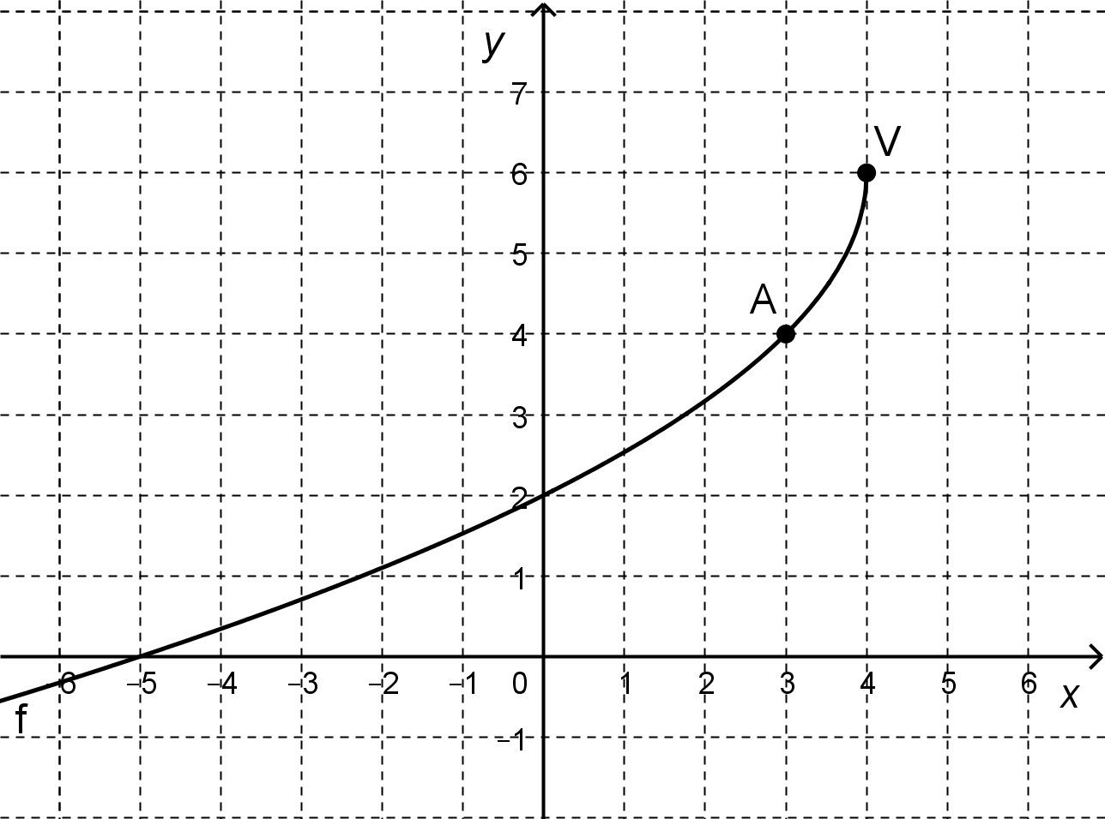
POINT COMMON TO FUNCTIONS f AND g
f (x) = −2. So, −2 = −2 $\sqrt{\text{-}\text{(}\text{x} \text{-} \text{4)}}$ + 6
−8 = −2 $\sqrt{\text{-}\text{(}\text{x} \text{-} \text{4)}}$
4 = $\sqrt{\text{-}\text{(}\text{x} \text{-} \text{4)}}$
16 = −(x – 4)
−12= x So point (−12, −2) belongs to functions f and g.
RULE OF FUNCTION g
According to the range of function g, parameter k = 4.
According to the axis of symmetry, parameter h = −8.
Mathematics – Science Option
So, g (x) = a │x – (−8) │ + 4
−2 = a │ – 12 + 8) │ + 4 Using point (−12, −2)
−6 = a │ – 4 │
−6 = a (4) → a = − 1.5
The rule of function g is g (x) = − 1.5 │x + 8 │ + 4.
VALUE OF g (−10)
g (−10) = − 1.5 │−10 + 8 │ + 4
= − 1.5 │−2 │ + 4
= − 1.5 (2) + 4 = 1
CONCLUSION
The value of g (−10) is 1.

Mathematics – Cultural, Social and Technical Option

The Food Truck

Information for students
The owner of Lucy’s Sea Shack restaurant has invested in a new food truck. The truck will move around to various locations around the city and sell two main dishes: lobster rolls and fish tacos.
Various constraints apply to the amount of food that the truck can sell on a given weekend. The polygon of constraints shown below represents the number of dishes that can be sold on a given weekend by the food truck.
Food Truck Sales
Coordinates of the vertices of the polygon of constraints
A (150, 150)
B (150, 700)
C (500, 700)
D (500, 500)
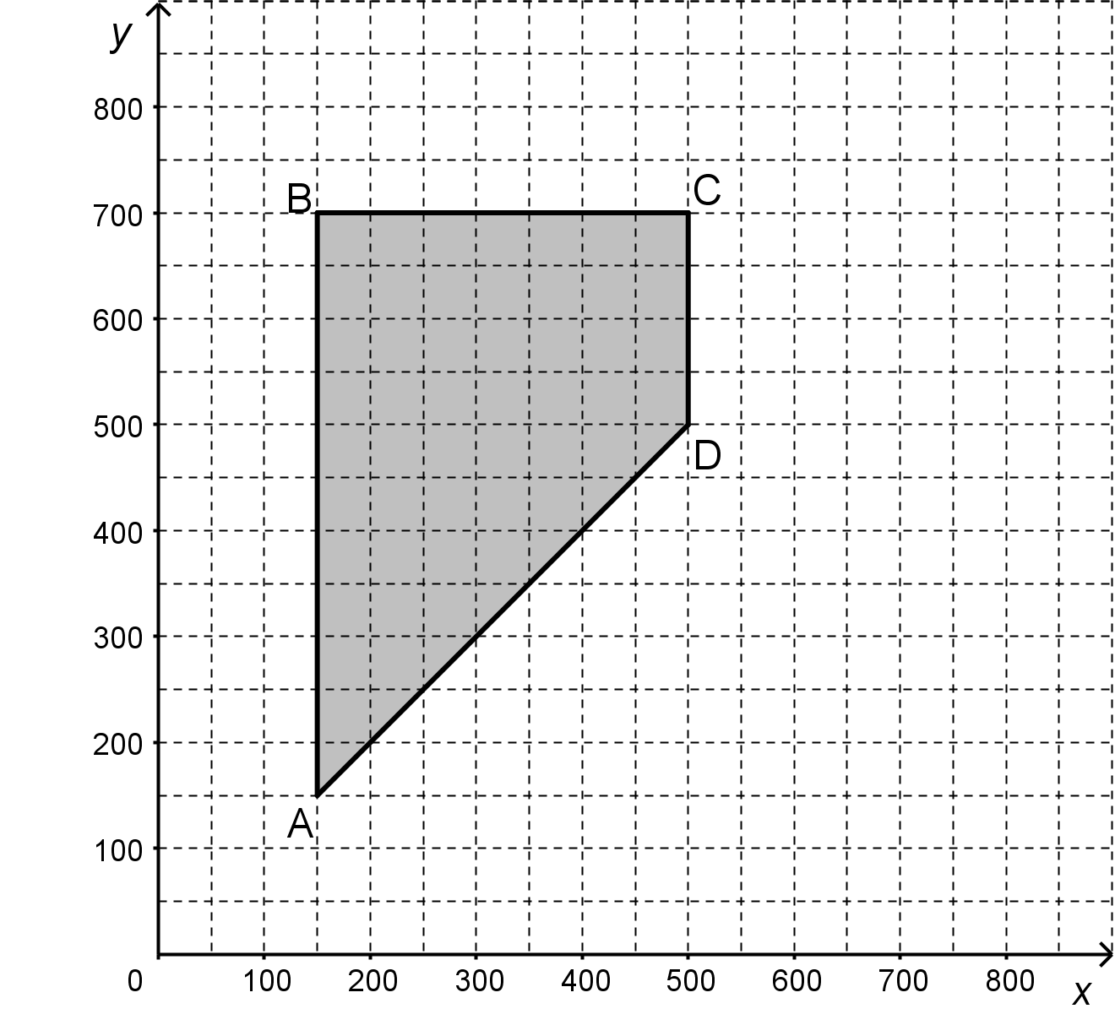
Where x: the number of lobster rolls sold
y: the number of fish tacos sold
Each lobster roll sells for $12, while the fish tacos sell for $10 each.
For the first weekend, the food truck was parked near an outdoor music festival and maximized its income.
However, on the second weekend, the truck moved to a new location, and its income was down by 30%.
The number of lobster rolls sold during the second weekend was $\frac{\text{3}}{\text{4}}$ of the number sold on the first weekend.
How many fish tacos were sold on the second weekend?

Mathematics – Cultural, Social and Technical Option

Materials required
Calculator
Writing and drawing materials

Information for parents

About the activity
Children could:
explain the problem-solving steps
Parents should:
read the instructions to their child, if necessary
discuss the task with their child
go over the task with their child once it is completed by using the answer key provided
The solution to the problem is provided in Appendix A.

Mathematics – Cultural, Social and Technical Option

Appendix A – The Food Truck
Solution
DETERMINATION OF THE FUNCTION RULE AND MAXIMUM INCOME EARNED
Function rule: R = 12x + 10y
VERTEX | R = 12x + 10y
A (150, 150) | $3 300
B (150, 700) | $8 800
C (500, 700) | $13 000 | Maximum
D (500, 500) | $11 000

The food truck earned a maximum income of $13 000 selling 500 lobster rolls and 700 fish tacos.
Income earned on the second weekend
Loss in income: 30% of $13 000
0.30 × $13 000 = $3 900
Income earned on the second weekend: $13 000 - $3 9000 = $9 100
NUMBER OF LOBSTER ROLLS SOLD ON THE SECOND WEEKEND
Number of lobster rolls sold: $\frac{\text{3}}{\text{4}}$ × 500 = 375
NUMBER OF FISH TACOS SOLD ON THE SECOND WEEKEND
R = 12x + 10y
9 100 = 12 (375) + 10y
9 100 = 4 500 + 10y
9 100 – 4 500 = 10y
4 600 = 10y
460 = y
CONCLUSION
The number of fish tacos sold on the second weekend was 460.

Chemistry

Sulfur Hexafluoride (SF₆): The Wonder Gas

Information for students
Sulfur Hexafluoride (SF₆) was first produced by chemists Henri Moissan and Paul Lebeau in 1901. This gas has some exceptional properties, some of which are very useful and others that are potentially dangerous. SF₆ is colourless, so it cannot be seen, odorless, so it cannot be smelled and very non-reactive, almost like a noble gas.
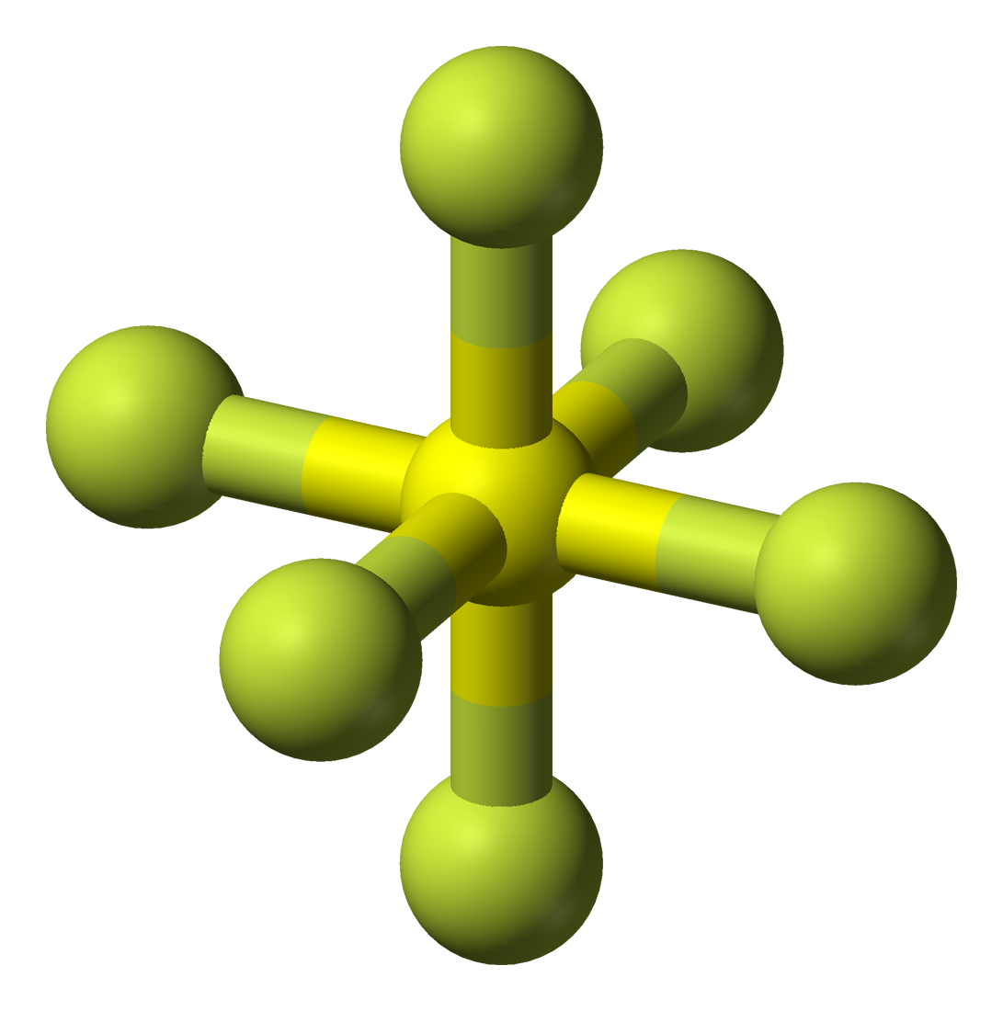
Because the density of SF (6.12 g/L) is higher than the density of air (1.225 g/L), it will fall to the ground, displacing the air above it. Sulfur Hexafluoride’s high density can sometimes have interesting effects. For example, light objects placed in a container of SF₆ will float on the gas, giving the impression that the objects are levitating. Also, breathing in SF₆ has the opposite effect of helium on one’s voice. Instead of producing a high-pitched voice, it makes one’s voice very deep because heavier molecules slow the speed of sound waves in the vocal chords. The danger is that because the gas is heavy, it can easily fall to the bottom of the lungs and cause suffocation.
Although SF₆ has some useful applications as an insulating gas, it is also the most potent greenhouse gas known to humankind. It is 23 900 times more impactful than CO₂ and can remain in the atmosphere for 800 to 3000 years. However, there are such low quantities in the atmosphere that it does not contribute significantly to climate change.
In this activity, you will determine the enthalpy of reaction of SF₆ production three different ways.
Video showing some of SF₆ properties in action by Steve Splangler
Experimenting with sulfur hexafluoride

Materials required
Calculator, paper and pencil
Chemistry notes or text may help
Chemistry

Information for parents

About the activity
Parents should:
support students in the Chemistry if needed

Chemistry

Appendix A – SF₆ Activity
In this activity, you will determine the enthalpy of reaction for SF₆ production three different ways: using bond energies, Hess’ Law and an enthalpy diagram.
Bond Energies
Sulfur Hexafluoride (SF₆), is a very inert gas with properties similar to those of noble gases.
The reaction to produce SF₆ is shown below.
$$H_{2}S\left(g\right)+4F_{2}\left(g\right)→2HF\left(g\right)+SF_{6}(g)$$

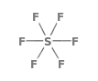
The average enthalpy associated with the breaking of certain bonds in kJ
H − F 567  H − S 330 | F − F 155  S − F 327
Using bond energies, what is the ΔH of this reaction?
Hess’ Law
H₂S(g) + 4F₂(g) → 2HF(g) + SF₆(g) ΔH = ?

Given:
$\frac{1}{2}$H₂(g) + $\frac{1 }{2}$ F₂(g) → HF(g) ΔH = -273 kJ
S(s) + 3F₂(g) → SF₆(g) ΔH = -1220 kJ
H₂(g) + S(s) → H₂S(g) ΔH = -21 kJ
Using Hess’ law, what is the ΔH of this reaction?

Chemistry
Energy Diagram
Sketch and use an enthalpy diagram to determine the enthalpy for the following reaction. Make sure to show the reactants, the products, the enthalpy of the reaction and the activation energy.
Note: This is just a sketch and does not need to be to scale.
H₂S(g) + 4F₂(g) → 2HF(g) + SF₆(g)
Given:
ΔH _{reactants} = 1980 kJ/mol
ΔH _{products} = 258 kJ/mol
E_{a} = 320 kJ/mol
Sketch the enthalpy diagram and show the ΔH of this reaction
Progression of Reaction
Enthalpy (kJ/mol)

Chemistry

Appendix B – SF₆ Solutions
Bond Energies
$$H_{2}S\left(g\right)+4F_{2}\left(g\right)→2HF\left(g\right)+SF_{6}(g)$$

$$∆H=∆H_{products}+∆H_{products}$$
Breaking bonds is positive and creating bonds is negative.
Solution:
Bond energy of products
ΔH= 6 x E_{(S-F)} + 2 x E_{(H-F)}
ΔH = 6 x (-325 kJ) + 2 x (-567 kJ)
ΔH = -1950 kJ - 1134 kJ
ΔH_{p} = -3084 kJ
Bond energy of reactants
ΔH= 4 x E_{(F-F)}+ 2 x E_{(H-S)}
ΔH = 4 x (155 kJ) + 2 x (330 kJ)
ΔH = 620 kJ + 660 kJ
ΔH_{r} = 1280 kJ
ΔH= ΔH_{p} + ΔH_{r}
ΔH= -3084 kJ + 1280 kJ
ΔH= -1804 kJ
Hess’ Law
H₂S(g) + 4F₂(g) → 2HF(g) + SF₆(g)

1. 1/2H₂(g) + 1/2F₂(g) → HF(g) ΔH = -273kJ
2. S(s) + 3F₂(g) → SF₆(g) ΔH = -1220kJ
3. H₂(g) + S(s) → H₂S(g) ΔH = -21kJ

Chemistry
3. H₂S(g) → S(s) + H₂(g) - 1 x – 21 kJ (Reverse reaction)
2. S(s) + 3F₂(g) → SF₆(g) 1 x -1220kJ
1. H₂(g) + F₂(g) → 2HF(g) 2 x -273kJ
H₂S(g) + 4F₂(g) → 2HF(g) + SF₆(g) ΔH = -1745 kJ

Enthalpy Diagram
258 kJ
H₂S(g) + 4F₂(g)
Ea = 320 kJ
1980 kJ
ΔH = - 1722 kJ
2HF(g) + SF₆(g)
Progression of reaction
Enthalpy (kJ)

Physics

Fibre Optics

Information for students
The following message was sent from Montreal to Paris.
01001000 01100001 01110110 01100101 00100000 01100001 00100000 01100111 01110010
01100101 01100001 01110100 00100000 01110011 01110101 01101101 01101101 01100101
01110010 0001010
How long did it take for this digital message to travel from Montreal to Paris using fibre optics?
What does the message say?
Research: In order to answer the question, you will need to find out the following information. (The following videos will be very helpful.)
What is fibre optics, and how is it used to send digital messages?
What does total internal reflection refer to?
- Demo: https://www.youtube.com/watch?v=Lic3gCS_bKo)
What is the speed of light in glass?
How does digital information travel through fibre optics?
- https://www.khanacademy.org/computing/ap-computer-science-principles/computers-101/digital-data-representation/v/khan-academy-and-codeorg-binary-data

Materials required
Clear bottle (plastic or glass)
Aluminum foil
Bright flashlight
Sink
Water

Information for parents

About the activity
Parents could:
watch the second video in the research section, as it provides interesting information

Physics

Appendix A – Fibre Optics Experiment

Information for Students
This experiment works best in the dark, so wait until after sunset. You will need to be in a dark room with a sink (bathroom or kitchen).

Materials required
Clear bottle (plastic or glass)
Aluminum foil
Bright flashlight
Sink
Procedure
- Wrap the clear bottle with aluminum foil (tightly). Leave the opening uncovered.
- With the aluminum foil, create an opening at the bottom big enough to insert the head of the flashlight.
- Fill the bottle with water.
- Turn the light off (it should be dark)
- Turn the flashlight on and press it tightly against the bottom of the bottle so the light shines up through the water.
- Over the sink, tilt the bottle so that the water starts to pour out. Keep the light pressed tightly to the bottom of the bottle.
What do you notice about the water flowing from the bottle?
Question:
The following message was sent from Montreal to Paris.
01001000 01100001 01110110 01100101 00100000 01100001 00100000 01100111 01110010
01100101 01100001 01110100 00100000 01110011 01110101 01101101 01101101 01100101
01110010 0001010
- How long did it take for this digital message to travel from Montreal to Paris using fibre optics?

- What does the message say?
Decode the message (binary to alphabet) using the table on the next page.

Physics

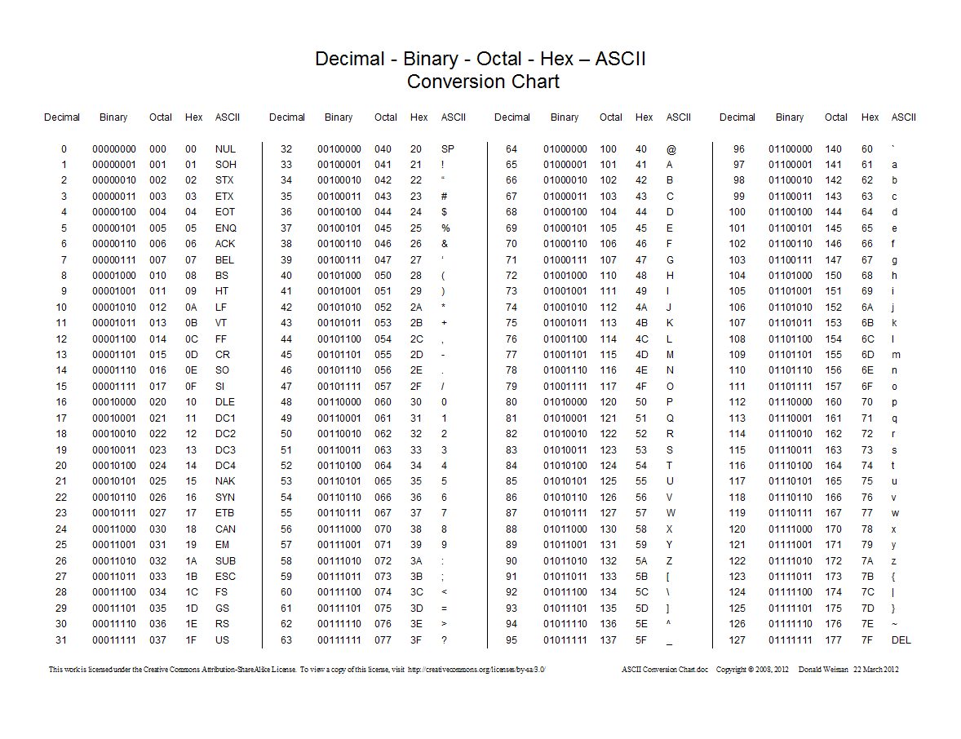
Physics

Appendix B – Solutions
How long does it take a digital message to travel from one source (for example, a computer) to another (a second computer)?
Messages travel in the form of light; therefore they travel at the speed of light. In fibre optics, light travels through glass, which has a refractive index of approximately 1.5.
The formula for refractive index is $n=\frac{c}{v}$, where:
- $n$ = refractive index of a medium (in this case glass)
- $c$ = the speed of light in a vacuum (approximately 300 000 km/s)
- $v$ = the velocity of the light in the medium (in this case glass)
Solve for $v.$ $v$= 200 000 km/s
The message would travel at the speed of light in glass, or 200 000 km/s
Distance from Montreal to Paris 5500 km (this is a direct distance, so the actual distance using fibre optics might be longer)
$$v= \frac{d}{t}$$
$$t = d/v$$
$= 5500 km/200 000 km/s$
$$= 0.0275 s$$

Physical Education and Health

Summer Safety and Summer Exercises

Information for students
Activity 1: Summer safety reading
Summer is right around the corner, but before you go outside, start work, or head out for a picnic, get some info first!
Read the article Summer Safety 101 from the perspective of an older sibling or a camp counselor. Think about what you have learned from the reading and what you could potentially teach others.
- Answer these questions:
- If your younger sibling or camper is looking sluggish and you know they have not been drinking water all day, what would you suggest or offer to entice them to hydrate? OR If your younger sibling is swimming in the pool and you have been asked to watch them, but your phone rings in the house, what should you do?
- If your friend decides that helmets are “not cool” and chooses not to wear one, what would you say to convince them to wear a helmet while they ride their bike?
- What did you lean about “respecting the environment” during the summer months?
- Do you have a first-aid kit in the car or at home? Why do you think it is important to have one?
Activity 2: Summer-time exercises
- Try one of these workouts:
- Cardio workout
- Yoga
- Full Body HIIT
- Which one did you do? How did it go? Do you think you could continue to do workouts like this over the summer?
- Over the past few months, you have learned and tried new exercises at home (restorative, yoga, HIIT), but a healthy lifestyle is one that is continuous and enjoyable.
- The most important thing is to find an activity, exercise, sport, or movement that you like and stick with it (or switch it up when you find a new enjoyable activity!).
- What do you think you will do this summer to be physically active? Make a tentative plan for what you will do this summer: 3 exercises a week for 9 weeks (e.g. swim, bike, run, dance, train, play, yoga, online workout videos).
June/July
August

Physical Education and Health

Materials required
None

Information for parents

About the activity
Children should:
read the article, reflect, and answer the 4 questions
reflect on the new workouts they learned, try a workout, and think about what they will do over the summer
Parents could:
encourage their children to read the article and answer the questions, and to stay safe over the summer
do the workout with their children or help them be more autonomous
encourage their children to be active over the summer

Source: "Sulfur Hexafluoride - PubChem Public Chemical Database". PubChem. National Center for Biotechnology Information. Archived from the original on 3 November 2012. Retrieved 5 June 2020

