Weekly Educational Options From the Ministère
secondary Iv
Week of June 1, 2020
Table of Contents
“I Lost My Talk”: Identity & Reconciliation 2
#Mission FLS : Erreur de traduction ! 5
Controversial Art Project 6
Appendix A – Catherine’s Blueprint and Fred’s Blueprint 8
Appendix B – Marks for the Art Project 10
Appendix C – Formula Sheet 11
Appendix D – Answer Key 12
You’ve got the Power 15
Appendix A – You’ve got the Power 16
Appendix B – Answer Key 18
The Importance of Mindfulness 20
Building Your Brand: Logo 21
June 21: National Indigenous Peoples Day 23
Québec at a Crossroads 24
Appendix – Québec at a Crossroads 28

English Language Arts

“I Lost My Talk”: Identity & Reconciliation

Information for students
During your History of Québec and Canada courses, you have most likely discussed the Indian Act
(1876) and the residential schools (1831-1996). The Indian Act is ‘’the principal statute through which
the federal government administers Indian status, local First Nations governments and the
management of reserve land and communal monies.’’ The residential schools were ‘’government
sponsored religious schools that were established to assimilate Indigenous children into Euro-Canadian
culture’.
- Think about the purpose of the residential schools and what Indigenous children had to face after being torn from their families and sent far from their homes to suffer from neglect and abuse, and in some cases, to die (due to diseases, malnourishment, overcrowding, poor sanitation, inadequate heating, lack of medical care, etc.) Think about what was covered in class. If you feel like you need to research more, see:
https://humanrights.ca/story/childhood-denied
https://thecanadianencyclopedia.ca/en/article/residential-schools
https://www.facinghistory.org/stolen-lives-indigenous-peoples-canada-and-indian-residential-schools/chapter-7/cultural-genocide
- Keeping in mind that the goal of the residential schools was to assimilate Indigenous youth, what do you think were the impacts of this cultural genocide on them – and on their parents? Think about the short-term and long-term impacts. Explain.

- How were the ones who survived able to cope, in your opinion?

- Read the poem ‘’I Lost My Talk’’ by Rita Joe, a Mi’kmaq poet and song writer who attended Shubenacadie Indian Residential School, in Nova Scotia. As you read the poem, think about what she experienced at a young age.

English Language Arts

I Lost My Talk
by Rita Joe

I lost my talk
The talk you took away.
When I was a little girl
At Shubenacadie school.

You snatched it away:
I speak like you
I think like you

I create like you
The scrambled ballad, about my world.
Two ways I talk
Both ways I say,
Your way is more powerful.

So gently I offer my hand and ask,
Let me find my talk
So I can teach you about me.

What is Rita’s talk? Think about the foundation of any culture; how we experience the world around us and how our thinking is framed by the language we’re taught.
Who is You, in the poem? Is it a single person, a group, a system? Discuss.
The talk you took away: Think about the primary goal(s) of the residential school system and explain how they were achieved while children were removed and isolated from the influence of their communities.
What are the Two ways? When Rita Joe writes that [your] way is more powerful, what does she acknowledge with that statement? How do you feel about it?
Why do you think she used the word scrambled? Remember that Indigenous students were punished for speaking their language and taught that their understanding of the world was wrong. Think about the disconnect she experienced.
With the last two lines, what seems to be Rita Joe’s intention? What is she trying to reclaim while gently offering her hand? Is there hope for residential schools’ survivors – and their descendants – to reconcile their past? You can research the Truth and Reconciliation Commission of Canada.
What do you notice about the use of language? Explain your reasoning.
All texts are created to serve a particular purpose, or to deliver a specific message to an audience. What do you think was the author’s intention with this particular piece? Think about the themes of identity, conformity and courage.
- Do you remember the moment you found out about the existence and the legacy of the residential schools in Canada? Has your identity as a Canadian developed or changed?
- What would you consider your talk? Think about how languages shape our identities and understanding of the world.

English Language Arts

Materials required
Paper, pen, phone, tablet or computer.

Information for parents
Children should:
reflect on the issues of cultural genocide and reconciliation
practice your literary analysis skills
Parents:
should discuss the information and the questions with their child and share their own thoughts with them
could encourage their child to contact a classmate if their child has more questions or wants to talk about this activity with a peer

French as a Second Language

#Mission FLS : Erreur de traduction !

Information for students
Cette activité t’aidera à accomplir la mission FLS suivante : « Je lis les informations sur des objets de mon quotidien et je compare la version en français et la version en anglais ».
As-tu déjà remarqué que la traduction entre le français et l’anglais de produits de tous les jours n’est pas toujours parfaite ? Non, un produit « Made in Turkey » n’est pas « Fait en dinde » !
Cette semaine, on te propose de t’amuser et de corriger certaines traductions.
Voici comment tu peux le faire :
Lis les versions en français et en anglais sur des objets de chez toi (boîte de céréales, bouteille de shampooing, carton de lait, etc.). Tu peux aussi lire des pages web qui montrent une sélection de mauvaises traductions.
Reformule-les : Comment est-ce que tu pourrais mieux dire les choses ? Quels mots pourrais-tu utiliser ? Par exemple : En anglais, il est écrit « Made in Turkey ». En français, au lieu d’écrire « fait en dinde », je pense qu’il faudrait dire « fait en Turquie ».
Pour aller plus loin
Partage les traductions amusantes ou étranges et ta propre version de la traduction avec le mot-clic #Mission FLS.

Materials required
Objets du quotidien : boite de céréales, bouteille de shampooing, carton de lait, etc.
Exemples de traduction
Mission FLS

Information for parents
In this activity, children will practise:
understanding the similarities and differences between English and French
choosing appropriate words to express ideas in French
playing with words
Parents can:
suggest funny translations (in French or in English) that they came across

Mathematics

Controversial Art Project

Information for students
Catherine recently submitted her project for her final art assignment. She believes that her classmate, Fred, copied her design.
Catherine’s teacher says that while they look similar, Catherine needs to prove that they are the same.
Using the information from both blueprints, can Catherine prove that the two projects are similar?
- What information does Catherine need to find in both blueprints to prove that they are not just similar but are in fact the same?
Catherine’s friends Bryan and Phyllis are having an argument. Bryan believes the mark for the project is based on the total area. Phyllis believes it is based on the perimeter. Catherine decided to look at all the projects and the marks to see if either one or both of her friends are correct.
Given the data, are either Bryan or Phyllis correct?

Materials required
Appendix A: Catherine’s Blueprint and Fred’s Blueprint
Appendix B: Marks for the Art Project
Appendix C: Formula Sheet
Appendix D: Answer Key

Mathematics

Information for parents

About the activity
Read the instructions to your child, if necessary.
Discuss the task together with your child, outlining what steps they need to carry out.
This activity can be done in multiple ways. For the geometry portion, your child can take multiple paths to find all the missing information. The statistics portion can be completed by creating a scatter plot or a contingency table.
Once the task is completed, you and your child can go over the task with the answer key provided (Appendix D).
Your child may obtain answers that could be slightly different from the answer key, depending on how they round off their results. Being off by a few tenths is fine. There is no need to worry about inconsistencies in rounding off the results. The important thing is that your child is able to show that they can solve the problem.

Mathematics

Appendix A – Catherine’s Blueprint and Fred’s Blueprint

Catherine’s Project
Images are not necessarily drawn to scale
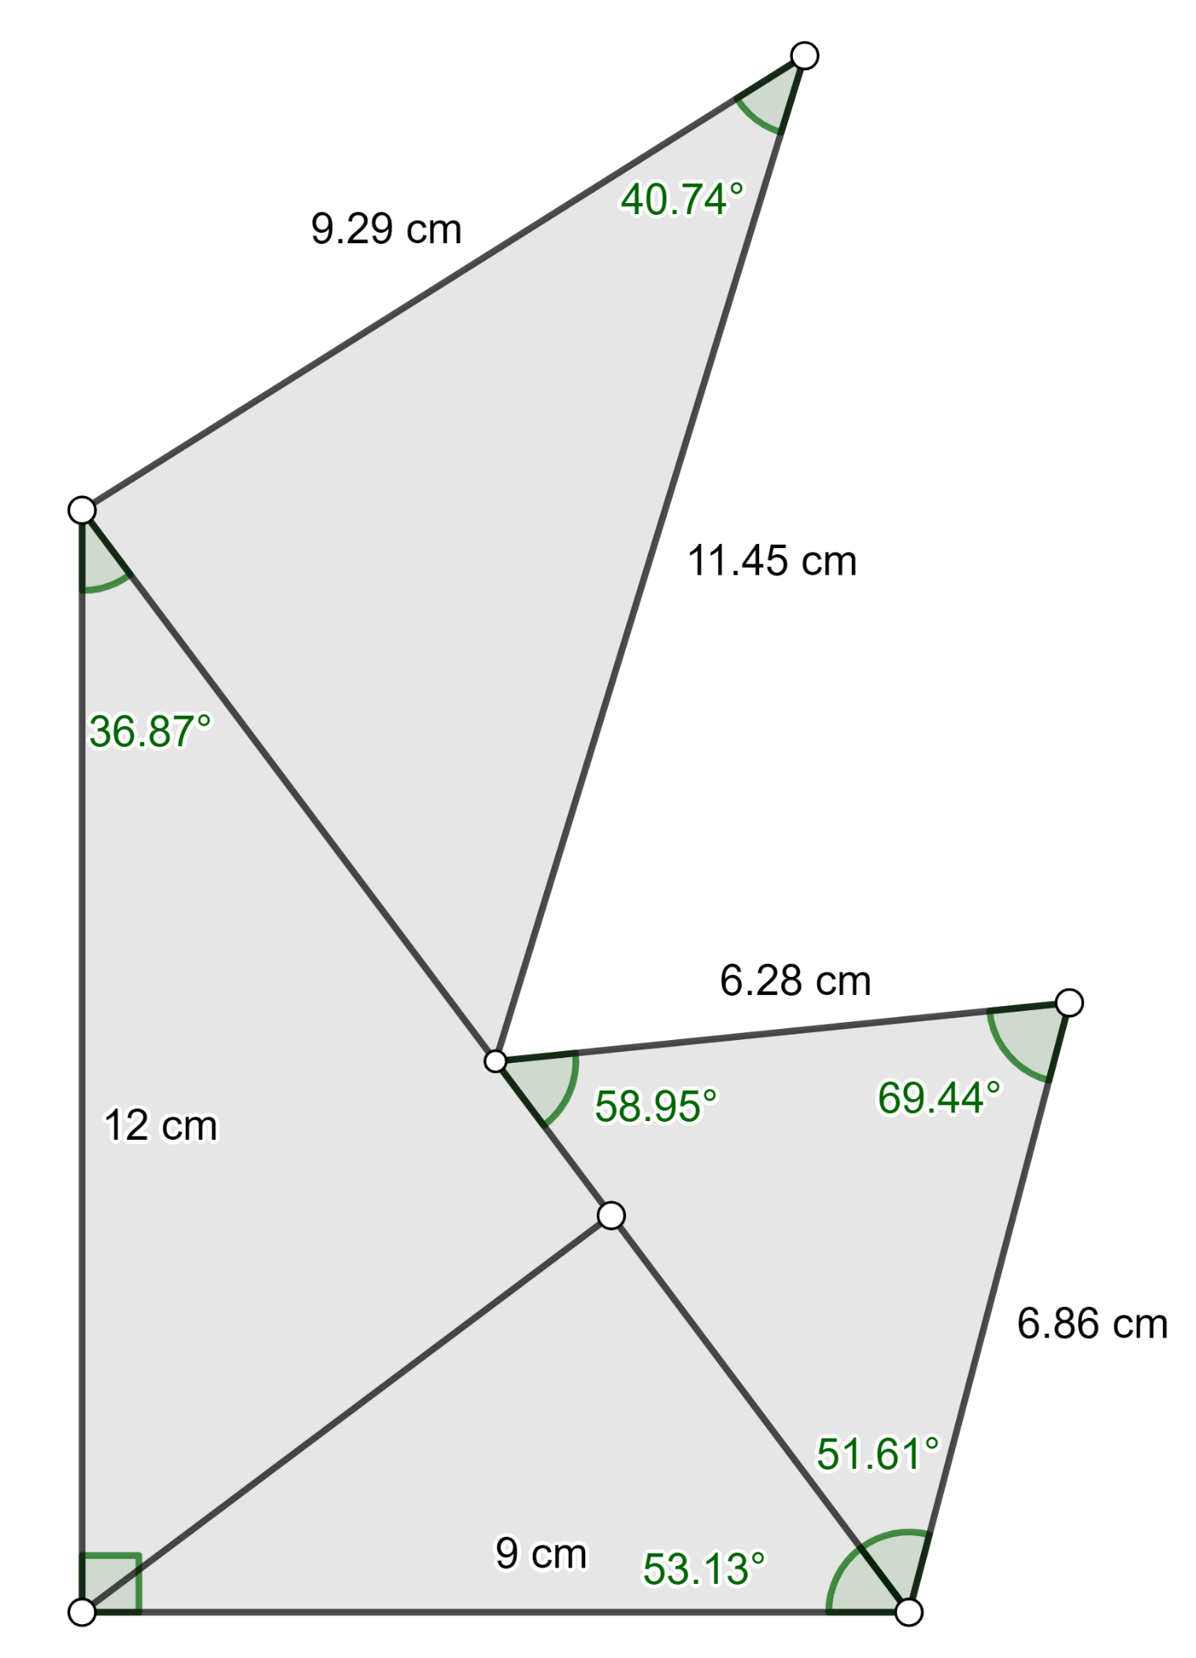

Mathematics

Fred’s Project
Images are not necessarily drawn to scale
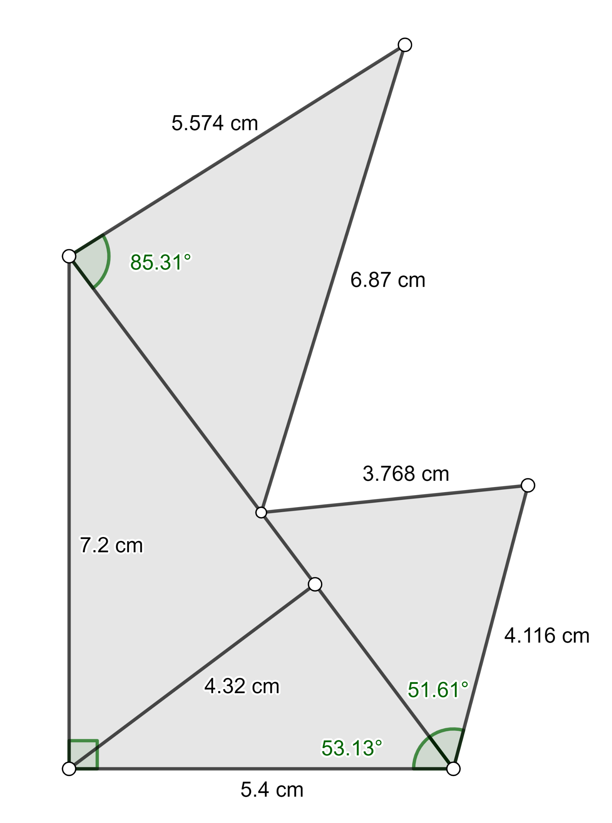

Mathematics

Appendix B – Marks for the Art Project

Perimeter | Area | Mark
54.88 cm | 108.89 cm² | 88
32.928 cm | 39.2 cm² | 60
55.63 cm | 176 cm² | 92
47.02 cm | 125 cm² | 73
47.25 cm | 38 cm² | 80
29.57 cm | 44.01 cm² | 52
28.98 cm | 24 cm² | 65
46.25 cm | 30.61 cm² | 81
39.27 cm | 69.67 cm² | 59
56.85 cm | 82.9 cm² | 97
43.68 cm | 24 cm² | 76
37.82 cm | 32.83 cm² | 64

Mathematics

Appendix C – Formula Sheet

Trigonometric Ratios
A
sin A = length of the leg opposite ∠ A
a
c
b
C
B
length of the hypotenuse

cos A = length of the leg adjacent to ∠ A
length of the hypotenuse

tan A = length of the leg opposite ∠ A
length of the leg adjacent to ∠ A

Sine Law

$\frac{\text{a}}{\text{sin A}}$ = $\frac{\text{b}}{\text{sin B}}$ = $\frac{\text{c}}{\text{sin C}}$

Hero’s Formula

Area = $\sqrt{\text{p}\text{(}\text{p} \text{–} \text{a}\text{)(}\text{p} \text{–} \text{b}\text{)(}\text{p} \text{–} \text{c}\text{)}}$

Trigonometric Formula

Area = $\frac{\text{a}\text{ x }\text{b}\text{ x sin }\text{C}}{\text{2}}$

Similar Triangles
Side-side-side (SSS)
Side-angle-side (SAS)
Angle-angle (AA)

Mathematics

Appendix D – Answer Key

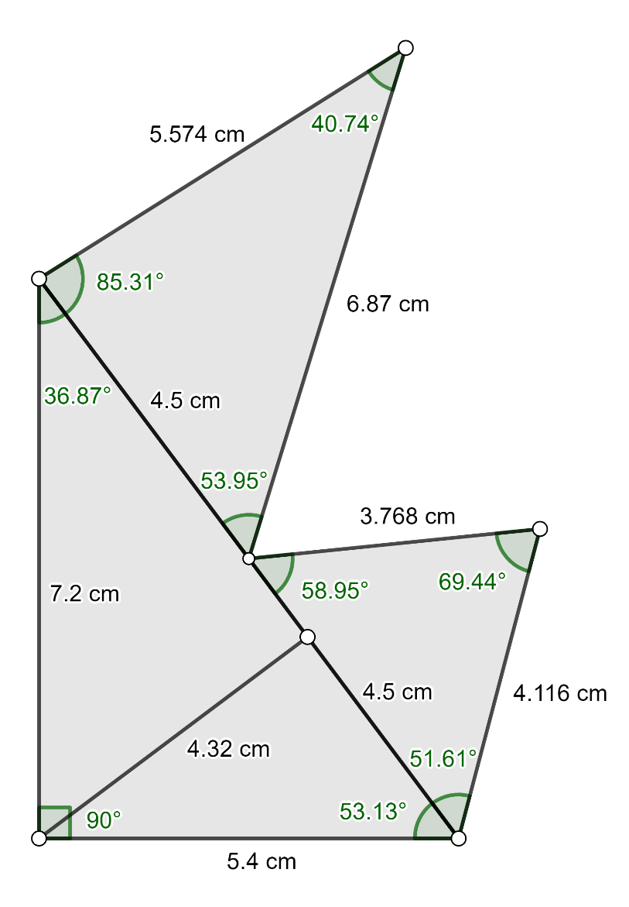
Catherine’s Design and Fred’s Design
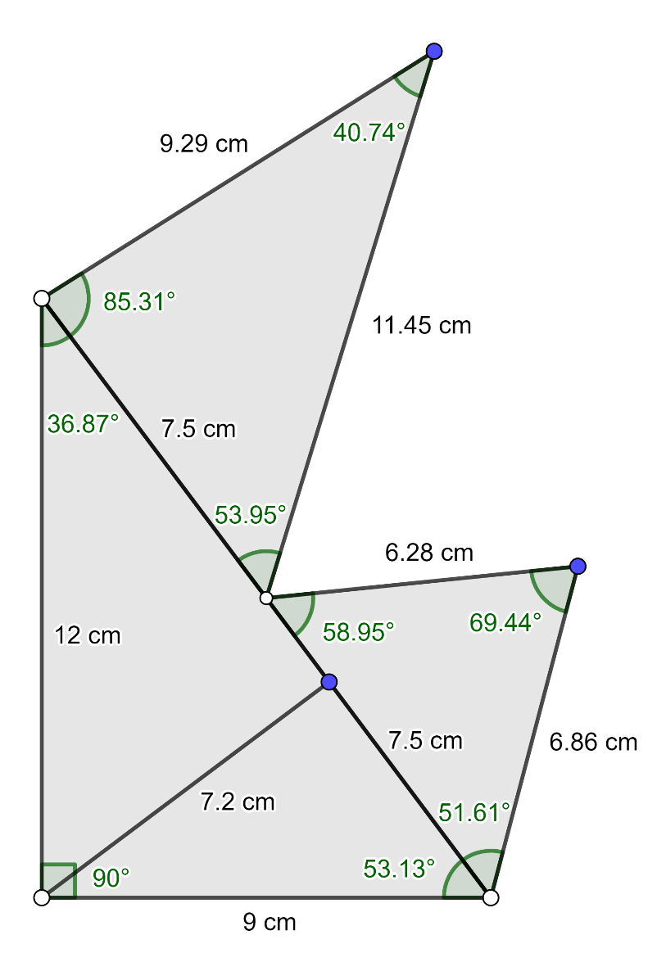

Ratio of similarity

$\frac{\text{5.4}}{9}$= $\frac{3}{5}$ or 0.6
Since all the triangles have the same ratio of similarity, both projects are similar, but not the same.

Mathematics

Correlation Coefficient for the Perimeter

1 – $\frac{\text{1.66}}{\text{8.12}}$ = 0.8

Correlation Coefficient for the Area

1 – $\frac{2.77}{\text{8.21}}$ = 0.66

Mathematics

Contingency Table for the Perimeter
^{Perimeter}  ^{(cm)}  ^{Marks} | [20, 28[ | [28, 36[ | [36, 44[ | [44, 52[ | [52, 60[
[50, 60[ | 0 | 1 | 1 | 0 | 0
[60, 70[ | 0 | 2 | 1 | 0 | 0
[70, 80[ | 0 | 0 | 1 | 1 | 0
[80, 90[ | 0 | 0 | 0 | 2 | 0
[90, 100[ | 0 | 0 | 0 | 0 | 3

Contingency Table for the Area
^{Area}  ^{(cm sq.)}  ^{Marks} | [20, 55[ | [55, 90[ | [90, 125[ | [125, 160[ | [160, 195[
[50, 60[ | 1 | 1 | 0 | 0 | 0
[60, 70[ | 3 | 0 | 0 | 0 | 0
[70, 80[ | 1 | 0 | 0 | 1 | 0
[80, 90[ | 2 | 0 | 1 | 0 | 0
[90, 100[ | 0 | 0 | 1 | 0 | 1
There is a strong correlation between the perimeter and the marks; the correlation between the area and the marks is not as strong.

Science and Technology

You’ve got the Power

Information for students
Electricity plays a big part in our lives every day. Our homes are filled with appliances that use electrical energy. Some of these include toasters, microwave ovens, televisions, and computers. Over the past couple of months, you have undoubtedly used many of your home’s electrical appliances, but have you ever wondered how much the energy used by all of these appliances costs?
This week, you will be taking a closer look at how much electrical energy is consumed at home and how much it costs.

Materials required
Instructions for the task (Appendix A)
Energy information from a variety of electrical appliances

Information for parents

About the activity
Children should:
decide which electrical appliances they would like to explore.
check their answers with the possible solutions provided in Appendix B.
Parents could:
help locate the basic energy information on the electrical appliances chosen by their children.

Science & Technology

Appendix A – You’ve got the Power

Information for students

Instructions
- Choose five electric appliances that you use daily (e.g. microwave, dryer, computer).
- For each appliance chosen, look for a rating plate (usually located on the bottom or back of the appliance) that provides information on your appliance such as power, current and/or voltage.
Example 1 Example 2
Model PCAONV
Serial #: 141516

120 V
60Hz
1.5 A
T-FAL
Type: 8744.82
Series: 21 2 A

960 W 120V 60 Hz

- Create and fill in a chart that will help you track all the relevant information. For example:
Appliance | Current (A) | Voltage (V) | Power (W) | Estimated time used daily (h)*
* Be careful when converting minutes to hours (e.g. 15 minutes = 0.25 h)
- After you have filled in the chart, answer the following questions:
- Which appliance did you expect to use the most power? Why? Did you find this to be true?
Note: Possible solutions appear in Appendix B – Answer Key.
- Which appliance did you expect to use the most energy? Why? Did you find this to be true?
Note: Possible solutions appear in Appendix B – Answer Key.
- The cost of electricity in Quebec is 9.3 ¢/kWh. Calculate the daily, monthly and annual cost of using each appliance.
Note: Possible solutions appear in Appendix B – Answer Key.
N.B.
Power (W) = Power (kW)
1000
Energy consumed = E (kW) x t (h)

Science & Technology
Science – Technology

- Electrical appliances that are used in the home transform electrical energy into “useful” forms of energy. For example, a hairdryer transforms electrical energy into thermal energy to dry your hair. However, some of the electrical energy is “wasted” as it is converted into sound energy.
      - Indicate the main “useful energy transformation” that occurs for each appliance,
      - Assuming that each appliance has an 85% energy efficiency, indicate the amount of “useful” energy that is consumed daily. How much does the “wasted” energy cost?
Note: Possible solutions appear in Appendix B – Answer Key.

Science & Technology
Applied Science & Technology

Appendix B – Answer Key

Answers to Questions
- Various possible answers. Only after calculating Power (P = IV) can we compare one electrical appliance to another.
Example: A toaster with a current of 8 A and a voltage of 120 V:
Step 1: P = I x V
P = 8 A x 120 V
P = 960 W
- Various possible answers. Only after calculating Energy (E = PΔt) can we compare one electrical appliance to another.
Example: A toaster with a current of 8 A and a voltage of 120 V that is used for 12 minutes/day
Step 1: P = I x V Step 3: E = PΔt
P = 8 A x 120 V = 960W E = 0.96 kW x 0.2 h
960W = 0.96 kW E = 0.192 kWh
1000
Step 2: 12 minutes = 0.2 hours
60 minutes
- Various possible answers. To calculate the cost of using each electrical appliance, electrical energy must be converted into kWh and time must be converted into hours.
Example: A toaster with a current of 8 A and a voltage of 120 V that is used for 12 minutes/day in Quebec:
Step 1: P = I x V Step 3: E = PΔt
P = 8 A x 120 V = 960W E = 0.96 kW x 0.2 h
960W = 0.96 kW E = 0.192 kWh
1000
Step 2: 12 minutes = 0.2 hours Step 4: Daily cost = Cost/unit x E
60 minutes Daily cost = 9.3 ¢/kWh x 0.192 kWh
Daily cost = 1.8 ¢
To calculate the monthly and annual cost:

Science & Technology
Applied Science & Technology

Step 5: Monthly cost = Daily cost x 30 days
Monthly cost = 1.8 ¢ x 30 days
Monthly cost = 54 ¢
Step 6: Annual cost = Daily cost x 365 days
Annual cost = 1.8 ¢ x 365 days
Annual cost = 657 ¢ ($6.57)
- i.Various possible answers.
Example: A toaster converts electrical energy into useful thermal (heat) energy.
ii. Various possible answers.
Example:
Step 1: % Energy Efficiency = amount of useful energy
amount of energy consumed daily
0.85 = amount of useful energy
0.192 kWh
0.163 kWh = amount of useful energy
Step 2: Wasted Energy = Amount of energy consumed daily – amount of useful energy
Wasted Energy = 0.192 kWh – 0.163 kWh
Wasted Energy = 0.029 kWh
Step 3: Cost = Cost/unit x E
Cost = 9.3 ¢/kWh x 0.029 kWh
Cost = 0.27 ¢

Physical Education and Health

The Importance of Mindfulness

Information for students

Activity 1: Practicing mindfulness
Watch the following video to learn about the importance of Mindfulness:
- Video: Why Mindfulness is the New Superpower – Featuring Dan Harris
Read through the following infographic for daily mindfulness practices:
- Infographic: Making Mindfulness a Way of Life and Work
What did you learn from the video? Why is it important to practice mindfulness? Do you think you could find one thing to be mindful about during your day? What would that be?
Discuss what you learned about mindfulness with a member of your family.

Activity 2: Yoga for mindfulness
Try the exercises in the following video:
- Video: 10 Minute Morning Yoga for All Levels
- If necessary, adapt the movements to your abilities.

Materials required
Device with Internet access

Information for parents

About the activity
Children should:
learn about the importance of mindfulness
practice mindfulness
try the yoga workout
Parents could:
support their children by asking them what they have learned about mindfulness
support their children by practicing mindfulness with them
support their children by doing the workout with them or encourage them be more autonomous during the activity

Arts

Building Your Brand: Logo
A logo connects your creations together and helps viewers identify what you create. What will your signature be?
As part of the branding process, this week we’ll explore how to create a logo.
- As you know, logos may be text, images or a combination of both. Before beginning the process, start with the intent. What do you want to communicate about your brand and your creative work?
- Start by following these 3 steps: https://spark.adobe.com/make/logo-maker/
- Once you are ready to create your logo, use an application or program for creating media. You might already have one at home, such as an Adobe program, or you can sign up to use free ones online like https://spark.adobe.com/sp/ or https://www.canva.com/.
- Mistakes might lead to interesting discoveries. Instead of being discouraged, keep going.
- Once you are satisfied with your logo, think about how you want to start using it to build your social presence.
Resources:
- Branding: Use the 10 steps found on this site to build the visuals. Focus on branding and brainstorming symbols. https://www.canva.com/learn/personal-branding/
- If you’ve already written an artist’s statement in class, going back to it could help you remember some key ideas about who you are as an artist and the work you create. Example: Artist's statement from Learnquebec

Materials required
Internet
Pencil and paper

Arts

Information for parents

About the activity
Children should:
Create logos that represent their creative work.
Parents could:
View the logos and give feedback on how the type of logo created matches the student’s intent.

Ethics and Religious Culture

June 21: National Indigenous Peoples Day

Information for students
Many people do not know that June 21 is an important holiday in Canada. It is known as Indigenous Peoples Day and is celebrated to honour the heritage, culture and contributions of Indigenous people in Canada.
This week’s activity is meant to bring awareness to this valuable holiday and encourage students to familiarize themselves with Canada’s history and Indigenous culture.
First, watch the short video “The Word Indigenous – Explained.”
Think about what you learned in this short video that you did not know before.
What can you do to honour Indigenous people and celebrate Canada’s important holiday? This website lists ten ways Canadians can celebrate on June 21 to honour Indigenous Peoples of Canada. Choose one way you can celebrate. To help you choose, think about your current level of knowledge on Indigenous culture, history and social issues. If your level of knowledge on Indigenous issues and culture is low, use the Internet to help you research. If you have a high level of knowledge, consider filling out a personal pledge of reconciliation.
Next week we will explore some Indigenous realities in Canada and what Canadians can do to reconcile the relationship with Indigenous people.

Materials required
Device with Internet access

Information for parents
Visit the websites listed above.
Have a discussion with your child about Indigenous people in Canada.
Consider the following questions:
- What have you learned that you did not know before?
- Were you aware that June 21 is National Indigenous Peoples Day in Canada?
- What do you think Canadians can do to reconcile the relationship with Indigenous people?

History of Québec and Canada

Québec at a Crossroads

Information for students
Culturally speaking, the second half of the 19th century was a turbulent time for Québec. Among other things, the Catholic Church was opposed to liberal ideas that were emerging, women were starting to demand their rights, and French Canadians were beginning to form an identity in the new country of Canada.
Click here to access an online version of your Reflections History textbook.
Pages 75-83 will teach you a little about the situation of the Catholic Church, the role of women, and new forms of cultural expression in the second half of the 19th century.
If you do not have access to the Internet, read pages 75-83 of your Reflections textbook. If you do not have your textbook, you can look at the historical documents on the following pages to help you with the activities.
Now that you have learned about the situation of the Catholic Church, the role of women, and new forms of cultural expression in the second half of the 19th century, do the following activities:
- Identify one of the differences between liberal and ultramontanist beliefs.
- Determine one of the causes of what became known as a nationalism of survival.
- Identify an element of continuity in the legal position of women in Québec as it relates to suffrage before and after 1900.
- Establish a connection between facts, differentiating between two poems.

Materials required
Useful resources, depending on personal preferences and availability:
Device with Internet access
Writing materials (paper, pencil, etc.)

Information for parents

About the activity
Children could:
do further research on the topic using resources like The Canadian Encyclopedia.
Parents should:
discuss the ideas presented and possible answers with their child.

History of Québec and Canada

- Document 1 presents some ultramontanist beliefs as well as some liberal ideas. Identify one of the differences between them.
Document 1
Ultramontanist beliefs | Liberal ideas
Power comes from God, and flows downward to the Pope, the Church and then to civil authorities. In all matters of faith, the Pope is infallible.  Church and State are united but the State is subordinated to the Church; one is a divine institution, the other is earthly. | People enter into a state of society (civil society) to resolve conflicts in a civil way with help from government.  Church and State are separated.  John Locke,  Enlightenment philosopher
Source: Claude Belanger, Department of History, Marianopolis College.
http://faculty.marianopolis.edu/c.belanger/quebechistory/readings/church.htm.

Answer: ____________________________________________________________________________________________________________________________________________________________________
- In the second half of the 19th century, a form of nationalism developed that was referred to as the “nationalism of survival.” Determine one of the causes of this nationalism of survival.
Document 2
The origins of immigrants arriving at the Port of Québec, 1868-1891
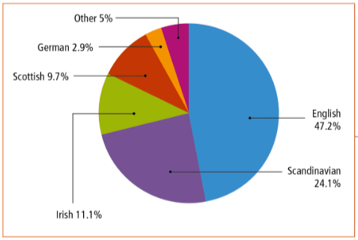

Source: Sylvain Fortin et al., Reflections.qc.ca: 1840 to Our Times, History of Québec and Canada, Secondary IV (Montréal: Chenelière Éducation, 2018), 74.

History of Québec and Canada

Answer:
____________________________________________________________________________________________________________________________________________________________________
- Document 3 presents the legal situation of women as it relates to suffrage before and after 1900. Identify an element of continuity in the situation of women in Québec during these two time periods.
Document 3
Before 1900 | After 1900
“Many early activists prioritized women’s suffrage and the reform of societies dominated by Canada’s White, urban and male middle class.” Although organized French- and English-speaking women often operated in what has been called “two solitudes” (that is, separate from one another and largely non-communicative), most assumed that a common capacity for motherhood meant they could speak for all women. Other groups — notably socialists, farm women and women of non-European origin — nevertheless wanted to speak for themselves.” | “Women had been able to vote in federal elections since 1919, and that same year New Brunswick ceased being the last provincial holdout — the last, that is, except for Quebec.”
Source: The Canadian Encyclopedia
https://www.thecanadianencyclopedia.ca/en/article/early-womens-movements-in-canada.
Source: The Montreal Gazette
http://www.montrealgazette.com/life/Quebec+1944+Finally+women+allowed+vote/7185694/story.html.

Answer: ____________________________________________________________________________________________________________________________________________________________________

History of Québec and Canada

- The École littéraire de Montréal imposed no themes on its writers. Some writers wrote on topics such as French-Canadian patriotism and the nationalism of survival, while others did not. Documents 4 and 5 are excerpts from two poems by Émile Nelligan, in translation. Which document presents the theme of French-Canadian patriotism?

Document 4 Document 5
Christ on the Cross The golden ship
The gypsum Jesus always stalled me in my steps
Like a curse at the old convent door;
Crouching meekly, I bend to exalt an idol
Whose forgiveness I do not implore.

Émile Nelligan
Translated by Konrad Bongard
There was a mighty ship, of solid gold ‘twas wrought:
Its masts reached to the sky, over oceans unknown;
The goddess Love herself, flesh bare and hair wind-blown,
Stood sculpted at its bow, in sunshine desert hot.

Émile Nelligan
Translated by Paul Leroux

Document

History of Québec and Canada

Appendix – Québec at a Crossroads

Information for students
Answers:
- Ultramontanist beliefs hold that power comes from God, whereas in liberal thought, power comes from the people and their government OR Ultramontanist beliefs hold that Church and State are united, whereas in liberal thought, Church and State are separated.
- Massive British immigration OR The arrival of non-French-speaking immigrants
- Both before and in the years immediately after 1900, Québec women did not have the right to vote at the provincial level.

Document
4

https://www.thecanadianencyclopedia.ca/en/article/indian-act
https://thecanadianencyclopedia.ca/en/article/residential-schools

