Weekly Educational Options From the Ministère
secondary Iv
Week of May 25, 2020
Table of Contents
Language Has Power 2
#Mission FLS : Donne-moi des mots qui sonnent, des mots qui résonnent ! 4
Lunch is Served! 6
Appendix A – Information Required for the Task 8
Appendix B – Formula Sheet 9
Appendix C – Answer Key 10
Why Are There So Many Different Objects? 12
Appendix A – Why do we have so many different objects? 13
Creating an Online Presence 15
Ridiculous Questions 17
Changing Times 18
Appendix – Changing Times 23

English Language Arts

Language Has Power

Information for students
In this activity, you will examine the relationship between an author’s purpose, craft and audience. How do the writer’s crafting choices (figurative language, word choice, repetition, structure, images) help to convey the message? Consider the intended audience. Was the audience just the children he is reading to or was it wider? How do you know?
Instructions
Watch the video titled “The Great Realisation” on http://www.probablytomfoolery.com/
Language has power. Watch the video a second time considering these points about how the author crafted this text
- The poem is written using simple language with interesting word choice (ex. weary,dwell)
- Why do think the author chose this kind of language to craft his text?
- Why do you believe the author chose to read the poem as a children’s story? Does this help you understand the message he is trying to convey? How? Would the poem be as effective if not structured as a story for children?
- In this poem the writer uses metaphor to create a picture in the reader’s head, ex. “The children’s eyes grew squarer”. What does he mean by that? Are you able to find other examples? He also uses visual images to reinforce the images he creates with his words. What phrases and images stand out for you as powerful? Why?
- Would simply reading the poem, without the added visuals, convey the writer’s purpose?
The writer of this poem had a purpose and an audience in mind. Considering what you think his purpose was, do you think his crafting choices (both words and images), effectively convey his purpose to his chosen audience? Discuss this video with a parent or friend
Create a text to share your thoughts on the meaning you took from the video? Choose the text that you find suits your purpose and audience the best: art, poetry, a story, a social media post, an article, etc. What would your message be about how our world has changed over the last two months and how you see the future? Plan your crafting choices in order to convey your message effectively

Materials required
Video titled “The Great Realisation” on http://www.probablytomfoolery.com/
Device with Internet access
Paper and writing materials
English Language Arts

Information for parents

About the activity
Children should:
- discuss the video with a parent or family member
- write their thoughts down on paper or digitally
- create a text that expresses their thoughts on how the world has changed over the last 2 months and how they see the future.
- choose the medium they feel suits their purpose the best (art, writing, video, etc.)
Parents could:
View the video with the student if possible
Discuss the instructions with the student as well as discuss their thoughts on the video

French as a Second Language

#Mission FLS : Donne-moi des mots qui sonnent, des mots qui résonnent !

Information for students
Cette activité t’aidera à accomplir la mission FLS suivante : « Je choisis mes cinq chansons préférées en français et j’écris un texte pour expliquer pourquoi je les aime ».
Quel genre de musique aimes-tu ? Le hip-hop, le country, la pop ? Cette semaine, on te propose de partager tes chansons francophones préférées avec ta famille ou tes amis.
Voici comment tu peux le faire :
Choisis les cinq chansons francophones que tu aimes le plus.
Pourquoi aimes-tu ces chansons ? Prends le temps de réfléchir au message, à la musique et aux paroles.
Fais une liste des raisons pour lesquelles tu aimes ces chansons.
Écris un court texte dans lequel tu nommes la chanson et tu expliques ton point de vue.
Pour aller plus loin :
Partage ton top 5 avec le mot-clic #MissionFLS Mission FLS.
Publie une vidéo où tu expliques pourquoi tu aimes ta chanson préférée.

Materials required
Pour écouter de la musique :
Les chaines radio francophones de ta région.
Ici Musique
La fabrique culturelle
Pour trouver les paroles des chansons québécoises :
Artistes québécois
French as a Second Language

Information for parents
Children should:
listen to and read songs or poems in French
understand oral and written text
appreciate francophone cultural references
Parent could:
share their favorite French songs with their children
encourage their children to read them their text and have a conversation about it

Mathematics

Lunch is Served!

Information for students
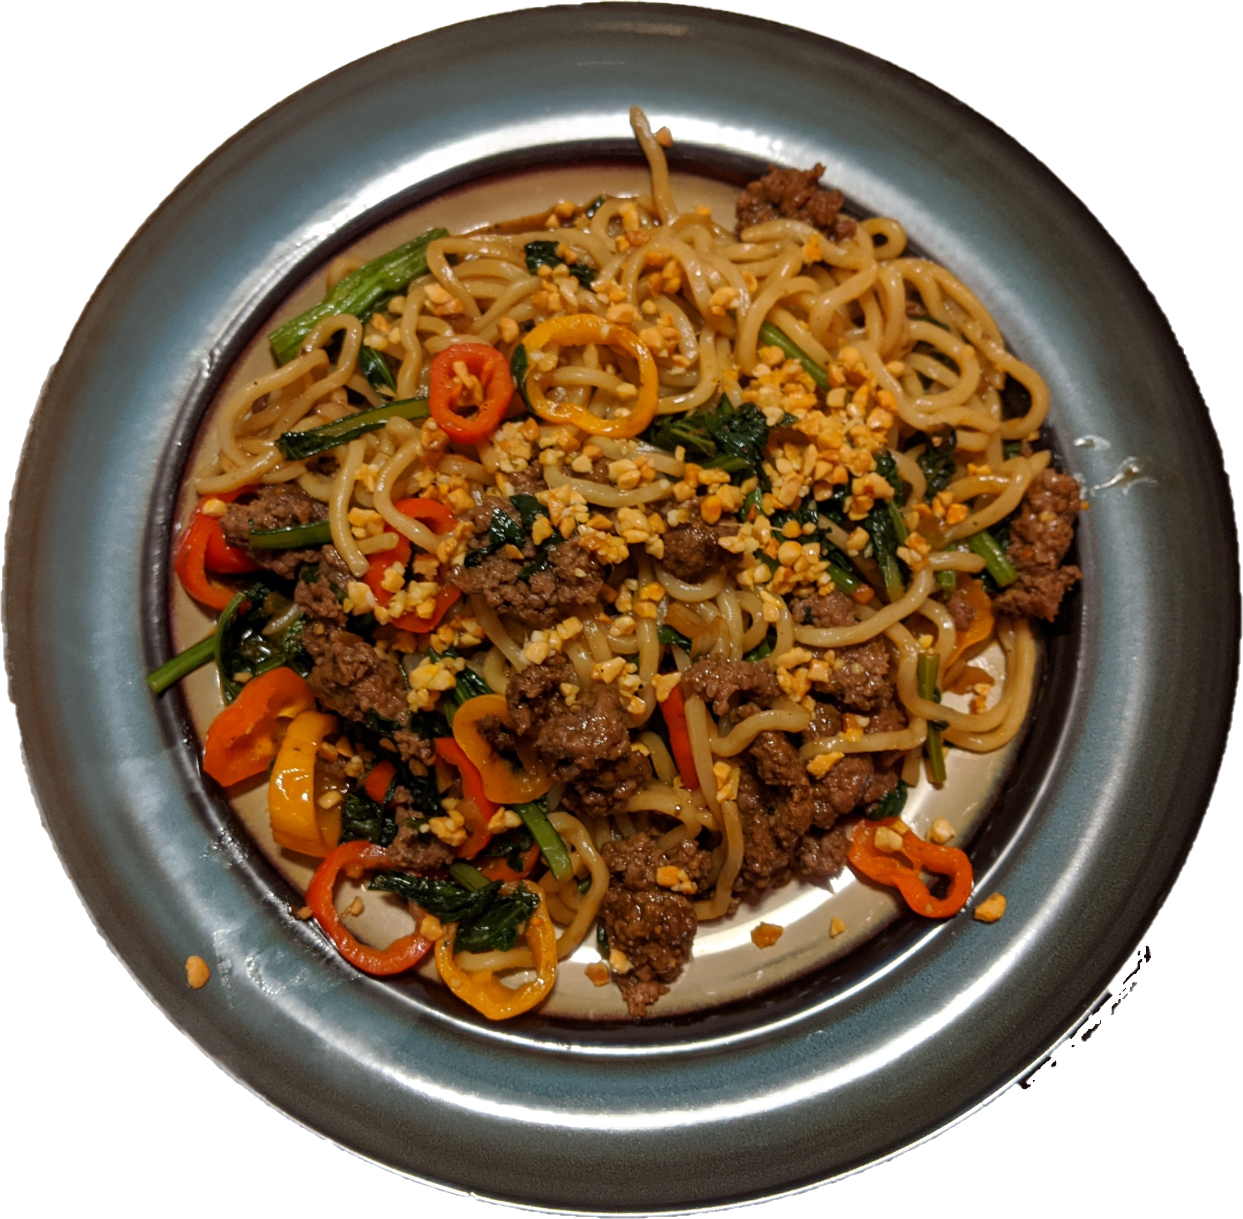
To the right is a dish of Asian-style beef and noodles.

- How long do you think it took to cook?
Think of a length of time that would be too much time
Think of a length of time that would be not enough time
- If you walk into your class and your teacher asked you to make
this meal for your entire class, what would you need to know so you can do it?

Ralph is taking an afterschool cooking class for extra credit. This class is intended to teach students the basics of cooking and to eventually cook a dish like the one in the photo above. During one of the classes, a discussion broke out about how watching cooking shows on TV and online makes people better chefs. Ralph was curious about this and took a poll to find out how much hours of cooking shows people watch per week and what their current grade is in the class. The results are found in appendix A
Is there any correlation between the amount of time spent watching cooking shows and success in the cooking class?
How do you know? What statistical tools can you use to prove your findings?
Ralph would like to eventually cook the meal that’s in the photo for his entire class. While he has plenty of the greens, spices and oil, he lacks the three main ingredients: ground beef, noodles, and mini peppers
He found the recipe online from a meal-kit company. He determined that per person, he would need to buy 150 g of ground beef, 100 g of udon noodles, and 70 g of sweet peppers. He knows that the noodles go for $1.75 per 100 grams. He called a couple of markets to price the meal. However, they did not like giving him prices over the phone so they only gave him total prices for all the ingredients
Community Market said that if he buys 600 grams of ground beef, 600 grams of udon noodles, and 350 grams of peppers, it would cost $26.75
The Co-Op Shop said if he buys 850 grams of ground beef, 400 grams of udon noodles, and 490 grams of peppers, it would cost $29.95
When he spoke to the Co-Op shop, they told him that their prices are identical to Community Market
What would it cost for Ralph to feed his entire class (including himself and his teacher)?
Mathematics

Materials required
Appendix A : Information required for task
Appendix B : Formula Sheet
Appendix C : Answer Key

Information for parents

About the activity
Read the instructions to your child, if necessary
Discuss the task together with your child outlining what steps they need to carry out
The first part of this activity is to help your child think about this problem and to think about what information is required to solve the problem. The questions in italics are used to guide student inquiry while the questions in bold are what’s required to solve the task
Once the task is completed, you and your child can go over the task with the answer key provided
The answer key provided is one example of a possible solution. It is very well possible that your child proves everything they need using different methods than those shown in the answer key. The important thing is that they show their proof using mathematical reasoning

Mathematics

Appendix A – Information Required for the Task

Student Survey
Time Watching Shows (hr) | 1.5 | 2 | 0 | 3 | 5 | 1.5 | 2.5 | 3 | 4 | 3.5 | 2 | 1 | 0.5 | 7 | 3
Class marks | 60 | 75 | 50 | 80 | 65 | 70 | 74 | 85 | 72 | 55 | 90 | 74 | 62 | 86 | 88

Pricing Information
For the recipe, 150 g of ground beef, 100 g of udon noodles, and 70 g of sweet peppers are required, per person
The only price he knows for sure is that the price of noodles is $1.75 per 100 g.
Community Market said that if he buys 600 grams of ground beef, 600 grams of udon noodles, and 350 grams of peppers, it would cost $26.75.
The Co-Op Shop said if he buys 850 grams of ground beef, 400 grams of udon noodles, and 490 grams of peppers, it would cost $29.95

Mathematics

Appendix B – Formula Sheet
The formula for correlation coefficient is r ≈ $(\text{1}- \frac{\text{length of short side}}{\text{length of long side}})$

Mathematics

Appendix C – Answer Key

Scatterplot and correlation coefficient

r ≈ $(\text{1}- \frac{\text{2.76 cm}}{\text{10.68 cm}})$
r ≈ (1 – 0.26)
r ≈ 0.74
There is a moderate correlation between time spent watching cooking shows and a student’s mark in class
NOTE: The measurements used in this answer key may differ depending on how this page is printed. However, regardless of the measurement, the correlation coefficient should be approximately 0.74 (give or take a few hundredths due to rounding).

Mathematics

Cost of food
Let
- x: cost of ground beef per 100 g
- y: cost of sweet peppers per 100 g
- Noodles per 100g = $1.75

6x + 5y + 10.5 = 26.75
8.5x + 7y + 7 = 29.95

7(6x + 5y + 10.5 = 26.75)
5(8.5x + 7y + 7 = 29.95)

42x + 35y + 73.5 = 187.25
42.5x + 35y + 35 = 149.75

42x + 35y = 113.75
42.5x + 35y = 114.75

42x – 113.75 = 42.5x – 114.75

1 = 0.5x

2 = x

6(2) + 5y + 10.5 = 26.75

12 + 5y + 10.5 = 26.75

5y = 4.25

y = 0.85

There are 17 people in the class (including Ralph and the teacher).Therefore you need 17(150 g of ground beef, 100 g of udon noodles, and 70 g of sweet peppers)
The cost would be 25.5(2) + 17(1.75) + 11.9(0.85) = $90.27

Science and Technology

Why Are There So Many Different Objects?

Information for students
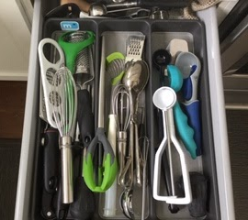
How many different objects do you think there are in your home? Why do you think there are so many different objects?
One of the reasons that we have so many different objects is that each object has been designed to meet a specific need.
In this activity, you will be analyzing an object that meets specific needs in your home. Then you will reflect on some of the environmental aspects of the object and on whether or not you really need this object.
Choose an object in your home to analyze. The object must have at least three components and some of the components must move in relation to one another.
Analyze the object by answering the questions in Appendix A.

Materials required
A household object
Appendix A
Paper and writing materials

Information for parents

About the activity
Children should:
apply their knowledge to analyze a household object and explain how it works
reflect on the environmental aspects of this household object
Parents could:
help their child choose an appropriate object to analyze
discuss the questions with their child
read the instructions to their child if necessary
Science & Technology

Appendix A – Why do we have so many different objects?

Information for students
Choose a household object that has at least three components and that has some parts that move in relation to one another. Analyze the object by answering the questions below.
- Why do we need this object?
- What is the overall function of the object?
- Do other objects exist that meet the same needs?
- Make a list of the main components of your object. For each of the main components, answer the questions below.
- Describe the function of the component
- What material(s) do you think were used to make the component? (e.g. wood, plastic, ceramic, metal)
- Why do you think this material was chosen for this component? Refer to the properties of the material in your answer
- Could the component be made from a different material? Why or why not?
- Identify two links on your object. For each link.
- Identify the characteristics of the link. (Direct or indirect? Partial or Complete? Removable or non-removable? Rigid or flexible?)
- Why was a link with these characteristics chosen?
- Identify where guiding occurs on your object.
- Which component acts as the guide? Which component is being guided?
- What type of guiding is involved?
- Now that you have taken a closer look at some of the components that make up your object, briefly describe in a few sentences how the object works. Where is a force applied to the object? How do the components move in relation to one another?
- What is the impact of this object on the environment?
The production use and eventual disposal of the many different objects we use affect the environment.

Science & Technology
A diagram of the life-cycle of a product is shown below.

Life-Cycle of a Product
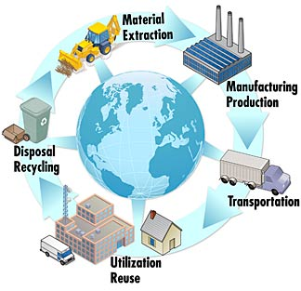

Think about the environmental impact of each of the stages of the life-cycle of your object. Some questions you may want to consider include:
Where do the raw materials for the components come from?
Where is it made?
How long does the object last?
Can it be repaired?
Does using the object have an impact on the environment?
Can it be recycled?
Are there any changes that can be made to the object to reduce the impact of this object on the environment? Explain your answer.
- People who are concerned about the environment believe that we should reduce the number of different things we buy and use.
- Do you really need the object you analyzed?
- Create a persuasive “elevator pitch”* for why or why not.
*An elevator pitch lasts no longer than a short elevator ride of 20 to 30 seconds

Arts

Creating an Online Presence

Ever wonder how to get your artistic creations noticed? By sharing them!
You are a year away from the end of your high school career. Will what you've created live a longer life than the assignment you made it for? Are there creations that could contribute to a visual representation of your identity? No matter how few images, videos, or pieces you have, you can share them to encourage wonder. Who knows, maybe it will even get your art moving professionally.
Good branding is the act of becoming known for something that you do. As part of the branding process, this week we’ll explore how to build an online presence for your artwork.
- Read this short outtake from the book Steal like an Artist, by Austin Kleon. https://journal.markusbaier.com/post/133354533530/the-not-so-secret-formula showing a couple of takeaways for building an online presence
- Are you photographing visual art? Have you thought of hanging it on the wall to shoot the photo? Or leaning against the wall on a shelf? Or with you working on a detail?
- Some artists use specific filters, colour palettes, or certain fonts on Instagram or other social media. They do so consistently to support their works’ visual identity.
- Time to take action: With one creation from this year and some of your takeaways about building an online presence, make some creative choices and decide how you want to share your work. Will you post a photograph of the making of? Will you share your influences? is there a story that connects you to your work?
- Have fun!
Resource:
- Branding: Use the 10 steps found on this site to build the visuals. Focus on branding and brainstorming symbols. https://www.canva.com/learn/personal-branding/
- If you’ve already written an artist’s statement in class, going back to it could help you remember some key ideas about who you are as an artist and the work you create. Example: Artist's statement from Learnquebec
Arts

Materials required
Internet
Pencil and paper

Information for parents

About the activity
Children should:
share some creations they had already completed this year and invite others to observe and notice them
Parents could:
encourage their children to share or promote their artwork or artistic creations

Ethics and Religious Culture

Ridiculous Questions

Information for students
Are hot dogs a sandwich?
Is cereal a soup?
Is Hawaiian pizza (a pizza with pineapple and ham as the toppings) really a pizza?
Society includes people with a variety of opinions. While we may not agree with everyone, understanding where their opinion comes from helps society flourish. Ambivalence is a topic that is explored throughout this course. Having a strong opinion about a given subject is important too. However, feeling strongly about something while having a deep understanding of the other side of the argument can help with refining your ideas to better support your opinion. It can also improve your ability to have a civil discussion with others who might disagree with your opinion.
Although the above questions do seem a little ridiculous (hence the title), they are being used as a stand-in for more controversial topics. Even so, despite the less serious tone of these questions, some people have strong opinions about these three topics. The goal of this exercise is to develop an understanding of the opinion of others.
Answer the following questions with a short paragraph explaining your answer. Your explanations should not be based on emotion or feeling, but with facts and evidence
After you have completed the paragraph that supports your opinion for each question, write another paragraph for each question that goes against your opinion. This will help with understanding someone else’s point of view

Information for parents

About the activity
Discuss the task together with your child
Each paragraph should state your child’s opinion and approximately three sentences with different ideas (facts, evidence) to support that opinion
There is no right or wrong answer. As long as your child provides support for their ideas, this exercise has been successfully completed

History of Québec and Canada

Changing Times

Information for students
Today, over 80% of Canadians live in urban centres. However, this was not always the case. In the second half of the 19th century, thousands flocked to cities in search of work. This led to a phenomenon called urbanization and new standards for working conditions thanks to unions.
Click here to access an online version of your Reflections History textbook. Pages 66-74 will teach you a little about the growing trend to urbanization and the population movements that led to it.
If you do not have access to the Internet, read pages 66-74 of your Reflections textbook. If you do not have your textbook, you can look at the historical documents below to help you with the activities
Now that you have learned about urbanization and the population movements that led to it, do the following activities:
- establish connections between documents, deciding if they represent a working condition or a living condition during the second half of the 19th century
- establish causal connections between three different trends relating to population movements
- situate in space the emigration of French Canadians to the United States between the years 1850 and 1890
- determine a consequence on Québec’s territory of French Canadian emigration to the United States

Materials required
Useful resources, depending on personal preferences and availability:
Device with Internet access
Writing materials (paper, pencil, etc.)

Information for parents
Students could:
do further research on the topic using resources like The Canadian Encyclopedia
Parents should:
discuss the ideas presented and potential answers with their child

History of Québec and Canada

- The following documents represent conditions in the second half of the 19th century. Establish connections by entering the number of each document in the appropriate space below.
Document 1
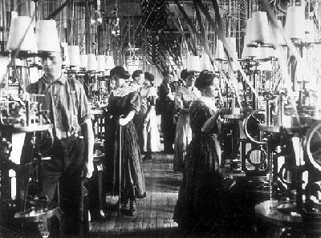
Factory life in the late 1900s
“Yet the ... conditions that they experienced and the wages they earned were, more often than not, less than ideal … and … accidents were common. Wages and hours were punishing ...”

The Canadian Encyclopedia

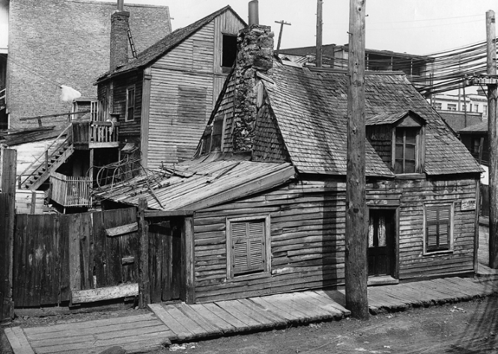
Document 2

Source: Open Text BC, Canadian History: Post-Confederation
https://opentextbc.ca/postconfederation/chapter/3-5-urbanization-and-industry/

Living conditions | Working conditions

History of Québec and Canada

- Explain how the rural exodus affected living conditions in urban areas in the second half of the 19th century.
Answer the question, providing details on the elements below and establishing the connections between them.
The reason for the rural exodus
The population in urban areas
Living conditions in urban areas
Document 3 Document 4
Urban and rural populations in Québec, 1861-1891
“In working-class neighborhoods, multi-storey buildings were crammed together. Working-class families lived modestly, often in uncomfortable and unhealthy conditions... Water ... had to be transported, since aqueducts only supplied certain neighborhoods."

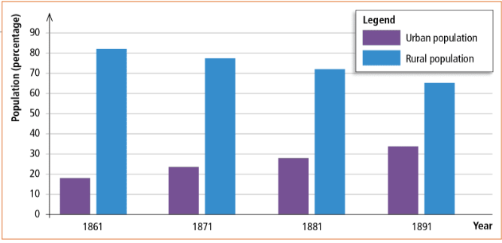
Source: Sylvain Fortin et al., Reflections.qc.ca: 1840 to Our Times, History of Québec and Canada, Secondary IV (Montréal: Chenelière Éducation, 2018), 68
Source: Sylvain Fortin et al., Reflections.qc.ca: 1840 to Our Times, History of Québec and Canada, Secondary IV (Montréal: Chenelière Éducation, 2018), 70
Document 5
“While the first factories (in glass, clothing, and shipbuilding industries) were set up in Nova Scotia, industrialization was soon centralized in Ontario and Québec (Montréal, Hamilton, Toronto) in the tobacco and textile industries, in foundries, and in the railway-supplies business. The demand for unskilled labour (especially for construction gangs) and the numbers of skilled workers (e.g., carpenters, bricklayers, tailors, and foundry and leather workers) grew rapidly.”

The Canadian Encyclopedia
Answer: ______________________________________________________________________________________________________________________________________________________________________________________________________________________________________________________

History of Québec and Canada
- Between the years 1850 and 1890, over 400 000 French Canadians settled in the United States, particularly in the northeast. Refer to Document 6 and indicate the letter that best corresponds to this population movement.
Document 6
Map of southern Québec
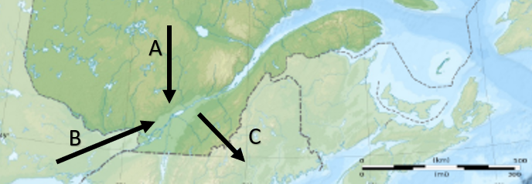
Letter

History of Québec and Canada
- Refer to Documents 7 and 8 to determine a consequence on Québec’s territory of French Canadian emigration to the United States.
Document 7 Document 8
A poster advertising a rail
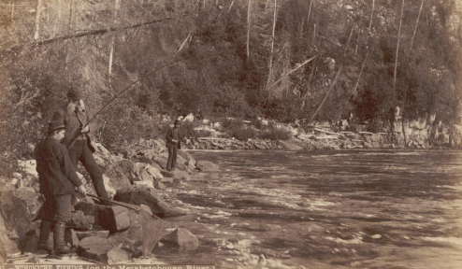
trip to Lac Saint-Jean, 1894 Fishing along the Métabetchouan, Lac Saint-Jean, 1896
Source: Bibliothèque et Archives nationales du Québec

Source: Corporation de l’activité pèche Lac Saint-Jean
https://claplacsaintjean.com/wp-content/uploads/2017/10/Perspective_historique_ouananiche_Final.pdf
Answer: ______________________________________________________________________________________________________________________________________________________________________________________________________________________________________________________

History of Québec and Canada

Appendix – Changing Times

Information for students
Answers:

Living conditions | Working conditions
2 | 1

Industrialization OR the opening of factories OR the demand for labour in the cities
led to
population growth in the cities OR urbanization,
which led to
poor living conditions OR overcrowding in working-class neighborhoods.

Letter
C

Colonization of the Lac-Saint-Jean region OR colonization of new areas in Québec

The National Institute of Standards and Technology (NIST), “Life-Cycle Thinking Product System” (2011) https://commons.wikimedia.org/wiki/File:Life_Cycle_Thinking_Product_System.jpg

