secondary Iv
Week of June 15, 2020
Table of Contents
The All-American Slurp 2
Parlons de risques 4
Nature Reserve 6
Appendix B – Formula Sheet 9
Appendix C – Answer Key 10
Summer Safety and Summer Exercises 12
Throwback: Your Creative Moments This Year 14
COVID-19 & the FOMO 15
The National Policy 17
Appendix – Answer Key 22

English Language Arts

The All-American Slurp

Information for students
Change can be hard. We have all discovered in the last few months how change can feel difficult and strange. Sometimes we long for things to be the way they used to be. In that same way, the change involved in moving to a new place can be difficult. When we reflect on all the ways a new place might be different, such as how people dress, how they act and the foods they eat, it’s clear there is a lot to learn. How do you fit in and still remain true to yourself? In this story a young girl moves to America from China and discovers all the ways people are different, and all the ways people can be the same.
- Watch the video. To start you thinking before reading the story, watch this short clip called “White People Lunch” from the TV show Fresh Off the Boat, a show about a family who moves to America from China: https://safeyoutube.net/w/OdAJ. Aside from being funny, it might also help you think more deeply about the challenges people face when moving to a new place and how those challenges are often tied to food culture.
- Read the story “The All-American Slurp” by Lensey Namioka.
- Annotate the text. Highlight or underline parts of the text that you find interesting, confusing or that are related to what you believe the big idea is that the author is trying to convey.
- Consider what the big idea of the text might have reminded you of. (Yourself, the world, other texts, etc.)
- What elements of the author's craft did you highlight as particularly interesting? How do those elements contribute to your understanding of the text?
- Talk about the story. Find someone else to read the story and discuss it with you. What are their thoughts about the story? Explain your thoughts and ideas to them. Discuss what you believe are the big ideas.
- Write about the story. Respond to this text, either in writing or by recording yourself discussing the story. Usually, when we respond to a text, either in writing or in another form, we should discuss what we believe the big idea to be, how we connect (our own lives, other texts, or the world) to that big idea, and what elements of the story helped us to better understand it. Test your skill at expressing your thoughts about this story in the form of a response.

Materials required
Device with Internet access
Paper and writing materials

English Language Arts

Information for parents
Children should:
- discuss the short story with a parent or family member
- write their thoughts down on paper or digitally
- write or record their response to the story
Parents could:
- discuss the instructions with their child

French as a Second Language

Parlons de risques

Information for students
- Choisissez un ami avec lequel vous pourriez avoir une discussion suite au visionnement de ce court reportage sur les pompiers et sur la bande-annonce sur ces superhéros.
- Partagez cette fiche d’activité avec votre ami.
- Écoutez les deux vidéos individuellement.
- Convenez d’un rendez-vous téléphonique ou d’un appel vidéo sur la plateforme de votre choix (par exemple : FaceTime, Messenger, Google Hangouts, etc.) Discutez en français en vous aidant des pistes de discussions fournies en annexe.

Materials required
Appareil branché à Internet
Imprimante (pour les pistes de discussion)
Papier et crayons pour la prise de notes
Un appareil de communication pour joindre votre ami (soit : téléphone /tablette/ordi)

Information for parents
Children should:
find a partner for a conversation
watch the two videos (report / 8m58s, trailer / 1m49s) as many times as needed
jot down some key elements from the videos
read the appendix and get ready for the conversation with their friend
Parents could:
have a conversation with their child, in French (if possible), on how the conversation went:
- vocabulary, development of ideas, details, fluency in general, etc.
- continue the conversation in order to practise developing ideas when sharing an opinion

French as a Second Language
Appendix – Parlons de risques

Information for students
Pistes de discussion qui peuvent relancer la conversation (à utiliser au besoin)
- Quels sont les dangers rencontrés dans la profession de pompier ? Nommez-les.
- À votre avis, est-ce plus difficile d’être pompier au 21e siècle ? Pourquoi?
- Selon vous, à part les chimistes, qui pourrait aider à la sécurité des pompiers? Développez.
- Croyez-vous que les pompiers se soucient de leur santé lors d’une intervention? Expliquez.
- Quelles sont les forces fréquemment observées chez les pompiers? Dressez une liste.
- Par ordre de priorité, lors d’un incendie, qu’est-ce que le pompier doit sauver? (3 items)
- Quelle est la plus grande qualité d’un pompier?
- Personnellement, rêvez-vous de devenir pompier ? Pourquoi?

Mathematics

Nature Reserve

Information for students
PART 1 – FOR ALL STUDENTS
A construction company has purchased 625 square kilometres of land northeast of where two highways meet
The company is using a map represented in the Cartesian plane.
- The x-axis represents an east-west highway.
- The y-axis represents a north-south highway.
- The coordinates are located in relation to the point where the two highways meet.
- Each interval of 1 on the axes of the Cartesian plane represents 1 kilometre.
The province has asked the company to set aside at least 100 square kilometres of land as environmentally protected green space.
- The company wants to build a large triangular nature park that would please people moving to the area and also increase local tourism.
- On the map, it has plotted the vertices of the large triangular nature park.
- It has also identified three other smaller areas that would be suitable for nature reserves and plotted the related vertices.
- Part of the promotional campaign is that the smaller parks must be similar to the largest park.
- A provincial inspector is going through the information the company has provided and has doubts that it has set aside 100 square kilometres for green space. The inspector is also not sure that the three smaller spaces are similar to the largest green space.
- Has the company done what it was supposed to do?
    - You could find the measurement of all 12 sides of the four triangles. How else could you find out if the triangles are similar without finding the length of every side of all the triangles?
The company would also like to develop roads that connect the parks to the highways.
- By analyzing the terrain, it has identified four potential roads by establishing two points where service stations would be located. A straight line would connect the service stations, a highway and a park
- For aesthetic reasons, the construction company wants these roads to run either parallel or perpendicular to side AB of the largest triangular park.
- Which of the four sets of points would meet all the conditions set for building a road?

Mathematics
The construction company has subcontracted additional road planning to two companies: Canadian Streets and Transport (CST) and Safeguarding Nature (SN).
PART 2 – FOR CST STUDENTS
The CST team will have to build roads that connect the parks to either highway.
- A road for emergency purposes must be built from a point two fifths of the way along side KL to a point one third of the way along side GI.
- The province needs to know the coordinates of the endpoints of this road and the distance between these two points.
PART 3 – FOR SN STUDENTS
The SN team has been asked to build a road, shaped like a parabola, which will pass through all three vertices of the largest triangular park.
- Point A represents the northern most point of the road surrounding triangle ABC.
- The SN team needs to identify the coordinates of the points where this road will intersect with the east-west highway.

Materials required
Appendix A: Map of Development Area (includes potential roads and the coordinates of the service stations)
Appendix B: Formula Sheet
Appendix C: Answer Key

Information for parents

About the activity
read the instructions to your child, if necessary
discuss the task together with your child, outlining what steps they need to carry out
this activity is split into three parts: PART 1 is for all Secondary IV math students. PART 2 is for CST students. PART 3 is for SN students
once the task is completed, you and your child can go over it with the answer key provided (Appendix C)
your child may obtain answers that could be slightly different from the answer key, depending on how they round off their results. Being off by a few tenths is fine. There is no need to worry about inconsistencies in rounding off the results. The important thing is that your child is able to show that they can solve the problem

Mathematics
Appendix A – Map of Development Area

Given Information
Images are not necessarily drawn to scale.
The arrow in the top right corner represents North on the map.
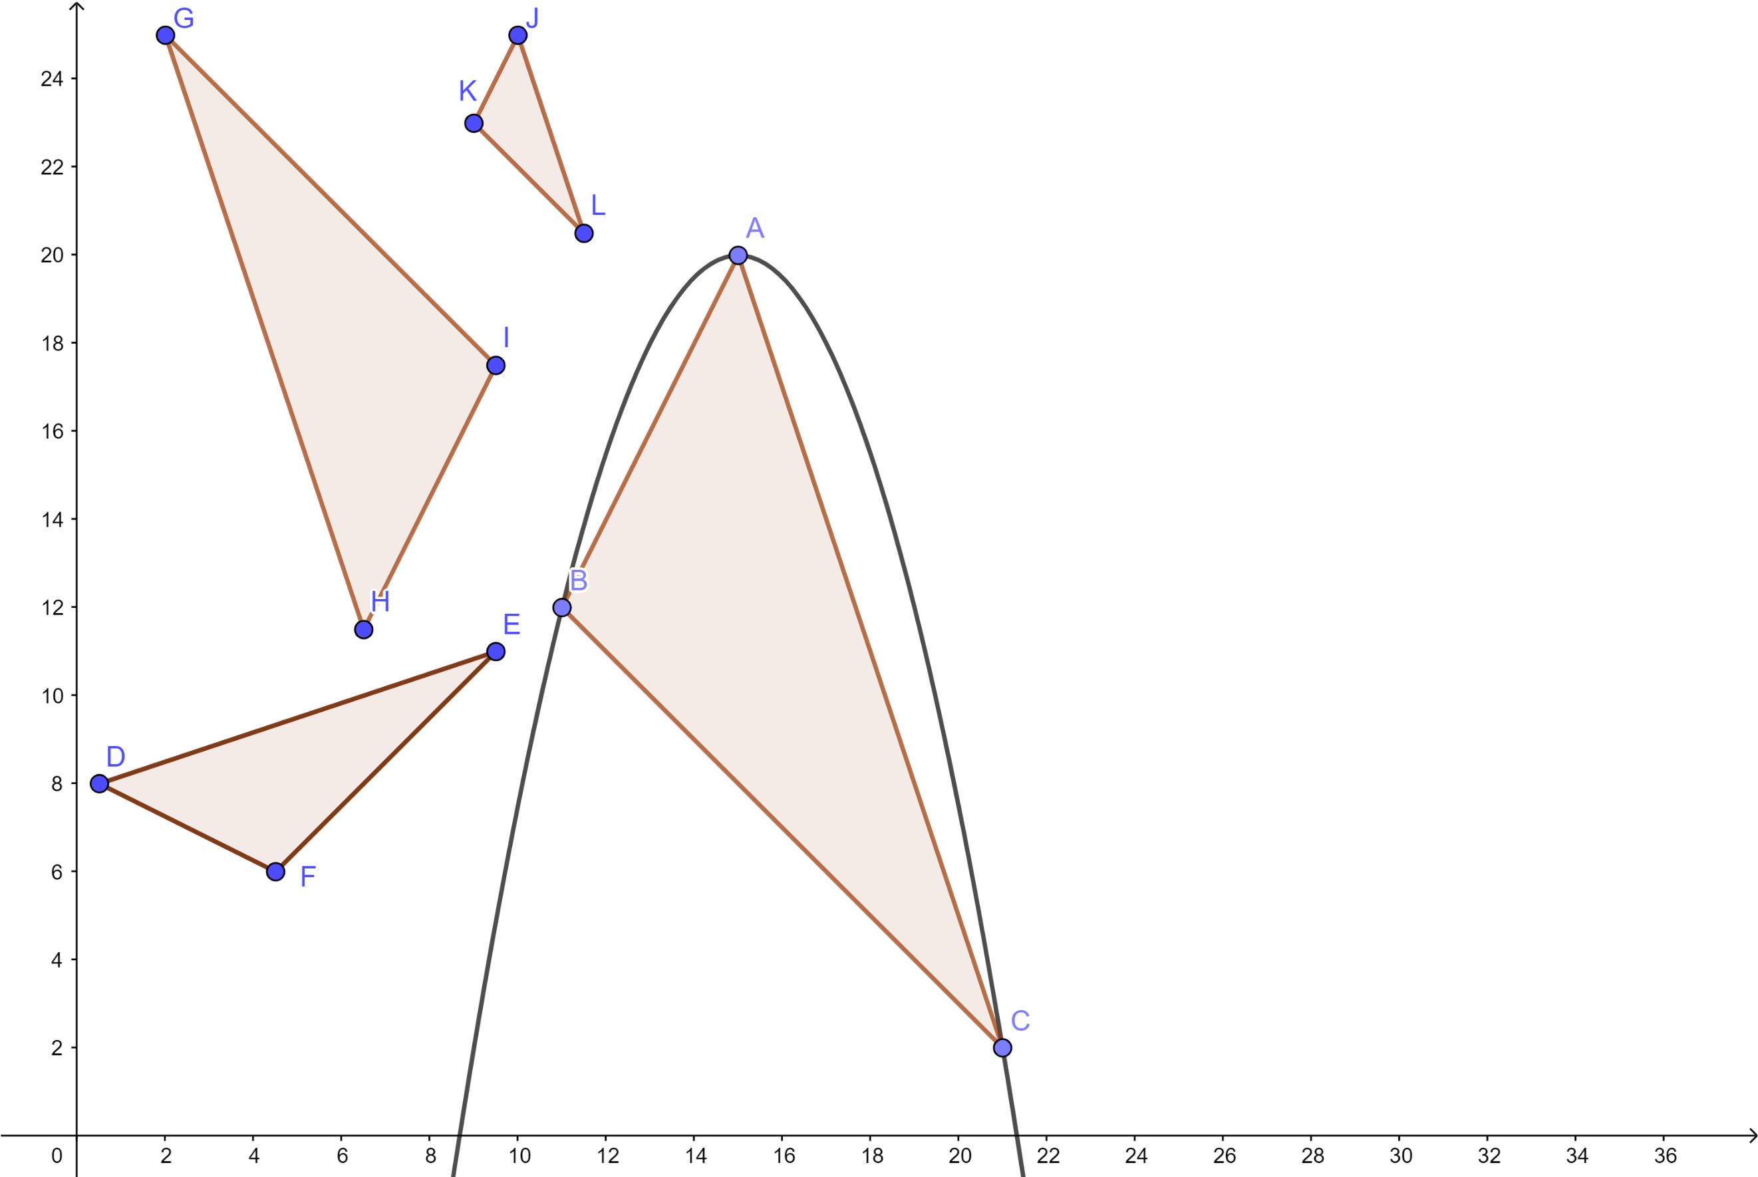  Point  N | Coordinates
A | (15, 20)
B | (11, 12)
C | (21, 2)
D | (0.5, 8)
E | (9.5, 11)
F | (4.5, 6)
G | (2, 25)
H | (6.5, 11.5)
I | (9.5, 17.5)
J | (10, 25)
K | (9, 23)
L | (11.5, 20.5)

Potential road | Coordinates of the service stations
1 | (6, 4) &  (10, 12)
2 | (2.5, 15) & (4, 18)
3 | (8, 8) &  (12, 10)
4 | (2, 11) &  (4, 10)
Point A represents the northern most point of the road surrounding triangle ABC.

Mathematics

Appendix B – Formula Sheet

Trigonometric Ratios
sin A = length of the leg opposite ∠ A
A
a
c
b
C
B
length of the hypotenuse

cos A = length of the leg adjacent to ∠ A
length of the hypotenuse

tan A = length of the leg opposite ∠ A
length of the leg adjacent to ∠ A

Sine Law
$\frac{\text{a}}{\text{sin A}}$ = $\frac{\text{b}}{\text{sin B}}$ = $\frac{\text{c}}{\text{sin C}}$

Hero’s Formula
Area = $\sqrt{\text{p}\text{(}\text{p} \text{–} \text{a}\text{)(}\text{p} \text{–} \text{b}\text{)(}\text{p} \text{–} \text{c}\text{)}}$

Trigonometric Formula
Area = $\frac{\text{a}\text{ x }\text{b}\text{ x sin }\text{C}}{\text{2}}$

Similar Triangles
Side-side-side (SSS)
Side-angle-side (SAS)
Angle-angle (AA)

Distance Between Two Points on a Line
d(A, B) = $\sqrt{{\left(x_{2 }-{ x}_{1}\right)}^{2}\text{ + }{\left(y_{2 }-{ y}_{1}\right)}^{2}}$

Point of Division
(x₁ + $\frac{\text{a}}{\text{b}}$(x₂ – x₁), y₁ + $\frac{\text{a}}{\text{b}}$(y₂ – y₁))

Mathematics

Appendix C – Answer Key

Lengths of the sides of each triangle
Side | Length (in km)
AB | 8.94
AC | 14.14
BC | 18.97
DE | 9.49
DF | 4.47
EF | 7.07
GH | 14.23
GI | 10.61
HI | 6.71
JK | 2.24
JL | 4.74
KL | 3.54

Area of each triangle
Triangle | Area (in km²)
ABC | 60
DEF | 15
GHI | 33.75
JKL | 3.75
The company has set aside more than 100 km² (112.5 km² in total) of land as environmentally protected green space.
Triangles DEF, GHI, and JKL are similar to triangle ABC.

Potential Roads
Equation of side AB: y = 2x – 10
Potential road | Equation | Parallel/  Perpendicular to side AB? | Connects a park to a highway?
1 | y = 2x – 8 | Yes | No
2 | y = 2x + 10 | Yes | Yes
3 | y = 0.5x + 4 | No | Yes
4 | y = -0.5x + 12 | Yes | Yes
Roads 2 and 4 can be built because they meet all the conditions.
Mathematics

Road Between Triangles GHI and JKL
Point $\frac{\text{2}}{\text{5}}$ of the way along side KL = (10, 22)
Point $\frac{\text{1}}{\text{3}}$ of the way along side GI = (4.5, 22.5)
Distance between these two new points created = 5.52 km

Road Surrounding Triangle ABC
Equation of the road: y = -0.5(x – 15)² + 20
Zeroes of the equation = 8.68 and 21.32 OR Points of intersection = (8.68, 0) and (21.32, 0)

Physical Education and Health

Summer Safety and Summer Exercises

Information for students
Activity 1: Summer safety reading
Summer is right around the corner, but before you go outside, start work, or head out for a picnic, get some info first!
Read the article Summer Safety 101 from the perspective of an older sibling or a camp counselor. Think about what you have learned from the reading and what you could potentially teach others.
- Answer these questions:
- If your younger sibling or camper is looking sluggish and you know they have not been drinking water all day, what would you suggest or offer to entice them to hydrate? OR If your younger sibling is swimming in the pool and you have been asked to watch them, but your phone rings in the house, what should you do?
- If your friend decides that helmets are “not cool” and chooses not to wear one, what would you say to convince them to wear a helmet while they ride their bike?
- What did you lean about “respecting the environment” during the summer months?
- Do you have a first-aid kit in the car or at home? Why do you think it is important to have one?
Activity 2: Summer-time exercises
- Try one of these workouts:
- Cardio workout
- Yoga
- Full Body HIIT
- Which one did you do? How did it go? Do you think you could continue to do workouts like this over the summer?
Over the past few months, you have learned and tried new exercises at home (restorative, yoga, HIIT), but a healthy lifestyle is one that is continuous and enjoyable.
The most important thing is to find an activity, exercise, sport, or movement that you like and stick with it (or switch it up when you find a new enjoyable activity!).
- What do you think you will do this summer to be physically active? Make a tentative plan for what you will do this summer: 3 exercises a week for 9 weeks (e.g. swim, bike, run, dance, train, play, yoga, online workout videos).
June/July
August

Physical Education and Health

Materials required
None

Information for parents

About the activity
Children should:
read the article, reflect, and answer the 4 questions
reflect on the new workouts they learned, try a workout, and think about what they will do over the summer
Parents could:
encourage their children to read the article and answer the questions, and to stay safe over the summer
do the workout with their children or help them be more autonomous
encourage their children to be active over the summer

Arts

Throwback: Your Creative Moments This Year
As the year winds down, you are invited to create an infographic as a reflection of some landmark creative moments this year.
See the sample infographic at this link: https://www.easel.ly/browserEasel/11632806
How is reflection worthwhile? Looking back often shows us the path forward.
This activity is the last in a series of creative branding activities.
Resources:
- Infographic: Sites like Easel.ly or canva.com are a way to make infographics for free if you register for an account. Families with Adobe or other design software wouldn’t necessarily need access to the Internet to do this activity.
- Branding: Use the 10 steps found on this site to build the visuals. Focus on branding and brainstorming symbols. https://www.canva.com/learn/personal-branding/
- If you’ve already written an artist’s statement in class, going back to it could help you remember some key ideas about who you are as an artist and the work you create. Example: Artist's statement from Learnquebec

Materials required
Internet
Pencil and paper

Information for parents

About the activity
Children could:
create a visual about their creative journey this year.
Parents could:
view the infographic created by their child and give constructive feedback.

Ethics and Religious Culture

COVID-19 & the FOMO

Information for students
Have you ever heard of the acronym FOMO? Do you know what it means? By definition, it’s a reference to ‘’a feeling of anxiety or insecurity over the possibility of missing out on something, as an event or an opportunity’’. It stands for “Fear of Missing Out”.
People who suffer from FOMO will often feel like they are not where they should be and would be feeling better if they were somewhere else, with other people, doing other things, feeling accomplished and happy. It’s easy to see how social media often contributes to that feeling and how it can be experienced by many people. On different platforms, some people want to be admired and be seen at certain places or around certain people. If you feel like the world keeps on spinning without you when you are not invited somewhere or you decide to stay home and later regret it, chances are you are experiencing FOMO.
In a world where the idea of being busy is glorified, people tend to link their self-worth to performances, social interactions, tasks, etc. In the same way, the idea of staying home and doing less is often associated with boredom or failure.
In early March, when COVID-19 was declared a worldwide pandemic and the Quebec government put the economy and many public sectors on hold and urged everyone to stay at home in order to flatten the curve and protect the most vulnerable, it became clear that the following weeks would be very different for many Quebecers. Some of the changes included workplaces going out of business, schools closed, appointments cancelled, gatherings forbidden, etc.
While some experienced a lot of anxiety over the new changes and felt a need to go back to normal as soon as possible, other people have expressed a sense of relief because of the opportunity they had to slow down, rest, and re-evaluate their mental workload or their validation seeking behaviors. For many, being able to break from the FOMO cycle they usually experience has been a positive experience.
Think about what you’ve experienced in the last months, and especially how you reacted to the global slowdown at first.
- Do you usually feel a need to go places, to be seen and to make sure you don’t miss social opportunities? Explain why or why not.
- In regards to social media, do you experience a certain pressure to publish content and let people know what you are up to? Explain why or why not.
- Since the beginning of the lockdown, have you experienced boredom, relief, anxiety, mindfulness, etc.? Discuss.
- What do you miss about your life and your routine prior to the pandemic? What don’t you miss?
- Did you experience a change of some sort during the lockdown, is there anything in your life that you plan on re-evaluating or even changing once we can safely deconfine ourselves?

Materials required
Paper, pen, phone, tablet or computer.

Ethics and Religious Culture

Information for parents

About the activity
Remember that the goal is to reflect on the idea of FOMO, business and the general idea of slowing down
Parents could:
discuss the information and the questions with their child and share their own thoughts with them; parents could encourage their child to contact a classmate if their child has more questions or wants to chat with a peer

History of Québec and Canada

The National Policy

Information for students
When John A. Macdonald became Prime Minister for the second time, in 1878, Canada was facing an economic crisis. This was a very serious situation for such a young country. In response to the crisis, Macdonald’s government adopted the National Policy in 1879. Among other things, this policy promised to expand the rail network to the West. Meanwhile, in the East, French-Canadian nationalism was emerging, with Honoré Mercier at the forefront.
Click here to access an online version of your Reflections History textbook. You can access Reflections even if your class uses a different textbook.
Pages 92-99 will teach you a little about the Macdonald government’s National Policy and some of the other political issues facing Canada in the second half of the 19th century.
If you do not have access to the Internet, read pages 92-99 of your Reflections textbook. If you do not have your textbook, you can look at the historical documents on the following pages to help you with the activities.
Now that you have learned about the Macdonald government’s National Policy and the provinces’ demand for greater autonomy, do the following activities:
- Establish causal connections between three documents relating to the National Policy.
- Establish a connection between documents by differentiating between favourable and unfavourable attitudes toward the National Policy.
- Situate the Canadian Pacific Railway in space.
- Determine a cause and a consequence of the first interprovincial conference in 1887.

Materials required
Useful resources, depending on personal preferences and availability:
Device with Internet access
Writing materials (paper, pencil, etc.)

Information for parents

About the activity
Children could:
do further research on the topic using resources like The Canadian Encyclopedia
Parents should:
discuss the ideas presented and possible answers with their child

History of Québec and Canada
- During the second half of the 19th century, the Macdonald government implemented the National Policy. Explain how the National Policy had an effect on the population of the West.
Answer the question, providing details on the elements below and establishing the connections between them.
- A measure taken to stimulate population growth
- A marketing strategy employed by the Canadian government
- The population of Western Canada
Document 1
“From 1867 to 1914, the Canadian West opened for mass settlement, and became home to millions of immigrant settlers seeking a new life. This immigration boom created key industries still important to Canada’s international role – like agriculture, mining, and oil.”
Source: https://pier21.ca/research/immigration-history/settling-the-west-immigration-to-the-prairies-from-1867-to-1914
Document 2 Document 3
A poster promoting land in Manitoba A poster describing the free farmland offered by the Canadian
to potential Dutch immigrants, 1897 government to potential British immigrants, 1890
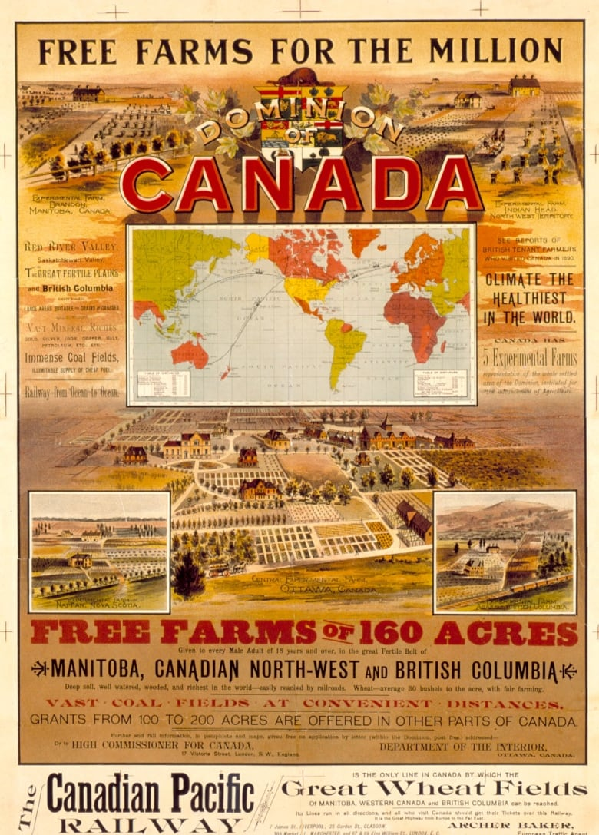
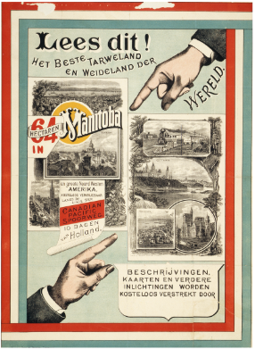

Source: Library and Archives Canada, C-052819 Source: Library and Archives Canada, C-095320

History of Québec and Canada
Answer: __________________________________________________________________________________
__________________________________________________________________________________
__________________________________________________________________________________
- In the 1870s, the American economy posed a threat to the young Canadian economy. From 1879 to 1911, the National Policy imposed increased custom duties on imported products in order to protect Canadian businesses. Not all Canadians were in favour of this strategy, however.
Establish a connection between Documents 4 and 5, differentiating between them to identify which represents a favourable attitude toward these increased customs duties, and which represents an unfavourable attitude.
Document 4 Document 5
Cartoon on the National Policy
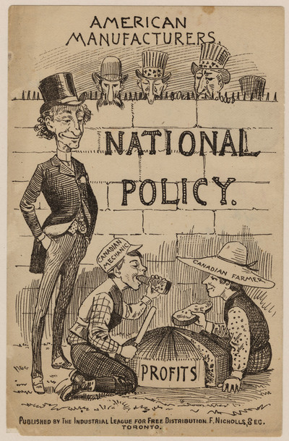
“… Wilfrid Laurier and President William Howard Taft of the United States negotiated a reciprocity agreement. Laurier was probably one of the first Prime Ministers to talk about free trade with our neighbours to the south. He believed that opening up trade would allow manufacturers and farmers to increase their production and sell their commodities to our neighbours.
‘We wish to open our markets to you on the condition that you open yours to us. It would be to our mutual advantage. We produce more of certain things than we can consume; on the other hand, our production is below capacity, such that we have commodities to export and import.’ (1910) [translation]”

Wilfrid Laurier

Source: Library and Archives Canada, 2957613
Source: http://wilfridlaurier175.ca/accord_de_reciprocite-reciprocity_agreement-eng

History of Québec and Canada

Document representing a favourable attitude toward increased customs duties | Document representing an unfavourable attitude toward increased customs duties

- Macdonald’s National Policy also included the building of an enormous rail network. This network was intended to link the provinces together, thereby uniting the emerging country. Refer to Document 6 and in the box below, write the letter that corresponds to the route chosen for the Canadian Pacific Railway.
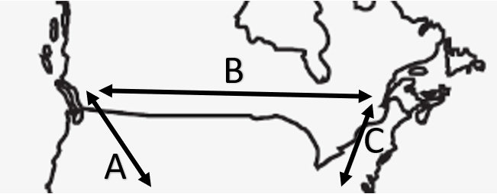
Document 6

Letter

History of Québec and Canada
- At the beginning of his term in office, Honoré Mercier organized the first interprovincial conference, in 1887. Using the documents below, identify a cause and a consequence of the first interprovincial conference.
Document 7
“The hanging of Riel had demonstrated to Quebec the futility of counting too much on its political strength in Ottawa to defend its rights and point of view … Mercier argued … that the autonomy of the provincial government of Quebec now constituted the best guarantee for the protection of French Canada's culture and rights.”

Source: http://faculty.marianopolis.edu/c.belanger/quebechistory/bios/mercier.htm
Document 8
“… A series of court judgements granted certain tax revenues to the provinces. They also limited the right of disallowance and federal encroachment on provincial jurisdictions. The Canadian federation became a little less centralized.”

Source: Sylvain Fortin et al., Reflections.qc.ca: 1840 to Our Times, History of Québec and Canada, Secondary IV (Montréal: Chenelière Éducation, 2018), 99.

Cause | Consequence

History of Québec & Canada

Appendix – Answer Key
Answers:
1.
The Canadian government decided to stimulate population growth in the West by offering free farmland to new immigrants. To accomplish this, they launched an advertising campaign with posters, primarily in Europe. This marketing strategy led to an increase in the population of Western Canada.
2.

Document representing a favourable attitude toward increased customs duties | Document representing an unfavourable attitude toward increased customs duties
4 | 3

3.

Letter
B

4.

Cause | Consequence
7 | 8

