Weekly Educational Options From the Ministère
secondary III
Week of June 1, 2020
Table of Contents
What Does It Mean to Be Canadian? 2
Qu’est-ce que je connais sur les commotions cérébrales? 6
Annexe : Questionnaire sur les commotions cérébrales et la dépression 7
Cylinders, Cones and Spheres 8
Appendix A – Volume of Solids 9
Appendix B – Solutions 12
Snack Attack 14
Appendix – Snack Attack 15
The Importance of Mindfulness 17
The Writing’s on the Wall 18
Appendix: The Writing’s on the Wall 20
1760-1791 – The American Revolution (1765-1783) 23
Appendix 1 – Determine Causes and Consequences 25
Appendix 2 – Answer Key 27

English Language Arts

What Does It Mean to Be Canadian?

Information for students
Below you will find a series of pictures and quotes from Reader’s Digest in which five famous Canadians share their answer to the question “What does it mean to be Canadian?”.
View the pictures and read the quotes with the following questions in mind:
- Are you familiar with these five Canadians? If not, do a quick internet search or ask a family member to get an idea of who they are
- Are there any quotes you agree with more than the others? Any that you agree with less than the others? Think about why.
- Are there common threads or ideas that link them all?
- Imagine you were asked by Reader’s Digest to write your own quote on what being a Canadian means to you. Write it based on your own beliefs and experiences.

Materials required
Device or other tools for writing
Device with Internet access (optional)

Information for parents
Parents could:
share their knowledge of these five Canadians (below) with your child if they ask you
discuss their own quote, once they have completed the task of writing it
consider sharing your perspective with them

English Language Arts

From: https://www.readersdigest.ca/travel/canada/being-canadian-meaning/
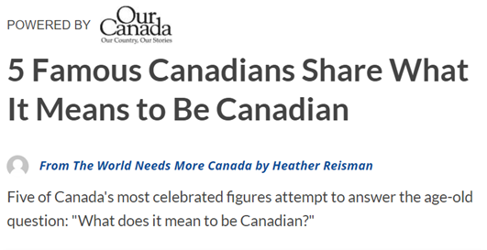
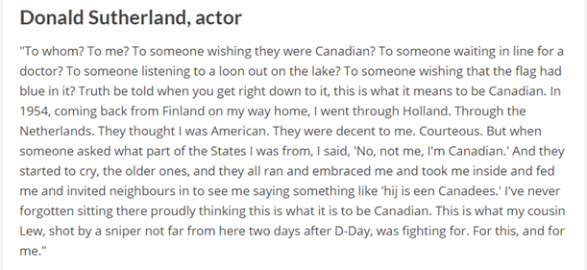

English Language Arts
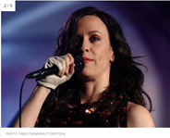
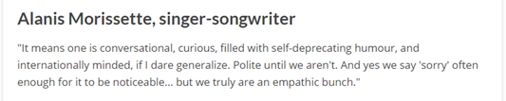
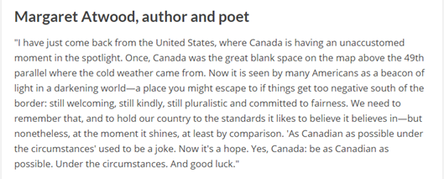
English Language Arts
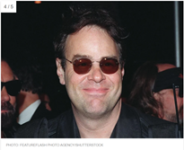
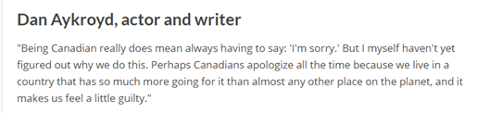
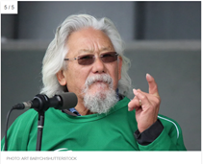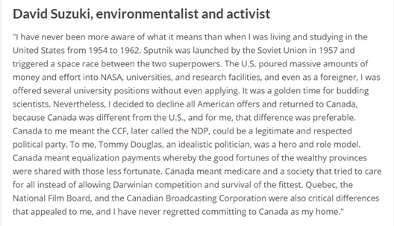

French as a Second Language

Qu’est-ce que je connais sur les commotions cérébrales?

Information for students
Suivre les consignes suivantes:
Écoutez deux fois la capsule vidéo suivante sur les commotions cérébrales : https://safeyoutube.net/w/ippH.
Répondez aux questions qui se retrouvent en annexe.
Vérifiez votre compréhension au sujet des informations présentées dans ce reportage avec la clé de correction fournie.

Materials required
Computer with Internet access
Printer (for the questionnaire)
Scissors
Writing materials

Information for parents
Children should:
watch the video twice (or more, if needed)
answer all questions on a sheet of paper
check their answers with the correction key (held by the parent)
Parents could:
cut the answer part from the questionnaire and keep it
review the answer with the correction key
discuss the answers with the child

French as a Second Language

Annexe : Questionnaire sur les commotions cérébrales et la dépression

Consignes
Répondez aux questions suivantes en lien avec le Reportage intitulé : « Découverte - Commotions cérébrales et dépression ». Écrivez vos réponses sur une feuille mobile.
Vérifiez ensuite vos réponses avec la clé de correction.

Questionnaire
- Nommez deux sports dans lesquels il est fréquent de constater des commotions cérébrales.
- Identifiez deux symptômes ressentis suite à une commotion cérébrale.
- Quel est le pourcentage pour ceux ayant subi un choc à la tête de souffrir de dépression ?
- Pour quelle raison les joueurs de football de McGill passent-ils une IRM en début de saison ?
- Quelle manifestation similaire y a-t-il entre une personne dépressive et une ayant subi une commotion ?
- Combien de temps le cerveau prend-il pour récupérer ?
- Compléter la phrase suivante :
« Plus une personne a eu de commotions cérébrales dans sa vie, plus ... »

For Parents : CUT HERE
____________________________________________________________________
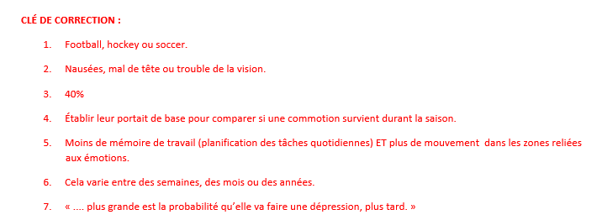

Mathematics

Cylinders, Cones and Spheres

Information for students
In this activity, you will use what you know about various solids to find their volume or their dimensions from their volume. You will also apply your understanding of volume to analyze different problems.

Instructions
Read each problem in Appendix A – Volume of Solids
Solve each problem one at a time
Show all your work to justify your reasoning. You may find it helpful to draw sketches of the problems

Materials required
Appendix A
Writing materials
Calculator

Information for parents

About the activity
Children could:
complete the activity on their own
refer to various sources to review the formulas for the volume of cylinders, cones and spheres (class notes, textbooks, Internet sources, etc.)
Parents should:
help their child organize the required materials, if necessary
read the instructions to their child, if necessary
have their child explain how they went about solving each problem
consider asking their child to solve only some of the problems, not all of them, especially if they are struggling
review the solutions to the problems with their child, which can be found in Appendix B

Mathematics

Appendix A – Volume of Solids

Information for students

Instructions
Read each problem in Appendix A – Volume of Solids
Solve each problem one at a time
Show all your work to justify your reasoning. You may find it helpful to draw sketches of the problems
Problem A
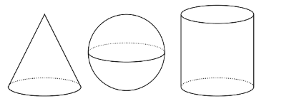

Here are a cone, a sphere and a cylinder that all have the same radii and heights. The radius of the cylinder is 5 units. When necessary, express all answers in terms of π.
- What is the height of the cylinder?

- What is the volume of the cylinder?
- What is the volume of the cone?
- What is the volume of the sphere?
- How are the 3 volumes related? Explain your reasoning.

Mathematics
Problem B
A movie theatre offers two containers of popcorn:
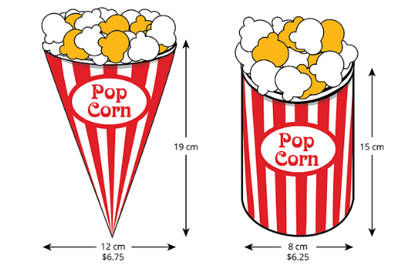
- Which container is a better value? Use 3.14 as an approximation of π
- Do you think your volume calculations overestimate or underestimate the amount of popcorn each container holds?
- Why do you think movie theatres charge more for the cone?
- Do you think a lot of people would buy the cone rather than the cylinder?
Problem C
Noah and Lin are making paper cones to hold popcorn that will be given out at parents’ night. They want the cones to hold 18π cubic centimetres of popcorn. What are two different possible values for the height and the radius of the cone?

Mathematics
Problem D
Some information is given about each of the following spheres. List them in order, from the one with the smallest volume to the one with the largest volume. Sketch the spheres to help you visualize. Explain your reasoning.
Sphere A: Has a radius of 4
Sphere B: Has a diameter of 6
Sphere C: Has a volume of 64π
Sphere D: Has a radius double that of sphere B

Problem E

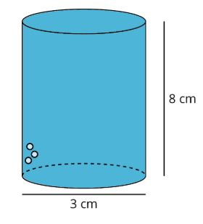

A cylinder with a diameter of 3 cm and a height of 8 cm is filled with water. Decide which figures described below, if any, could hold all the water from the cylinder. Explain your reasoning.
- Cone with a height of 8 cm and a radius of 3 cm
- Cylinder with a diameter of 6 cm and height of 2 cm
- Rectangular prism with a length of 3 cm, a width of 4 cm and height of 8 cm
- Sphere with a radius of 2 cm

Mathematics

Appendix B – Solutions

Information for students
Problem A:
- 10 units. The top of the sphere touches the top of the cylinder, so the diameter of the sphere is the height of the cylinder
- $250π$ cubic units because $V=π5^{5} × 10$
- $\frac{250}{3}π$ cubic units because $V=\frac{1}{3} π5^{2}× 10$
- $\frac{500}{3}π$ cubic units. Answers vary. Sample response: Subtracting the volume of the cone from the volume of the cylinder gives you the volume of the sphere. Therefore, the volume of the sphere is $\frac{500}{3}π$cubic units because $250π – \frac{250}{3}π = \frac{500}{3}π$
Problem B:
- The cylindrical container is a better value. The cone’s volume is about 715.92 cubic centimetres. With the conical container, you get about 106.07 cubic centimetres per dollar ($715.92÷6.75 ≈ 106.07$). The cylinder’s volume is about 753.6 cubic centimetres. The cylindrical container gives you about 120.58 cubic centimetres per dollar ($753.6÷6.25 ≈ 120.58$). Since the cylinder gives you more volume per dollar, it is a better value
- Answers will vary. Sample response: I think the calculations underestimate the amount of popcorn each container holds because the popcorn piles higher than the lip of the container
- Answers will vary. Sample response: Some people may think the cone has a greater volume, since it has a larger diameter and height. It may be easier to place in a cup holder
- Answers will vary. Sample response: Yes, the 50-cent difference is not a lot, and since it is taller and wider, people may think the cone is bigger. Although the cylinder is a better value, there may be other considerations like how easy it is to hold the cone or to put it in the cup holder in the seat, or whether you have time in line to calculate the actual value

Mathematics
Problem C:
Answers vary. Sample responses:
A radius of 3 cm and a height of 6 cm, since $\frac{1}{3}π∙3^{2}∙6=18π$
A radius of 2 cm and a height of 13.5 cm, since $\frac{1}{3}π∙2^{2}∙13.5=18π$
Problem D:
B, C, A, D
Sphere A: Has a radius of 4, so its volume is $\frac{256}{3}π$.
Sphere B: Has a diameter of 6, so its radius is 3, and its volume is $36π$.
Sphere C: Has a volume of $64π$.
Sphere D: Has a radius twice that of Sphere B, so its radius is 6, and its volume is $288π$.
Problem E:
The cone, cylinder and rectangular prism can hold the water. The sphere cannot. Explanations vary. Sample responses could include:
The volume of the given cylinder is 18π, or around 56.5 cubic centimetres
($V=π{\left(\frac{3}{2}\right)}^{2}\left(8\right)=π (\frac{9}{4})(8) = 18π$).
- Cone: $V=\frac{1}{3}π\left(3^{2}\right)\left(8\right)=\frac{1}{3}π\left(9\right)\left(8\right)=24π$. Since the volume is greater than $18π$, the cone can hold the water
- Cylinder: $V=π\left(3^{2}\right)\left(2\right)=π\left(9\right)\left(2\right)=18π$. Since the volume is equal to $18π$, the cylinder can hold the water
- Rectangular prism: $V=(3)(4)(8)=96$. Since the volume is greater than $56.6$, the rectangular prism can hold the water
- Sphere: $V=\frac{4}{3}π\left(2^{3}\right)=\frac{4}{3}π\left(8\right)=\frac{20}{3}π$. Since the volume is less than $18π$, the sphere cannot hold the water

Science and Technology

Snack Attack

Information for students
What do you reach for when you want a snack? In this activity, you will evaluate the nutritional value of the foods in your home that you might choose to snack on. Then you will plan what snacks to pack for a challenging hike.

Instructions
Complete the tasks provided in the Appendix

Materials required
Textbook and/or device with Internet access
Appendix
7-10 examples of foods with nutritional labels

Information for parents

About the activity
Children should:
analyze the nutritional value of different foods
consult information in their textbooks or in Canada’s Food Guide to help them answer the questions
Parents could:
encourage independent research
discuss the answers with their child
help their child find examples of foods with food labels

Science & Technology

Appendix – Snack Attack

What is the nutritional value of your snacks?
Nutrients
The snacks you eat may contain a variety of nutrients that your body needs to function. Different snacks may contain different nutrients.
The six types of nutrients are fats, carbohydrates, protein, vitamins, minerals, and water.
What is the role (biological function) of each of these nutrients in the human body? Use your textbook or do some research online to find out
Evaluating the nutritional value of foods
The energy and nutritional value of foods can be evaluated by using food labels. A food label is shown below.
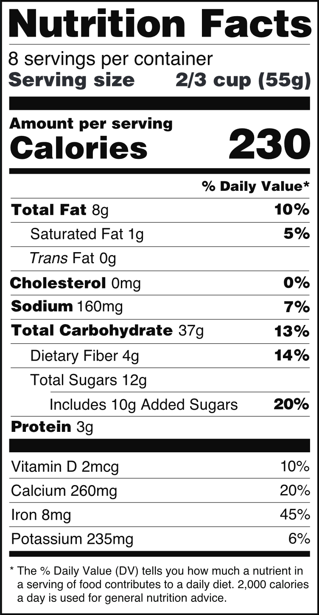
The food label provides information on serving size, calories, and the nutrients in the food
The % Daily Value, or %DV, is used to indicate how much of a nutrient a serving of the food contains. According to Canada’s Food Guide:
- 5% DV or less is a little
- 15% DV or more is a lot
You can use the information on food labels to help you make informed choices about what you eat. This includes choosing foods based on the nutrients they contain

Science & Technology
- Follow the instructions on the next page to evaluate the nutritional value of your snacks
- Find 7-10 different packaged foods that you might eat as a snack in your home. Use the nutrient facts label to help you answer the questions below
- How many grams of fats, carbohydrates and protein does each serving contain?
- What do you notice about the vitamins and minerals?
You may find it useful to organize the information in a table as shown below.
Food | Fat (g) | Carbohydrates (g) | Protein (g) | What do you notice about the vitamins and minerals?

Note: You can find the nutrition facts for some foods online if you are interested in finding out about foods that you do not have in your home.
- Now that you have collected the information on the different foods, answer the questions below
- Did you notice any trends for the nutrient facts of the foods? For example, did certain types of food have more protein or more carbohydrates? Is there anything else you noticed?
- Did anything about the nutritional value of the foods surprise you?

- Which 3 of the foods that you analyzed do you think have the best nutritional value? Which of the foods that you analyzed do you think has the least value nutritionally?
The information on this Website on healthy eating from Canada’s Food Guide might help you decide
- What criteria did you use to decide?
- Was it difficult to choose? Why or why not?
- Do you think different people with different needs might answer this question differently? Why or why not?
- You are planning a hike in the mountains on your favorite trail. This 10 km hike is rated as difficult and will take about 5 hours to complete
What could you pack as snacks for the hike? Justify your answer by referring to the biological function of the different nutrients in your choices

Physical Education and Health

The Importance of Mindfulness

Information for students
Activity 1: Practicing mindfulness
Watch the following video to learn about the importance of Mindfulness:
- Video: Why Mindfulness is the New Superpower – Featuring Dan Harris
Read through the following infographic for daily mindfulness practices:
- Infographic: Making Mindfulness a Way of Life and Work
What did you learn from the video? Why is it important to practice mindfulness? Do you think you could find one thing to be mindful about during your day? What would that be?
Discuss what you learned about mindfulness with a member of your family
Activity 2: Yoga for mindfulness
Try the exercises in the following video:
- Video: 10 Minute Morning Yoga for All Levels
- If necessary, adapt the movements to your abilities

Materials required
Device with Internet access

Information for parents

About the activity
Children should:
learn about the importance of mindfulness
practice mindfulness
try the yoga workout
Parents could:
support their children by asking them what they have learned about mindfulness
support their children by practicing mindfulness with them
support their children by doing the workout with them or encourage them be more autonomous during the activity

Arts

The Writing’s on the Wall

Information for students
Inspired by an activity created by the Musée de la civilisation à Québec, explore the origins of rock art and discover other forms of art that occupy our public spaces today.
Rock art can be described as art created by hand using natural surfaces as a canvas, specifically drawings or paintings on stone
It can be traced back to the prehistoric times as a tool of expression and the opportunity to pass on a message or one’s history. An example of a prehistoric cave painting of animals from Spain can be found in Example #1 in the appendix
Rock art can be found in Canada, as seen in Example #2 in the Appendix
As civilizations began to evolve, along with changes in tools and innovations, the styles of art changed too. For example, instead of using rock and nature, the side of a building or wall has become the canvas. Around cities, you can see the history and the present being displayed on murals. Example #3 in the appendix showcases the mural “Fresque des Québécois” in Old Quebec, which shows the history of the city
In addition to the three examples provided, take the time to discover other types of wall art, including graffiti art, yarn bombing, and sculptures in an outdoor space
As a challenge, you can try to create your own variation at home. Make sure you have permission to use the space/canvas/materials

Materials required
Device with Internet access
Paper, writing, and drawing materials
Art materials (if necessary)
Music and/or instruments (if necessary)
Space to move and create (if necessary)
iPod, CD player or Bluetooth speakers

Arts

Information for parents

About the activity
The original idea for the activity can be found at https://imagesdanslapierre.mcq.org/en/rock-art-in-class/lets-create-on-stone/
Children should:
view the examples listed in the appendix
visit https://imagesdanslapierre.mcq.org/en/rock-art-in-class/lets-create-on-stone/ for additional examples of rock art
visit https://www.quebec-cite.com/en/quebec-city/murals-of-the-city for additional examples of murals
Parents could:
view the examples listed in the appendix (and suggested websites)
have a discussion with their child on their thoughts about the works of art

Arts

Appendix: The Writing’s on the Wall

Examples of art
Example 1: Prehistoric cave painting of animals at Albarracín, Teruel, Spain (Rock art in the Iberian Mediterranean basin)
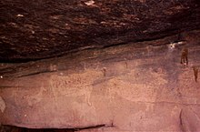

Source: https://commons.wikimedia.org/wiki/File:Rock_art_bull.jpg

Arts
Example 2:“Hell’s Gate: A Red Ochre Quarry Along the Mattawa River (Ontario), A Major Waterway Across the Canadian Shield”
Source: https://imagesdanslapierre.mcq.org/en/discover/how/
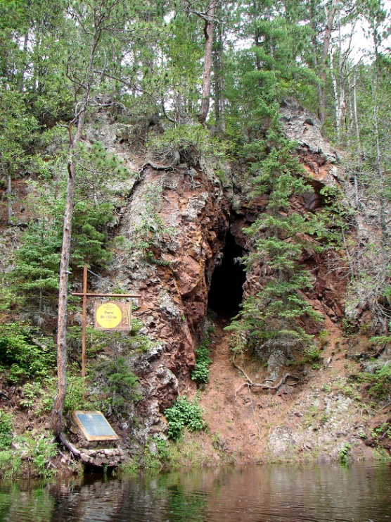
Arts
Example 3: “Fresque des Québécois”
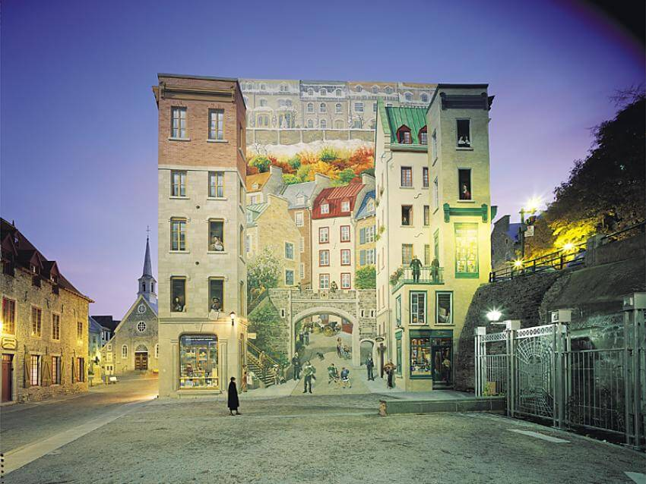
Source: https://www.quebec-cite.com/en/quebec-city/murals-of-the-city

History of Québec and Canada

1760-1791 – The American Revolution (1765-1783)

Information for students
In the midst of the American Revolution, the Thirteen Colonies declared their independence from Great Britain in 1776 and called themselves the United States of America. The Revolution finally came to an end in 1783, with the Americans victorious.
Intellectual operation: Determine causes (explanatory factor) and consequences.
Task: Identify two causes of the American Revolution and two consequences of the American Revolution for the Province of Quebec.
Using the documents in Appendix 1, indicate whether they represent a cause or a consequence by writing the document numbers in the appropriate box
Using the documents as a guide, write a text that explains two causes of the American Revolution and a text outlining two consequences that this revolution had for the province of Quebec
You may use your Reflections.qc.ca textbook, your workbook or the following website to learn more about the American Revolution and its effect on the Province of Quebec: https://www.thecanadianencyclopedia.ca/en/article/american-revolution
Take it to the next level:
Take your analysis further by researching and answering the following question:
- Why did both the Canadiens and the British merchants in the Province of Quebec refuse to join the American insurgents in their fight against the British?

Materials required
Useful resources, depending on personal preferences and availability:
Device with Internet access
Writing materials (paper, pencil, etc.)
Textbook or workbook
History of Québec and Canada

Information for parents

About the activity
Students could:
take their knowledge further by doing the extra activity suggested above
learn more about the American Revolution and its effect on the Province of Quebec by watching the following video: Canada: A People's History - Episode 5 - A Question of Loyalties
Parents should:
help their child to understand the documents, if necessary, and review possible answers with them

History of Québec and Canada

Appendix 1 – Determine Causes and Consequences

Information for students:
Indicate whether the following documents represent a cause of the American Revolution or a consequence for the Province of Quebec by writing the document numbers in the appropriate box on the following page.
Document 2
Document 1
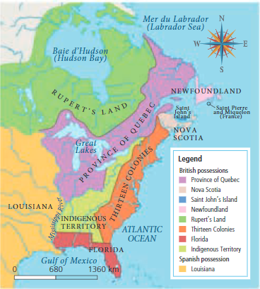
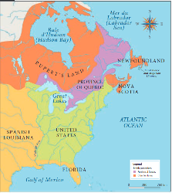

Marie-Andree Courval, Luc Dujardin, andt Guylaine Labonte, Journeys: Origins to 1840, Secondary III (Anjou, Quebec: Les Éditions CEC, 2018), Content Workbook, 160.

Marie-Andree Courval, Luc Dujardin, and Guylaine Labonte, Journeys: Origins to 1840, Secondary III (Anjou, Quebec: Les Éditions CEC, 2018), Content Workbook, 152.

Document 3
Document 4

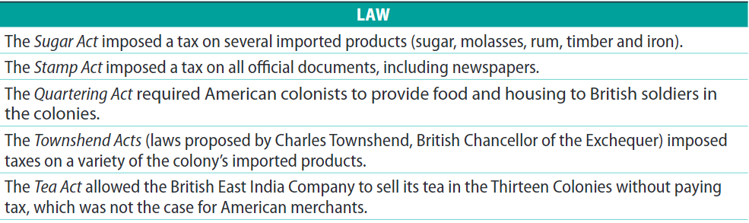
The Province of Quebec received close to 10 000 Loyalists, which caused a sudden increase in the Anglophone population a colony that, until that point, had been predominantly francophone…

Marie-Andree Courval, Luc Dujardin, and Guylaine Labonte, Journeys: Origins to 1840, Secondary III (Anjou, Quebec: Les Éditions CEC, 2018), Content Workbook, 155.

Marie-Andree Courval, Luc Dujardin, and Guylaine Labonte, Journeys: Origins to 1840, Secondary III (Anjou, Quebec: Les Éditions CEC, 2018), Content Workbook, 162.

History of Québec and Canada
Indicate whether the documents represent a cause of the American Revolution or a consequence for the Province of Quebec by writing the document numbers in the appropriate box below.
Causes (Explanatory Factors) of the American Revolution | THE AMERICAN REVOLUTION | Consequences of the American Revolution for Quebec
Using the documents as a guide, write a text that explains two causes of the American Revolution and a text outlining two consequences that this revolution had for the Province of Quebec.
Two Causes (Explanatory Factors) of the American Revolution | THE AMERICAN REVOLUTION | Two Consequences of the American Revolution for Quebec

History of Québec and Canada

Appendix 2 – Answer Key
Indicate whether the documents represent a cause of the American Revolution or a consequence for the Province of Quebec by writing the document numbers in the appropriate box below.
Causes (Explanatory Factors) of the American Revolution | THE AMERICAN REVOLUTION | Consequences of the American Revolution for Quebec
3  2 |  | 4  1
Using the documents as a guide, write a text that explains two causes of the American Revolution and a text outlining two consequences that this revolution had for the Province of Quebec.
Two Causes (Explanatory Factors) of the American Revolution | THE AMERICAN REVOLUTION | Two Consequences of the American Revolution for Quebec
In the 1760s and 1770s, Great Britain imposed a series of taxes on the Thirteen Colonies. The Thirteen Colonies felt that because they had no elected representatives in Parliament, Britain had no right to tax them and so they declared these taxes illegal.  Among the Intolerable Acts imposed by Great Britain, the Thirteen Colonies found the Quebec Act to be the most infuriating because it meant that they were once again denied access to the land in the Ohio Valley and the Western Territories that they so desperately wanted. This land was given to Quebec instead, which made the Thirteen Colonies very angry. |  | The Treaty of Paris in 1783 officially recognized the independence of the United States of America. This treaty took away all of Quebec’s land south of the Great Lakes and granted it to the Americans instead.  During and after the American Revolution, many Americans who remained loyal to Britain left America. Almost 10 000 loyalists settled in Quebec, which caused a large increase in the anglophone population.

All problems adapted from Open-up Resources, accessed May 21, 2020, https://openupresources.org/math-curriculum/6-8-math/
Image: U.S. Food and Drug Administration, FDA Nutrition Facts Label, 2016, PNG, Wikimedia Commons, https://commons.wikimedia.org/wiki/File:FDA_Nutrition_Facts_Label_2016.png

