Weekly Educational Options From the Ministère
secondary III
Week of June 1, 2020
Table of Contents
Connecting Through Poetry 2
Votre gomme est-elle biodégradable? 3
Applying the Pythagorean Theorem 4
Appendix A – Applications of the Pythagorean Theorem 6
Appendix B – Hints 8
Appendix C – Solutions 9
Clear Vision 10
Appendix A – Clear Vision Tasks 11
Appendix B – Selected Answers 15
Poetry as Inspiration 17
https://www.youtube.com/watch?v=qyDEEQoVqjY 20
1760-1791 – Pontiac’s Revolt 24
Appendix 1 – Identify Differences (divergence) 25
Appendix 2 – Answer Key 27

English Language Arts

Connecting Through Poetry
Whenever we read, listen to, or view anything we can enhance our appreciation and deepen our understanding of it by making connections. Today we’ll do this after listening to a poem in a video you may have seen on social media lately. It’s called “The Great Realisation”.
Instructions
Head over to http://www.probablytomfoolery.com/ and prepare to watch the video titled “The Great Realisation”. It’s only four minutes long so it’s easy to watch more than once
For your first viewing just see what sort of impression the poem makes on you. Did you like it? What did it make you think? What did it make you feel? How would you describe the poem and video in one or two words to someone who hasn’t seen it?
For your second viewing think about making connections. Here are a series of questions you can use to get you thinking:
- Can you personally relate to anything expressed in the poem and video?
- How did you feel about life before the shutdown?
- How do you feel during it?
- What do you imagine life will be like after it’s all over?
- Is any of what the poet expresses similar to your experiences, thoughts, and feelings. How so?
- Does anything in this poem remind you of other things you’ve read about or watched or seen happening in the world? How are they connected? How are they similar or different?
After thinking about these questions, put your thoughts and feelings into words. You can do this through discussion with family members and/or by writing. These processes force you to deepen and clarify your understanding of ideas, yours or someone else’s.

Materials required
Device or other tools for writing
Device with Internet access for watching the video

Information for parents
Parents could:
allow their child to talk with them about the poem and video while keeping the questions in mind. Talking helps students process their thoughts and feelings. It also helps them develop critical thinking about what they see, read, and learn
offer to read what their child wrote for further discussion

French as a Second Language

Votre gomme est-elle biodégradable?

Information for students
Objectif de l’activité : comprendre des textes vus et entendus en français. (transcription disponible)
Durée : 1 heure
Déroulement de l’activité :
- Visionnez le documentaire en cliquant sur le lien suivant. Vous pouvez lire la transcription fournie, si nécessaire:
https://apprendre.tv5monde.com/fr/exercices/b1-intermediaire/mexique-un-chewing-gum-biodegradable
- Répondez aux questions de compréhension et de vocabulaire. Les réponses sont fournies à la fin de chaque exercice.
Pour aller plus loin (3 heures)
Écrivez un texte de 175 mots, dans lequel vous:
- Décrivez l’initiative prise par Jesus Manuel Aldrete ;
- Exprimez ce que vous pensez de cette initiative et expliquez pourquoi vous pensez que c’est une initiative importante ou pas.

Materials required
Accès à Internet
Papier, matériel pour écrire (pour la troisième activité Pour aller plus loin), dictionnaire anglais-français

Information for parents
Children could:
watch a short documentary film in French
discuss the content of the documentary in French
Parents should:
read the instructions with their children
share their opinion about the documentary with their children
ask their children to read their final text to them (only for the Pour aller plus loin activity)

Mathematics

Applying the Pythagorean Theorem

Information for students
This task will help strengthen your understanding of the Pythagorean Theorem as you will be applying it in different contexts.
Instructions
- Read each problem presented in Appendix A – Applications of the Pythagorean Theorem
- Solve each problem one at a time. Refer to the hints provided in Appendix B when needed

Materials required
Appendix A – Applications of the Pythagorean Theorem
Writing materials
Calculator

Mathematics

Information for parents

About the activity
Children should:
complete the activity on their own
refer to various sources to review the Pythagorean Theorem (class notes, textbooks, internet sources, etc.)
Parents could:
help the children organize the required materials, if necessary
read the instructions to the children, if necessary
have the children explain how they went about solving each problem
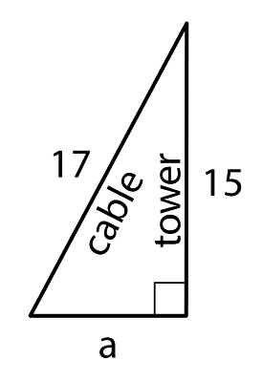
share the following information about the Pythagorean Theorem with the children, if necessary:
- the Pythagorean Theorem can be used to solve any problem that can be depicted with a right triangle where the lengths of two sides are known and the length of the third side needs to be determined
- for example, let’s say a cable is being installed to a support a tower. It is a 17 m cable, and the cable should run from the ground to the top of a 15 m the tower (see image on the right.) How far away from the foot of the tower should the bottom end of the cable be located?
- it is assumed that the tower makes a right angle with the ground. Since this is a right triangle, the relationship between its sides is $a^{2}+b^{2}=c^{2}$, where $c$ represents the length of the hypotenuse and $a$ and $b$ represent the lengths of the other two sides. The hypotenuse is the side opposite the right angle. Substituting the given information for b and c in the equation, we get $a^{2}+{15}^{2}={17}^{2}$. Solving this equation to find the value of a, we get $a=8$. The bottom end of the cable should be located 8 metres away from the foot of the tower
The solutions to the problems can be found in Appendix C.

Mathematics

Appendix A – Applications of the Pythagorean Theorem

Information for students
This task will help strengthen your understanding of the Pythagorean Theorem as you will be applying it in different contexts.
Instructions
- Read each problem below
- Solve each problem one at a time. Refer to the hints provided in Appendix B, when needed
Problem 1
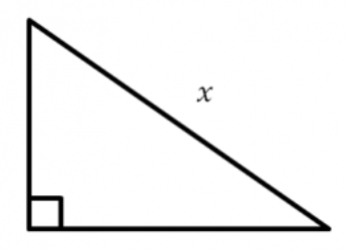
What could the lengths of the legs be if the lengths must be integers and x must be an irrational number between 5 and 7? Try to find at least two possible solutions.

Mathematics
Problem 2
Mai and Tyler were at one corner of a large rectangular field and decided to race to the opposite corner. Since Mai had a bike and Tyler did not, they thought it would be a fairer race if Mai rode along the sidewalk that surrounds the field, while Tyler ran the shorter distance directly across the field. The field is 100 metres long and 80 metres wide. Tyler can run at around 5 metres per second, and Mai can ride her bike at around 7.5 metres per second.
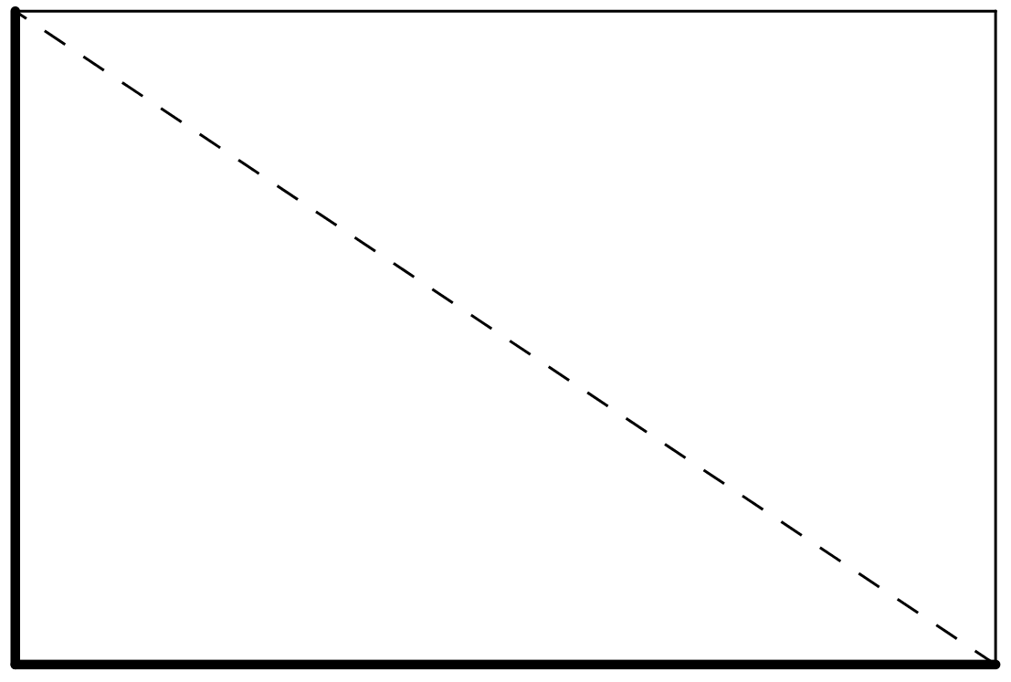
- Before doing any calculations, who do you think will win? By how much? Explain your thinking
- Who wins? Show your reasoning. How accurate was your prediction?
- If you could give the loser of the race a head start, how much time would they need in order for both people to arrive at the same time?
- If you could make the winner go slower, how slow would they need to go in order for both people to arrive at the same time?
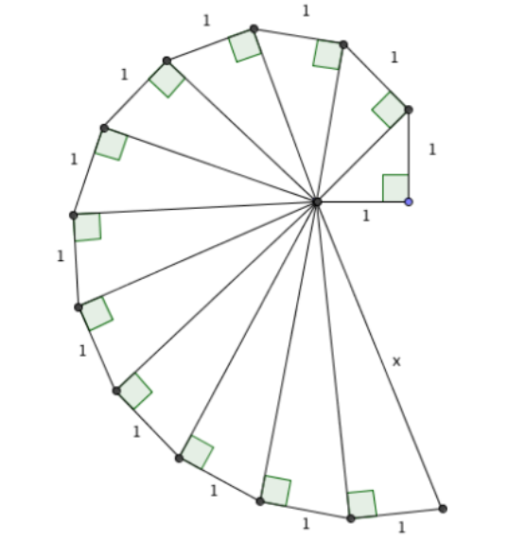
Problem 3
Find the length of side x in the diagram.

Mathematics

Appendix B – Hints
Problem 1:
What is a wrong answer? How can you use this wrong answer to move towards an answer?
What does it mean when we say that a number between 5 and 7 is irrational?
An irrational number is a number that cannot be expressed as a fraction. For example, the square root of 2 is an irrational number because it cannot be written as a fraction
Problem 2:
Use your knowledge of the Pythagorean Theorem and of rates and ratios to solve the problem.
$$\frac{Distance Travelled}{Time}=Speed$$
Problem 3:
What pattern do you see? Can you use the pattern to find the value of x?
Mathematics

Appendix C – Solutions
Problem 1:
Here are the possible lengths of the legs
3 and 5
3 and 6
4 and 4
4 and 5
2 and 5
2 and 6
1 and 5
1 and 6
Problem 2:
- Answers will vary
- Mai wins. Mai has 180 metres to travel. At 7.5 metres per second, it will take her 24 seconds, since $\frac{180}{7.5}=24$. According to the Pythagorean Theorem, Tyler travels $\sqrt{16 400}$ metres. At 5 metres per second, it will take him approximately 25.6 seconds, since $\frac{\sqrt{16 400}}{5}≈25.6$
- Mai beats Tyler to the opposite corner by about 1.6 seconds. Tyler needs a head start of roughly 1.7 seconds to beat Mai
- About 7 metres per second. If Mai goes 7 metres per second, then she will finish the race in $\frac{180}{7}≈25.7$seconds. She will lose to Tyler by a fraction of a second.
Problem 3:
x is equal to $\sqrt{13}$

Science and Technology

Clear Vision

Information for students
This week, you will take a closer look at how humans are able to see. Complete the tasks in Appendix A to learn more about the visual system. After you have completed the tasks in Appendix A, you will be able to explain how the eye functions in order to see and how lenses can improve the clarity of images.

Materials required
Text book and/or device with Internet access
Appendix A
Flat mirror
Metal spoon
Glass or jar (circular)
Water
Paper, pencil/pens, markers

Information for parents

About the activity
The activity on page 3 can be done on the computer (colour). Otherwise the activities can be done on a paper copy. Some of the activities are meant to be hands-on.
Children should:
- watch the following videos to review the visual system
- https://www.youtube.com/watch?v=i3_n3Ibfn1c
- https://www.youtube.com/watch?v=hsh2kPdgazo
Parents could:
- encourage independent research. Some answers are provided in Appendix B, but not all. Students can use textbooks, notes or online research to complete the tasks

Science and Technology

Appendix A – Clear Vision Tasks

Anatomy of the Eye
Research the anatomy of the eye in your textbook or online.
- Draw a diagram of the human eye and label the following parts: iris, cornea, lens, retina, vitreous humor and optic nerve
- Describe the function of each of the following parts of the eye:
- Iris
- Cornea
- Lens
- Retina
- Vitreous humor
- Optic nerve
- Without light, we would not see anything. Explain the role of light in our ability to see objects

Science and Technology

The Blind Spot and the Visual System
- Did you know you had a blind spot? The retina of the eye is lined with photoreceptors, rods and cones. Describe the role of these specialized cells
- Locating a blind spot: (an area where an image is unseen)
Part 1: Position your head to look straight at the image below
- Cover your left eye, and look at the star with your right eye
- Move closer to the screen/paper. There will be a moment when the circle disappears. This is the blind spot of your right eye
- Cover your right eye, and look at the circle with your left eye
- Move closer to the screen/paper until the star disappears. This is the blind spot of your left eye

Part 2: Repeat the same steps with the image below. What do you notice?

Visual system: The eye and the brain work together as a system. When the reflected light projects on the blind spot of the retina, the shape will disappear and the brain will fill in the gap with the surrounding color.
Science and Technology

Reflected Images
Mirrors reflect light so images can be seen that are not in our direct line of sight.
- Images in a flat (plane) mirror
- Stand directly in front of a plane mirror. Look straight ahead and describe the area in which objects can be seen (field of vision)
- Take on step to the right. Describe your new field of vision
- Take two steps to the left. Describe your new field of vision
In the diagram below, where could a person stand to view X in the mirror?
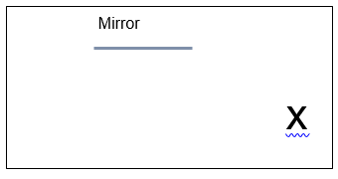
- Images in a curved mirror
Take a metal spoon, as large as possible.
- Look at the concave side of the spoon (curves away from you). What do you notice about the image? Give an example of how concave mirrors are used in everyday life.
- Look at the convex side (curves toward you). What do you notice about the image? Give an example of how convex mirrors are used in everyday life
Science and Technology

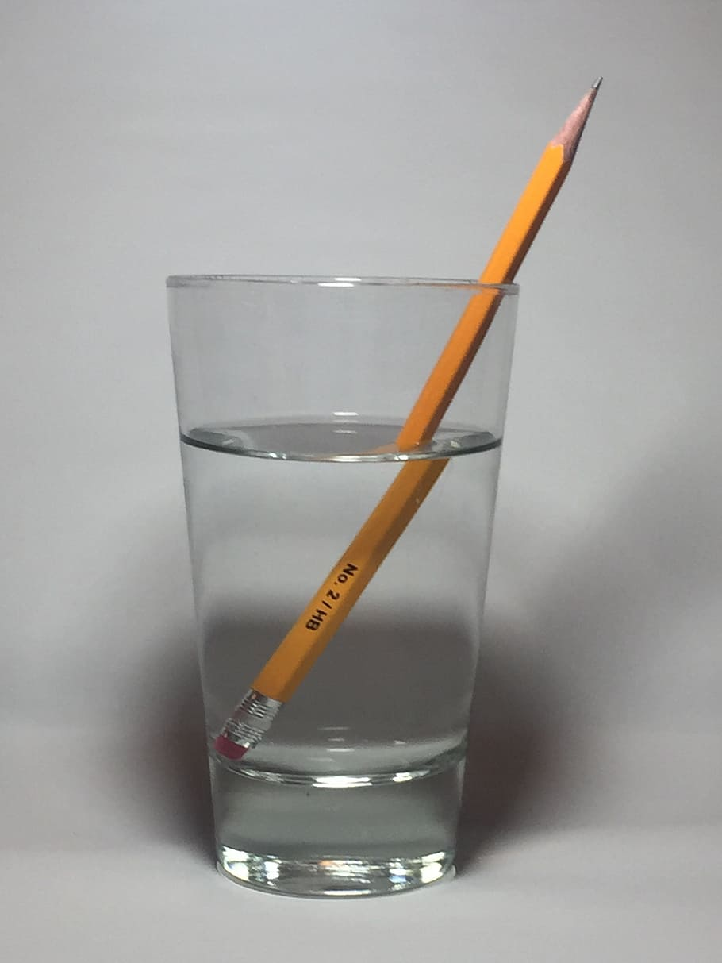
Lenses
- Fill a glass with water and put a straw or a pencil in the glass
What do you notice?
Draw two arrows (see image below) on a piece of paper or on an index card approximately 10 cm x 20 cm.
Place the image 20 cm behind an empty circular shaped glass, similar to the one shown above. (A square mason jar or square shaped glass may not work.)
Fill the glass with water. Look at the image through the glass
What do you notice about the image?
Repeat with a colourful image like the one shown below on the right
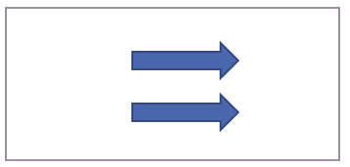
- Research and explain the concept of refraction

Putting It All Together
Knowing how the vision system works, describe how eyeglasses, also known as corrective lenses, make it possible to help a person who has myopia see clearly. Myopia is a common vision condition in which close objects can be seen clearly, but distant objects appear blurry. (You may have to do a little more research to answer this question.)
Science and Technology

Appendix B – Selected Answers

Anatomy of the Eye
To answer questions 1-3 on page 2, refer to your textbook, notes or online resources.

The Blind Spot and the Visual System
The retina lines the back of the eye and contains specializes cells called photoreceptors that respond to light. There are 120 million rods in the human retina. They are sensitive to light and dark, shapes and movement. There are “only” 6 million cones and these photoreceptors are responsible for seeing colour and fine details. They need more light to function well.

Reflected Images
- Flat mirror
If someone stands in the grey area, they should be able to see the X. Any answer in the grey area would be correct.
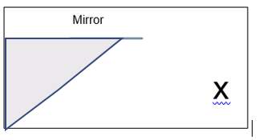
- Images in a curved mirror
Possible answers for concave mirrors
The image is upside down except when the spoon is held very close. The image is enlarged when the spoon is held close. Concave mirrors are used in cars; there is a concave mirror behind the headlight to help focus the light on the road. They can be used to magnify images. Some people use them to see their eyes when they put contact lenses on, when they shave, when they put makeup on, etc.
Possible answers for convex mirrors
The image is right side up. I notice that I can see more of the area behind me (greater field of vision). Convex mirrors are used in car parking lots so that drivers can see if there is anything around the corner. They are also used as passenger side mirrors of cars, where they increase the field of vision. You might notice the warning, “Objects in mirror are closer than they appear.” Convex mirrors are also used in some telescopes.
Science and Technology

Putting It All Together
Myopia is caused by the lens in the human eye forming an image (of a distant object) in front of the retina instead of on the retina. The retina acts like a screen, but the image is blurry, not focused. Lenses bend the light so that the image appears further back on the retina and the image is focused and clear.
For more detail, visit The Physics Classroom:
https://www.physicsclassroom.com/class/refrn/Lesson-6/Nearsightedness-and-its-Correction

Arts

Poetry as Inspiration

Information for students
“Painting is poetry that is seen rather than felt, and poetry is painting that is felt rather than seen.” – Leonardo da Vinci
Inspiration can be found in many shapes and forms. One genre that has served as a muse to performing arts and visual arts is poetry
Take a look at how poetry has influenced dance, drama, music and visual arts by completing this activity
On the following pages are four different examples that showcase how poetry has influenced each specific work. Here are some questions to consider before, during, and after your observation and appreciation of the dance, drama, music, and visual arts works:
- What is the meaning of the poem?
- What emotions does this poem evoke?
- What is your first impression of the work?
- Does performance or artwork change your interpretation of the poem?
- Do you think the performance enhances or hinders the poetry?
Feel free to jot down your ideas in a journal
You are encouraged to look at all four examples or go directly to the discipline of your choice via the link: dance, drama, music, and visual arts
After you’ve analyzed the various works, create or adapt your own work of art inspired by a poem of your choice!

Arts

Dance
Sir Kenneth MacMillan choreographed the ballet “Song of the Earth” in 1965. The ballet’s music is Gustav Mahler’s composition of the same name, set to German poet Hans Bethge’s adaptation and translation of 7th and 8th century Tang Dynasty poetry!
Here is an excerpt from the sixth movement of “Song of the Earth”:

Der Abschied
Der Bach singt voller Wohllaut durch dasDunkel.
Die Blumen blassen im Dämmerschein.
Die Erde atmet voll von Ruh und Schlaf,
Alle Sehnsucht will nun träumen.
Die müden Menschen gehn heimwärts,
Um im Schlaf vergeßnes Glück
Und Jugend neu zu lernen!
Die Vögel hocken still in ihren Zweigen.
Die Welt schläft ein!
Hans Bethge

The Farewell
The brook sings loudly through the darkness.
The flowers stand out palely in the twilight.
The earth breathes, full of peace and sleep,
and all yearning wishes to dream now.
Weary men go home,
to learn in sleep
forgotten happiness and youth.
The birds crouch silently in their branches.
The world is asleep!
Translation copyright © by Emily Ezust, from the LiederNet Archive -- https://www.lieder.net
Arts

Here is an excerpt of the English National Ballet performing “Song of the Earth” | This video features the Royal Opera Ballet rehearsing a portion of the sixth movement
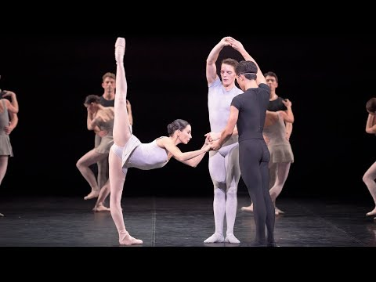  https://www.youtube.com/watch?v=oxyYHRqpCLw | https://www.youtube.com/watch?v=lQMLZJXUDi8
For additional information on MacMillan and “Song of the Earth”, please refer to this link.
(https://www.kennethmacmillan.com/new-page-28)
Arts

Dramatic Arts
When You Are Old
When you are old and grey and full of sleep,
And nodding by the fire, take down this book,
And slowly read, and dream of the soft look
Your eyes had once, and of their shadows deep;
How many loved your moments of glad grace,
And loved your beauty with love false or true,
But one man loved the pilgrim soul in you,
And loved the sorrows of your changing face;
And bending down beside the glowing bars,
Murmur, a little sadly, how Love fled
And paced upon the mountains overhead
And hid his face amid a crowd of stars.
W.B. Yeats
The Irish poet William Butler Yeats wrote the poem “When You Are Old” in 1893. Many years later, Australian playwright Jessica Bellamy adapted the poem into the monologue “Little Love” for the Australian Theatre for Young People (ATYP). This in turn became the short film called Bat Eyes, which you can see here:
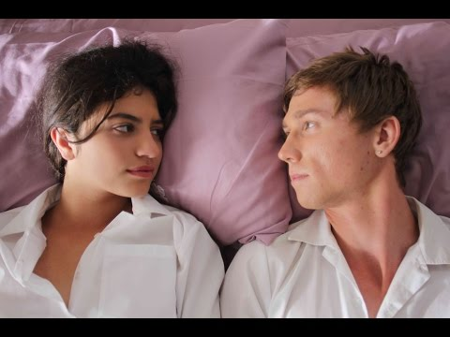

https://www.youtube.com/watch?v=qyDEEQoVqjY

Arts

Music
Baroque composer Antonio Vivaldi composed the music and it is believed that he also wrote the sonnets for his violin concerti “The Four Seasons”. There is debate as to which component was created first but it is certain that the story of the poem can be heard in the music. This idea is known as programmatic music.
As you listen to this excerpt from “Spring”, try to follow along simultaneously with the poem.
La Primavera | Spring
Allegro  Giunt' è la Primavera e festosetti  La Salutan gl' Augei con lieto canto,  E i fonti allo Spirar de' Zeffiretti  Con dolce mormorio Scorrono intanto:  Vengon' coprendo l' aer di nero amanto  E Lampi, e tuoni ad annuntiarla eletti  Indi tacendo questi, gl' Augelletti;  Tornan' di nuovo al lor canoro incanto:  Largo  E quindi sul fiorito ameno prato  Al caro mormorio di fronde e piante  Dorme 'l Caprar col fido can' à lato.  Allegro  Di pastoral Zampogna al suon festante  Danzan Ninfe e Pastor nel tetto amato  Di primavera all' apparir brillante. | Allegro  Springtime is upon us.  The birds celebrate her return with festive song,  and murmuring streams are  softly caressed by the breezes.  Thunderstorms, those heralds of Spring, roar,  casting their dark mantle over heaven,  Then they die away to silence,  and the birds take up their charming songs once more.  Largo  On the flower-strewn meadow, with leafy branches  rustling overhead, the goat-herd sleeps,  his faithful dog beside him.  Allegro  Led by the festive sound of rustic bagpipes,  nymphs and shepherds lightly dance  beneath the brilliant canopy of spring.  Source: The Four Seasons Sonnets
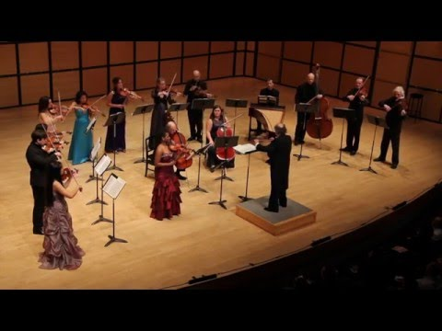

https://www.youtube.com/watch?v=9h1jDLHh1DQ

Arts

Visual Arts
Here are several examples of paintings inspired by the 1842 poem “The Lady of Shalott”, by Alfred Tennyson.
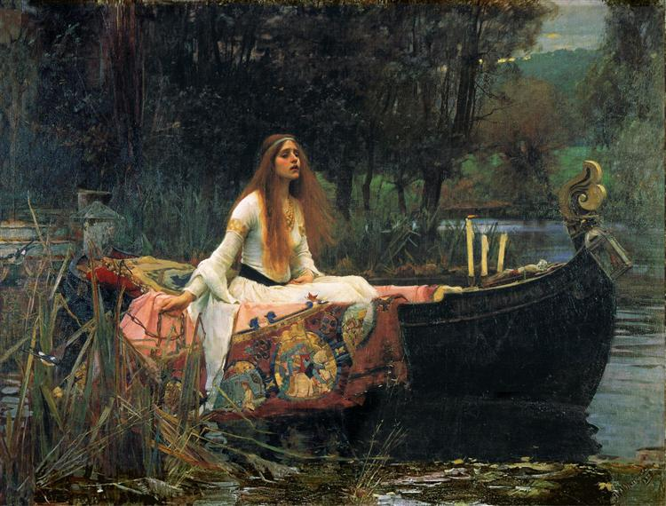 | 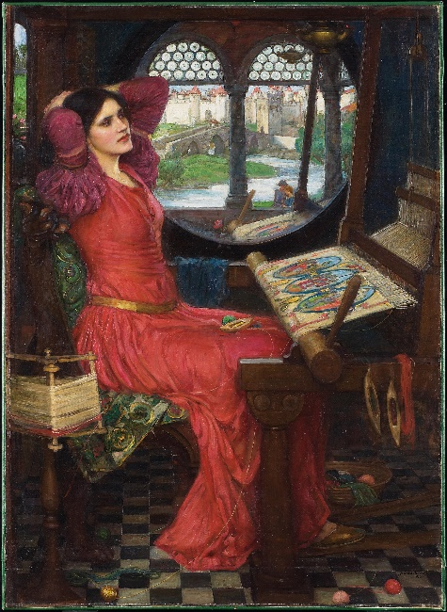
“The Lady of Shalott” by John William Waterhouse (1888) | “I Am Half-Sick of Shadows, Said the Lady of Shalott” by John William Waterhouse (1915)

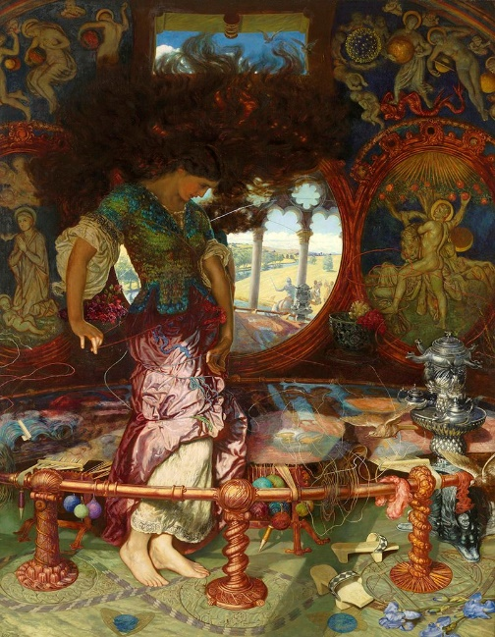
The Lady of Shalott by William Holman Hunt (1905)

Arts

Materials required
Device with Internet access
Paper, writing and drawing materials
Art materials (if necessary)
Variety of poems
Music (if necessary)
Instruments (if necessary)
Space to move and create
iPod, CD player or Bluetooth speakers

Information for parents
have a discussion with your child about brainstorm ideas throughout the process
act as an audience member for their performance or exhibit

History of Québec and Canada

1760-1791 – Pontiac’s Revolt

Information for students
The study of history can be complicated. While facts and dates are difficult to dispute, perceptions of historical events can vary.
Intellectual operation: Identify differences and similarities.
Task: Identify the point of divergence between the points of view. In other words, indicate how two positions are different.
Following the change of Empire, Pontiac, chief of the Odawa Nation, led a revolt against the British
- Using the document in Appendix 1, outline the points of view of Sir William Johnson (British superintendent of Indian Affairs) and Pontiac, chief of the Odawa Nation, in the table provided
- Using your outlines, identify a specific point on which these two historical figures disagree
- You may use your textbook, workbook or the following website to learn more about Pontiac’s Revolt: https://www.thecanadianencyclopedia.ca/en/article/pontiacs-war-feature
Take it to the next level:
take your analysis further by researching and answering the following questions:
- the Royal Proclamation recognized the territorial rights of Indigenous peoples. Indicate one major cause and one major consequence of this event

Materials required
Useful resources, depending on personal preferences and availability:
device with Internet access
writing materials (paper, pencil, etc.)
textbook or workbook

Information for parents
Students could:
add to their knowledge by doing the extra activity suggested above
learn more about the early history of the Province of Québec by watching the following video: Canada: A People's History - Episode 4 - Battle for a Continent
Parents should:
help with the language used in the documents and review potential answers with their child
History of Québec and Canada

Appendix 1 – Identify Differences (divergence)

Information for students:
Read the documents and complete the table that follows.
Document 1
“Your lordship may please to observe by my letter before mentioned that I therein, represented the jealousy which the Indians in general entertained of the increasing power of the English…In 1761, I had in a great measure removed these prejudices at the Conference which I then held with the Ottawa Confederacy at the Detroit and delivered them a handsome present…but as the Nations are Warlike, numerous and accustomed to receive considerable gifts and good treatment from the French for permitting them to occupy several posts…which custom I was in no wise enabled to continue to them, they began to look on our friendship as not very interesting and indeed in general they have but an imperfect idea of friendship, unless they reap some considerable advantage from it…”

Excerpts of a letter from Sir William Johnson, British Superintendent of Indian Affairs, to the Lords of Trade
July 1, 1763
Detroit Historical Society
https://detroithistorical.org/
Document 2
“It is important for us, my brothers, that we exterminate from our lands this nation which seeks only to destroy us. You see as well as I that we can no longer supply our needs, as we have done from our brothers, the French. The English sell us goods twice as dear as the French do, and their goods do not last…When I go to see the English commander and say to him that some of our comrades are dead, instead of bewailing their death, as our French brothers do, he laughs at me and at you. If I ask for anything for our sick, he refuses with the reply that he has no use for us. From all this you can well see that they are seeking our ruin. Therefore, my brothers, we must all swear the destruction and wait no longer. Nothing prevents us: They are few in numbers, and we can accomplish it...”

Chief Pontiac of the Ottawa tribe addressing a gathering of Ottawa, Huron and Potawatomie Indians
May 5, 1763
Detroit Historical Society
https://detroithistorical.org/

History of Québec and Canada

Steps to take after reading the document:
1
Identify the actors or historical figures in the documents.
2
Identify the points of view of each of the actors or historical figures in the documents.
3
Indicate the specific point on which the two actors or historical figures disagree (divergence).
ACTOR OR HISTORICAL FIGURE
IDENTIFY THEIR POINT OF VIEW

ACTOR OR HISTORICAL FIGURE
IDENTIFY THEIR POINT OF VIEW

INDICATE THE SPECIFIC POINT ON WHICH THE TWO ACTORS OR HISTORICAL FIGURES DISAGREE (POINT OF DIVERGENCE)

History of Québec and Canada

Appendix 2 – Answer Key
Answers may vary
ACTOR OR HISTORICAL FIGURE
Chief Pontiac

IDENTIFY THEIR POINT OF VIEW
He believes that the goal of the English is the destruction of the Indigenous nations. Pontiac believes that the English are taking advantage of them. He states that the goods being offered by the British cost more and are of poorer quality that those of the French. He claims that the English do not respect them, that the English mock them and have no use for them. Pontiac believes that they must attack the British before the British destroy them.

ACTOR OR HISTORICAL FIGURE
Sir William Johnson

IDENTIFY THEIR POINT OF VIEW
He believes that Indigenous nations are jealous of the increasing power of the English.
Sir William Johnson believes that the Indigenous nations are trying to take advantage of the English. He believes that Indigenous nations have been spoiled by the French and that they have unrealistic expectations regarding the trade goods received from the English. He believes that if Indigenous nations can’t take advantage of the English like they did with the French, then they will cause war.

INDICATE THE SPECIFIC POINT ON WHICH THE TWO ACTORS OR HISTORICAL FIGURES DISAGREE (POINT OF DIVERGENCE)
They disagree on the reasons for the poor relationship between the British and the Indigenous peoples following the change of empire.

Adapted from: Open-up Resources, accessed May 14, 2020, https://openupresources.org/math-curriculum/6-8-math/
Task adapted from Open-up Resouces, “Pythagorean Theorem Problem,” accessed May 14, 2020, https://www.openmiddle.com/pythagorean-theorem-prob/
Adapted from Open-up Resources, accessed May 14, 2020, https://openupresources.org/math-curriculum/6-8-math/
Adapted from Open-up Resources, accessed May 14, 2020, https://www.openmiddle.com/pythagorean-shell/
National Eye Institute, NIH, “The Visual System: How Your Eyes Work,” YouTube Video, 2:20, February 3, 2016, https://www.youtube.com/watch?v=i3_n3Ibfn1c
National Geographic, “How Your Eyes Make Sense of the World: Decoder,” YouTube Video, 4:06, October 18, 2018, https://www.youtube.com/watch?v=hsh2kPdgazo
Science Giant, “Pencil Bent Pencil Pencil in Water Refract,” 2017, JPG, Pixabay, https://images.app.goo.gl/Xrj8py7tSSQTuYwW8

