secondary III
Week of May 11, 2020
Table of Contents
Examine a Work of Art: Journal Reflection 2
#Mission FLS - Influenceurs à domicile 3
The Digital Yearbook 5
Appendix A: The Context 6
Appendix B: Tools to Show your Work 7
Building a Model of a Lung 11
Learn About Hunger and Fullness and Get Moving! 14
Analyzing Historical Documents 17
Appendix 18

English Language Arts

Examine a Work of Art: Journal Reflection

Information for students
- Choose an artwork from the collection at the Montreal Museum of Fine Arts by clicking here: https://educart.ca/en/resources/
- Examine your chosen work of art. Use these questions as a guide:
- What is going on in this piece and what makes you say that?
- What do you think happened before the moment captured in this work?
- What do you think happened after?
- What is happening outside the frame?
- Write your reflections as a journal entry. Be sure to mention the title and artist in your reflection.
- Discuss your reflections with a friend or family member.
Ideas for going further:
- Recreate the artwork using whatever materials you have around the house.
- Write a short story or poem based on what’s happening in the work of art or what you imagine happened before or after the moment it represents.

Material required
- Artwork (real or digital)
- Writing materials
- Journal or paper

Information for parents
- Help your child find a work of art to examine.
- Discuss the work with your child using the questions as a guide.
- The best things your child can do are read, write and talk every

French as a Second Language

#Mission FLS - Influenceurs à domicile

Consignes à l’élève
- Cette activité t’aidera à accomplir la mission FLS suivante : J’explique à mes parents ou à mes amis comment faire une de mes activités préférées (jeu, passe-temps, sport, etc.).
- Tu as une passion? Une activité insoupçonnée? Un loisir étonnant? C’est le temps d’en parler aux autres!
- Cette semaine, on t’invite à expliquer à tes parents, à tes amis… ou à la province au complet, en français, comment faire quelque chose qui te passionne.
Voici comment tu peux le faire :
- Pense à une chose qui te passionne (une technique de maitrise de ballon, des stratégies pour un maquillage sensationnel, la meilleure façon de créer une histoire, etc.).
- Choisis: quelle partie de cette activité est facile à comprendre et amusante à réaliser? Pense à ce que tu pourrais enseigner à quelqu’un qui ne connait pas ton activité. Ce sera le but de ton explication.
- Décris: précise le matériel qui est nécessaire et les étape à suivre pour faire ton activité. Pense à garder des explications simples et claires. Tu peux les écrire sous forme de points.
- Explique cette activité à tes parents ou à tes amis et mets-les au défi: seront-ils capables de la faire?
Pour aller plus loin :
- Publie un tutoriel (une vidéo DIY) avec le mot-clic #MissionFLS.
- Demande à tes parents ou à tes amis de pratiquer les différentes étapes que tu as décrites.

Matériel requis
Pour trouver de l’inspiration, tu peux consulter des magazines de loisir ou des vidéos de tutoriel en ligne.
- Mission FLS

French as a Second Language

Information for parents

About the activity
Children should:
- summarize the essential elements of a task
- give a clear and concise explanation of something
Parents could:
- be the target audience of the activity
- try to accomplish what their children will have taught them

Mathematics

The Digital Yearbook

Information for students
- This task will help you strengthen your understanding of how to represent a real-life situation in different ways to make decisions.
- Read the description of the context provided in Appendix A. Think about how the design creation fee and the publishing fee are represented in a graph, a table of values and an algebraic rule. Try to determine the costs for various numbers of yearbooks in order to determine when it would make no difference which company you chose.

Materials required
- Appendix A: The Context
- Writing materials
- Calculator
- Graph paper (or print the grid in Appendix B); to determine a solution; students can also use the interactive site Desmos at https://www.desmos.com/calculator.

Information for parents
- Help your child organize the required materials, if necessary.
- Read the description of the context and instructions to your child, if necessary.
- Discuss possible strategies and/or have your child explain how they went about finding the solution.
- One possible solution is provided in Appendix C.

Mathematics

Appendix A: The Context

The Digital Yearbook
Given the current situation, your high school wants to publish a digital version of the yearbook this year. The school wants to spend the least amount of money possible for any number of yearbooks. Your high school is considering two companies: Shutter Box and Digitize It. The table below provides information about the costs involved in choosing each company.
Shutter Box  A design creation fee of $250  A publishing fee of $10 per yearbook. | Digitize It  No design creation fee  A publishing fee of $15 per yearbook.

- 1. When should the school choose Shutter Box to publish the yearbooks?
- 2. When should the school choose Digitize It to publish the yearbooks?
Justify your decisions using different representations (table of values, equations, algebraic solution, a graph).

Mathematics

Appendix B: Tools to Show your Work

Table of Values:
# of Yearbooks Purchased | Cost with Shutter Box in Dollars ($) | Cost with Digitize It in  Dollars ($)

Equation to Represent the Situation:
Shutter Box:
Digitize It:

Algebraic Solution:

Mathematics

Graph:

Mathematics
Appendix C: Solutions

Table of Values:
# of Yearbooks Purchased | Cost with Shutter Box in Dollars ($) | Cost with Digitize It in  Dollars ($)
0 | 250 | 0
10 | 350 | 150
20 | 450 | 300
30 | 550 | 450
40 | 650 | 600
50 | 750 | 750
60 | 850 | 900
70 | 950 | 1050
80 | 1050 | 1200
90 | 1150 | 1350
100 | 1250 | 1500

Equation to Represent the Situation:
Shutter Box: $y= 10x+ 250$

Digitize It: $y=15x$
Algebraic Solution: $10x + 250 = 15x$
$$-10x -10x$$
$$+250 = 5x$$
$$÷5 ÷5$$
$50 = x$

If $x =50$, then $15x =15(50) = \$750$. This means that each company will charge $750 for 50 yearbooks.

Mathematics

Graph:
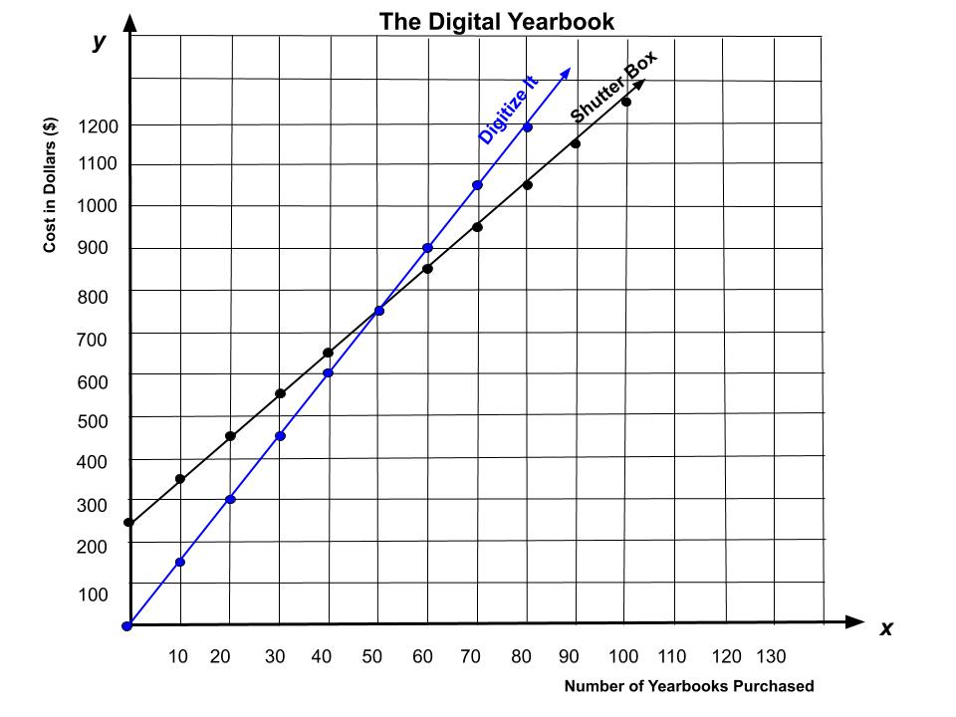

Answers to Questions:
- 1. When should the school choose Shutter Box to publish the yearbooks?
- You should use Shutter Box if you are ordering more than 50 yearbooks.
- 2. When should the school choose Digitize It to publish the yearbooks? You should use Digitize It
- if you are ordering fewer than 50 yearbooks.
- If you are ordering exactly 50 yearbooks, the cost will be the same ($750) with both companies.

Science and Technology

Building a Model of a Lung

Information for students
- In this activity you will build a functional model of a lung.
- Instructions on how to build a model of a lung are provided in Appendix A.
- Once you’ve built your lung model, observe how it works and answer the questions at the end of Appendix A.

Materials required
- Plastic bottle (500 mL)
- Straw
- Elastic band
- Scissors
- 2 balloons
- Play dough

Information for parents
- If you do not have or are unable to obtain the required materials, click on the link below to watch the YouTube video on how to build a lung model.
- If you do not have Internet access, go to the top of the second page of Appendix A to see how a lung model works.

Science and Technology
Appendix A: How to Build a Lung Model
Instructions: (Link to YouTube video)

- Carefully cut the plastic bottle in half.
- Tie a knot in the neck of one balloon and cut the balloon along its widest point.

- Stretch the balloon around the cut edge of the plastic bottle.

- Put a straw in the neck of the second balloon and secure the balloon tightly to the straw using the elastic band. | 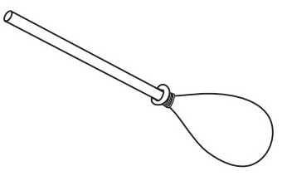
- Insert the balloon and straw into the neck of the plastic bottle, making sure to leave one end of the straw outside of the bottle. | 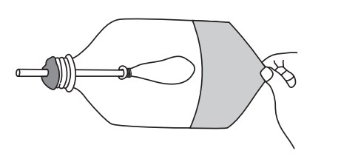
- Seal the plastic bottle with the play dough

Observations:
- 1. Pull down on the knot on the balloon on the bottom of the bottle. What do you observe?
- 2. Release the knot. What do you observe?

Science and Technology

What happens when you pull the balloon down. | What happens when you release the balloon.

Questions:
- 1. What part of the respiratory system does each of the following items in your lung model represent?
- A) Plastic bottle
- B) Straw
- C) Balloon inside the bottle
- D) Balloon covering the bottle
- 2. What action in the respiratory system does pulling down on the knot on the balloon on the bottom of the bottle represent?
- 3. What action in the respiratory system does releasing the knot represent?

Physical Education and Health

Learn About Hunger and Fullness and Get Moving!

Information for students
Activity 1: How does your body know you are full?
- Watch this video.
- What types of food keep you feeling fuller for longer?
- Discuss what you learned with a family member. For better effect, you could do so during a mealtime!
Activity 2: Get moving!
- Complete the 30-Minute Hip-Hop Workout in this video.
- Adjust the movements and level of intensity to your personal fitness level.
- If you are up for practicing your French and want to explore more activity ideas, visit the Rest Actif! website.

Information for Parents
Children should:
- learn about fullness and satiety
- complete a hip-hop fitness workout
Parents could:
- ask their children questions about what they learned about hunger and fullness
- complete the workout with their children

Arts
Zentangle Drawing
https://kinderart.com/blog/zentangles-101/

Information for students
- A Zentangle is a miniature abstract work of art created by a collection of patterns. See the examples below.
- It is typically done on a 3 ½” x 3 ½” paper square using a pencil and a black pen. The small size allows for a work of art that can be completed in a relatively short period of time. The “zen” part of the name comes from how it can be a very relaxing and meditative experience.
- The artwork can be any size (they just refer to it by a slightly different name) and colour can be added as well.
- You can start with any size paper you like, but make sure it’ square.
- Here are some steps to help you get started on the “tile” option:
- Using a pencil, put a small dot in the each of the corners of your paper.
- Connect the dots with a line, not necessarily a straight one though.
- Using the pencil, scribble in lines going in various directions until you have created several spaces on the paper.
- Using a black pen (if possible), create a different pattern in each one of the spaces that you have drawn with your pencil. This step can also be done with a pencil.
- Have fun in creating all sorts of patterns. Don’t forget to add your initials or signature and date in a bottom corner of your artwork.
- Another option for this Zentangle activity is to trace your hand or the hands of your family members and create spaces inside the hand to fill out with different patterns (See example #2 below.
- Share your artwork with your teacher or school!

Materials required
- Paper, writing and drawing materials
- Internet access is not required, however the link provided will take you to the Zentangle creators’ web page which has more information and examples

Information for parents
This activity is suitable for ages 8 and up.

Arts

Zentangle Example #1
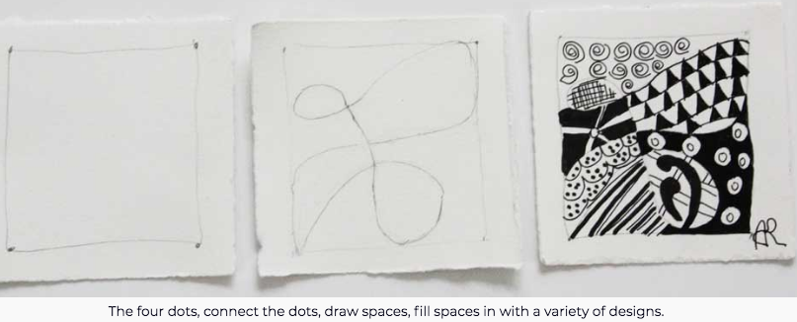
https://kinderart.com/blog/zentangles-101/

Zentangle Example #2
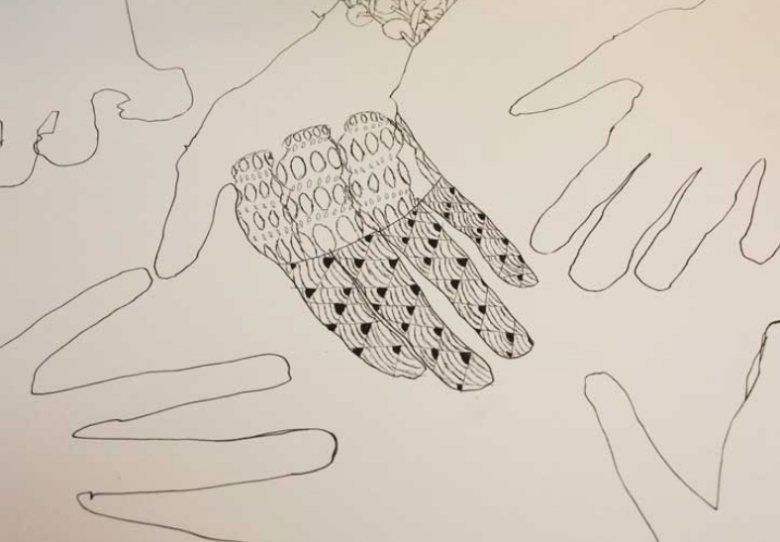
https://kinderart.com/blog/zentangles-101/

History of Québec and Canada

Analyzing Historical Documents

Information for students
- An essential skill in your History of Québec and Canada course is analyzing documents.
- Using the chart in the Appendix, analyze the documents, extracting as much information as possible. You will need to print a copy of the chart (or reproduce it by hand) for each document that you analyze.

Materials required
Useful resources, depending on personal preferences and availability:
- Device with Internet access
- Writing materials (paper, pencil, etc.)

Information for parents
- Some students may need help reading the text and extracting information from the documents.
- Encourage your child to do this activity with a classmate (using FaceTime or the phone). They can compare answers and find additional information together.
- Discussing what they have written with each other can help them understand and remember more.

History of Québec and Canada

Appendix
Document Analysis

Time period represented:
Theme/Issue/Event represented:

What type of document is it?
Written | Visual | Audiovisual | Artifact

Identify the 5Ws+H for the document you are analyzing.
Who?
What?
* When?
Where?
Why?
How?
*If you don’t have the exact date, try to place it in the correct time period.

History of Québec and Canada

Document 1
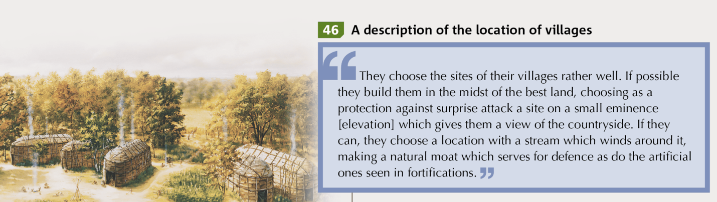
Source: Francis Campeau et al., Reflections.qc.ca: Origins to 1840, History of Québec and Canada, Secondary III (Montréal: Chenelière Éducation, 2018), 36.

Document 2
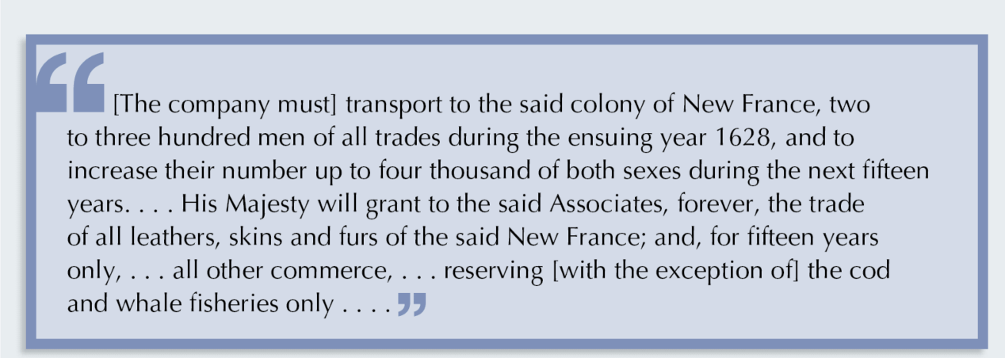
Source: Francis Campeau et al., Reflections.qc.ca: Origins to 1840, History of Québec and Canada, Secondary III (Montréal: Chenelière Éducation, 2018), 73.

Document 3
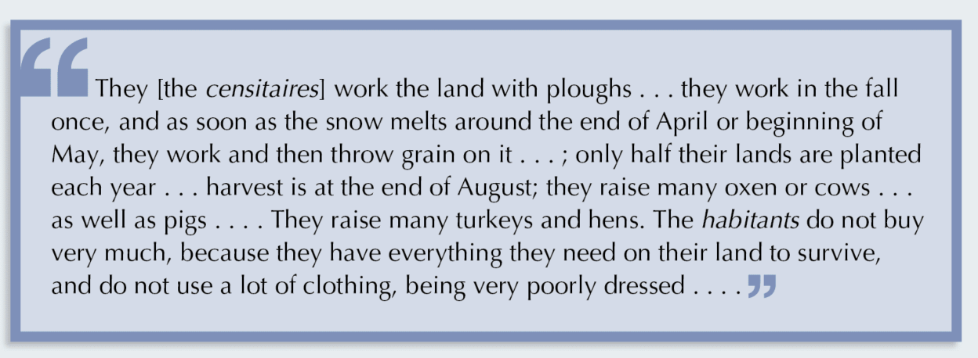
Source: Francis Campeau et al., Reflections.qc.ca: Origins to 1840, History of Québec and Canada, Secondary III (Montréal: Chenelière Éducation, 2018), 78.

History of Québec and Canada

Document 4

Source: Francis Campeau et al., Reflections.qc.ca: Origins to 1840, History of Québec and Canada, Secondary III (Montréal: Chenelière Éducation, 2018), 152.

Document 5
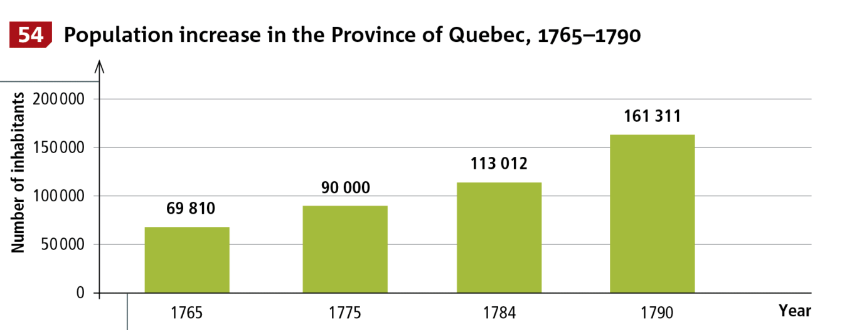

Source: Francis Campeau et al., Reflections.qc.ca: Origins to 1840, History of Québec and Canada, Secondary III (Montréal: Chenelière Éducation, 2018), 172.

Document 6
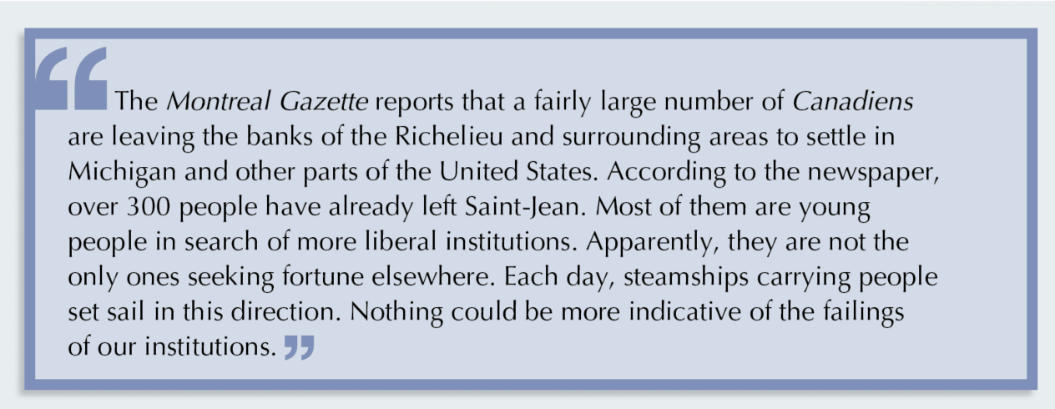

Source: Francis Campeau et al., Reflections.qc.ca: Origins to 1840, History of Québec and Canada, Secondary III (Montréal: Chenelière Éducation, 2018), 206.

Task adapted from: Emma Vanstone, “How do Lungs Work? Make a Model Lung,” last modified August 12, 2018, https://www.science-sparks.com/breathing-making-a-fake-lung/
Images for steps 1, 2 and 3 Hearts of Habit, Lung Model, 2000, Science of Museum of Minnesota, Saint-Paul. Accessed May 1, 2020, https://www.smm.org/heart/lessons/lesson7.htm
Images for steps 4, 5 and 6, Human Lung Simulator, n.d., Science World, Vancouver. Accessed May 1, 2020, https://www.scienceworld.ca/resource/human-lung-simulator/
Images, C.R.Nave, HyperPhysics, 2016., Georgia State University, Atlanta. Accessed May 1, 2020, http://hyperphysics.phy-astr.gsu.edu/hbase/hph.html#hph

