secondary III
Week of June 15, 2020
Table of Contents
What is News? 2
Décris-moi le bonheur! 3
Homework Buyout 4
Appendix A – Homework Buyout 5
Appendix B – Suggested Tools 6
Appendix C – Solution 7
Feel It in Your Bones 9
Appendix A – Task Sheet 10
Appendix B – Engineering Design Process 11
Appendix C – Task Sheet 12
Summer Safety and Summer Exercises 13
1791-1840 – A Changing Colony 15
Appendix 1 – Coherent representation of a period in the history of Québec and Canada 17
Appendix 2 – Answer Key 20

English Language Arts

What Is News?

Information for students
News is everywhere. It’s all over TV, radio, print and social media. It’s hard to escape it. But just how valuable is it? What qualities does it have that make it valuable or not?
Watch this short BBC video from CBC’s Curio website called What is news?. Write a short, free-form response to the ideas presented in this piece. Here are some critical thinking questions to guide your response:
- What’s your opinion on the role of news in your life?
- What sort of news do you read, watch or listen to and why?
- What sort of effect(s) does news have on you?
- How do news headlines grab your attention or make you want to read/view/listen?
- How do you know what news sources to trust?
- Do you believe media organizations always follow the five fundamental principles of news mentioned at the very end of the video?
- Is there such a thing as too much news?

Materials required
Device or other tools for writing
Device with Internet access

Information for parents
Parents should:
extend the discussion by examining how or if news actually empowers us all the time (Are there diminishing returns? Or can you argue that there is no such thing as too much information?)

French as a Second Language

Décris-moi le bonheur!

Information for students
Objectif de l’activité : comprendre un texte vu, lu et entendu et interagir en français.
Durée : 30 minutes.
Déroulement de l’activité :
- Visionnez le documentaire suivant : https://safeyoutube.net/w/zw8J
- Lisez l’article suivant : https://www.lapresse.ca/actualites/national/201903/20/01-5218904-indice-de-bonheur-le-canada-glisse-au-neuvieme-rang.php
- Choisissez un ou deux ami.e.s avec qui vous souhaitez discuter du sujet.
- Convenez d’un rendez-vous téléphonique ou d’un appel vidéo sur la plateforme de votre choix (par exemple : Facetime, Messenger, Google Hangouts, etc.)
- Discutez en français en vous aidant des pistes de discussions ci-dessous :
- Êtes-vous d’accord avec les critères énoncés dans les deux documents? Expliquez.
- Quel critère est le plus important pour vous?
- D’après vous, est-ce que le documentaire a oublié un ou des critères de bonheur?
- Quelle est votre définition du bonheur?

Materials required
Device with Internet access
Paper, writing materials (to take notes)

Information for parents
Read the instructions with your child.
Watch the short documentary.
Share your definition of happiness.
Have a conversation about happiness with your child, in French if possible.
Let your child develop their critical thinking (the language you are using doesn’t matter).

Mathematics

Homework Buyout

Information for students
Happy Valley Secondary School is having a spring fundraiser. Students are given the opportunity to buy their way out of their homework assignments. You need to decide which option each student should choose.
Instructions
Read the information provided in Appendix A – Homework Buyout.
Determine which option each student should choose. Show all your work to justify your answer.
You may choose to use the suggested tools in Appendix B to help you solve the problem.
EXTENSION: Given the two equations in Appendix A, write a word problem that could go with them, and solve the problem using your choice of representation.

Materials required
Appendix A: Homework Buyout
Appendix B: Suggested Tools
Writing materials
Calculator
Graph paper (optional)

Information for parents

About the activity
Children could:
complete the activity on their own
refer to various sources to review how to solve a system of equations (class notes, textbooks, Internet sources, etc.)
Parents should:
help their children organize the required materials, if necessary
read the instructions to their children, if necessary
have their children explain how they went about solving the problem
Solutions to the problems can be found in Appendix C.

Mathematics

Appendix A – Homework Buyout

Information for students
Happy Valley Secondary School is having a spring fundraiser. Students are given the opportunity to buy their way out of their homework assignments. You need to decide which option each student should choose.
Teacher Buyout Deals
Teacher A  $160 flat rate for an unlimited number of homework assignments |  | Teacher B  $21.60 per homework assignment |  | Teacher C  $105 fixed fee (for administrative fees) and $6.25 per homework assignment
Students and Their Homework Assignments
Adam has 5 homework assignments Brian has 9 homework assignments

Claire has 7 homework assignments
Which buyout option should each student choose because it is the least expensive for them? Show all your work to justify your answer.
You may choose to use the suggested tools in Appendix B to help you solve the problem.
EXTENTION: Given these two equations, write a word problem that could go with them, and solve the problem using your choice of representation.
$y=2x+10$ $y=3.5x+7$

Mathematics

Appendix B – Suggested Tools

Information for students
Tools you may want to use to solve the problem:
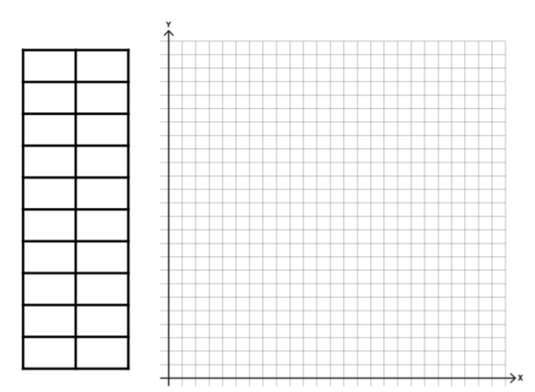

Mathematics

Appendix C – Solution
There are various ways students may choose to solve this problem:
Trial and error / guess and check
Table of values
Graphing to find points of intersection
Creating equations and solving the system of equations
All methods will result in approximately the same solution. The solution presented here involves creating equations and solving the system of equations by drawing a graph.
- Identify the variables:
x represents number of homework assignments
y represents the total cost
- Create an equation for each teacher:
Teacher A: $y=160$ Teacher B: $y=21.6x$ Teacher C: $y=6.25x+105$
- Graph the three equations on the same set of axes.

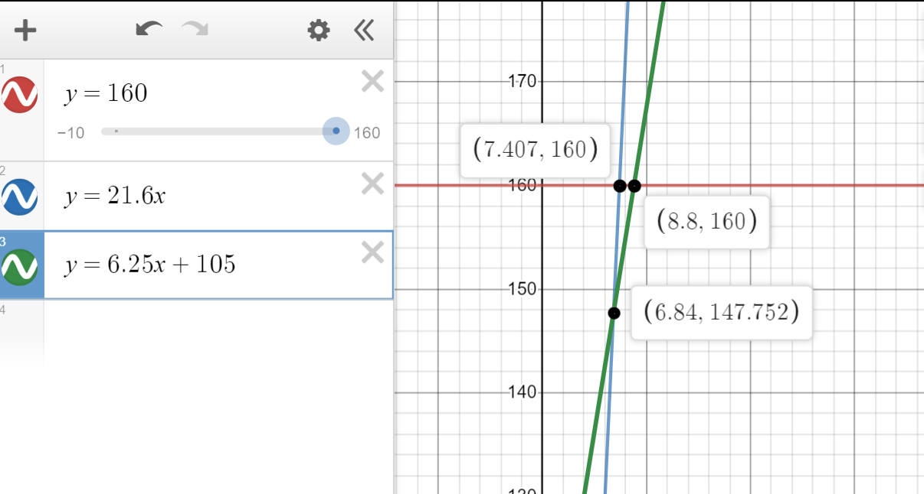

Mathematics
- Find the points of intersection of the lines by using the graph, or solve this by using algebra.
Teachers A and B intersect at (7.407, 160)
Teachers A and C intersect at (8.8, 160)
Teachers B and C intersect at (6.84, 147.752)
- Determine which option each student should choose.
Adam has 5 homework assignments and should choose Teacher B because it is the least expensive option for him.
Brian has 9 homework assignments and should choose Teacher A because it is the least expensive option for him.
Claire has 7 homework assignments and should choose Teacher C because it is the least expensive option for her.

Science and Technology

Feel It in Your Bones

Information for students
Your skeletal system performs many functions, some of which are not very obvious. Your bones, for example, serve critical metabolic functions. Bone marrow is key to the production of blood cells, and bone tissue acts as a reservoir for a number of minerals and stores fat.
Other skeletal functions, however, are more obvious. For example, you can feel the support and strength your bones give you when you move. You may even be aware of how your skeleton protects your internal organs from damage. Without your skeleton, you would be a floppy mass of organs, muscles and skin.
As you can see, the skeletal system is extremely important. There are specialists whose job it is to focus on this very system. Orthopedists, for example, are doctors who specialise in diagnosing and treating disorders and injuries related to the skeletal system. Although they treat some problems with medication, exercise, and surgery, they treat others can with braces and other physical equipment.
This week, we will explore this amazing system a little more in-depth.

Materials required
Appendix A: Task Sheet
Appendix B: Engineering Design Process
Materials for Task 1
- Tennis ball (or similar)
- 10 sheets of A4 paper
- 1 m of transparent adhesive tape
Materials for Task 2
- Paper and pen
Materials for Task 3
- Various materials found in and around the home

Information for parents

About the activity
Children should:
use their class notes to answer the questions in Task 1 and Task 2
use any materials found around the home to build their design in Task 3, if they so choose
check their answers to the questions in Tasks 1, 2 and 3 with the solutions provided in Appendix C
Science and Technology

Appendix A – Task Sheet

Information for students
Task 1: One of the functions of the skeleton is to provide support. In this activity, you will focus on how a structure can support a load effectively.
- Design and construct a structure that will support a ball as high above the table top as possible. The structure should not be fixed to the table.
- What shape will work best?
- What is the best use of the materials in order to produce something strong?
- How can you make certain the structure is stable?
Possible answers to these questions can be found in Appendix C.
- Now consider the human skeleton.
- What makes bones such as those in the legs and backbone effective at providing support?
- What makes bones such as those in the pelvis and feet effective at providing stability?
Possible answers to these questions can be found in Appendix C.
Task 2: The skeletal system also plays an important role in our metabolism. Answering the following questions will allow you to see how important this role is.
- What functions would your body not be able to perform if your bone marrow was not able to function properly?
- Suppose your bone tissue could not store calcium. What functions would your body not be able to perform?
Possible answers to these questions can be found in Appendix C.
Task 3: EXTENSION ACTIVITY
Using the engineering design process (Appendix B), design a brace that will support a knee that has been injured.
- Keep in mind that this brace should allow your knee to move as it normally does while still supporting your body weight.
- Remember: research is key when going through the engineering process.
- Extend this extension activity by trying to build your design. Have fun with the different materials you have around your home.

Science and Technology

Appendix B – Engineering Design Process
The engineering design process has a cyclical component to it.
Once a problem is identified and researched, ideas are brainstormed, and an initial design is put down on paper.
After the design is built, it is tested and evaluated. It is at this point that an engineer may decide to redesign and rebuild. If so, the new design will be tested and evaluated again to see if it meets the required standards.
Present solution

Science and Technology

Appendix C – Task Sheet

Possible Answers to Task Questions
Task 1
- Tubular structures provide the best support for the ball.
- Various answers are possible.
- Broader structures, rather than narrow ones, help provide stability.
- The leg and backbone are both tubular structures. Their shape is a major reason why they can support the human body in the way they do. A second factor is their composition. They are composed of marrow and osseous tissue, which provide some rigidity and support.
- The shape and broadness of the pelvis and foot make them effective at providing stability.
Task 2
- Without red bone marrow, you would not be able to produce blood cells.
- Red blood cells transport oxygen to tissues. Without red blood cells, the cells of the body would be unable to produce energy.
- White blood cells play a role in the immune system. Without white blood cells the body would not be able to recover from infection.
- Platelets are responsible for clotting blood when a vessel ruptures. Without platelets, one would bleed to death.
- The calcium stored in bones provides them with support. Without this calcium, the bones would not be rigid and could not provide support. The bones are also important storage sites for calcium. Other organ systems rely on this calcium to perform certain functions. For example, muscle contraction and neural signaling would be affected if those calcium stores were not available.
Task 3
There are a multitude of possible designs. You may:
- Choose to check your design with those found on the Internet
- Wish to share your design with your teacher / classmates
- Compare / contrast the different designs of your classmates

Physical Education and Health

Summer Safety and Summer Exercises

Information for students
Activity 1: Summer safety reading
Summer is right around the corner, but before you go outside, start work, or head out for a picnic, get some info first!
Read the article Summer Safety 101 from the perspective of an older sibling or a camp counselor. Think about what you have learned from the reading and what you could potentially teach others.
- Answer these questions:
- If your younger sibling or camper is looking sluggish and you know they have not been drinking water all day, what would you suggest or offer to entice them to hydrate? OR If your younger sibling is swimming in the pool and you have been asked to watch them, but your phone rings in the house, what should you do?
- If your friend decides that helmets are “not cool” and chooses not to wear one, what would you say to convince them to wear a helmet while they ride their bike?
- What did you lean about “respecting the environment” during the summer months?
- Do you have a first-aid kit in the car or at home? Why do you think it is important to have one?
Activity 2: Summer-time exercises
- Try one of these workouts:
- Cardio workout
- Yoga
- Full Body HIIT
- Which one did you do? How did it go? Do you think you could continue to do workouts like this over the summer?
- Over the past few months, you have learned and tried new exercises at home (restorative, yoga, HIIT), but a healthy lifestyle is one that is continuous and enjoyable.
- The most important thing is to find an activity, exercise, sport, or movement that you like and stick with it (or switch it up when you find a new enjoyable activity!).
- What do you think you will do this summer to be physically active? Make a tentative plan for what you will do this summer: 3 exercises a week for 9 weeks (e.g. swim, bike, run, dance, train, play, yoga, online workout videos).
June/July
August

Physical Education and Health

Materials required
None

Information for parents

About the activity
Children should:
read the article, reflect, and answer the 4 questions
reflect on the new workouts they learned, try a workout, and think about what they will do over the summer
Parents could:
encourage their children to read the article and answer the questions, and to stay safe over the summer
do the workout with their children or help them be more autonomous
encourage their children to be active over the summer

History of Québec and Canada

1791-1840 – A Changing Colony

Information for students
Following the Constitutional Act in 1791, the Province of Quebec underwent territorial, political, economic, social and cultural changes.
Competency 1, evaluation criterion 3: Coherent representation of a period in the history of Québec and Canada.
Task: Describe the economic and social situation in the colonial society of Québec at the beginning of the 19th century.
- Examine the documents in Appendix 1 and decide whether they represent an economic or a social aspect of society.
- Using the documents, complete the diagram. (Note that some of the documents in Appendix 1 are not relevant to the task, meaning that they have nothing to do with the economic and social situation during this time period.)
- You may use your Reflections.qc.ca textbook, a workbook or the following website to learn more about this period of Canada’s history: https://www.thecanadianencyclopedia.ca/en/article/lower-canada
Take it to the next level:
Take your analysis further by researching the territorial, political and cultural changes during this period and answer the following question: Explain why this period in Canada’s history is entitled “The Demands and Struggles of Nationhood”?

Materials required
Useful resources, depending on personal preferences and availability:
Device with Internet access
Writing materials (paper, pencil, etc.)
Textbook or workbook

History of Québec and Canada

Information for parents

About the activity
Children should:
take their knowledge further by doing the extra activity suggested above
learn more about this period in Canada’s history by watching the following video: Canada: A People's History - Episode 7 - Rebellion and Reform
Parents could:
help their child to understand the documents, if necessary, and review possible answers with them

History of Québec and Canada

Appendix 1 – Coherent Representation of a Period in the History of Québec and Canada

Information for students
Examine the documents and determine whether they represent an economic aspect or a social aspect of colonial society at the beginning of the 19th century or, if the document does not belong in the period of 1791-1840, indicate that it is not relevant.
The exploitation of wood in Canada's forests, dates back… [to] the beginning of [the 19th] century. ... It was after the wars of the First Empire and the continental blockade imposed by Napoleon on all the ports of Europe to drive out English trade that serious attention began to be given to the exploitation of [Canada’s] forests.
Economic | Social | Not relevant

John Dickinson and Brian Young, A Short History of Quebec (Montréal and Kingston: McGill-Queen’s University Press, 2008), 112.

"Between 1815 and 1851 almost 800 000 British immigrants, including many Irish, were recorded at the Port of Quebec. Although most of them were en route to Upper Canada and the United States, some 50 000 settled in Lower Canada. Immigration raised the percentage of anglophones in the total population [of Lower Canada] from 15 percent in 1815 to a high of 24.3 percent in 1861....”
Document 2
Document 1
Economic | Social | Not relevant

Source: Service national du RÉCIT, domaine de l’univers social, https://documents.recitus.qc.ca/2e-cycle/dossier/commerce-bois [Adaptation]

Document 3
Document 4
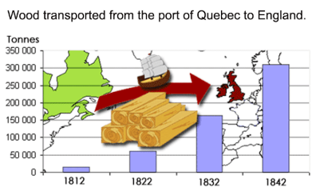
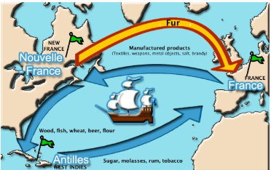

Source: RECITUS via Societies and Territories, at
http://blogdev.learnquebec.ca/societies/societies/lower-canada-around-1820/the-timber-trade/.

Source: Service national du récit de l'univers social, www.recitus.qc.ca.
Economic | Social | Not relevant

Economic | Social | Not relevant

History of Québec and Canada
Document 6 – Arrival of Les filles du roi
Document 5 – Immigrants, escaping poverty and starvation in the British Isles, board a ship bound for North America

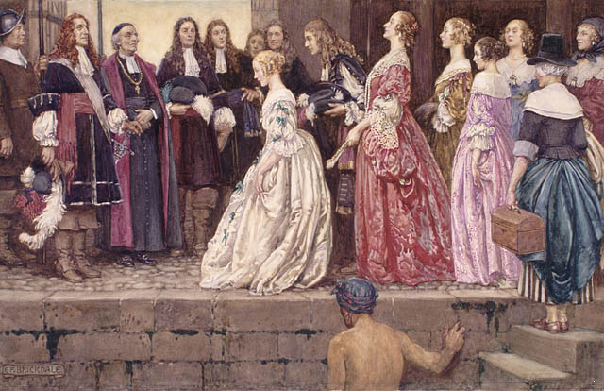
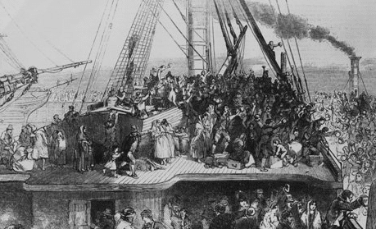

Source: https://fr.wikipedia.org/wiki/Filles_du_Roi
Source: https://www.intriguing-history.com/great-migration-of-canada/

Economic | Social | Not relevant

Economic | Social | Not relevant

Document 8
Document 7

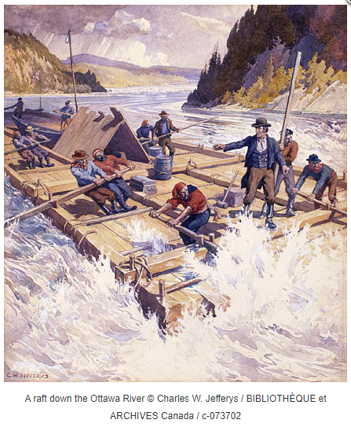
The massive influx of British immigrants provoked fear and anger… Among other things, the people were concerned about the spread of disease in their territory… In 1832, the government set up a quarantine station at Grosse-Île…

Marie-Andrée Courval, Luc Dujardin and Guylène Labonté, Journeys: Origins to 1840, Secondary III (Anjou, Québec: Les Éditions CEC, 2018) Content Workbook, 215.

Economic | Social | Not relevant

Source: RECITUS via Societies and Territories, at
http://blogdev.learnquebec.ca/societies/societies/lower-canada-around-1820/the-timber-trade/.

Economic | Social | Not relevant

History of Québec and Canada
Using the documents, describe the economic and social situation in the colonial society of Québec at the beginning of the 19th century. Complete the diagram below.

Reason why they left their country of origin
Reaction of the Canadiens to these newly arrived immigrants
A factor that contributed to the growth of this economic activity
A new job created linked to this activity
The growing economic activity during this period

Origin of newly arrived immigrants to the colony during this period

Topic of the description
Name of the colony between 1791 and 1840

Central element

Central element
History of Québec and Canada

Appendix 2 – Answer Key
Document 1 | Document 2 | Document 3 | Document 4
Economic | Social | Economic | Not relevant
Document 5 | Document 6 | Document 7 | Document 8
Social | Not relevant | Social | Economic

A factor that contributed to the growth of this economic activity

The Napoleonic Wars OR Napoleon’s blockade OR British protectionism OR Preferential tariffs

Origin of newly arrived immigrants to the colony during this period

British Isles OR Great Britain OR Scotland OR Ireland

Central element
Reason why they left their country of origin

Terrible living conditions OR Poverty OR Starvation OR Famine

Name of the colony between 1791 and 1840.

Lower Canada

Central element

The growing economic activity during this period

Timber trade

A new occupation created in connection with this activity

Log driver OR Raftsman OR Logger OR Lumberjack OR Carter OR Sawmill worker OR Longshoreman OR Shipbuilder OR Cooper

Topic of the description
Reaction of the Canadiens to these newly arrived immigrants

Fear of disease OR Anger over competition for work

Adapted from: Kyle Pearce, “The Dentention Buyout,” n.d. Tap Into Teen Minds, accessed June 1, 2020, https://tapintoteenminds.com/3act-math/detention-buyout/.
Image: “Coordinate Grid Paper 1st Quadrant,” n.d., PDF, K-5 Math, https://www.k-5mathteachingresources.com/support-files/coordinate-grid-paper-1st-quadrant.pdf accessed June 3, 2020.
Graph created with https://www.desmos.com/calculator.

