Weekly Educational Options From the Ministère
secondary II
Week of May 18, 2020
Table of Contents
Creative Writing 2
L’autobus du futur 3
A Toothpick Pattern 4
Appendix A: The Context 5
Appendix B: Tools to Show your Work 6
Appendix B: Tools to Show your Work-2 7
Appendix C: Solution 8
Energy Resources 9
Reflect on Stereotypes in Sports and Physical Activity and Get Moving! 11
Watercolour Print Making 12
Bell Ringer: Evaluating Online News 13

English Language Arts

Creative Writing

Information for students
If you want to become a better writer, just like any other skill, you have to practice… a lot! Many students ask what to write about.
Here are a couple of creative writing prompts to get you started:
Dreamcatcher: Describe something inspired by a recent dream you had.
Dragon: Envision a dragon. Describe it. Where does it live? Is it friendly or ferocious?
Smoke, fog and haze: Describe what it is like being trapped and not being able to see ahead of you. Perhaps you are able to escape?
Need more inspiration? Visit the website in the link below.

Materials required
Activity adapted from: https://thinkwritten.com/365-creative-writing-prompts/
Paper, pen or pencil, phone, tablet or computer.
Information for parents
Above all, this activity is designed to be simple. We hope it will appeal to your child whatever their grade level. The best things your child can do are:
Read every day.
Write every day.
Talk every day.

French as a Second Language

L’autobus du futur

Information for students
Lis l’article L’autobus du futur de la revue Les Explorateurs et regarde la vidéo.
Cherche les mots que tu ne comprends pas dans un dictionnaire papier ou numérique :
- Dictionnaire bilingue : Wordreference
- Dictionnaire unilingue : Usito
Réponds aux questions :
- Élèves FSL BASE : quizizz.com/join?gc=324799
- Élèves FSL ENRICHI : quizizz.com/join?gc=856706
- Pense à un mot qui représente bien l’article lu et écris-le en utilisant le lien : https://www.menti.com/zgheg1z1yp
Tu peux aussi voir les résultats de tous les participants sous forme de nuage!

Materials required
Appareil numérique avec un accès Internet.
- Dictionnaire (papier ou numérique)

Information for parents
Your child will:
learn vocabulary related to buses and technology in French.
improve their reading skills by answering reading comprehension questions.
use technology to record their answers (Quizizz and Mentimeter).
Students from the enriched program will:
practise their writing skills.

Mathematics

A Toothpick Pattern

Information for students
This activity will help you develop your understanding of growing patterns. You will describe a pattern by building models, using a table of values, making a graph and creating an equation to represent the pattern algebraically.

Materials required
Appendix A: The Context
Appendix B: Tools to Show Your Work
Paper
Writing materials
Toothpicks or other manipulatives (coffee stir sticks, pipe cleaners, Q-Tips, etc.). These are optional, but can be very helpful.
Internet access (optional)

Information for parents
Help your child organize the necessary materials, if needed.
Read the instructions together and help them build the pattern, if needed.
Discuss the patterns together and/or ask your child to describe how they determined the answers to the questions. A possible solution is found in Appendix C.

Mathematics

Appendix A: The Context

Toothpick Pattern Task
The image below shows the first three terms in a growing pattern. Watch this video or look at the pattern below to see how it grows. It would be helpful to build the pattern. Then, answer the questions below.
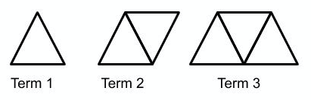
- How many toothpicks are in each of the first three terms of the pattern?
- How many toothpicks are in the 4th, 5th, and 6th terms of the pattern?
- Describe in words what the 10th term will look like.
- Describe how to find the number of toothpicks that are in the 100th term.
- What is the term number of the figure that would be made of 65 toothpicks?
- Write a rule that relates the number of toothpicks to the term number. Explain how each part of your equation relates to the toothpick pattern.
- Graph the function. Explain how the graph relates to the equation you found and what is happening with the toothpick pattern.
- Using this same pattern, how many toothpicks would be in term 0?

Mathematics

Appendix B: Tools to Show your Work

Table of Values:
Term # | Number of Toothpicks Needed

Mathematics

Appendix B: Tools to Show your Work-2
- Equation to Represent the Situation:
- Graph to Represent the Situation:
Mathematics

Appendix C: Solution
- Term 1= 3 toothpicks, Term 2= 5 toothpicks, Term 3=7 toothpicks
- Term 4= 9 toothpicks, Term 5= 11 toothpicks, Term 6= 13 toothpicks
- The tenth term will look like 10 interlocking triangles with five pointing up and five pointing down.
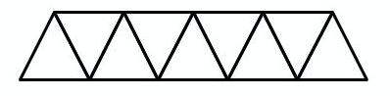

- The first triangle is made of three toothpicks. Each additional triangle is made with two additional toothpicks because of the shared side. To find the number of toothpicks in the hundredth term, you need to have two additional toothpicks for every term and 1 extra toothpick at the end for the third side. The number of toothpicks is therefore calculated as follows: 100 x 2 = 200 + 1= 201.
- 65 toothpicks are needed to make 32 triangles. The term number would be 32, based on the following calculation: [(32 x 2) +1 =65].
- The rule is Y= 2x +1 where Y= the number of toothpicks and x = the term number. The 2 means two sides for each triangle as each new triangle created needs two additional toothpicks because of the shared sides. The 1 is for the third side of the first triangle, as there are no shared sides in Term 1.
- Graph the function. Explain how the graph relates to the equation you found and what is happening with the toothpick pattern.
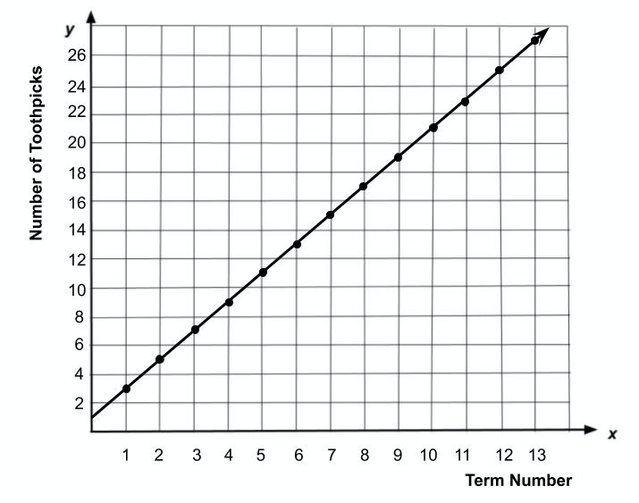

- Using the graph, term 0 would still take 1 toothpick but would create 0 triangles.

Science and Technology

Energy Resources

Information for students
Our world needs energy to function. Especially electrical energy. Since energy cannot be created or destroyed, only transformed, there are only a few ways to take existing energy and turn it into electricity.
There are two kinds of energy resources:
- Renewable
- Non-renewable
Research the following terms:
- Law of conservation of energy
- Conductors and insulators
- Solar, nuclear, thermal, chemical, wind, electrical and mechanical energy
- Generators, turbines, power plants
- Renewable and non-renewable
Simulation: follow this link to explore how energy moves and changes https://phet.colorado.edu/en/simulation/energy-forms-and-changes
- Draw and explain how water can be used to power a lightbulb.
- Use coloured rectangles to represent energy types
- Use arrows to show movement
Energy in Québec: From Nature to the Microwave

Science and Technology
Quebec generates its electricity from moving water. Sketch and explain how energy is generated in a hydropower plant, gets to your house and is used in microwaves to heat your food. Be as precise as possible.
- Is this an example of renewable energy? Explain.
- What would be an example of non-renewable energy? Explain.
- What happens to the energy after your food gets heated? Explain.
What are the pros and cons of both renewable and non-renewable sources of energy? Make a table.
Design two portable power generators that can be used to charge your cell phone. One device must use renewable energy, and the other must use non-renewable energy. Sketch and explain your invention. Be as precise as possible.

Materials required
Paper, pencil
Device with internet access

Information for parents

About the activity
Children should:
Research the terms in an encyclopedia or on the internet
Share their sketches and explanations on social media using the hashtag #ScienceAtHomeQC-grade8
Use recycled cardboard/plastic, an electric motor, some wires, and a small lightbulb (for a flashlight) to build a model hydroelectric generator
CAUTION: do not plug homemade devices into any electrical outlets
Parents can:
Help their children read the instruction
Discuss the tasks and what their children can learn from them
Navigate to the correct website
Help build or design simple electrical circuits (optional)
CAUTION: do not plug homemade devices into any electrical outlets

Physical and Health Education

Reflect on Stereotypes in Sports and Physical Activity and Get Moving!

Information for students
Activity 1: Stereotypes in sports
Watch this video.
What are your thoughts after watching the video? What representations of people did you notice (for example, the inclusion of older women participating in team sports)? What stereotypes about participation in sports and physical activity are you aware of? Do the images we see of sports and physical activity provide an accurate representation of our society? Why or why not? Reflect and discuss it with a friend or family member.
- English Language Arts cross-curricular bonus question: Do you know who wrote the poem that is narrated throughout the video?
Activity 2: Get Moving!
Get ready to develop your coordination and agility by learning how to juggle.
Find three objects that you can juggle with (hacky sacks, tennis balls, rolled-up socks, etc.).
- Watch this video and follow along to develop your juggling skills. Pause the video as needed to practise each progression.
- For more juggling progressions that you could work on, visit the Reste Actif website (available in French only) and look at the Secondaire section for the week of May 18. This could be your start to a career in Cirque du Soleil!

Materials required
Objects for juggling

Information for parents

About the activity
Children should:
reflect on stereotypes in sports
practise their juggling skills
Parents could:
discuss stereotypes in sports with their children
learn how to juggle together with their children

Arts

Watercolour Print Making

Information for students
In this activity, you will learn how to make your own note cards and/or pages for journaling
Let your imagination guide you.

Materials Required:
Watercolour paints
Paint brush
Water (for watercolour paints and in a small spray bottle)
Cardstock paper (cut into note sized squares)
Square piece of cardboard
Resealable plastic bag (medium or small based on the size of your painting)
Black marker (fine tip)
Paper towel

Instructions
- Place the plastic bag on top of the cardboard.
- Select an initial colour for your project.
- Begin by creating an abstract pattern on the plastic bag with your first colour.
- Select a second complementary colour and add to your pattern.
- Spray a little bit of water onto your painting.
- Take your cardstock paper (now cut into squares) and press firmly onto your painting.
- Carefully peel back your card stock paper from the plastic bag and admire your creation.
- If you want more colour intensity, repeat steps 2 to 7. (You may wish to clean your plastic bag between prints.)
- Let dry.
- Using your black marker, create patterns or write a quick note on your card.

Information for parents
Encourage your child to share their art with you.
If your child created a page for journaling, encourage them to write a journal entry.
For more watercolour print making ideas, please visit: https://www.youtube.com/watch?v=WZQZXF5B-Nw

Ethics and Religious Culture

Bell Ringer: Evaluating Online News

Information for students
Go to Newseum ed.
Explore the suggested websites.
Ask yourself:
What makes news real or fake?
Is it likely that you have shared fake news?

Materials required
Device with Internet access
Paper and writing materials

Information for parents
Students should:
Have questions regarding the information they are reading
Parents could:
Help their child find the link to the website
Read through the activity with their child
Discuss the questions together

Kyle Pearce, “Placing Toothpicks Part 4 – Act 1 – Linear Relations and Patterning,” YouTube, October 15, 2015, video, 0:28, http://www.youtube.com/watch?v=da15Q-g6HaI&feature=youtu.be.
Images from : Microwave PNG, n.d., PNG, 3636 KB, PNGIMG.com, https://pngimg.com/download/15744 and 2492809, July 11, 2017, JPEG, Pixabay.com, https://cdn.pixabay.com/photo/2017/07/11/08/33/dam-2492809_960_720.jpg

