secondary II
Week of May 11, 2020
Table of Contents
The Family Portrait 2
#MissionFLS - Dis-moi c’est quoi ta toune 3
Sugar Shock 5
Appendix A: Exploring Sugar Intake 7
Species and Dichotomous Keys 9
Appendix A: Species and Dichotomous Keys Activity 11
Think About What Matters and Get Moving! 14
Mindful Art Moment 15
Challenging Gender Stereotypes (Part 2: Miss Representation) 16
Rights and Freedoms – Part 2 17
Appendix 1 – Universal Declaration of Human Rights 19

English Language Arts

The Family Portrait

Information for students
Look at the piece of art called The Family Portrait
https://educart.ca/en/theme/family/#/the-family-portrait/cartel
Observe this work in silence for a full minute.
Write down three words that this artwork brings to mind.
Now jot down your answers to the following questions:
- What connections do you see between the artwork and the title? Does the fact that this work comes from “The Fantasy Collection” make any difference to your understanding of it?
- Imagine that you have to describe this artwork to a friend. What distinctive elements would you point out?
- What message do you think the artist wished to express at the time it was made? Does the artwork address any current issues?
- Do the three words you associated with this artwork still apply? Why or why not?
Share your observations with a friend or family member.
Write a detailed description that describes what your family portrait looks like.

Material required
Device with Internet access
Paper and writing materials
This lesson has been adapted from: https://educart.ca/en/theme/family/#/the-family-portrait/cartel

Information for parents
Help your child follow the instructions, if necessary.
Discuss the different questions about this piece of art and offer your own observations.

French as a Second Language

#MissionFLS - Dis-moi c’est quoi ta toune

Consignes à l’élève
Cette activité t’aidera à accomplir la mission FLS suivante : Je découvre deux nouvelles chansons en français et j’essaie de comprendre le message de ces chansons.
Quel genre de musique aimes-tu? Le hip hop, le country, la pop? Cette semaine, on te propose de découvrir la chanson francophone!
Voici comment tu peux le faire :
Écoute des chansons à la radio ou sur une application de musique en continu.
Choisis les deux chansons que tu aimes le plus et cherche les paroles en ligne.
Prends le temps de lire les paroles et de les comprendre pour saisir le sens de la chanson.
Pour aller plus loin :
Partage tes coups de cœur de musique francophone avec #MissionFLS.
Fais une recherche pour découvrir des artistes qui ont marqué la chanson québécoise.

Voici quelques noms d’artistes québécois pour t’inspirer :
Artistes contemporains : Cœur de Pirate, Alex Nevsky, Yann Perreau, Ariane Moffat, Bleu jeans bleu, Pierre Lapointe, Karim Ouellet, Patrice Michaud, Vincent Vallières, Charlotte Cardin, Koriass, Dubmatique, Loco Locass, Les Tireux d’Roches, Les Trois Accords, Les Cowboys Fringants.

Artistes classiques : Harmonium, Beau Dommage, Marjo, Muzion, La Bottine Souriante, Florent Vollant, Jean Leloup, Robert Charlebois, Luce Dufault, Linda Lemay, La Bolduc, Les Colocs, Diane Dufresne, Richard Desjardins, Martin Deschamps, Offenbach.

Matériel requis
Pour écouter de la musique:
Les chaines radio francophones de ta région
https://www.icimusique.ca/
https://www.lafabriqueculturelle.tv/themes/musique

Pour trouver les paroles des chansons québécoises : https://www.repertoiredesartistesquebecois.org/Parolesdechansons.asp

French as a Second Language
Mission FLS: https://www.learnquebec.ca/fr/misionsflsc1

Information for parents

About the activity
Children should:
listen to and read songs or poems in French
understand spoken and written text
appreciate francophone cultural references

Parents could:
share their favorite French songs with their children
discover new songs in French with their children and discuss them

Mathematics

Sugar Shock

Information for students
Did you know that one sugar packet contains 4 grams of sugar?

According to Health Canada, many packaged food products contain added sugar.

The American Heart Association recommends that a person not consume more than 500 g of sugar per day.

Some examples of foods that are high in sugars include breakfast cereals, chocolate bars, cookies, granola bars, ice cream, pudding and many sugary drinks, including fruit juice. According to Health Canada,
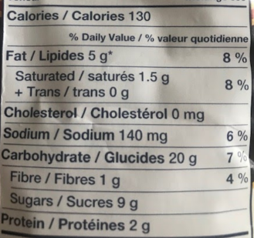

“Almost all packaged food labels must have an ingredient list and a nutrition facts table. This information can help you to make healthier food choices. Excess consumption of sugars is a concern, as it can lead to tooth decay and excess calorie consumption. Excess calories lead to overweight and obesity. Obesity is a risk factor for chronic diseases.”
https://www.canada.ca/en/health-canada/services/nutrients/sugars.html
So then, how much added sugar is too much?

What are some of your favourite packaged foods or drinks?

In Appendix A, complete the tables and draw a circle graph to explore your own sugar intake!

Materials required
A printed copy of Appendix A  Paper and pencil (to work out operations)  Protractor | Ruler  Packaged food items with added sugar (with nutrition facts table)

Mathematics

Information for parents
In this activity, students will practice proportional reasoning and construct a circle graph. They will then interpret the information they have gathered and exercise critical judgement regarding personal health and well-being.
This activity can also be carried out by a Secondary I student.

Mathematics

Appendix A: Exploring Sugar Intake
Make a list of up to 8 of your favourite packaged food items with added sugar that you can find around the house or look up online. Each food item must include a nutrition facts table.
Use the table below to indicate the number of sugar packets in each serving of the product based on the added sugar content of each item.
Item | Sugar content / serving | Number of sugar packets
Ex: Packaged Oatmeal Cookies | 9 grams / 2 cookies | 2.25

Mathematics
Using the table you completed on the previous page, fill out the table below. Then use all the information you have gathered to construct a circle graph in the circle provided on this page.
Item | # of sugar packets/serving | Ratio:  packets per serving/maximum # of packets per day | Percent % | # of degrees out of 360$°$
Ex: Packaged Oatmeal Cookies | 2.25

.
Based on your data and AHA Sugar Recommendation , what have you learned about your sugar intake?

Science and Technology

Species and Dichotomous Keys

Information for students
Essential question: Are people more like mushrooms or trees?
A dichotomous key is a tool used to help sort and classify objects. In our case, we will use it to classify living things.
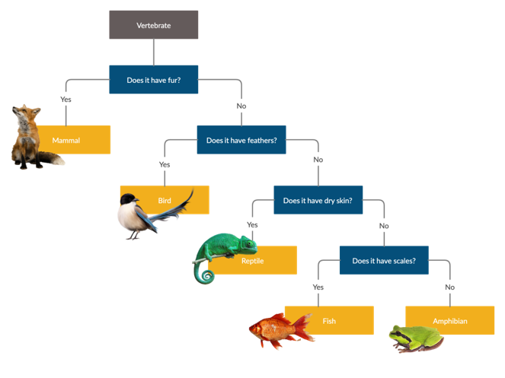
Research the following terms:
- Plants, fungi and animals
- Species
- Evolution
- Taxonomy (in biology)
To use a dichotomous key, we answer a set of yes-no questions that lead us down the branches of a decision tree until we get to the bottom. At the bottom, we have the name of the object or organism that we were trying to classify.
The image below is an example of a dichotomous key for objects you may find in your kitchen.

Science and Technology

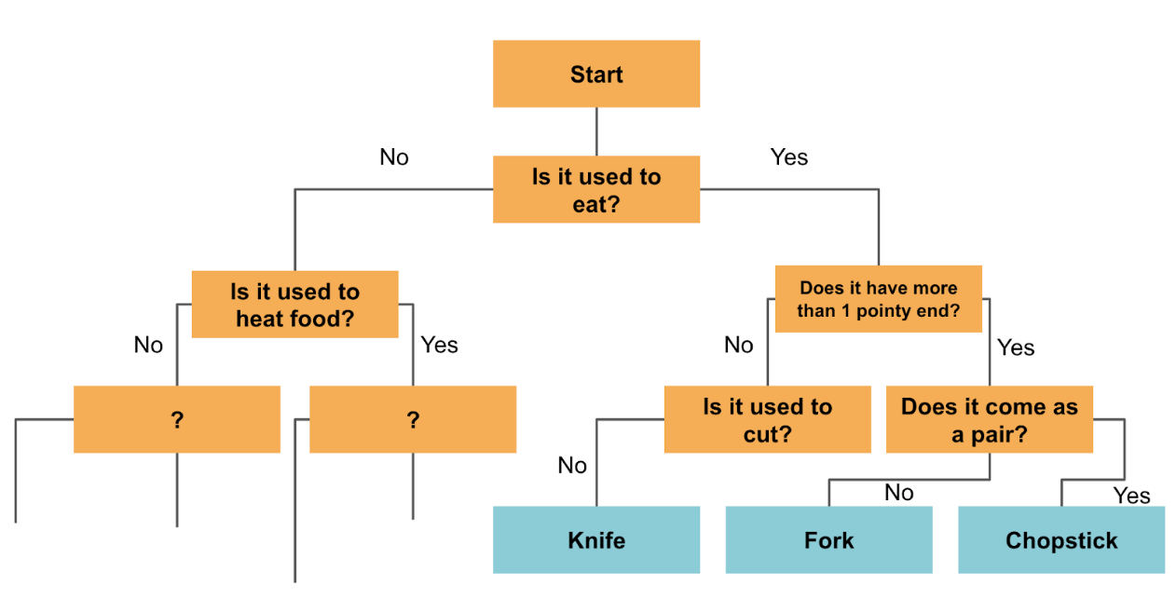
Continue adding yes-no questions to this dichotomous key until you can classify all the objects in your kitchen.
Use the dichotomous keys found in Appendix A to identify the trees in your yard or park.
You can also use this online dichotomous key to identify the trees in your yard or park (optional)
- https://www.eekwi.org/explore/identification/dichotomous-tree-key
- Try to code your own digital dichotomous key to identify household pets by using the one shown here as an example: https://scratch.mit.edu/projects/100170286/

Materials required
Device with Internet access (optional)
Paper, writing and drawing materials
Access to a kitchen

Information for parents
Help your child find the link to the websites, if necessary.
Read the instructions to your child, if necessary.
Discuss the questions together.
Brief video explanation: https://www.youtube.com/watch?v=UGSW8aFvr_Q (optional)

Science and Technology

Appendix A: Species and Dichotomous Keys Activity
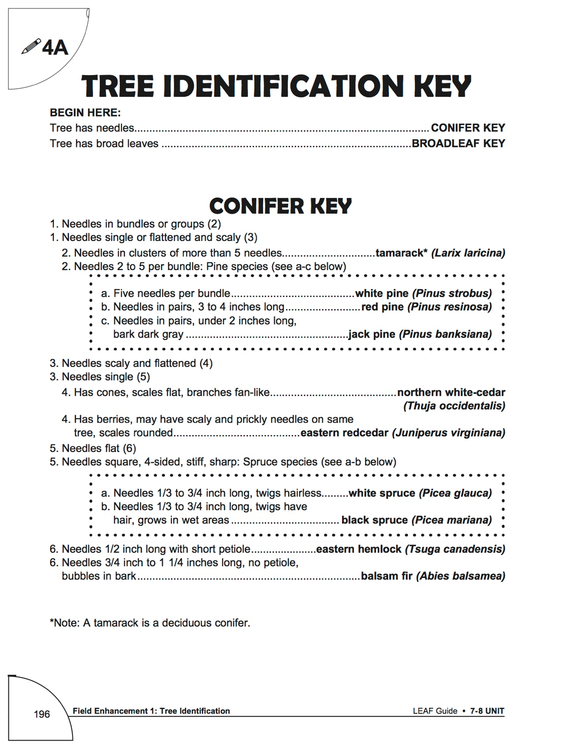

Science and Technology

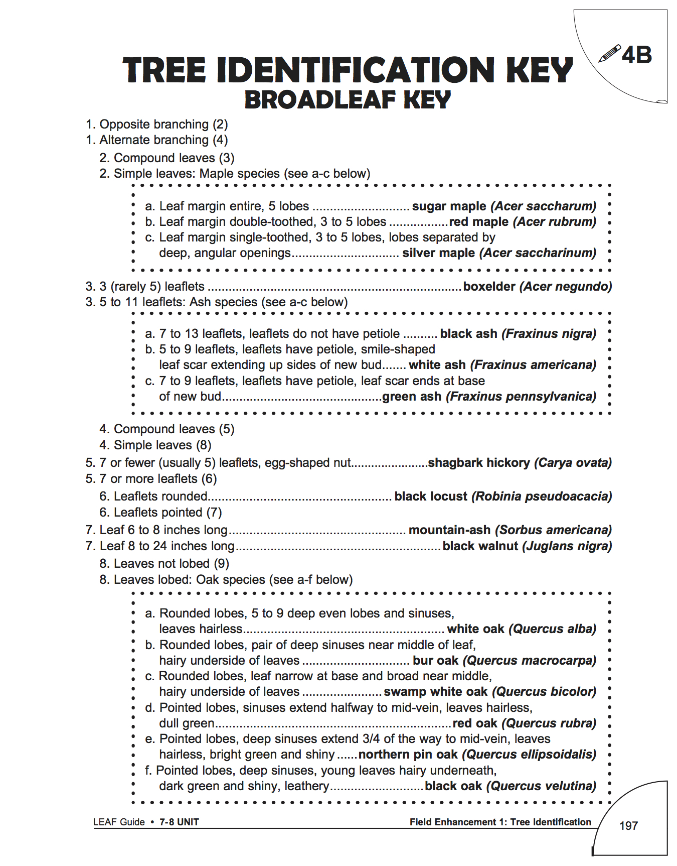

Science and Technology
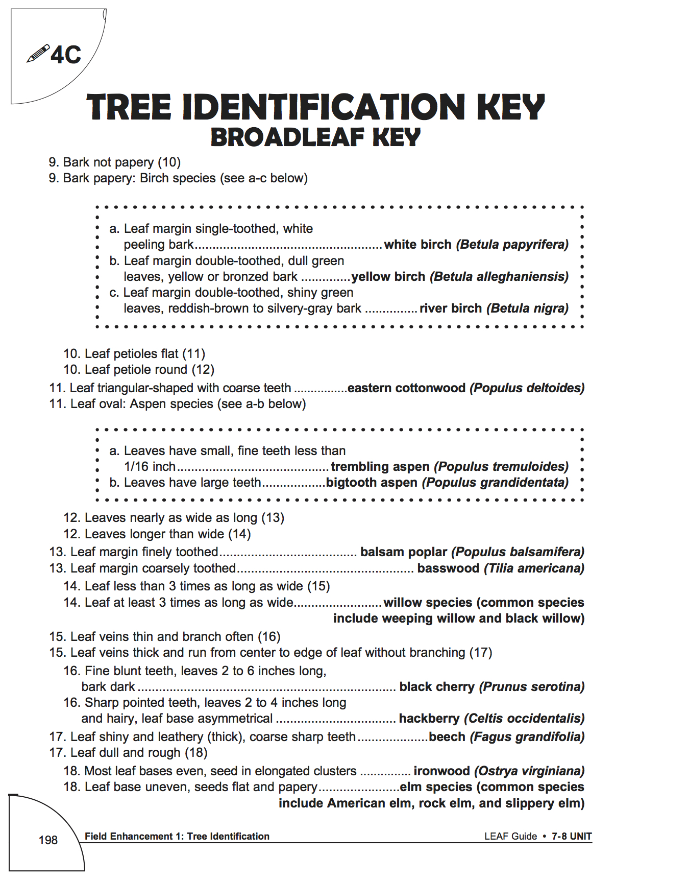

Physical Education and Health

Think About What Matters and Get Moving!

Information for students
Activity 1: It’s what’s on the inside that counts!
- Watch this video.
What are your thoughts after watching the video? Do you think that society places too much importance on looks? If so, can you name examples of this? Discuss the topic with an older member of your family.
Think of three qualities you have that do not have anything to do with looks. Think of a friend of yours and name three qualities that you like about them (and that are not related to the way they look).
Activity 2: Improve your stamina, speed and agility!
Change up your workout and improve your skill-related fitness by developing your stamina, speed and agility.
- Complete the 14-minute workout in this video. Don’t forget to warm up first!
If you are up for practicing your French and want to explore more activity ideas, visit the Rest Actif! website.

Materials required
None

Information for parents
Children should:
reflect on the focus society places on looks
complete a workout to develop their stamina, speed and agility
Parents could:
support their children by discussing appearance and what matters most to them
complete the workout with their children

Arts

Mindful Art Moment

Information for students
Take a moment to think about all the little and big things you’re grateful to have despite the challenging times we’re facing at the moment. It can be your family, being able to connect with your friends, your video games… anything goes!
Make a list of 10 of these items.
On a piece of white paper, slowly and carefully trace each hand. Think about how you want to position your fingers. Will they be spread out? Closer together?
Consider how you will position both hands. Side by side? Facing each other? Spread like the wings of a bird?
Inside the tip of each finger, write one word from the list you made at the beginning of the lesson.
Using your markers or colored pencils, create patterns or mandala-like designs.
Fill in your design by being mindful of the colours. Will you pick only your favorites? Will you pick the ones that match your current mood?
Once the art work has been completed, place it somewhere in your house as a reminder of all the things that make you smile and feel happy in these trying times.

Materials required
Plain white paper
Pencils
Markers or colouring pencils

Information for parents
You can assist your child with this mindfulness technique by helping them write their list of 10 items. This may help them be aware that there are many things to be grateful for even if they might be feeling low-spirited at times.
An extension to this lesson might be to get all members of the household to go through the same process and tape all the art work together. Creating a collage by cutting and gluing the hands in a desired fashion could also be another possibility.

Ethics and Religious Culture

Challenging Gender Stereotypes (Part 2: Miss Representation)

Information for students
Watch the trailer for the film Miss Representation. If you’re interested in watching the full documentary, the link is provided below.
Write a short reflection on the video. Consider some of the following questions in your reflection:
- What have you learned?
- What information surprised you?
- What do you think it means to be feminine?
- What do you think it means to be sexy?
- What are some common female stereotypes?
- What impact can these stereotypes have on romantic relationships?
- What are some qualities about yourself you are most proud of?

Materials required
Paper, pen or pencil, device with Internet access
Short trailer for the film (required): https://www.youtube.com/watch?v=keVhWR9esmA
If you are interested in watching the full documentary: https://www.youtube.com/watch?v=gx-Ou03fj0c
If you are interested in learning more about The Representation Project:
http://therepresentationproject.org/about-us/

Information for parents
Please note that the documentary may contain images and language of a sexual and/or violent nature.
This activity teaches the importance of challenging gender stereotypes and being confident with our identity.

History and Citizenship

Rights and Freedoms – Part 2

Information for students
In 1948, the United Nations (UN) released the Universal Declaration of Human Rights. Today there are 192 member states of the UN, all of whom have signed on in agreement with the Universal Declaration of Human Rights. This document outlines 30 different fundamental human rights.
Do you know your human rights? What about the people around you?
On a sheet of paper, brainstorm as many of the 30 human rights that you can think of. Refer to Appendix 1 to fill in the ones that you are missing.
Click on the following link to find out more about the evolution of human rights:
https://www.youthforhumanrights.org/what-are-human-rights/

Ask at least three other people (parents, siblings, friends, etc.) to identify as many human rights as they can. How did they do? Was anyone able to name all 30?
Pick one fundamental human right that is meaningful or important to you or, based on the answers of the people you talked to, a human right that you think people should know more about.
- Create a public service announcement to let the world know about this human right. (A public service announcement informs or educates others about a topic or an issue.)
- Your public service announcement can be in the form of a poster or a 30-60 second video.
To help you create your poster or video, click on the following link for examples of human rights public service announcements created by Youth for Human Rights:
https://www.youthforhumanrights.org/what-are-human-rights/videos/born-free-and-equal.html

Take it to the next level:
Share your public service announcement with friends and family, especially with the people you asked about human rights.
If you created a video, share it on YouTube.

Materials required
Useful resources, depending on personal preferences and availability:
Device with Internet access
Device with access to a video camera
Writing materials (paper, pencil, etc.)

History and Citizenship

Information for parents
Go over the list of 30 human rights and freedoms with your child. Discuss why they are important.
Ask your child which ones are the most meaningful to them and why.

History and Citizenship

Appendix 1 – Universal Declaration of Human Rights
https://www.youthforhumanrights.org/about-us.html
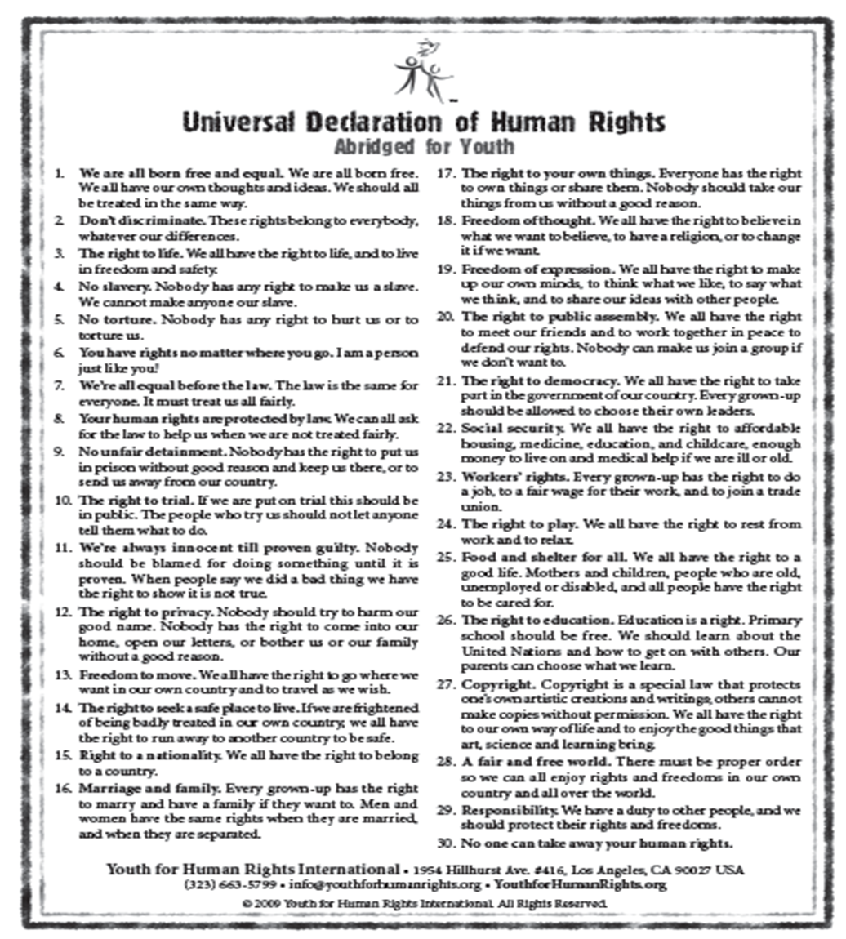

361699, PxHere, n.d., JPEG, https://pxhere.com/en/photo/361699
Image taken by Claudia Anzovino (2020)
Amanda Athuraliya, Dichotomous Key for Animals, n.d., PNG, Creately.com, https://app.creately.com/diagram/XIiBxZ4XyAp/edit
Wisconsin Department of Natural Resources - Division of Forestry and Wisconsin Center for Environmental Education, Tree Indentification Tools, 2012, in Wisconsin K-12 Forestry Lesson Guide: 7-8 UNIT (Stevens Point: University of Wisconsin, 2012), https://www.uwsp.edu/cnr-ap/leaf/Documents/LEAFTreeIDKey2014November172014.pdf

