secondary II
Week of June 15, 2020
Table of Contents
Food 2
Replonger dans ses souvenirs 3
Looking at Equations in Different Ways 4
Appendix A – Looking at Equations in Different Ways 5
Appendix B – Hints and a Possible Solution 6
Chemical Elements 9
Appendix A – Chemical Elements 11
Appendix B – Possible Answers 13
Learn About the F.I.T.T. Principle and Do a Tabata Workout! 14
Music in Isolation 16
Appendix – Music in Isolation 18
June 21st: National Indigenous Peoples Day 19
Map Challenge 20
Appendix – Map Challenge 21

English Language Arts

Food

Information for students
- Read “Fish Cheeks” and “Plate of Peas.”
- Choose one of the stories and answer the following questions:
- What problems is the child experiencing in the story?
- Describe the mother.
- What lessons did the child learn in the story?
- Is the title appropriate for the story? Why?
“Fish Cheeks” by Amy Tan
https://www.ncps-k12.org/cms/lib8/CT01903077/Centricity/Domain/638/LA/Short%20Story%20-%20Fish%20Cheeks.pdf
“Plate of Peas” by Rick Beyer
http://www.imthatteacher.com/wp-content/uploads/Plate-of-Peas-1.pdf

Materials required
Device with Internet access
Paper and writing materials

Information for parents
Parents could:
read the story their child has chosen and discuss it with them.

French as a Second Language

Replonger dans ses souvenirs
Information for students
Tu as certainement plusieurs photos chez toi, que ce soit dans un téléphone, dans un ordinateur, ou en version imprimée. Pourquoi ne pas profiter du temps que tu as pour créer un album ?
- Choisis d’abord les photos que tu souhaites regrouper sous un même thème.
Exemples : Chalet – Été 2019, Amis – 1re ou 2e secondaire, Famille – Noël 2019
- Organise les photos sur une feuille ou dans une application pouvant servir à conserver des photos, comme BeFunky ou PowerPoint.
- Rédige une courte explication du contexte dans lequel chaque photo a été prise ou raconte une anecdote afin de garder des souvenirs concrets.
Pour aller plus loin
Présente ton album aux personnes de ton choix et explique-leur pourquoi ces photos sont importantes pour toi.
#MissionFLS : J’organise un album photo et j’ajoute un court texte en français pour décrire les photos.

Materials required
Papier, crayon
Photos de ton choix
Appareil avec accès à l’Internet
BeFunky (https://www.befunky.com/fr)

Information for parents
Students should:
use photos to remember and talk about past events
read and write short sentences in French
practise saying verbs in the past tense
Parents could:
ask questions about the photos chosen by their children
look at the photo album their children created and listen to them give explanations in French
share the album with friends and members of the family, with their children’s consent

Mathematics

Looking at Equations in Different Ways

Information for students
The ability to look at equations in different ways is essential as you move forward to Grade 9. Understanding how changing the value of the variable and the constants can affect the solution to the equation will help you to deepen your understanding of the rate of change and to make connections in solving systems of equations.
Instructions
Answer the questions in Appendix A. Try to find more than one solution for each question.
Hints as well as a possible solution can be found in Appendix B.

Materials required
Appendix A – Looking at Equations in Different Ways (It can be printed, but it is not necessary.)
Writing tools
Calculator
Paper to do calculations

Information for parents

About the activity
Children could:
answer the questions in any order
answer all three questions or focus on coming up with multiple solutions to some of the questions
Parents should:
help their child get the necessary materials printed and organized, if needed
remind their child that these questions are more challenging than simply solving equations and that they should expect to have to make a few attempts; it will be important to encourage them to persist
hints and a possible solution are found in Appendix B
Mathematics

Appendix A – Looking at Equations in Different Ways

Information for students
Instructions
Answer each of the questions below. Try to find more than one solution for each question.
Question 2
Two equations of the form $ax + b = c$ have the same solution. In the first equation, $a = 4$ and in the second equation, $a = 5$. The value of b in the second equation is 1 greater than the value of b in the first equation. What could the equations be? How do these changes affect the value of constant c? Explain why this relationship must be true.
Question 3
An equation that includes the number 24 has the same solution as $3x - 8 = 12$. What might the equation be?
Question 1
The solution to five different equations is $x= -1$. At least one equation has an ‘$x$’ on both sides. What might the five equations be?
Mathematics

Appendix B – Hints and a Possible Solution

Information for students
Below are hints and a possible solution for each of the three questions.
Question 1
Hints:
If your solution was $x = 1$, what could the numbers for each side of the equation be? How does the coefficient of the variable on one side of the equation relate to the constant on the other side of the equation?
How can you change the equation to make the solution $x = -1$?
If you include a variable ‘x’ on the right side of the equation, what change will you have to make to the constant on that side to maintain the equality in the equation?
Some Possible Solutions:
$$2x = -2$$
$3x -7 = -10$, which is $3x =-3$ when simplied
$5x – 10 = -15$, which is $5x = -5$ when simplified
$4 – (-2x) = 2$, which is $2x = -2$ when simplifed
$2x – 12 = x – 13$, which is $1x = -1$ when simplified
There are a variety of other possible solutions where the coefficient of the variable on one side of the equation is equal to the opposite of the constant on the other side of the equation once the equation is simplified before solving for x.

Mathematics
Question 2
Hints:
It may be helpful to set the value of the variable in order to determine the two equations.
How can the value of the constants “a” and “b” on the left side of the equation relate to the value of the constant “c” on the right side of the equation?
How does the difference between the value of c in the first equation and the value of c in the second equation relate to the changes in the values of “a” and “b”?
Some Possible Solutions:
Let $4x + 9 = 61$ be the first equation. Then the second equation would be $5x +10 = ?$. Given that the solution to the first equation is $x = 13$, then the second equation would be 5x +10 = 75. The difference between the two c values is $75 - 61 = 14$. The 14 comes from an increase of 13 (the change from $4x$ to $5x$) and 1 (the increase from 9 to 10). Therefore, the value of the second c constant will always be increased by the value of the variable plus 1.
A second example could be $4x - 9 = 19$. In this equation, the value of x would be 7. Then $5x - 8 = 19 + 8 = 27$. Check that value of $x$in the second equation is in fact 7.
How does this work algebraically? If the first equation is $ax + b = c$, then the second equation would be $\left(a+1\right)x + \left(b+1\right)= ax + x + b + 1$
$$= ax + b + x +1$$
$$= c + x +1$$

Mathematics
Question 3
Hints:
How can you use multiplicative properties to change one of the values in the equation to 24?
What do you need to remember in order to preserve the equality in the equations as you multiply?
Some Possible Solutions:
The idea is to make one of the values 24 by using multiplicative properties. For example:
$24x – 64 = 96$ would work. To change the $3x$ to 2$4x$, you will need to multiply by a factor of 8 and to do this for all three terms. $8(3x – 8= 12)$ will give us $24x – 64 = 96$.
$9x – 24 = 36$ would also work. To change the -8 to -24, you will need to multiply by a factor of 3 and to do this for all three terms. $3(3x – 8 = 12)$ will give us $9x – 24 = 36$.
$6x – 16 = 24$ would also work. To change the 12 to 24, you will need to multiply by a factor of 2 and to do this for all three terms. $2(3x – 8 =12)$ will give us $6x – 16 = 24$.

Science and Technology

Chemical Elements

Information for students
Elements are everywhere. For instance, the average smartphone is made up of around 70 different elements, including gold, silver and copper. In this activity you will explore the main elements that make up some of the different objects around you.
In Part 1, you will think about the elements that make up some of the matter around you.
In Part 2, you will do some research to find out what elements make up an everyday object and present your findings in an infographic.
An element is a substance that is made up of only a single type of atom. If you need a refresher on atoms and elements you can watch this video.
There are 118 different elements, and these elements are organized in the periodic table. You can learn about the names, symbols and some of the properties of these elements by consulting the periodic table in your textbook or one of the many periodic tables online. Try exploring this Periodic Table in Pictures, which provides examples of the uses of the different elements.
Elements can combine to make new substances. For example, water (H₂O) is made up of the elements hydrogen (H) and oxygen (O).

Materials required
Appendix A: Chemical Elements
Paper and writing materials
Periodic table
Device with Internet access for research (Part 2)

Science and Technology

Information for parents

About the activity
Children should:
explore what chemical elements make up some of the matter around them
do some research to determine the main elements that make up an everyday object
present their findings in an infographic
Parents could:
read the instructions to their child, if necessary
discuss the answers to Part 1, provided in Appendix B, with their child
discuss the results of the research in Part 2 with their child

Science and Technology

Appendix A – Chemical Elements

Part 1: What elements make up the matter around you?
- Different examples of matter are provided below. Write down what you think are the main elements that make up each of these examples of matter. You can refer to the periodic table to help you think of the elements.
Example | What are the main elements?
Ice cube
Air
Glass in a window
Paper
Table salt
Stainless steel spoon
Plastic spoon
- Check your answers in the Appendix. What do you notice? Did anything surprise you?
- a) What are the properties of an ice cube?
b) What are the properties of the elements that make up an ice cube?
c) Why do you think the properties of an ice cube are different from the properties of the elements that make up an ice cube?

Part 2: Create an infographic about the elements in an everyday object
An infographic uses images, charts and text to present an overview of a topic. An infographic is designed so that information can be communicated quickly and clearly.
For this part of the activity, you will do some research to determine the main elements found in an everyday object and then create an infographic to effectively communicate your findings.
Here is an example: The Chemical Elements of a Smartphone.
Follow the steps below to create your infographic.
Choose an object to research such as a pencil, a light bulb or something else that interests you.

Science and Technology

List the different parts of the object and the materials that make up the object.
- For example, for a pencil, you might list the parts as: the pencil “lead,” the body, the eraser holder, and the eraser. Then, you can determine the different materials that each part is made from (e.g. the body of the pencil is made from wood). You might have to do some research to find out what the materials are.
Then, for each material that makes up the object, do some research to find out the main elements that make up the material. You can also make note of interesting information about the properties of the materials and the elements.
You could use a table similar to the one below to help you organize your work.
Part | Material | Main Elements | Interesting Information
Now that you have completed your research, think about how you could organize and present the information in the form of an infographic.
- Which information will you include? Can the information be grouped into categories?
- What pictures or graphics could you use to best communicate the information?
- Does the information need to be presented in a certain order?
You can make your infographic using paper and writing materials or using digital tools. Look up different examples of infographics to inspire you.

Science and Technology

Appendix B – Possible Answers

Answers for Part 1
Answers for some of the questions in Part 1 are provided below.
- Here are the main elements that make up the examples of matter. There may be other elements present in some of these examples; only the main elements are provided. Note that elements can combine to make new substances.
Example | What are the main elements?
Ice cube | Hydrogen and oxygen
Air | Nitrogen, oxygen, carbon, argon
Glass in a window | Silicon, oxygen
Paper | Carbon, hydrogen, oxygen
Table salt | Sodium, chlorine
Stainless steel spoon | Iron, carbon, chromium, nickel
Plastic spoon | Carbon, hydrogen
- a) Some of the properties you may have listed could include: solid, melting point 0 °C, transparent, colourless.
b) Some of the properties you may have listed could include:
hydrogen gas, colourless, odourless, flammable, “pops” in the presence of a lighted wooden splint
oxygen gas, colourless, odourless, reignites a glowing wooden splint
c) When hydrogen and oxygen combine to form water, a chemical change occurs. In chemical changes, new substances with different properties form.

Physical Education and Health

Learn About the F.I.T.T. Principle and Do a Tabata Workout!

Information for students

Activity 1
You have probably learned about the F.I.T.T. principle already. Watch this video as a review.
Think about setting a fitness goal for yourself using the F.I.T.T. principle:
- Frequency: how many days a week would you train?
- Intensity: how hard would your training sessions be? (e.g. jogging on flat ground while maintaining the ability to talk comfortably the whole time may be less intense than running intervals or running up mountains, although both are excellent ways to stay healthy!)
- Time: how long will you train for?
- Type: what kind of exercise will you do? Different activities improve your fitness in different ways.
Talk to a family member about their physical activity. Do they use the F.I.T.T. principle when they plan their physical activity?

Activity 2
Do you know what Tabata training is?
Tabata training is a high-intensity interval training (HIIT) workout, involving exercises that last four minutes. You could do the same exercise the whole time, or change it up. The four minutes are broken down as follows:
- Perform high intensity exercises for 20 seconds.
- Rest for 10 seconds.
- Following this cycle for 4 minutes means you will complete 8 rounds of 20 seconds of exercise.
Tabata training uses the F.I.T.T. principles of intensity and time – because it’s a short workout, its high intensity!
With Tabata workouts where you do the same exercises (e.g. squats) for all 8 rounds, the idea is to work hard from the start then strive to maintain the same number of repetitions that you did in the first round. For example, if you did 15 squats in the first 20-second round, you want to try to do that number of repetitions in the other 7 rounds. Your body will be getting more and more tired, so it will be tough! Remember to maintain proper technique. Slow down or stop if you get too tired to do the exercises properly.
Try this 4-minute Tabata workout. For the push-ups, do any of the variations shown below according to your personal fitness level.

Physical Education and Health

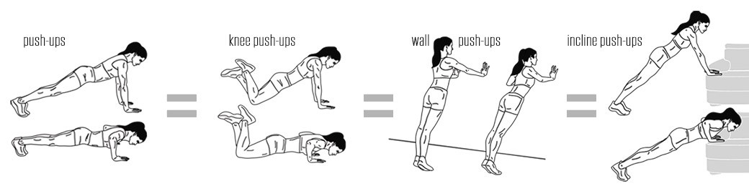

Materials required
None

Information for parents

About the activity
Children should:
learn about the F.I.T.T. Principle
complete a Tabata workout
Parents could:
discuss the F.I.T.T. Principle with their children
complete the Tabata workout with their children

Arts

Music in Isolation

Information for students
We are living in extraordinary times.
This era will have historical significance because time stood still and we were forced to be isolated.
Yet, while we are separated, musicians and artists have been inspired to come together (virtually) and produce music. These collaborations exemplify the tenacity and creativity of the human spirit.
Your task is to create a chart which catalogues selections of the extraordinary music which is being created in this moment in time.

Materials required
Pencil or pen
Paper
Device with Internet access (video-sharing and music sharing websites)

Instructions
Step 1: Locate examples of music created in isolation
Examples of key search terms are "virtual choir," "quarantine edition" or "stay at home edition."
Step 2: Listen to the recording with a critical ear
Is this a recording which you believe will stand the test of time?
What qualities make this recording stand out to you?
Write down all of your ideas!
Step 3: Annotate your selections in your table (see the appendix)
This step is important as it gives the piece historical context.
What is the rationale behind the recording?
Why was this music created?
Who created it?
Was there cause or fundraising goal?
Be sure to add this to your description of the recording.
Step 4: Share your findings!
This step is crucial. You need to share your findings with others!
Share this incredible music and this remarkable period in musical history.

Arts

Here is a sample chart to get you started.
Music in Isolation Sample Data Collection Chart
Artist/Name of Song | URL/Source | Description of the Recording
1. Ottawa Bach Choir: O Canada | https://www.youtube.com/watch?v=QIoH_8jBoRA | Director, Lisette Canton, leads the Ottawa Bach Choir in the singing of our national anthem in support of the movement: #canadatogether  Notable fact: 4th person from the left is our Governor General, Julie Payette
2. Michael Bublé, The Barenaked Ladies & Sofia Reyes: Gotta Be Patient | https://www.youtube.com/watch?v=QP-vO6jwnxI | Canadian musicians Michael Bublé, Barenaked Ladies, and Sofia Reyes came together to perform “Gotta Be Patient” as part of the Stronger Together, Tous Ensemble broadcast, which raised funds for Food Bank Canada amid the ongoing novel coronavirus pandemic and in support of frontline workers.
5. Celine Dion, Andrea Bocelli, Lady Gaga, Lang Lang, John Legend: The Prayer | https://www.youtube.com/watch?v=SYJCYr1I-Sk | Performed during One World: Together At Home on April 18, 2020.  In support of the social action platform, Global Citizen.

Information for parents

About the activity
Children should:
share their findings with the hashtag: #musicinisolation
use the appendix to collect their data
Parents could:
encourage their child during the research portion of the activity
make suggestions of recordings or videos they have seen
discuss the selections once the chart is complete
encourage their child to continue adding to the chart

Arts

Appendix – Music in Isolation
MUSIC IN ISOLATION DATA COLLECTION CHART
Artist/Name of Song | URL/Source | Description of the Recording

Ethics and Religious Culture

June 21st: National Indigenous Peoples Day

Information for students
Many people do not know that June 21st is an important holiday in Canada. It is known as Indigenous People’s Day and is celebrated to honour the heritage, culture and contributions of Indigenous people in Canada.
This week’s activity is meant to bring awareness to the valuable holiday and encourage students to familiarize themselves with Canada’s history and indigenous culture.
First, watch the short video “What is Indigenous.” https://www.youtube.com/watch?v=CISeEFTsgDA
Think about what you have learned in this short video that you did not know before.
What can you do to honour Indigenous people and celebrate Canada’s important holiday? The website below lists 10 ways Canadians can celebrate on June 21st that will honor indigenous peoples of Canada. Choose one way you can celebrate. To help you choose, think about your current level of knowledge on indigenous culture, history, and social issues. If your level of knowledge on indigenous issues and culture is low, use the internet to help you research indigenous issues. If you have a high level of knowledge, consider filling out a personal pledge of reconciliation.
https://www.ictinc.ca/blog/national-aboriginal-day-10-ways-to-celebrate

Materials required
Device with Internet access

Information for parents
Visit the websites listed above. Have a discussion with your child about Indigenous people in Canada. Consider the following questions: What have you learned that you did not know before? Were you aware that June 21st is National Indigenous People’s Day in Canada? What do you think Canadians can do to reconcile the relationship with Indigenous people?

Geography

Map Challenge

Information for students
This activity is a map challenge. In the Appendix, you will find blank maps of Canada, the United States and Europe. Your challenge is to identify as many countries, provinces/territories/states and capital cities as possible without looking at an atlas or your textbook. See how many places you can identify on your own and then use an atlas, your Issues and Territories textbook or the Google Earth site to fill in the rest.
Instructions
Look at the maps in the Appendix and provide the information requested.

Materials required
Useful resources, depending on personal preferences and availability:
Device with Internet access
Writing materials (paper, pencils, etc.)
Atlas
Printer

Information for parents

About the activity
Children could:
do the task with a friend or, working separately, see who can identify the most places on their own (As an added challenge, they could also identify major lakes, rivers and other bodies of water.)
Parents should:
do the challenge with their child to see how many places each of them can find on their own (Parents can help their child fill in the blanks using an atlas, the textbook or the Internet.)

Geography

Appendix – Map Challenge

Information for students
Blank map of Canada
Look at the example provided. Identify each province, territory and capital city.
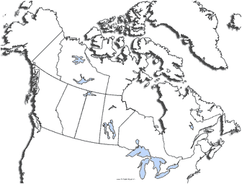
Nova Scotia: Halifax
Geography

Blank map of the United States
Florida: Tallahassee
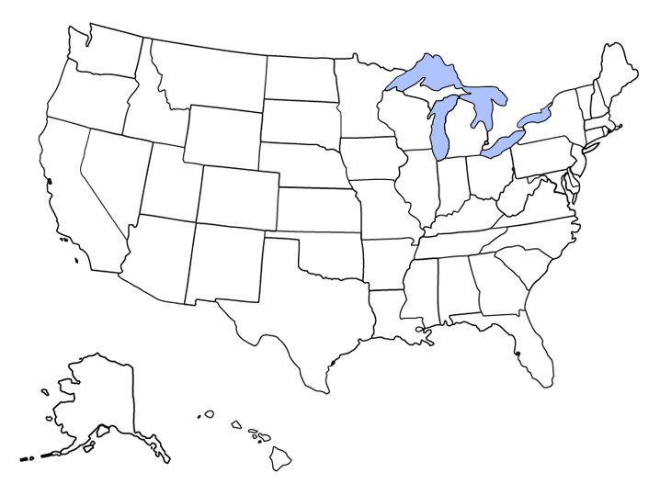
Look at the example provided. Identify each state and capital city.

Geography

Blank map of Europe
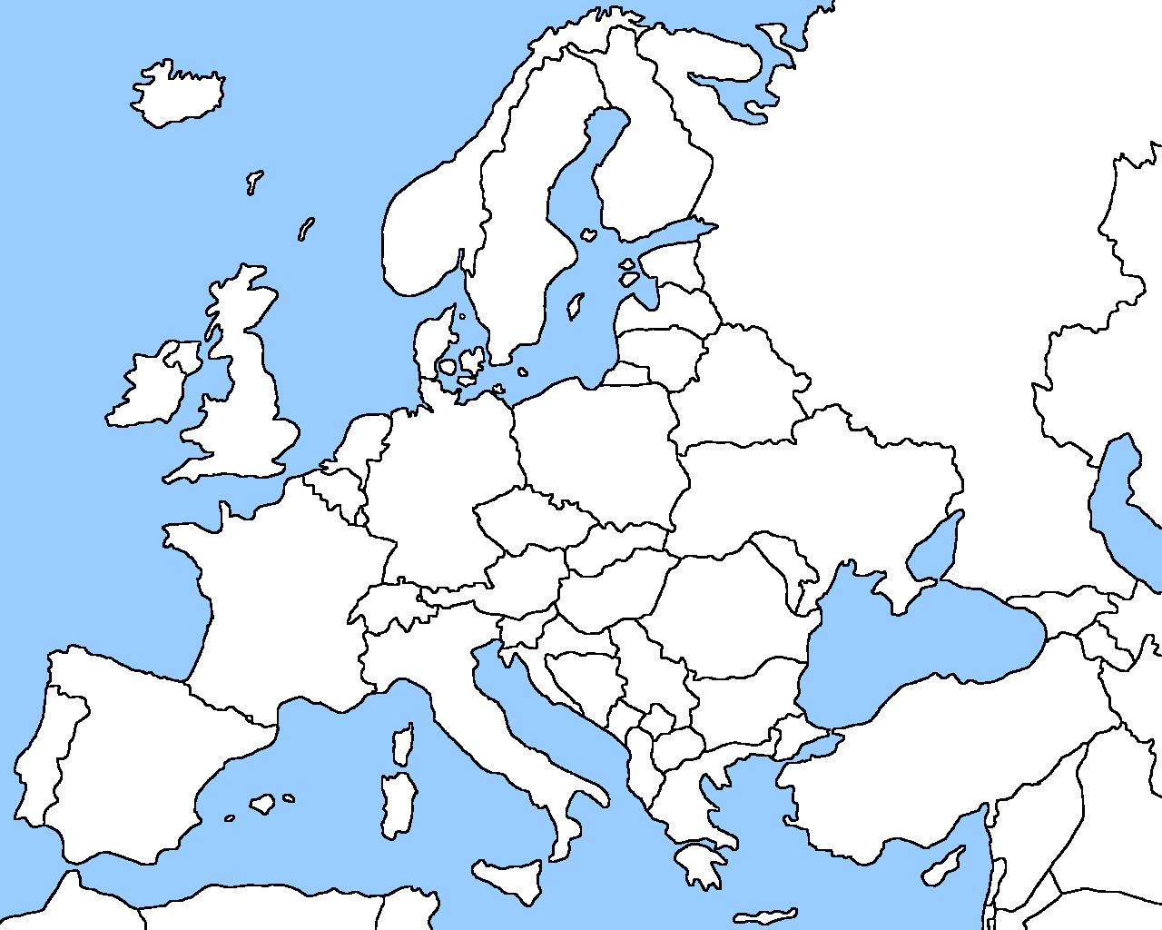
Look at the example provided. Identify each country and capital city.
Portugal: Lisbon

Modified from “Patterns and Algebra: Consolidation Questions,” in Marian Small, Open Questions for the Three-Part Lesson: Measurement Patterning and Algebra. Oakville, ON: Rubicon Publishing Inc., 2016, pp.181-182.
Kim Preshoff, “What’s a smartphone made of?” October, 2018, Ted-Ed Video, 4:47, https://www.ted.com/talks/kim_preshoff_what_s_a_smartphone_made_of/transcript?language=en#t-47108.

