Weekly Educational Options From the Ministère
secondary I
Week of June 1, 2020
Table of Contents
Who Are You? 2
#Mission FLS : Ça me dit de rire ! 5
What’s in a NAME? 6
Appendix A – What’s in a NAME? 8
Learn About the Canadian 24-Hour Movement Guidelines and Get Moving! 10
Messages on Stone 11
Appendix – Messages on Stone 13
Student-Led Inquiry Lab on Roman Roads 14

English Language Arts

Who Are You?

Information for students
Who are you? The Merriam-Webster online dictionary defines “identity” as the distinguishing character or personality of an individual. Take some time to explore your individuality, your identity and what makes you, you.

Instructions
Read the following three poems. Then, answer the questions that follow.

Time Somebody Told Me
by Kacy

Time somebody told me
That I am lovely, good, and real
That I am beautiful inside,
If they only knew how that would make me feel
Time somebody told me
That my mind is quick and sharp
That my humor is full of uncensored wit
That I should keep on trying and never quit
Time somebody told me
How they loved and needed me
How my smile is filled with hope and my spirit sets them free
How my eyes shine full of light
How good they feel when they hug me tight
It's Time somebody told me
So, I had a conversation with myself
Just me
Nobody else
Cause it was time....Somebody told me.

Face it
by Janet S. Wong

My nose belongs
to Guangdong, China -
Short and round, a Jang family nose.

My eyes belong
To Alsace, France-
wide like Grandmother Hemmerling’s.

But my mouth, my big-talking mouth, belongs
to me, alone.

English Language Arts

Almost Ready
by Arnold Adoff
as
this
cool
and
in-
control
young
dude:
I
am
going
to
her
birth-
day
party

as
soon
as
I
find
my
deep
voice,
as
soon
as
I
find
my
right
mask.
as
soon
as
I
find
my
hip
shoes,
as
soon
as
I
find
my
new
shirt,

- What do you think the authors of these three poems are trying to say about their identity? Choose one of the poems and list the ways the writer would define themselves, both their personality and appearance. Remember, this might be related to what they say directly, but also what they hint at in their writing.
- Think about how you would define your identity? Would you define yourself as a son/daughter? Friend? Brother/sister? Student? Athlete? Reader? What aspects of your personality, interests, appearance and ancestry make you into you? Do you show an outside that looks different from how you feel on the inside? How much of your identity is related to how other people see you?
- Has the definition of your own identity changed over the last 2 months? Would you still define yourself as an athlete if you can’t play sports? Are you still a good friend if you can’t see the people you are friends with? What have you learned about yourself over the last few weeks? Have you added to your identity: learned a new skill, found a new interest?
- Brainstorm aspects of your identity (list, quick write, sketch, etc.)
- Using your brainstorm as inspiration, write a short piece where you share your identity and what makes you uniquely you. Choose the form that suits your personality best: a poem, narrative, letter, even an art piece, and that expresses what you consider to be the most important parts of your identity. Attempt to convey to your reader what makes you, you. Share your work with a family member or friend.

English Language Arts

Materials required
Poems: “Time Somebody Told Me” by Kacy (https://www.poems-and-quotes.com/poems/1235428) and “Almost Ready” by Arnold Adoff and “Face It” by Janet S. Wong (http://www.glencoe.com/sec/languagearts/ose/literature/course2/docs/g7u07.pdf)
Device with access to the Internet
Paper and writing materials

Information for parents
Children should:
- discuss their ideas with a parent or family member
- write their thoughts down on paper or record them electronically
- create a text that expresses their thoughts on their own identity and how it might have changed over the last 2 months
- choose the medium they feel suits their purpose the best (art, writing, video, etc.)
Parents could:
- discuss the instructions with their child.

French as a Second Language

#Mission FLS : Ça me dit de rire !

Information for students
Cette activité t’aidera à accomplir la mission FLS suivante : « J’imagine une mini pièce de théâtre ou un petit film en français avec ma famille ou virtuellement, avec mes amis ».
Qu’est-ce qui te fait rire ? Qu’est-ce qui fait rire les gens autour de toi ? Cette semaine, on t’invite à écrire un sketch rigolo !
Voici comment tu peux le faire:
pense à l’histoire que tu pourrais raconter
écris un court dialogue. Pour t’aider dans ton écriture, consulte cette capsule de LEARN: https://www.learnqueabec.ca/fr/ecrire-un-dialogue1
trouve des accessoires pour t’aider à réaliser ton sketch
joue-le avec les gens qui habitent chez toi ou filme-le avec un ami en ligne
Pour aller plus loin
Exprime ta créativité: utilise une application de création d’histoire comme Puppet Pal.
Publie ton sketch avec le mot-clic #MissionFLS.

Materials required
Écrire un dialogue
Puppet Pal
Mission FLS

Information for parents
In this activity, children will practise:
writing a short dialogue in French
creating a story about an anecdote from everyday life
Parents can:
share ideas about funny things their child could write about
be an actor in the sketch
watch the final product

Mathematics

What’s in a NAME?

Information for students
Look at the letters in the word NAME in the title. Do you notice all the angles that make up each letter? Your name written in block letters is made up of many different types of angles.
Let’s explore the angles in your name!

Instructions
Turn a blank sheet of paper horizontally. Then, use a ruler and pencil to write your name across the sheet of paper, using only straight lines (no curved edges) and using no more than 2 right angles.
Try to make the letters large enough to cover as much of the sheet of paper as possible (see the example in Appendix A).
Using a ruler, trace over your name with different coloured markers or pens.
If your first name has fewer than 5 letters, you can use your last name or middle name.
Use a protractor to determine the measure of every angle you can find for each letter of your name.
Try to use the measure of one angle to determine the measure of the other angles in each letter without measuring them (optional).
Answer the questions in Appendix A.

Materials required
A blank sheet of paper (8 ½ X 11)
Pencil
Ruler
Different coloured markers or pens
Protractor

Mathematics

Information for parents

About the activity
This activity will help students practice using a protractor to measure angles and identify right, obtuse, acute straight and reflex angles. This activity is for Secondary I students.
Children should:
review procedures for measuring angles, using a protractor, and identify different types of angles
Parents could:
help their child use a protractor to measure angles

Mathematics

Appendix A – What’s in a NAME?

Sample:
90º
In geometry, there are different types of angles. Can you match the name of the angle with its description?
- Acute _____ A 180-degree angle

- Right _____ An angle greater than 90 degrees but less than 180
degrees

- Obtuse _____ An angle greater than 0 degrees but less than 90 degrees

- Reflex _____ A 90-degree angle

- Straight _____ An angle greater than 180 degrees but less than
360 degrees
Which letter in your name has the greatest number of angles? _________

Mathematics
Now, list each angle measure and the type of angle in the table below.
Angle measure | Type of Angle

Physical Education and Health

Learn About the Canadian 24-Hour Movement Guidelines and Get Moving!

Information for students
Activity 1
Take a look at the Canadian 24-Hour Movement Guidelines for teens (click here and scroll down to page 4).
Read the recommendations for the four categories of daily activity: SWEAT, STEP, SLEEP, SIT.
Do you get the recommended amount of sleep each night? Do you do the recommended moderate-to-vigorous physical activity each day? What are the light physical activities that you do each day? (Hint: if you’re not sure what is considered “light” physical activity, click here, then click on the letter L).
Scroll down to the infographic (D). Do you already do any of the suggested tips for getting more active? Are you interested in trying any of them?
Discuss the movement guidelines and how well you meet the recommended time in each category with a parent.
Activity 2
Accumulate some SWEAT time with the Fitness Marshall. Follow this dance fitness workout.

Materials required
Device with Internet access

Information for parents

About the activity
Children should:
- learn about the Canadian 24-Hour Movement Guidelines
- complete a dance workout
Parents could:
- discuss the movement guidelines with their children
- complete the dance workout with their children

Ethics and Religious Culture

Messages on Stone

Information for students
Rock art is one of the oldest forms of communication in human societies. Take a look at these examples from the Musée de la Civilisation’s virtual exhibition, Images on Stone:
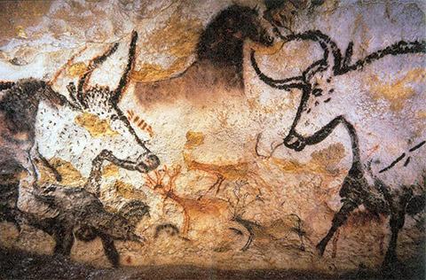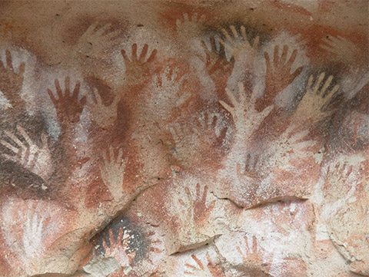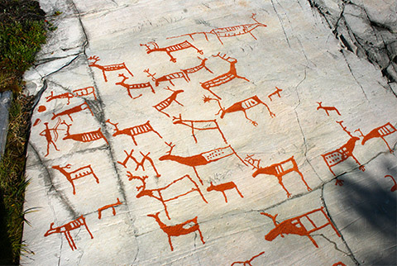
PETROGLYPHS TRACED OVER USING QUARTZ, ALTA, NORWAY Photo: Wikimedia Commons

NEGATIVE HANDPRINTS, ARGENTINA
Photo: Wikimedia Commons

PAINTING, LASCAUX CAVE, FRANCE
Photo: Wikimedia Commons

Prehistoric societies used rock art to represent religious and spiritual symbols related to myths, values and beliefs. The Musée de la Civilisation’s virtual lesson, Messages on Stone, offers the following information about rock art:
Why did Indigenous peoples create rock art sites?
- Rituals, including healing ceremonies and vision quests
- Shamanic practices
- Teachings, commemorations or historical accounts
- Marking of territorial boundaries
What types of images are found on rock art sites?
- Representations of supernatural beings
- Representations of historical events
- Symbols
The following activity allows you to explore an example of rock art and the associated myth from the Memekueshuat peoples. These images are found in Manitoba as well as in Québec.

Materials required
Device with internet access
Paper
Writing materials

Ethics and Religious Culture

Information for parents

About the activity
Students could:
view the Musée de la Civilisation’s virtual lesson, Messages on Stone, to gather information about the spiritual and religious aspect of rock art
- read the Memekueshuat legend that goes with the rock painting found in the Appendix and answer the questions
Parents should:
view the Musée de la Civilisation’s virtual exhibit on the spiritual and religious aspects of rock art with their child
read the Memekueshuat legend that goes with the rock painting in the Appendix, and discuss possible answers to the questions and the reasoning behind them with your child

Ethics and Religious Culture

Appendix – Messages on Stone

Information for students
Read the Memekueshuat legend that goes with this rock painting and answer the following questions:
What characteristics of Memekueshuat are revealed by this legend?
What values and beliefs significant to the Indigenous peoples are conveyed by this legend?
Legend and Questions
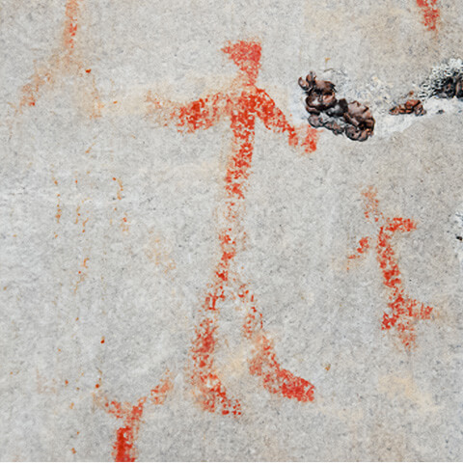
Source: https://imagesdanslapierre.mcq.org/wp-content/themes/mcq/img/nisula/representation/480/memekwueshuat.jpg

History and Citizenship

Student-Led Inquiry Lab on Roman Roads

Information for students
Step 1: Activate prior knowledge
Write down what you already know about Roman roads.
______________________________________________________________________________________________________________________________________________________________________________________________________________________________________________________
Step 2:
Observe the following image carefully and then record five observations in the table below:
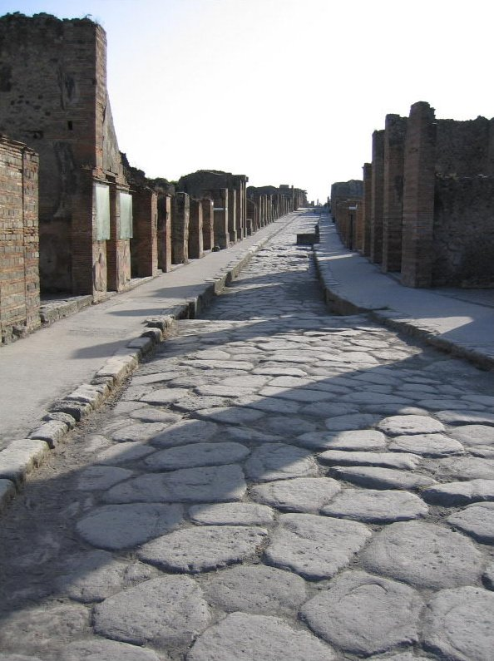
Source: Wikipedia
https://en.wikipedia.org/wiki/Roman_roads

History and Citizenship
Five observations about the image (What do I see?)

Observation 1:

Observation 2:

Observation 3:

Observation 4:

Observation 5:

Step 3: Make inferences
Based on your observations of the image, what do you think is going on? Make three inferences and explain your thinking for each one.

Inference 1:

Inference 2:

Inference 3:

Step 4: Discover the context of the image
The image is an example of a Roman road in Pompeii, Italy.
Step 5: Learn more about the topic
Click on this link to learn more about Roman roads or read the following text carefully:

History and Citizenship
“Roman roads (Latin: viae Romanae [ˈwɪ.ae̯ roːˈmaːnae̯]; singular: via Romana [ˈwɪ.a roːˈmaːna]; meaning "Roman way") were physical infrastructure vital to the maintenance and development of the Roman state, and were built from about 300 BC through the expansion and consolidation of the Roman Republic and the Roman Empire.^{[1]} They provided efficient means for the overland movement of armies, officials, civilians, inland carriage of official communications, and trade goods.^{[2]} Roman roads were of several kinds, ranging from small local roads to broad, long-distance highways built to connect cities, major towns and military bases. These major roads were often stone-paved and metaled, cambered for drainage, and were flanked by footpaths, bridleways and drainage ditches. They were laid along accurately surveyed courses, and some were cut through hills, or conducted over rivers and ravines on bridgework. Sections could be supported over marshy ground on rafted or piled foundations.^{[3][4]}
At the peak of Rome's development, no fewer than 29 great military highways radiated from the capital, and the late Empire's 113 provinces were interconnected by 372 great roads.^{[3][5]} The whole comprised more than 400,000 kilometres (250,000 miles) of roads, of which over 80,500 kilometres (50,000 mi) were stone-paved.^{[6][7]} In Gaul alone, no less than 21,000 kilometres (13,000 mi) of roadways are said to have been improved, and in Britain at least 4,000 kilometres (2,500 mi).^{[3]} The courses (and sometimes the surfaces) of many Roman roads survived for millennia; some are overlaid by modern roads.”
Source: Wikipedia
https://en.wikipedia.org/wiki/Roman_roads
The Roman Empire in the time of Hadrian (ruled 117–138), showing the network of main Roman roads.
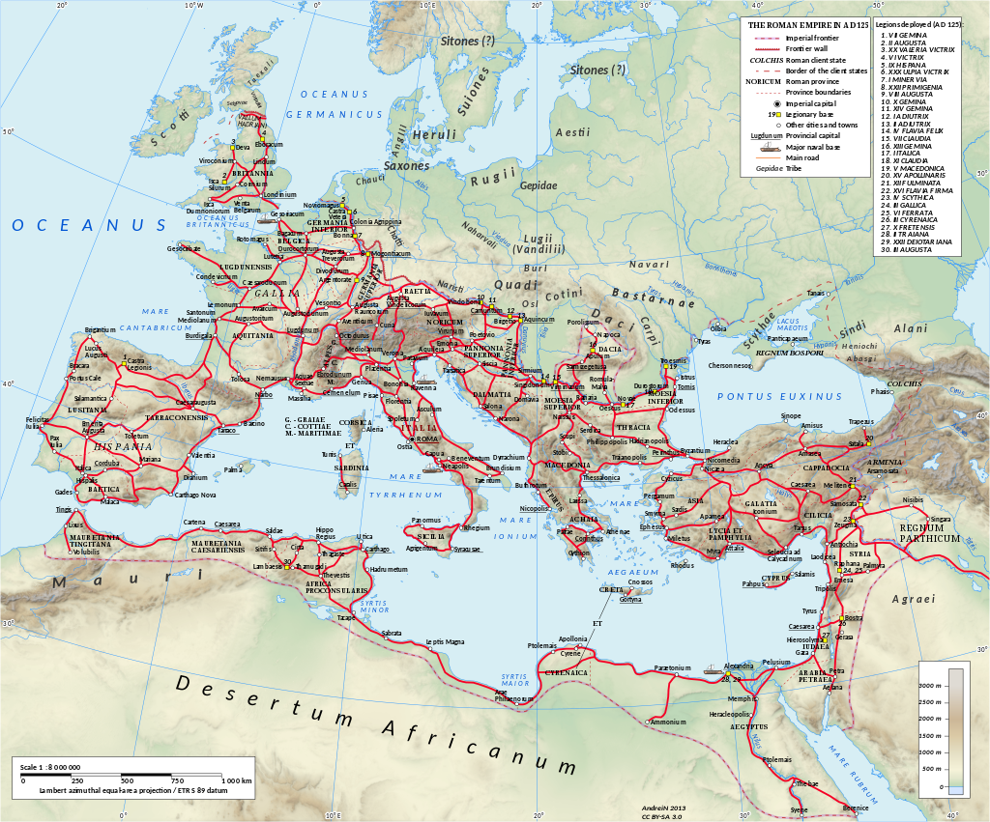
Source: Wikipedia
https://en.wikipedia.org/wiki/Roman_roads#/media/File:Roman_Empire_125_general_map_(Red_roads).svg
History and Citizenship
Step 6:
After you have read the article, what are you the most interested in or curious about? To generate inquiry questions, start by writing down as many questions as you can think of about Roman roads:
Questions that I have:

Step 7: Choose your best question…
Now place a star next to your favourite question, the one that you really want to research further.
Step 8: Research your question
You can use https://www.britannica.com/ to help you conduct your research.
My question:

What I have found out about my question:

History and Citizenship
Step 9: Present your findings to a friend or family member

Information for parents

About the activity
This activity is student-led. The student may at some point benefit from reading the instructions with a parent. The activity will take 2-3 hours.
If you do not have access to the Internet, an alternative is to choose an interesting historical image from a book or magazine about Ancient Rome and then use that image instead of the image at the beginning of this activity. Then, students can practise the same inquiry skills for the observation, inference and question-formation phases.

