secondary I
Week of May 11, 2020
Table of Contents
Comic Strip 2
A Mathematical Heart 6
Appendix - A Mathematical Heart 7
Identifying Acids and Bases 8
Appendix A: Acid-Base Indicator Lab 10
Appendix A: Data Collection 11
Paper Cuts: Making Art Can Soothe 13
The Texter: A Moral Dilemma 14
Rights and Freedoms – Part 2 16

English Language Arts

Comic Strip

Information for students
Create a one-page comic strip that tells a story.
Follow these steps to create your comic strip.
- Step 1: Write down your ideas. Remember that your story needs a beginning, a middle and an end. Consider what the rising action in your story will be and how the plot will be resolved.
- Step 2: Draw your frames. Play around with the size. Perhaps some of your frames are small. One may be a long frame the width of the page.
- Step 3: Use basic shapes to draw your scenes. Begin in pencil and then, when you are happy with your drawings, go over them with a black Sharpie. Add colour to your comic strip to really bring it to life.
- Step 4: Add your text. Consider what parts of the story are told through dialogue and what you will put at the bottom of the frame. Use speech and thought bubbles.
Visit this website for tips on how to create a comic strip: https://www.learnquebec.ca/create-a-comic-strip1
Need ideas for a story? https://www.makebeliefscomix.com/story-ideas/
Show your comic strip to your family.

Material required
Paper
Pen or pencil
Sharpie,
Coloured pens or pencils.

Information for parents
Brainstorm story ideas with your child.
The best things your child can do are read, write and talk every day.

French as a Second Language

Critique de film: combien d’étoiles?

Consignes à l’élève
Pour cette activité, tu dois regarder un film en français. (L’utilisation des sous-titres en français est suggérée pour les élèves de niveau FLS de base, s’ils le désirent.).
Prends des notes en regardant le film. Tu peux aussi regarder le film plus d’une fois pour mieux comprendre.
Remplis le document « Critique de film ».
Pour aller plus loin, contacte une personne de ton entourage pour lui raconter en français le résumé de l’histoire et lui faire ta recommandation. Ce film vaut-il la peine d’être vu?
Pour les élèves en FLS enrichi : Tu es également invité à répondre à trois des six questions du document ci-dessous après avoir visionné le film que tu as choisi et en avoir fait la critique.

Matériel requis
Un film en français
French as a Second Language

Information for parents
Help your child find a French movie.
Read the instructions to your child, if necessary.
Ask your child to summarize the storyline of the movie and ask if they would recommend it.

Pour les élèves de FLS enrichi: Pour chacune des catégories (A-B-C), réponds à la question que tu préfères.

Questions A

- Choisi un personnage et fais-en la description. Trouve au moins trois caractéristiques.
ou
- Fais la description d’un lieu où se déroule l’histoire. Trouve au moins trois caractéristiques.

Questions B

- Quel message l’auteur de cette histoire veut-il transmettre? Explique pourquoi tu penses cela en donnant au moins un exemple tiré du film.
ou
- Quel autre titre donnerais-tu à ce film? Explique pourquoi en donnant au moins un exemple tiré du film.
Questions C

- Quel personnage t’a le plus marqué/fasciné? Lequel as-tu aimé/détesté? Est-ce que ce personnage te ressemble? Explique pourquoi en citant un moment de l’histoire. Quel lien personnel peux-tu faire avec ce personnage et ce qu’il vit?
ou
- Qu’as-tu aimé et moins aimé dans l’histoire de ce film? Justifie ta réponse en donnant un exemple pour chaque cas tiré du film. Quels liens personnels peux-tu faire?
French as a Second Language

CRITIQUE DE FILM

TITRE: ___________________________________________________________________________

GENRE:  comédie  drame  aventure  romantique  horreur  fantastique
 action  science-fiction  policier  autre : _______________________

ANNÉE : ___________

PRODUCTEUR / RÉALISATEUR: _____________________________________________________

PAYS: _________________________

RÉSUMÉ DE L’HISTOIRE

LES PERSONNAGES PRINCIPAUX et LEURS RÔLES DANS LE FILM

MES PRÉFÉRENCES

Personnage préféré :

Scène préférée :

Fin de l’histoire :

MA RECOMMANDATION
Public cible
Mon appréciation globale

Mathematics

A Mathematical Heart

Information for students
Look at the mathematical heart shown on the next page.
Answer the questions found below the diagram.

Materials required
Paper and pencil

Information for parents
Read the instructions to your child, if necessary, and explain to them what they must do.
If necessary, you can help your child with this task by reviewing the three definitions given below.
- Perimeter: The distance around a polygon (or closed shape).
- Area: The number of square units needed to cover a given surface.
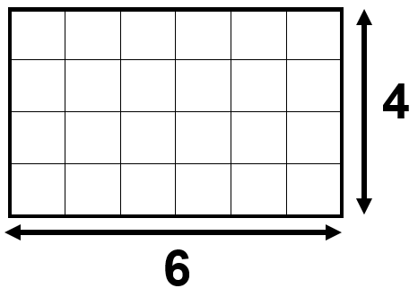
For example:
The rectangle has a perimeter of 20 units.
To find its perimeter, add the lengths of all its
sides. 4 + 6 + 4 + 6 = 20 units
The rectangle has an area of 24 square units.
To find the area, count the number of square units
inside the rectangle. The length and width of the
rectangle can also be multiplied together to get the
answer. 6 x 4 = 24 square units.
- Rhombus: A type of parallelogram with 4 straight sides that are all equal in length. The opposite sides are parallel, and the opposite angles are equal.

Mathematics

Appendix - A Mathematical Heart
What is the area of the shape?
What is the perimeter of the shape?
How did you find the area?
How did you find the perimeter?
How many rhombuses do you see?
How many triangles do you see?
How would you colour in the mathematical heart?
What other mathematical questions can you ask about the heart?

Science and Technology

Identifying Acids and Bases

Information for students
Some substances can be classified as either an acid or a base. Think of acids and bases as opposites—acids have a pH lower than 7 and bases have a pH greater than 7.
For reference, water (a neutral) has a pH of 7 on a scale of 0–14. Scientists can tell if a substance is an acid or a base by using an indicator. An indicator is typically a chemical that changes color if it comes in contact with an acid or a base.
In this activity, you will make an indicator and test various household substances to determine whether they are acids or bases.
The instructions for this activity can be found in Appendix A.
Note: Please follow the same safety precautions you would follow in your science classroom when performing any experiments.

Materials Required
Red cabbage (3 or 4 big leaves)
Tall transparent and colourless glasses
Water
Paper and writing materials
Blender (optional)
Device with Internet access (optional)
Possible solutions to be tested:
Tap water
Bottled water
Vinegar
Lemon juice
Baking powder dissolved in water
Sugar solution
Colourless soft drink
Bleach
Sanitizer (ammonia)
Milk
Science and Technology

Information for parents
Read the instructions to your child, if necessary.
Provide your child with a safe workplace and the materials needed for this activity.
Make sure that your child is manipulating the material safely.
Help your child create a table to record their results.
Help your child choose other liquids to test.

Science and Technology

Appendix A: Acid-Base Indicator Lab

Part 1: Make the indicator
Click here for an example of how to carry out this experiment: https://youtu.be/I18K2upEHLc
Peel off three or four big red cabbage leaves and put them in a blender filled to the halfway mark with water. Blend the mixture on high until you have purple cabbage juice. Note: If you do not have a blender, you can shred the cabbage leaves and soak them in hot water for 10 minutes instead.
Pour the purple cabbage juice through a strainer to filter out the big pieces of cabbage.
Pour the strained cabbage juice into several transparent and colourless glasses until they are half full. Make sure to leave enough room for the solutions that you will be adding to the cabbage juice to test their pH.

Part 2: Testing Solutions
Create a table to record your results (see Appendix A for an example).
Choose a solution from the list “Possible solutions to be tested,” and predict if the solution is an acid, a base or a neutral solution.
Test the solution. To do this, add some of the solution you chose to one of the glasses with the cabbage juice.
Very acidic solutions turn the indicator (the cabbage juice) red, neutral solutions turn the indicator purple, and basic solutions turn the indicator a greenish-yellow color. Use this information to determine if the tested solution is an acid, a base or neutral.
Record your findings in your table.
Test as many of the solutions listed as possible.
What other liquids are you curious about? Test them to determine if they are acids or bases.

Science and Technology

Appendix A: Data Collection

Sample table:
Name of Solution | Prediction:  Acid, Base or Neutral | Colour of solution in indicator | Conclusion:  Acid, Base or Neutral
Vinegar
…

Sample results:
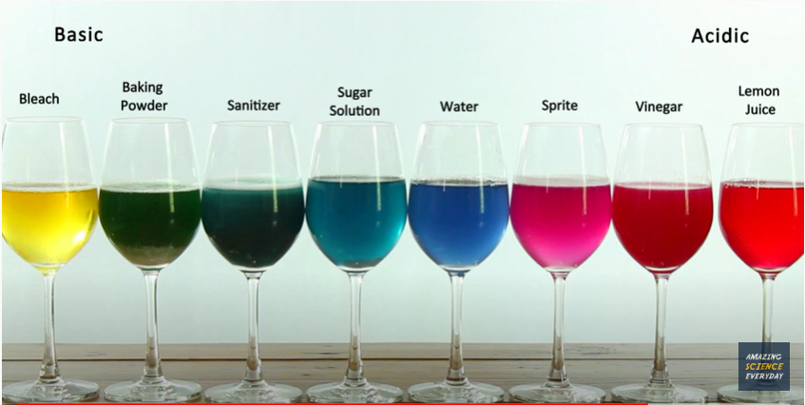

Physical Education and Health
Think About What Matters and Get Moving!

Information for students
Activity 1: It’s what’s on the inside that counts!
Watch this video.
What are your thoughts after watching the video? Do you think that society places too much importance on looks? If so, can you name examples of this? Discuss the topic with an older member of your family.
Think of three qualities you have that do not have anything to do with looks. Think of a friend of yours and name three qualities that you like about them (and that are not related to the way they look).
Activity 2: Improve your stamina, speed and agility!
Change up your workout and improve your skill-related fitness by developing your stamina, speed and agility.
Complete the 14-minute workout in this video. Don’t forget to warm up first!
If you are up for practicing your French and want to explore more activity ideas, visit the Rest Actif! website.

Materials required
None

Information for parents
Children should:
reflect on the focus society places on looks
complete a workout to develop their stamina, speed and agility
Parents could:
support their children by discussing appearance and what matters most to them
complete the workout with their children

Arts

Paper Cuts: Making Art Can Soothe

Information for students
Watch a Canadian artist, Kelly Pousette, overcome her fear by making art out of paper. Let yourself be inspired to take on your worries, frustrations and fears by creating your own art.
Then answer the following questions:
1-Was there at least one thing you appreciated about the content and themes featured in video?
2-Kelly had a fear of forests. In this video, you learned that by creating papercut forests, she tamed her fear by changing her perspective. What does that mean?
3-At 1:30 in the video, Kelly speaks about that moment when she discovered that she can explore shadows and depth using her desk lamp. Why was that a powerful moment in her development?
4-Why is it important to Kelly for her viewers to feel like they are in her diorama?
5-Please explain how creativity (especially by creating art) can help humans relax?
6-What do you do to cope with your fears?
7-Like Kelly, have you tried creating art to tame your fears? How?
8-There is a quote from award-winning dancer/choreographer Twyla Tharp that states “Art is the only way to run without leaving home”. What do you think that means? Does it apply to you? Why?

Materials required
Device with Internet access for watching a CBC Arts Exhibitionists video (https://www.youtube.com/watch?v=pwZHGZyZAP4)

Information for parents
Encourage your child to reflect about their work.
Encourage your child and offer assistance without insisting.
Once the activity is finished, encourage the student to share their appreciation with you or with their friends.

Ethics and Religious Culture

The Texter: A Moral Dilemma

Information for students
Life is full of difficult decisions. Read the scenario below carefully and consider the situation.
Consider the questions that follow, either in writing or simply by thinking about them.
Take things further and share the story with a family member, asking them how they would respond.
Scenario:
Sebastian, a Secondary I student, started secondary school at a big school in the city. He was always pretty popular, but recently he started receiving really upsetting text messages from an “unknown” number. The texts said things like:
“Go back to elementary school where you belong.”
“Good luck getting a girlfriend, loser.”
“Nice lunch bag you had today. Did your mommy pick that out for you?”
“You’d better watch out, loser, we’re watching you!”
Sebastian really didn’t know who could be sending the texts. He was scared. There was a big group of Secondary II kids who sneered at and mocked the Sec. Ones, but he didn’t know any of them personally.
At first, Sebastian tried to just ignore the messages. He even deleted the first one that came in. They frightened him. When each additional text message would ding on his phone, his heart would pound, his throat would tighten and his palms would begin to sweat. How did this person even get his number? What should he do?
Finally, Sebastian shared the messages with his neighbour, Aleks. Aleks was a great friend, but he didn’t go to the same school as Sebastian. Aleks was kind and reassuring, telling Sebastian not to take the messages personally. He told Sebastian that he should show the messages to his parents or maybe even a teacher.
Sebastian felt torn. He was scared that if he tried to ignore the text, they would never stop and things could get worse. But if he showed them to a teacher or his parents, he was worried that others would find out and people would think he was a snitch. There was no way he wanted things to get worse!

Ethics and Religious Culture

Questions:
1-What should Sebastian do?
2-Would you do the same thing?
3-What would you tell Sebastian if he came to you for advice? What would you do?
4-What would happen if this was a student at your school? Do these kinds of situations exist at your school?
5-Have you even known someone in a situation like Sebastian? How was it resolved?
6-Why do you think people bully others? Have you ever said hurtful things (either in person or over the Internet) to someone? Why did you do it?

Materials required
None

Information for parents
Read the instructions to your child, if necessary.
Discuss the questions together

History and Citizenship

Rights and Freedoms – Part 2

Information for students
In 1948, the United Nations (UN) released the Universal Declaration of Human Rights. Today there are 192 member states of the UN, all of whom have signed on in agreement with the Universal Declaration of Human Rights. This document outlines 30 different fundamental human rights.
Do you know your human rights? What about the people around you?
On a sheet of paper, brainstorm as many of the 30 human rights that you can think of. Refer to Appendix 1 to fill in the ones that you are missing.
Click on the following link to find out more about the evolution of human rights:
https://www.youthforhumanrights.org/what-are-human-rights/

Ask at least three other people (parents, siblings, friends, etc.) to identify as many human rights as they can. How did they do? Was anyone able to name all 30?
Pick one fundamental human right that is meaningful or important to you or, based on the answers of the people you talked to, a human right that you think people should know more about.
- Create a public service announcement to let the world know about this human right. (A public service announcement informs or educates others about a topic or an issue.)
- Your public service announcement can be in the form of a poster or a 30-60 second video.
To help you create your poster or video, click on the following link for examples of human rights public service announcements created by Youth for Human Rights:
https://www.youthforhumanrights.org/what-are-human-rights/videos/born-free-and-equal.html

Take it to the next level:
Share your public service announcement with friends and family, especially with the people you asked about human rights.
If you created a video, share it on YouTube.

Materials required
Useful resources, depending on personal preferences and availability:
Device with Internet access
Device with access to a video camera
Writing materials (paper, pencil, etc.)

History and Citizenship

Information for parents
Go over the list of 30 human rights and freedoms with your child. Discuss why they are important.
Ask your child which ones are the most meaningful to them and why.

Stanford Graduate School of Education, “YouCubed My Heart,” n.d., https://www.youcubed.org/tasks/youcubed-my-heart/
Adapted from “Red Cabbage Chemistry,” Steve Spangler Science, accessed April 20, 2020 and The Sci Guys, “The Sci Guys: Science at Home – SE2 – EP4: Red Cabage pH Indicator – Acid Base Indicator,” YouTube, March 25, 2014, video, 6:22, https://www.youtube.com/watch?v=I18K2upEHLc
Image taken from Yucky Science, Red Cabbage Indicator Colors: Chemistry Experiment for Kids to do at Home, YouTube, October 8, 2015, png, https://www.youtube.com/watch?v=OMXMlWybv8A

