Short Story Writing
Information for students
- Click on the link to read through the story starters.
- Choose one story starter to use to write a short story.
- You could start by spending 5 to 10 minutes writing whatever the story starter inspires. Then take what you’ve written and craft it into a short story.
- Tips:
  - Craft your story.
  - Develop your protagonist.
  - Include dialogue.
  - Show, don’t tell: use descriptive language and snapshots.
  - Revise your ideas.
  - Edit your text!
Image by Welcome to all and thank you for your visit! ツ from Pixabay.
Materials required
- Link to the story starters (https://www.literacyshed.com/the-story-starter-shed.html)
- Paper, pen or pencil
- Phone, tablet or computer
Information for parents
Above all, this activity is designed to be simple! We hope it will appeal to your child whatever their grade level. The best things your child can do are:

Read every day.
Write every day.
Talk every day.

Jouons ensemble !
Information à l’élève
- Cette semaine, invite ta famille à jouer en français à un jeu de société. Tu as certainement des jeux à la maison. Sinon, il existe en ligne des jeux interactifs à imprimer. Choisis celui qui te plaît le plus!
Pour aller plus loin…
- Découvre les intégrammes. Le plus célèbre est « À qui le zèbre? » (en annexe), mais il y en a plusieurs autres à explorer.
Matériel requis
- Jeu de société qui se trouve à la maison.
- Jeux de société à imprimer gratuitement :
https://aujeumag.asmodee-canada.com/imprimez-et-jouez.html.
- Intégrammes (énigmes à résoudre) :
https://brigittepage.files.wordpress.com/2011/10/intc3a9grammes.pdf.

Information for parents
Activity details
This activity will help students successfully meet the following #MISSIONFLS challenge:
- Mission en équipe – Je joue à un jeu de société en français.

In this activity, students will practise:
- speaking French with no preparation
- developing their vocabulary
- developing their confidence speaking French

Parents could:
- play a game with their children
- recommend board games that could be played in French (Boggle, Uno, Clue, Hangman, Battleship, etc.)
- print out or find some games online
Reference: bit.ly/MissFLSSecCycle2
Annexe – À qui le zèbre ?
Information for students
L’énigme suivante est parfois attribuée à Einstein, parfois à Lewis Carroll. Même si son origine est incertaine, il s’agit de l’une des énigmes les plus célèbres de tous les temps.

Énoncé
Cinq maisons de couleurs différentes sont habitées par des hommes de nationalités et de professions différentes ayant chacun une boisson et un animal préférés.

Indices
1. L’Anglais habite dans la maison rouge.
2. Le chien appartient à l’Espagnol.
3. On boit du café dans la maison verte.
4. L’Ukrainien boit du thé.
5. La maison verte est située à droite de la blanche.
6. Le sculpteur élève des escargots.
7. Le diplomate habite dans la maison jaune.
8. On boit du lait dans la maison du milieu.
9. Le Norvégien habite la première maison à gauche.
10. Le médecin habite la maison voisine de celle où demeure le propriétaire du renard.
11. La maison du diplomate est à côté de celle où il y a un cheval.
12. Le violoniste boit du jus d’orange.
13. Le Japonais est acrobate.
14. Le Norvégien demeure à côté de la maison bleue.

Résumé
Nationalités : Anglais, Espagnol, Ukrainien, Norvégien, Japonais.
Maisons : rouge, verte, blanche, jaune, bleue.
Boissons : café, thé, lait, jus d’orange, eau.
Animaux : chien, escargots, renard, cheval, zèbre.
Professions : sculpteur, diplomate, médecin, violoniste, acrobate.

Questions
A) Qui boit de l’eau?
B) À qui appartient le zèbre?

Non, ce n’est pas le zèbre qui a bu l’eau!

Une image vaut mille mots
Information à l’élève

- Objectif de l’activité : écrire des textes variés en français.
- Durée : trois heures.
- Déroulement de l’activité :
- Choisissez une image parmi les cinq images proposées;
- Écrivez un texte dans lequel vous :
- décrivez l’image choisie ;
- expliquez votre choix ;
- exprimez ce que vous ressentez en regardant cette image.
- À partir de cette image, écrivez un texte narratif.

Si aucune de ces images ne vous inspire, vous êtes libre d’en choisir une personnelle.
Matériel requis
- Papier, crayon
- Image personnelle au besoin
- Dictionnaire

Information for parents
- Read the instructions with your child.
- Provide different images if you have some in mind.
- Ask your child to read his/her final text to you.
- Share your feelings about the image.

Liens pour les images, les photos sont sur la page suivante :

https://cdn.pixabay.com/photo/2015/05/02/08/00/sea-749619__340.jpg
https://cdn.pixabay.com/photo/2016/04/23/14/53/mural-1347673__340.jpg
https://cdn.pixabay.com/photo/2020/04/09/16/48/landscape-5022256_960_720.jpg
https://cdn.pixabay.com/photo/2020/04/12/14/44/fantasy-5034448_960_720.jpg
https://cdn.pixabay.com/photo/2016/05/02/10/13/ship-1366926_960_720.jpg

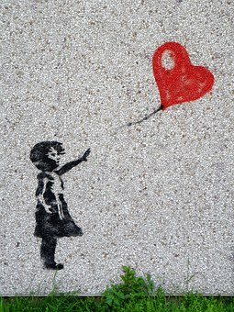

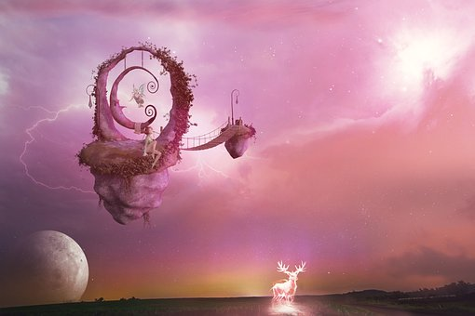

The Big Nickel

Information for students

The Big Nickel, which is a replica of a 1951 Canadian nickel, is located on the grounds of the Dynamic Earth science museum in Sudbury, Ontario. The 1951 Canadian nickel is in the shape of a dodecagon.

Task
- Determine the approximate number of actual nickels it would take to fill the Big Nickel.
- Determine the total value of these nickels and compare it with the cost of building the Big Nickel in 1964.

Dimensions and cost of building the Big Nickel in 1964
- Height of the Big Nickel: 9.1 m
- Thickness of the Big Nickel: 61 cm
- Cost of building the Big Nickel in 1964: $35 000
Picture 1: Height of the Big Nickel  9.1 m | Picture 2: Thickness of the Big Nickel  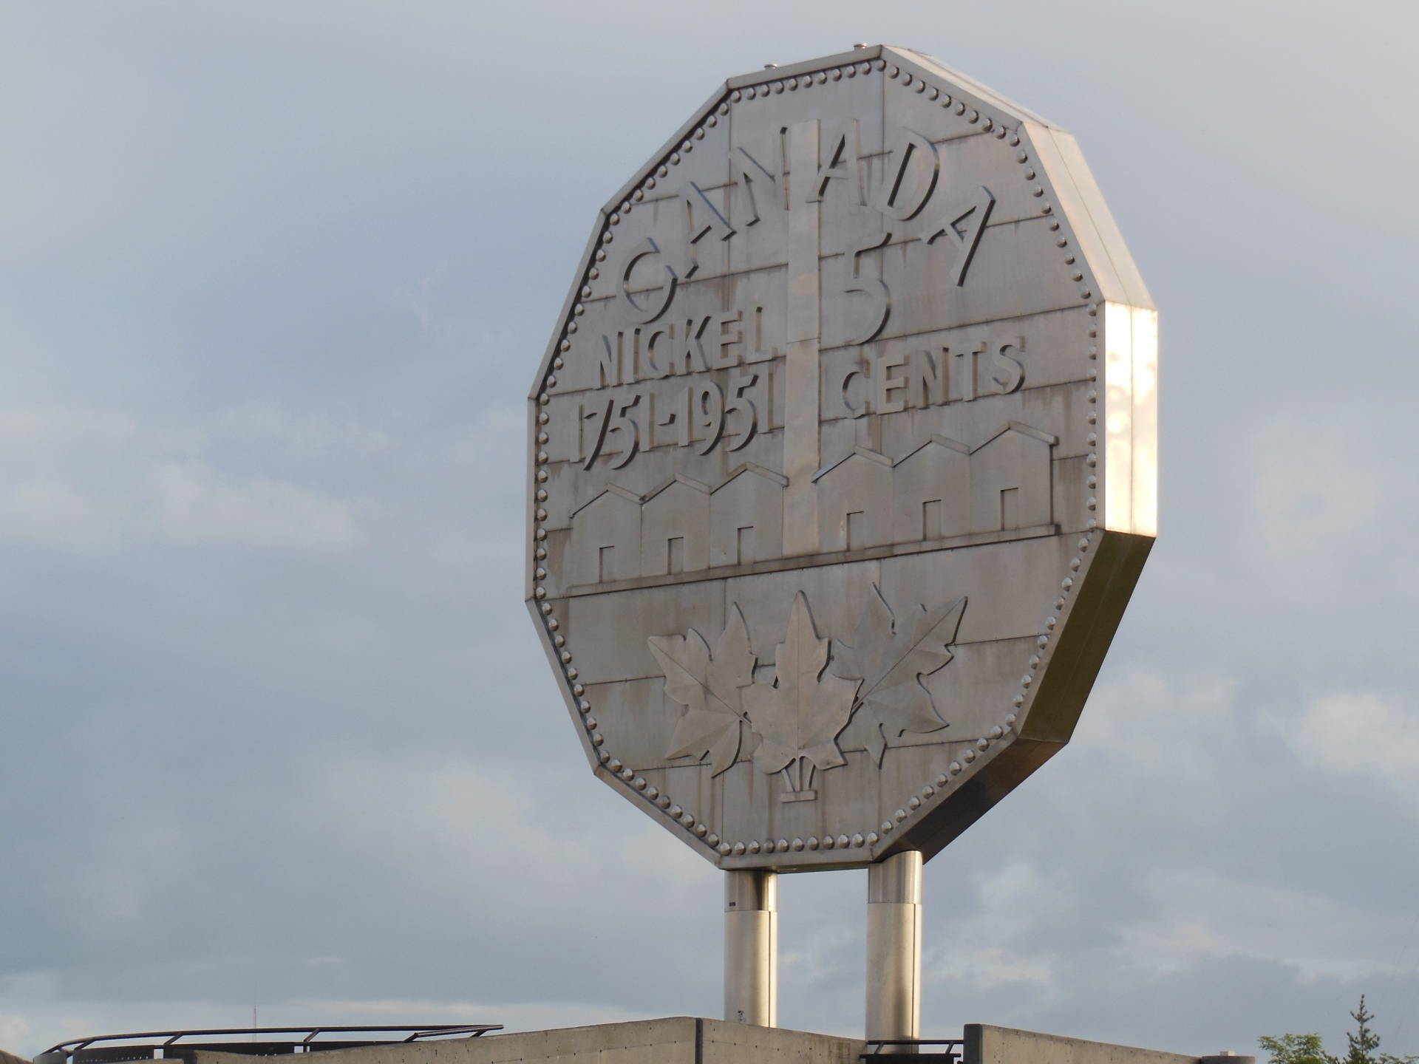  61 cm

Dimensions and shape of a 1951 nickel
- Shape of a 1951 nickel: dodecagonal prism
- Apothem of a 1951 nickel: 1.06 cm
- Thickness of a 1951 nickel: 0.176 cm
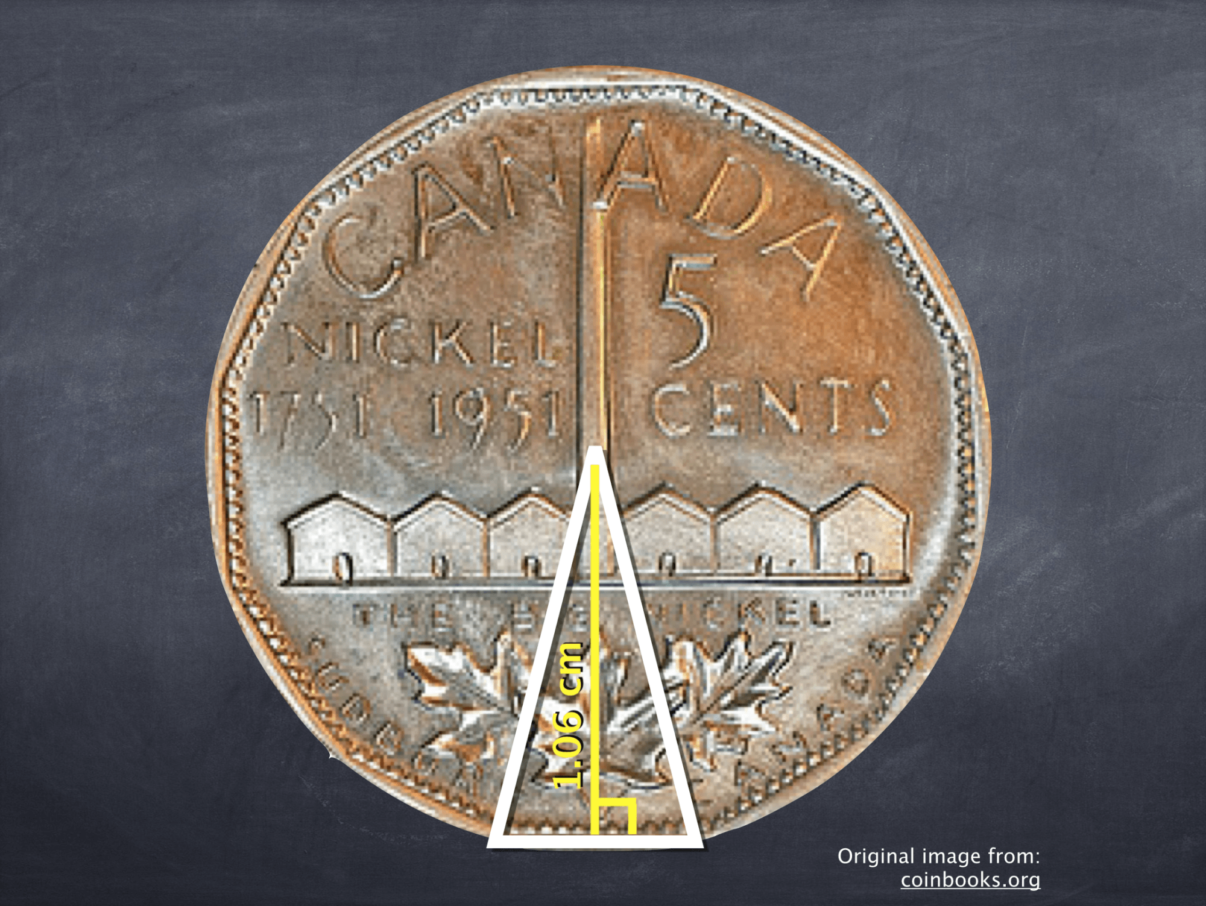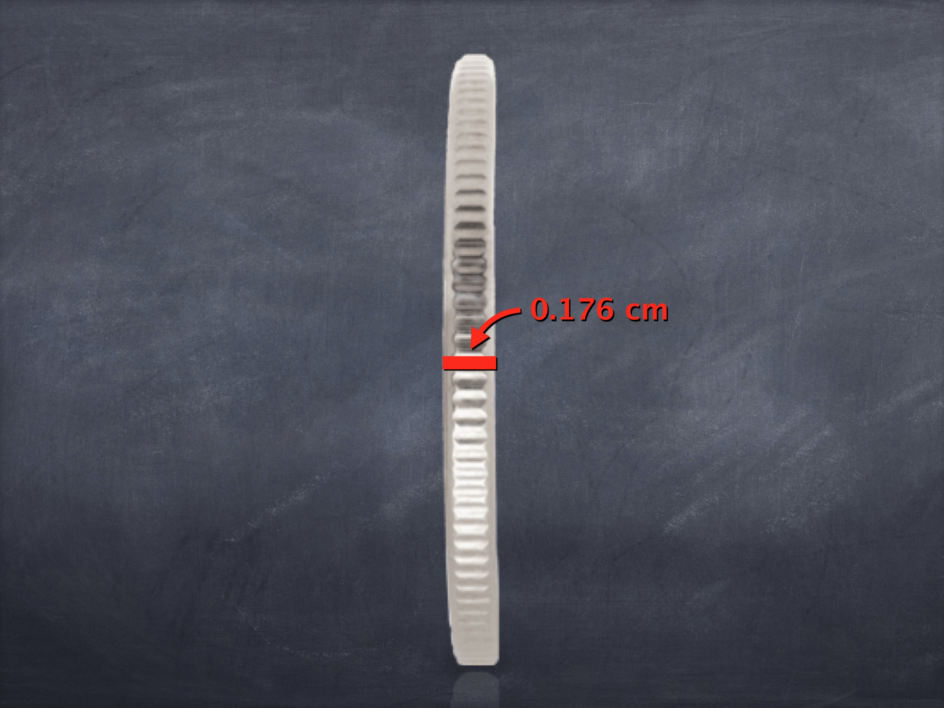

Materials required
- Device with Internet access
- Paper, writing and drawing materials
Information for parents
Discuss the task together

Suggestion: Once your child has completed the task, ask them if they have any questions concerning the task.

Solution

It would take approximately 63 859 898 nickels to fill the Big Nickel.

The total value of the nickels is $3 192 994, which is about 91 times the cost of building the Big Nickel in 1964.

Endothermic and Exothermic Changes

Information for students
For this activity, you will learn about two different inventions that make use of endothermic or exothermic changes.
Endothermic changes absorb heat from the environment. Exothermic changes release heat into the environment.

Invention 1: Self-cooling water bottle for cycling
- This water bottle is designed to cool the water inside it as you ride your bicycle.
- The water bottle fits into a rack on the bicycle frame.
- The outer layer of the water bottle is a canvas material.
- The inventor claims that in order for the cooling effect to work, the outer canvas layer needs to be saturated with water. As you ride, the airflow created by the bike moving through the air helps the water evaporate from the canvas material, which cools the water inside the bottle.
- Can you prove that this actually works? Set up an experiment using materials you have at home.
  - Find some containers to hold water, and some paper towels or a cloth to represent the canvas layer. What can you use to create the effect of the bicycle moving through the air?
  - Make sure you have a control so you can compare your test to an ordinary container of water.
  - If you have a thermometer, you can use it to check the temperature of your test and compare it to the control. How else could you compare the temperatures?
  - Tip: Start with room temperature water and be patient. It can take some time for the temperature of the water to change.
  - Try changing a variable (e.g. the container, the amount of water, etc.). Does this change the results? Why or why not?
- Using what you know about endothermic and exothermic changes and heat exchange, explain the science behind this self-cooling water bottle. Click here for help with your explanation.
See the next page for invention 2

Invention 2: Self-heating meal kit
- These kits include a meal, which needs to be heated, inside a container. This container fits into a larger, outer container. A heating packet is placed at the bottom of the outer container.
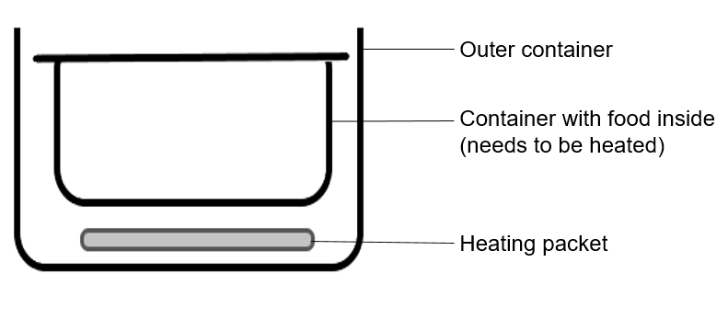
- When water is poured onto the heating packet, a chemical reaction occurs and heat is released.
- The heating packet contains calcium oxide. The reaction of calcium oxide with water is shown below.
CaO _{(s)} + H₂O _{(l)} à Ca(OH)_{2 (s)} ΔH = - 65.2 kJ

  - Using what you know about endothermic and exothermic changes and heat exchange, explain the science behind this self-heating meal kit.
  - How much heat is released when 100 g of CaO reacts completely with water?
  - Note: The molar mass of Ca is 40.08 g/mol and the molar mass of oxygen is
  - 16.00 g/mol. (Check your answer in Appendix A.)
  - Do you think there are other substances that can be used in the heating packet? Will heat be released when this substance is mixed with water? Is it safe to use at home? What other factors would you have to consider? Do some research to find out.

Materials required
- Thermometer (optional)
- Room temperature water
- Drinking glasses, bottles, or other containers to hold water
- Paper towels or a cloth
- Paper, writing materials and calculator
- Device with Internet access (optional)

Information for parents
Activity details
- In this activity, children will be applying their chemistry knowledge to explain how two different inventions work. This task includes setting up a simple experiment.
Parents could:
- Provide their child with a safe workplace and materials that could be used for this activity.
- Ensure that their child is manipulating the material safely.

Appendix A: Answer Guide

How much heat is released when 100 g of CaO reacts completely with water?
- Molar mass of CaO = 56.08 g/mol

- Number of moles of CaO
n = 1.78 mol

- Heat released = (1.78 mol)(65.2 kJ/mol)
= 116 kJ

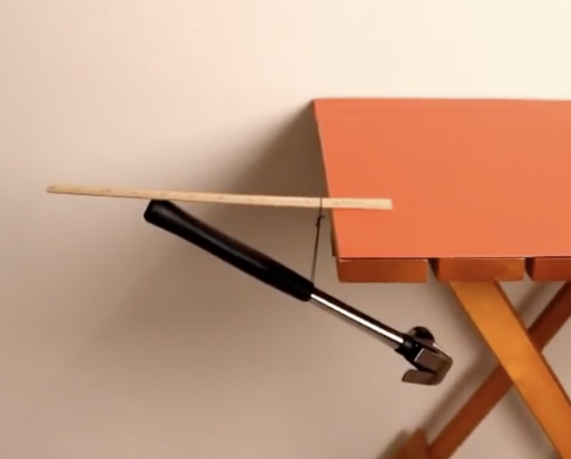
Dynamics

Information for students
- Observe the image to the right or watch the video by clicking this link: https://www.youtube.com/watch?v=Hj-NX0xtcVY
- Explain why the ruler and hammer are not falling off the table.
- Draw a free body diagram of this phenomenon by showing the forces acting on the objects. You may share your diagram with the rest of the province by using the hashtag #ScienceAtHomeQC-physics
Image taken from: https://www.youtube.com/watch?v=Hj-NX0xtcVY
- Research:
  - What are Newton's 3 Laws? Can you explain what each says in your own words?
  - What is a “centre of mass”? Explain in your own words.
  - What is “gravitational acceleration”? Explain in your own words.
  - What is a “normal force”? Explain in your own words.
  - How can Newton’s Laws explain the above phenomenon?

- Experiment:
  - Keeping your feet flat on the floor, lean forward until you cannot continue anymore without falling over.
  - Repeat the same movement several times with a full backpack on your back. Change how high you wear the backpack each time.
  - Write down what you feel each time you move the backpack. When do you feel the most stable? When do you feel the least stable?
  - What is the relationship between the height of the backpack and how stable you feel?

- What mathematical formulas would describe the forces on the table?
- What role does friction play in this phenomenon?
- What would happen if the hammer were twice as heavy?
- Using your knowledge of physics, how would you explain to a friend why it is hard to balance a pencil on one finger.

Materials required
- Device with Internet access (optional)
- Paper, writing and drawing materials
- A backpack
Information for parents

- Discuss the questions together.

Learn About Your Body and Get Moving!
Information for students

Activity 1: Learn about your body
- Watch this video (2 mins 18 sec) to learn about what happens to your lungs when you exercise.
- What effect does exercise have on your lungs?
- Discuss what you learned with a member of your family.

Activity 2: Get moving!
- Watch this video (10 min 35 sec) and carry out the 10-minute cardiovascular and muscular workout.
Materials required
- None

Information for parents
About the activity
Children should:
- learn about the function of lungs during exercise
- complete a workout

Parents could:
- discuss what their child has learned about the function of lungs during exercise
- participate in the workout with their child

Visual Response Journals
Information for students
A visual journal can be used to respond to events and moments that happen in your daily life. The goal is to be free and expressive using words, paint, drawings and collage.

- This journal can be used as a diary or just a place where you work on anything that inspires you. Start by collecting papers, receipts, photos, photos cut out from magazines, receipts, parking receipts, old movie stubs, stamps, grocery lists or just about anything that you might normally discard.
When you’re ready, sit with a journal, notebook, sketchbook or recycled book. Set up glue, tape, markers, scissors, paint, pencils nearby and have your collage materials ready.
Without overthinking, begin to create exciting pages, highlight words, colour, create drawings and fill pages with visual information by being as free as possible. Work on the journal whenever you like and create a theme to your journal if you prefer. The important thing to work on is filling the pages.
A great inspiration are the journals of photojournalist, Dan Eldon. Please click on the link below to get a glimpse into Dan’s journals, which chronicle his brief life as a photojournalist in Africa.
Be adventurous as you collage in your book, have fun and push yourself to fill every page!
Materials required
- Tape, glue, glue stick, scissors
- Sketchbook or reuse an old calendar, journal, or any book
- Art supplies of your choice: paint, ink, markers, coloured pencils, pencils, pens, etc.
- Collage materials: stickers, receipts, wrappers, photos, cards, magazines, miscellaneous found objects, etc.
Information for students and parents
- Link to explore information on Dan Eldon and his journals: https://youtu.be/L1rrmW8FLVE

- This activity can be ongoing and become a response journal for other subjects.

Team Sports
Information for students
According to many scientific studies, there are many benefits to playing team sports.

- What are the physical benefits of playing team sports?
- Can team sports help teens socially and academically?
- Do team sports teach valuable life skills?
- How so?
To answer these questions about teens playing team sports, you will need to read articles on the subject. You can find scientific articles online, in magazines, in books, etc. Discuss the topic and the questions with your family or a friend. What are their thoughts on this subject?
Materials required
- Read various articles using a device with Internet access, magazines, books, etc.
Information for parents
About the activity
- In this activity, the student will explain their point of view by reading scientific articles to support their arguments.
- Ensure that discussions are respectful and that all participants listen to the perspectives of others.

Recipes on a Budget
Information for students
Next year, you may be going away for school and might need to consider budgeting and cooking for yourself. Select two of your favourite meals or recipes. Make a list of the ingredients and include the price of each item. Calculate how much it costs to make each recipe. Consider these questions:
  - Which recipe is more expensive to make?
  - Which recipe yields more portions?
  - Can items be substituted in a given recipe to decrease the cost of making it?
  - Do some of the ingredients for a given recipe go on sale often?
  - Calculate the cost of each portion.

To find the cost of ingredients, you can check flyers and the Internet. You can also download grocery store apps to check the cost of items on sale. Here are a few helpful sites:

https://talkwithourkidsaboutmoney.com/resources/teens-plan-a-meal/

https://talkwithourkidsaboutmoney.com/resources/filling-the-pantry/

Materials required
Useful resources, depending on personal preferences and availability:
- device with Internet access
- writing materials (paper, pencil, etc.)

Information for parents
- Help your child select a recipe and find the cost of items. Suggest ways to find certain ingredients at the lowest cost.

- Help them select recipes that will yield several portions and calculate the cost of each portion.

Is It time to Reopen the Economy?
Information for students
Background
With most countries demanding one form or another of social distancing and/or self-isolation to combat the coronavirus, many companies have shut their doors, jobs have been lost, and the global economy has weakened.

At this point, a percentage of the population believes it is time to begin reviving the economy by slowly letting people return to work. Many others believe that more time respecting distancing guidelines is necessary to guarantee our health and safety.

This is not an easy decision to make – it sets the health of the populace versus the long-term economic prospects of the country (and individuals) against each other.

For the purpose of this activity, we will focus on how this debate is playing out in the USA.

Activity
Having read at least one article below for the reopening of the economy and one against it (feel free to read more – a simple Google search will suffice), do any of the following to help establish your position on the topic.

- Articles for the reopening of the economy:
  - Across America, Frustrated Protesters Rally To Reopen The Economy
  - Sen. Barrasso on economic impact of coronavirus pandemic: 'It is time to reopen America'

- Articles against the reopening of the economy:
  - The economic costs of reopening too soon
  - Reopening the economy now is a bad idea

- General
  - This is where all 50 states stand on reopening

Write a letter to a local newspaper explaining your position.

Engage in a debate with a classmate using any video platform (Zoom, Facetime, etc) with each of you defending one side of the debate. Optional extras include involving more than one other person (i.e. teams), or following an actual structure (set a time limit for making arguments, allow for rebuttal by both sides, closing arguments, etc.)

Draw a cartoon or caricature expressing your position on the question.
Materials required
Useful resources, depending on personal preferences and availability:
- device with Internet access
- writing materials (paper, pencil, etc.)

Information for parents
- If needed, please help your child read the articles. Ingrained in this debate are questions of personal ideology (beliefs) and political loyalties. Depending on their prior knowledge, students may be more or less comfortable with those concepts.

- If Internet access isn’t readily available, see if your newspaper has an opinion piece from a columnist taking one side of the argument. Ask whether your child agrees with that position, and for the sake of debate, take the opposite position and see where the conversation goes.

3 Act Math Tasks: Real World Math Problems to Make Math Contextual, Visual and Concrete From K-12 (n.d.). Tap into Teen Minds. Retrieved April 20, 2020
Image taken from: https://commons.wikimedia.org/wiki/File:Big_Nickel_%E2%80%93_Sudbury,_ON_%E2%80%93_(2018-07-03).jpg.
Image taken from: https://commons.wikimedia.org/wiki/File:Big_Nickel_%E2%80%93_Sudbury,_ON_%E2%80%93_(2018-07-03).jpg.
Images taken from Coinbooks.org
Inspired by Turner, T. (2012, June 21). Sweat is a Good Thing. Yanko Design.

