Poetry/Song Writing

Information for students

Read the poem, “[March the Ninth Twenty Twenty](https://lithub.com/march-the-ninth-twenty-twenty/)”.

Use the following prompts to help you think about the poem. Record your thoughts on paper or electronically.

* I noticed . . . I wonder . . . I was reminded of . . . I think . . . I’m surprised that . . . I’d like to know . . . I realized . . . If I were . . . The central issue(s) is/are . . .  If _________, then . . . I’m not sure . . . Although it seems . . . This part/line makes me think that . . . This makes me feel that . . . The author is suggesting that . . .
* Discuss the poem with a family member or send it to a friend and talk about it together.
* Write a poem or song lyrics inspired by the current state of affairs.
* Take it to the next level! Have a poetry reading with your family or friends. If you’re musical, set your lyrics to a melody and record it!

Materials required

* Link: <https://lithub.com/march-the-ninth-twenty-twenty/>
* Paper, pen phone, tablet or computer.

|  |
| --- |
| Information for parents  Above all, activity is designed to be simple! We hope it will appeal to your child. The best things your child can do are:  Read every day.  Write every day.  Talk every day. |

**Comment ça va?**

**Consignes à l’élève**

* C’est important de prendre du temps pour parler à sa famille et à ses amis et de prendre de leurs nouvelles.
* Cette semaine, appelle quelqu’un que tu connais qui parle français, un ami ou un membre de ta famille éloignée, et parle-lui en français pendant au moins dix minutes.
* Tu peux ensuite informer les personnes avec qui tu habites de ce que l’autre personne t’a raconté (en français ou en anglais).

**Matériel requis**

* Téléphone
* Médias sociaux

|  |
| --- |
| **Information for parents**  **About the activity**  This activity will help students successfully accomplish the following [#MISSIONFLS](https://www.learnquebec.ca/fr/missionsflsc2) challenge:   * Mission en équipe - Je parle pendant dix minutes en français avec mes amis pour prendre de leurs nouvelles   In this activity, students will practise:   * conversing in French without prior preparation * developing their vocabulary * developing their confidence speaking French   Parents could:   * ask for support from someone they know who speaks French * schedule a specific time during the week for the conversation in French to take place   Reference: [bit.ly/MissFLSSecCycle2](https://bit.ly/MissFLSSecCycle2?fbclid=IwAR1wgOfGkCsAOnrb2qXcEzBvIhnj5ciVwnr-SUW25XyFGknf8p-_JzoB5yQ) |

**Écriture rapide[1]**

**Information pour l’élève**

* **Objectif de l’activité:** écrire en français pour le plaisir. Se concentrer uniquement sur les idées et la créativité avant de penser à la grammaire, l’orthographe, la syntaxe. Donner du sens au travail de relecture et d’autocorrection.
* **Durée:** trois minutes maximum par activité, neuf minutes en tout! Utilisez un chronomètre. Quand les trois minutes sont passées, arrêtez, même si c’est en plein milieu d’une phrase.

**Déroulement de la première partie de l’activité** :

1. Prenez une feuille de papier et un crayon. Préparer votre chronomètre sur trois minutes;
2. Sans réfléchir, compléter la phrase suivante : *Je suis….;*
3. Trois minutes : STOP on passe à la 2e production.
4. Repartez votre chronomètre;
5. Écrivez un texte avec ce titre : *Un beau souvenir*...
6. Arrêtez d’écrire après trois minutes. On passe à la 3e production.
7. Repartez votre chronomètre;
8. Complétez la phrase suivante : *J’aime vraiment….*
9. Arrêtez après trois minutes.

**Déroulement de la deuxième partie de l’activité :**

1. Prenez le temps d’apprécier votre créativité;
2. Choisissez le texte que vous préférez
3. Finissez votre texte;
4. Apportez les corrections nécessaires;
5. Entraînez-vous à le lire à haute voix;
6. Lisez-le à votre famille.

Cette deuxième partie peut s’étendre sur toute la semaine.

**Materials required**

* paper, writing materials and a stopwatch
* a paper book dictionary and a grammar book **o**r device with Internet access
* Dictionnaire en ligne : <https://usito.usherbrooke.ca/>
* Grammaire : <https://www.ccdmd.qc.ca/fr/exercices_interactifs/>

|  |
| --- |
| **Information for parents**   * Read the instructions with the student. * Set the timer for 3 minutes. * Ask the student to read their final text to you. * Share what feelings you experienced listening to it. |

f

Event Planning

Information for students

Your school is planning an event.

Your group has been asked to sell hats and sweaters to commemorate the event.

Within your group, Lucy and Ricardo have come up with some sales projections:

* + Lucy came up with a few equations based on surveys that she has done. You notice that one of her equations is incorrect. **Identify the incorrect equation.**
  + Ricardo created a few polygons of constraints based on Lucy’s work. However, Ricardo was not sure about Lucy’s work so he created more than one graph. **You need to determine which one of Ricardo’s graphs matches Lucy’s work. Also, what elements of the graph did Ricardo forget to use?**
* **You need to figure out the possible combinations of hats and sweaters sold.**
* The profit made from each hat sold is $6 while the profit from each sweater sold is $12.
* The clothing company is charging a $150 processing and shipping fee, regardless of how many hats and sweaters are purchased.
* **You also need to come up with an optimizing formula and determine the greatest amount of profit possible!**

Materials required

* Projected sales data, Lucy’s equations, Ricardo’s graphs, and their combined work
* Formula sheet with the formula for optimization

|  |
| --- |
| Information for parents  Read the instructions to your child, if necessary.  Discuss the task with your child, outlining what steps need to be carried out.  Once the task is completed, you and your child can go over the task with the answer key provided. |

Appendix – Lucy and Ricardo’s Work

Projected Sales Data

* More hats than sweaters will be sold.
* There will be no more than 20 sweaters sold.
* There will be less than or equal to 80 items sold if you combine the hats and double the number of sweaters.
* Up to 60 hats may be sold.

Lucy’s Equations

* *x* ≤ 60
* *y* ≤ 20
* *x + 2y* ≤ 80
* *y* ≤ *x*
* 2*x* + *y* ≤ 80

Ricardo’s Graphs

Graph 1 Graph 2

Graph 3 Graph 4

Lucy and Ricardo’s Work Combined and Corrected

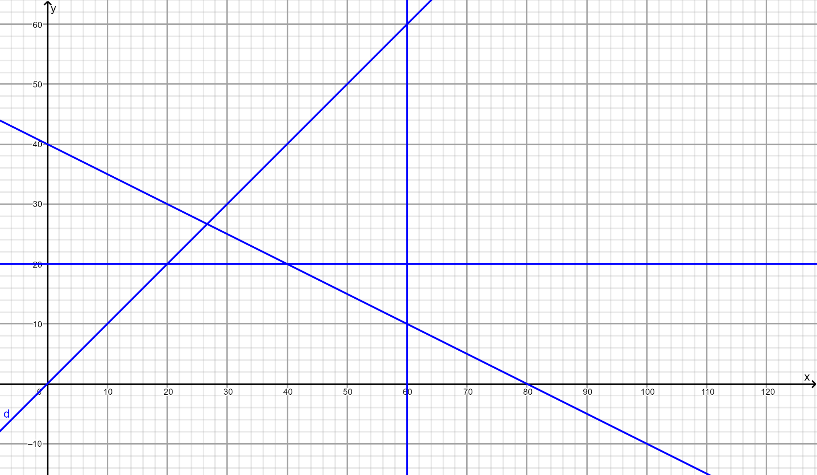

**Appendix – Formula Sheet**

*ax* + *by* + *c* = *z*

**Appendix – Answer Key**

Lucy’s incorrect equation

* 2*x* + *y* ≤ 80

Ricardo’s correct graph

* Graph 4

Coordinates of the vertices for the polygon of constraints

(0, 0)

(40, 20) 🡨 These two options generate the greatest profit.

(60, 10) 🡨

(60, 0)

(20, 20)

Other possible coordinates (on the line *x* + 2*y* ≤ 80)

(42, 19)

(44, 18)

(46, 17)

(48, 16)

(50, 15)

(52, 14)

(54, 13)

(56, 12)

(58, 11)

The optimizing function to determine the maximum profit

6*x* + 12*y* – 150 = *z*

The maximum profit obtainable

* 6(40) + 12(20) – 150 = 330

The Chemistry of Food Science

Information for students

Food science is a multi-disciplinary field; it includes all technical aspects of food, beginning with harvesting and ending with cooking and consumption. The amount of chemistry involved in this industry is staggering. This week, you will use your chemistry knowledge and skills to focus on the foods in your very own kitchen.

N.B. As you do in your science classroom, please keep safety in mind when attempting any/all challenges.

* **Challenge 1: Ahhhh, Sweet Kool-Aid© (or other flavored drink mix)**
  + Make an 8 M Kool-Aid© solution (assume Kool-Aid© = sucrose (C12H22O11)).
  + Dilute this solution to 2 M.
  + Some questions to ponder:
    - Did you taste the solutions? Which do you prefer?
    - Did you weigh out the ingredients or did you estimate?
    - How is making this solution different from/the same as making solutions in a chemistry lab?
    - Would the process you employed be the same if the ingredients you used included solvents other than water?
* **Challenge 2: I Scream, You Scream, We all Scream for Ice Cream**
  + Go ahead and treat yourself by making your very own ice cream. Click [here](https://youtu.be/y-69y9GsS_4) for a quick recipe and how-to.
  + As you are enjoying your treat, ask yourself:
    - Did I manage to make ice cream? If yes, how did the ingredients turn into ice-cream? If no, what could I have done differently?
    - Which ingredients played a key role in the heat exchange that occurred?
    - What is happening at a molecular level?
  + [Scientific American](https://www.scientificamerican.com/article/scrumptious-science-making-ice-cream-in-a-bag/) provides a good scientific explanation about making ice cream in a bag.
* **Challenge 3: No “Pressure” Here – Get an Egg in a** **Bottle**
  + Design and conduct an experiment in which you get a hardboiled egg to fit into a bottle with an opening that is too narrow to simply push the egg through.
  + Jot down the scientific explanation for this phenomenon (Hint: Nothing is ever too “gassy”.)
  + To check if you were on the right track, click [here](https://youtu.be/kr1V0KtZPGw).

Materials required

N.B. Safety first. Pretend you are in science class and your teacher will not let you near your lab station without your goggles, apron, etc. Use them if they are available.

* **Challenge 1:**
  + Water
  + Kool-Aid© (or other flavoured drink mix)
* **Challenge 2:** 
  + 2 Ziploc© bags (1 larger than the other)
  + Ice cubes
  + Milk (or Half and Half)
  + Flavouring (e.g. vanilla)
  + Powdered sugar
  + Table salt
* **Challenge 3:**
  + 1 hardboiled egg (shell removed)
  + 1 flask or bottle (with opening slightly narrower than the egg)
  + Paper strips
  + Lighter/matches

|  |
| --- |
| Information for parents  About the activity  Children should:   * be working in the kitchen and using their chemistry knowledge of food science   Parents could:   * oversee their children’s work to make sure all safety precautions are taken for all the experiments * ask questions (some suggestions are provided above) while children are carrying out the experiments to further develop their thinking skills |

**Can You Hit the Target?**



**Horizontal Projectile Motion**

**Information for students**

**What to think about**

* What factors are in play when a ball rolls down a bowling alley? Carefully roll a ball along the floor and think about velocity, acceleration, distance, time. What can you do to change any of these variables?
* What factors are in play when a ball is thrown vertically? Toss a ball straight up (outside) and, again, think about velocity, acceleration, distance and time. What can you do to change any of these variables?
* Formulas can be used to solve for the variables velocity, acceleration, distance and time.
* In projectile motion, horizontal movement and vertical movement **are independent** of each other.
* Acceleration
  + **Horizontal velocity** will not change. Acceleration is $0 m/s^{2}$.
  + **Vertical velocity** will increase on the way down due to the force of gravity. The **acceleration** due to the force of gravity (g) is $-9.8 m/s^{2}$. It is **negative**, because of the downward direction.
* Measurements should be recorded in meters.

**How close will your calculation be to an actual horizontal projectile motion?**

**Setting up the activity (see the diagram on the next page)**

* Create your target out of paper and markers.
* Stack 3-4 books on a table.
* Secure the cardboard tube so that it is always in the same position. It might help to put a small towel on top of the books to keep them steady. You can tape the towel in place.
* Follow the steps below.

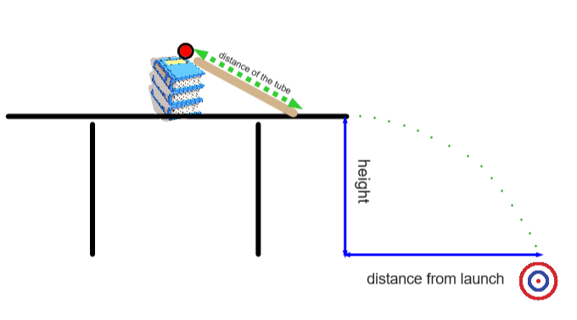

**Measurements in meters**

Be sure to convert cm to m by dividing by 100*. Forgetting to convert is a common error.*

Length of the ramp (cardboard tube): __________meters

Height of the table: _________ meters

***Step 1: Finding the velocity of the ball when it leaves the table***

1. **Time**

With a stopwatch, time how long it takes the ball to roll down the ramp. The time for the ball to roll down the ramp will be very fast (less than a second) therefore, it may require several attempts. You may need a second person for this step.

* The ball must start from rest (initial velocity = 0 m/s).
* Perform 10 trials and take the average time. $t= _______ s$

1. **Velocity** Calculate the velocity of the ball.

Formula

 

$d= \frac{(v_{i}+v_{f})}{2}x t$ $d=\frac{(0+ v_{f})t}{2}$ $v_{f}=\frac{2d}{t}$

Where,

* $d$ = length of the ramp
* $v_{i}=0 m/s$ (the initial velocity is $0 m/s$ because the ball is at rest when you release it)
* $v_{f}$ = the velocity at the end of the ramp
* $t$ = the amount of time it takes for the ball to travel down the ramp (found in A)

$v_{f}=\frac{2d}{t}$ = __________

The ball will be rolling at a velocity of __­­­­­­­_______m/s (horizontally) when it leaves the table. We are assuming that there is no change in velocity from the time the ball leaves the ramp to when it leaves the table.

***Step 2: Time in the air***

The one variable shared by vertical and horizontal motion is **time**.

1. Calculate the amount of time the ball will be in the air using the vertical information.

Formula



$∆y=v_{i}t+\frac{1}{2}gt^{2}$ $t=\sqrt{\frac{∆y }{\frac{1}{2}(-9.8m/s^{2})}}$

$∆y$ is a negative value

Where,

* $∆y$ is the height of the table (vertical distance)
* $∆y$ is negative since the displacement of the ball is downward
* $v_{i}$ = 0 m/s since there is no vertical velocity when the ball leaves the table
* $g$ is the acceleration due to the force of gravity
* $t$ is the amount time the ball will be in the air until it lands

$$time=\sqrt{\frac{∆y}{\frac{1}{2}(-9.8 m/s^{2})}}$$

The amount of time that the ball will be in the air is _______ seconds (round of to the nearest hundredth).

If you get an error on your calculator, double check that $∆y$ is a negative value.

***Step 3: Placing the target***

* Horizontal velocity is not affected by the force of gravity. The acceleration is 0 $m/s^{2}$.

Now that we know the initial velocity and time, we can calculate the horizontal distance.

Formula $d= v_{1}t+ \frac{1}{2}at^{2}$

Where,

* $d$ is the distance from launch (edge of the table to where the ball will land)
* $v_{1}$ is the velocity, found it step 1
* $t$ is the amount of time that the ball will be in the air, found in step 2
* $a=0 m/s^{2}$ since there are no significant forces acting on the ball in the horizontal direction

$$d= v_{1}t+ \frac{1}{2}\left(0\right)t^{2} d= v_{1}t$$

I will place my target _________m from the table.

***Step 4: Game time***

Time to test your results.

Place your target ______ m from the edge of the table. Release the ball and watch what happens.

How close did you get?

**Materials required**

* Tape
* Cardboard tube from wrapping paper, at least 60 cm long (the tube must be long enough or it will be too difficult to measure the time in step 1).
* Paper, pencil and markers
* Small ball or marble
* Measuring tape or ruler
* Stopwatch (can be found on a cellphone or electronic device)
* Several books
* Small towel
* Calculator

|  |
| --- |
| **Information for parents**   * This is an activity intended to explore the kinematic equations used in projectile motion. * Students may need help timing the ball on the ramp (step 1). * Video with a similar example and more problems (optional): <https://www.khanacademy.org/science/ap-physics-1/ap-two-dimensional-motion/horizontally-launched-projectiles-ap/v/horizontally-launched-projectile>. |

**Smoking vs. vaping**

**Instructions for students**

**Brain Bite**

According to a 2018-2019 [Health Canada survey,](https://www.canada.ca/en/health-canada/services/smoking-tobacco/vaping/canada.html) youth (15 to 19 years) and young adults (20 to 24 years) have the highest rates of trying vaping. Additionally, 54% of all students thought it would be "fairly easy" or "very easy" to get an e-cigarette with nicotine if they wanted one (even though in most provinces you have to be 19 to legally buy an e-cigarette, 18 in Quebec). A common misconception is that vaping isn’t as bad for you as smoking is. Watch the following video for more information on smoking vs. vaping.

* Video (2 mins) [Is vaping healthier than smoking?](https://www.youtube.com/watch?v=pzyDoGsnyxY)

**Activity 1- Discussion**

* discuss what you know about smoking and vaping with a parent or a friend (using technology). To learn more about the health effects of vaping, explore this [Teen Health website](https://kidshealth.org/en/teens/e-cigarettes.html?ref=search).
* reflect on what healthy lifestyle habits you currently practice, and which ones you want to avoid in order to maintain optimal health, now and in the future.

**Activity 2- Healthier Habits - Daily Physical Activity**

* Speaking of healthy habits, being physically active on a daily basis is one of the healthiest things you can do for yourself. But it’s not just cardiovascular exercise you need- [Canada’s 24-Hour Movement Guideline](https://csepguidelines.ca/wp-content/themes/csep2017/pdf/Canadian24HourMovementGuidelines2016_2.pdf)s encourage you to do muscle and bone strengthening exercise at least 3 times a week.
* Try the following workout to benefit your muscles and help them work hard for you on a regular basis:
  + Video (32 minutes) [Refresh, Relax, and Restore: Stretching, Pilates, Yoga Workout for Tight Muscles](https://www.youtube.com/watch?v=Pp8UNgkcAYs)

**Materials required**

* None

|  |
| --- |
| **Information for parents**  Students should:   * watch the video on vaping and smoking then discuss with a parent or friend; * complete the muscle restoration workout.   Parents could:   * discuss vaping and smoking with your child. |

AUDIO COLLAGE PROJECT

Information for students

Create an audio journal about the music you like and what you think your choices say about you.

Include favorite songs from your childhood and/or music that you have only recently started to enjoy.

You may shape your project in many ways: 1. A written journal with song clips; 2. A video journal; 3. A PowerPoint with visuals and audio links…the format is up to you!

**Materials Required:**

* Pen/Pencil
* Paper
* Access to musical selections (personal listening device or Internet)
* Computer (optional)

**Instructions**

* Reflect on music’s role in your life.
* Collect the songs that you want to use in your project.
* Determine what those specific songs mean to you or say about you.
* Write and record a script to accompany your music.

Here are some suggestions to get you started in your writing:

* When did you first hear this song?
* What does this song represent to you?
* Is there a specific part of the music that is most significant?
* Is this a piece of music that you share with your friends or family?
* Is this a “guilty pleasure” song? (It might even be a song that you don’t want other people to know you like to listen to!)

|  |
| --- |
| Information for parents  Your child may not wish to share the collage with you, however, you can engage in discussion following the activity.  Here are some possible discussion questions:   * Do you see a connection between music and identity? Why or why not? * Do you feel like the music you listen to accurately reflects your personality? Why or why not? * Do you feel any differently about music’s role in helping to shape your identity? Why or why not? |

Life Expectancy and Exercise

Information for students

According to many scientific studies, regular physical activity may potentially add years to people’s lives. Can exercise really increase life expectancy? How much exercise is needed to improve health and longevity? How much does exercise increase life expectancy?

To answer these questions about life expectancy and exercise, you will need to read articles on the subject. You can find scientific articles online, in magazines, in books, etc. Discuss the topic and the questions with your family or a friend. What are their thoughts on this subject?

Materials required

* Read various articles using devices with internet access, magazines, books, etc.

|  |
| --- |
| Information for parents  About the activity   * In this activity, your child will explain their point of view by reading scientific articles to support their arguments. * Ensure that discussions are respectful and that all participants listen to each other’s perspectives. |

Terry’s Wheels

Information for students

Terry is looking to buy a car when he starts CEGEP.

He has been saving $50 from each bi-weekly paycheck since the end of last summer. By the time he’s ready to buy, he will have saved up for an entire year.

His local car dealership has a few cars that fit within his price range, with an option to buy the car in full or get a car loan.

Terry also has to take into account maintenance and fuel costs.

If Terry has to take out a loan, it would be based on a six-year term.

**Which car should Terry purchase and how much would it cost him per month (excluding gas and maintenance)? Prepare a brief report supporting your decision (and explaining why you did not select the other cars). Present your report to a family member or friend.**

Materials required

* car dealership advertisement
* Terry’s research on the costs associated with each car

|  |
| --- |
| Information for parents  Read the instructions to your child, if necessary.  Discuss the task with your child and outline the steps they need to carry out.  Once the task has been completed, you and your child can go over the task with the answer key provided.  Because of rounding, the answers your child might get could be slightly different from the ones in the answer key. Being off by a few tenths is fine. The important thing is that your child demonstrates they know how to solve the problem rather than worry over rounding inconsistencies. |

Appendix – Car Dealership Ad



Clipart credits: https://publicdomainvectors.org/en/free-clipart/Red-sports-racing-car-vector-clip-art/21502.html

<https://commons.wikimedia.org/wiki/File:Sedan-car.svg>

http://www.publicdomainfiles.com/show_file.php?id=13551072615158

https://www.needpix.com/photo/91500/passenger-car-automotive-car-driving-vehicle

**Appendix – Terry’s Notes**

**Average fuel cost per year (all cars)**

$1.20/litre

1 000 litres per year

**Okada Lion**

Annual repair costs: $1 500

Credit rate: 12%

**CanAuto Vroom**

Annual repair costs: $4 000

Credit rate: 6%

**EuroStar Zip**

Annual repair costs: $750

Credit rate: 7%

**USM Flow**

Annual repair costs: $575

Credit rate: 9%

**Appendix – Answer Key**

Terry’s savings

$50 x 26 = $1 300

Costs of Okada Lion

29 500 – 1300 = 28 200 (Terry’s savings applied)

28 200 x 1.126 = 55 661.80 (Interest applied to total cost of car)

1 2000 ÷ 100 x 12.1 x 1.2 = 1 742.40 (Fuel cost per year)

* (1 742.40 + 1 500) x 6 = 19 454.40 (Service and fuel costs over six years)

**55 661.80 + 19 454.40 = $75 116.20 (Total cost of car over six years)**

* **55 661.80 ÷ 6 ÷ 12 = $773.08 (Monthly cost of car loan)**

Costs of CanAuto Vroom

5 250 – 1 300 = 3 950 (Terry’s savings applied)

3 950 x 1.066 = 5 603.15 (Interest applied to total cost of car)

12 000 ÷ 100 x 8.2 x 1.2 = 1 180.80 (Fuel cost per year)

* (1 180.80 + 4 000) x 6 = 3 1084.80 (Service and fuel costs over six years)

**5 603.15 + 31 084.80 = $36 687.95 (Total cost of car over six years)**

* **5 603.15 ÷ 6 ÷ 12 = $77.82 (Monthly cost of car loan)**

Costs of EuroStar Zip

13 888 – 1300 = 12 588 (Terry’s savings applied)

12 588 x 1.076 = 18 891.19 (Interest applied to total cost of car)

12 000 ÷ 100 x 5.9 x 1.2 = 849.60 (Fuel cost per year)

* (849.60 + 750) x 6 = 9 597.60 (Service and fuel costs over six years)

**18 891.19 + 9 597.60 = $28 488.79 (Total cost of car over six years)**

* **18 891.19 ÷ 6 ÷ 12 = $262.38 (Monthly cost of car loan)**

Costs of USM Flow

12 777 – 1300 = 11477 (Terry’s savings)

11 477 x 1.096 = 19 248.07 (Interest applied to total cost of car)

12 000 ÷ 100 x 6.8 x 1.2 = 979.20 (Fuel cost per year)

* (979.20 + 575) x 6 = 9 325.20 (Service and fuel costs over six years)

**19 248.07 + 9 325.20 = 28 573.27 (Total cost of car over six years)**

* **19 248.07 ÷ 6 ÷ 12 = $267.33 (Monthly cost of car loan)**

1. From Linda Rief *The Quickwrite Handbook*