Instagram Poetry Notebook

Information for students

Read the article: “[15 Instagram poetry accounts to follow for inspiration](https://bookriot.com/2019/03/14/best-instagram-poetry/).”

Do you already follow other poets on Instagram? Discuss your favourite poems with your family or friends.

* Start a poetry notebook and write down anything that strikes you as inspirational.
* You can even add illustrations or a collage to your notes.
* Each day choose something from your notes as a seed and write a new poem. The seed might be a line or even just one word.
* Take it to the next level and post your poetry on Instagram!

Material required

* Link to the article:  (<https://bookriot.com/2019/03/14/best-instagram-poetry/>)
* Paper, pen or pencil
* Phone, tablet or computer

|  |
| --- |
| Information for parents  Above all, this activity is designed to be simple! We hope it will appeal to your child whatever their grade level. The best things your child can do are:   * Read every day. * Write every day. * Talk every day. |

**Jouons ensemble !**

**Consigne à l’élève**

* Cette semaine, invite ta famille à jouer en français à un jeu de société. Tu as certainement des jeux à la maison. Sinon, il existe en ligne des jeux interactifs à imprimer. Choisis celui qui te plaît le plus!

**Pour aller plus loin…**

* Découvre les intégrammes. Le plus célèbre est « À qui le zèbre? » (en annexe), mais il y en a plusieurs autres à explorer.

**Matériel requis**

* Jeu de société qui se trouve à la maison.
* Jeux de société à imprimer gratuitement :
* <https://aujeumag.asmodee-canada.com/imprimez-et-jouez.html>
* Intégrammes (énigmes à résoudre) :

<https://brigittepage.files.wordpress.com/2011/10/intc3a9grammes.pdf>.

|  |
| --- |
| Information for parents  **Activity details**  This activity will help students successfully meet the following [#MISSIONFLS](https://www.learnquebec.ca/fr/missionsflsc2) challenge:   * Mission en équipe – Je joue à un jeu de société en français.   In this activity, students will practise:   * speaking in French with no preparation * developing their vocabulary * developing their confidence speaking French   Parents could:   * play a game with their children * recommend board games that could be played in French (Boggle, Uno, Clue, Hangman, Battleship, etc.) * print out or find some games online   Reference: [bit.ly/MissFLSSecCycle2](https://bit.ly/MissFLSSecCycle2?fbclid=IwAR1wgOfGkCsAOnrb2qXcEzBvIhnj5ciVwnr-SUW25XyFGknf8p-_JzoB5yQ) |

**Annexe – À qui le zèbre ?**

**Consigne à l’élève**

L’énigme suivante est parfois attribuée à Einstein, parfois à Lewis Carroll. Même si son origine est incertaine, il s’agit de l’une des énigmes les plus célèbres de tous les temps.

**Énoncé**

Cinq maisons de couleurs différentes sont habitées par des hommes de nationalités et de professions différentes ayant chacun une boisson et un animal préférés.

**Indices**

1. L’Anglais habite dans la maison rouge.

2. Le chien appartient à l’Espagnol.

3. On boit du café dans la maison verte.

4. L’Ukrainien boit du thé.

5. La maison verte est située à droite de la blanche.

6. Le sculpteur élève des escargots.

7. Le diplomate habite dans la maison jaune.

8. On boit du lait dans la maison du milieu.

9. Le Norvégien habite la première maison à gauche.

10. Le médecin habite la maison voisine de celle où demeure le propriétaire du renard.

11. La maison du diplomate est à côté de celle où il y a un cheval.

12. Le violoniste boit du jus d’orange.

13. Le Japonais est acrobate.

14. Le Norvégien demeure à côté de la maison bleue.

**Résumé**

Nationalités : Anglais, Espagnol, Ukrainien, Norvégien, Japonais.

Maisons : rouge, verte, blanche, jaune, bleue.

Boissons : café, thé, lait, jus d’orange, eau.

Animaux : chien, escargots, renard, cheval, zèbre.

Professions : sculpteur, diplomate, médecin, violoniste, acrobate.

**Questions**

A) Qui boit de l’eau ?

B) À qui appartient le zèbre ?

Non, ce n’est pas le zèbre qui a bu l’eau !

Ma chasse aux trésors !

Information aux élèves

Fais un montage (un journal daté, une présentation PowerPoint ou une murale de type calendrier) où tout au long de la semaine, jour après jour, tu consigneras un détail qui t'aura apporté une petite joie: un mot gentil, un service rendu, une marche dans le bois, etc.

L'objectif, ici, est de jouer au détective, en un mot, d'observer toutes ces petites choses qui nous font du bien au quotidien et qui contribuent à nous rendre heureux. Peut-être t'apercevras-tu après une semaine de cet exercice que tu as plus d'éléments positifs à célébrer que tu ne le croyais! Qui sait?

Prends en photo (ou dessine, ou découpe dans un magazine) cet objet, ce paysage, bref, tout symbole susceptible de représenter ce moment de grâce et accompagne-le d'un paragraphe expliquant pourquoi tu as choisi ce moment en particulier. Justifie chacun de tes choix à l'aide d'au moins deux arguments bien développés (accompagnés d'une explication, d'un exemple ou d'une citation).

Au moment de te relire, assure-toi de porter une attention toute particulière aux éléments suivants: la pertinence de tes propos et la progression de tes idées (n'oublie pas d'enchaîner tes idées de façon adéquate et variée).

Si l'envie est au rendez-vous, tu peux toujours poursuivre cette activité les semaines et mois à venir.

Matériel requis

* Appareil photo ou cellulaire, magazines ou crayons, logiciel Microsoft PowerPoint ou feuilles de papier et cartons.
* Tout matériel de références jugé utile (dictionnaire, grammaire, conjugueur)

|  |
| --- |
| Information for parents  You could ask your entire family to participate in an introductory activity. Have every member of the family write on a slip of paper one positive word that describes their day, and then place it in a jar. As the slips of paper are removed from the jar, family members give the reasons why they choose their word.  This activity could take place just before dinner. Later, suggest that your teen do a writing task based on the activity after having discussed his or her reasons with you in French. |

Similar and Congruent Designs

Information for students

You’ve been contracted by Vandelay Industries to create a logo for their company.

They have made specific requests concerning the design of the logo (see the order information in Appendix B.).

In addition to the logo you submit, they want mathematical proof that their specific requests have been met. **You must therefore provide a written proof showing that the triangles are similar or congruent.**

Materials required

* Appendix B: Order information about the logo design
* Appendix C: Formula sheet with information on similar and congruent triangles

|  |
| --- |
| Information for parents   * Students are not required to use trigonometric ratios or the sine law to find missing information, but they may choose to use them to complete this activity if they wish.   Once the task has been completed, you and your child can go over it with the answer key provided in Appendix E.   * The answer key provides one example of a possible solution. Your child could use different methods from those shown in the answer key to prove everything required in the problem. The important thing is that they use mathematical reasoning in their proof. |

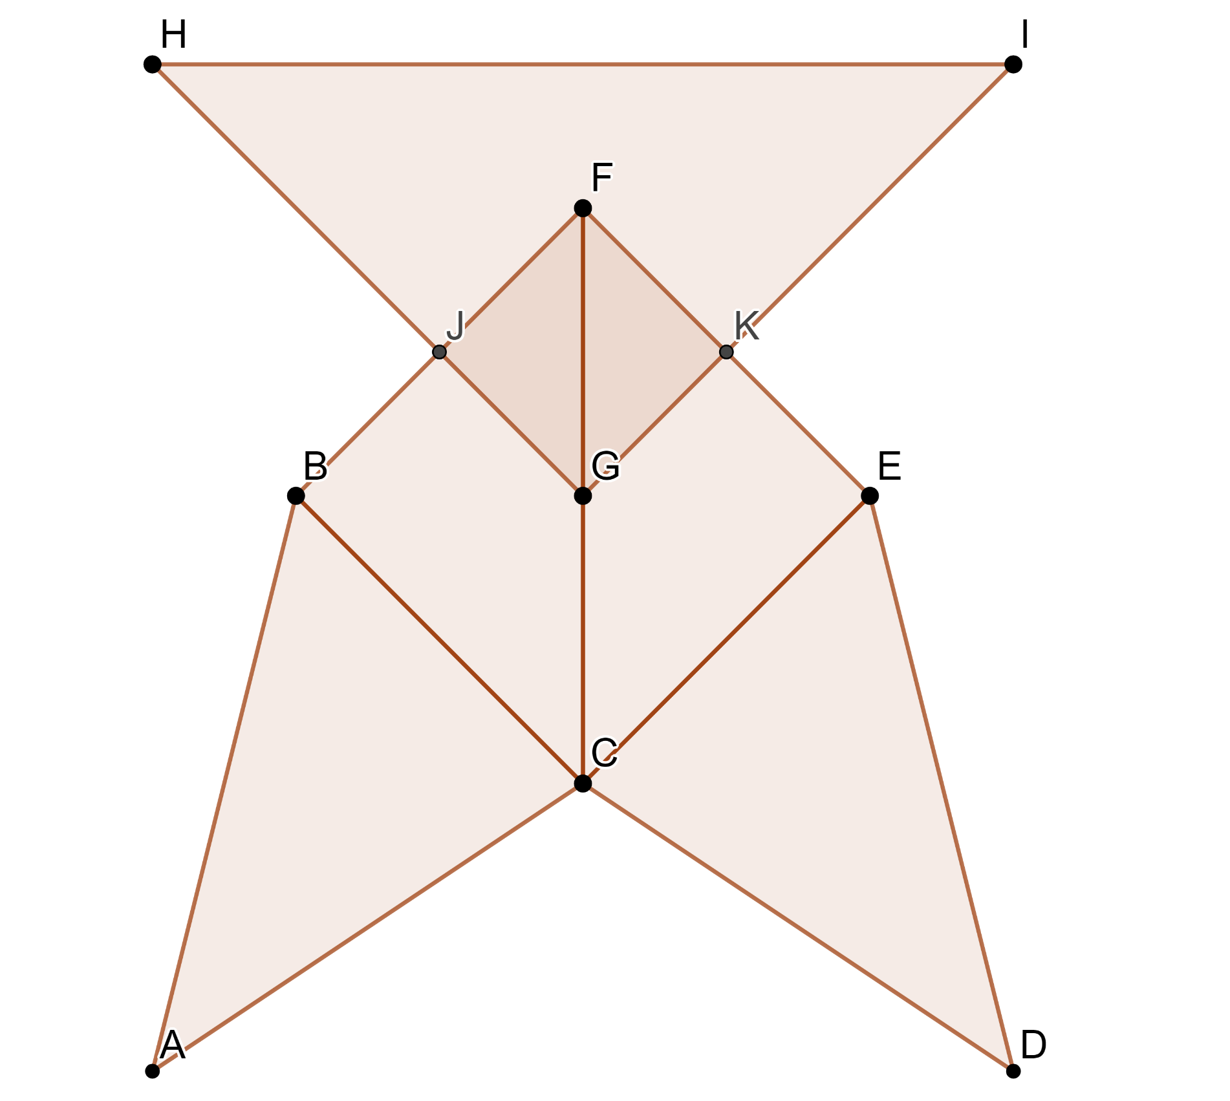Appendix A : Vandelay’s Logo

7

6

5

4

3

2

1

**Appendix B : Order Information**

**This information corresponds to the logo presented in Appendix A.**

|  |  |
| --- | --- |
| **Triangles** | **Angles** |
| * Triangle 1 - △ABC * Triangle 2 - △CDE * Triangle 3 - △BCF * Triangle 4 - △CEF * Triangle 5 - △FGJ * Triangle 6 - △FGK * Triangle 7 - △GHI | * ∠ BAC = 42.27o * ∠ ABC = 59.04o * ∠ DCE = 42.27o * ∠ CED = 59.04o * ∠ BCE = 90.00o * ∠ BFE = 59.04o * ∠ GHI = 45.00o |
| **Measurements** | **Requirements** |
| $\overline{\text{AB}}$* = 4.12 cm $\overline{\text{BC}}$* = 2.83 cm $\overline{\text{BF}}$* = 2.83 cm $\overline{\text{CF}}$* = 4.00 cm $\overline{\text{GH}}$* = 4.25 cm $\overline{\text{HI}}$* = 6.00 cm $\overline{\text{JB}}$* = $\overline{\text{FJ}}$ $\overline{\text{KE}}$* = $\overline{\text{FK}}$ $\overline{\text{CF}}$* = $\overline{\text{GC}}$ | * Triangles 1 and 2 have to be congruent * Triangles 3 and 4 have to be congruent * Triangles 5 and 6 have to be congruent * Triangles 3, 4, 5, 6 and 7 have to be similar to one another |

**Appendix C : Formula Sheet**

Congruent Triangles

* Side-side-side (SSS)
* Side-angle-side (SAS)
* Angle-side-angle (ASA)

Similar Triangles

* Side-side-side (SSS)
* Side-angle-side (SAS)
* Angle-angle (AA)

**Appendix D : Answer Key**

Triangles 1 and 2

* ∠ABC = 59.04o and ∠CED = 59.04o
* = 2.83 cm and = 2.83 cm
* ∠BCA = 78.69o and ∠EDC = 78.69o (because 180 – 59.04 – 42.27 = 78.69)
* Therefore, triangles 1 and 2 are congruent (ASA)

Triangles 3 and 4

* ∠BFC and ∠EFC share the same angle
* $\overline{\text{CF}}$ is shared
* ∠BCF and ∠ECF share the same angle
* Therefore, triangles 3 and 4 are congruent (ASA)

Triangles 5 and 6

* ∠JFG and ∠KFG share the same angle
* $\overline{\text{GF}}$ is shared
* ∠JGF and ∠KGF share the same angle
* Therefore, triangles 5 and 6 are congruent (ASA)

Triangles 3 and 5

* The length of $\overline{\text{JB}}$ is double the length of $\overline{\text{FB}}$ (Ratio 2:1)
* ∠KFG and ∠EFC share the same angle
* The length of $\overline{\text{CF}}$ is double the length of $\overline{\text{GF}}$ (Ratio 2:1)
* Therefore, triangles 3 and 5 are similar (SAS)

Triangles 4 and 6

* The length of $\overline{\text{KF}}$ is double the length of $\overline{\text{EF}}$ (Ratio 2:1)
* ∠JFG and ∠BFC share the same angle
* The length of $\overline{\text{CF}}$ is double the length of $\overline{\text{GF}}$ (Ratio 2:1)
* Therefore, triangles 4 and 6 are similar (SAS)

Since triangles 3 and 4 are congruent and therefore similar, and triangles 5 and 6 are congruent and therefore similar; triangles 3, 4, 5, and 6 are similar to one another.

Triangles 6 and 7

* The length of $\overline{\text{GH}}$ is 1.5 times the length of $\overline{\text{FB}}$ (Ratio 1.5:1)
* ∠BFC = 45o and ∠GHI = 45o
* The length of $\overline{\text{HI}}$ is 1.5 times the length of $\overline{\text{FC}}$ (Ratio 1.5:1)
* Therefore, triangles 6 and 7 are similar (SAS)

Since triangles 6 and 7 are similar, and triangles 3, 4, 5, and 6 are similar; triangles 3, 4, 5, 6, and 7 are similar to one another.

Creating an Automaton

Instructions for students

Simple machines include levers, inclined planes, pulleys, wheels and axles, and screws. With them, humankind has been able to create electric motors and computers. Before these inventions, however, there was a time when simple mechanics ruled.

During the age of mechanics, machines called *automata* were made up of surprisingly complex engines that mirrored various behaviours. Their motion was driven by cranks and gears and coding was done with cams and followers. Some interesting examples of automata can be found on [Exploratorium](https://www.exploratorium.edu/tinkering/blog/2014/08/19/automata-examples).

This week, why not give a “hand” to health care workers and applaud them for their work during this most difficult time. Your task is to create your own **automaton** (using materials found around the home) that mimics clapping hands. Before producing it, though, remember the design process.

1. Design your automaton – A simple design plan will go a long way.
   * What does my automaton need to do?
   * What motion transformation or motion transmission systems will I use?
   * Does my automaton require guiding controls?
   * What about its reversibility?
   * What constraints do I have?
2. Do a little research
3. Collect your materials – What materials do you have accessible?
4. Plan – Now that you have a basic idea of what needs to happen and what materials you have, refine your design.
5. Create – Go forth and build.
6. Test and evaluate your creation:
   * Am I happy with my final product?
   * Can I improve it? If so, how?

Now clap away!

***Investigate further***

If automata and steampunk culture is of interest to you, why not . . .

* read some great steampunk books that feature automata? You may wish to check out:
  + A Clockwork Angel Series by Cassandra Clare
  + Cinder by Marissa Meyer
  + Leviathan by Scott Westerfeld
  + The Invention of Hugo Cabret by Brian Selznick

(Virtually) the [Mechanical Art & Design (MAD) Museum](https://themadmuseum.co.uk/) located in Stratford-upon-Avon in England. It houses a great collection of automata.

Materials required

* Suggested consumable materials (will depend on availability around the home):
  + cardboard, thick card stock, pencils, dowels, push pins, straws
* Suggested equipment (will depend on availability around the home):
  + cutting mat, cutting implements (utility knife, scissors etc.), adhesives (glue, tape etc.), ruler

|  |
| --- |
| Information for parents  About the activity  Children should:   * build their own automaton with simple materials found around the home. Safety is always paramount and therefore great care and caution should be taken when working with glue guns and utility knives.   Parents could:   * focus on safety (students may use utility knives, hot glue guns etc.). * encourage children to think outside the box when it comes to possible materials to be used. |

Learn About Your Body and Get Moving!

Information for students

Activity 1: Learn about your body

* Watch [this video](https://youtu.be/Ovk5qEQ9vmw) (2 mins 18 sec) to learn about what happens to your lungs when you exercise.
* What effect does exercise have on your lungs?
* Discuss what you learned with a member of your family.

Activity 2: Get moving!

* Watch [this video](https://youtu.be/odwhg4uTiBQ) (10 min 35 sec) and carry out the 10-minute cardiovascular and muscular workout.

Materials required

* None

|  |
| --- |
| Information for parents  About the activity  Children should:   * learn about the function of lungs during exercise * complete a workout   Parents could:   * discuss what their child has learned about the function of lungs during exercise   participate in the workout with their child |

Creating a Mandala

**Information for students**

* A mandala is a geometric design meant to symbolize the universe. It is an art form that is found in many cultures around the world.
* The word mandala comes from Sanskrit and means “healing circle” or “whole world."
* Mandalas are usually circular in shape, with designs starting at the center, and working their way outward (or vice versa). They can be seen as a model for the organizational structure of life and the universe.

**Materials required**

* Paper
* Pencil or fine tipped marker for drawing
* Markers or paint for decoration
* Ruler
* Geometry compass (optional; for drawing circles)

**Instructions**

Please see Appendix A for visual instructions for this activity.

1. Create a mandala template. Draw a circle on a blank piece of paper with either a geometry compass or something round (like a bowl or glass) as a guide.
2. Find the centre of your mandala. If drawn with a compass, the hole in the paper is the centre. If drawn with a plate, draw a light line in pencil from the top to bottom, and from the left side to the right side. The point where these lines cross is the centre.
3. Keep your mandala symmetrical. Line up your motifs along directional lines. Use a ruler and protractor to mark some lines lightly on your mandala.
4. Draw a small shape in the middle of the circle, with a pencil or a marker.
5. Draw another shape outside this first shape. (You can change colours at any point.)
6. Repeat it in a ring all around your centre motif.
7. Keep going, drawing new motifs in expanding rings, as you work toward the outside circle of your mandala. Repeat some of your motifs and introduce new ones as you go.
8. Try overlapping some motifs. This creates new and interesting shapes, which still harmonize with what you've drawn so far.
9. You may find yourself wanting to go back and add something to a previous ring.

The mandala is finished when it feels finished to you.

|  |
| --- |
| Information for parents   * Ask your child to share their mandala with you. * Ask your child to describe their process of drawing the mandala to you. * For more ideas on drawing mandalas, encourage your child to visit:   <https://www.youtube.com/watch?v=sIOh615w4Nk> |

Appendix A: Creating a Mandala

|  |  |  |
| --- | --- | --- |
| **STEP 1** | **STEP 2** | **STEP 3** |
| **STEP 4** | **STEP 5** | **STEP 6** |
| **STEP 7** | **STEP 8** | **STEP 9** |
| **Finished Project** | | |

The Many Impacts of COVID-19   
Part 1: The Environment

Information for students

Over the next couple of weeks, you will be asked to read and reflect on a variety of online articles discussing the different impacts COVID-19 is having on our lives. It is suggested that you use a journal or Duo-Tang to keep your reflections.

For this week, read and reflect on the BBC article “Will COVID-19 Have a Lasting Impact on the Environment?”

In paragraph 6 the journalist asks the following question:

* When the pandemic eventually subsides, will carbon and pollutant emissions “bounce back” so much that it will be as if this clear-skied interlude never happened? Or could the changes we see today have a more persistent effect?

Write a short reflection on the article. Consider the following questions in your reflection:

* Can the positive changes to the environment continue after the COVID-19 pandemic?
* Or will industries and individuals go back to their regular destructive habits?
* What has this pandemic taught you about your personal values and lifestyle habits?

Materials required

* Paper, pen or pencil
* Device with Internet access (<https://www.bbc.com/future/article/20200326-covid-19-the-impact-of-coronavirus-on-the-environment>)

|  |
| --- |
| Information for parents  In this activity students should:   * Learn about some of the impacts the COVID-19 pandemic is having on the environment and think critically on whether these will be lasting changes.   Parents could:   * Read the article and discuss it with their child. |

Creating Canada

The process that led to Confederation was arduous. There were many obstacles to founding a country, but the Fathers of Confederation, who led the way, never gave up. In this activity, you’ll learn a little about the journey toward Confederation, as well as some of its immediate consequences.

Information for students

Go to this website and read a little about the road to Canadian Confederation as well as some of its immediate consequences: <https://thecanadianencyclopedia.ca/en/article/confederation-1867>

* If you do not have access to the Internet, you can still consult the historical documents on the next page to help you with the activity.
* Now that you’ve learned about Canadian Confederation, do the following activities:

1. ***Fill in the chart*** *below using the documents provided.*
2. ***Give your own thoughts*** *on Canadian Confederation (guiding questions are provided below).*

Materials required

Useful resources, depending on personal preferences and availability:

* device with Internet access
* writing materials (paper, pencil, etc.)

|  |
| --- |
| Information for parents   * Discuss the potential answers and ideas with your child. |

Documents

Document 1 Document 2

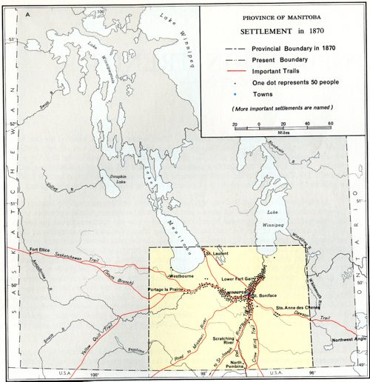*Original map of the province of Manitoba*

**“And that claim is by the right of our manifest destiny to overspread and to possess the whole of the continent which Providence has given us for the development of the great experiment of liberty and federated self-government entrusted to us.”**

John L. O’Sullivan,

discussing America’s right to control all of North America, which boosted fears of the American annexation of British colonies

Originally appearing in a column in the

*New York Morning News*

The Winnipeg Free Press

Document 3 Document 4

*The Numbered Treaties with Indigenous peoples*

**“…, the map of Canada was redrawn: the Northwest Territories [was divided] into two territories to allow for the creation of Nunavut, a homeland for [the] Inuit. The creation of Nunavut is testament to the strength of Inuit political leaders...”**

CanadasHistory.com

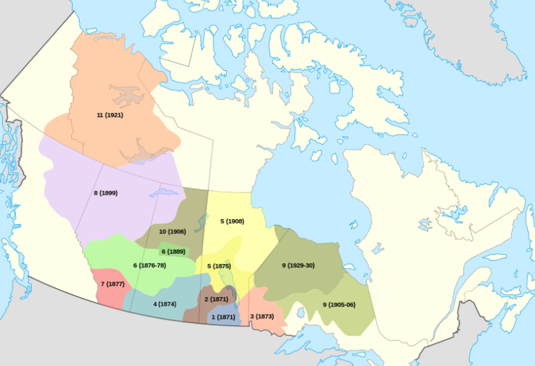

https://en.wikipedia.org/wiki/Numbered_Treaties

Document 5 Document 6

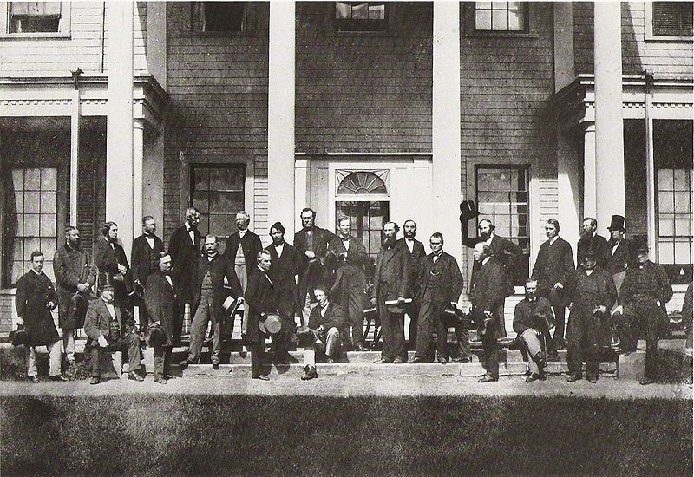The Great Coalition The Charlottetown Conference

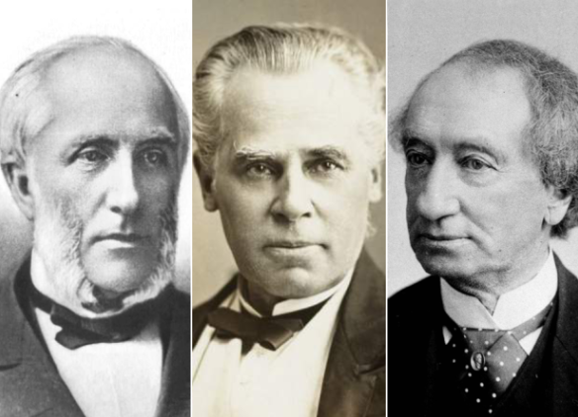 Library and Archives Canada

Left to right: George Brown, George-Étienne Cartier,

John A. Macdonald – National Post

1. Enter the document numbers in the correct spaces.

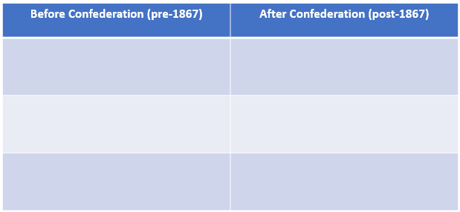Answers:

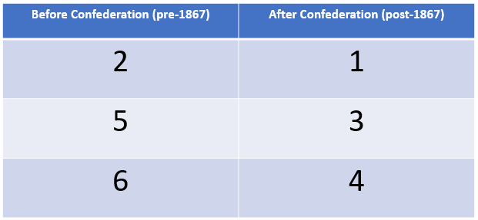Answer Guidekey:

1. **Give your own thoughts on Canadian Confederation.**

* What does Canadian Confederation represent to you?
* How would you have approached Confederation differently?
* Why do we celebrate Confederation on July 1?

____________________________________________________________________________________________________________________________________________________________________________________________________________________________________________________________________________________________

_______________________________________________________________________

_______________________________________________________________________

_______________________________________________________________________