Poetry/Song Writing
Information for students
Read the poem, “The White”.
Use the following prompts to help you think about the poem:
- I noticed . . . I wonder . . . I was reminded of . . . I think . . . I’m surprised that . . . I’d like to know . . . I realized . . . If I were . . . The central issue(s) is/are . . . If _________, then . . . I’m not sure . . . Although it seems . . . This part/line makes me think that . . . This makes me feel that . . . The author is suggesting that . . .
- Discuss the poem with a family member or send it to a friend and talk about it together.
- Using Patricia Hampl’s poem as a model, attribute a colour to the current season and write a poem or song lyrics that captures how you are experiencing spring right now.
- Take it to the next level! Share your poem with your family or friends. If you’re musical, set your lyrics to a melody and record it!
Material required
- Link: http://pennykittle.net/uploads/images/PDFs/Poetry/ColorPoemTheWhite.pdf

- Paper, pen, phone, tablet or computer.

Information for parents
Above all, this activity is designed to be simple! We hope it will appeal to your child. The best things your child can do are:
Read every day.
Write every day.
Talk every day.

Comment ça va?
Consignes à l’élève
- C’est important de prendre du temps pour parler à sa famille et à ses amis et de prendre de leurs nouvelles.

- Cette semaine, appelle quelqu’un que tu connais qui parle français, un ami ou un membre de ta famille éloignée, et parle-lui en français pendant au moins 10 minutes.

- Tu peux ensuite informer les personnes avec qui tu habites de ce que l’autre personne t’as raconté (en français ou en anglais.)

Matériel requis
- Téléphone
- Médias sociaux
Information for parents
About the activity

This activity will help students successfully accomplish the following #MISSIONFLS challenge:

- Mission en équipe - Je parle pendant 10 minutes en français avec mes amis pour prendre de leurs nouvelles

In this activity, students will practise:

- conversing in French without prior preparation
- developing their vocabulary
- developing their confidence speaking French

Parents could:

- ask for support from someone they know who speaks French
- schedule a specific time during the week for the conversation in French to take place

Reference: bit.ly/MissFLSSecCycle2

Vide ton disque dur mental!
Information aux élèves
Prépare une exposition qui aura pour titre Je vide mon disque dur mental! Cette exposition sera interactive, c'est-à-dire qu'elle sera non seulement visuelle, mais auditive.
Dans un premier temps, on te demande de t'enregistrer en train de t'exprimer sur une des questions suivantes:
- Les leçons que tu espères que la société tirera de cette période de confinement
- Les frustrations qu'engendre chez toi cette période de confinement
- Les petites douceurs que tu as découvertes pendant cette période de confinement
L'objectif est de sortir ce que tu as sur le cœur et/ou en tête, que tes idées soient pêle-mêle ou pas. Il ne faut pas te censurer, sois libre de dire ce que tu veux, dans l'ordre que tu veux. Le but ici est de vider ton disque dur mental.
Une fois l'enregistrement terminé, fais ton autoportrait sur une feuille et/ou carton de grand format. Remplis l'une des parties de ton dessin (chevelure ou chandail) de ton discours (retranscription des paroles que tu as enregistrées).
Tu dois, pour cette partie, couper, retrancher, ajouter ou remplacer certains mots ou expressions par d'autres. Tu dois t'assurer que tes phrases ou mots ne sont pas redondants. Si tu observes que tes phrases enregistrées ne sont pas très compréhensibles à l'écrit, tu dois les améliorer. Mets l'accent sur la syntaxe, la ponctuation, les pronoms de reprise et la richesse / la variété du vocabulaire. Comme tu le sais, on ne s'exprime pas de la même façon à l'oral qu’à l'écrit. Il est donc approprié de faire un petit ménage linguistique ici!
Matériel requis
- Feuille, carton grand format
- Toute application sur ton cellulaire te permettant de t'enregistrer ou enregistreuse traditionnelle
- Crayons HB, de couleur et/ou peinture
Information for parents
You can invite the entire family to visit the exhibit. It can take place in the hallway or in a room of your choice. Everyone should be able to hear and read the student’s work. The entire family could go through the exhibit and have a discussion afterwards about their feelings during this period of confinement.

Lights for the Logo
Information for students
The Math Institute of Québec is looking to create a large version of its logo, which will be displayed outside its office with lights of different colours that will be turned on in the evening.
Unfortunately, someone spilled coffee on the blueprints, so some of the information is missing and you’ll need to find it.
The lights around the perimeter of the logo are to be white, while the interior lines are to be blue.
There are two companies that offer lighting services. Their price lists are in the appendix on page 3. Blue lights cost more in case the colour must be changed for special events. You need to figure out which company is cheaper.
The Math Institute of Québec has also considered making smaller logos for indoor signage. The smaller logo will have only white lights. To save on costs, you need to determine the size of the job for which both companies will charge the same amount for their services.
All taxes are included in the final costs.
Materials required
- The diagram of the logo with measurements (see page 2)
- The pricing list for the two companies that offer lighting services (see page 3)
- Formula sheet for metric relations (geometric mean theorem), trigonometric ratios and sine law (see page 3)

Information for parents
Read the instructions to your child, if necessary.
Discuss the task together with your child, outlining the steps they need to carry out.
Once the task is completed, you and your child can go over it with the answer key provided.
Please note that some students may not have covered trigonometric ratios or the sine law yet in their class. This assignment has been created with that in mind, so students can also solve the problem using metric relations (geometric mean theorem) instead.
Also, your child may obtain answers that are slightly different from the answer key, depending on how they round off their results. Being off by a few tenths is fine. There is no need to worry about inconsistencies in rounding off the results. The important thing is that your child is able to show that they can solve the problem.
Appendix – Diagrams of the Logo
Artist’s Rendition of the Logo

Blueprint of the Logo (with some measurements)
A
B
C
E
F
4.24
4.24
1.9
D

- ∠ADC = 45º
- ∠DCE = 26.65º
- ∠CFE = 26.48º
- $\overline{\text{AC}}$ = 4.24 m
- $\overline{\text{DC}}$ = 4.24 m
- $\overline{\text{DE}}$ = 1.9 m

NOTE: All lengths are in metres

Appendix – Lighting Company Price Lists

 | Bright Lights | Lumenessence
White Lights | $300 per metre | $375 per metre
Blue Lights | $900 per metre | $750 per metre
Service Fee | $2 000 | $1 250

Appendix – Formula Sheet

$\frac{\text{x}}{\text{b}} \text{= }\frac{\text{b}}{\text{c}}$ or b² = cx
h
C
b
a
A
B
c
x
y
D

$\frac{\text{y}}{\text{a}} \text{=} \frac{\text{a}}{\text{c}}$ or a² = cy

$\frac{\text{x}}{\text{h}} \text{=} \frac{\text{h}}{\text{y}}$ or h² = xy

sin A = length of the leg opposite ∠ A
a
c
b
C
B
length of the hypotenuse

cos A = length of the leg adjacent to ∠ A
length of the hypotenuse

tan A = length of the leg opposite ∠ A
length of the leg adjacent to ∠ A

$\frac{\text{a}}{\text{sin A}}$ = $\frac{\text{b}}{\text{sin B}}$ = $\frac{\text{c}}{\text{sin C}}$

Appendix – Answer Key
Lengths of each side

$\overline{\text{AB}}$ = 6 m
$\overline{\text{AD}}$ = 6 m
$\overline{\text{AC}}$= 4.24 m
$\overline{\text{BC}}$= 4.24 m
$\overline{\text{CD}}$= 4.24 m
$\overline{\text{DE}}$ = 1.9 m
$\overline{\text{CE}}$ = 3.79 m
$\overline{\text{CF}}$ = 8.49 m
$\overline{\text{EF}}$ = 7.59 m

Total length of the interior and exterior lines

- Blue = 12.27 m ($\overline{\text{AC}}$, $\overline{\text{CD}}$, $\overline{\text{CE}}$)
- White = 34.23 m ($\overline{\text{AB}}$, $\overline{\text{AD}}$, $\overline{\text{BC}}$, $\overline{\text{DE}}$, $\overline{\text{CF}}$, $\overline{\text{EF}}$)

Cost of the lighting services provided by each company

- Company A = 300(34.23) + 900(12.27) + 2000 = $23 312.00
- Company B = 375(34.23) + 750(12.27) + 1250 = $23 288.75

The size of the job for which both companies will charge the same amount for their services

- y = 300x + 2000 and y = 375x + 1250
  - 300x + 2000 = 375x + 1250
  - 2000 – 1250 = 375x – 300x
  - 750 = 75x
  - 10 = x (The total length of all the parts of the logo)
- y = 300(10) + 2000
  - y = 5000 (The total cost of the lighting job)

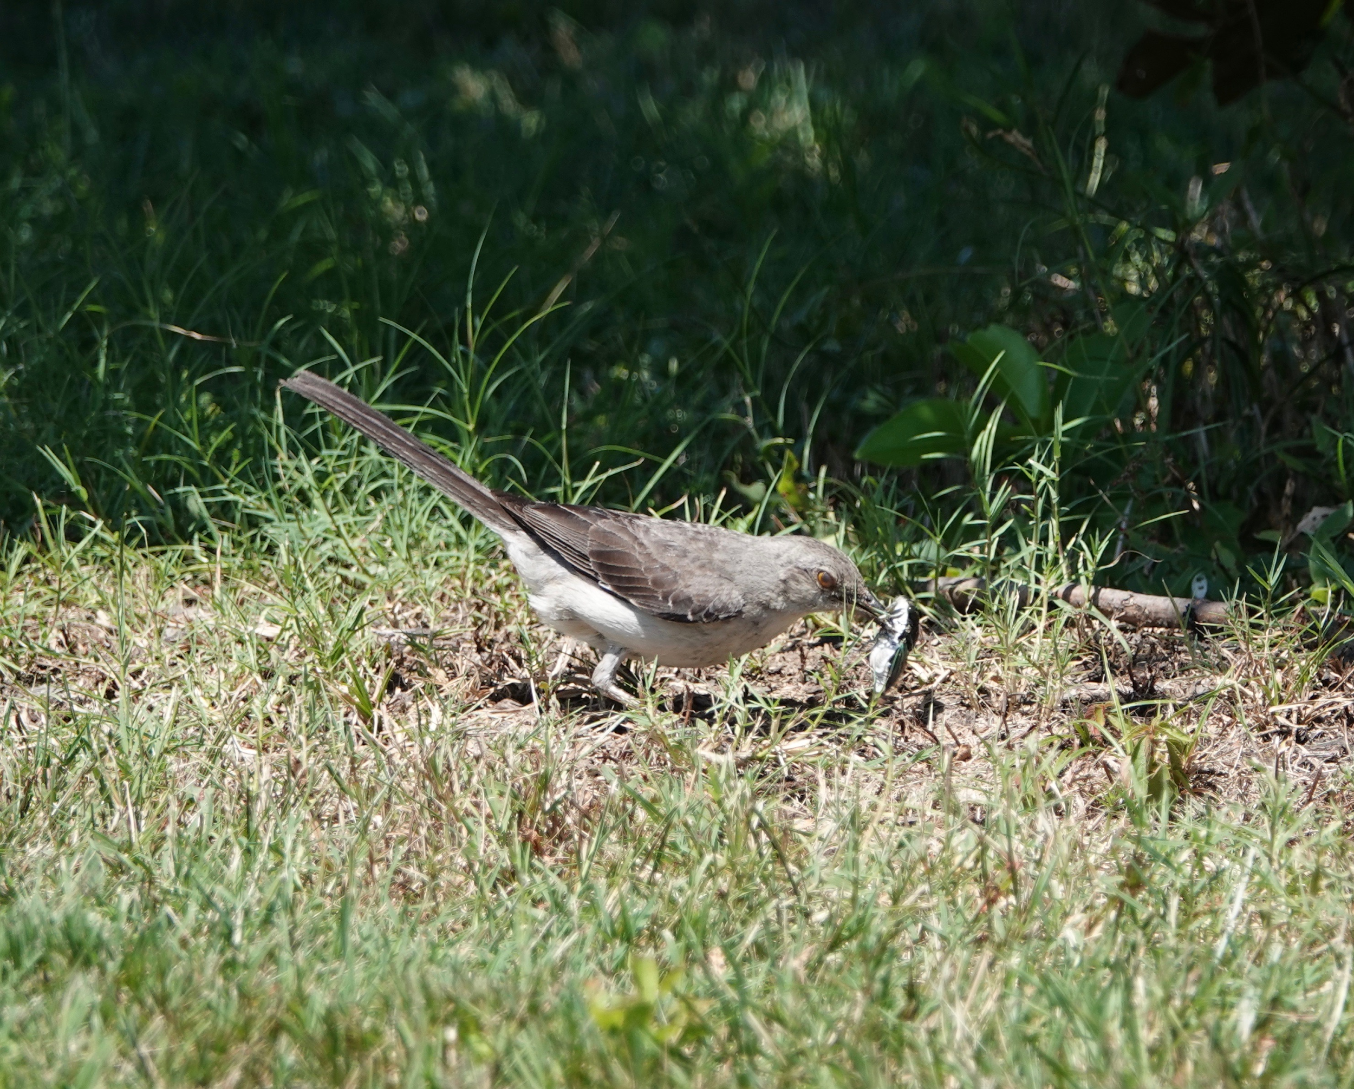
Ecosystems

Information for students
- Take a look in your yard or nearby park. What animals, plants and fungi do you think live there? Make a list of all the things you can think of.
- Research:
  - What is an “ecosystem”?
  - What is a “trophic relationship”?
  - What are “producers, consumers and decomposers”?
Image taken from: https://matthewwills.com/2019/08/23/an-ecosystem/
  - What is a “food web”?
  - What are “natural” and “human disturbances”?
  - Explain the above in your own words.
- Field work:
  - Make a sketch of your yard or nearby park (ecosystem). Include some of the animals, plants and fungi that may live there.
  - Draw arrows to indicate the “trophic relationships” (who eats who) in your sketch.
  - Explain what natural resources (biotic and abiotic) exist in your ecosystem.
  - Explain where the living organisms get the energy to live. Trace the energy through the food chain to its original source.
- Describe what may happen to a population of birds living in your area if all your neighbours start using a pesticide that is also toxic to many insects. Explain what makes you think that.
- What are some natural disturbances that affect the ecosystem near your house? Explain.
- What are some human disturbances that affect the ecosystem near your house? Explain.
- Research - sketch and explain each of the following cycles and describe how they affect ecosystems:
  - Water cycle
  - Carbon cycle
  - Nitrogen cycle
- How is the ecosystem in your yard or nearby park different from an ecosystem in a desert? How have living organisms adapted to live in each ecosystem (your yard and a desert)?

Materials required
- Device with Internet access (optional)
- Paper, writing and drawing materials
- Access to a yard or nearby park
Information for parents

- Read the instructions to your child, if necessary.
- Discuss the questions together.
- Brief video explanation: https://www.youtube.com/watch?v=v6ubvEJ3KGM (optional)

How much water do you really need to drink?
Instructions for students
Brain Bite
We’ve been told for a long time now that we should be drinking 8 glasses of water a day - but is that really true for all of us? Watch the video to learn more about how much water we need.
  - Video (4 min 51 sec): What would happen if you didn’t drink water?

Activity 1 - Hydration
- discuss what you know about hydration with a parent (in person) or a friend (using technology). How much water do you drink a day? If you don’t drink enough water, what are some things you could to make it easier for you to drink more water?
- one of the main messages of Canada’s new Food Guide is “make water your drink of choice”. For ideas on how to add some flavour to your water, visit Canada’s food guide website section on water.

Activity 2 - Get Moving!
- Hopefully you’re already drinking more water, and now it’s time to sweat it out! Get 25 of your recommended 60 minutes of moderate-to-vigorous physical activity with this at-home. Fill up your water bottle, put your running shoes on, grab a chair and enjoy the workout!
Video (25 mins): Cardio and muscular circuit training using a chair
Materials required
- A chair
Information for parents
Student should:
- share what they learned from the video with a family member and discuss their water consumption
- complete the chair-based physical activity.
Parents could:
- discuss different ideas for consuming more water throughout the day - what helps your child to remember to drink.

Your Choreography danced before your very own eyes!
How to try out dance composition without a dancer?
Imagining how a dance choreography will look like is often challenging when we are the ones dancing. This week, we’ll try building a choreography all the while being the choreographer (who knows, it might even get you inspired to try the dance yourself)
In this Virtual Dance Studio, you get to be the choreographer and try out dance composition. Visit http://www.artsalive.ca/en/dan/yourturn/virtualdance/default.asp and build your choreography.
Try a second style of dance or on another type of music. How does it change the choreography? What have you found as a constant across the different styles?
After having made the choreography; how could this process of visualising your ideas be beneficial with your dance style or way of creating? Did you need to readjust the flow?
Keep going; ever wondered why people say ‘’Break a leg’’ or what a ‘’Green Room’’ is? Explore some dance know-how here, http://www.artsalive.ca/en/dan/yourturn/virtualdance/default.asp
Materials required
- Device with Internet access
Information for parents
This activity is designed to be simple and take the mystery out of building a choreography!
We hope it will appeal to your child whatever their grade level.

Gender Stereotypes in Movies and TV Shows
Information for students
Images of men and women in the media and in the entertainment industry (movies, TV and radio shows, news, music, print media, etc.) are often based on stereotypical roles of men and women.
By definition, a stereotype is “a set idea that people have about what someone . . . is like, especially an idea that is wrong.”
- Think about how realistically men and women are portrayed on TV and in movies. Compare the men and women you see as characters with people you know in real life.
- Make a list of characteristics portrayed in the entertainment industry that you find true and untrue to your reality. Think about their gender, race, age, culture, etc. Do you think stereotypes in TV shows and movies can limit how we see others or even how we see ourselves?
- Try to remember a show or movie you have watched, watch a new show or movie, or use the Internet to help you remember how some characters were portrayed. You could even call or video chat with classmate to exchange ideas and work together.
Materials required
- DVDs or device with Internet access
- Paper and writing materials
Information for parents
Talk about the last movies and TV shows that you watched with your child or that your child, and point out non-traditional heroes or heroines.

Look at how boys, girls, men and women are stereotyped in movies and TV shows. Talk about how these images can be limiting for people who may feel inadequate because they don’t fit the mould.

Familiarize your child with the concept of stereotyping (simple, one-dimensional portrayals of people based on generalizations of gender, race, age, culture, etc.) and help them understand the role gender stereotypes can play in the content they watch.

Creating Canada
Unlike many former colonies, Canada was not created through war or revolution. Instead, Canadian Confederation came about through political debate and negotiation.
Information for students
Go to the following website and use the timeline to learn a little about how Canada came to be a country in 1867: https://www.thecanadianencyclopedia.ca/en/timeline/confederation

- John A. Macdonald became Canada’s first Prime Minister in 1867. This short clip introduces him: https://www.historicacanada.ca/content/heritage-minutes/sir-john-macdonald

- If you do not have access to the Internet, you can look at the historical documents at the bottom of this page to help you instead of visiting the websites above.

- Now that you have learned about Canadian Confederation, answer the following questions:
- Name the original provinces of the country of Canada.
- Name and explain one of the obstacles to Confederation.

- If you’re interested in learning more about Canadian Confederation, this CBC production is a great way to start: https://www.youtube.com/watch?v=0XAxrNei0d4
Materials required
Useful resources, depending on personal preferences and availability:

- writing materials (paper, pencils, etc,)

- device with Internet access

Information for parents
Discuss the potential answers and ideas with your child.
Appendix
Document 1
"Did anybody ever propose to unite Scotland with Poland or Hungary? Inland countries 800 miles off in the very heart of Europe."

Joseph Howe,
arguing against
Confederation,
The Halifax Chronicle

Maritime Opposition, CBC.ca/history

Modified from https://en.wikipedia.org/wiki/Canadian_
Confederation#/media/File:Canada_provinces_1867-1870.png

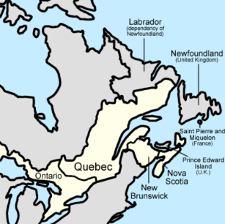
Document 2

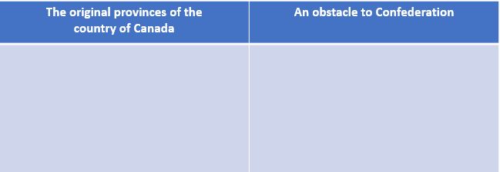
Answers:

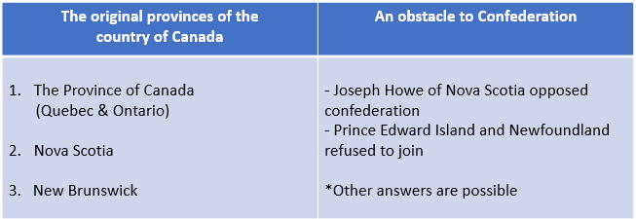
Answer Key:

Cambridge Dictionary, s.v. “stereotype (n.),” accessed April 15, 2020, https://dictionary.cambridge.org/dictionary/english/stereotype

