Through My Window
Information for students
- In this writing activity you will describe what you see when you look out a window, choosing words that will create a mood.
- Choose the window and time of day.
- Spend time looking out the window noting the different things you see, both big and small.
- Identify the mood you want to create. Brainstorm words and phrases that will help create that mood.
- With a highlighter, choose the words and phrases you most want to include in your writing.
- In a paragraph or poem, describe what you see when you look out your window, creating a mood for the reader.
- Edit, proofread and share your writing.
Materials required
- highlighter
- paper or journal
- writing materials
Information for parents
Encourage your child to share their writing with you.
- The best things your child can do are: read every day, write every day and talk every day.

Artistes au féminin
Information for students
Même si on les connaît moins, des femmes d’exception ont marqué tous les domaines des arts à toutes les époques.
Lis le texte suivant pour t’informer sur quelques artistes au féminin : https://www.lesdebrouillards.com/quoi-de-neuf/artistes-au-feminin/ .
Fais quelques recherches sur des femmes artistes que tu admires.
Écris un cours texte, max 50 mots, qui décrit l’artiste au féminin qui t’inspire le plus. Ton texte doit expliquer ce qu’elle fait et ce qui te marque chez elle.
Fais lire ton texte à une personne de confiance pour avoir des commentaires et améliorer ce texte.
Fais parvenir ton texte au concours Mon héroïne sur le site des Débrouillards : https://www.lesdebrouillards.com/espace-debs/mon-heroine/ . Tu pourrais gagner un jeu et un livre. Tu as jusqu’au 22 mai pour participer.

Materials required
- Device with Internet access
- paper, writing materials or access to a writing application on your computer like Office Word.
Information for parents

Help your child understand the instruction, if necessary.

Proof read your child’s text if he or she ask you to.

Crossword Challenge
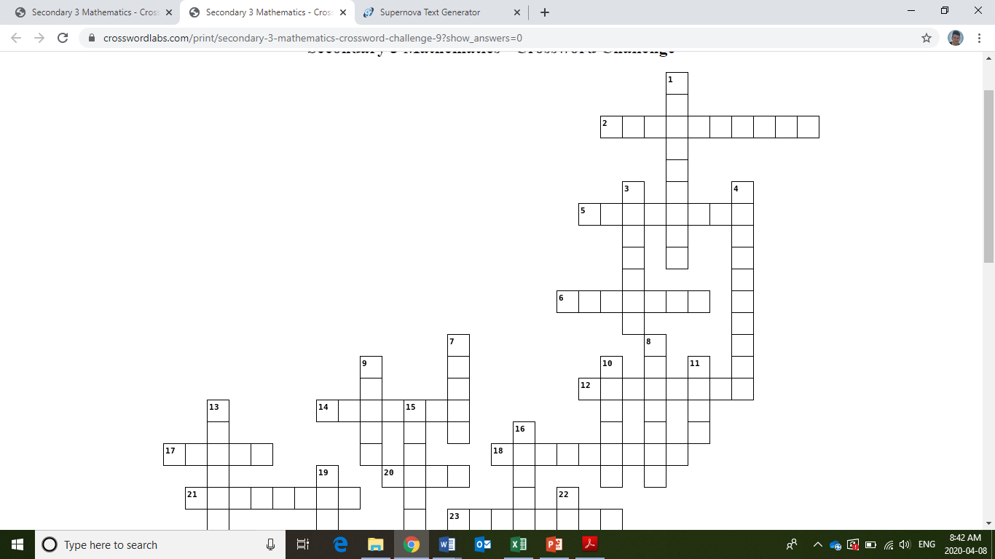
Name of activity
Information for students
Niveau 1
  - Niveau 2
Materials required

Information for parents
Activity details
Children should:

Parents could:

ACROSS
2. 5a + 6b is an algebraic ___________.
5. f(x) notation
6. geometric solid found in Egypt
12. unit of measurement for a container
14. variable for determining the area of a polygon
17. area divided by length for a rectangle
18. another word for equal size
20. 6a and 12b are examples of ______mials.
21. two lines that never intersect
23. fractions, percents and ___________.
24. a 2D plan of a 3D solid
26. formula named after a 570 B.C.E. cult leader
29. cm, kg, mL etc. are examples
31. plane named after French philosopher
34. a way of knowing an answer is correct
36. 90 degree angled triangle
37. notation used to simplify large numbers
38. Square_________

DOWN
1. the length around a plane figure
3. b in y=ax +b is the y-intercept or ___________ value
4. an equation with > or < symbols for example
7. 2,3,5,7,11 and 13 are ___________ numbers.
8. triangle with all different side lengths
9. the rate of change of an equation
10. half of the diameter
11. terms can be grouped together
13. the middle most number in a data set
15. longest side of a right-angled triangle
16. an event that might occur
19. five-sided figure
22. 60 is a useful number since it has many
25. two or more linear equations
27. ¼
28. has one third the volume of a cylinder
30. ___________ of values.
32. the number that repeats most often
33. a number out of 100
34. a cube has 4 (singular)
35. partial area of a circle with a central angle
Inquiry into Air Pressure
Information for students
- In each breath we take, we suck into our lungs roughly a milion billion billion gas particles, some of which are oxygen which we need to live.
- If you blow up a balloon, you are putting those gas particles inside. Sketch what the inside of a balloon might look like if it's filled with air particles. Use little circles to show the particles and arrows to show any movement.
- Inflate a balloon. Put it in the freezer for a few hours. Write (or sketch) a prediction of what you think will happen when you take the balloon out again.
- When you take the balloon out, observe what has changed. Does this match your prediction? Sketch and explain what the balloon looked like before and after it was in the freezer.
- Make a list of possible explanations for any change observed. Here are some sentence starters to help you come up with hypotheses:
  - I think ______ has something to do with _______
  - I think ______ causes _______ to happen.
  - The reason I expect to see this [what I’m seeing] is because [give a cause and effect explanation].
- If you have a friend who is doing this activity too, share with them your favourite hypothesis/possible explanation. You may also share with the province using social media and the hashtag #ScienceAtHomeQC-g9.
- How could you test if your hypothesis/possible explanation is correct? Design an experiment and if possible, run it.
- Try to convince someone you know that your explanation is correct using evidence (you may also do research).
- Choose one of the following to complete the task. If possible, share a picture of your work on social media with the hashtag #ScienceAtHomeQC-g9:
  - How can you use what you have learned to explain why bicycles that have been left out in winter seem to have deflated tires? Try to convince someone you know using evidence.
OR
  - Watch this video then sketch and explain what is happening inside the can at the particle level. https://www.youtube.com/watch?v=qXclcimrmfI.

Materials required
- paper, writing and drawing materials
- Access to a freezer
- Party balloons
- (optional) Device with Internet access
Information for parents
- Read the instructions to your child, if necessary.
- Discuss the questions together.
- (optional) Help your child find the link to the video of the demo.
- (optional) This video gives a brief summary of what is happening: https://www.youtube.com/watch?v=sEbxLrP_ZCU.

Stress Management
Information for students
- Look at the PDF document and the video about stress management.
- During supper time, tell your family what you learned about stress management. You may also call a friend to talk about your new discoveries.
- Plan three physical activities you will carry out this week.
- Carry out the physical activities you planned.

Materials required
- The PDF document about stress management
- The video about stress management

Information for parents
Aim of the activity:
- To find ways to manage stress.

Still Life Drawing
Information for students
Still life drawing is a fundamental in art instruction. Traditionally using everyday objects arranged on a tabletop. To start a still life drawing, you will need to arrange several objects (fruits, vase, cloth, objects of your choice) If you can use a light source (optional) such as a desk lamp you can position the light source on one side of your objects. This will create shadows and give you a better view of the composition.
Begin your drawing lightly sketching the objects, as you define shapes you can than add shadows to enhance the objects in your drawing. Don’t worry if you only get to the sketching part. This exercise is to help students develop observation skills, understand composition and work on basic drawing techniques. The better you see, the better you can draw!
Have fun, try it several times and compare, the secret to all drawing is being able to see.
This lesson is used in all art instruction at every level from kindergarten to Universities.
Materials required
Found objects from around your home (ex. fruit, bottle, vase, bowls, books, etc.) try with at least three objects.
- Plain Drawing paper, 8.5” x 11” but larger paper and or sketch books will work just fine.
- Drawing materials; Pencils, eraser, charcoal (optional), color pencils (optional).
- A directed light source if possible, such as a desk lamp would be ideal but not necessary.
Information for parents
- This drawing activity is suitable for all grade levels and parents are encouraged to participate as well.
(The attached link gives step by step directions to assist in completing this lesson.) https://youtu.be/Xie8oMlME44

Try this lesson a few times with different objects for practice and to challenge your drawing skills. If possible, you can research on-line Still Life drawing and or Still Life painting.

Origins to 1608
Information for students
The Indigenous peoples of Canada have a rich and long-standing history. Before the arrival of the Europeans, Indigenous peoples settled in different regions of present-day Québec. As they moved into these territories, they developed different ways of life.

- Characterize the way of life of the Iroquoian and Algonquian peoples by using the following concepts:

- Territory occupied
- Natural environment
- Primary subsistence activity
- Way of life
- Type of Dwelling

- See Appendix 1 for a guiding worksheet.

- Use the following website or the documents in Appendix 2 as a guide:
https://thecanadianencyclopedia.ca/en/article/aboriginal-people-eastern-woodlands

- Now that you have learned about the way of life of the Iroquoian and Algonquian peoples, answer the following question in a short text. (Don’t forget to include information on both the Iroquoian and Algonquian peoples!)

Explain how the territory had an effect on the way of life of Indigenous peoples.

Materials required
Useful resources, depending on personal preferences and availability:
- writing materials (paper, pencil, etc.)
- device with Internet access

Information for parents
- Common concepts in the History of Quebec and Canada program include culture, society, and
territory.
- In class, students are expected to make links between these common concepts.
- If your child would like to learn more, please view the following video: Canada: A Peoples History - Episode 1: When the World Began.

Appendix 1 – Guiding Worksheet

 | IROQUOIANS | ALGONQUIANS
Territory occupied
Natural environment
Primary subsistence activity
Way of life
Type of Dwelling

Appendix 2 – Documents
Document 3

Vidéanthrop, Un village iroquoien vers 1500, ©Vidéanthrop. Licence : Free illustration for use in an educational context only and with mention of the original source "Vidéanthrop".
Retrieved from Service national du RÉCIT, domaine de l’univers social, www.recitus.qc.ca

Banque Frederick Arthur Verner, Tipis (1890), Bibliothèque et Archives du Canada, C-094103, MIKAN 2897993. License: public domain image
Retrieved from Service national du RÉCIT, domaine de l’univers social, www.recitus.qc.ca

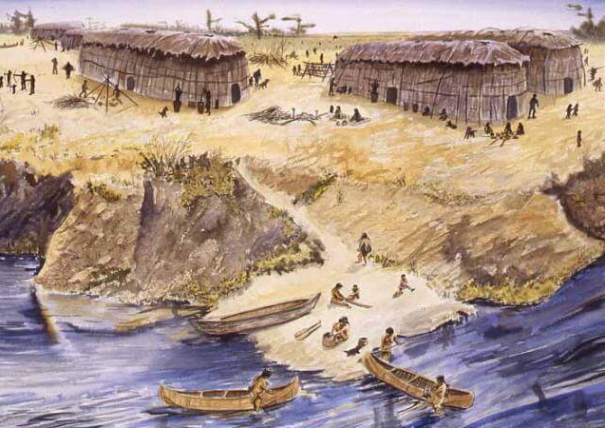
Document 2
Document 1
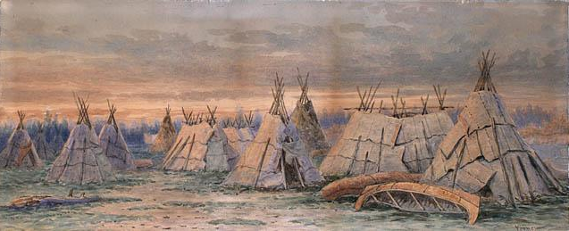
Service national du RÉCIT, domaine de l’univers social, www.recitus.qc.ca [Translation].

“…they live in longhouses and cultivate the land for food… [They] remain there for ten, fifteen or twenty years, as long as the earth produces enough food.”
Service national du RÉCIT, domaine de l’univers social, www.recitus.qc.ca [Translation].

“… [They] occupy a vast territory which is mainly located in the Canadian Shield and the Appalachians… [They] live by hunting, fishing and gathering. Among other things, they feed on game such as hare or partridge, which they can find in the forests, and fish that live in the many lakes and rivers of the Canadian Shield.”
Document 4
Service national du RÉCIT, domaine de l’univers social, www.recitus.qc.ca

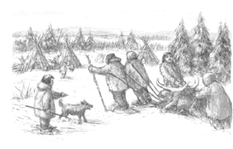
Document 6
Document 5 – Types of climate in North America
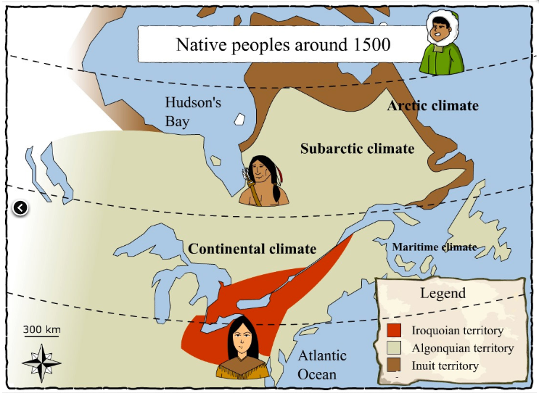
Service national du RÉCIT, domaine de l’univers social, www.recitus.qc.ca

Document 7
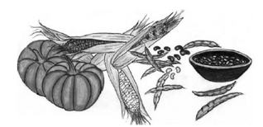
Service national du RÉCIT de l'univers social, www.recitus.qc.ca
Retrieved from: https://hosted.learnquebec.ca/societies/societies/algonquians-around-1500/algonquian-image-bank/

Appendix 3 – Answer Guide

 | IROQUOIANS | ALGONQUIANS
Territory occupied | St. Lawrence Lowlands | Canadian Shield and Appalachians
Natural environment | Fertile region with multiple waterways and a temperate climate | Dense and mixed forests, uneven terrain, soil not particularly fertile but game was plentiful
Primary subsistence activity | Agriculture | Hunting
Way of life | Sedentary | Nomadic
Type of Dwelling | Longhouse | Wigwam

Effect of the Territory on Iroquoian way of life:
Sedentary

because of the fertile soil or The land was suitable for agriculture
or
because they lived in the St. Lawrence Lowlands

Effect of the Territory on Algonquian way of life:
Nomadic

because of the infertile soil or The land was unsuitable for agriculture
or
The territory is large and they follow game (food)
or
because they lived on the Canadian Shield

Make sure that you have the materials required for an activity before you add it to your schedule.

