Poetry/Song Writing
Information for students
Read the poem “Winter.”
Use the following prompts to help you think about the poem. Record your thoughts on paper or electronically.
- I noticed . . . I wonder . . . I was reminded of . . . I think . . . I’m surprised that . . . I’d like to know . . . I realized . . . If I were . . . The central issue(s) is/are . . . If _________, then . . . I’m not sure . . . Although it seems . . . This part/line makes me think that . . . This makes me feel that . . . The author is suggesting that. . .
- Discuss the poem with a family member or send it to a friend and talk about it together.
- Capture a moment of the current changing season in a poem or song lyrics entitled “Spring”.
- Take it to the next level! Have a poetry reading with your family or friends. If you’re musical, set your lyrics to a melody and record it!
Materials required
- Link to the poem (https://lithub.com/winter/)
- Paper and pen
- Phone, tablet or computer

Information for parents
Above all, this activity is designed to be simple! We hope it will appeal to your child whatever their grade level. The best things your child can do are:

- Read every day.
- Write every day.
- Talk every day.

Jouons ensemble !
Consigne à l’élève
- Cette semaine, invite ta famille à jouer en français à un jeu de société. Tu as certainement des jeux à la maison. Sinon, il existe en ligne des jeux de société à imprimer. Choisis celui qui te plaît le plus!
Pour aller plus loin…
- Découvre les intégrammes. Le plus célèbre est « À qui le zèbre? » (en annexe), mais il y en a plusieurs autres à explorer.
Matériel requis
- Jeu de société qui se trouve à la maison.
- Jeux de société à imprimer gratuitement :
https://aujeumag.asmodee-canada.com/imprimez-et-jouez.html.
- Intégrammes (énigmes à résoudre) :
https://brigittepage.files.wordpress.com/2011/10/intc3a9grammes.pdf.
Information for parents
Activity details
This activity will help students successfully meet the following #MISSIONFLS challenge:
- Mission en équipe – Je joue à un jeu de société en français.

In this activity, students will practise:
- speaking French with no preparation
- developing their vocabulary
- developing their confidence speaking French

Parents could:
- play a game with their children
- recommend board games that could be played in French (Boggle, Uno, Clue, Hangman, Battleship, etc.)
- print out or find some games online

Reference: bit.ly/MissFLSSecCycle2

Annexe – À qui le zèbre ?
Consigne à l’élève
L’énigme suivante est parfois attribuée à Einstein, parfois à Lewis Carroll. Même si son origine est incertaine, il s’agit de l’une des énigmes les plus célèbres de tous les temps.

Énoncé
Cinq maisons de couleurs différentes sont habitées par des hommes de nationalités et de professions différentes ayant chacun une boisson et un animal préférés.

Indices
1. L’Anglais habite dans la maison rouge.
2. Le chien appartient à l’Espagnol.
3. On boit du café dans la maison verte.
4. L’Ukrainien boit du thé.
5. La maison verte est située à droite de la blanche.
6. Le sculpteur élève des escargots.
7. Le diplomate habite dans la maison jaune.
8. On boit du lait dans la maison du milieu.
9. Le Norvégien habite la première maison à gauche.
10. Le médecin habite la maison voisine de celle où demeure le propriétaire du renard.
11. La maison du diplomate est à côté de celle où il y a un cheval.
12. Le violoniste boit du jus d’orange.
13. Le Japonais est acrobate.
14. Le Norvégien demeure à côté de la maison bleue.

Résumé
Nationalités : Anglais, Espagnol, Ukrainien, Norvégien, Japonais.
Maisons : rouge, verte, blanche, jaune, bleue.
Boissons : café, thé, lait, jus d’orange, eau.
Animaux : chien, escargots, renard, cheval, zèbre.
Professions : sculpteur, diplomate, médecin, violoniste, acrobate.

Questions
A) Qui boit de l’eau ?
B) À qui appartient le zèbre ?
Non, ce n’est pas le zèbre qui a bu l’eau !
#MissionFLS - À table !
Consignes à l’élève
Cette activité t’aidera à compléter la Mission FLS : J'écris mes propres recettes de cuisine.

Est-ce que ta famille a une recette spéciale ? Une recette traditionnelle ? Est-ce que tu aimes cuisiner ou inventer des recettes ? Cette semaine, on t’invite à écrire ta propre recette ou à adapter une recette en français. Peut-être que tu pourrais même préparer cette recette pour souligner la fête des mères le 10 mai !

Voici comment tu peux le faire :
  - Pense à un plat que tu aimes beaucoup.
  - Pour savoir comment on écrit des recettes, regarde des livres, des magazines ou consulte des sites web.
  - Écris la liste des ingrédients et le matériel nécessaire.
  - Écris les étapes pour préparer la recette.
  - Impressionne ta famille et cuisine ton plat !!
Pour aller plus loin :
  - Tu peux réaliser une courte vidéo à la manière d’une émission de cuisine.
  - Tu peux partager ta recette et ta vidéo avec #MissionFLS.
Matériel requis
  - Site web de recettes: Ricardo, Recettes d’ici, Fondation OLO, Recettes du Québec
  - Mission FLS: bit.ly/MissFLSSecCycle2

Information for parents
Activity details
This activity will help your child accomplish successfully the following challenge on #MISSIONFLS:
- Mission solo - J’écris mes propres recettes de cuisine.
In this activity, the student will practice:
- Giving instructions in French.
- Reading and using food and cooking related vocabulary.
- Reading and writing verbs at the infinitive and imperative tenses.
- Cooking!
Parent can:
- Have a conversation about traditional family recipes
- Have a conversation about the importance of cooking in everyday life.
- Share some cooking tips.

Complete the Equations

Information for students
  - Use your knowledge of algebraic equations to find solutions to the three problems below.
  - Challenge yourself to find more than one solution to each problem.
  - Hints and possible solutions can be found in Appendix A.

Materials required
  - Paper, writing materials
  - Calculator (optional)

Problem 1: Writing Equivalent Polynomial Expressions¹
Use digits 1 to 9 to create a statement that is true. Use each digit only once.

Problem 2: Creating an Equation with a Given Solution²
Use digits 0 to 9 to fill in the boxes to write three equations whose solution is -1/2. Use each digit only once.

Problem 3: Multiplying Binomials³
Fill in the boxes with any numbers that make this equation true.
Information for parents
- Read the instructions with your child, if needed.
- Encourage your child to keep trying. They may need to come back to a problem several times before finding a solution that works.
- If you wish, try the challenge with your child.

Appendix A: Hints and Possible Solutions

Problem 1: Writing Equivalent Polynomial Expressions

Hints:
Use what you know about addition/subtraction facts (for example: 3+4 = 2+5)

Possible Answers:

There are many possible answers, including: 3x² + 6x³ + 4x² – 1x³ = 9x² + 5x³ – 2x².

Problem 2: Creating an Equation with a Given Solution

Hints:
What does it mean to be a solution of the equation?
How would you check if a value is a solution to an equation?
What kind of numbers would you put in for the coefficients of x?

Possible Answers:
There are many possible answers, including the following:
2x + 5 = 4x + 6 2x + 7 = 4x + 8 8x + 5 = 4x + 3

Problem 3: Multiplying Binomials

Hints:

What number is the easiest to fill in? What are the factors of 12?

Possible Answers:
There are many possibilities. Here are some: 2, 6, 5, and 8; 1, 12, 5, and 31.

Something Fishy Happened

Information for students
- During a fishing competition in the Iles de la Madeleine, one of the competing groups, Group A, brought back a mackerel from the Gulf of St. Lawrence that weighed slightly less than the one caught by another group of competitors, Group B. Once ashore, Group A cleaned the fish in a pail of fresh water. Group A ended up winning the competition for capturing the heaviest fish! Why did they win? Complete the activity below and use your research skills to give a detailed explanation.
- The Gulf of St. Lawrence is a body of salt water.

Experiment

Prepare the following three glasses and label them:

Glass 1: Add 125 mL of water (1/2 cup)

Glass 2: Add 125 mL of water (1/2 cup) and 5 mL of salt (1 teaspoon). Stir.

Glass 3: Add 45 mL of salt (3 tablespoons). No water.

Control gummy bear: Leave one gummy bear aside for comparison later.

Put a gummy bear in each of the 3 glasses and leave them for 6-8 hours.

What do you think will happen?
Carefully remove the gummy bears and place them on a plate or paper towel. Measure the 3 dimensions of each bear with a ruler and record each bear’s mass with a kitchen scale, if you have one.

Observations:

 | Control | Bear in Glass 1  (water only) | Bear in Glass 2  (salt water) | Bear in Glass 3  (salt only)
Length (cm)
Width (cm)
Height (cm)
Mass (grams)

Research:
Describe the meaning of the terms diffusion and osmosis after watching this short video
https://www.youtube.com/watch?v=tHzkRtzVmUM

Include a drawing:

Diffusion | Osmosis
Why did Group A win the competition? Explain in detail, using the concepts you explored in your research.

Materials required
- Gummy bears (or any type of gummy candy)  - Internet device (if possible) | - Water  - Salt  - 3 glasses | - Ruler (cm)  - Kitchen scale (optional)
Information for parents
- A device with Internet access is optional but helpful to define the terms diffusion and osmosis. The definitions for these terms can be found in science books, dictionaries etc.
- Extension: To observe osmosis in action, you can cut the end of a soft piece of celery and put it in a glass of water overnight. Describe what happened to the celery. How does that demonstrate the process of osmosis?
- More about Îles de la Madeleine
https://www.tourismeilesdelamadeleine.com/en/discover-the-islands/

Learn About Your Body and Get Moving!
Information for students
Activity 1: Learn about your body

- Watch this video (2 mins 18 sec) to learn about what happens to your lungs when you exercise.
- What effect does exercise have on your lungs?
- Discuss what you learned with a member of your family.

Activity 2: Get moving!

- Watch this video (10 min 35 sec) and carry out the 10-minute cardiovascular and muscular workout.
Materials required
- None

Information for parents
About the activity
Children should:
- learn about the function of lungs during exercise
- complete a workout
Parents could:
- discuss what their child has learned about the function of lungs during exercise
- participate in the workout with their child

Blind Contour Portrait Drawing
Information for students
Blind contour drawing is creating a drawing without watching your hand as you draw. It has been
practiced by artists throughout history and is a great way to train the artistic eye. At first, your blind
contour drawings will look silly but with practice you will improve.

Find a model for your drawing – this can be another person, a clear photo of a person, or a mirror
to create a self-portrait.

Pick a point on the model where the eye can begin its slow journey around the contour or edge of
the object. When the eye begins to move, so should the hand holding the pencil. At no time
should you look at your hand as it draws.

Try drawing the entire contour of the model without lifting your pencil from the paper.
If you’d like to view a tutorial, go to: https://www.youtube.com/watch?v=fjJhZ4DYh50.

Practise, practise, practise. That’s how the real artists do it. If you’d like to take it further, try
creating a blind contour drawing of an object found in your home.

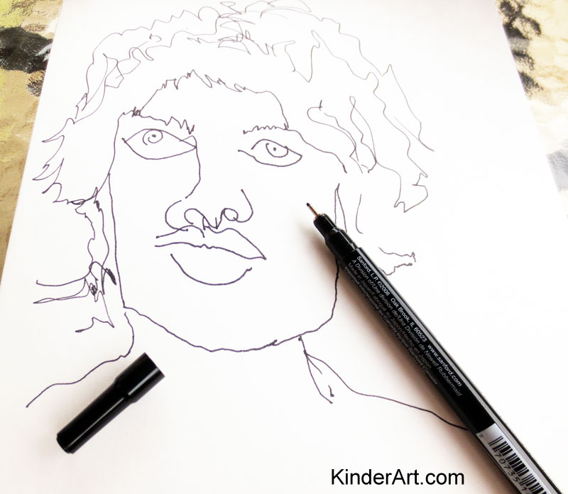

Materials required
- Paper
- Pencil
- Model (person, photo, or mirror for self-portrait)
Information for parents
Read the instructions to students, if necessary.

1608-1663
Information for students
In 1608, Samuel de Champlain, who is considered the founder of New France, established a habitation in Québec. During this period, the colony of New France began to develop.
- Characterize the early history of New France (1608-1663) according to the following concepts:
- Culture
- Economy
- Society
- Territory
- Power

- Connect each document in Appendix 1 with the theme it best represents by writing the document number in the appropriate place in the table provided.
- You may use the following website as a guide: https://www.historymuseum.ca/virtual-museum-of-new-france/introduction/

- Based on the information found in the documents, write a text characterizing the early history of New France (1608-1663). Don’t forget to include the five concepts mentioned above in your text!

Materials required
Useful resources, depending on personal preferences and availability:
- device with Internet access
- writing materials (paper, pencil, etc.)

Information for parents
- Common concepts in the History of Québec and Canada program include culture, economy, society, territory and power. In class, students are expected to link information found in documents to these concepts.
- If your child would like to learn more about the early history of Québec, please view the
following video: Canada: A People's History - Episode 2 - Adventures and Mystics

Appendix 1 – Establish connections between facts
Document 1
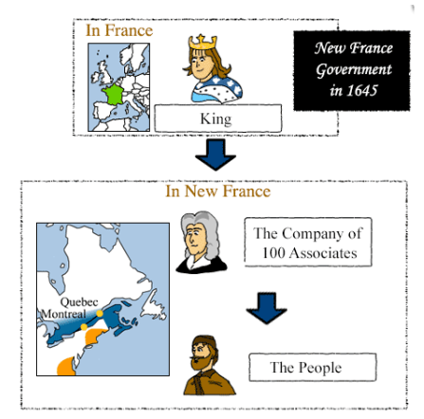
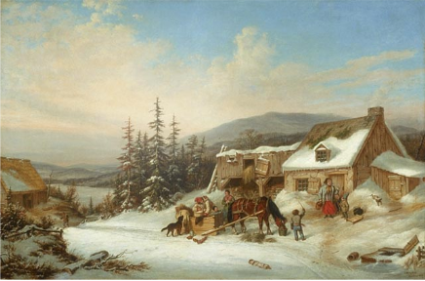
Document 2 – Winter in New France
The Canadian Encyclopedia
https://www.thecanadianencyclopedia.ca/en/article/habitant
Service national du RÉCIT, domaine de l’univers social, www.recitus.qc.ca

Document 4 – A man going to war on snowshoes
Document 3
Mercantilism…, popular in the 17th and 18th centuries in Europe, stated that a country's wealth and power was best served through the accumulation of gold and silver and raw materials…

…State action, an essential feature of the mercantile system, was used to accomplish its purposes - to sell more than it bought to accumulate gold bullion and raw materials. In the case of New France, fur was the raw material. France imported raw materials, such as furs, from its colony, New France, and transformed them into finished products (beaver hats) to be sold back to the colonies and to other countries.

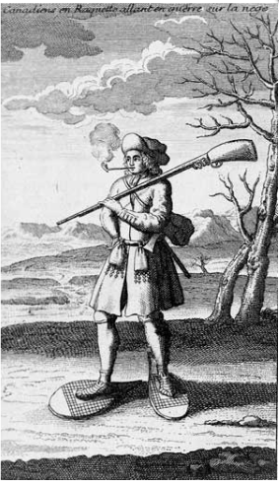

Library and Archives Canada
http://collectionscanada.gc.ca/pam_archives/index.php?fuseaction=genitem.displayItem&rec_nbr=2945957&lang=eng&rec_nbr_list=2926918,2945957,5014148,2834728,3025436,2899188,2837698,790541,3994521,2916030

History of Quebec and Canada Resource Center
http://history.lbpsb.qc.ca/m1u3l2.htm
Document 7
Service national du RÉCIT, domaine de l’univers social, www.recitus.qc.ca

Document 6
LEARN Quebec
https://hosted.learnquebec.ca/societies/societies/new-france-around-1645/life-at-a-trading-post/

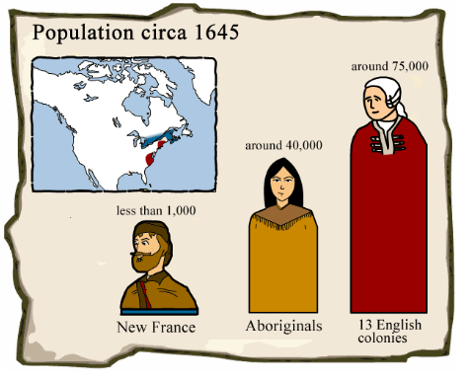
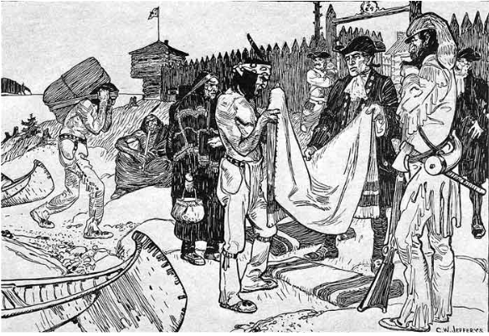
Document 5
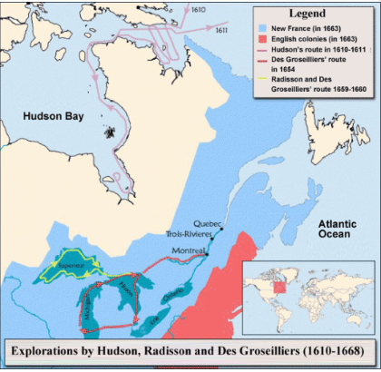

Service national du RÉCIT, domaine de l’univers social, www.recitus.qc.ca

ANSWER: Write the document number in the appropriate place
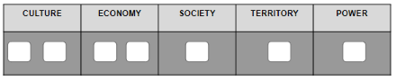

Appendix 2 – Answer Key
Establish connections
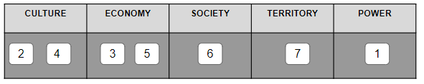

Characterize the early history of New France
Answers will vary but should include the following details:
CULTURE | Adapting to the climate and natural geography – sloped roofs because of the snow, brick houses, snowshoes, etc.
ECONOMY | Economic policy based on mercantilism, benefiting the mother country.  Trade between Europeans and various Indigenous peoples
SOCIETY | European population in New France remained relatively small
TERRITORY | Territory expanded greatly due to fur trade
POWER | The Company of 100 Associates was left in charge of running the colony

