Blog
Information for students
Create your own blog.

blog
noun
- a website containing a writer's or group of writers' own experiences, observations, opinions, etc., and often having images and links to other websites.
- a single entry or post on such a website: She regularly contributes a blog to the magazine's website.

You can create a blog about literally anything – food, fashion, music, poetry, dogs, or even memes. Choose a subject you love – something that speaks to you. You could create a blog based on a talent or hobby you have.

Your goal will be to write one blog post per week. The beauty of a blog post is that you can play with the format – try a different type of post every week, for example: a top ten list, an opinion article, a commentary, a review, a feature, etc. Illustrate your posts! Follow the link below to choose from a ton of free images.

- Tips: Revise your ideas. Edit your posts!
- Take it to the next level: publish your blog online!
Materials required
- Link: www.simplesite.com – Choose “Blog” and get started.
- Free images: https://pixabay.com/
- Paper, pen or pencil, phone, tablet or computer.

Information for parents
Above all, this activity is designed to be simple! We hope it will appeal to your child. The best things your child can do are:

Read every day.
Write every day.
Talk every day.

Comment ça va?
Consigne à l’élève
- C’est important de prendre du temps pour parler à sa famille et à ses amis et de prendre de leurs nouvelles.
- Cette semaine, appelle quelqu’un que tu connais qui parle français, un ami ou un membre de ta famille éloignée, et parle-lui en français pendant au moins dix minutes.
- Tu peux ensuite informer les personnes avec qui tu habites de ce que l’autre personne t’a raconté (en français ou en anglais.)
Matériel requis
- Téléphone
- Médias sociaux

Information for parents
Activity details
This activity will help your child accomplish successfully the following challenges on #MISSIONFLS:
- Mission en équipe - Je parle pendant dix minutes en français avec mes amis pour prendre de leurs nouvelles.
In this activity, children will practice:
- Speaking in French with no preparation;
- Developing his/her vocabulary;
- Developing his/her confidence speaking French.
Parent can:
- Ask the support of someone who speaks French in their surroundings.
- Plan a specific moment for the conversation in French to happen during the week.
Reference: bit.ly/MissFLSSecCycle2

Défi cuisine
Cette semaine tu es invité à cuisiner en français
Consigne à l’élève
Choisis une recette sur un site internet ou dans un livre en français. Tu peux décider de préparer un plat principal, un dessert ou autre. Voici quelques sites internet qui pourront t’aider :
  - http://www.pratico-pratiques.com/galeries-thematiques/50-soupers-de-semaine-a-seulement-5-ingredients/
  - https://www.fraichementpresse.ca/recettes
- Tu peux utiliser un dictionnaire bilingue si certains mots te sont inconnus.
- Écris une liste des ingrédients requis.
- Vérifie auprès de tes parents que ces ingrédients sont disponibles à la maison. Sinon, vérifie s’il est possible de les acheter ou alors choisis une autre recette.
- À la cuisine :
  - Prépare les quantités dont tu as besoin
  - Suis les instructions
- Déguste!
- Commente ta recette sur le site de la recette, sur ta page Facebook, ou sur un autre média social.
Materials required
- French cookbook or device with Internet access
- Access to the kitchen and to the ingredients and equipment needed

Information for parents
Help the student make sure that all the ingredients are available for the recipe.
Supervise from a distance, as needed, especially if they are not familiar with cooking.
Bon appétit!

Would You Rather
Information for students
Would you rather drive to the airport and pay for parking OR take a taxi?
What factors will affect your decision?
Research the information you need to make your decision. If possible, plan a fun family vacation for when travel restrictions are lifted.
TAXI | PARKING
The rate for a taxi is $3.50 (basic initial fee) plus $1.75 per kilometre. | 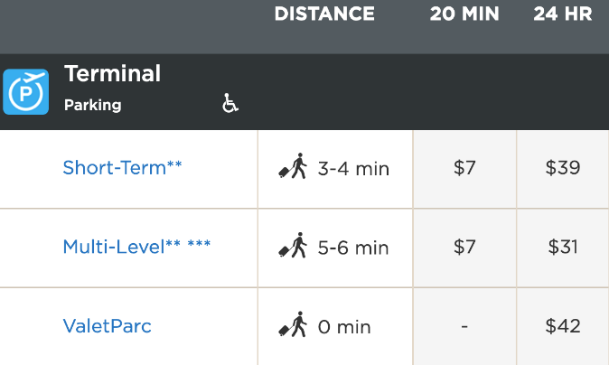
If you don’t know where to start, please see the “Guiding Questions” on the next page.
Materials required
- Device with Internet access (optional)
- Paper and writing materials

Information for parents
The purpose of this activity is to develop critical thinking skills and linear relations.
There are multiple possible answers depending on the values the student chooses.
Provide the student with the following information:
  - You live 38 km from the airport.
  - Your trip will last one week (7 days).

Guiding Questions
If you live thirty-eight (38) kilometres from the airport, how much will a taxi cost?
If your vacation is planned for seven (7) days, how much would it cost to park your car at the airport?
When is it less expensive to take a taxi?

DNA and Genetic Diversity
Information for students
- Deoxyribonucleic acid (DNA) are long molecules that can be found in each of our cells. Do some research to answer the following questions:
  - Where in our cells is DNA found? Sketch and explain.
  - What is the shape of DNA? Sketch and explain.
  - What is the purpose of DNA? Sketch and explain.
  - What are three (3) surprising things you discovered about DNA while you were doing your research? If possible, share these discoveries on social media using the hashtag #ScienceAtHomeQC-g9
- Extract real DNA from a fruit. Before you do, sketch and explain what you expect you will see happen.
  - Put half a banana in a resealable bag (with a zipper at the top) and mash the banana.
  - Pour half a cup of hot water and a teaspoon of salt into the bag. Mix well.
  - Add a teaspoon of dish soap to the bag and gently mix (to avoid making bubbles).
  - Pour the mixture through a coffee filter and into a tall and narrow glass. Wait for the mixture to pass through the filter.
  - Pour some isopropyl alcohol slowly into the glass until it forms a layer that is two (2) centimeter thick above the banana mixture. Do not mix. Wait while the DNA floats up into the alcohol.
- Children get their DNA from their parents. This is why they resemble them so much. Make a list of all the similarities and differences between you and your parents.
- Research the following genetic traits and check if your close family members have them too:
  - Hairline (i.e. do you have a widow’s peak or not?)
  - Earlobes (i.e. are your earlobes attached or detached?)
  - Tongue (i.e. can you roll your tongue?)
  - Hand clasping (i.e. which thumb goes on top when you clasp your hands?)
  - Cleft chin (i.e. do you have a dimple on your chin or not?)
  - https://www.genome.gov/genetics-glossary/Trait (optional)
- Explain, using evidence, why you look more like your mother or father than you do your grandmother or grandfather (you may use the research you did).
- Explain why twins look more alike than other siblings but are not perfect copies of each other.
Materials required
- Paper, writing and drawing materials
- Tall narrow glass
- Coffee filter
- Banana (or any other fruit)
- Resealable bag (with a zipper at the top)
- Salt
- Isopropyl alcohol (rubbing alcohol)
- Device with Internet access (optional)

Information for parents

- Help your child find the link to the video of the book being read aloud.
- Read the instructions to your child, if necessary.
- Discuss the questions together.
- Watch the video of the DNA extraction demo (optional): https://askabiologist.asu.edu/activities/banana-dna
- Brief video explanation: https://www.youtube.com/watch?v=mXvgcBr1rTA (optional)

How much water do you really need to drink?
Information for students
Brain Bite
We’ve been told for a long time now that we should be drinking 8 glasses of water a day - but is that really true for all of us? Watch the video to learn more about how much water we need.
  - Video (4 min 51 sec): What would happen if you didn’t drink water?

Activity 1 - Hydration
- Discuss what you know about hydration with a parent (in person) or a friend (using technology). How much water do you drink a day? If you don’t drink enough water, what are some things you could to make it easier for you to drink more water?
- One of the main messages of Canada’s new Food Guide is “make water your drink of choice”. For ideas on how to add some flavour to your water, visit Canada’s food guide website section on water.

Activity 2 - Get Moving!
- Hopefully you’re already drinking more water, and now it’s time to sweat it out! Get 25 of your recommended 60 minutes of moderate-to-vigorous physical activity with this at-home. Fill up your water bottle, put your running shoes on, grab a chair and enjoy the workout!
Video (25 mins): Cardio and muscular circuit training using a chair
Materials required
- A chair
Information for parents
Student should :
- share what they learned from the video with a family member and discuss their water consumption
- complete the chair-based physical activity.
Parents could:
- discuss different ideas for consuming more water throughout the day - what helps your child to remember to drink.

Your Choreography danced before your very own eyes!
Information for students
How to try out dance composition without a dancer?
Imagining how a dance choreography will look like is often challenging when we are the ones dancing. This week, we’ll try building a choreography all the while being the choreographer (who knows, it might even get you inspired to try the dance yourself)
In this Virtual Dance Studio, you get to be the choreographer and try out dance composition. Visit http://www.artsalive.ca/en/dan/yourturn/virtualdance/default.asp and build your choreography.
After having made the choreography; how could this process of visualising your ideas be beneficial with your dance style or way of creating? Did you need to readjust the flow?
Keep going; ever wondered why people say ‘’Break a leg’’ or what a ‘’Green Room’’ is? Explore some dance know-how here, http://www.artsalive.ca/en/dan/yourturn/virtualdance/default.asp

Materials required
- Device with Internet access
Information for parents
This activity is designed to be simple and take the mystery out of building a choreography!
We hope it will appeal to your child whatever their grade level.

Origins to 1608
Information for students
Following the capture of Constantinople (present-day Istanbul), Europeans began searching for a new route to Asia. This eventually led to the arrival of Europeans in North America. Several attempts at colonization in Québec were made during these early explorations.

- Situate in time the following events, voyages and settlement attempts:
- Establishment of Tadoussac trading post
- Jacques Cartier’s three voyages
- Establishment of Port-Royal
- Voyage of John Cabot
- Settlement on Île Sainte-Croix
- Establishment of Charlesbourg Royal settlement
Use the following website as a guide: https://www.historymuseum.ca/history-hall/timeline/

- Use your research to create a timeline and situate the events, voyages and settlement attempts accordingly. You may draw your timeline or use the following site to create a digital version: https://spark.adobe.com/make/timeline-maker/

- Using your timeline as a guide, situate the four documents found in Appendix 1 in chronological order.
Materials required
Useful resources, depending on personal preferences and availability:

- writing materials (paper, pencil, etc.)
- device with Internet access

Information for parents
- Intellectual operations are a large part of the evaluation criteria in History. They specify the purpose of an evaluation question and help guide the student toward the appropriate answer. Situate in time and/or space is one of these intellectual operations and is the main focus of this lesson.

- If your child would like to learn more about the early explorations in Québec, please view the following video: Canada: A People's History - Episode 2 - Adventures and Mystics.
Appendix 1 – Situate in Time
Walter Baker, Jacques Cartier érigeant une croix à Gaspé en l'honneur du roi de France, Bibliothèque et Archives Canada, C-011050, Mikan 2837262.

Document 1 – Cartier erecting a cross in Gaspé

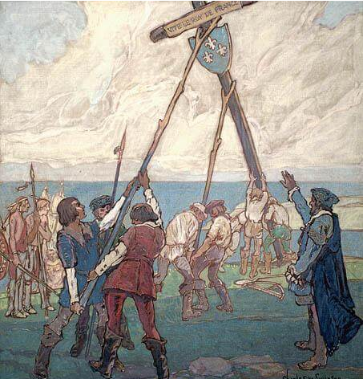
https://www.britannica.com/biography/John-Cabot
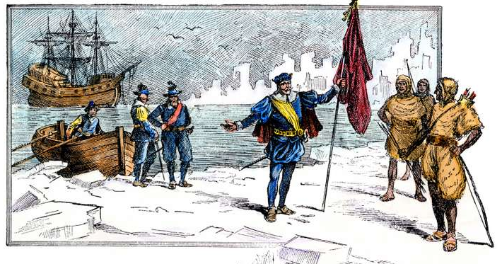
Document 2 – John Cabot landing on the shores of Labrador
Document 3
“It was during their exploratory voyage… in search of a suitable site for a colony that de Mons and his companions first entered the basin that Champlain would name Port-Royal. Struck by the beauty of the surroundings and the potential for settlement, Poutrincourt convinced Sieur de Mons to give him a grant to the land. The following summer, near a stream, the first buildings were erected in a rectangle around an interior courtyard, a fortified farm configuration common at the time.”
http://www.ameriquefrancaise.org/en/article-533/The_Habitation_at_Port-Royal,_Acadia.html
“Pierre Chauvin, a French naval and military captain, tried in vain to establish a colony at Tadoussac… [a few years later] Samuel de Champlain and Chief Anadabijou built an alliance [at Tadoussac], the first of its kind between Europeans and the Innu.
Document 4
https://www.thecanadianencyclopedia.ca/en/article/tadoussac

Appendix 2 – Answer Key
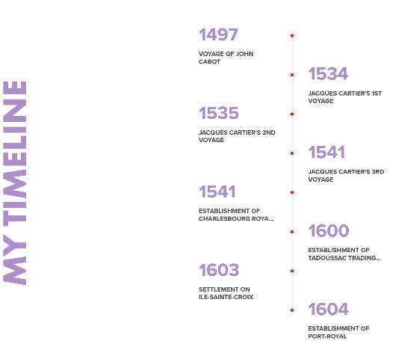
Digital timeline was produced by using the following website:
https://spark.adobe.com/make/timeline-maker/

Situate in time: Answer key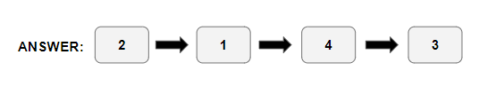

Stevens, J., Drive to the Airport and Pay for Parking or Take a Taxi. Would You Rather Math. (April 7, 2015). Available online at: https://www.wouldyourathermath.com/would-you-rather-55/.
Taken from: https://www.admtl.com/en/access/parking.
Taken from: https://commons.wikimedia.org/wiki/File:TAXI.jpg.

