Journal Entry
Information for students
The Present

Watch the short film and then discuss it with your parents or friends online.
Write a series of diary entries from the point of view of the boy in the film. Use the following prompts to guide you in your writing:
- May 16, 2020: Video games
- May 17, 2020: The present
- May 23, 2020: Determination
Materials required
- Link to the short film (https://www.youtube.com/watch?v=C_nJJHaNmnY)
- Paper and pen
- Phone, tablet or computer

Information for parents
Above all, this activity is designed to be simple! We hope it will appeal to your child. The best things your child can do are:
- Read every day.
- Write every day.
- Talk every day.

La bonne nouvelle du jour !
Consigne à l’élève
- As-tu lu ou entendu une bonne nouvelle cette semaine? Quelque chose d’inspirant? As-tu appris quelque chose d’intéressant ou d’amusant?
- Cette semaine, appelle quelqu’un que tu connais et parle-lui en français de ce que tu as appris.
- Peut-être qu’une personne de ton entourage parle français? Sinon, tu peux parler en français avec un ami pendant cinq minutes… ou plus! C’est à vous de décider.
Matériel requis
- Journal, livres, magazines de la maison.
- Site 1jour1actu (actualités quotidiennes) : https://www.1jour1actu.com.
- Téléphone, médias sociaux.

Information for parents
Activity details
This activity will help students successfully meet the following #MISSIONFLS challenge:
Mission en équipe – Je discute d’un sujet d’actualité positif qui m’intéresse avec ma famille ou mes amis.

In this activity, students will practise:
- speaking French with no preparation
- developing their vocabulary
- developing their confidence speaking French

Parents could:
- ask for support from someone they know who speaks French
- plan a specific time during the week for the conversation in French to take place
Reference: bit.ly/MissFLSSecCycle1

Portez votre masque, mais pas n’importe comment…
Information à l’élève
Lis le texte du Journal de Montréal en cinq minutes Portez votre masque, mais pas n’importe comment… https://www.journaldemontreal.com/2020/04/07/portez-votre-masque-mais-pas-nimporte-comment (Tu peux aussi imprimer les documents si nécessaire.)

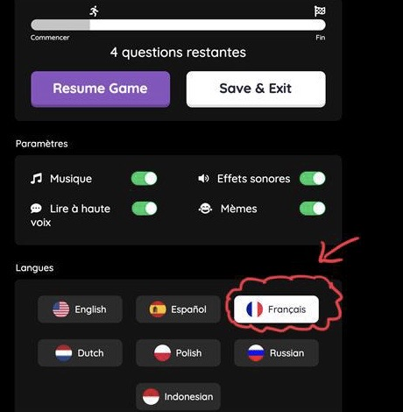
Réponds aux questions sur Quizizz joinmyquiz.com. Entre le code 479580 si on le demande.

Tu peux même te faire lire les questions en choisissant « lire à haute voix » mais tu devras t’assurer que tes paramètres soient en français!

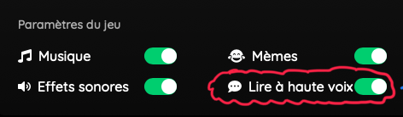

Matériel requis
- Appareil numérique avec un accès Internet.

Information for parents
In this activity, students will:
- learn vocabulary related to COVID-19 in French
- learn how to put on and remove a mask
- improve their reading skills by reading (listening) and answering comprehension
- use technology to record their answers

*A recording of the text is provided for all students, but especially for those who need assistive technology.

Pattern Block Fractions

Information for students
- The purpose of this activity is to allow you to explore fractional parts of a whole, using pattern block manipulatives.

- Using the pattern blocks (either the manipulative you print and cut out (see Appendix A) or the online manipulative):

  - build the fraction that represents the whole
  - build the fraction that represents the part
  - determine what fraction of the whole is represented by the part

- Extension Questions :

  - Is it possible for the numerator to be greater than the denominator? What does that mean when we look at the relationship between the part and the whole?
  - Does the part always have to fit perfectly into the whole? Why or why not?
  - What is another tool or model that we use to represent fractions? What would the questions below look like if we used that model? Try it out, using interactive models.

Materials required
- Pattern block manipulatives: Print the attached document (Appendix A) on paper and cut them out, or trace them onto cardboard, cut them out and colour them in, or use the interactive online pattern blocks to build the fractions and answer the questions.

- The question sheet or paper to record your answers, writing materials.

Information for parents
- It is important for students to understand the relationship between fractional parts and wholes, as this helps them make sense of mathematical operations involving fractions. Students must understand this to be able to make sense of the proportional relationships and algebra studied in Grade 8.
- If needed, help your child print and prepare the pattern blocks for this activity.
- Encourage your child to try each question. If needed, prompt them to break the whole down into smaller equal parts such as triangles, rhombuses, or trapezoids. Discuss the relationship between the pattern blocks. For example, it takes 2 triangles to cover a rhombus, 3 triangles to cover a trapezoid, and 6 triangles to cover a hexagon.
- Work through the questions with your child if they need your help. They can do one question or all five as time allows.
- The answers to the questions are found in Appendix B.

Question #1
If This Image Represents 1 Whole | Then This Image Represents | Answer
 | 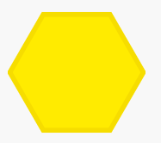

Question #2
If This Image Represents 1 Whole | Then This Image Represents | Answer
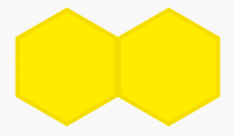 | 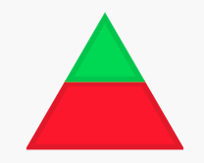
 | 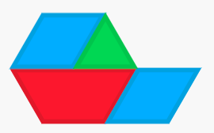

Question #3

If This Image Represents 1 Whole | Then This Image Represents | Answer

Question #4
If This Image Represents 1 Whole | Then This Image Represents | Answer
 | 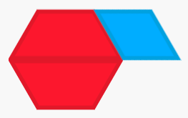
 | 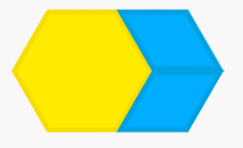

Question #5
If This Image Represents 1 Whole | Then This Image Represents | Answer

Appendix A: Pattern Block Template
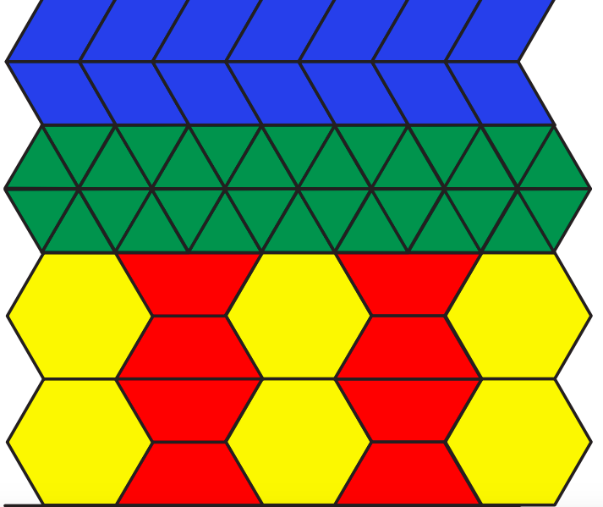

Appendix B: Solutions

ANSWERS to Question #1
If This Image Represents 1 Whole | Then This Image Represents | Answer
 |  | 2
 |  | $$\frac{2}{3}$$
 |  | $$\frac{1}{3}$$

ANSWERS to Question #2
If This Image Represents 1 Whole | Then This Image Represents | Answer
 |  | $\frac{4}{12}$ OR $\frac{1}{3}$
 |  | $\frac{8}{12}$ OR $\frac{2}{3}$

ANSWERS to Question #3
If This Image Represents 1 Whole | Then This Image Represents | Answer
 |  | $$\frac{5}{6}$$

ANSWERS to Question #4
If This Image Represents 1 Whole | Then This Image Represents | Answer
 |  | $\frac{6}{5}$ OR 1$\frac{1}{5}$
 |  | $\frac{8}{5}$ OR 1$\frac{3}{5}$
 |  | $\frac{10}{5}$ OR 2

ANSWERS to Question #5
If This Image Represents 1 Whole | Then This Image Represents | Answer
 |  | $\frac{6}{9}$ OR $\frac{2}{3}$
 |  | $\frac{3}{9}$ OR $\frac{1}{3}$
 |  | $$\frac{2}{9}$$
 |  | $$\frac{5}{9}$$

Kitchen Chemistry: Home-Made Ice Cream

Information for students
Have you ever made ice cream? The ice cream making process involves a lot of chemistry. As you do the following activity, you may want to ask yourself the following questions. Would you start with refrigerated or room-temperature ingredients? How would you turn a liquid mixture into a solid? How cold do you think the ice cream ingredients need to get to change from their liquid to their solid state? Do you think you could change the temperature needed for the phase change to occur?

Procedure
- In a small resealable plastic bag, combine the half-and-half cream, sugar, and vanilla. Be sure to push any excess air out of the bag and to seal the bag tightly.
- In a large resealable plastic bag, combine the ice and salt. Place the small bag from step 1 inside the large bag and shake vigorously (with gloves) for 10 to 15 minutes or until the ice cream has hardened.
- Remove the small bag of ice cream from the large bag containing salt, ice, and water.
- Rinse off the little bag with cold water (including the top part above the seal) before opening it up to eat the ice cream. This will prevent any salt on the outside from leaking in.
- Enjoy with your favorite ice cream toppings!

Follow-up

The secret to making ice cream is to lower the freezing point of ice so the cream can freeze.
When salt and ice mix, the freezing point of the ice is lowered. The freezing point reached depends on the amount of salt used. The more salt is added, the lower the temperature can get before the saltwater solution freezes.

When salt is added to ice, some of the ice melts because the freezing point is lowered. The heat that melts the ice comes from the warmer cream mixture.

By lowering the temperature at which ice freezes, you create an environment in which the cream mixture could freeze at a temperature below 0℃ and become ice cream.

Materials required
- 1 cup of half-and-half cream (you can also use 3.25% milk, but the ice cream won’t be as creamy)
- 2 tbsp granulated sugar
- 1/2 tsp pure vanilla extract
- 3 cups of ice
- 1/3 cup of kosher salt
- Small zip-lock bad
- Large zip-lock bag
- Toppings of your choice

Information for parents
- If you do not have kosher salt, you can use other kitchen salts, but it is preferable to use coarser salt (larger grains) as this will also help prevent the salt from getting into the little bag.
- You can control how fast the ice cream forms by modifying the amount of salt you use.
- Make sure you properly seal the small bag containing the cream. You do not want any salt to get into this bag. You could also double bag the small bag as an extra precaution.
- Finally, be extra careful when taking the ice cream out of the bag. If there is any salt still on the outside of the small bag, it will mix with the ice cream.

Learn About Vaping and Get Moving!
Information for students
Activity 1: Learn about vaping
- Learn about the mechanics of vaping by watching this video (1 min 8 sec).
- What substance do vaping products contain that is highly addictive?
- The video says that “vaping is not intended for youth and non-smokers.” Who do you think vaping could be a valid option for?
- Discuss what you learned about vaping with a member of your family.

Activity 2: Get moving!
- Look at the diagram containing circuit training exercises to be completed with a soccer ball (available in French only).
- Read the instructions for each step and look up any French words that you do not understand. Find an area where you can set up the circuit. Use chalk or tape to create your own agility ladder.
- Follow the circuit training instructions, performing the ball movements and exercises.
- Using the same circuit set-up, create a new workout routine by changing the exercises. What other ball skills and strength exercises can you include?
Materials required
- A soccer ball or another type of ball
- Chalk or tape
Information for parents
About the activity
Children should:
- learn about vaping
- set-up and carry out the circuit training workout

Parents could:
- discuss what their child has learned about vaping
- participate in the circuit training workout with their child

Contour Drawing
Information for students
Contour drawing is a fun way to practice your hand-eye coordination. This exercise is strictly
about the outline of the selected object you are drawing. No shading is required.
Pick one object at a time and try to draw the exact outline as it appears.
After a few attempts, improve your skills even more by trying the exercise without lifting the pencil
(or drawing tool of your choice) from the paper.
This simple lesson is used to build hand-eye coordination and will assist you when you are
sketching for more involved drawings in the future.
Materials required
- Your choice of drawing tool (pencil, charcoal, ink pen, coloured pencil, etc.)
- Paper or sketchbook (11” x 8.5” or larger)
- A few objects to draw that can be placed close to you (candy, small containers, eyeglasses, fruit, etc.)
Information for parents
- Link to a basic tutorial on contour drawing: https://youtu.be/RpZ1TwGaugM

Be an Upstander
Information for students
- Go the Canadian museum for Human Rights
- What are your human rights?
- Explore stories of real upstanders
- Explore how you would stand up for injustice
Materials required
- device with Internet access
- paper, writing materials

Information for parents
- Help your child find the link to the website
- Read through the activity with your child
- Discuss the questions together

Infographic on a Metropolis
Information for students
- An infographic is a popular way of quickly communicating important facts in a visual way. By using icons and only a little text, you can make dry facts more visually appealing, more interesting to read and easier to understand.
- In this activity, you will learn to create your own infographic to share information about a world metropolis. Begin by choosing a metropolis and learning a bit about it.
  - Choose from Montréal, New York City, Sydney, Cairo or Mexico City.
  - You will find links to some demographic information about the populations of these cities in the materials section below. Pick out some facts that tell the story of this metropolis.
  - You may also conduct your own searches to find out other characteristics about your chosen metropolis.
- Option 1 - Online:
  - Access the first video in the “Design an Infographic in Google Drawings” project on the Applied Digital Skills website. This project consists of 5 video lessons. Each video will show you how to complete a few steps of your infographic using Google Drawings. There is no need to sign in to the Applied Digital Skills website. Watch each video and complete the suggested steps using your chosen metropolis as your topic. You can re-watch as many times as you need to and pause as you go. Once you are ready to move on, click the “Next” button at the bottom of the page.
  - The tutorial uses Google Drawings, but you can use the same principles in any tool that will allow you to insert images and text.
- Option 2 - Occasional access to an Internet connection
  - If you are able to access an Internet connection some of the time (e.g. drive to a school and connect while remaining in your car), you can download the videos to view them offline. The full download is 470 MB. Use this link to download
  - If you are not able to download the videos but you have some connectivity from home, you may be interested in accessing the “Design an Infographic in Google Drawings” but working from the transcripts beneath each video.
- Extensions – Option 1 and 2:
  - If you would like to continue working on your infographic, consider some of the following extensions:
    - Add Shapes and Lines
    - Add Word Art
    - Use Icons to Represent a Number or Statistic
  - Consider an issue that affects this metropolis. Examples include: housing problems, urban sprawl encroaching on agricultural land, population moving to the suburbs, road congestion, waste management, water supply, high population density. Create a section in your infographic for raising awareness about this issue.

- Option 3 - No Internet connection or no device
  - Refer to the printable resources in Appendix 1. These include
    - some demographic information about New York City
    - an example of an infographic.
  - Create a simple poster with a few facts and simple icons to illustrate it.
  - You can use any offline tool that will allow you to combine text and images. Remember that, even if you are using a Chromebook, Google Drawings and Google Slides can be created in offline mode.
  - You can create a paper version of an infographic if you have no device.
Materials required
Useful resources, depending on personal preferences and availability:
- device with Internet access (optional)
or
device with occasional access and the ability to download the videos (optional)
- Google (GSuite or personal) account for Google Drawings or other graphics tool (can be offline)
or
paper, writing, and drawing materials

The “Design an Infographic in Google Drawings” lesson materials:
- online: “Design an Infographic in Google Drawings” lesson from the Applied Digital Skills website
- some Connectivity: Downloadable Videos Version

Useful links to begin your research
- Montréal, Canada
  - Montreal Census Data from Statistics Canada

- New York City, USA
  - NYC Planning from the New York Department of City Planning

- Sydney, Australia
  - Census Data from the Australian Bureau of Statistics

Information for parents
- The goal of this activity is to have the student identify and work with the characteristics of a metropolis.
- You child may need help choosing meaningful data to include in their infographic. It can be helpful to discuss with them the picture they are painting of this metropolis. Let them tell the story through the data. Points of interest include location in the world, population, population density, relative size compared with the country, multi-ethnicity, and urban sprawl
- Note that, while the example given uses Google Drawings, the same activity can be carried out using any tool that allows a combination of icons and text.

Appendix 1
Printable Resources for Students Without an Internet Connection
Here are some interesting facts about the New York City population:
- With a July 2015 population of 8 550 405, New York is the most populous city in the United States, more than twice the size of the second largest city, Los Angeles.
- About 1 in every 38 people living in the United States resides in New York City.
- New York has the highest population density of any major city in the United States, with over 27 000 people per square mile.
- Over 3 million of New York City’s residents are foreign-born; over one quarter arrived in 2000 or later.
- Nearly 2 million New Yorkers are under the age of 18.
- New York City has more people than 40 of the 50 U.S. states.
- New York City comprises over two fifths of New York State’s entire population.
- New York City has grown by over 1 million people since 1990.
- The 2014 median age in New York City was 35.8 years, almost two years lower than the national median of 37.7 years.
- Over one third of the population 25 and over in New York City has a bachelor’s degree or higher, compared with 30 percent nationally.
- There are nearly 400 000 more women than men in New York.
- There is a birth in New York City every 4.4 minutes.
- There is a death in New York City every 9.1 minutes.
- The borough of Brooklyn on its own would be the 4th largest city in the United States; Queens would also rank 4th nationally.
- Approximately two thirds of dwelling units in New York are renter-occupied, over twice the national average.
- The average commute for New Yorkers is just over 40 minutes, about 14 minutes longer than the national average.
- New York City has the largest Chinese population of any city outside of Asia.
- More persons of West Indian ancestry live in New York City than any city outside of the West Indies.
- New York has the largest Puerto Rican population of any city in the world.
- More Dominicans live in New York than any other city in the world, barring Santo Domingo.
- Over 2.4 million Hispanics reside in New York City, more than in any other city in the United States.
- The Black non-Hispanic population of New York City numbered 1.89 million in 2014, more than double the count in any other U.S. city.
- Half of all New Yorkers speak a language other than English at home.
- Over 200 languages are spoken in New York City.
Sample Infographic:
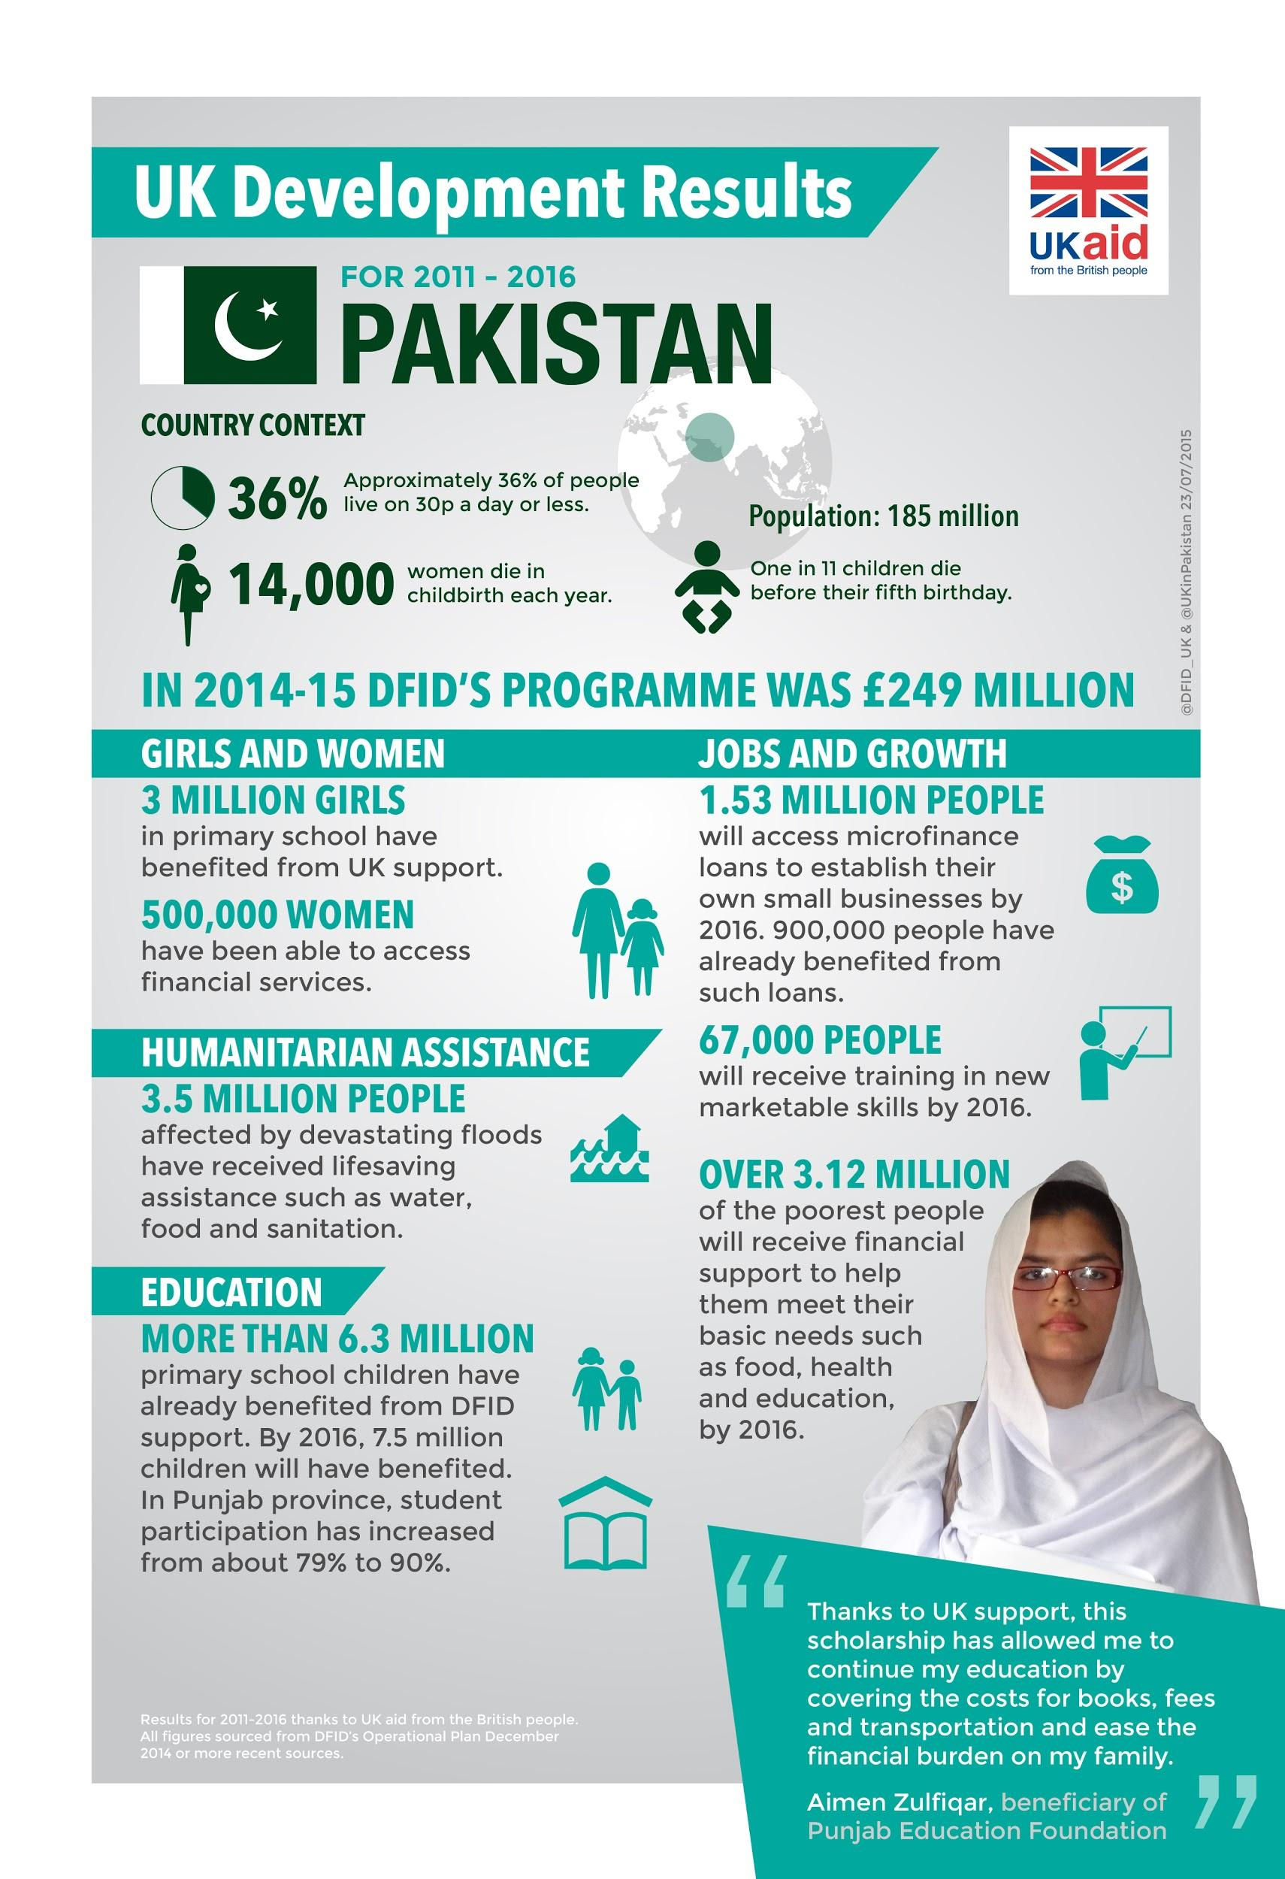
"File:Infographic- Pakistan - 2016 (20570481241).jpg." https://commons.wikimedia.org/wiki/File:Infographic-_Pakistan_-_UK_aid_development_results_for_2011_-_2016_(20570481241).jpg. Accessed 22 Apr. 2020.

Civil Rights & Freedoms
Information for students
Civil rights and freedoms you may have studied or discussed in your history class include:
  - Right to vote
  - Right to justice
  - Equality before the law
  - Freedom of expression
  - Freedom of Religion
  - Right to marry

Using the attached chart, identify places around the world today where people do not have these rights and freedoms as well as places where these rights and freedoms were not recognized in the past. Provide an example for each and identify the people affected. Your examples may be specific or general, depending on how much information you can find or what you recall (see examples provided).

You may remember some examples from your history class, or you may use your textbook or the Internet. Here are a few sites you may want to consult:
  - https://www.nelson.com/common/polisci/rights.html
  - https://ccla.org/education/remote-rights-project/
  - https://www.thecanadianencyclopedia.ca/en/article/civil-liberties
Materials required
Useful resources, depending on personal preferences and availability:
- device with Internet access
- writing and drawing materials
- attached chart
Information for parents
You can help your child complete the chart and find historical and current examples.

If necessary, help your child read information they have found and help them make comparisons and identify changes in rights and freedoms.

Discuss how some rights and freedoms may be granted in one country but not in another.

Civil rights and freedoms | Places in the world today where people do NOT have these rights and freedoms | Places where people did not have these rights and freedoms in the past
Right to vote |  | e.g. In Québec, women were not allowed to vote in provincial elections until 1940. (You don’t need a specific date, simply an example.)
Right to justice
Equality before the law
Freedom of expression
Freedom of Religion
Right to marry | e.g. Some countries do not allow same-sex couples to marry.

Images built using the online manipulatives at https://apps.mathlearningcenter.org/pattern-shapes/
Free Downloadable Goodies. (2018, January 13). Jessica’s Corner of Cyberspace. Retrieved April 20, 2020
Abraham, L. (2019, March 29). Ice Cream in a Bag. Delish
"Planning-Population-NYC Population Facts - DCP - NYC.gov." https://www1.nyc.gov/site/planning/planning-level/nyc-population/population-facts.page. Accessed 22 Apr. 2020.

