Weekly Educational Options From the Ministère

secondary v

Week of May 4, 2020

English Language Arts

Heroes in Our Midst

Information for students

There are many symbolic stories happening right now. We are living through a unique and important moment in history.

1-View

Go to the TED Talks website and watch the video “What Makes a Hero?” <https://www.ted.com/talks/matthew_winkler_what_makes_a_hero?language=en>

As you watch the video note down the stages of the Hero’s Journey.

2-Quickwrite: Write as much as you can in three minutes.

Read this quote from the TED Talk: “We humans reflect on our own world through symbolic stories of our own lives.”

Do a **quickwrite** inspired by what quote makes you think about. What is a quickwrite? Set a timer for three minutes and don’t stop writing until time is up.

3-View

Watch this Global News slide show: <https://globalnews.ca/video/6724432/these-are-the-heroes-of-covid-19>

This slideshow presents a wide variety of people in different roles, including some that society has already defined as heroes (nurses and doctors) and some that are new to the role of hero. Think about who we now consider heroes (or heroines) in light of the pandemic.

4-Produce

* Choose an image from the Global News video and note how different people’s roles have been redefined during this COVID‑19 crisis. Why are essential service workers, who we might not have previously defined as heroes, now being viewed differently? Is there someone in your life you now view as a hero that you didn’t before? Why has your point of view of them changed recently?
* Create a short video or written response to explain your changing point of view. You could create a short slideshow similar to the Global News video.
* Share your video with a local news outlet (such as CBC, CTV or Global) as a way to say “thank you” to the new heroes of the current crisis.

Materials required

Link: <https://www.ted.com/talks/matthew_winkler_what_makes_a_hero?language=en>

Paper, pen, phone, tablet or computer

English Language Arts

|  |
| --- |
| Information for parents  Activity details  The best things your child can do are: Read every day. Write every day. Talk every day.  Above all, this activity is designed to be simple! We hope it will appeal to your child whatever their grade level.  Read the instructions to your child if necessary. |

French as a Second Language

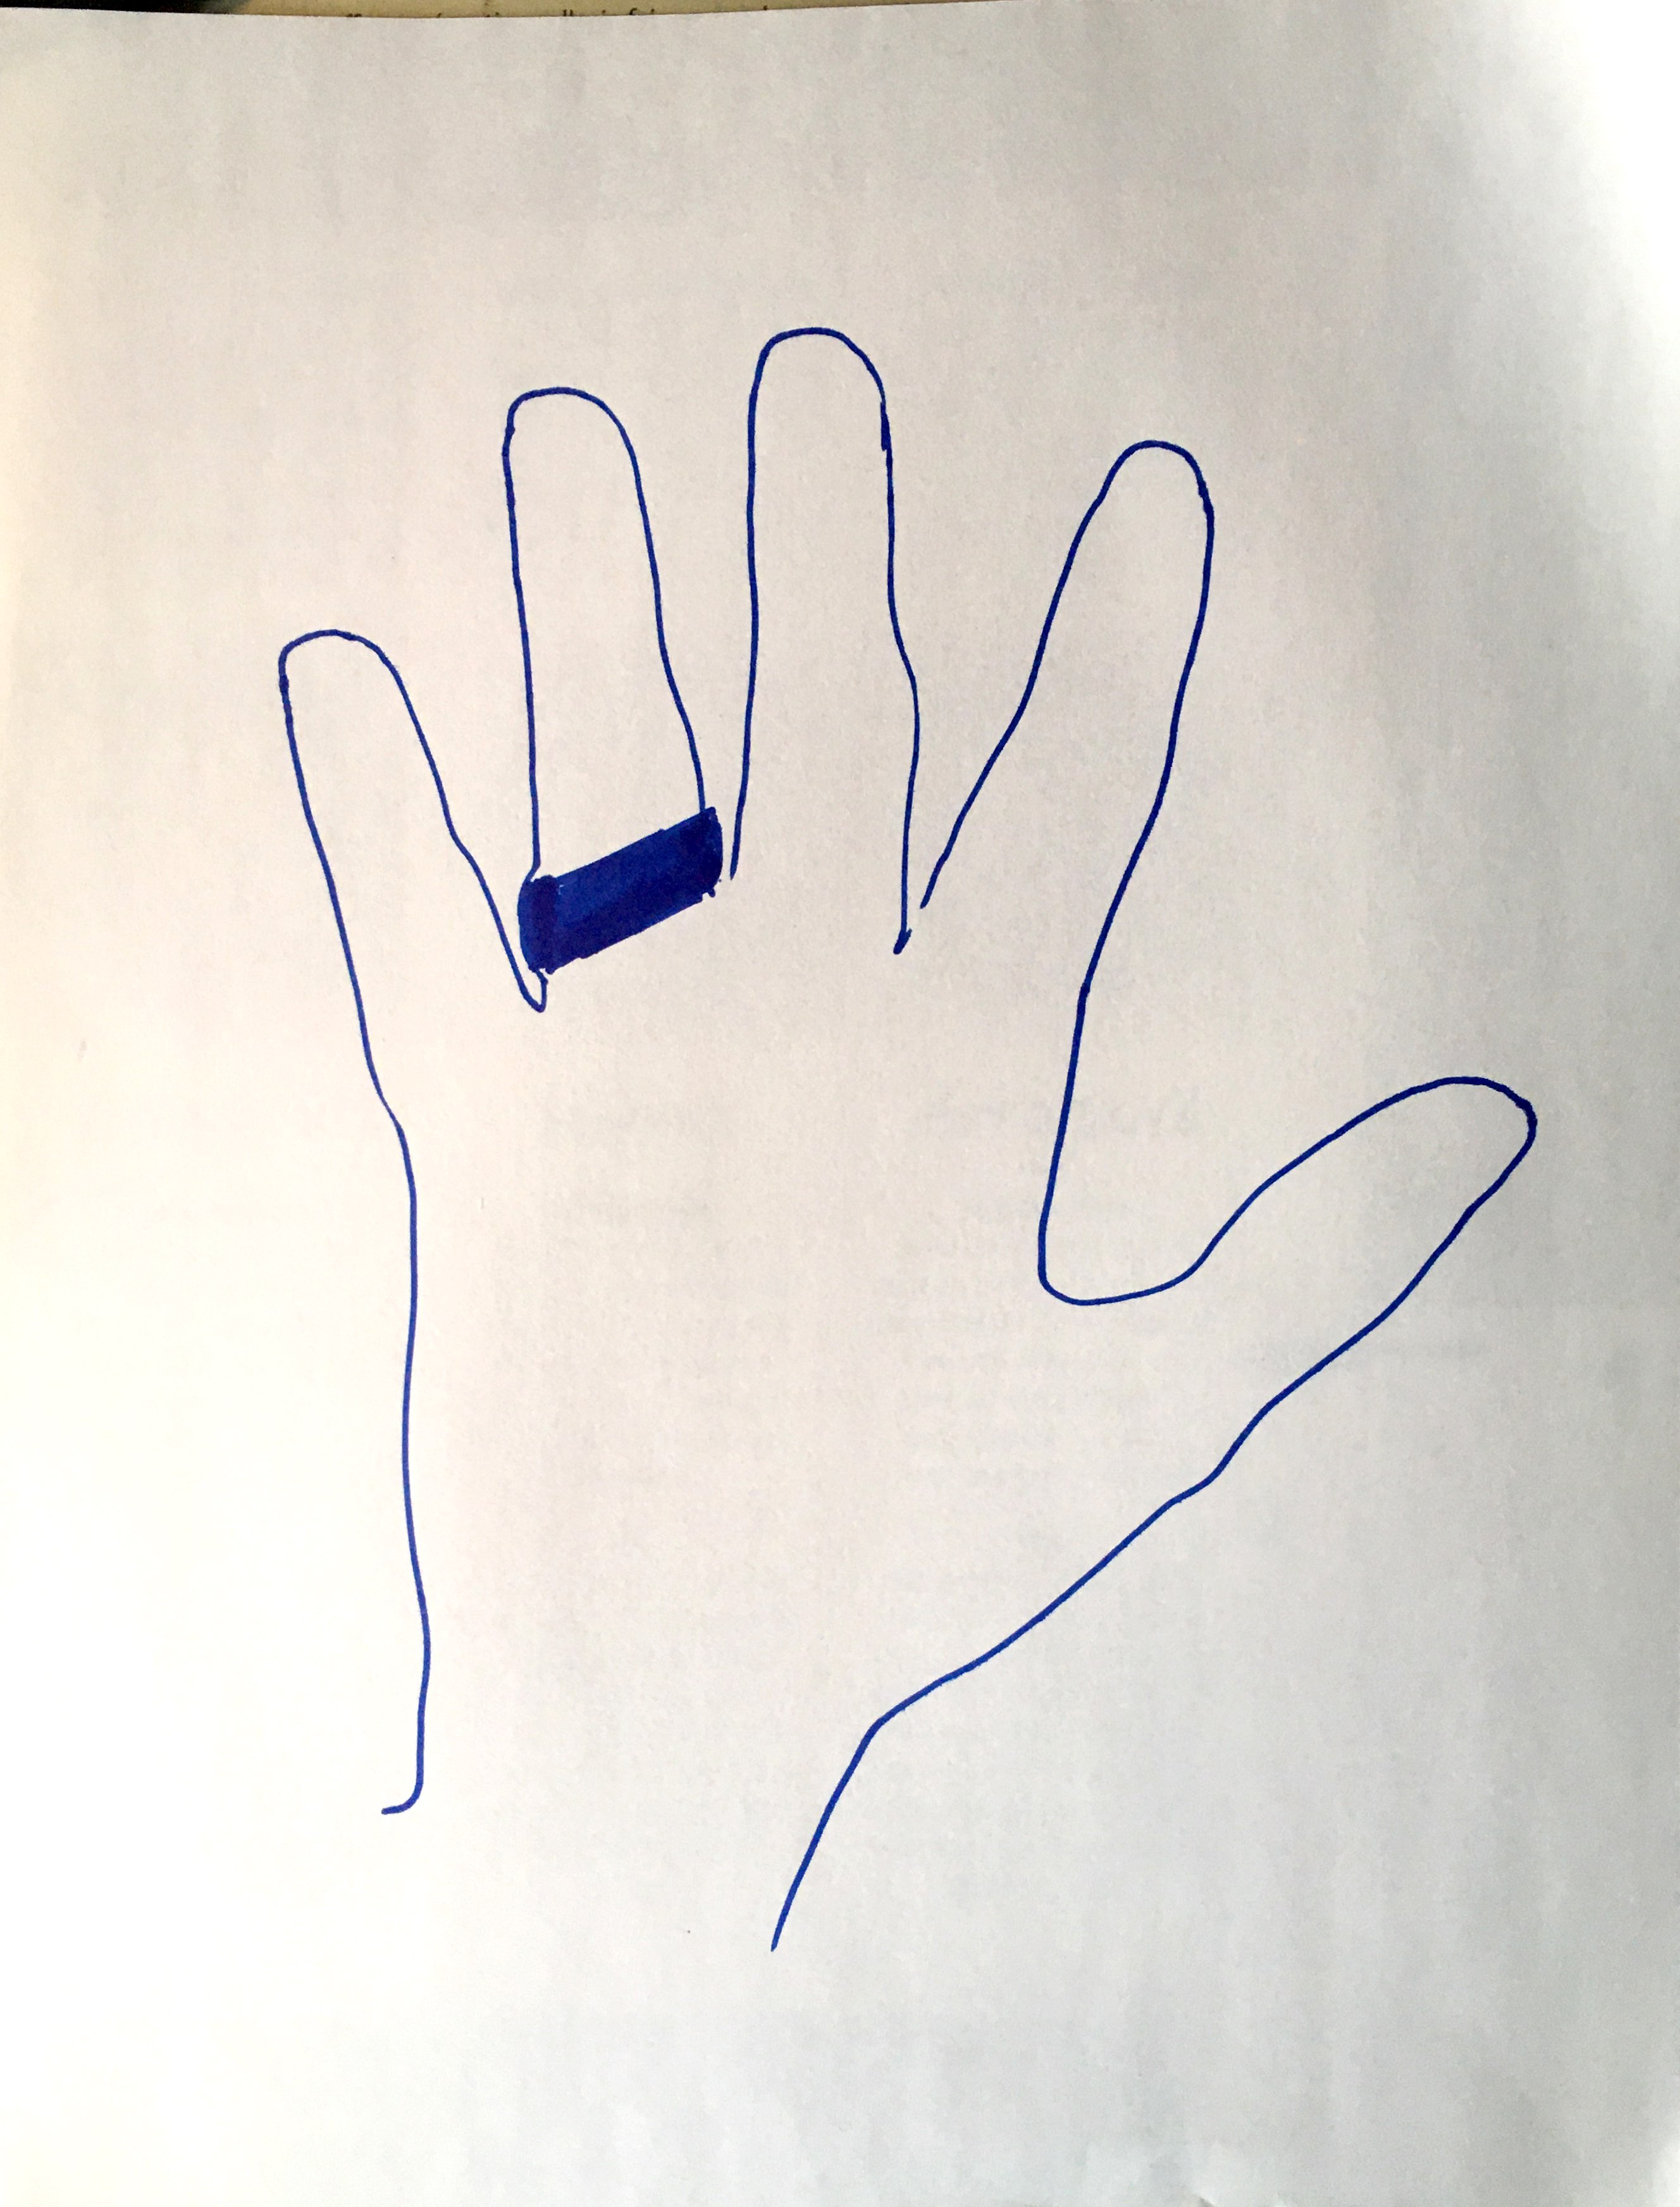Ma main[1]…

Information for students

Déposez une main sur une feuille de papier, écartez les doigts et tracez le contour;

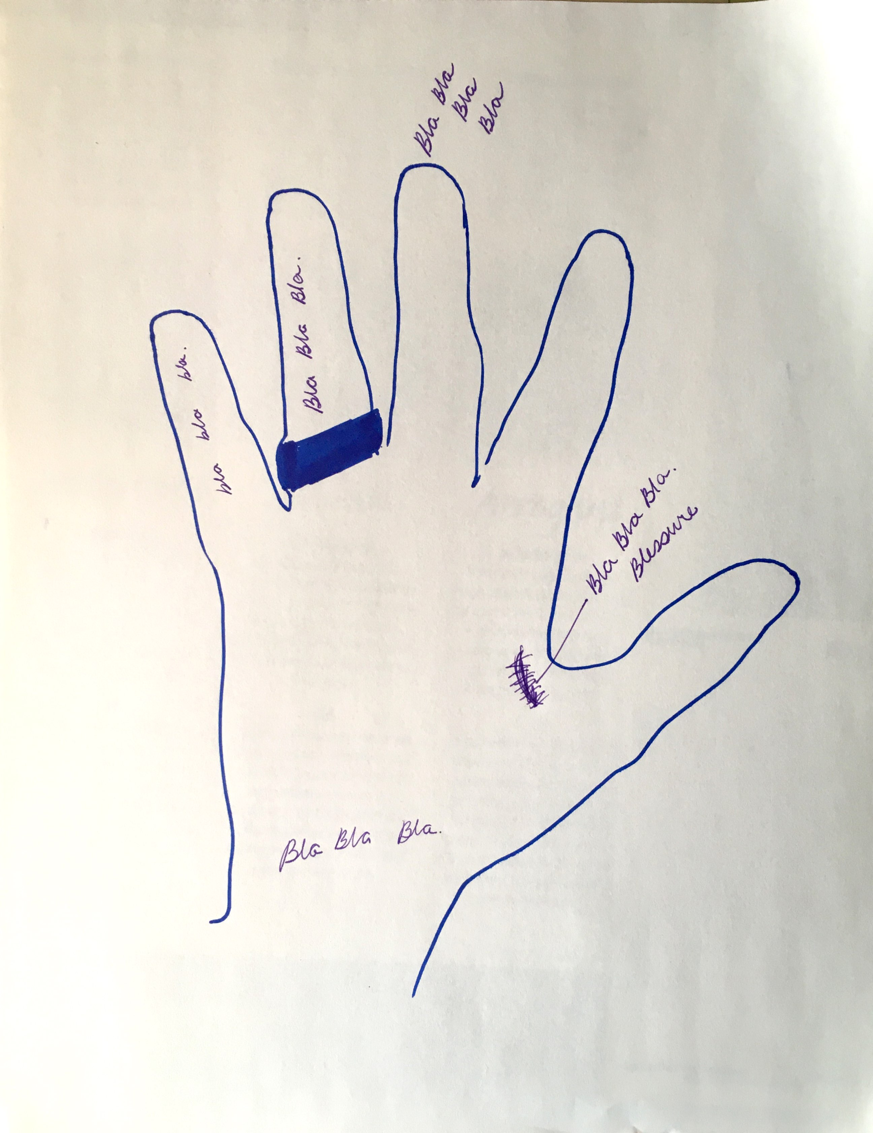Écoutez le poème de la jeune Sarah Kay; [Sarah Kay ­­– Hands](https://www.youtube.com/watch?v=kqCMHcdYR_E" \o "Sarah Kay- Hands)

* Empruntez un mot, une phrase ou une idée de Sarah Kay qui vous rattache à quelque chose de votre propre vie ou du monde près de vous;
* Écrivez n’importe où sur le dessin.

Après l’écoute de la vidéo :

* Prenez 3 minutes et écrivez aussi vite que possible sans réfléchir;
* Sur votre dessin, dans chaque doigt, écrivez des idées qui vous ramènent à des souvenirs ou des histoires en lien avec ce doigt en particulier / (une histoire qui raconte comment cette main a touché, tenu ou vécu quelque chose).

Après l’écriture :

* Discutez avec votre parent. Peut-être que d’autres souvenirs vous reviendront en mémoire;
* Choisissez une des idées que vous avez écrites sur la main;
* Composez un texte sur cette idée en y ajoutant des détails et des descriptions.

Materials required

Appareil avec connection Internet

* Allez écouter le clip à partir de 2m 13s

Papier et crayons (facultatif : crayons à dessin)

|  |
| --- |
| Information for parents  Watch the time and tell your child to stop writing after 3 minutes.  Help your child to remember fond memories that could be related to their hands.  Ask your child to read the final text to you.  Optional: Your child can colour the drawing. |

Mathematics

The Pyramid of Pennies

Information for students

First, use the following link to watch the video of the building of the pyramid of pennies: <https://www.youtube.com/watch?v=zSAp-g5DzpQ>

Here’s a photo[2] of the pyramid.

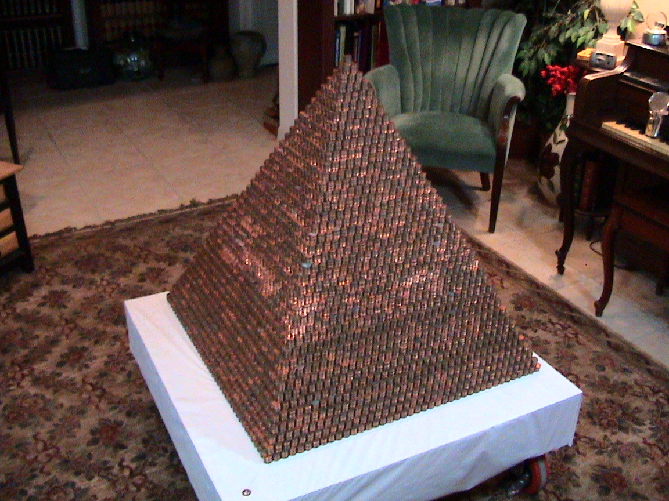

Using the information provided in Appendix A, determine how many pennies are in the Penny Pyramid.

Materials required

Device with Internet access

paper, writing and drawing materials

|  |
| --- |
| Information for parents  Encourage your child to guess the number of pennies that make up the pyramid.  The solution appears at the bottom of Appendix A.  Extension: Once your child has completed the task, ask them to come up with other questions that could be used as part of the task. |

Mathematics

Appendix A: Task Description

Your task is to determine:

how many pennies are in the pyramid

what the approximate volume of the pyramid is (*Note: not the volume of pennies in the pyramid*)

how much Mr. Bezos’ pennies would be worth in 2020 if he invested his pennies in 2006 at an annual interest rate of 4%

Here’s the information you need to know to solve the problem:

Base layer[3]: 40 stacks × 40 stacks

Single stack of pennies: 13 pennies per stack

Diameter of a penny: 19.05 mm

Thickness of a penny: 1.52 mm

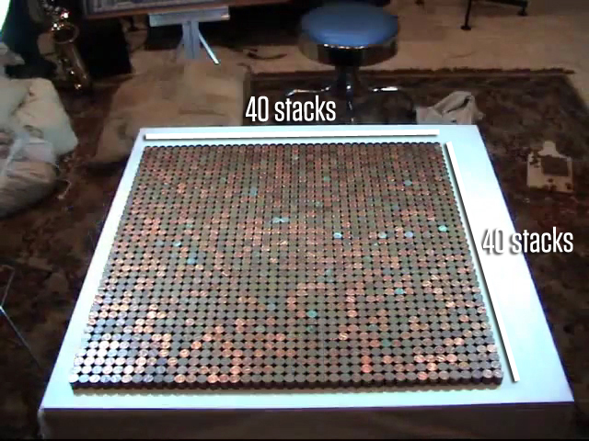 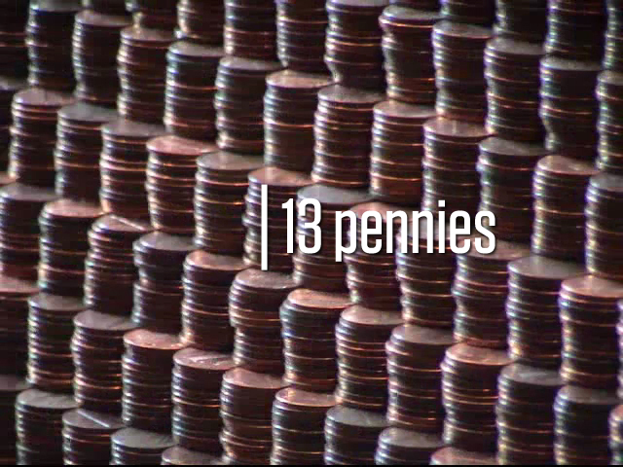

Source: <https://mrmeyer.com/threeacts/pyramidofpennies/>

Solution

There are 287 820 pennies in the pyramid of pennies.

The approximate volume of the pyramid is 152 980 339 mm3.

The pennies would be worth $4 984.11 in 2020.

Chemistry

Factors Affecting Reaction Rates[4]

Information for students

For two or more substances to enter into a chemical reaction, there must be a direct collision between the reactants’ atoms or molecules. If there is sufficient energy, bonds between the reactants’ atoms break and are rearranged to form new products. Several factors affect the rate at which this takes place.

In this activity, you will conduct two experiments to illustrate how temperature and concentration affect the rate of the reaction between vinegar (CH3COOH), and baking soda (NaHCO3). The chemical equation for this reaction is the following:

CH3COOH (aq) + NaHCO3 (s) → CO2 (g) + H2O (l) + NaC2H3O2 (aq)

Note: Please keep in mind the safety precautions you would normally follow in your science classroom when performing any experiments.

**Experiment 1: Control reaction (for comparison)**

Click on the following link for an example of how you can carry out this experiment: <https://www.youtube.com/watch?v=uVzzHoE6Edg&feature=youtu.be>

Use a funnel to put two tablespoons of baking soda in a balloon.

Clean the funnel well with running water, then dry it.

Use the funnel to put about 100 mL (about ½ cup) of white vinegar in the bottle.

Stretch the neck of the balloon over the top of the bottle. Be careful not to spill the baking soda while you do this.

Tip the balloon upwards to drop the baking soda into the vinegar.

Record your results and observations.

**Experiment 2: How does temperature affect reaction rate?**

Conduct an experiment to investigate the relationship between temperature and rate of reaction. To do this, use some or all of the materials listed below and the procedure for experiment 1.

Record your results and observations.

Write a conclusion for your findings to help you answer the question.

**Experiment 3: How does concentration affect reaction rate?**

Design an experiment to investigate the relationship between concentration of reactants and rate of reaction. To do this, use some or all of the materials listed below and the procedure for experiment 1. **Hint:** dilute the vinegar to change the concentration of a reactant.

Record your results and observations.

Write a conclusion for your findings to help you answer the question.

Chemistry

Materials required

Empty plastic bottle

White vinegar

Baking soda

Bowl

Ice water

3 or more balloons

Small funnel

Tablespoon

Thermometer (optional)

Timer (optional)

Paper, writing materials

|  |
| --- |
| Information for parents  Provide your child with a safe workspace and materials that could be used for this activity.  Make sure that your child is manipulating the material safely.  Ask your child questions to further develop their thinking skills. For example, ask them to explain the steps they are taking and why they are taking them, or to explain their answers to the experiments’ questions. |

Physics

Moving is hard work

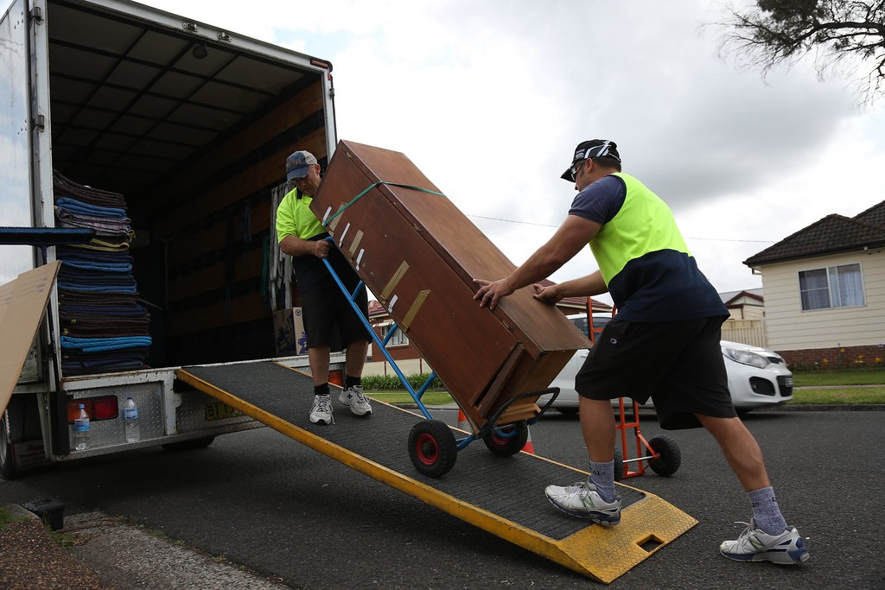

Image : <https://www.sunsetremovalsnewcastle.com.au/>

Information for students

Moving heavy objects can be difficult.

Inclined planes can make it easier.

The formula for work is $W=F x d$

Where:

W = work done ( in joules)

F = force applied parallel to the displacement (in Newtons)

d = distance travelled (in metres)

* Trigonometric Ratios

$Sin θ= \frac{opposite}{hypotenuse} Cos θ=\frac{adjacent}{hypotenuse} Tan θ=\frac{opposite}{adjacent}$

Alex says it takes the same amount of work (energy) to lift a fridge straight up as it does to push the same fridge up an inclined plane. However, pushing a fridge up an inclined plane is much easier to do. Can you explain why?

Use a free body diagram to model lifting the fridge straight up and another to model the movers pushing the fridge up the inclined plane. Describe the relationship between force, distance travelled and work. Finally, which of those three (force, distance travelled or work) makes it easier to lift heavy objects?

The mass of the fridge is 120 kg.

Lifting the fridge straight up



Physics

Pushing the fridge up the inclined plane

The length of the inclined plane is 2.0 m. The angle of inclination is 30o. Assume there is no friction.

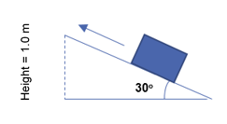

Predict what will happen if you change

the angle

the length of the inclined plane

Alex then said that the threads of a screw are like an inclined plane wrapped around a cylinder. Describe the relationship between force, distance travelled, and work/energy when using this simple machine.

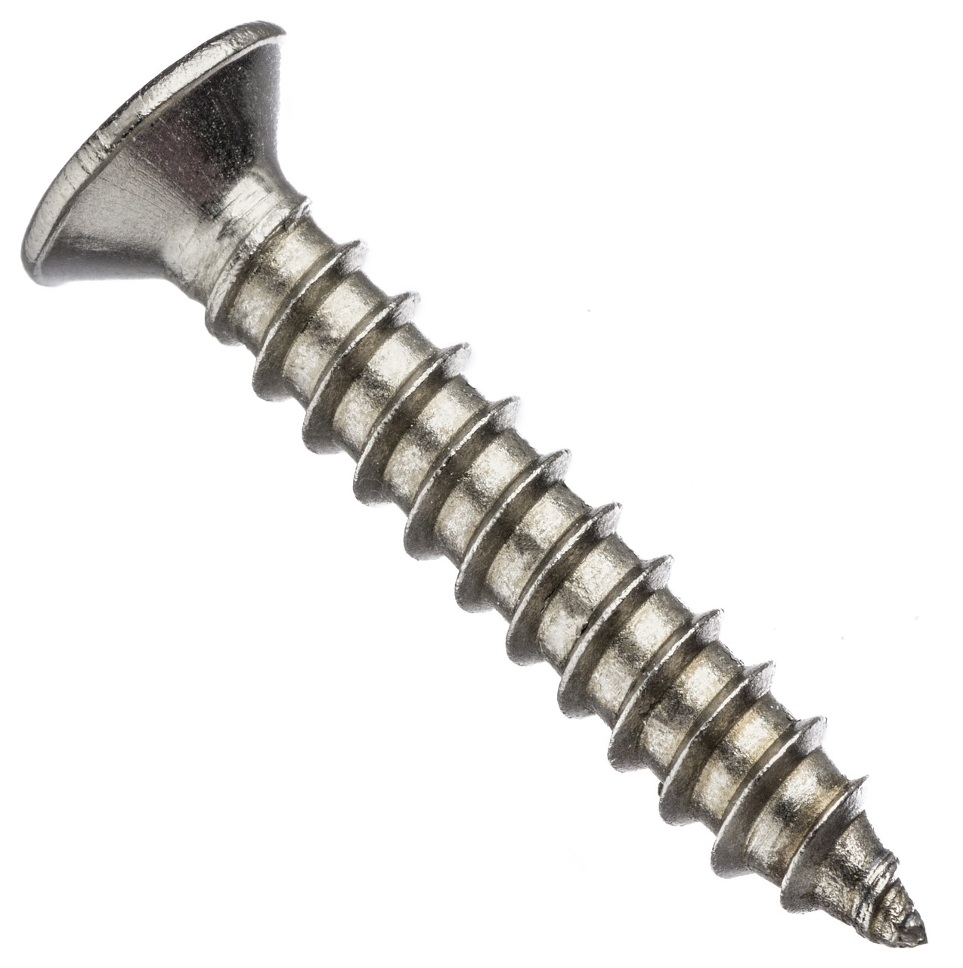

Image: https://www.needpix.com/photo/1191944/screw-nail-hardware-metal-parts-parts-free-pictures-free-photos-free-images-royalty-free

Materials required

Calculator

|  |
| --- |
| Information for parents  Carefully explore lifting objects straight up and then pulling these objects using a ramp (an inclined plane) with your child. Inclined planes make transporting heavy objects much easier.  The concept of applied force is introduced in Secondary 4, but some students may need to review the components of force on an inclined plane. This video reviews forces on an inclined plane: <https://www.khanacademy.org/science/ap-physics-1/ap-forces-newtons-laws/inclined-planes-ap/v/inclined-plane-force-components> |

Physical Education and Health

Learn About the Cardiovascular System and Get Moving!

Information for students

Activity 1: Learn about the function of your heart during exercise

Watch [this video](https://safeYouTube.net/w/tMf9). Speaking to a friend or a family member, can you summarize the function of the cardiovascular system and how it performs that function? Challenge yourself to remember as many details as possible. For example, can you remember how many times your heart beats in a year or how many valves your heart has?

Activity 2: Get moving!

Complete the following training programs on three separate days:

* [Day 1 - Abs](https://darebee.com/workouts/abs-please-workout.html) [Day 2 – Lower body](https://darebee.com/workouts/home-alone-workout.html) [Day 3 – Arms and back](https://darebee.com/workouts/arms-and-back-workout.html)

Make sure you select the workout level (number of sets) according to your personal fitness level.

Do not forget that the number of repetitions (reps) is a suggestion only. If you can no longer hold or perform a technique, stop the set and rest.

If you are up for practicing your French and want to explore more activity ideas, visit the [Reste Actif!](https://sites.google.com/view/resteactif/accueil) website.

Materials Required

None

|  |
| --- |
| Information for parents  About this activity  Children should:  learn about the cardiovascular system  complete the at-home training programs  Parents could:  discuss the circulatory system with their children  join their children in completing one of the proposed training programs |

ARTS

Negative Space Drawing

Information for students

Negative space drawing is a more advanced way to help you with your drawing techniques. Negative space is the space that we see around an object. Looking at a stool, instead of drawing the legs of the stool, your focus will be the space between the legs. These spaces are called the negative space. This exercise is a classic study of how observation of space can quickly enhance your skills.

To begin, choose a subject you would like to draw. I will use a chair as an example. Place the chair at a medium distance from you so you can observe the whole object. The angle is not important.

Once you have your subject set, closely observe the negative spaces that surround and are in between the actual shape of the chair.

Begin to draw those spaces with a pencil. If you are focusing on the proper shapes of the negative spaces, you will see your drawing begin to take shape.

Optional: This lesson is used to build hand-eye coordination and observation skills. It will certainly improve your ability to render 3-D objects Use a lighter colour on the spaces farther from your subject to create a softened effect. This will allow you to define the outer edges of the subject and give your drawing a more three-dimensional look. This exercise may take several tries but it is essential to creating better drawings.

Materials required

Pencils, charcoal, ink pen, coloured pencils

Paper or sketchbook (11” x 8.5” minimum size)

An object to draw that can be placed at a medium distance so you can view the entire object. (Chair, small table, plant, lawn furniture, park bench, etc.)

|  |
| --- |
| Information for parents  Link to a basic tutorial on negative space drawing: <https://youtu.be/OwAwPA1padM> |

Credits: Activity proposed by – optional

Ethics and Religious Culture

Reflection on Social Norms

Information for students

Social norms have changed so quickly due to COVID‑19, creating a “new normal”. Will our old lives ever come back?

Take a moment to reflect on some behaviours that we used to take for granted (such as shaking hands) and make a prediction as to whether they will come back soon, in a few years, or never. Perhaps they will come back in a modified way, such as grasping forearms instead of shaking hands.

Organize your thinking using a chart like the example below. Consider other common practices such as riding the bus, going to a sporting event, eating at a restaurant, etc. Add your own examples too.

Save your predictions so that you can refer to them in the future...were you right?

|  |  |  |  |
| --- | --- | --- | --- |
| **SOCIAL NORM** | **SOON** | **A FEW YEARS** | **NEVER** |
| **Shaking hands** |  |  |  |
| Reasons:  Changes: | | | |

Materials required

Device with Internet access

Paper, writing and drawing materials

|  |
| --- |
| Information for parents  Discuss changing social norms with your child, and how they are affecting our behaviour and attitudes towards one another.  Make your own predictions about the future of social norms along with your child and discuss your reasoning behind your predictions. |

Contemporary World

Environmental Impacts of the Coronavirus Crisis

Information for students

In your Contemporary World class, you have likely explored the theme of environment. Some of the topics include:

* + Choices regarding the environment made by states or other organizations/groups
  + Establishing international agreements
  + Recognizing environmental problems and seeking solutions

In recent weeks, satellite images showing dramatic drops in air pollution have circulated on social media; the fog surrounding polluted cities has been replaced by blue skies, to the point where people in India have been able to see the peaks of the Himalayas for the first time in decades. In some areas of the world, polluted rivers and bodies of water have also become clearer and some species have been sighted in places they haven’t been seen in years.

All these changes are seen as a silver lining to an otherwise very dark period. More and more, scientists are explaining how certain changes could lead to a healthier planet, and a healthier population, with many diseases and physical conditions being linked to pollution.

Think about these topics and how the pandemic could lead to potential changes in the future.

* Do you think that most states and businesses will want to go back to normal as soon as they can, in order to stimulate the economy? Support your opinion with examples from articles, TV and radio news reports, or by browsing on social media.
* Do you think the pandemic will reshape the world after people observe the environmental and societal advantages of a global economic slowdown?

Make a list of changes you might have noticed in your surroundings and other changes you’ve seen happening around the world.

Materials required

Useful resources, depending on personal preferences and availability:

Device with Internet access

Writing materials (paper, pencil, etc.)

Contemporary World

|  |
| --- |
| Information for parents  Remember that the purpose is for your child to do research and to become informed, not to produce work to be evaluated.  You can familiarize your child with some concepts that might be challenging for them. Think about the environmental changes you’ve observed or heard about in the last decade. Discuss the questions together and perhaps encourage them to contact someone else if they have more questions. |

1. From Linda Rief *The Quickwrite Handbook*
2. Marcelo Bezos, “Penny Pyramid Project: Photo Gallery,” accessed on April 24, 2020, <http://www.pennypyramidproject.com/pennypyramid.html>
3. Image: Dan Meyer, “Pyramid of Pennies,” accessed on April 24, 2020, <http://www.pennypyramidproject.com/pennypyramid.html>
4. Activity adapted from: “Baking Soda and Vinegar Balloon,” Education.com*,* accessed April 28, 2020, <https://www.education.com/science-fair/article/baking-soda-and-vinegar-balloon/> and “How to Blow Up a Balloon With Baking Soda and Vinegar,” wikihow.com, accessed April 28, 2020.