Weekly Educational Options From the Ministère
secondary III
Week of May 4, 2020

English Language Arts

What Personal Artifacts Reveal About You

Information for Students
A personal artifact is an object, probably found in your room, that means something to you. It can trigger a story or memory. It can be a stuffed animal, a hockey card, an old toy or game, jewelry, a trophy, etc.
Find 3 to 5 personal artifacts in your room that reveal something significant about you.
Take a picture of each item.
Create a personal photo essay that expresses what is unique about your personality and your life story by writing a short paragraph or poem about each artifact. Combine the photos and the texts into one document or booklet.
For more information about photo essays, click here: https://en.wikipedia.org/wiki/Photo-essay

Materials required
Writing tools
Device for taking pictures

Information for parents
Read your child’s photo essay and ask some follow-up questions. Did anything surprise you? Was there anything you didn’t know?

French as a Second Language

Une surprise pour …

Cette semaine je te propose d’écrire une lettre à ta mère, ta grand-mère, ta belle-mère ou une autre personne qui joue ce rôle dans ta vie.

Information for students
Pour t’inspirer, je te suggère d’écouter ces deux petites vidéos. La première est un court-métrage animé, la deuxième une entrevue avec la ministre Catherine McKenna. Elle discute de la conciliation travail famille.
- https://www.onf.ca/film/petit_big_bang/
- https://curio.ca/fr/video/catherine-mckenna-entre-mere-et-ministre-8305/
Admire et observe l’œuvre de Thérèse Schwartze : https://educart.ca/fr/theme/famille/#/une-mere-et-ses-enfants-a-leglise/cartel
Prépare-toi à écrire. Note tes idées dans un plan. Comment est-elle, dis-lui merci pour ce qu’elle fait pour toi, raconte ton meilleur souvenir avec elle, etc.
Compose ton brouillon. Fais de ton mieux pour bien exprimer tes idées.
Relis ton texte. Peux-tu l’améliorer?
Écris ta lettre au propre. Décore la page de dessins.
Donne ta lettre dimanche matin le 10 mai. C’est le jour de la fête des Mères.

Materials required
Device with Internet access
Paper, writing and drawing materials

Information for parents
Help your child find the link to the video of the book being read aloud.
Read the instructions to your child, if necessary.

Mathematics

It’s magic! No, it’s algebra!!

Information for students
The purpose of the problems in Appendix A is to deepen your knowledge of algebra.
They will also strengthen your understanding of the formula to calculate the area of a trapezoid.
Working through these problems may also help you develop a greater understanding of algebraic concepts and a greater appreciation for algebra.

Materials required
Paper, writing materials (you should not use a calculator!)

Information for parents
Start by encouraging your child to solve the problems without assistance (electronic or otherwise), but allow them to reach out to friends or teachers (or help them yourself) to find the answers through discussion.
Use the hints related to each problem to provide that little extra push to help them along.

Mathematics

Appendix A

Problem 1
Here is a “magic” trick to impress your friends and family
# | Action | Result
1 | Pick a number between 1 and 25.
2 | Add 9.
3 | Multiply the sum by 3.
4 | Subtract 6 from the product.
5 | Divide the result by 3.
6 | Subtract the original number from your final result.
7 | What is your answer?
Repeat with a different number. What do you get? Write an algebraic expression that would allow you to find the solution for any number between 1 and 25.

Problem 2
The sum and product of these two numbers are equal. What characteristic displayed here makes this true for all similar types of equations?
$\frac{3}{16}- \frac{3}{19}= \frac{3}{16}× \frac{3}{19}$
Use algebra to explain why this works. Start with this: $\frac{a}{b}- \frac{a}{c}= \frac{a}{b}× \frac{a}{c}$

Mathematics

Problem 3
The formula for the area of a trapezoid is as follows:
b

B

h

h

b

h

B - b

$A=\frac{\left(B+b\right)h}{2}$; where b is the length of the small base, B is the length of the large base and h is the height of the trapezoid. (see Figure 1)

= +

Figure 1: Area of a Trapezoid
Show that the formula for the total area of the trapezoid can be found by adding the area of the rectangle, b X h, to the total area of the triangles found at both ends of the trapezoid and given by $\frac{\left(B-b\right)h}{2}$ .
Use your knowledge of algebra to simplify the formula below and compare it to the standard formula provided above.
$A=b×h+\frac{\left(B-b\right)h}{2}$

Mathematics

Appendix B – Hints and Solutions

Problem 1
Hints to help students and encourage them to explore the topic:
Tell your child/student to perform the operations with any number (i.e. 1).
Encourage them to write down each step (i.e. 1 + 9, 3(1 + 9), etc.).
Encourage them to create another series of operations that would be “magical.” What would that look like algebraically?
Encourage them to develop another series of operations, but using more complex operations (i.e. square, square roots, exponents).

Solution
# | Action | Result
1 | Pick a number between 1 and 25. | $$x$$
2 | Add 9. | $$x+9$$
3 | Multiply the sum by 3. | $$3(x+9)$$
4 | Subtract 6 from the product. | $$3\left(x+9\right)-6$$
5 | Divide the result by 3. | $$\frac{3\left(x+9\right)-6}{3}$$
6 | Subtract the original number from your final result. | $$\frac{3\left(x+9\right)-6}{3}-x$$
7 | What is your answer? | $$7$$

Mathematics

Problem 2
Hints to help students and encourage them to explore the topic:
Use the steps of the answer provided as hints to allow your child/student to move forward.
Ask them how fractions are to be added (they must have the same denominator).
Remind them that whatever they do on one side of the equation, they must do on the other side of the equation.
Ask them to create another equation with different fractions, using the relationship observed, to verify if the rule remains true.

Solution
$$\frac{a}{b}- \frac{a}{c}= \frac{a}{b}× \frac{a}{c}$$
$$\frac{ac}{bc}- \frac{ab}{bc}= \frac{a^{2}}{bc}$$
$$ac-ab= a^{2}$$
$$a(c-b)= a^{2}$$
$$\frac{a(c-b)}{a}= \frac{a^{2}}{a}$$
$c-b= a$

Mathematics

Problem 3
Hints to help students and encourage them to explore the topic:
Help children/students see the triangular portions of the trapezoid (the right triangles at the ends of the figure) and how they combine to form an isosceles triangle.
Ask them if they understand why breaking the trapezoid down into a rectangle and a triangle (or two) works?
Does the formula work for a trapezoid that is not an isosceles trapezoid? Using algebra and given the following figure, show (explain) why it is still true.

Solution
b
h
B
h
$$A=b×h+\frac{\left(B-b\right)h}{2}$$
$$A=\frac{2bh}{2}+\frac{Bh-bh}{2}$$
$$A=\frac{2bh+Bh-bh}{2}$$
$$A=\frac{bh+Bh}{2}$$
$$A=\frac{h(b+B)}{2}$$

Science and Technology

Reaction Time

Information for students
For this activity, you will perform a test for reaction time and then design an experiment to determine what might affect reaction time.
Reaction time is how long it takes an organism to respond to a stimulus in the environment.

Part 1: How fast do you react?
To test reaction time, you can use the ruler test on someone in your home. The ruler test gives you a measure of how quickly someone reacts when a ruler is dropped, without warning, and this person tries to catch it. The distance the ruler falls before it is caught is a measure of the reaction time.
The reaction time for the voluntary reaction involved in the ruler test includes how long it takes for the information to travel from the sensory receptors in the eye to the brain, for the brain to process the information, and for the brain to send a signal to the muscles to react.
The instructions for the ruler test are below.
- Ask the person you are testing (your test-subject) to hold out their hand, with their fingers and thumb stretched apart.
- Hold the end of a 30 cm ruler (the end that starts with zero) between your test-subject’s open fingers. If you do not have a ruler, try making one with materials from your home such as cardboard or a paint stick.
- Explain to your test-subject that you will drop the ruler, without warning them, and that they will have to try and catch it, as quickly as they can, by pinching their fingers and thumb together.
- Drop the ruler and record where the test subject caught it (e.g. 25 cm).
- Repeat at least 4 more times.
- Change roles and test your own reaction time.
- Organize and present your results in a table or a graph.
- You can also try this online reaction time test.
- Do you think that practicing the ruler drop can improve reaction time? Why or why not?

Science and Technology

Part 2: What factors affect reaction time?
What do you think might affect a person’s reaction time? Think of one condition or variable you could change for the ruler test. Could the time of day or additional distractions such as music or conversation make a difference? What if you asked the test subject to close their eyes and used a different stimulus, such as a sound to indicate when you were dropping the ruler? What if you used more than one stimulus at once?
For this part of the activity, you will design and perform an experiment to test one factor that might affect a person’s reaction time. See the instructions on the next page.
Choose what you would like to test and write a testable question: How is reaction time affected when ______________?
Write your hypothesis for the question you are testing. What do you think will happen? Why?
Design and perform your experiment. Think about how you will control the variables in your experiment.
Record and organize your results.
What can you conclude based on the results of your experiment? How could you improve your experiment?
In what situations do you think a short reaction time is important? Do you think it is helpful to know what can affect reaction time in these situations? Why or why not?
If you are interested in learning more about the nervous system and some of the science behind this experiment, take a look at this backgrounder, Neurons: The Building Blocks of the Brain, from Let’s Talk Science.

Materials required
30 cm ruler, or a ruler made from household materials such as cardboard or a paint stick
Paper and writing materials
Device with Internet access (optional) for online reaction time test

Information for parents

Activity details
In this activity, your child will design and perform a simple experiment to test reaction time.
Parents could:
Provide their child with a workplace and materials that could be used for this activity.
Read the instructions to their child, if necessary.
Volunteer to be test subjects for the reaction time test.
Discuss the questions with their child.

Physical Education and Health

Learn About the Cardiovascular System and Get Moving!

Information for students
Activity 1: Learn about the function of your heart during exercise
Watch this video. Speaking to a friend or a family member, can you summarize the function of the cardiovascular system and how it performs that function? Challenge yourself to remember as many details as possible. For example, can you remember how many times your heart beats in a year or how many valves your heart has?
Activity 2: Get moving!
Complete the following training programs on three separate days:
- Day 1 - Abs Day 2 – Lower body Day 3 – Arms and back
Make sure you select the workout level (number of sets) according to your personal fitness level.
Do not forget that the number of repetitions (reps) is a suggestion only. If you can no longer hold or perform a technique, stop the set and rest.
If you are up for practicing your French and want to explore more activity ideas, visit the Reste Actif! website.

Materials Required
None

Information for parents

About this activity
Children should:
learn about the cardiovascular system
complete the at-home training programs
Parents could:
discuss the circulatory system with their children
join their children in completing one of the proposed training programs

ARTS

Continuous Line Portrait Drawing

Information for students
Drawing with a continuous line means that you complete a drawing with only one line. Once you start a continuous line drawing, you cannot lift your pen or pencil from the surface you are drawing on until you are finished your drawing. This means the results can be very creative and surprising, and that’s ok!
For this activity, you are drawing a portrait. A portrait is a drawing, painting or other visual artwork focusing on a person’s face and shoulders. In this case you are drawing yourself or a member of your family.
The idea is to draw very slowly and really notice all the small details of the person’s face.
You can also draw yourself by using a mirror.
An added challenge is to do the drawing without looking at it until you are done. This is called “blind contour drawing”. See the examples below.
Once you have drawn your first portrait, you can experiment with the size of your portrait. Try to use all the space on the paper or surface you are drawing on.
This technique of drawing without lifting your pencil or looking at your drawing allows you to observe every detail of the face or object you are drawing.
It is also fun to do this activity with someone else and see the different results.

Materials required
Paper of any size
Pencil, coloured pencils, pen
Mirror (optional)

Information for parents
This activity is suitable for all ages.
"Blind contours are a great way to loosen kids up and help them not be apprehensive about drawing. This drawing method is also a great warm-up exercise if your kids need something to get their creative juices flowing. As an added bonus, blind contours are really fun to look at and compare! The key to a good blind contour is a lot of detail and not looking at the paper. Every time you do a blind contour (even of the same object) you get a new result”. (From: http://artprojectswithkids.blogspot.com/2010/04/project-6-blind-contour-drawings.html)

ARTS

Examples of continuous blind portraits:
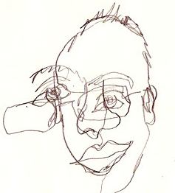
http://artprojectswithkids.blogspot.com/2010/04/project-6-blind-contour-drawings.html
A 20-minute blind continuous line portrait | A 22-minute blind continuous line portrait
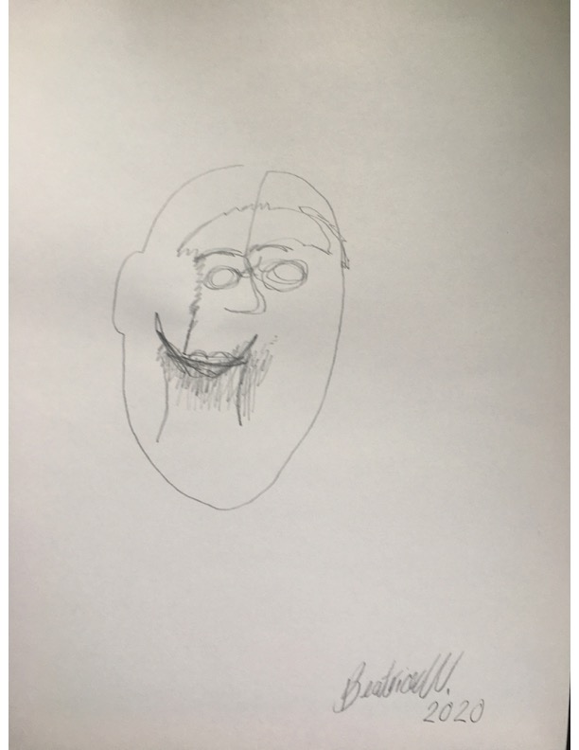 | 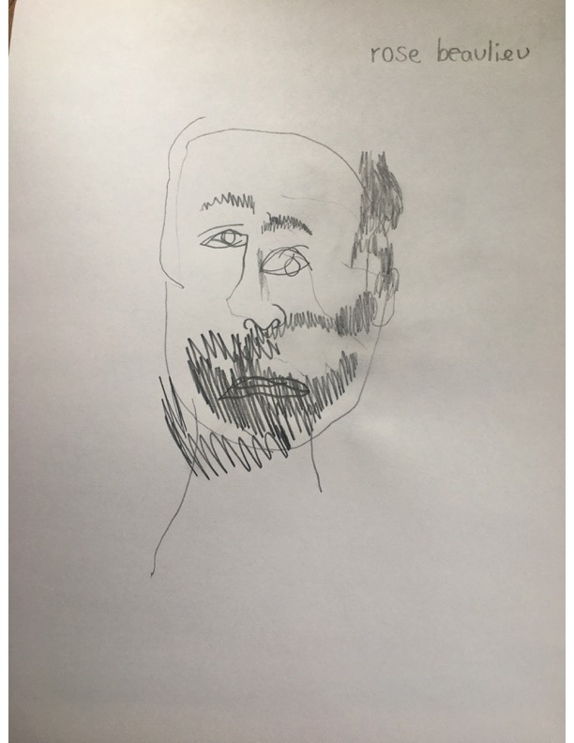

History of Québec and Canada

1608-1663

Information for students
In 1665, Jean Talon was the Intendant of New France. One of his main objectives was to increase the population.
Explain the evolution of population growth in New France.
- Characterize the population of New France before the arrival of Jean Talon. Be sure to provide an explanation as to why the population remained low.
- Identify measures taken by Jean Talon to increase the population.
- Explain the consequences of these measures for the population of New France.
- Establish a logical sequence of facts.
Using the documents, complete the table in Appendix 1 in point form.
- You may use the following website as a guide: https://www.historymuseum.ca/virtual-museum-of-new-france/population/
Based on the information you have listed in Appendix 1, write a text establishing causal connections between the facts. Be sure to include connecting phrases such as: this led to and as a result.

Take it to the next level:
Research the measures taken by the current government of Québec to encourage population growth in the province. Identify similarities and differences with respect to the measures taken by Jean Talon in 17th-century New France.

Materials required
Device with Internet access
Writing materials (paper, pencil, etc.)

Information for parents
Intellectual operations, which indicate the purpose of an evaluation question, are an important part of the evaluation process in History. In order to perform these operations, students must draw on different skills. Establishing causal connections is one of these intellectual operations and is the main focus of this lesson.
If your child would like to learn more about the early history of New France, please view the following video: Canada: A People's History - Episode 2 - Adventures and Mystics.

History of Québec and Canada

Appendix 1 – Establish Causal Connections
Document 4
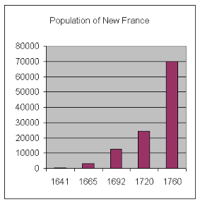
Dictionary of Canadian Biography
http://www.biographi.ca/en/bio/talon_jean_1E.html
“…to fathers of 10 children “born in lawful wedlock and who are not priests, religious, or nuns” he gave an annual grant of 300 livres, and 400 to fathers of 12 children; to young men who married when they were 20 years of age or less he gave 20 livres…”
Document 1 – Filles du Roi
Document 2
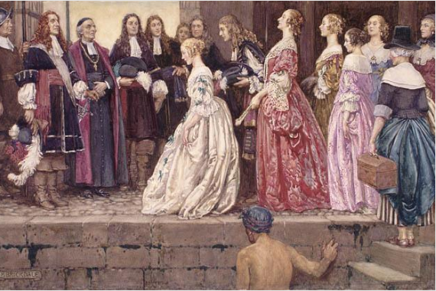

Library and Archives Canada
https://www.bac-lac.gc.ca/eng/discover/immigration/history-ethnic-cultural/Pages/french.aspx
University of Toronto
http://homes.chass.utoronto.ca/~reak/hist/A3.htm
Document 3
Marie-Andrée Courval, Luc Dujardin et Guylaine Labonté, Journeys: Origins to 1840, Secondary 3 (Anjou, Québec: Les Éditions CEC, 2018) Content Workbook, p. 59

“The obligations and privileges of chartered companies were somewhat balanced; however, their interest was in potential fur trade profits, not colonization and evangelization, which were a financial burden.”

History of Québec and Canada

Document 5 - Régiment de Carignan-Salières, 1665-1668

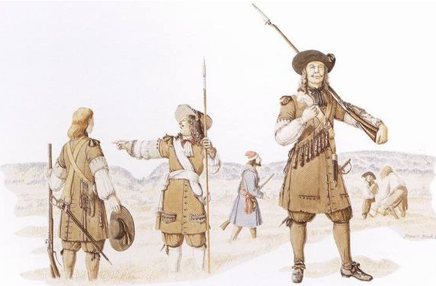
Government of Canada (http://cmhg-phmc.forces.gc.ca/cmh-pmc/image-65-eng.aspx?page=51
)

History of Québec and Canada

A → Explanatory Factors (Cause):
Explain why the population of New France remained low prior to 1665
…this led to…

Identify measures taken by Jean Talon to increase the population
…as a result of these measures…

B → Consequence:
Explain the consequences of these measures for the population of New France

Write a text establishing causal connections between the facts. Be sure to include connecting phrases such as: this led to and as a result.

History of Québec and Canada

Appendix 2 – Establish Causal Connections – Answer Key
A → Explanatory Factors (Cause):
Explain why the population of New France remained low prior to 1665
Answers will vary: → Chartered companies did not fulfill their duties to populate the colony → They were more interested in profits than in populating the colony
…this led to…

Identify measures taken by Jean Talon to increase the population
Answers will vary: → Encouraged immigration (Filles du Roi, Carignan-Salières soldiers) → Encouraged natural growth (gave money to familes with 10 or more children, granted fines and suspended hunting and fishing licence if not married by a certain age, filles du roi were granted dowries, etc.)
…as a result of these measures…

B → Consequence:
Explain the consequences of these measures for the population of New France
Answers will vary: → Initial small population gorwth due to immigration → In the long term, the population grew significantly mostly due to natural growth

Activity adapted from “Reaction Time: How fast does your brain send messages to your body,” Science-U @ Home, n.d., https://science-u.org/experiments/reaction-time.html and from «Hands on Activities: How Fast can you React,” Let’s Talk Science, n.d., https://letstalkscience.ca/educational-resources/hands-on-activities/how-fast-can-you-react

