secondary Iv
Week of May 11, 2020
Table of Contents
A Short Story 2
Une histoire bien étrange… 3
Une histoire bien étrange… 4
Appendix A – Map and Info 7
Appendix B – Formula Sheet 8
Appendix C – Guide to the Activity 9
Appendix D – Bonus Section 10
Appendix E – Answer Key 11
Energy Transformations 13
Learn About Hunger and Fullness and Get Moving! 15
Song Remix 16
The Many Impacts of Covid-19: Society 17

English Language Arts

A Short Story

Information for students
Click on the link to read through the story starters.
Choose one story starter.
Write freely for 5-10 minutes using your chosen story starter as inspiration.
Reread what you wrote and expand on it to write a short story.
Tips:
Develop your protagonist by adding specific characteristics and actions.
Include dialogue.
Show, don’t tell: use descriptive language and snapshots.
Revise your ideas.
Edit your text.
Choose an intriguing title.
Write a polished version of your short story.
Share your story with family of friends.
It’s okay to take breaks between steps. You may get ideas for your story while you are doing other things.

Material required
Link to the story starters: https://www.literacyshed.com/the-story-starter-shed.html
Paper, pen or pencil
Phone, tablet or computer.

Information for parents
Brainstorm short story ideas with your child.
Read and discuss their short story if they ask you to.
The best things your child can do are read, write and talk every day.

French as a Second Language

Une histoire bien étrange

Consignes à l’élève
Lis l’article suivant: COVID-19: pandémie de rêves https://www.lapresse.ca/societe/sante/202004/17/01-5269824-covid-19-pandemie-de-reves.php
Crée ensuite une histoire folle, digne de remporter la première place sur le palmarès des rêves les plus étranges en cette période de pandémie.
Trouve des illustrations (prises sur Internet) qui te fascinent par leur caractère particulier (des photos drôles, stupides, affreuses, banales ou cauchemardesques).
Copie ces photos dans un tableau (voir modèle proposé) sans observer d’ordre particulier. Évite seulement que ton montage soit logique.
Inspire-toi du jeu Serpents et Échelles et ajoute des échelles et des serpents (à l’ordinateur ou à la main) ici et là.
Voir les règles (accompagnant le modèle proposé) pour connaître le déroulement de ce jeu narratif.

Matériel requis
https://www.lapresse.ca/societe/sante/202004/17/01-5269824-covid-19-pandemie-de-reves.php
Ordinateur et imprimante (ou papier, magazines, colle, ciseaux), un dé & des pions.

Information for parents
This is a board game activity that children (and parents, if possible) should carry out in French.
Parents can help their children find different pictures that have nothing in common. These pictures are then put in a grid pattern (see example below). The idea behind this activity is to create a story. Each box has an image that triggers your child’s imagination to create a short part of the full story. With each new image, children need to add a new logical part to the story. In the end, the resulting story must be logical.
If a child is the only one able to speak in French at home, the parents could ask their child to record or write the story they are creating while playing alone or ask them to play online with their friends.

French as a Second Language

Une histoire bien étrange

Crée un jeu de société similaire au modèle suivant. Ajoute des illustrations, des serpents et des échelles et suis les instructions.

21 | 22 | 23 | 24 | Situation finale  25
20 | 19 | 18 | 17 | 16
11 | 12 | 13 | 14 | 15
10 | 9 | 8 | 7 | 6
1 | 2 | 3 | 4 | 5

French as a Second Language (Regular)

Instructions :
Nombre de joueurs : deux à quatre joueurs.
But du jeu : Créer une histoire en équipe.
Déroulement :
Mettre son pion sur la case no. 1. À tour de rôle, les joueurs lancent le dé et déplacent leur pion selon le nombre indiqué. Le premier à déplacer son pion commence l’histoire. Il doit s’inspirer de l’illustration suggérée sur sa case. Le deuxième joueur poursuit l’histoire… et ainsi de suite.
Une histoire bien étrange se termine dès qu’un joueur atteint la dernière case (numérotée 25). Si le chiffre apparaissant sur son dé dépasse le nombre de cases restant, il recule du nombre de points en surplus.
L’objectif est de composer une histoire folle et débridée, mais en équipe. Chaque fois qu’un joueur tombe sur une nouvelle case / nouvelle illustration, il doit raconter cette nouvelle péripétie, mais en faisant des liens avec la précédente. *Si les coéquipiers jugent que les liens faits ne sont pas assez clairs / explicites, le joueur pris en défaut doit reculer de trois cases.
Si le pion arrive sur le bas d’une échelle, il monte à la case où se trouve le haut de l’échelle. Si le pion arrive sur la queue du serpent, il descend à la case où se trouve la tête du serpent. Si le pion arrive sur une case normale, il ne bouge pas. Si le pion arrive sur une case déjà occupée, il retourne à la case départ. Chaque joueur joue à tour de rôle, le deuxième à jouer est celui qui se trouve à la gauche du premier et ainsi de suite.

Mathematics

The Final Episode

Information for students
Alistair has been waiting all year for the very last episode of his favourite TV show called “Miami Math Mysteries.” However, a power transformer stopped working in his neighbourhood, and he doesn’t have any power.
He has three friends he can go visit to watch the show. He wants to make sure that he goes to the closest friend, so he doesn’t miss a second of the show.
He was going to use the GPS on his phone to find out which friend is closest to him, but he dropped his phone in the dark. It still works and is showing him the map, but it’s no longer giving him directions.
Alistair has texted you to help him find out which friend he should go to so that he can watch as much of his show as possible. However, since he is in such a big rush, he has sent you very little information.

Materials required
Appendix A: A map with the information that Alistair has provided
Appendix B: Formula sheet with information on how to determine the distance represented by a line

Information for parents
Read the instructions to your child, if necessary
Discuss the task together with your child, outlining what steps they need to carry out
If your child is having trouble determining what steps to take, you can help them by consulting Appendix C, which will provide a step-by-step guide for this exercise. To begin with, your child should try the assignment on their own without the guide.
Once the task is completed, you and your child can go over the task with the answer key provided (Appendix E)
For an extra challenge, Appendix D adds the element of speed and stop lights to the problem. This section is optional.
Your child may obtain answers that could be slightly different from the answer key, depending on how they round off their results. Being off by a few tenths is fine. There is no need to worry about inconsistencies in rounding off the results. The important thing is that your child is able to show that they can solve the problem.

Mathematics

Appendix A – Map and Info

Location of Friends
Esther lives 19 km directly north and 8 km east of Alistair.
Esther’s house is on Terry Fox Road, which is parallel to Forest Promenade.
For Alistair to get to Esther’s street, he must first drive 16 km north on Chemin Jeanne-Mance and turn right at Horizon Campgrounds.
Danny lives 17km directly north and 21 km east of Alistair.
Danny’s house is on Rue Principale, which is perpendicular to Forest Promenade.
The two roads criss-cross at the Detour Park.
Bonnie lives 12 km north and 32 km east of Alistair.
Bonnie lives on the same road as Alistair.
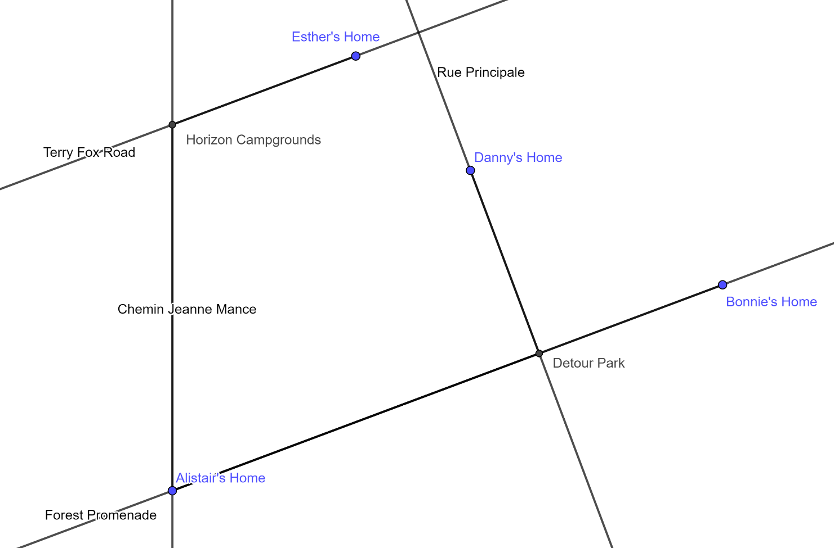
Mathematics

Appendix B – Formula Sheet

Distance Represented by a Line
d(A, B) = $\sqrt{{\left(x_{2 }-{ x}_{1}\right)}^{2}\text{ + }{\left(y_{2 }-{ y}_{1}\right)}^{2}}$

Mathematics

Appendix C – Guide to the Activity
Alistair’s home is located at (0, 0).
Use the distance formula to find the distance between Alistair and Bonnie (32, 12)
Find the equation of Forest Promenade (in the form y = ax + b)
Given that Danny lives on a road perpendicular to Alistair’s and that Danny’s home is located at (21, 17), find an equation for Rue Principale.
With those two equations, find the coordinates of the Detour Park.
Find the distance from Alistair’s house to the park and then from the park to Danny’s house.
Given that you can connect with Terry Fox Road by heading north on Chemin Jeanne-Mance, use the intersection point at Horizon Campgrounds (0, 16) to determine the distance from Alistair’s to Esther’s (Alistair’s place to the campgrounds to Esther’s place).

Mathematics

Appendix D – Bonus Section
The speed limits on all roads except for Forest Promenade is 50 km/hr.
The speed limit on Forest Promenade is 70 km/hr.
Stop lights on the way to Esther’s add 10 minutes to the driving time.
Stop lights on the way to Bonnie’s add 5 minutes to the driving time.
Stop lights on the way to Danny’s add 3 minutes to the driving time.

Mathematics

Appendix E – Answer Key

Distance between Alistair’s place and Bonnie’s place
d(A, B) = $\sqrt{{\left(24-0\right)}^{2}\text{ + }{\left(9-0\right)}^{2}}$ = 25.63 km

The equation of Forest Promenade
Using the points (0, 0) and (32, 12), the equation is y = $\frac{\text{3}}{\text{8}}$x

The equation of Rue Principale
Using the coordinate (21, 17), the equation is y = $-\frac{\text{8}}{\text{3}}$x + 73

The coordinates of Detour Park
Using the equations y = $\frac{\text{3}}{\text{8}}$x and y = $-\frac{\text{8}}{\text{3}}$x + 73, the coordinates are (24, 9)

Distance between Alistair’s place and Danny’s place
d(A, P) = $\sqrt{{\left(24-0\right)}^{2}\text{ + }{\left(9-0\right)}^{2}}$ = 25.63 km
d(P, D) = $\sqrt{{\left(21-24\right)}^{2}\text{ + }{\left(17-9\right)}^{2}}$ = 8.54 km
25.63 + 8.54 = 34.17 km

The equation of Terry Fox Road
Using the coordinates (8, 19), the equation is y = $\frac{\text{3}}{\text{8}}$x + 16

The coordinates of Horizon Campgrounds
Using the equations y = $\frac{\text{3}}{\text{8}}$x + 16 and x = 0, the coordinates are (0, 16)

Mathematics

Distance between Alistair’s place and Esther’s place
d(A, C) = $\sqrt{{\left(0-0\right)}^{2}\text{ + }{\left(16-0\right)}^{2}}$ = 16 km
d(C, E) = $\sqrt{{\left(8-0\right)}^{2}\text{ + }{\left(19-16\right)}^{2}}$ = 8.54 km
16 + 8.54 = 24.54 km
Esther’s place is closest to Alistair’s place.

** BONUS CONTENT**

Example of a Formula
Distance ÷ speed x 60 minutes + stopping time = total time

Time to Get to Bonnie’s Place
34.18 ÷ 70 x 60 + 5 = 34.30 minutes

Time to Get to Danny’s Place
25.63 ÷ 70 x 60 = 21.97 minutes
8.54 ÷ 50 x 60 + 3 = 13.25 minutes
21.97 + 13.25 = 35.22 minutes

Time to Get to Esther’s Place
24.54 ÷ 50 x 60 +10 = 39.45 minutes
Even though Esther is much closer, it would take less time to get to Danny’s place place compared to Esther’s place.

Science and Technology

Energy Transformations

Information for students
Energy exists in different forms and changes from one form to another in almost everything we do. In this activity, you will develop a proposal for a new toy that transforms energy. The proposal will include a detailed drawing or model and an explanation of how the toy works.
The specifications for your toy include:
The toy should be fun and engaging for children
The toy must be safe for children
The toy should involve at least two energy transformations
In order to develop a proposal for your toy, follow the steps below.

Define the problem
To further define the problem, you may need to do some additional research.
Your toy has to transform energy. The different forms of energy include chemical, electrical, mechanical, radiant, and thermal. You can consult this website for more information on the different forms of energy.
  - Find examples of objects in and around your home that transform energy. Could you use any of these energy transformations in a toy?
Your toy needs to be fun and engaging for children. What makes a toy fun? What characteristics does a toy need to have to maintain a child’s interest?
  - Given that the answers to the questions above will depend on a child’s age, choose the age range for which your toy will be designed.
Your toy must be safe for children. Given the age range you have chosen, what do you need to take into account when designing the toy? Think about the size of the components or the materials that could be used.
Are there are other specifications that you need to include for your toy?

Brainstorm Ideas and Choose an Idea
Be creative and innovative! What will the toy do? What materials could you use? There are many different possibilities.
Come up with a few different ideas and choose one that you would like to work on.

Science and Technology

Develop a proposal
Imagine that you are presenting your idea to a toy company, in the hope that the company will use your idea. Choose a way to present your proposal. For instance, you could use a drawing or model with an explanation, a video, or a poster.
Your proposal should include:
  - A list of the specifications for your toy based on the work you did when you were defining the problem. (Include an explanation of why you chose some of the specifications.)
  - A drawing or model of the toy
  - The materials that could be used to manufacture the toy.
  - An explanation of how the toy works, including an explanation of the energy transformations
  - An explanation of how the toy meets the specifications that you used.

Materials required
Paper, writing and drawing materials
Device with Internet access (optional)

Information for parents

About the activity
Children should:
Develop a proposal for a new toy that has at least two energy transformations.
Parents could:
Discuss ideas for the toy with their child
Ask their child to present the proposal for the toy to them

Physical Education and Health

Learn About Hunger and Fullness and Get Moving!

Information for students
Activity 1: How does your body know you are full?
Watch this video.
What types of food keep you feeling fuller for longer?
Discuss what you learned with a family member. For better effect, you could do so during a mealtime!
Activity 2: Get moving!
Complete the 30-Minute Hip-Hop Workout in this video.
Adjust the movements and level of intensity to your personal fitness level.
If you are up for practicing your French and want to explore more activity ideas, visit the Rest Actif! website.

Materials required
None

Information for Parents
Children should:
learn about fullness and satiety
complete a hip-hop fitness workout
Parents could:
ask their children questions about what they learned about hunger and fullness
complete the workout with their children

Arts

Song Remix

Information for students
For some artists, self-isolation has stirred in them a desire to reach out and inspire or amuse people, even though we can’t physically be together. Where have you used your creativity lately?
Singer and composer Ariane Moffatt remade part of her song ‘Debout’ to encourage everyone to stick together during these days of confinement. Watch here: https://www.youtube.com/watch?v=jnw9nA82RQo
School principal Andy Orr remixed the popular song “I Will Survive” to give hope to his school community. Watch here:https://www.youtube.com/watch?v=mjm5K5hses8.
What song’s chorus or lyrics could you rework to represent part of how you have been feeling during this pandemic or with a message for others? What is a legacy that this pandemic will leave with us?
Record your lyrics then try it out with the original piece of music. Readjust as necessary
Share with those you live with or a friend. What is their impression?

Materials required
Device with Internet access
Paper and writing tools, if necessary

Information for parents
This activity is designed to be simple and let your child experiment with song writing.
We hope it will appeal to your child whatever their grade level.

Ethics and Religious Culture

The Many Impacts of Covid-19: Society

Information for students
Over the next couple of weeks, you will be asked to read and reflect on a variety of online articles or events that you have heard about locally, nationally or internationally on the different impacts COVID-19 is having on our lives.
It is suggested that you use a journal, Duo-Tang or, again, any digital device to document your reflections.
For this week, read and reflect on the article in Newsela, “Why Tough Times Can Create Better Neighbors” by following this link:
https://bit.ly/2KFRkfV
If you do not have access to a digital or printed version of this article, think of positive examples you have witnessed locally, nationally or internationally during Covid-19.
In paragraph 17, the journalist states that “This crisis will necessarily alter the way we connect socially during the crisis” and continues by quoting Suttie from Greater Good Magazine: “What matters most is how we interact with others . . . pointing to two major research papers on how emotions are contagious within social circles – including online associations.’’
Write, draw, or record a short reflection on the article. Consider the following:
What are some of the positive social changes observed during Covid-19?
Can these positive social changes continue after the pandemic? Why or why not?
What has this pandemic taught you about your personal values and your implication in your family or community?
Is there something more you can do to contribute to the greater good?

Materials required
Paper, pen, pencil or any other writing or creating materials
Digital or printed version of this article: https://bit.ly/2KFRkfV
Device with Internet access or any way to hear or see positive social initiatives (article, radio, TV, conversations)

Ethics and Religious Culture

Information for parents

Students should:
learn about some of the impacts the COVID-19 pandemic is having on society and think critically on whether these will be lasting changes
identify how they can contribute or continue to contribute to the local or global community

Parents could:
read the article and discuss it with their child
discuss some of the positive social events or changes that they have heard about, read about, witnessed or experienced
discuss some of the ways they can make a difference socially (while respecting social distancing guidelines)

History of Québec and Canada

The First Phase of Industrialization
The origins of our present-day economy can be traced back to the first phase of industrialization. Factories began to pop up, and factory workers were hired to make goods that could be sold at a lower cost than ever before. Sectors of activity including food, textile and lumber production underwent tremendous development. Some groups profited from this, while others did not.

Information for students
Click on this link to bring you to an online version of your History textbook:
https://www.iplusinteractif.com/books/187/254/3804/67482/235996
Pages 56-58 will teach you a little about the first phase of industrialization in Québec.
If you do not have access to the Internet, go to pages 56-58 of the print version of your textbook. If you do not have your textbook, consult the historical documents provided below.
Now that you have learned about the first phase of industrialization, do the following activities:
  - Determine a consequence of the introduction of mechanization.
  - Establish connections by matching the activity shown in a given document with the correct production sector during the first phase of industrialization.
  - Situate a historical document on a timeline.

Materials required
Useful resources, depending on personal preferences and availability:
Device with Internet access
Writing materials (paper, pencil, etc.)

Information for parents
Discuss the ideas presented and potential answers with your child.

History of Québec and Canada

Mechanization completely changed the way goods were produced in Québec and Canada.
Look at the document below and determine a consequence of the introduction of mechanization after approximately 1850.
Document 1
Before 1850 | After 1850
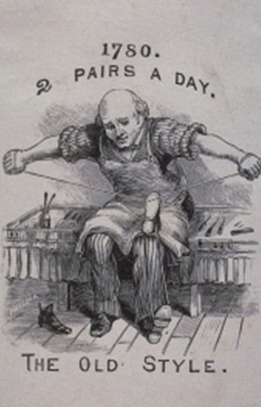 | 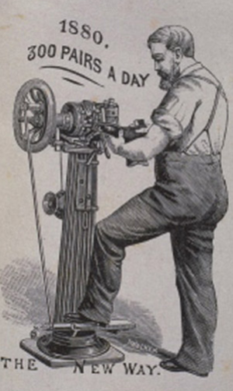
McCord Museum: http://collections.musee-mccord.qc.ca/scripts/viewobject.php?Lang=1&section=false&accessnumber=M930.50.5.262&imageID=303038&pageMulti=1

History of Québec and Canada

A consequence of mechanization was: ___________________________________________________________________________________________________________________________________________________________________________________________________
Establish connections by matching the activity shown in each document with the correct production sector during the first phase of industrialization.
Place the following documents in the appropriate boxes.
Document 2 Document 3
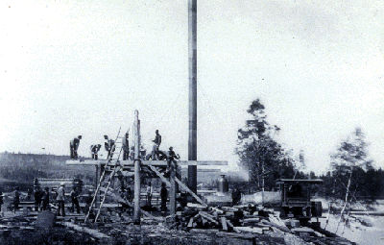
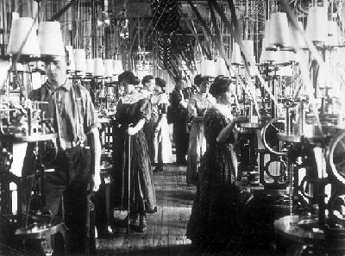
Factory workers sewing clothing Steam-powered sawmill
The Canadian Encyclopedia
The Canadian Encyclopedia: https://thecanadianencyclopedia.ca/en/article/industrialization

Library and Archives Canada
Document 4
Sherbrooke Mills
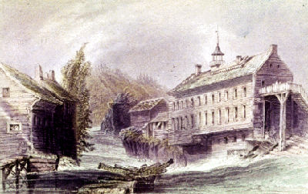

Toronto Public Library – via the Canadian Encyclopedia
The Canadian Encyclopedia: https://thecanadianencyclopedia.ca/en/article/industrialization

History of Québec and Canada

Food sector | Textile sector | Lumber sector

The document below is a photograph of the port of Montréal during the first phase of industrialization.
On the timeline, circle the letter that corresponds to the period in which the photograph was taken.
Document 5
Port of Montréal

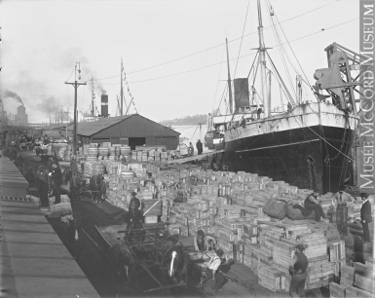

McCord Museum: http://collections.musee-mccord.qc.ca/fr/collection/artefacts/II-116749
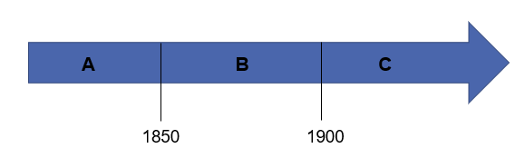
History of Québec and Canada

Answers:
A consequence of mechanization was that now a greater quantity of goods could be produced in the same amount of time.
Extra info:
This resulted in the price of goods dropping, making them more accessible to the general public. However, low wages among the working class still made it extremely difficult for workers to have a comfortable lifestyle.

Food sector | Textile sector | Lumber sector
4 | 2 | 3

