Weekly Educational Options From the Ministère
secondary II
Week of June 1, 2020
Table of Contents
Identity 2
#Mission FLS: Ça me dit de rire! 5
Area of Circles 6
Appendix A - Area of Circles 7
Appendix B - Possible Solution 9
Layers of the Earth 10
Appendix – Layers of the Earth 11
Learn About the Canadian 24-Hour Movement Guidelines and Get Moving! 12
Messages on Stone 13
Appendix – Messages on Stone 15
Forests and Their Impact 16
Appendix – Forests and Their Impact 17

English Language Arts

Identity

Information for students
- First, read the poem “Hanging Fire” by Audre Lord
- Then, read the poem “I Remember” by Abundance C Nwosu
- Think about the following questions and write a reflection of at least two pages:
- What are some of the difficulties in growing up that were identified in the poems?
- What are some of the challenges you face as a young adult?
- How do you define yourself as a young adult? How do you see yourself?
To go further: Write your own poem about coming of age.

Hanging Fire
by Audre Lorde
I am fourteen
and my skin has betrayed me
the boy I cannot live without
still sucks his thumb
in secret
how come my knees are
always so ashy
what if I die before morning
and momma’s in the bedroom
with the door closed.
I have to learn how to dance
in time for the next party
my room is too small for me
suppose I die before graduation
they will sing sad melodies
but finally
tell the truth about me
there is nothing I want to do
and too much
that has to be done
and momma’s in the bedroom
with the door closed.
Nobody even stops to think
about my side of it
I should have been on Math Team
my marks were better than his
why do I have to be

English Language Arts

the one
wearing braces
I have nothing to wear tomorrow
will I live long enough
to grow up
and momma’s in the bedroom
with the door closed.
(Reference: https://www.poetryfoundation.org/poems/42580/hanging-fire)

I Remember
by Abundance C Nwosu
I remember-
of days so long in the past
when I wished I would grow up so fast.
I remember-
endless races we had to school.
Coming first ensured you were cool.
I remember-
the sudden hot summer's rain,
dancing 'round and 'round again.
I remember-
playing in the luscious grass
with all my friends in my class.
I remember-
the spooky monsters under my bed;
Mum and Dad said it was all in my head.
I remember-
when I grew to be as old as ten,
my dad made me a tree-house as my den.
I remember-
hide-and-seek was the best game,
but as we grew up it became so lame.
I remember-
Haribos were as good as gold.
I will have as many as I want when I am old.

English Language Arts

I remember-
when I wanted to be a king
the one
with a large throne and a diamond ring.
I remember-
my first camping trip
or my first time on a ship.
I remember-
when I broke my wrist
all the fun is what I missed.
I remember-
Mr. Cuddles, my first teddy bear.
I loved him so much and took him everywhere.
Now that I am grey and old,
My childhood memories I have told.
(Reference: https://www.familyfriendpoems.com/print/poem/MTI4OTUz)

Materials required
Paper and writing materials

Information for parents
This activity asks your child to reflect on the challenges of becoming a young adult.
Discuss this with your child and share your own observations.

French as a Second Language

#Mission FLS: Ça me dit de rire!

Information for students
Cette activité t’aidera à accomplir la mission FLS suivante : « J’imagine une mini pièce de théâtre ou un petit film en français avec ma famille ou virtuellement, avec mes amis ».
Qu’est-ce qui te fait rire ? Qu’est-ce qui fait rire les gens autour de toi ? Cette semaine, on t’invite à écrire un sketch rigolo !
Voici comment tu peux le faire :
pense à l’histoire que tu pourrais raconter
écris un court dialogue. Pour t’aider dans ton écriture, consulte cette capsule de LEARN : https://www.learnquebec.ca/fr/ecrire-un-dialogue1
trouve des accessoires pour t’aider à réaliser ton sketch.
joue-le avec les gens qui habitent chez toi ou filme-le avec un ami en ligne
Pour aller plus loin
exprime ta créativité : utilise une application de création d’histoire comme Puppet Pal
publie ton sketch avec le mot-clic #MissionFLS

Materials required
Écrire un dialogue
Puppet Pal
Mission FLS

Information for parents
In this activity, children will practise:
writing a short dialogue in French
creating a story about an anecdote from everyday life
Parent can:
share ideas about funny things their child could write about
be an actor in the sketch
watch the final product

Mathematics

Area of Circles
The ability to find the area of whole circles and parts of circles is an important skill to master in Secondary II. Below are some challenges to help you practice working with the relationship between the radius and the area of a circle.

Instructions
Read the two challenge questions in Appendix A.
Try to find a solution for the challenge, using your knowledge of how to find the area of a circle.
If you have time, try to find a different solution to the same challenge.
Show your solutions to a parent, a peer or your teacher for feedback.

Materials required
Questions in Appendix A
Writing tools and calculator
Materials

Information for parents
Children could:
find one or more answers to the problem
compare their answers with those of their teacher or a friend
Parents should:
help their child organize the necessary materials, if needed
read the instructions together with their child and help them create representations, if needed
encourage their child to discuss the representations they found easiest and hardest to complete
discuss the problems together with their child and/or ask them to describe how they determined the answers to the questions
A possible solution is found in Appendix B.

Mathematics

Appendix A - Area of Circles

Information for students
Below are two circle problems. These questions are open-ended in that there are many possible answers. See if you can find more than one answer.
Hints:
- to find the area of a circle, use the formula $A=πr^{2}$
- think about the relationship between the diameter and the radius of a circle
- think about how the area changes as you change the value of the diameter and radius

Question #1:
Create a design made of at least three circles of different sizes. The total combined area of these circles must be approximately 100 cm². How do you know your design is correct?

Mathematics

Question #2:
Examine the figure below. It is made up of right triangle ABC with a semicircle along each side of the triangle. The side lengths of the triangle represent the diameter of the respective semicircles.

Determine the area of each semicircle.
What do you notice about the areas of the three semicircles?
Extension:
Draw a right triangle with three different side lengths, using multiples of the side lengths given in Question #2. For example, multiply each side length by the same number. On each side of the triangle, draw a semicircle so that each side of the triangle is the flat side of a semicircle like in the image above.
Repeat the steps from Question #2 above by finding the area of each semicircle and then comparing these areas.
Is what you noticed in Question #2 still true for a triangle with different side lengths?

Mathematics

Appendix B - Possible Solution
Below is a sample solution to each of the two circle problems. Other solutions are possible.
Question #1: You can play with the number of decimal places to get even closer to 100. The more decimal places you use, the more precise your answers will be and the closer you will get to 100 as the sum of the areas.
 | Possible Solution Where the Radii are Whole Numbers | Possible Solution Where the Radii are Whole Numbers | Possible Solution Where the Radii are Decimal Numbers | Possible Solution Where the Radii are Decimal Numbers
Circle #1 | $$r=5, A= 78.50$$ | $$r=5, A= 78.50$$ | $$r=3.3, A= 34.19$$ | $$r=3.3, A= 34.19$$
Circle #2 | $$r= 2, A = 12.56$$ | $$r= 3, A = 28.26$$ | $$r= 1.75, A= 9.61$$ | $$r= 1.75, A= 9.61$$
Circle #3 | $$r= 1, A=3.14$$ | $$r= 1, A=3.14$$ | $$r=4.23, A=56.18$$ | $$r=4.24, A=56.45$$
Total Area | 94.20 units² | 109.90 units² | 99.98 units² | 100.25 units²
Question #2:
Side Length | Radius of the Circle | Area of the Whole Circle | Area of the Semicircle
6 cm | 3 cm | 28.26 | 14.13
8 cm | 4 cm | 50.24 | 25.12
10 cm | 5 cm | 78.5 | 39.25
You might notice that the sum of the areas of the semicircles on the two smaller sides of the triangle is equal to the area of the semicircle on the longest side (14.13 + 25.12 = 39.25). If you are interested in an extension of this idea, which you will learn about next year, please watch the following two videos: water demo (https://safeyoutube.net/w/fweE) OR this video about the Pythagorean theorem: (https://safeyoutube.net/w/vxeE)

Science and Technology

Layers of the Earth

Information for students
The Earth is composed of four (4) layers: the inner core, outer core, mantle and crust. The radius of the Earth can vary depending on where it is measured. For this activity, the radius of the Earth is approximately 4 540 km. Figure 1.1 in the Appendix represents a wedge of the Earth’s layers.

Instructions
Colour and label the four (4) layers of the Earth in Figure 1.1 in the Appendix.
The radius of the inner core is 1 300 000 m. Label the radius of the inner core in km above the appropriate arrow in Figure 1.1.
If the approximate radius of the Earth is 4 540 km, the outer core’s radius is 49.56% of the length of the Earth’s radius. Calculate the radius of the outer core (rounded to the nearest whole number) and label it above the appropriate arrow in Figure 1.1.
The mantle layer’s radius is 650 km longer than the radius of the inner core. Calculate the radius of the mantle and label it above the appropriate arrow in Figure 1.1.
Using the above information, determine the radius of the crust and label it above the appropriate arrow in Figure 1.1.

Materials required
Markers, coloured pencils or crayons
Pencil
Calculator

Extension question
A quick Google search of “the radius of the Earth” returns a result of 6 371 km. Write a hypothesis as to why the radius of the Earth varies.

Information for parents

About the activity
Children should:
build a 3-dimensional model of the Earth’s layers using play dough or other household materials
Parents could:
remind the students that the layers of the Earth are the inner core, the outer core, the mantle and the crust (in order from inner to outer), if necessary

Science and Technology

Appendix – Layers of the Earth

Information for students
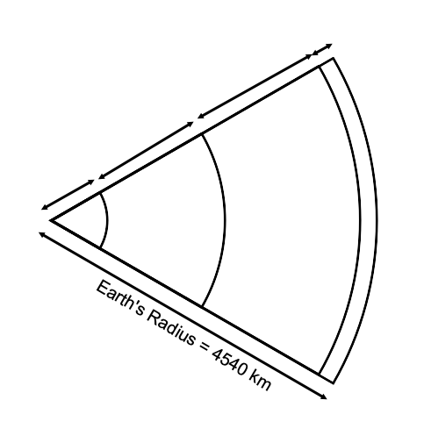
Figure 1.1

Physical Education and Health

Learn About the Canadian 24-Hour Movement Guidelines and Get Moving!

Information for students
Activity 1
Take a look at the Canadian 24-Hour Movement Guidelines for teens (click here and scroll down to page 4).
Read the recommendations for the four categories of daily activity: SWEAT, STEP, SLEEP, SIT.
Do you get the recommended amount of sleep each night? Do you do the recommended moderate-to-vigorous physical activity each day? What are the light physical activities that you do each day? (Hint: if you’re not sure what is considered “light” physical activity, click here, then click on the letter L).
Scroll down to the infographic (D). Do you already do any of the suggested tips for getting more active? Are you interested in trying any of them?
Discuss the movement guidelines and how well you meet the recommended time in each category with a parent.
Activity 2
Accumulate some SWEAT time with the Fitness Marshall. Follow this dance fitness workout

Materials required
Device with Internet access

Information for parents

About the activity
Children should:
- learn about the Canadian 24-Hour Movement Guidelines
- complete a dance workout
Parents could:
discuss the movement guidelines with their children
complete the dance workout with their children

Ethics and Religious Culture

Messages on Stone

Information for students
Rock art is one of the oldest forms of communication in human societies. Take a look at these examples from the Musée de la Civilisation’s virtual exhibition, Images on Stone:
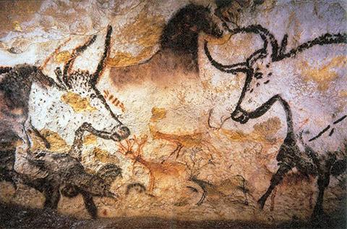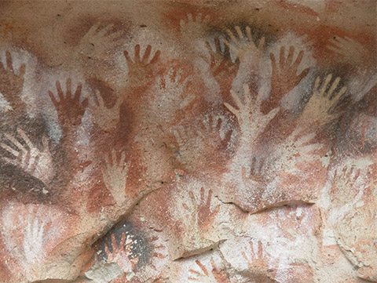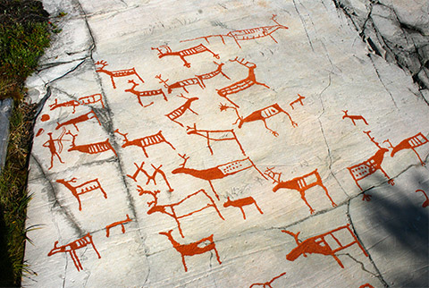
PETROGLYPHS TRACED OVER USING QUARTZ, ALTA, NORWAY
Photo: Wikimedia Commons

NEGATIVE HANDPRINTS, ARGENTINA
Photo: Wikimedia Commons

PAINTING, LASCAUX CAVE, FRANCE
Photo: Wikimedia Commons

Prehistoric societies used rock art to represent religious and spiritual symbols connected with myths, values and beliefs. Look at the Musée de la Civilisation’s virtual lesson, Messages on Stone to discover why Indigenous peoples created rock art sites and what types of images can be found at these sites.
The following activity allows you to explore an example of rock art and the associated myth from the Memekueshuat peoples. These images are found in Manitoba as well as in Québec.
Create your own legend about mythical beings to convey values for children 8-10 years old.

Materials required
Device with internet access
Paper
Writing materials

Ethics and Religious Culture

Information for parents

About the activity
Students could:
view the Musée de la Civilisation’s virtual exhibit, Images on Stone, to gather information about rock art
view the Musée de la Civilisation’s virtual lesson, Messages on Stone, to gather information about the spiritual and religious aspect of rock art
- read the Memekueshuat legend that goes with the rock painting found in the Appendix and answer the questions
- create their own legend to convey values
Parents should:
- view the Musée de la Civilisation’s virtual exhibit on rock art and the spiritual and religious aspects with their child
- read the Memekueshuat legend that goes with the rock painting, and discuss possible answers to the questions and the reasoning behind them with their child
- help their child convey values through the creation of their own legend

Ethics and Religious Culture

Appendix – Messages on Stone

Information for students
Read the Memekueshuat legend that goes with this rock painting and answer the following questions:
What characteristics of Memekueshuat are revealed by this legend?
What values and beliefs significant to the Indigenous peoples are conveyed by this legend?
Legend and Questions
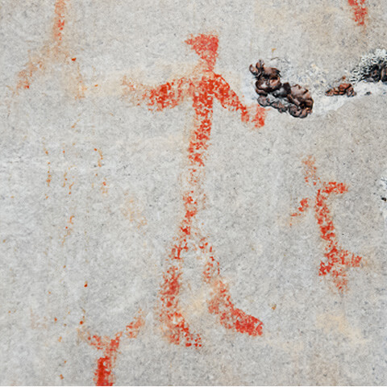
Source: https://imagesdanslapierre.mcq.org/wp-content/themes/mcq/img/nisula/representation/480/memekwueshuat.jpg
Now create your own legend:
Carvings and paintings representing various figures, such as supernatural beings that interact with humans, are found on rock art sites. In stories describing the actions of these mythical beings, values important to Indigenous peoples are conveyed: sharing, respect, tolerance, transmission of knowledge, etc.
Do the activity titled A Telling Legend by choosing a rock painting representing a supernatural being from the websites listed, applying a value and writing a legend that will convey that value to children aged 8 to 10.

Geography

Forests and Their Impact

Information for students
The goal of this activity is to explore the role of forests in conserving the ecosystem and the impact of the forest industry on the territory. The readings in the Appendix are a starting point to help you generate your own ideas and make connections. You can do the mind map task alone and then compare your work with a friend or you can complete the mind map together.
Think about or discuss with a friend or family member the many ways that people, animals and certain industries depend on forests.
Read the related excerpts to better your understanding of the role of forests and the impact of the various forest industries.
Create a mind map to show your understanding of the situation of forest territories in Canada. You may use the sample mind map attached.
Think about what we can do better to protect forests and the natural habitats of animals and ecosystems.

Materials required
Useful resources, depending on personal preferences and availability:
Writing materials (paper, pencil, etc.)
Textbook (optional)

Information for parents

About the activity
Children could:
complete the mind map with a friend or on their own and then compare their work with a friend and add to their own mind map
Parents should:
help their child think of other items that may not be in the excerpts but that can be added to the mind map. See how many new items you can find together

Geography

Appendix – Forests and Their Impact

Information for students
Use the following excerpts and images from pages 166-219 of the textbook Issues and Territories¹ to complete the mind map.
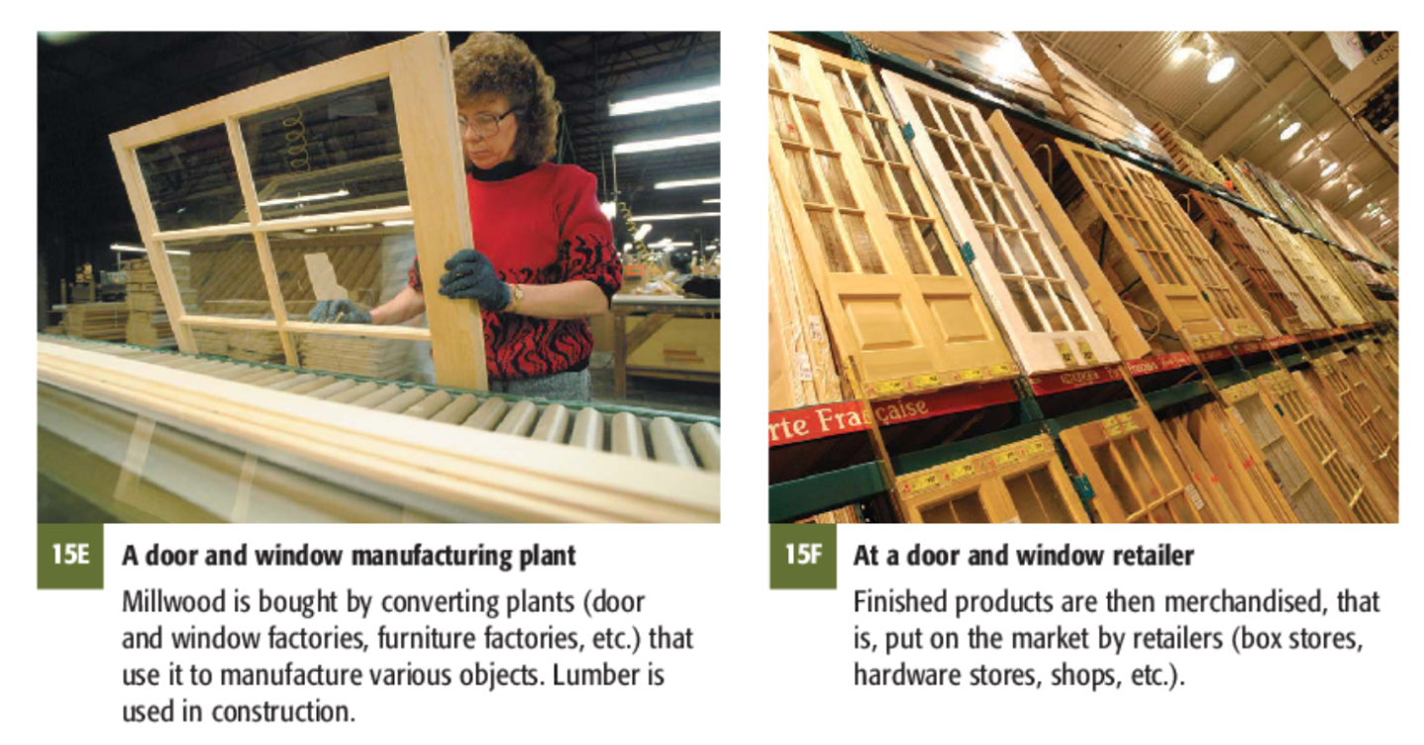

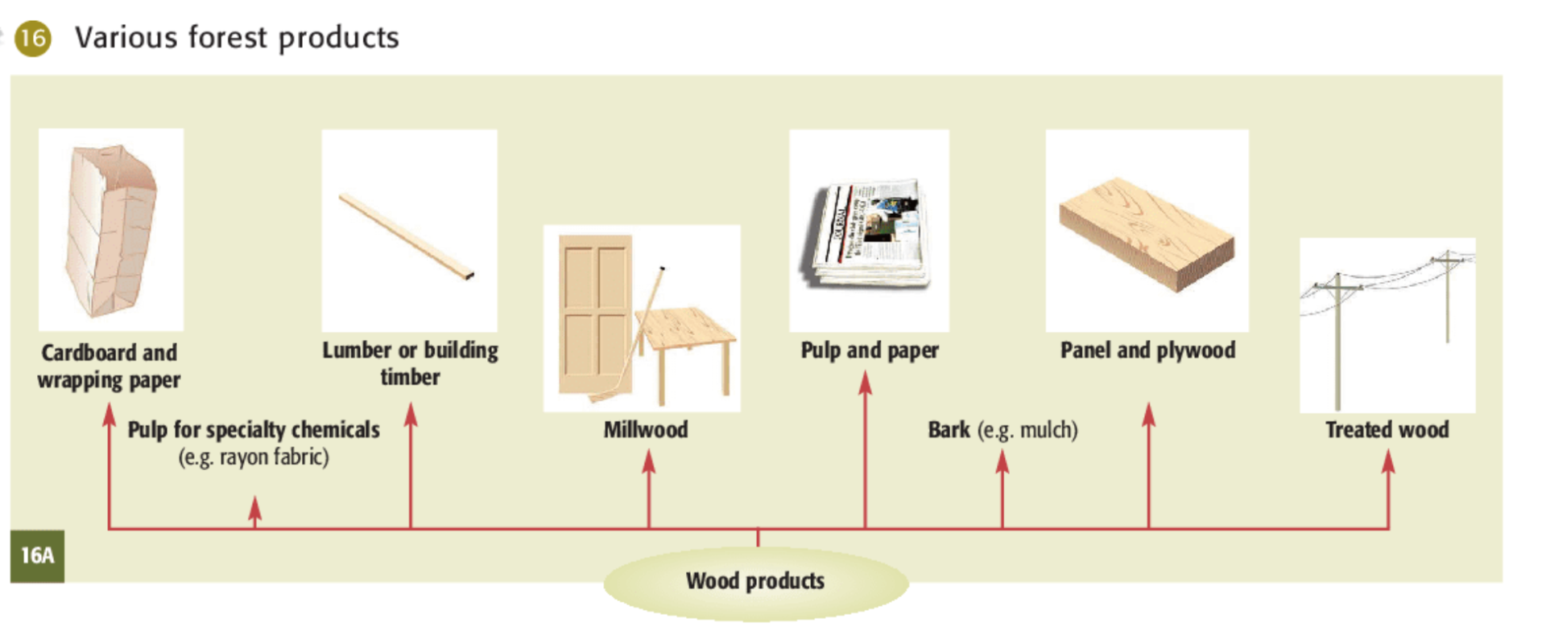

¹ Nathalie Boudrias,et al.,, Issues and Territories, Geography, Secondary Cycle One (Montréal: Chenelière Éducation, 2006), Textbook B, 166-219.

Geography
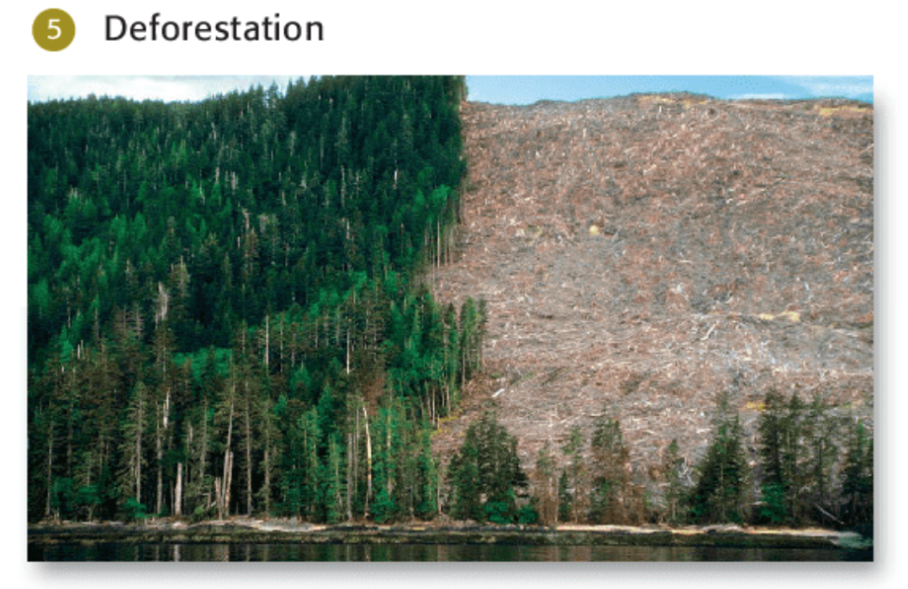

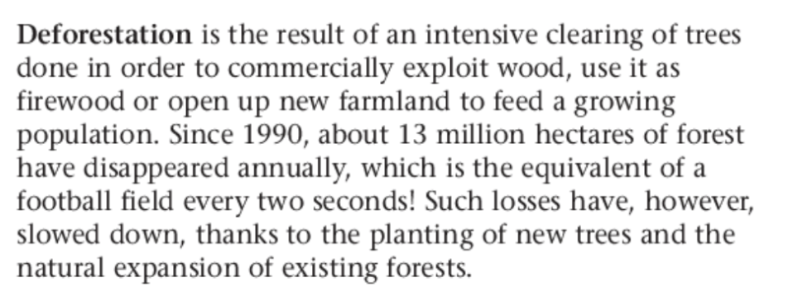

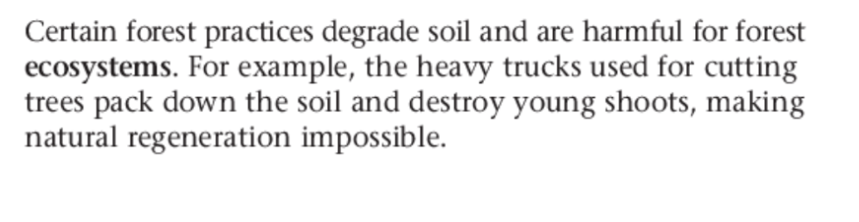

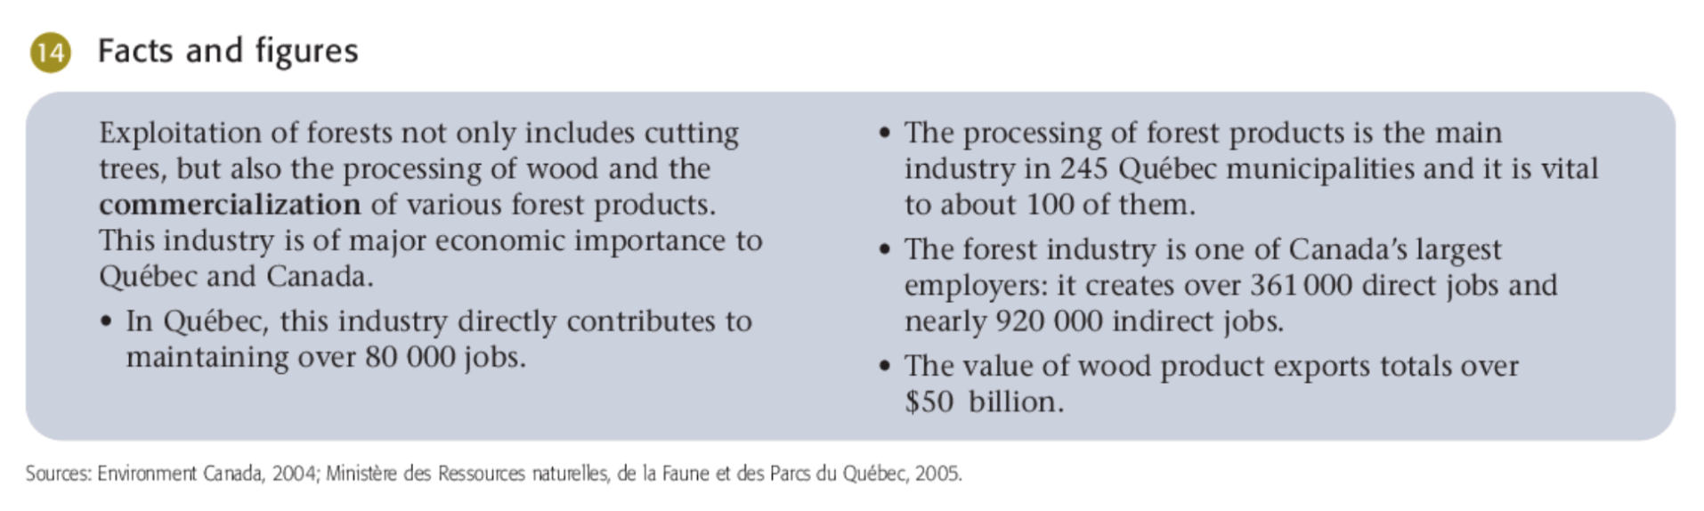

Geography
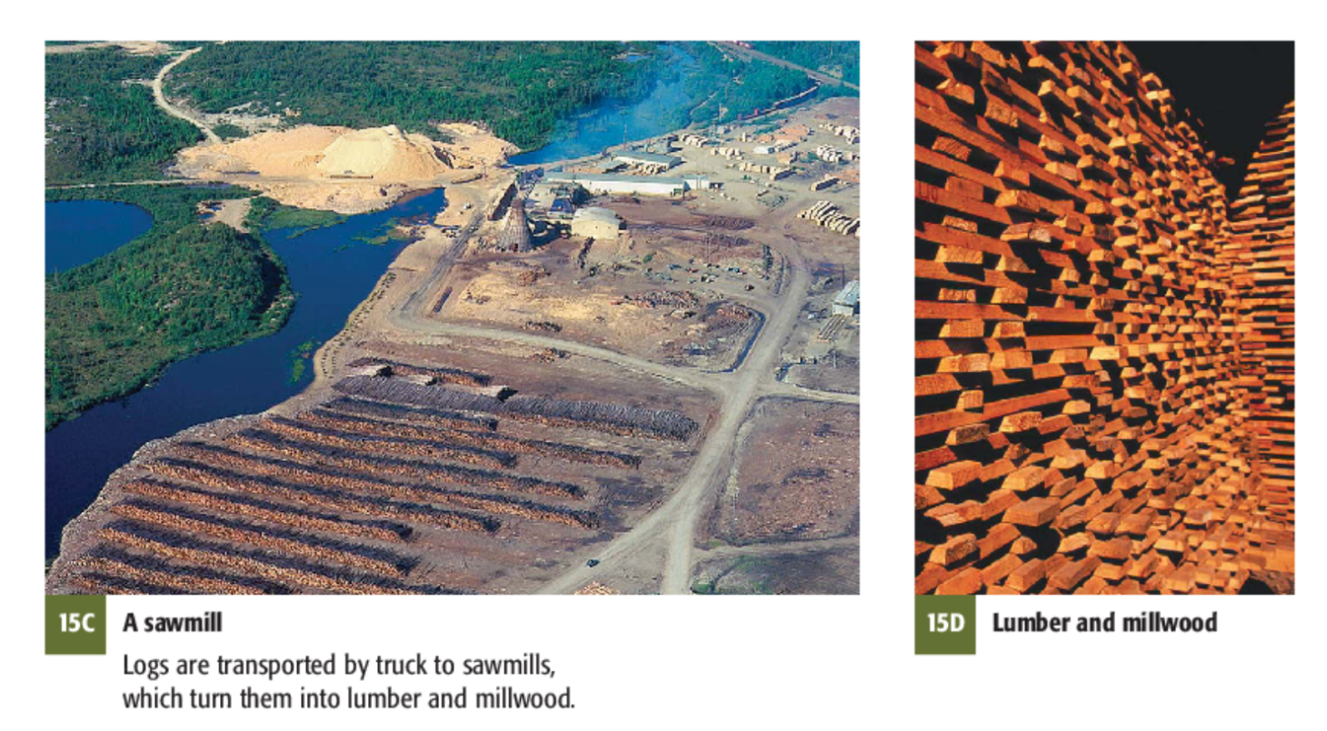

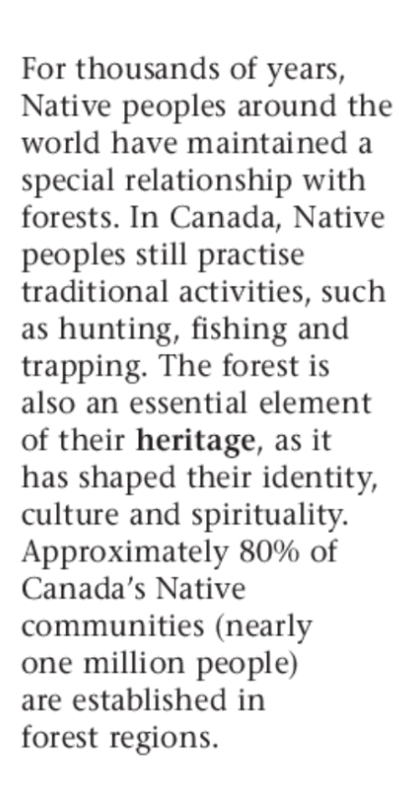

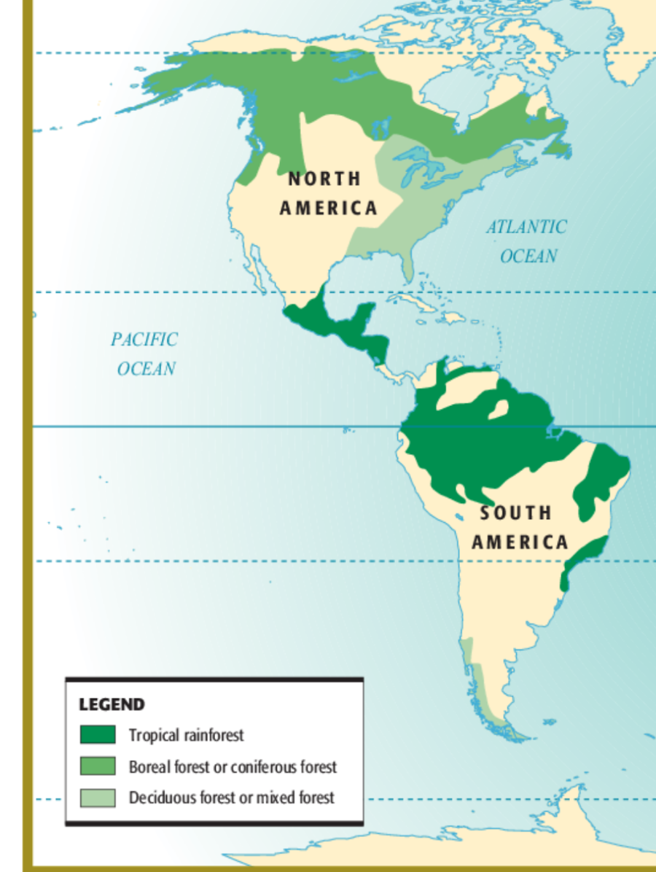

Geography

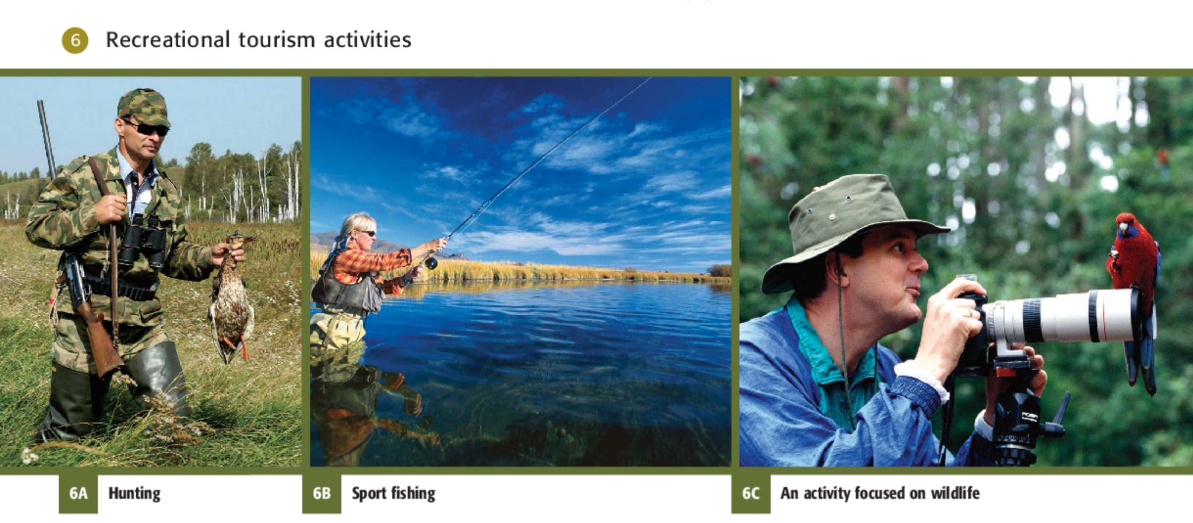

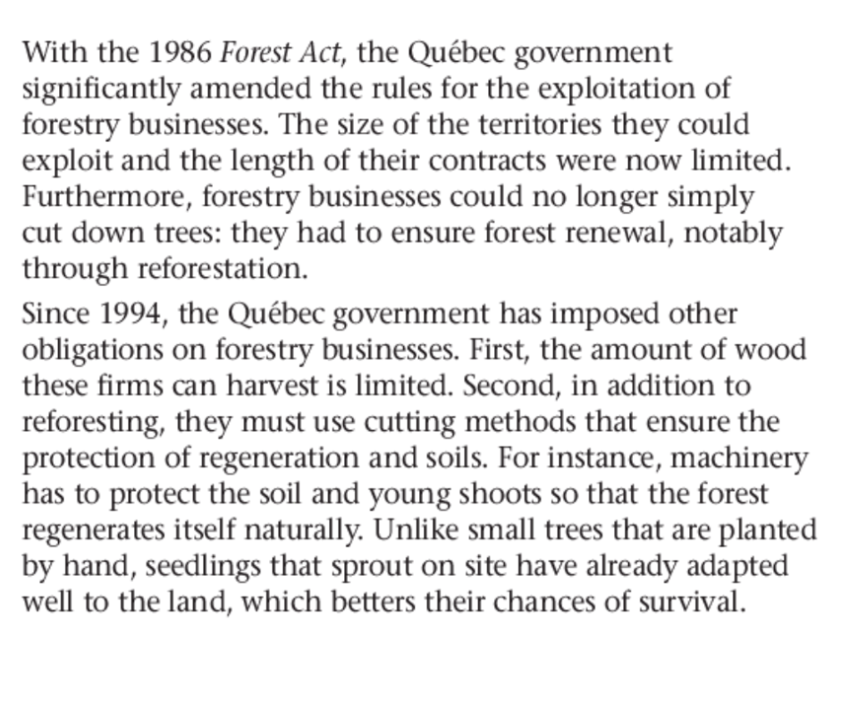
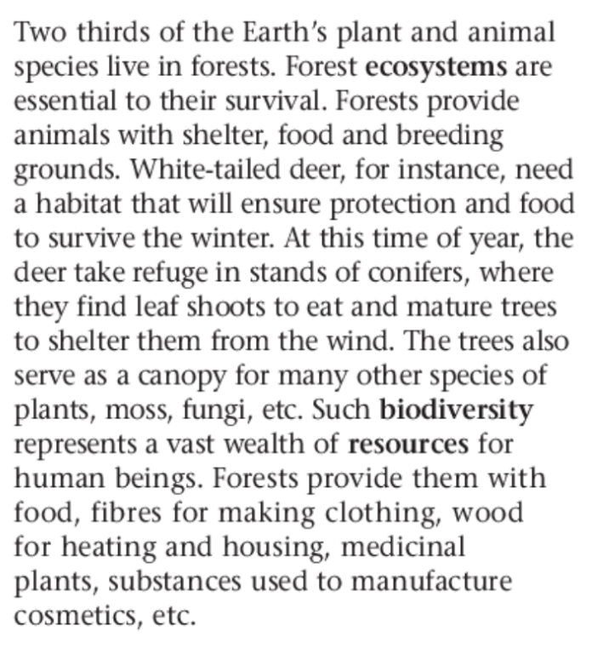

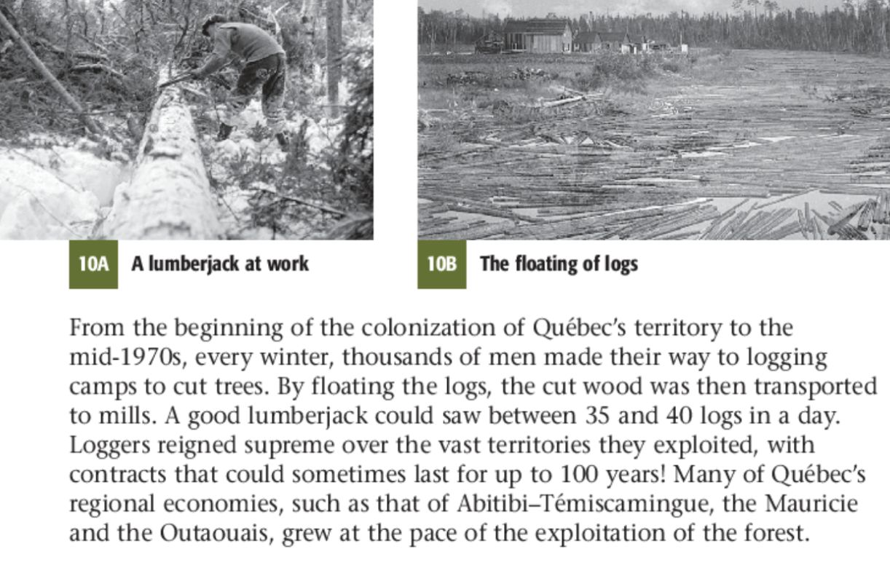

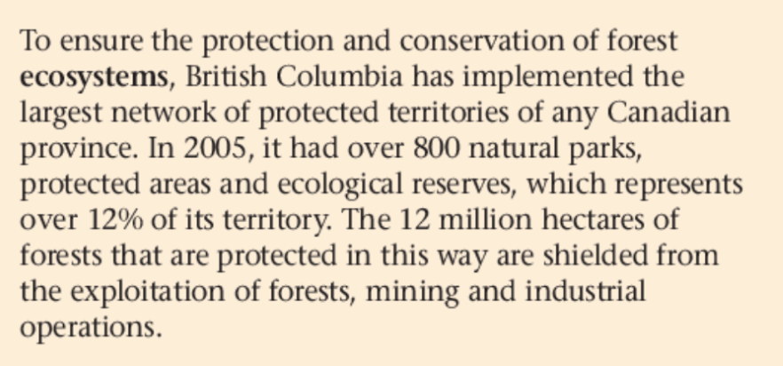
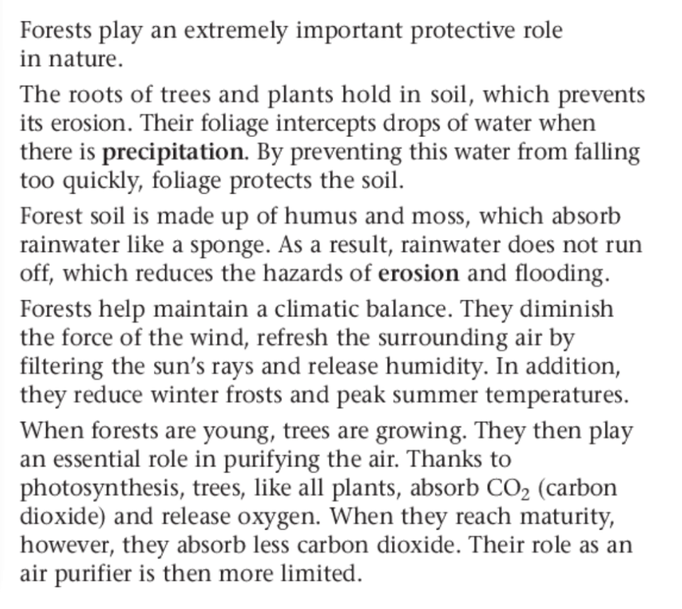
Geography

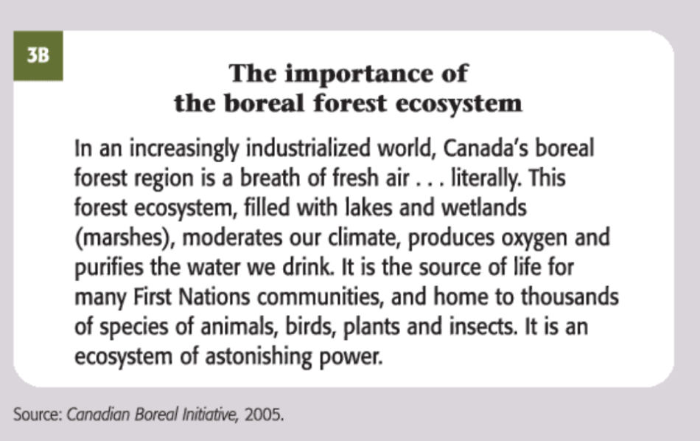

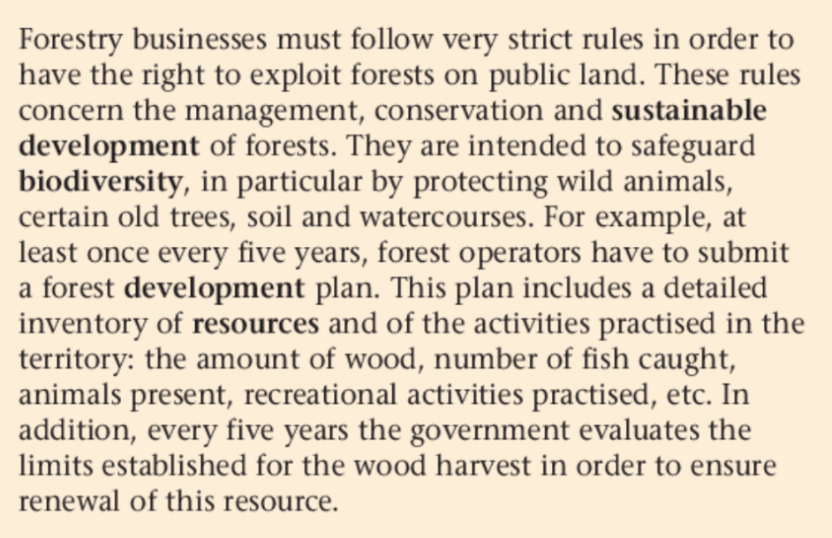
Geography

What are some environmental concerns related to forests and ecosystems?
How can forests be used in manufacturing industries?
What type of forests can be found in North America?
In what ways are governments trying to protect forests?
What are some cultural and social activities related to forests?
Describe forests as a natural habitat.
Forests

