Weekly Educational Options From the Ministère
secondary II
Week of May 25, 2020
Table of Contents
The Great Realisation 2
Appendix: The Great Realisation 3
#Mission FLS : Qu’est-ce qu’on mange? 6
Modes of Representation 7
Appendix A – Questions 1 & 2 9
Appendix B – Answers to Questions 1 & 2 12
The Many Degrees of Science 14
Appendix A – The Many Degrees of Science 16
Appendix B – Answer Key 18
What’s the Dilemma? 20
Urban and Rural Regions 21
Appendix – Urban and Rural Regions 22
Continuity and Change in History 26
Continuity and Change in History 27

English Language Arts

The Great Realisation

Information for students
You are going to look at two versions, video and print, of a poem entitled “The Great Realisation” by Tomos Roberts.
Watch the video first. Scroll down until you find it: http://www.probablytomfoolery.com/
Write down what you think the poem is about.
Now read the print version of the poem, which you can find in the appendix. Reading the poem allows you to slow down so that you can pause and reflect. Make annotations on the text as you read.
Write a short paragraph about you think is the poem’s main idea. The following questions may guide your thinking.
- Why do you think Tomos Roberts wrote the poem?
- Why do you think he chose to share it as a video?
- Did the video make the poem’s impact stronger? Why or why not?
- Did you have a preference?

Materials required
Device with Internet access
Paper, writing and drawing materials

Information for parents
Parents should:
share your own reactions to the print and video version
discuss with your child why you think this video has gone viral

English Language Arts

Appendix: The Great Realisation
The Great Realisation
by Tomos Roberts
“Tell me the one about the virus again, then I’ll go to bed.”
“But, my boy, you’re growing weary, sleepy thoughts about your head.”
“That one’s my favourite. Please, I promise, just once more.”
“Okay, snuggle down, my boy, but I know you all too well.
This story starts before then in a world I once would dwell.”
It was a world of waste and wonder, of poverty and plenty,
Back before we understood why hindsight’s 2020
You see, the people came up with companies to trade across all lands
But they swelled and got much bigger than we ever could have planned
We always had our wants, but now, it got so quick
You could have anything you dreamed of, in a day and with a click
We noticed families had stopped talking, that’s not to say they never spoke
But the meaning must have melted and the work life balance broke
And the children’s eyes grew squarer and every toddler had a phone
They filtered out the imperfections, but amidst the noise, they felt alone.
And every day the skies grew thicker, ‘till you couldn’t see the stars,
So, we flew in planes to find them, while down below we filled our cars.
English Language Arts

We drove around all day in circles, we’d forgotten how to run
We swopped the grass for tarmac, shrunk the parks ‘till there were none
We filled the sea with plastic because our waste was never capped
Until, each day when you went fishing, you’d pull them out already wrapped
And while we drank and smoked and gambled, our leaders taught us why
It’s best to not upset the lobbies, more convenient to die
But then in 2020, a new virus came our way,
The governments reacted and told us all to hide away
But while we were all hidden, amidst the fear and all the while,
The people dusted off their instincts, they remembered how to smile
They started clapping to say thank you and calling up their mums
And while the car keys gathered dust, they would look forward to their runs
And with the skies less full of voyagers, the earth began to breathe
And the beaches bore new wildlife that scuttled off into the seas
Some people started dancing, some were singing, some were baking
We’d grown so used to bad news, but some good news was in the making
And so, when we found the cure and were allowed to go outside,
We all preferred the world we found to the one we’d left behind
Old habits became extinct and they made way for the new
And every simple act of kindness was now given its due.”
“But why did it take us so long to bring the people back together?”
English Language Arts

“Well, sometimes you’ve got to get sick, my boy, before you start feeling better.
Now, lie down and dream of tomorrow and all the things that we can do
And, who knows, if you dream hard enough, maybe some of them will come true
We now call it The Great Realisation and yes, since then, there have been many
But that’s the story of how it started and why hindsight’s 2020.”

French as a Second Language

#Mission FLS : Qu’est-ce qu’on mange?

Information for students
Cette activité t’aidera à accomplir la mission FLS suivante : « Je prépare et j’écris en français la liste d’épicerie avec mes parents ».
Qu’est-ce qu’on mange? Une question que tes parents entendent probablement très souvent! Cette semaine, on t’invite à choisir avec tes parents des recettes et à écrire la liste d’épicerie en français.
Voici comment tu peux le faire :
Discute avec tes parents des repas que vous allez manger cette semaine.
Trouve des recettes et lis la liste les ingrédients.
Vérifie si tu as les ingrédients ou non chez toi.
Écris la liste des ingrédients que tes parents devront acheter à l’épicerie.
Ajoute une petite douceur, une surprise.

Pour aller plus loin
As-tu appris un nouveau mot lié aux aliments? Partage-le sur #MissionFLS.

Materials required
Feuille de papier ou application en ligne telle que Google Keep
Missions FLS

Information for parents
Children should:
learn vocabulary related to food in French
write a shopping list in French
Parents could:
write a shopping list in French with their children

Mathematics

Modes of Representation

Information for students
To move forward in mathematics, you need to be able to use different mathematical representations to represent a situation. By using stories, tables of values, algebraic equations and graphs to create different representations of real-life situations, you develop a more complete understanding of the relationship between these representations.

Instructions
Examine the situation presented in Appendix A, Question #1. You will notice that the situation is presented as a story. Use this information to create these other representations: a table of values, an algebraic equation and a graph.
What connections can you make? Is some information easier to find in some representations than in others?
Think about the meaning of the initial value in the situation, and discuss this with someone if possible. How is it represented in the story, the graph, the table of values and the equation?
Think about the meaning of the rate of change, and discuss this with someone if possible. How is it represented in the story, the graph, the table of values and the equation?
Extension: Try Question #2. In this challenge, you are given an equation and asked to come up with a corresponding story, table of values and graph. Using the blank template found in Appendix A, you can also create your own problem complete with a story, equation, table of values and graph.

Materials required
Writing tools
Calculator, ruler
Appendix A and B

Information for parents

About the activity
Children could:
complete one or both of the questions in Appendix A.
make a note of any questions, challenges and successes they might want to discuss with their parents or teachers.
create their own problem with the four different representations. They could discuss it with their teacher or a peer to get feedback.
if they wish, students can use the interactive site Desmos at https://www.desmos.com/calculator to check their solutions.
Parents should:
help their child organize the necessary materials, if needed.
read the instructions together with their child and, if needed, help them create the different representations.
encourage their child to discuss the representations they found easiest or hardest to complete.
encourage them to seek help or feedback from their teacher or their peers for any representations they found difficult to create.
discuss the problems together with their child and/or ask their child to describe how they determined the answers to the questions. A possible answer is found in Appendix B.

Mathematics

Appendix A – Questions 1 & 2

Information for students
Here are questions 1 and 2. There is also a blank template if you want to create your own question to challenge a peer. You can print these pages or do the work on a piece of paper.

Question 1
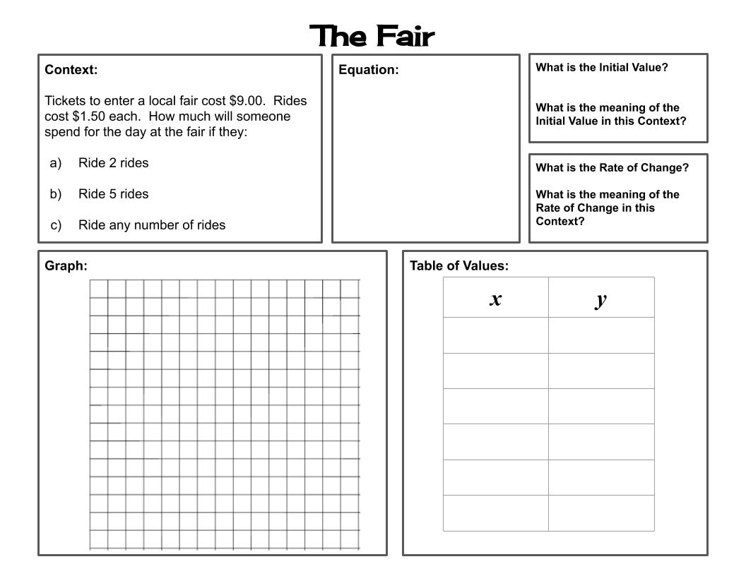
Mathematics

Question 2
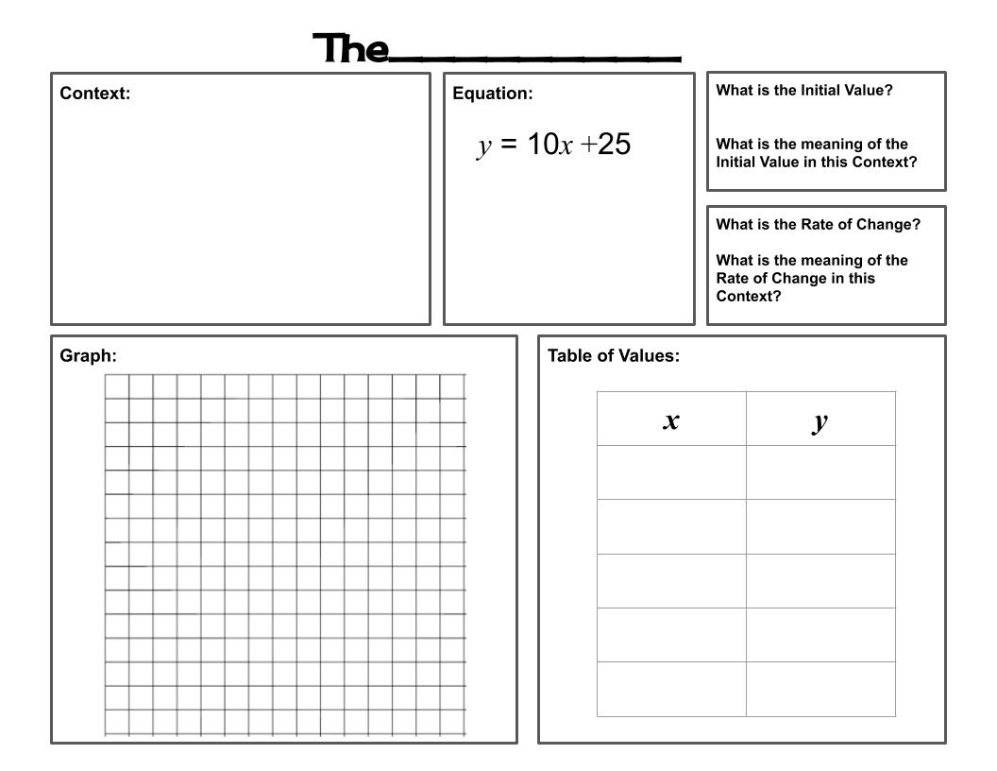
Mathematics

Blank Template
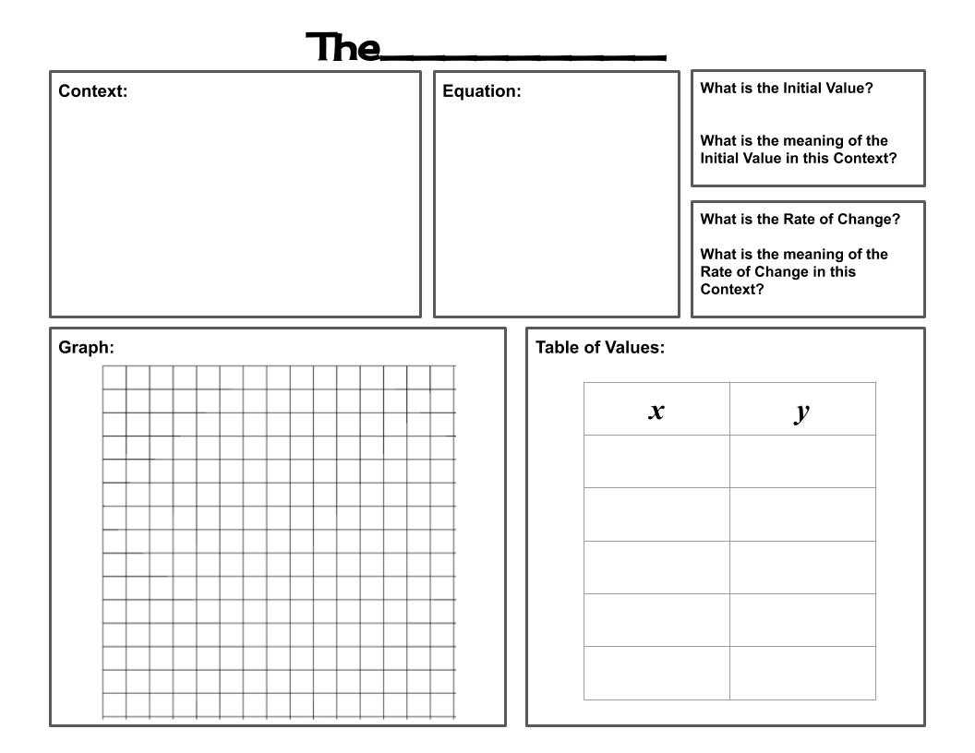
Mathematics

Appendix B – Answers to Questions 1 & 2

Question 1: Possible Answer
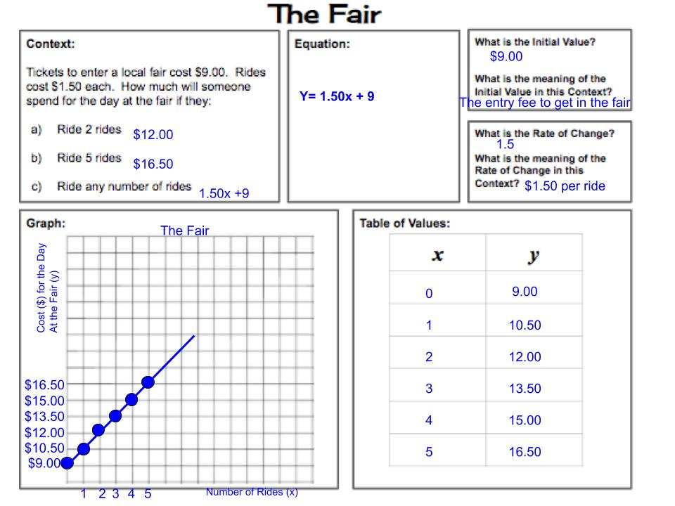
Mathematics

Question 2: Possible Answer. The story will vary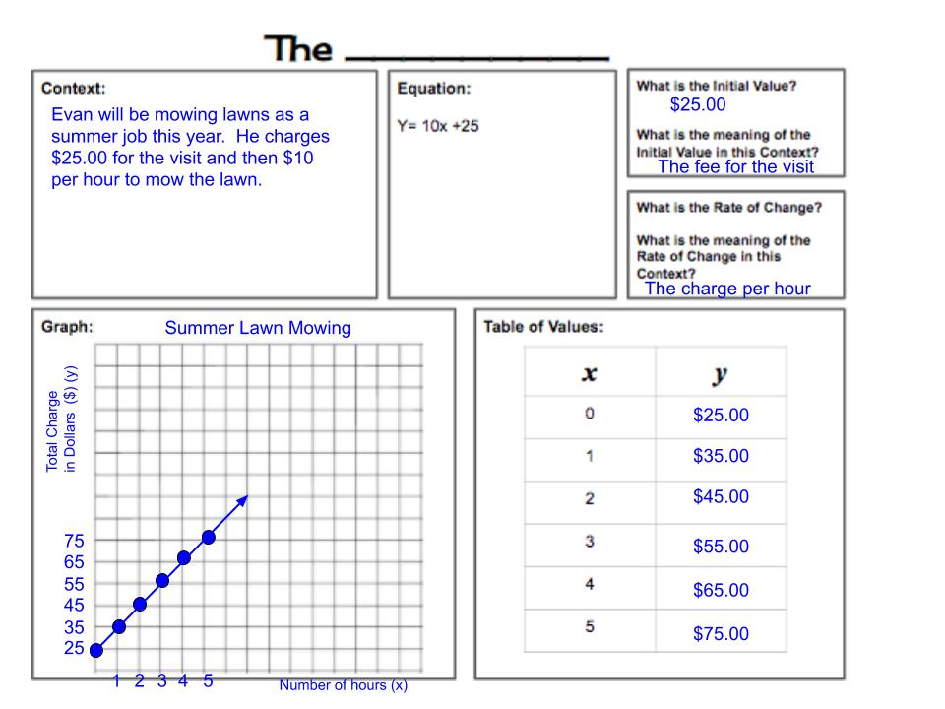

Science and Technology

The Many Degrees of Science

Information for students
Liquid-filled thermometers have been used for centuries to measure temperature. Different liquids can fill the reservoir of a thermometer. But how do thermometers work?
This week, we will make a simple thermometer using rubbing alcohol, water, and some household items, and explore how thermometers work.
Instructions on how to build your thermometer as well as some extension questions can be found in Appendix A.

Materials required
1 plastic water bottle (empty)
1 clear plastic straw
Modelling clay (e.g. plasticine, playdough or fun-tak)
Ruler
Marker (waterproof is preferable)
Heat-resistant mitts
Kettle (or pot) to heat water (you may also use a microwave)
Water
Ice cubes
Rubbing alcohol
Food colouring (any colour)

Science and Technology

Information for parents

About the activity
Children should:
work in a well-ventilated room and remember to put the cap back on the bottle of rubbing alcohol when it is not being used
use heat-resistant mitts
dispose of the solution in the thermometer by pouring it down the sink while using plenty of running water to flush any remaining alcohol out of the drain pipe
Parents could:
go over the safety rules with their children before they start the activity
review the examples of appropriate answers found in Appendix B with their children

Science & Technology

Appendix A – The Many Degrees of Science

Part A: Building a Water-bottle Thermometer
- Measure out equal portions (approximately 45 mL each or a little less than a ¼ cup) of water and rubbing alcohol. Fill the water bottle ¼ of the way up.
- Make sure to put the cap back on the bottle of rubbing alcohol after use.
- Add a few drops of food colouring to the solution in the water bottle. Swirl the liquids in the bottle to mix them well.
What does the addition of food colouring enable you to do?
- Using a ruler and waterproof marker, make small marks on the straw at ½ cm intervals.
- Insert the straw into the water bottle. It must not touch the bottom of the bottle.
- Seal the top of the bottle with the modelling clay so that it is airtight.
- Make sure the straw is securely in place
- Make sure that the end of the straw in the bottle is immersed in the solution, but does not touch the bottom of the bottle.
- Do not seal the opening of the straw.
- Mark the level of the liquid on the straw.
What does this “mark” indicate?
Now, we are ready to test the water-bottle thermometer.
- Using a kettle, heat 2 cups of water. Pour warm water into a pitcher that is large enough to hold your water-bottle thermometer.
- Be careful when handling the hot pitcher. Use heat-resistant mitts to work safely.
- Predict what will happen to the fluid inside the straw.
- Place the water-bottle thermometer into the pitcher. Wait approximately 20 seconds. Observe.
Using scientific concepts and terms, explain what happened.
- Add 2 cups of cold water and 3 or 4 ice cubes to another pitcher. Let it rest 3 – 4 minutes.
- Predict what will happen to the fluid inside the straw.
- Place the water-bottle thermometer into the pitcher. Wait approximately 20 seconds. Observe.
Using scientific concepts and terms, explain what happened.
Science & Technology

Part B: Building a Water-bottle Thermometer

Extension Activities/Questions
- How would you go about “scaling” a thermometer? (Hint: Characteristic properties)
- Take your thermometer on a tour of your home or yard. Remember to give the thermometer time to respond to each new environment.
- How did you collect your data? Did you use a data table? Graph?
- Which areas are warmer? Which areas are the coolest?
- How could you get a more accurate reading?
Science & Technology

Appendix B – Answer Key

Answers to This Week’s Activity
Part A – Building a Water-bottle Thermometer
Step 2 – What does the addition of food colouring enable you to do?
Adding food colouring makes it easier for you to read the thermometer and to observe how the fluid level moves up or down. Although the thermometer would work without the food colouring, it might make it more difficult for you to see the fluid level.

Step 9 & 12 – Using scientific concepts and terms, explain what happened.
The ability of matter to change volume as a result of a temperature change is called "Thermal Expansion and Contraction”.
Gases can expand and contract significantly.
Liquids do not expand and contract as much.
Solids also change volume when they are heated or chilled. However, the change is so small that it cannot be measured using an everyday thermometer.

Step 9
When the water-bottle thermometer is placed in the pitcher with the hot water, the heat energy from the hot water is transmitted to the fluid inside the thermometer. As the temperature of the fluid in the reservoir increases, the fluid expands, and the only place for it to go is up the narrow tube.
Step 12
When the water-bottle thermometer is placed in the pitcher with the ice cubes, the heat energy from the fluid inside the thermometer is transmitted to the pitcher with the ice-cubes. Since the temperature of the fluid decreases, it contracts, thereby allowing more fluid to collect in the reservoir. The level in the narrow tube then falls to a lower level.

Step 6 – What does this “mark” indicate?
The mark to which the fluid level rises right after the thermometer is built indicates room temperature. Each mark on the straw (or any narrow tube) corresponds to a specific volume of fluid, and therefore, to a specific temperature. This allows you to gauge to which degree the temperature is changing.

Science & Technology
Part B – Extension Activities/Questions
Question 1
An easy way to provide a rudimentary scale to a thermometer is to use the information we have about characteristic properties. For example, we know that the boiling point of water is 100°C and that the freezing point of water is 0°C. We can therefore experiment with water at different “temperatures” and mark off our straws to indicate those temperatures. Then, we can mark off regular intervals between O°C and 100°C.

Question 3
A narrower tube results in a more accurate thermometer because the same expansion or contraction of fluid will cause a rise or fall over a longer distance.

Question 2
Various data values could be collected. A great way to present data in an orderly fashion, so that one can identify whether a pattern exists, is by placing the data in a table and then graphing it. Draw a bar graph, line graph, or pie chart to see if one provides more information than the others.

Ethics and Religious Culture

What’s the Dilemma?

Information for students
We see ethical dilemmas in movies and in everyday life: taking credit for someone else’s work, buying something and selling it for more, telling someone to do one thing and doing the opposite yourself, and many others.
Think of an ethical dilemma you have heard or seen.
Use the graphic organizer from Brain Pop to find a solution to the dilemma.

Materials required
Device with Internet access
Printer (if available)
Paper
Writing tool

Information for parents

About the activity
Students could:
Ask you what an ethical dilemma is
Need help finding solutions
Work independently
Parents should:
Discuss ethical dilemmas
Help the student understand how a solution could be possible
Give real-life examples

Geography

Urban and Rural Regions

Information for students
Geography is not just about maps. It is also about exploring the differences between rural and urban areas and the resources and industries that can be found there. Try to take note of the similarities and differences between regions as you do this task.

Instructions
Look at the map provided in the Appendix and think about the different regions and locations.
Read the description of urban and regional territories in the “Types of territories” document in the Appendix.
Choose ONE of the locations from the map and think about some of the concepts you’ve discussed in class, such as industries, tourism, sources of energy, natural resources and transportation.
In the chart, give an example that relates to your chosen location for each of the concepts mentioned above. An example has been provided to help you organize your ideas.
Read the information on your chosen location in the Appendix to help you complete the chart, or do some research on your own.

Materials required
Useful resources, depending on personal preferences and availability:
Device with Internet access
Writing materials (paper, pencil, etc.)

Information for parents
students could:
- research different regions that interest them and compare the differences and similarities
Parents should:
- help their child think about how natural resources are often linked to industries and the differences and similarities between regions

Geography

Appendix – Urban and Rural Regions
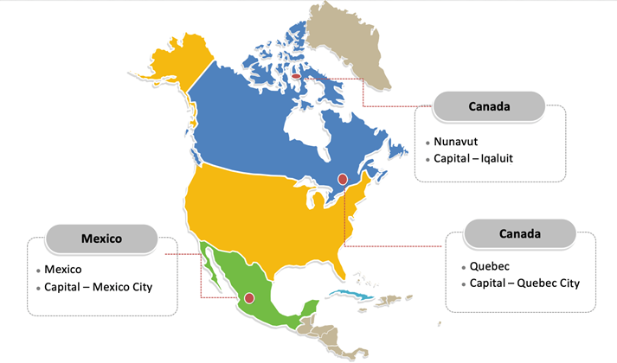

Geography

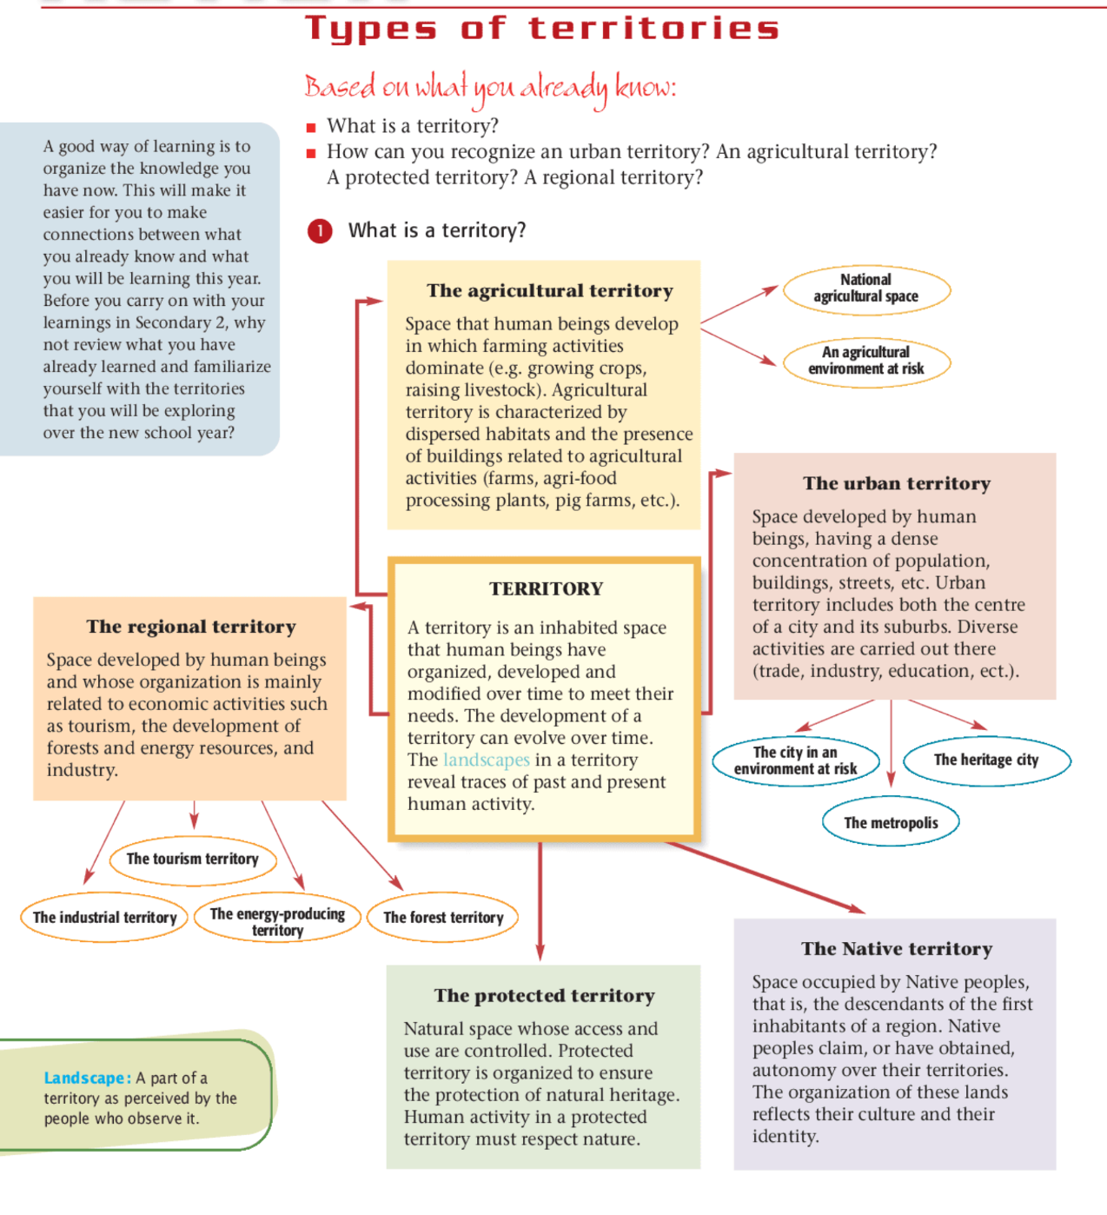
Source: Nathalie Boudrias, Danielle Marcheterre, and Mélanie Langlais, Issues and Territories, Geography, Secondary Cycle One (Montréal: Chenelière Éducation, 2006), Textbook B, 10.

Geography

Concepts | Cavendish, PEI (example) | (Your chosen location)
Urban or rural | Rural
Agricultural or industrial | Agricultural – potato farming
Transportation networks | Roads, bridges, buses, boats
Industries | Tourism, potato farming, fisheries
Sources of energy | Wind energy and solar power
Natural resources | Rich soil for agriculture, forestry, fisheries

Geography

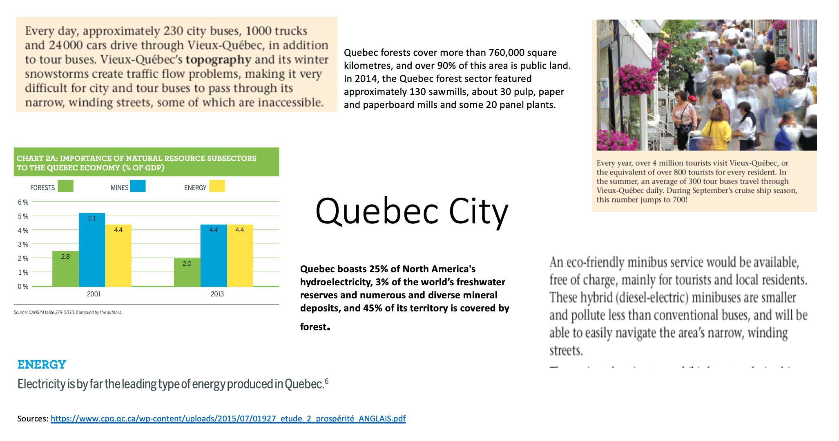
The following information is from the textbook Issues and Territories and other sources.
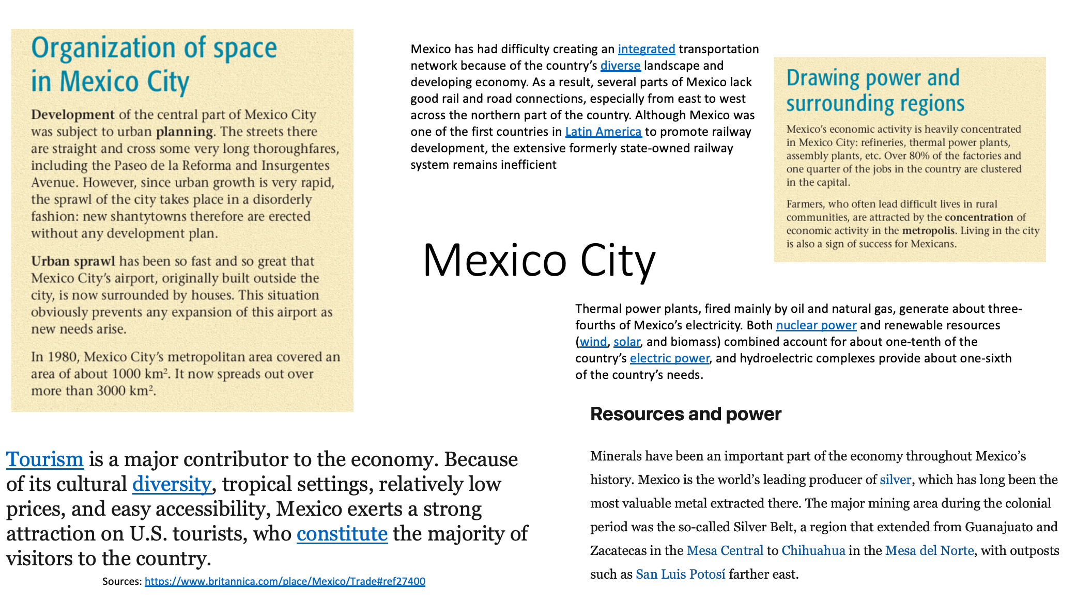
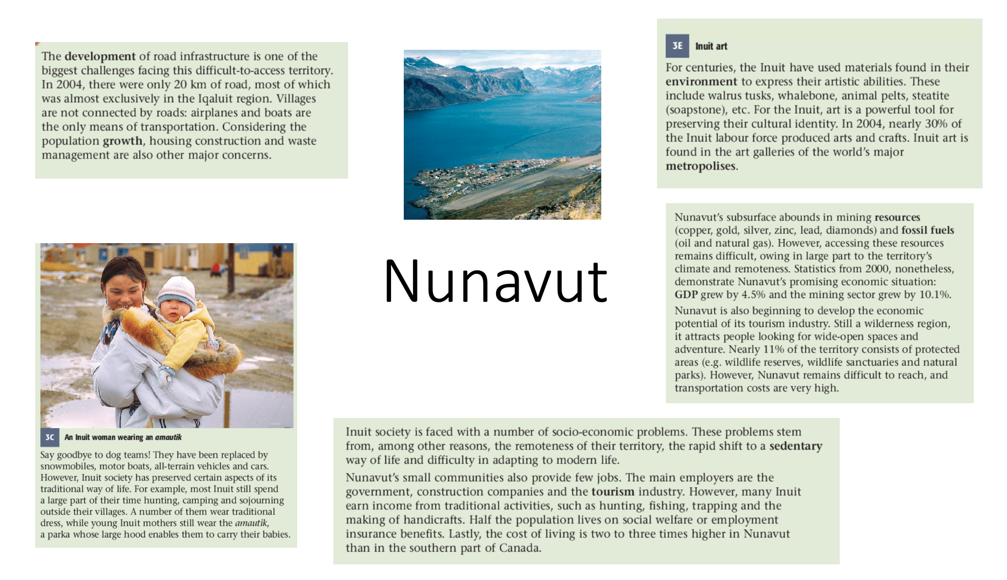

History and Citizenship

Continuity and Change in History

Information for students
An important skill to develop in History class is the ability to make comparisons between the past and the present. It is important to be able to recognize what has remained the same, or continued, and what has changed (continuity and change). In this task, you will look at elements of continuity and change.

Instructions
Read the excerpts in the Appendix and determine what elements still remain in today’s society and what elements have changed. You can also use your textbook From Yesterday to Tomorrow (pages 160-165).
A chart has been provided to help you to organize your ideas and to think about various elements and concepts such as laws, industries, individual rights and transportation.

Materials required
Useful resources, depending on personal preferences and availability:
Device with Internet access
Writing materials (paper, pencil, etc.)
Textbook

Information for parents
Students could:
choose any time or place in history to compare and identify elements of continuity and change
Parents should:
help their child recognize elements that still remain in today’s society

History and Citizenship

Continuity and Change in History

Information for students
Chart to help you organize your ideas:
Elements and concepts | Continues today | What has changed
Laws
Industries
Individual rights
Transportation

History and Citizenship
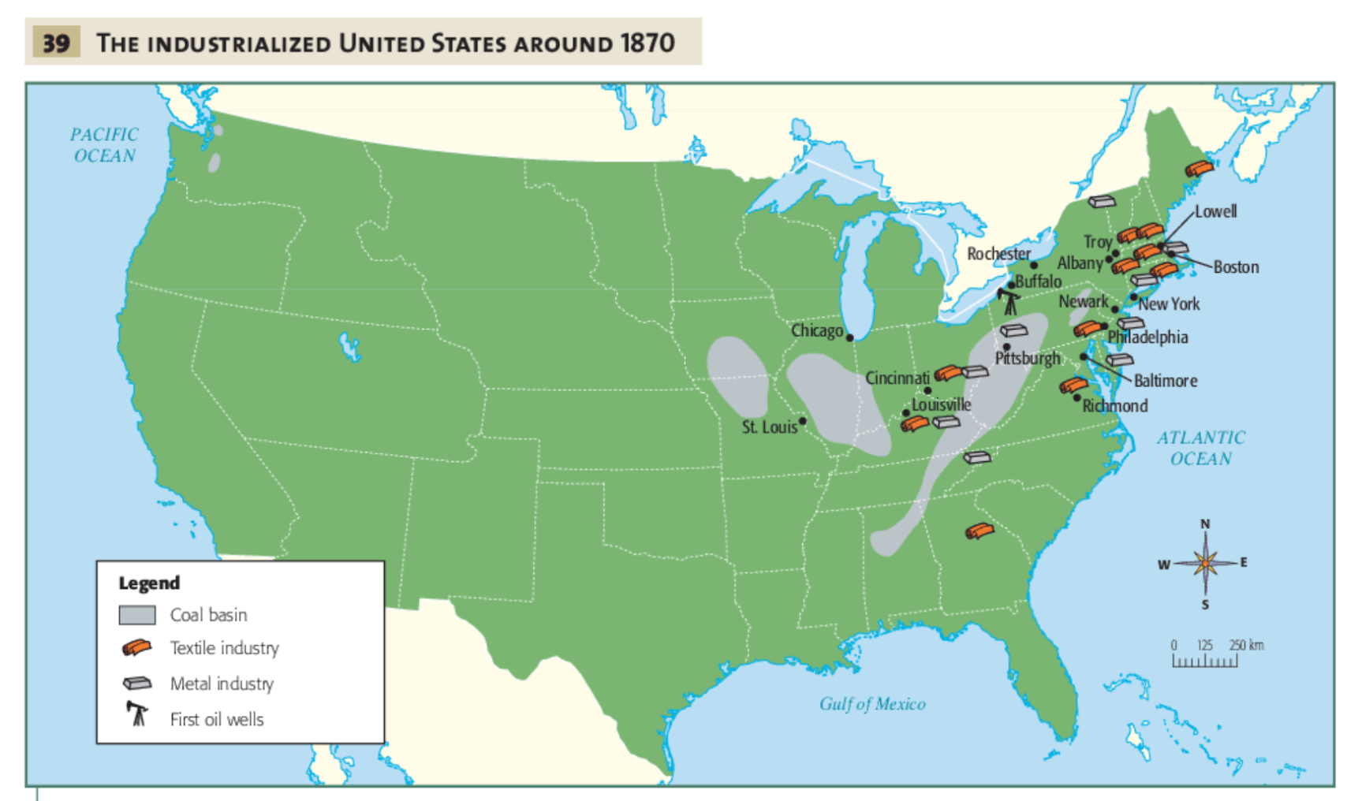
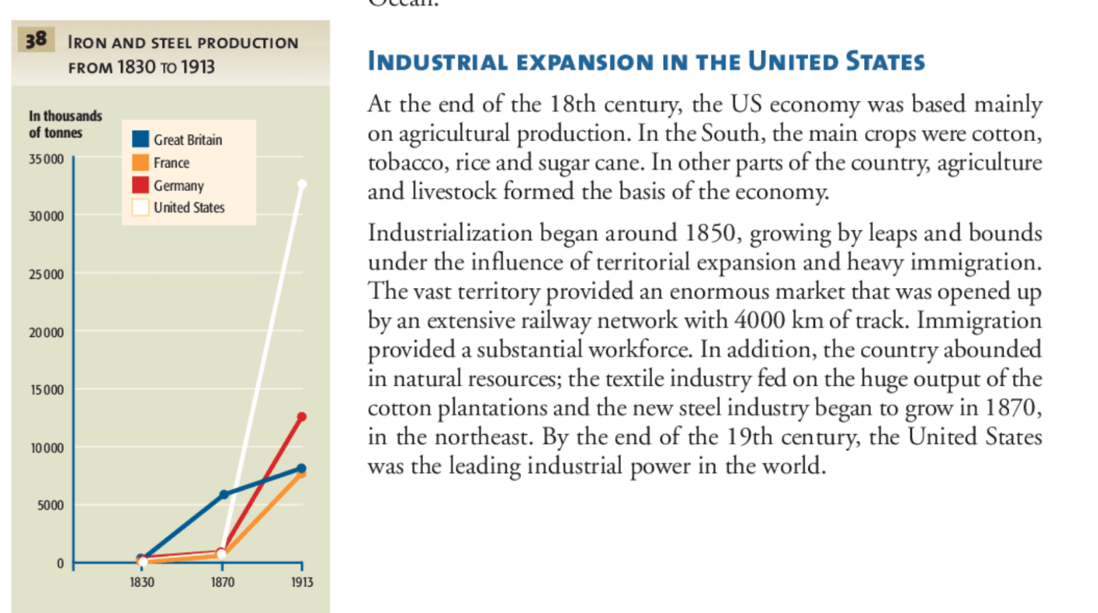
History and Citizenship
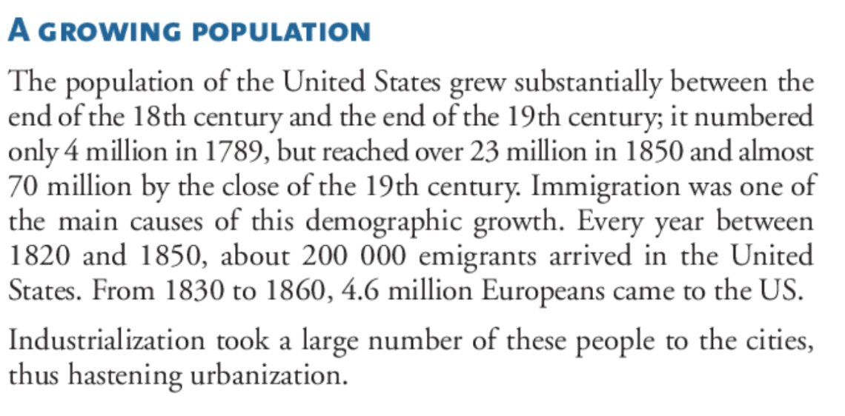
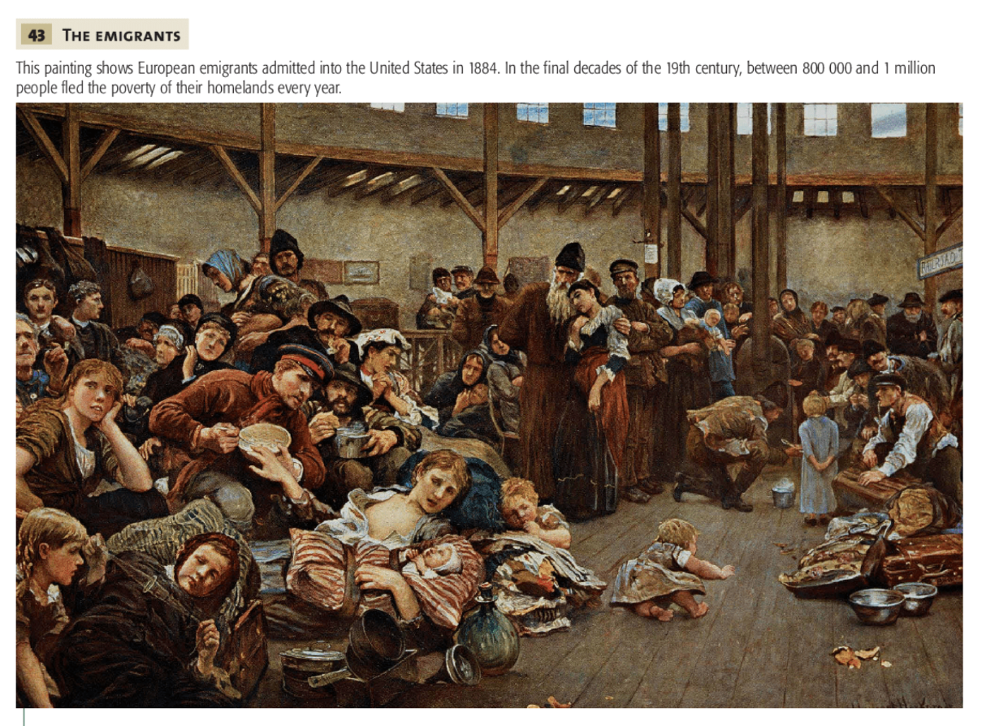
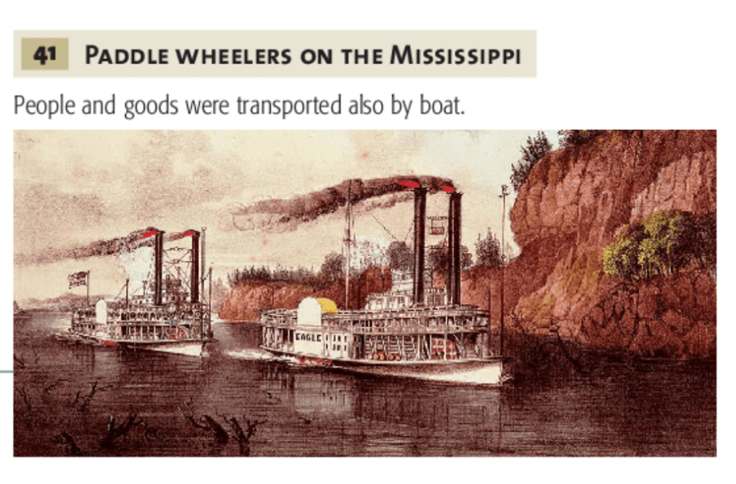
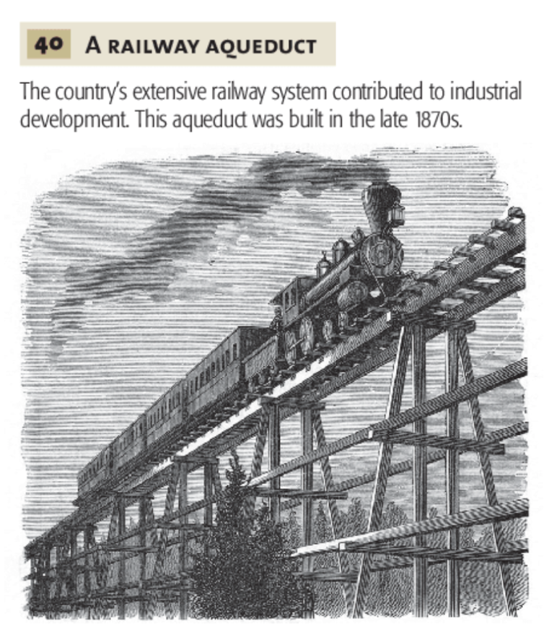
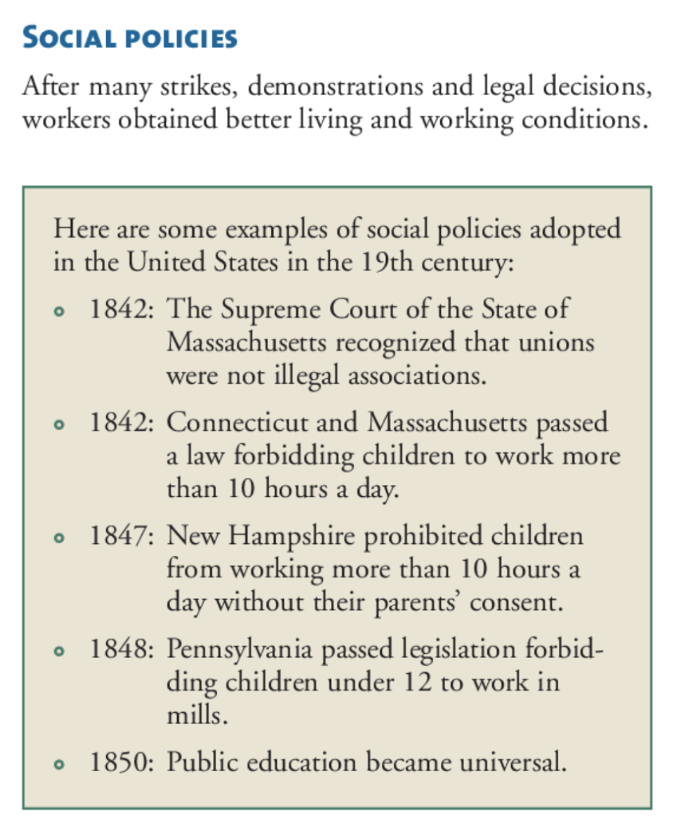
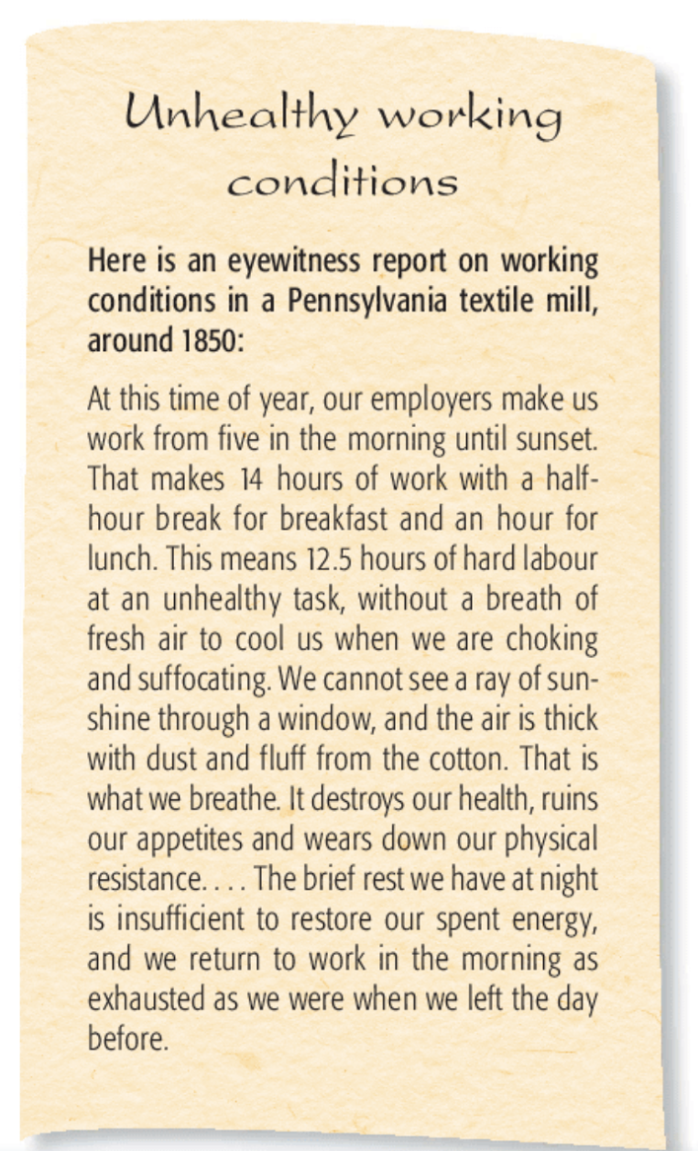
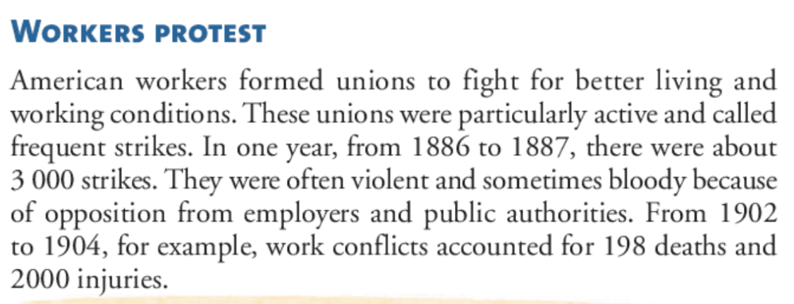
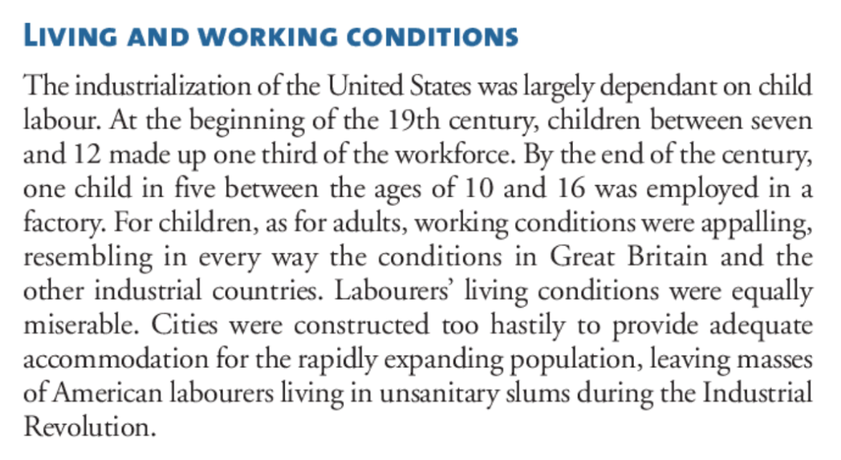
Source: Christian Laville, From Yesterday to Tomorrow, History and Citizenship Education, Secondary Cycle One (Montréal: Chenelière Éducation, 2008), Textbook B, 160-165.

Adapted from “Measure Up with a Homemade Thermometer,” Science Buddies, n.d. https://www.sciencebuddies.org/stem-activities/homemade-thermometer#summary

