Weekly Educational Options From the Ministère
secondary I
Week of May 25, 2020
Table of Contents
Take a Stance 2
Appendix: Take a Stance 3
Mots mêlés 4
Annexe: Mots mêlés 5
The Gate Escape 6
Appendix A – The Gate Escape 7
Appendix B – The Answer Key 9
Levels of Organization 10
Appendix – Grow a Plant from a Seed 12
Urban and Rural Regions 13
Appendix – Urban and Rural Regions 14
Continuity and Change in History 18
Appendix - Continuity and Change in History 19

English Language Arts

Take a Stance

Information for students
This activity is all about forming an opinion.
Instructions
- Watch the following video that shows some teens talking about being digitally connected: https://safeyoutube.net/w/O4PF
- Think about how being digitally connected affects your life
- How does being connected improve your life? Does being connected also have some negatives?
- Take a stance and formulate an argument to either support or argue against the following statement: Social media improves the lives of teenagers in Canada
- Can you find reliable information (research) to support your view?
- Watch this short video to get some tips on finding out if what you read online is true or false: https://safeyoutube.net/w/0APF
- Write a short argument that supports your view (a page or two.) Refer to some reliable sources to back up what you say

Materials required
Internet connection
Writing materials

Information for parents

About the activity
Students are asked to watch two videos that pertain to how teens interact with and are affected by the digital world. The first video presents perspectives on whether or not social media improves the quality of teen’s lives. The second video helps students evaluate the reliability of the news they receive online.
Parents could:
- ask the student to share their view on this issue
- listen to the student’s perspective and ask questions about it. Can the student support their view with evidence that goes beyond their personal experience? This is a complex issue, and talking about it, and the evidence and research around it, is necessary for both teens and parents

English Language Arts

Appendix: Take a Stance

Information for students
Evaluating if online material is true and reliable is important. Here are a few sites that can teach you how to do this and a few sites that are dedicated to revealing what’s true and not so true.
This site will give you some great tips on how to evaluate a website:
https://firstdraftnews.org/latest/verifying-online-information-the-absolute-essentials/
This site provides you with some reliable sources of trustworthy news—great go-to sites for honest reporting: https://www.commonsense.org/education/top-picks/most-reliable-and-credible-sources-for-students
These two sites are dedicated to checking facts and online stories:
https://www.snopes.com/
https://www.politifact.com/

French as a Second Language

Mots mêlés

Information for students
Trouvez et encerclez les 16 mots dans la grille qui se trouve dans l’annexe
Corrigez les 16 mots en ajoutant les accents nécessaires (les accents ont été enlevés)
Composez une définition simple et compréhensible pour chacun des 16 mots
Choisissez 10 mots qui ne vous sont pas familiers
Pour chacun des 10 mots, composez une phrase en y insérant le nouveau mot
Vérifiez l’orthographe de votre phrase avec l’aide du dictionnaire en ligne USITO

Materials required
Appareil avec accès à Internet
https://usito.usherbrooke.ca/ (dictionnaire en ligne Usito)
Imprimante
Papier, matériel pour écrire
Information for parents
Children should:
find the 16 words in the grid
add the accents where needed
write a French definition of the 16 words
compose 10 sentences
Parents could:
print the appendix
help their children navigate the Usito online dictionary
correct the 10 sentences

French as a Second Language

Annexe: Mots mêlés
Voir les instructions sur la page précédente.
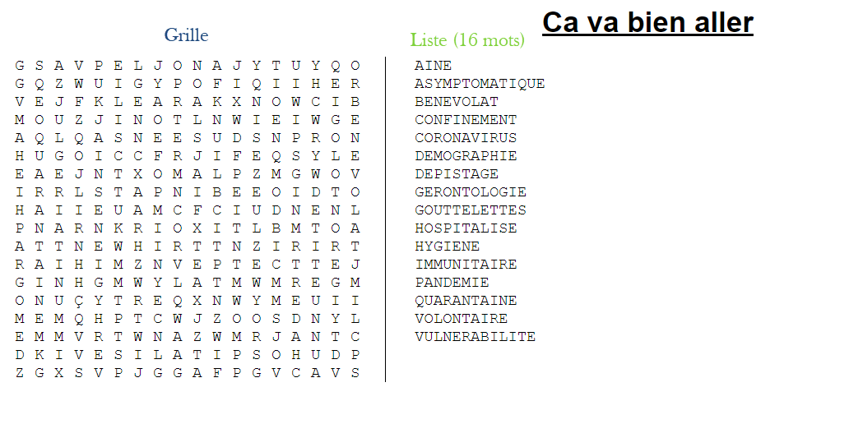

Mathematics

The Gate Escape

Information for students
Have fun trying to escape captivity by solving your way through The Gate Escape!
Instructions
- Before you start, you may want to review the procedures for the order of operations involving square roots and integers. Here are a few videos to help refresh your memory: https://www.youtube.com/watch?v=ClYdw4d4OmA&t=220s https://www.youtube.com/watch?v=gjrGd9TjjnY
- Follow the directions in Appendix A carefully in order to execute your escape

Materials required
Pencil and paper

Information for parents

About the activity
Students will try to escape captivity by first solving an order of operations riddle to get past the gatekeeper and then solving another set of problems to get through the chamber doors to retrieve the three-number combination that will unlock the gate and set them free. Given arithmetic operations involving integers, exponents and square roots, students will practice carrying them out in the correct order.
Children should:
review the procedures for the order of operations involving integers, square roots and exponents
Parents could:
help them review these procedures (see videos above)

Mathematics

Appendix A – The Gate Escape

Information for students
You are being held captive against your will. To escape, you must first solve the riddle to get past the gatekeeper. Then you must open the combination lock on the gate by finding the three-number combination.
Solve the following order of operation expressions to reveal the message that will get you past the gatekeeper. Some letters may be used more than once
T | $-4+5-2$ | = | H | $$8-5×4^{2}$$ | =
U | $$7-8×2$$ | = | A | $(10÷(-5)-(-2))×(-3)$³ | =
B | $6×5+(-4)$² | = | G | $5-(-4)×(-3)$² | =
E | $$-5×(7-4+2^{3})$$ | = | O | $$4×-6÷8+27$$ | =
I | $$10×-5+36$$ | = | Y | $$-27-2+8÷(-8)$$ | =
S | $$-7×-4+2^{3}$$ | = | R | $$10×5-36-8$$ | =
W | $3×(9+\left(-8\right))$² | = | D | $$8-16+3×10$$ | =
_____ _____ _____ _____ _____ _____ _____ _____ _____ _____
$-1$ $-72$ $-55$ $46$ $-55$ $36$ $-1$ $3$ $0$ $-30$
_____ _____ _____ _____ _____
$24$ $-9$ $-1$ $-14$ $36$
_____ _____ _____ _____ _____ _____ _____ _____ _____ _____
$-1$ $-72$ $6$ $24$ $-9$ $41$ $-72$ $-1$ $-72$ $-55$
_____ _____ _____ _____
$22$ $24$ $24$ $6$
Congratulations, you made it past the gatekeeper! Now you must retrieve the three combination numbers to unlock the gate that will set you free. To do so, you must solve the content of each of the following chambers to unlock their door.

Mathematics
Get through doors A, B and C to retrieve the FIRST combination number:
Door A  Solve the following order of operation expression:  $$\left(-17+25\right)÷2$$  $=\boxed{}$ | Door B  Use the answer from A to solve the following order of operation expression:  $$\sqrt{\left(-6+42\right)}× \boxed{}$$  $=$ _______ | Door C  $\frac{1}{8}$ of the answer to question B is the side measure of a regular octoagon. What is the perimeter of this polygon?  ______ cm | 1st Number  to the combination lock is:  The sum of the digits in the answer to question C squared.
Get through doors D, E and F to retrieve the SECOND combination number:
2nd Number
to the combination lock is:

The sum of D, E and F.

Get through doors G, H and I to retrieve the THIRD combination number:
Door G - Solve:  Yesterday, you had $47 saved and were paid $12.50/h for 7 hours of work. You spent $110.50. How much was left?  $_________ was left after 7 hrs. of work. | Door H - Solve:  Today, you will need to spend $99. Based on the amount you had left yesterday, how many hours will you need to work to break even?  I will need to work ___ hrs. | Door I - Solve:  Tomorrow, you will need to spend only $62 and believe you can work one hour less than today. Will it be enough?  Yes, __hrs. are enough.  No, __hrs. are needed. | 3rd Number  to the combination lock is:  The total number of hours you must work over the three days.

Breakout combination numbers are: $-2$
*You will know that the combination numbers are correct if the difference of the three numbers is$-23$.
If not, return and trace back your steps until you have the correct combination numbers.

Mathematics

Appendix B – The Answer Key
T | $-4+5-2$ | = -1 | H | $$8-5×4^{2}$$ | = -72
U | $$7-8×2$$ | = -9 | A | $(10÷(-5)-(-2))×(-3)$³ | = 0
B | $6×5+(-4)$² | = 46 | G | $5-(-4)×(-3)$² | = 41
E | $$-5×(7-4+2^{3})$$ | = -55 | O | $$4×-6÷8+27$$ | = 24
I | $$10×-5+36$$ | = -14 | Y | $$-27-2+8÷(-8)$$ | = -30
S | $$-7×-4+2^{3}$$ | = 36 | R | $$10×5-36-8$$ | = 6
W | $3×(9+\left(-8\right))$² | = 3 | D | $$8-16+3×10$$ | = 22
Riddle: THE BEST WAY OUT IS THROUGH THE DOOR
Door A:  Solve the following order of operation expression:  $$\left(-17+25\right)÷2$$  $=$ 4 | Door B:  Use the answer from A to solve the following order of operation expression:  $\sqrt{-6+42}$ $×$  $=$ 24 |  |  |  | Door C:  $\frac{1}{8}$ of the answer to question B is the side measure of a regular octoagon. What is the perimeter of this polygon? 24 cm |  | 1st Number to the combination lock is:  The sum of the digits in the answer to question C squared.  36
2nd Number
to the
combination
lock is:

The sum of D, E and F.

41
Door G:  Yesterday, you had $47 saved and were paid $12.50/h for 7 hours of work. You spent $110.50. How much was left?  $24 | Door H:  Today, you will need to spend $99. Based on the amount you had left yesterday, how many hours will you need to work to break even?  6 hrs |  |  | Door I:  Tomorrow, you will need to spend only $62 and believe you can work one hour less than today. Will it be enough?  5 hrs x 12.5= $62.50 |  |  |  | 3rd Number to the combination lock is:  The total number of hours you must work over the three days.  18 (7+6+5)

Science and Technology

Levels of Organization

Information for students
Plants are made up of many parts, as are human beings and animals. Plants have parts such as roots, stems, leaves and flowers. Human beings have cells, tissues, organs and systems. The difference is that plants are made up of only two systems: the shoot system and the root system.
Let us see how cells form in organisms such as plants and animals. You can access the free video From the cell to the organism on the eduMedia website to learn more about the Organism level, System level, Organ level, Tissue level and Cell level of organisms.
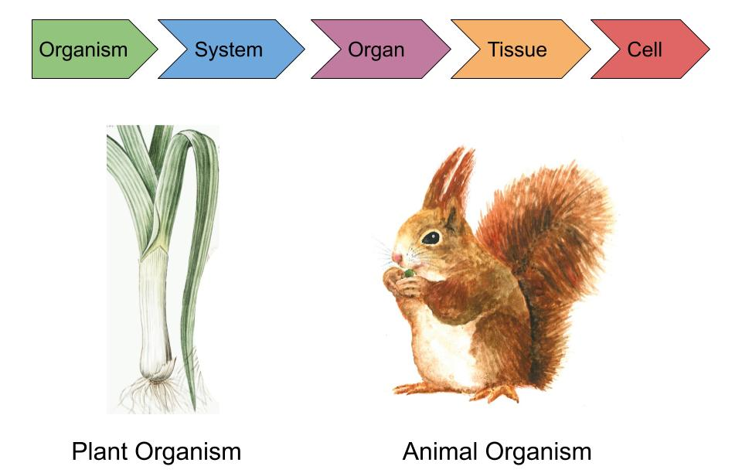
Organism → Systems to organism: A plant is made up of the shoot system and the root system, which work together.
System → Organs to system: The shoot system of a plant is formed when the organs (leaves, stems, flowers and fruits) work together. The root system of a plant is formed when the organs (root hairs and roots) work together.
Organ → Tissues to organ: An organ, such as the stem, is made up of different tissues. Organs, such as root hairs, are made up of root hair tissues.
Tissue → Cells to tissue: Xylem and phloem cells group together to form stem tissue. Root cells group together to form root tissue.
Cell → Xylem and root cell

Materials required
Appendix A: Grow a plant from a seed (optional)

Science and Technology

Information for parents

About the activity
Children should:
try planting some seeds to observe how a seed grows to form the different parts of a plant
Parents could:
try to encourage their children to grow a plant as a hands-on experiment, which can allow them to understand the Living World from a scientific perspective

Science and Technology

Appendix – Grow a Plant from a Seed

Information for students
You may wish to grow your own plant (for example, from a sunflower seed). It is fun and easy! Then, you can observe how much it grows every day.
Instructions on how to grow a plant from a seed:
- plant your seed in a recycled pot, or plant it outdoors in a garden
- every day, observe how the seed (organ) slowly grows into a plant (organism)
- remember to water it every day, or when you notice that the soil is getting dry

Geography

Urban and Rural Regions

Information for students
Geography is not just about maps. It is also about exploring the differences between rural and urban areas and the resources and industries that can be found there. Try and take note of the similarities and differences between regions as you perform this task.
Instructions
- Look at the map provided the Appendix and think about the different regions and locations
- Read the description of urban and regional territories in the Types of territories document in the Appendix
- Select ONE of these locations from the map and think about some of the concepts you’ve discussed in class, such as industries, tourism, sources of energy, natural resources, and transportation
- Identify an example for each of the concepts above for your chosen location. A chart with an example has been attached to help you organize your ideas
- Read the information on your chosen location in the Appendix to help you complete the chart or you can research on your own!

Materials required
Useful resources, depending on personal preferences and availability:
Device with Internet access
Writing materials (paper, pencil, etc.)

Information for parents

About the activity
Children could:
research different regions that interest them and compare the differences and similarities
Parents should:
help their child think about how natural resources are often linked to industries and the differences and similarities between regions

Geography

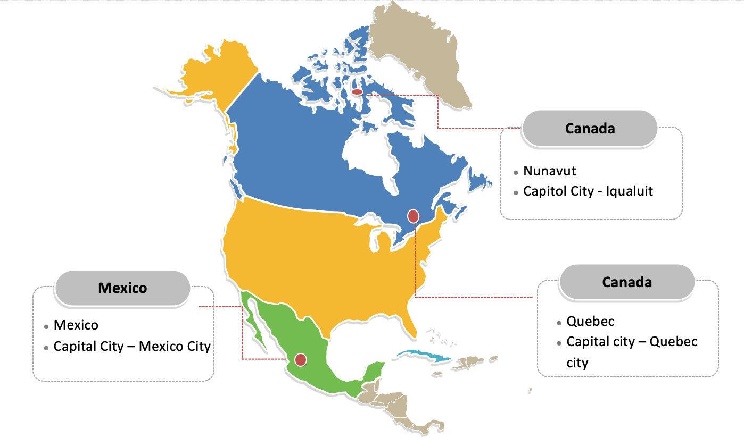
Appendix – Urban and Rural Regions

Geography
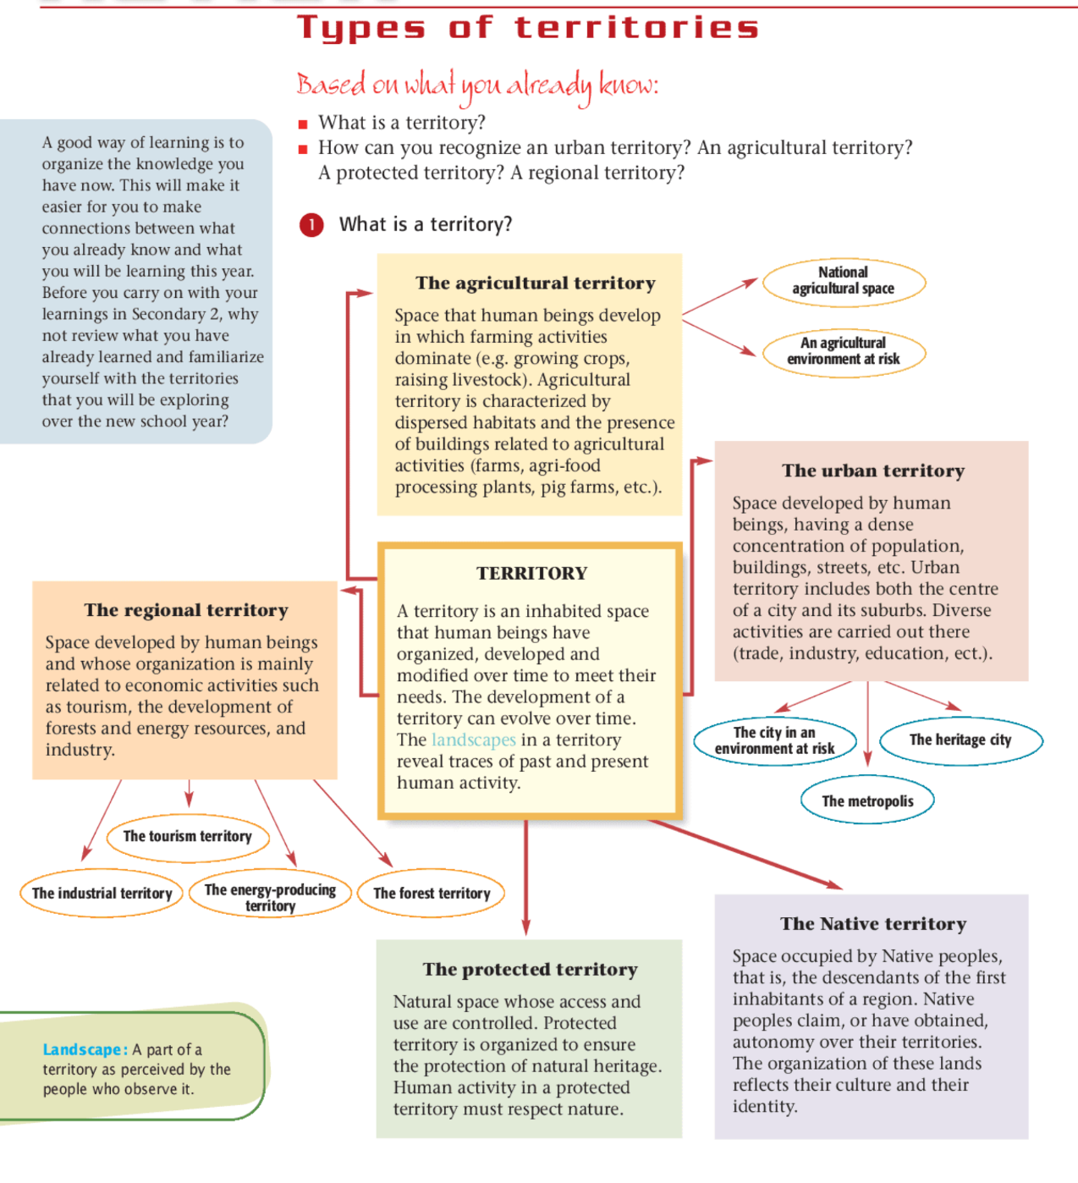Source: Issues & Territories page 10

Geography
Concepts | Cavendish, PEI (example) | (your selected location)
Urban or Rural | Rural
Agricultural, or industrial | Agricultural – potato farming
Transportation Networks | Roads, bridges, buses, boats
Industries | Tourism, potato farming, fisheries
Sources of energy | Wind energy and solar power
Natural Resources | Rich soil for agriculture, forestry, fisheries
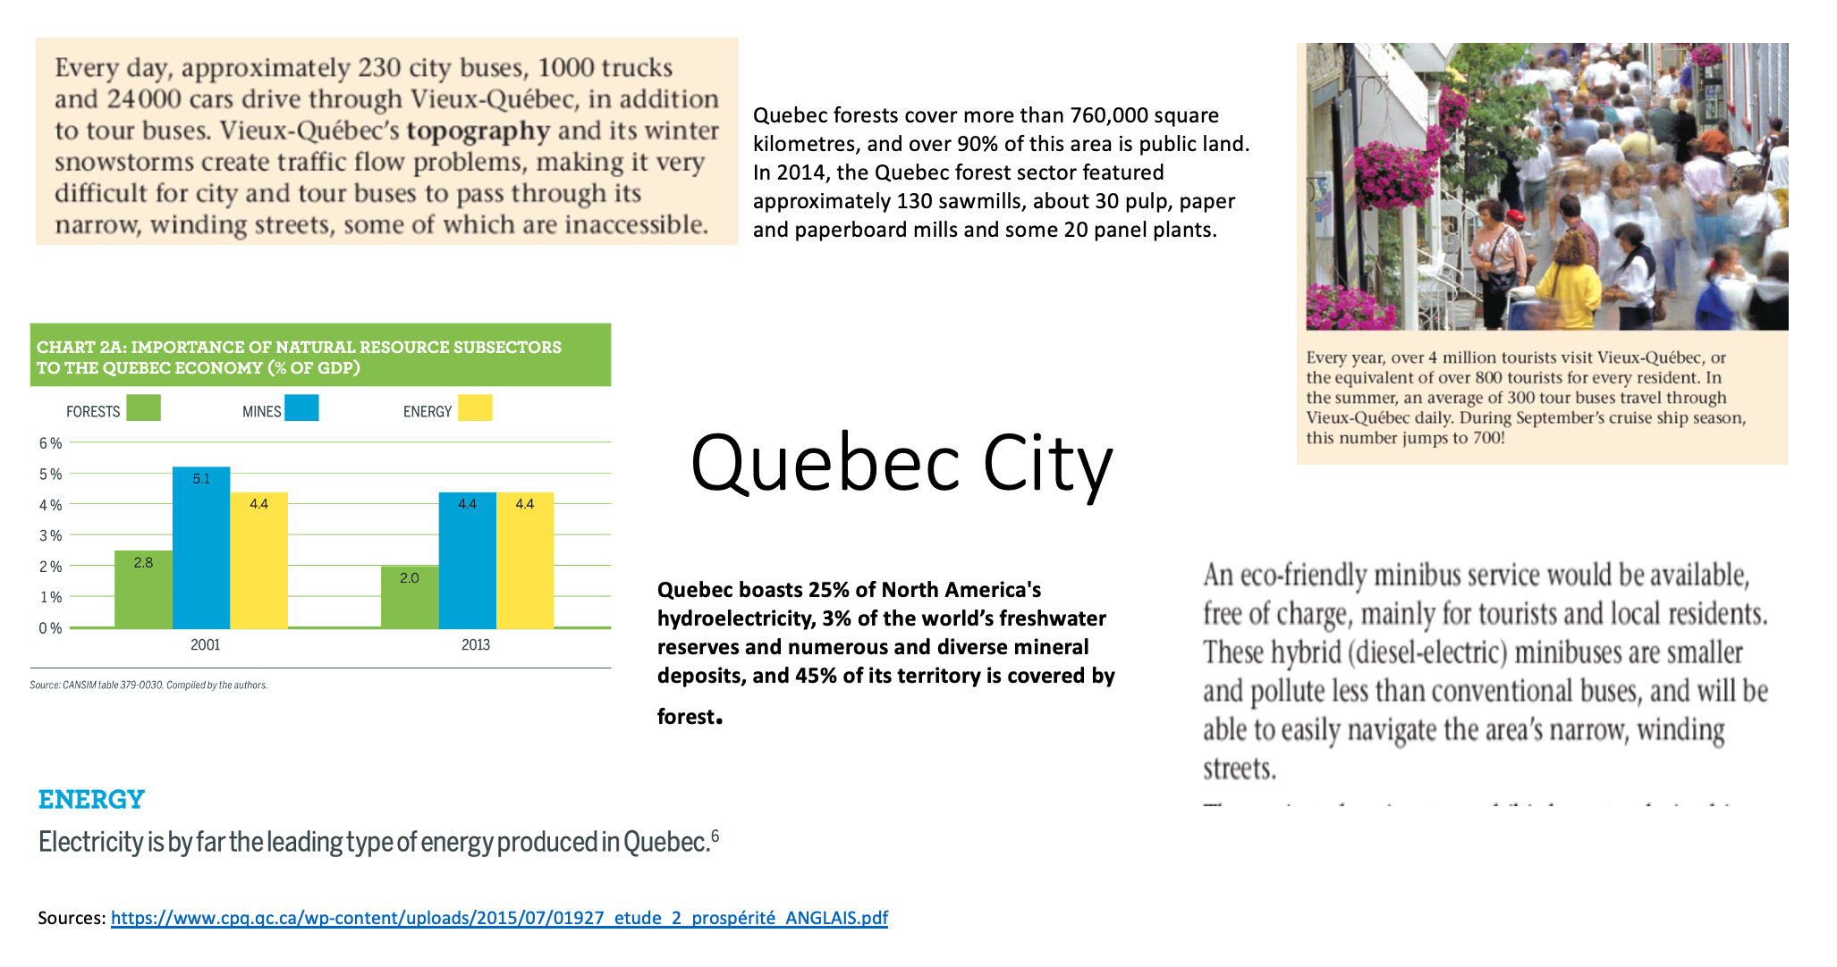
The following pieces of information are taken from the textbook: Issues & Territories & other sources.

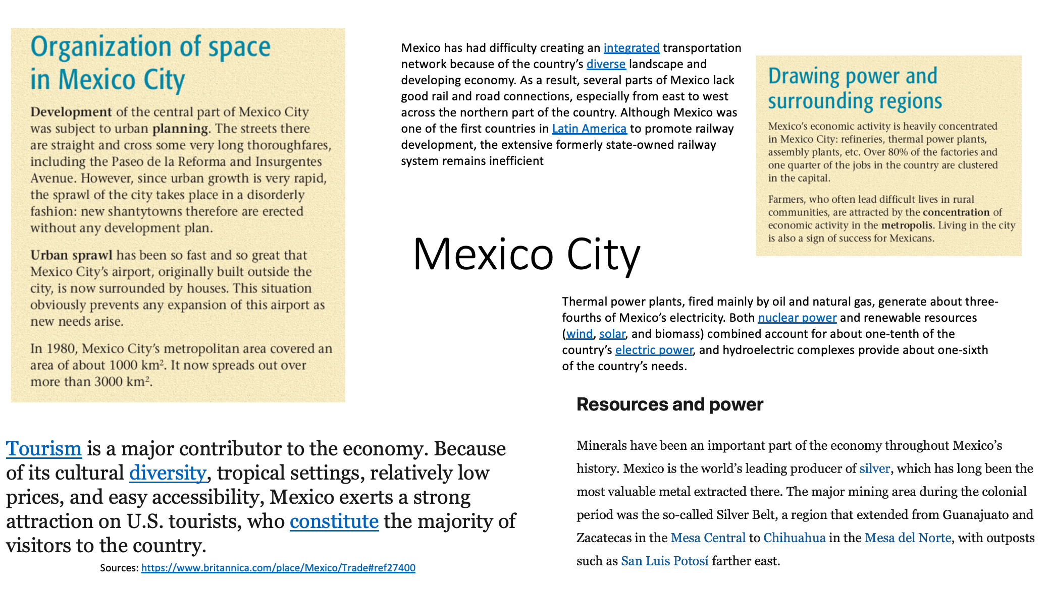
Geography
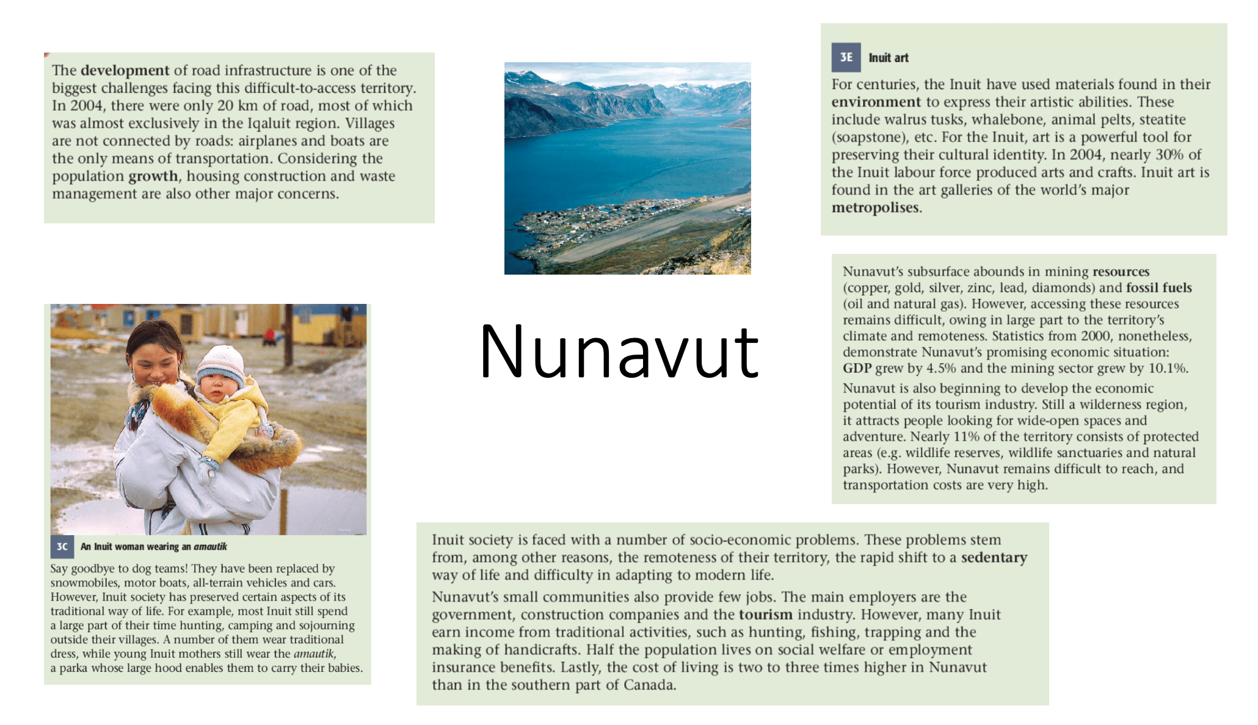

History and Citizenship Education

Continuity and Change in History

Information for students
An important skill to develop in History class is the ability to make comparisons between the past and the present. It is important to be able to recognize what has remained the same, or continued, and what has changed (continuity and change). In this task, you will look at elements of continuity and change.
Instructions
- Read the excerpts in the Appendix and determine what elements still remain in today’s society and what elements have changed. You can also use your textbook From Yesterday to Tomorrow (pages 160-165)
- A chart has been provided to help you to organize your ideas and to think about various elements and concepts such as laws, industries, individual rights and transportation

Materials required
Useful resources, depending on personal preferences and availability:
device with Internet access
writing materials (paper, pencil, etc.)
textbook

Information for parents
Students could:
choose any time or place in history to compare and identify elements of continuity and change
Parents should:
help their child recognize elements that still remain in today’s society

History and Citizenship Education

Appendix - Continuity and Change in History

Information for students
Chart to help you organize your ideas:
Elements and concepts | Continues today | What has changed
Laws
Industries
Individual rights
Transportation

History and Citizenship Education
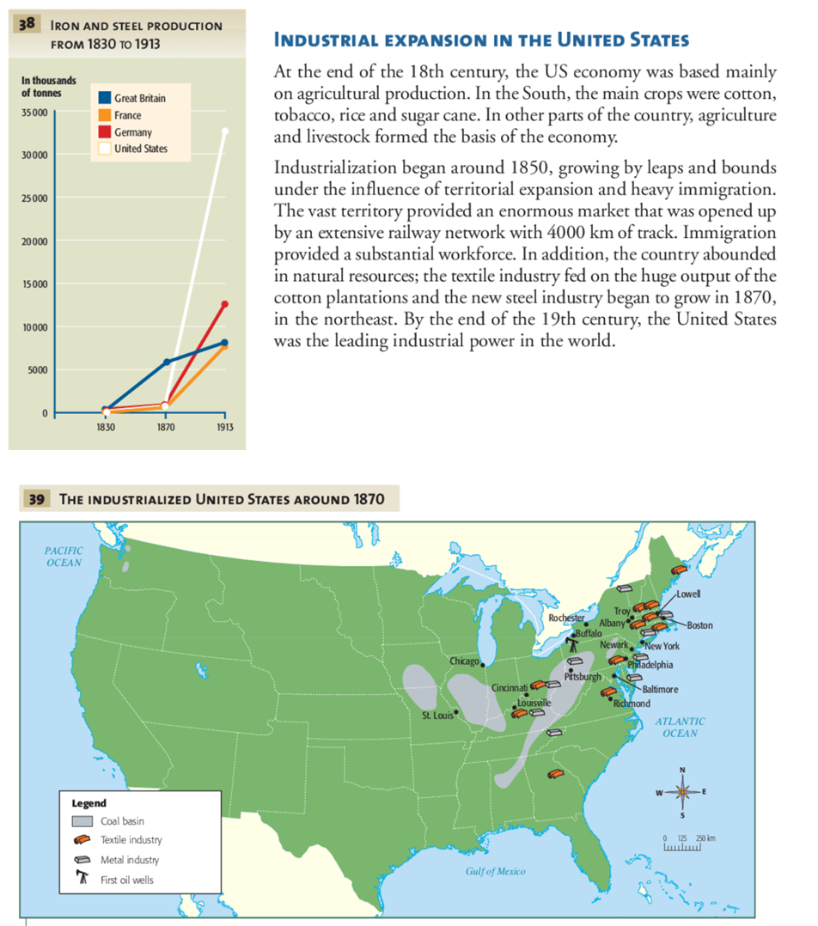
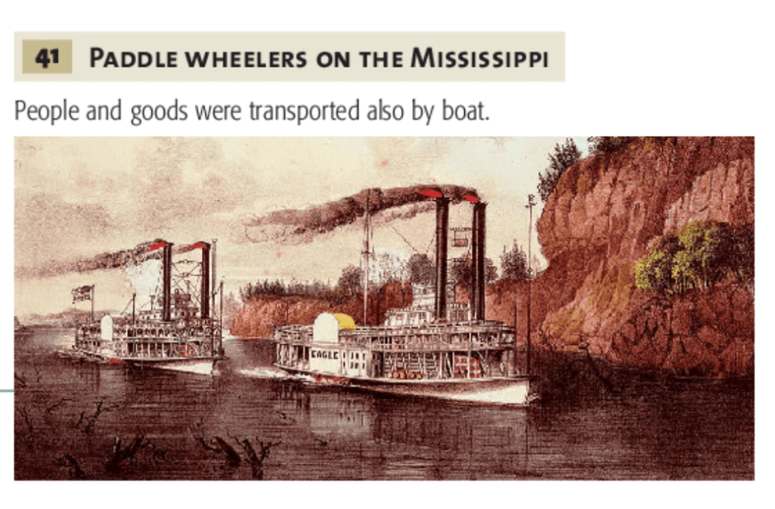
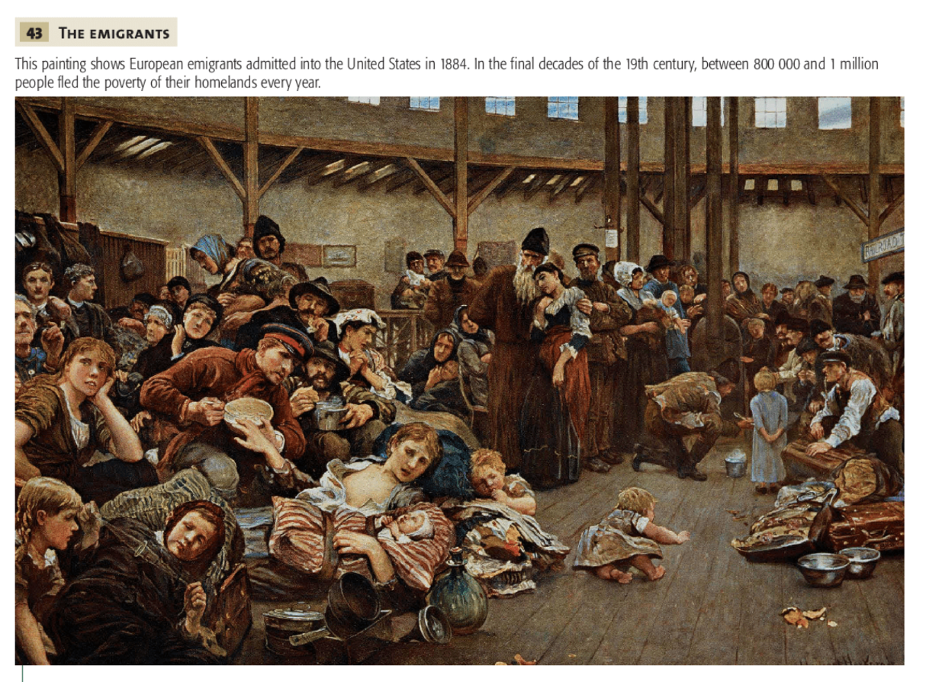
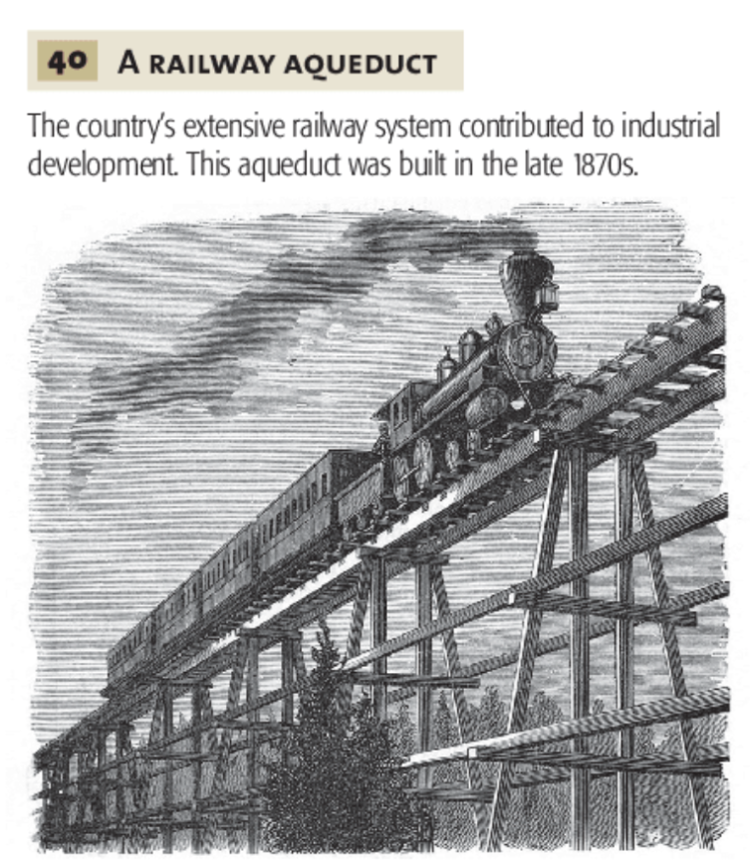
History and Citizenship Education
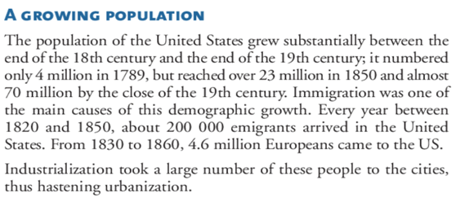
History and Citizenship Education
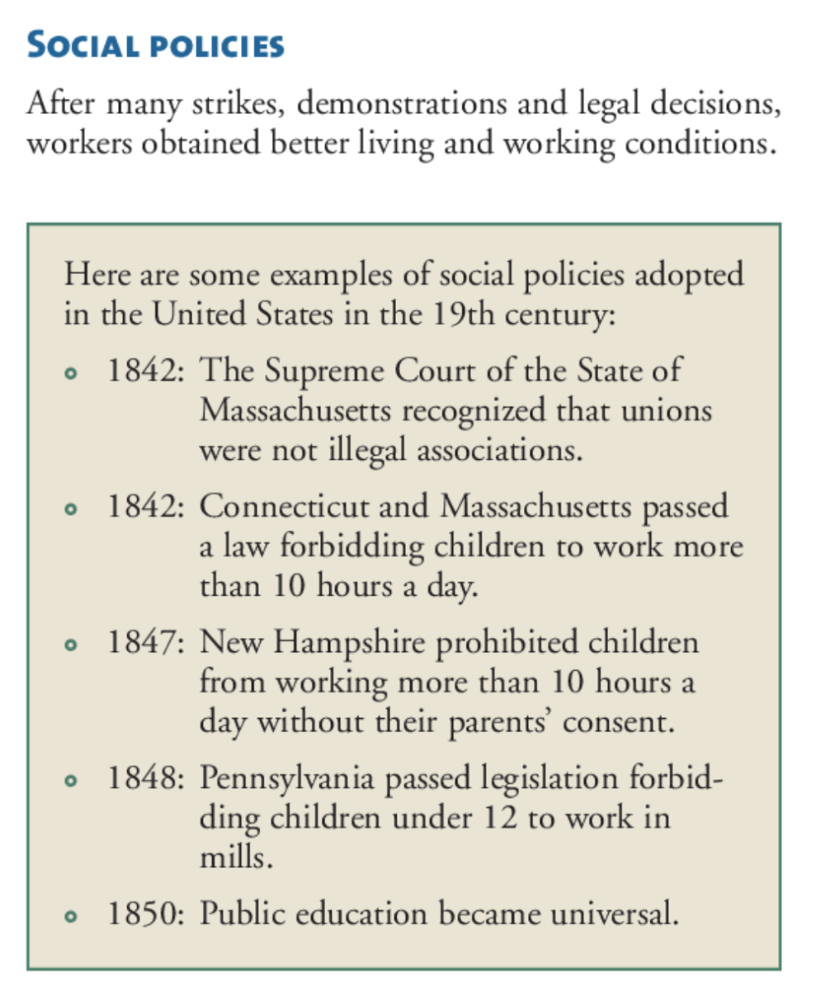
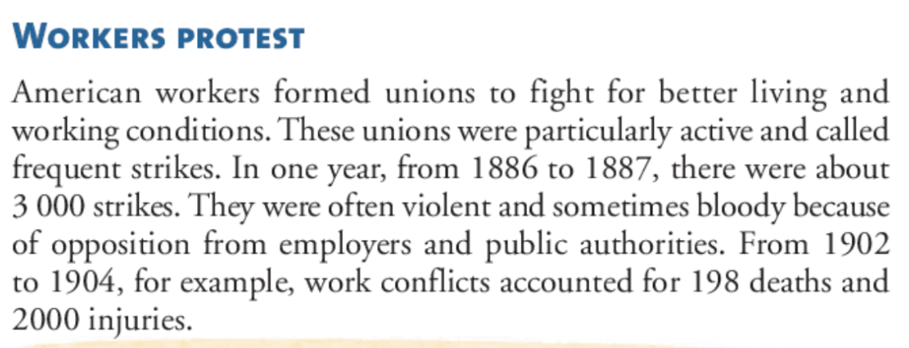
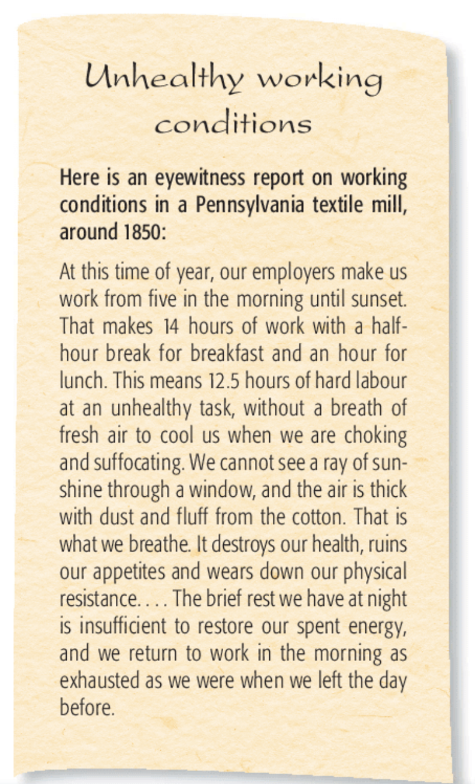
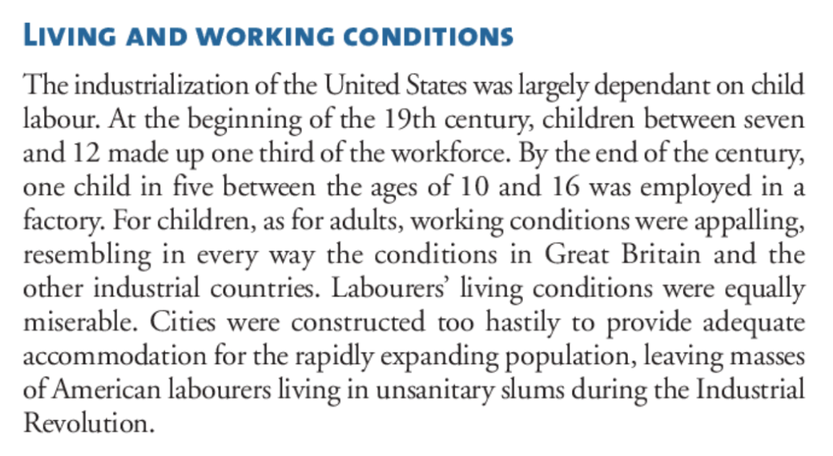
Source: Christian Laville, From Yesterday to Tomorrow, History and Citizenship Education, Secondary Cycle One (Montréal: Chenelière Éducation, 2008), Textbook B, 160-165.

