secondary I
Week of June 15, 2020
Table of Contents
The Knowing Chair 2
Appendix: The Knowing Chair 3
Replonger dans ses souvenirs 8
Welcome to Poly-Park! 9
Appendix A – Welcome to Poly-Park! 12
Water Infiltration: How Does Water Flow? 13
Appendix A: Water Infiltration Test 15
Learn About the F.I.T.T. Principle and Do a Tabata Workout! 16

English Language Arts

The Knowing Chair

Information for students
- Read the story “The Knowing Chair” by Deborah Ellis (see the appendix.) As you read, write down notes, observations or any questions you may have.
- Read the story a second time, but this time read the story using the questions below to provoke and guide your thinking:
- What are some of the changes that Barry undergoes during the story? Can you make any connection to the changes that Barry is undergoing?
- Who in the story does Barry feel he has to protect? Have you been any situations when you felt you had to protect someone? If so, what was the situation?
- Why do you think the author chose a food court as a setting for the story?
- Do you think there were any symbols in the story? If so, what were they and what did they symbolize?
- Write a paragraph about what you think the big idea is in this story and why.

Materials required
Paper, writing and drawing materials

Information for parents
have your child read, write and discuss everyday
share any experiences you may have had about coping with bad news
does sharing meals make life experiences easier? If so, why?

English Language Arts

Appendix: The Knowing Chair

The Knowing Chair by Deborah Ellis
Barry was sitting on a red metal chair that was attached to a metal table in the food court of the mall.
He was waiting for his parents to decide what they would all eat. He settled in for a long debate.
“I’m not running all over the place to get forty different meals,” his father always said, even though there were only four of them in Barry’s family.
“Pick one.”
They usually settled on the pizza place. Not the one where you could get meatballs on the pizza but the other one, where Mom could get a salad.
It would take them a long time to get around to that, though.
“We’re going to let you both choose your own suppers tonight,” his father said.
“Really?” asked Sue, Barry’s seven-year-old sister. “Anything? Like, three desserts?”
“Don’t be foolish,” their mother snapped, then softened her tone. “Sue, go with Daddy. Barry, here’s some money. Go get your own. I’ll stay here and hold the table.”
“Really?” Barry knew he sounded like a little kid, but he couldn’t help it as he stared down at the bills his mother placed in the palm of his hand.
“It’s time you were more self-sufficient,” she said. “You’re too old to have everything done for you all the time. Go on. We want to make that movie.”
Supper out and a movie. On a school night! Aliens had clearly taken over Barry’s parents. He pocketed the money and went on a tour around the food court.
He would not get pizza, or a burger, or a hot dog, or a sub. Those were safe things, boring things, foods old people or a little kid might choose.
No, he would exercise his freedom of choice on wild things, exotic things. Things that would show his family that he was not afraid of adventure. His meal would become a story.
“You should have seen what Barry chose,” he could imagine his mother saying on the phone to one of her nosy friends. “I had no idea he was such a brave eater.”
Barry filled up his tray with a fish taco, Japanese noodles with shiitake mushrooms, and four little Chinese moon cakes, one for each person in his family to try.
He carried it all back to the table where the others were already eating.
And what had Sue chosen? Cheese pizza! Barry sat tall with his three extra years of adventurous spirit keeping his head high. The chili sauce on the fish taco was a bit too strong and the mushrooms in the noodles tasted like erasers, but he did not let on.
Sue was chattering, as usual, like a cage full of monkeys. Barry let her have all their parent’s attention. That left him free to indulge in his favourite hobby - watching people.
English Language Arts
Barry suspected it was wrong, but he often imagined that every person on the planet was some kind of zoo animal, there for him to watch and think about.
At the next table an old guy in a brown suit was eating something on a pita. He was all by himself at the table, and he read while he ate, some sort of work report. Barry could see charts on the old guy’s paper. A dollop of pita sauce dropped on one of the charts. Barry watched the man frantically dab at it with his napkin.
That won’t help, Barry thought. He’d dropped enough food on enough homework to know it always left a mark.
At another table sat another family. It looked just like his family only with an extra kid - a boy - while the dad stared down at his phone. The mom’s face was scrunched tight and her finger was pointed in her son’s face. One of the children was a girl about Barry’s age. She caught him watching her and she looked away, embarrassed.
Barry’s eyes shifted to a gray-haired woman sitting across from a little girl at one of the tables for two. The little girl was Sue’s size. The old woman leaned in toward her with a smile on her face that overflowed to her eyes. She was hanging onto the little girl’s every word, and the two of them looked as happy as sea otters.
The table down from those two was a different story.
The man and woman were both looking at their phones, ignoring their little boy who was having trouble lifting his massive burger with his tiny hands. Every few moments one of the adults would snarl something at the other. Barry couldn’t hear exactly what they said because of the noise in the food court, but he recognized the short, sharp tones and the rolling eyes and the dismissive shakes of their heads.
It’s always the same, Barry thought. People argue in public places
and think no one knows they’re fighting.
He spotted the telltale signs of posture and face, the sharpness of shoulders and stiffness of chins that showed anger and hatred.
Julius Caesar and Cleopatra probably looked the same when they fought, Barry thought. He wanted to list off other famous fighting couples in history but realized he didn’t know any.
Research for tomorrow, he promised himself.
“There’s a van!” squealed Sue.
“Inside voice,” said Mom.
“A van! A camper van!” Sue said only slightly less loudly.
“We’re in a mall, Suet,” Barry said. “There’s no van in a mall.”
“Un-huh!” insisted Sue, kicking Barry under the table for calling her Suet. She pointed toward the end of the food court.
She was right. Next to the elevators, a light blue VW camper van was set up like a food truck.
“Oh,” said Dad. “I didn’t see that before.”
“Stop pointing, Sue, and eat,” said Mom.
English Language Arts
“Is that why you brought us here on a school night?” Sue asked. “Are we going on the trip?”
The trip. The trip Barry had been hearing about all is life.
“Wouldn’t it be great to take you kids out of school for a year and just travel?” his parents had said many times, daydreaming over their collection of maps. “We could live in an old VW van and you can learn all about the country. Not from a geography book but from seeing it and living in it.”
Every summer, as they got closer to the opening of the school year, Barry hoped that this would be the year. This would be the September they hit the road instead of the schoolyard. The Trip would bring Barry so much freedom! His parents would be so busy keeping track of Sue that he would be able to slip away from time to time to explore new places and watch the new people in them.
His parents would send him on errands to get milk when they got to a new town, or they’d ask him to sit with the laundry in the laundromat, or they’d say things like, “Go find the manager of this camp ground and ask if we can stay an extra week because Sue’s been asked to a birthday party.”
He would have so many chances to be on his own, to wander without an adult to police him, to think his own thoughts without a parent intruding, to see different people and think about what they were doing without his mother saying, “I’ve told you before it’s rude to stare,” and without his father saying to his mother, “Can’t you get him to do something?”
Was Sue right? Was this why they were out on the town on a school night?
“Can we go see all the big things?” Sue asked, as she always did whenever The Trip came up. “Can we go stand right up beside the giant nickel in Sudbury? Can we take a picture of me by the big nickel holding up a little nickel? Can we go to Dunnville and see the giant catfish? And then the giant Easter egg? Can we go to the giant apple and walk around inside it? And can you take a picture of me eating a regular-sized apple outside the giant apple?
Sue had no idea of what was close to what, but she sure did know her giant attractions. She was so excited!
“We’ll do our school lessons on the computer and Barry will help me with my arithmetic, won’t you, Barry? Remember? You promised!”
“Sure, I’ll help you,” said Barry. “Are we really going?” The Trip had been talked about so often and in such detail - down to packing lists - but had never materialized.
Barry was a little nervous about getting too excited, because he was afraid of being disappointed again.
Sue would not shut up about the giant statues.
“Maybe we could make them come alive with magic and the giant moose will follow us down the highway. There’s a giant goose too. The goose will fly and the moose will walk and we’ll be a parade of giant creatures that are really, really big but they will be really gentle, too.”
Their parents let Sue prattle on. Their mom kept spearing lettuce with her plastic fork, and their father separated pizza slices in the box.
They wouldn’t let her go on about it if it wasn’t going to happen, would they? Barry thought.
Trying to contain his own excitement, he looked around the food court, checking in on people he had watched earlier.
English Language Arts
The man in the suit was stuffing papers in his briefcase. He had not noticed the blob of pita sauce on his necktie.
The little girl and the old lady were giggling. They had soaked their paper napkins in the woman’s cup of water and were molding them into creatures as if the wet paper was modeling clay.
The arguing couple were still snarling. Their little boy had still not managed to take a bite of this burger. He looked unhappy and like he was afraid to really try.
“Oh come on,” Barry said. He got up from his red chair, went to the fighters’ table and knelt down beside the little boy.
“Hey buddy, let me help,” Barry said to the boy quietly. He took the tomato and lettuce off the burger, because no one wanted those. Then he used a plastic knife to cut the burger into four pieces. The little guy easily picked one of the pieces up and started eating.
“What are you doing?” the dad asked Barry. The mom simply told Barry to take off, only she didn’t say “take”.
Barry smiled at the little boy and headed back to his own table.
He caught a glimpse of another arguing couple in one of the mirrors hanging all over the food court.
This couple had a little girl with them, around seven years old. They were watching the girl talk, but their faces said they were not listening to her. Their bodies were tense with sharp shoulders and stiff chins. They had themselves pulled far away from each other.
The woman looked at the man with disgust and the man looked back at the woman like he hated her.
Always the same, Barry thought.
Barry realized then that he was looking at his own parents.
He realized something else, too.
They had not brought him and Sue to the mall on a school night to tell them they were all going on a trip.
The supper and the movie were not treats. They were bribes.
They were We are doing these nice things for you so you can’t feel bad at what we are about to tell you and you won’t dare make a scene in public because you both know we won’t stand for that.
The fish taco and the Japanese noodles went round and round in the boxing ring of Barry’s stomach.
He sat down in his red metal chair. He looked full at his parents and they looked full at him.
They know that I know, he thought. Good. Just try to lie to me. Just try.
Barry took hold of his little sister’s hand. She yanked it away.
Their mother said. “We’ve got something to tell you.”
Barry kept his eyes on his parents through the whole unraveling, while Sue cried and his father cried and his mother said that she knew they should have told them at home. No one touched the moon cakes Barry had brought for them to try.
Barry did not cry and he did not speak. He glanced away from his parents’ faces only once, to the girl his age at the table with the family sort of like his.
English Language Arts
The girl was now watching him like he was an animal in a zoo. When she saw him look at her she did not look away. She grimaced and pointed her head toward her own idiot parents.
I’ll get my own van, Barry thought. I’ll take Sue and we’ll go see the giant nickel and we won’t invite them to come with us.
He tried to hold his sister’s hand again.
She would not let him.
He kept on trying.
Source: Sit Stories by Deborah Ellis, 2017

French as a Second Language

Replonger dans ses souvenirs

Information for students
Tu as certainement plusieurs photos chez toi, que ce soit dans un téléphone, dans un ordinateur, ou en version imprimée. Pourquoi ne pas profiter du temps que tu as pour créer un album?
- Choisis d’abord les photos que tu souhaites regrouper sous un même thème.
Exemples : Chalet – Été 2019, Amis – 1re ou 2e secondaire, Famille – Noël 2019
- Organise les photos sur une feuille ou dans une application pouvant servir à conserver des photos, comme BeFunky ou PowerPoint.
- Rédige une courte explication du contexte dans lequel chaque photo a été prise ou raconte une anecdote afin de garder des souvenirs concrets.
Pour aller plus loin
Présente ton album aux personnes de ton choix et explique-leur pourquoi ces photos sont importantes pour toi.
#MissionFLS : J’organise un album photo et j’ajoute un court texte en français pour décrire les photos.

Materials required
Papier, crayon
Photos de ton choix
Appareil avec accès à l’Internet
BeFunky (https://www.befunky.com/fr)

Information for parents
Students should:
use photos to remember and talk about past events
read and write short sentences in French
practise saying verbs in the past tense
Parents could:
ask questions about the photos chosen by their children
look at the photo album their children created and listen to them give explanations in French
share the album with friends and members of the family, with their children’s consent

Mathematics

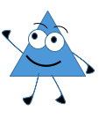
Welcome to Poly-Park!

Information for students
Your task is to design an imaginary park called Poly-Park. To get started on your design, you will need two blank sheets of 8 ½ in x 11 in (approx. 22.5 cm x 28 cm) paper, taped together on the back side along the length of the two sheets (see example below). Then follow the instructions.
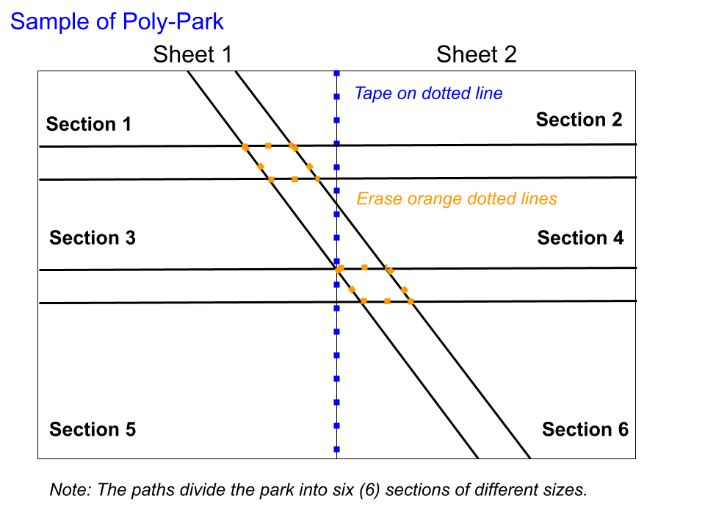
INSTRUCTIONS
Watch the following review videos:
- Area of a Rectangle and a Triangle
- Area of a Trapezoid
Using a pencil and a ruler, draw two parallel walking paths that run across the two sheets, leaving plenty of space between the two paths. Make sure that the paths are of the same width (about 2 cm wide).
Draw one more walking path that intersects the two parallel paths (transversal line). Now erase the lines where the paths meet for a neater look (see example above).
Using the table in Appendix A, determine the area and the perimeter of each quadrilateral section of the park (with a scale of 1 cm = 1 m) to help you with your design plan.

Mathematics
Each section of the park should include one of the following structures:
- A large splash park in the shape of a rectangle and a wading pool in the shape of a trapezoid whose base is in line with the width of the splash park
- A sandbox in the shape of a right-angle triangle
- A sectioned-off playground area in the shape of a right triangle
- A pond in the shape of a scalene triangle
- A recreation centre in the shape of a rhombus
- A cement picnic area in the shape of a square
Use mathematical terms to name each section of the park (for example, Parallel Playground; Polygon Pool; Right-Angle Recreation Centre).
Using graph paper and a ruler, design each structure to scale, making sure it will fit properly in each section (with space around it) by taking into account the area and perimeter involved. Make sure the structures are realistic in size.
Colour, decorate and cut out the structures, then glue each structure in its designated section.
Add trees and plants along both sides of each walking path, leaving 2 metres between each plant and tree.
Find the perimeter and area of each structure, and record this information in the table in Appendix A.
Note: Feel free to draw in park equipment and other items.

Materials required
2 blank sheets of paper (8 ½ in X 11 in)
Clear tape
A few sheets of graph paper
Pencil
Ruler
Scissors
Different coloured pencils, crayons or markers
Printed copy of Appendix A: Welcome to Poly-Park!
Mathematics

Information for parents

About the activity
This geometry activity is for Secondary I students. It allows them to:
practice constructing parallel lines, transversal lines and polygons (triangle, rectangle, trapezoid rhombus and square)
find the perimeter and area of polygons (triangle, rectangle, trapezoid, rhombus and square)
Children should:
review procedures for finding the perimeter and area of triangles, rectangles, trapezoids, rhombuses and squares
Parents should:
provide children with all the required materials

Mathematics

Appendix A – Welcome to Poly-Park!
Sections | Perimeter of the section (m) | Area of the section  (m²) | Structure  chosen for each section | Name given to each structure | Perimeter of the structure  (m) | Area of the structure  (m²)
1
2
3
4
5
6
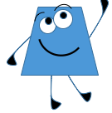

Science and Technology

Water Infiltration: How Does Water Flow?

Information for students
When rainwater falls on the ground, it infiltrates the soil by moving through the surface. The movement of water through the soil is called infiltration. How quickly water infiltrates depends on the type of soil and its composition. For example, Earth’s surface can be made of sand, clay or organic material. The infiltration process can be seen in the illustration below.
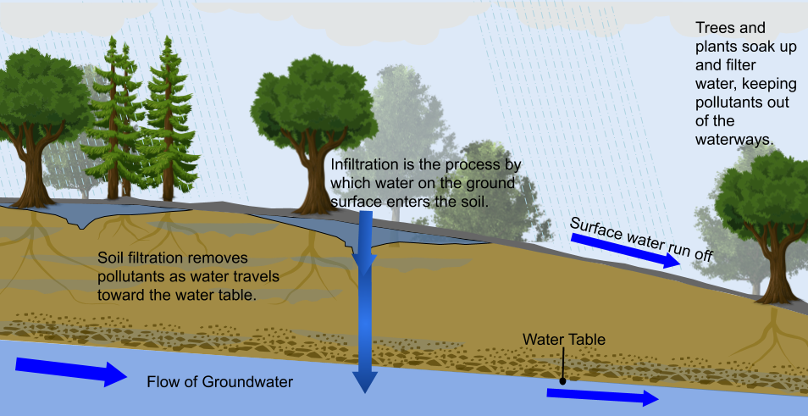
As the water infiltrates the deeper layers of the soil, it reaches groundwater, which is the water below the surface of the Earth. Thus, infiltration is the process by which water soaks into subsurface soils and makes its way through cracks and porous spaces. The bulk of the infiltrated water is rainwater and snow.

Materials
A spoon or scoop
Cylinder or measuring cup with water
A clear plastic bucket or bag
Stopwatch
Appendix A: Water Infiltration Test
Writing instruments
Science and Technology

Information for parents

About the activity
Children should:
draw their own diagram as their own visual representation while writing their answer next to each step describing water infiltration
Parents could:
help their children review the above video and diagram to help them understand how water flows on our planet. Water remains on our planet and is recycled. Should they like to have more information, here is another video and a downloadable poster from NASA Science: How Much Water Is on Earth?

Science and Technology

Appendix A: Water Infiltration Test
Instructions
Watch the video entitled Water Infiltration Test. What is the process used to quickly determine whether water will penetrate through the soil? You can replicate this experiment in your backyard or at the park. If you have access to sand, you may want to do a comparison study experiment with sand as well. Write your observation(s) in the box below.

Response Box

Materials required
A bucket or clear plastic bag of soil
A spoon or scoop
Water
An object to calculate time (e.g. a handheld timer or mobile phone stopwatch)

Procedure
- Fill a bucket or clear plastic bag with soil, depending on what you would have available. Once this experiment is done, you will put it back where you found it. Not to worry, as this experiment does not require any substances that are harmful to the soil.
- Prepare your timer, as you will need to press start once you pour the water in the soil.
- Pour enough water onto the soil to cover it completely. Observe how long it takes the water to infiltrate the soil. Can you see any remaining water at the bottom of the bag or bucket? Why or why not? Make sure to include your idea in your response.

Physical Education and Health

Learn About the F.I.T.T. Principle and Do a Tabata Workout!

Information for students
Activity 1
You have probably learned about the F.I.T.T. principle already. Watch this video as a review.
Think about setting a fitness goal for yourself using the F.I.T.T. principle:
- Frequency: how many days a week would you train?
- Intensity: how hard would your training sessions be? (e.g. jogging on flat ground while maintaining the ability to talk comfortably the whole time may be less intense than running intervals or running up mountains, although both are excellent ways to stay healthy!)
- Time: how long will you train for?
- Type: what kind of exercise will you do? Different activities improve your fitness in different ways.
Talk to a family member about their physical activity. Do they use the F.I.T.T. principle when they plan their physical activity?
Activity 2
Do you know what Tabata training is?
- Tabata training is a high-intensity interval training (HIIT) workout, involving exercises that last four minutes. You could do the same exercise the whole time, or change it up. The four minutes are broken down as follows:
  - Perform high intensity exercises for 20 seconds.
  - Rest for 10 seconds.
  - Following this cycle for 4 minutes means you will complete 8 rounds of 20 seconds of exercise.
- Tabata training uses the F.I.T.T. principles of intensity and time – because it’s a short workout, its high intensity!
- With tabata workouts where you do the same exercises (e.g. squats) for all 8 rounds, the idea is to work hard from the start then strive to maintain the same number of repetitions that you did in the first round. For example, if you did 15 squats in the first 20-second round, you want to try to do that number of repetitions in the other 7 rounds. Your body will be getting more and more tired, so it will be tough! Remember to maintain proper technique. Slow down or stop if you get too tired to do the exercises properly.
Try this 4-minute Tabata workout. For the push-ups, do any of the variations shown below according to your personal fitness level.
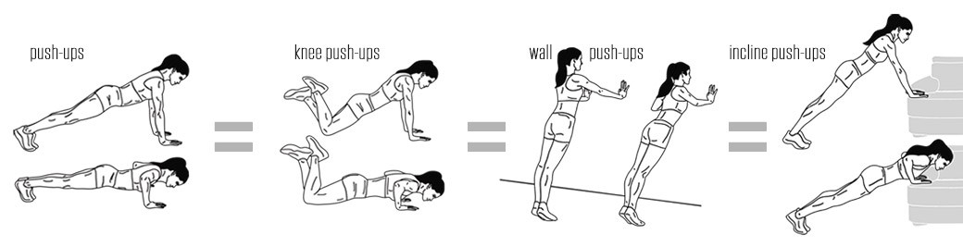
Physical Education and Health

Materials required
None

Information for parents

About the activity
Children should:
learn about the F.I.T.T. Principle
complete a tabata workout
Parents could:
discuss the F.I.T.T. Principle with their children
complete the tabata workout with their children

Jody Meacher and Cheryl Cantin. “Water Cycle: Infiltration” June 8, 2020, PNG, personal collection.

