What We Remember
Information for students
Read the first-person opinion essay ‘How Will My Children Remember This Pandemic?’ by Alice Irene Whittaker, published in The Globe And Mail, April 7th, 2020: https://www.theglobeandmail.com/life/first-person/article-how-will-my-children-remember-this-pandemic/
Consider the article, and which things Whittaker hopes her children will remember from the pandemic.
Draft a list of positive things you will remember from the pandemic. To do this, you will also need to consider what things you might choose to forget!
Share your list with some family members, and encourage them to list and discuss their ideas too.
Write your own first-person opinion essay, or a letter to your future self, that you will re-read in years to come. This essay, or letter, should explore and discuss some recent positive events and your opinion on how your reality has changed during the pandemic.
Materials required
- Device with Internet access

- Paper writing materials
‘’Years from now, our students’ children and grandchildren will ask them about this moment in time, and I want them to have a record of it. Their history.’’ – Kelly Gallagher, March, 2020.

Information for parents
Consider reading the article, too and discuss this mother’s perspective.

Help your child to recognize (and list) some positive aspects of their reality during the pandemic.

Support your child during the writing of a personal essay or letter to their future self.

f
C’est génial!
Information à l’élève
- Visionne un épisode de l’émission GÉNIAL télédiffusée à Télé-Québec du mardi au jeudi à 12h00.
- Lors du visionnement, note les réponses aux questions suivantes pour t'aider dans la rédaction d'un court texte descriptif :
- Laquelle des expériences présentées est la plus intéressante ? Explique.
- Quels sont les dangers à reproduire cette expérience à la maison ?
- Quelles seraient les consignes à donner à un ami qui voudrait tenter l’expérience chez lui ?
- Rédige un court texte descriptif que tu feras parvenir à un ami sous forme de courriel dans lequel tu décris l’expérience que tu as visionnée et que tu as aimé le plus afin de partager ton appréciation. Intègre dans ton texte cinq consignes à respecter lors de la réalisation de l’expérience. Termine en invitant ton ami à visionner un épisode de l’émission.
Matériel requis
- Téléviseur/ la chaine Télé - Québec
- Émission(s) GÉNIAL !
Information for parents
Your child will practice:
- Listening to a French show featuring various Science experiments;
- Take notes and answer questions;
- Elaborate safety rules when performing a Science experiment.
- Write a short appreciation of the show and invite a friend or relative by e-mail to watch an episode.
You could:
- Discuss why your child picked the particular experiment
- Read their text and ask questions if necessary
- Watch an episode together

A penny for your thoughts
Instructions for students
- Find a definition for the word “sedentary” and explain the concept to an older member of your family.
- Do you think your lifestyle is sedentary?
- For the physical activity, create your own choreography and practise it.
- Present your choreography to a family member. Better yet, invite them to perform it with you.
- Explain your choreography and the choices behind it to the family member.
- Watch the following videos:
  - Applying Physical & Health Literacy video
  - Everybody Dance Now

Materials required
- device with Internet access (optional)
- paper, pencil and calculator
Information for parents
- The video links are helpful but optional
- Suggestion: Once your son or daughter has completed the task, have him/her ask you to make the 2 choices and then show you his/her solutions and explanations.

Choice # 1 How would you like to be paid?

Peter is hired to help a neighbor with yard work.
There are two payment options.

- $20 a week
- A penny for the first day and the amount will double each day.

He will work every day for 2 weeks (14 days). Which payment option would you suggest Peter take?

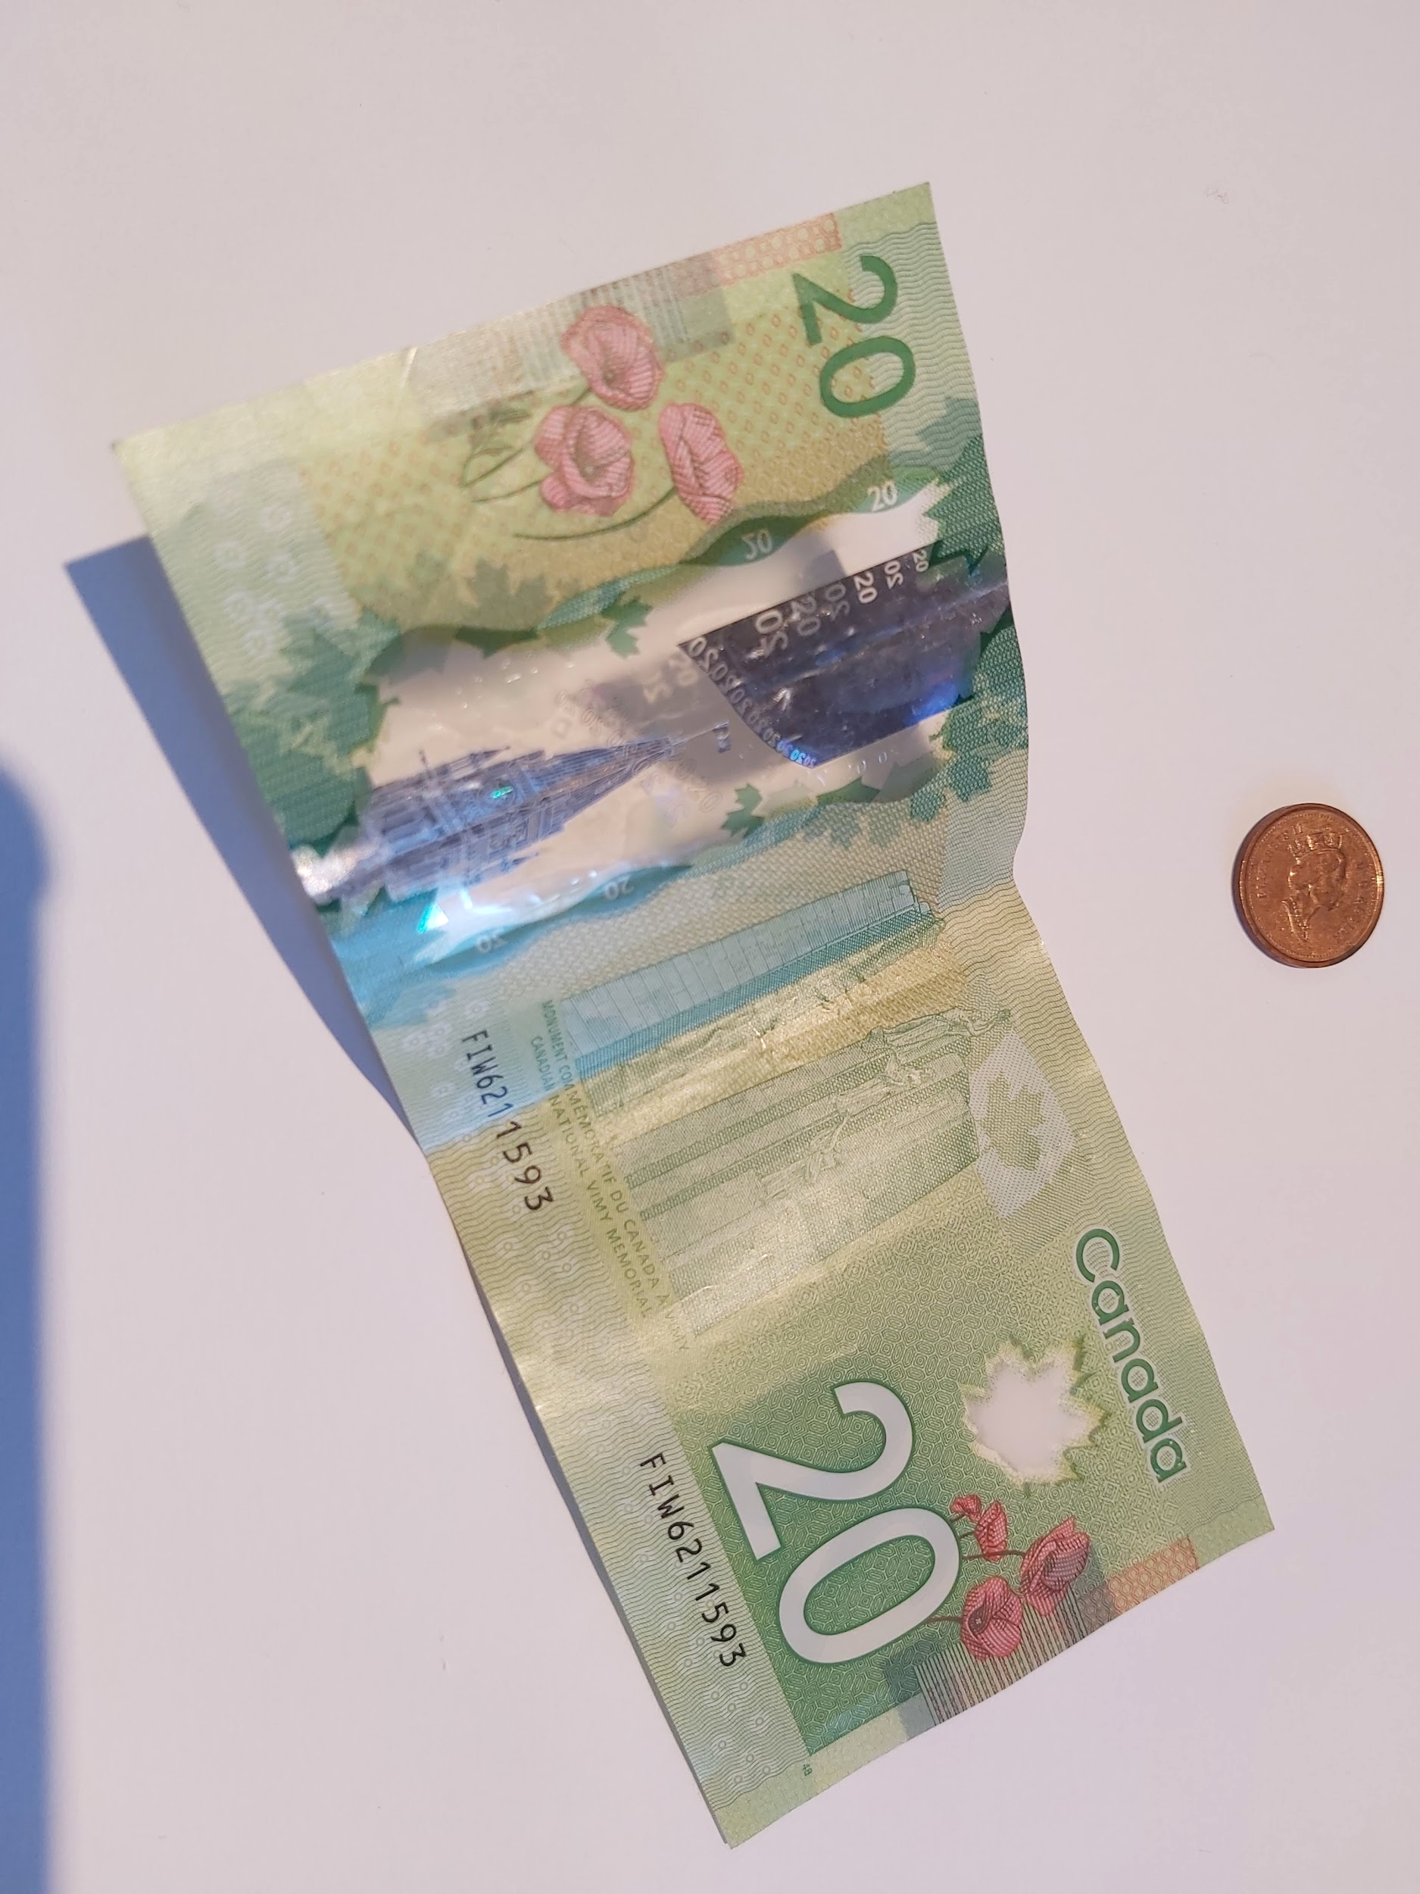 | 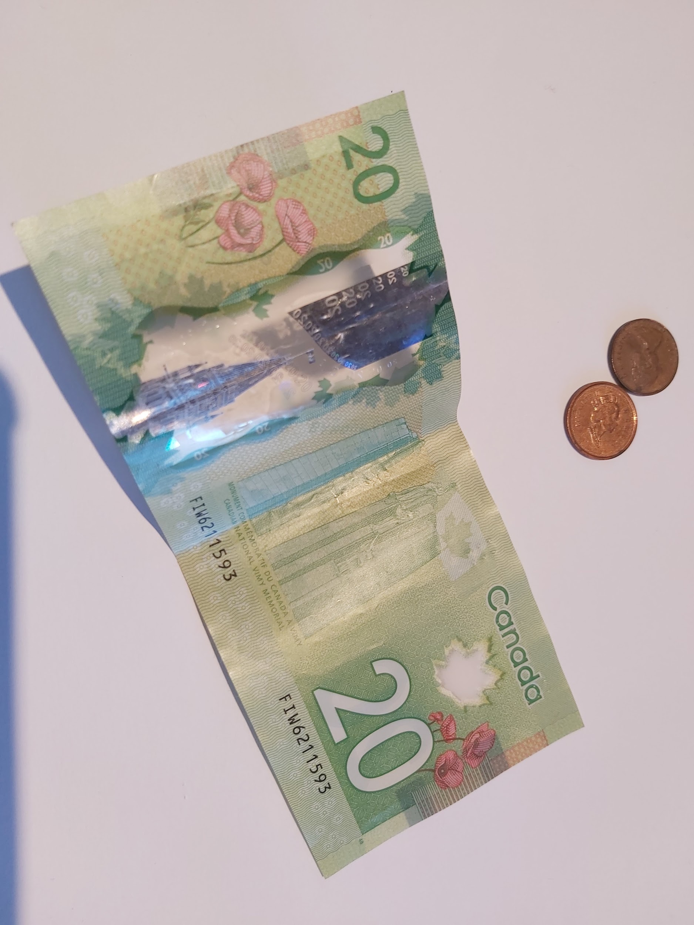 | 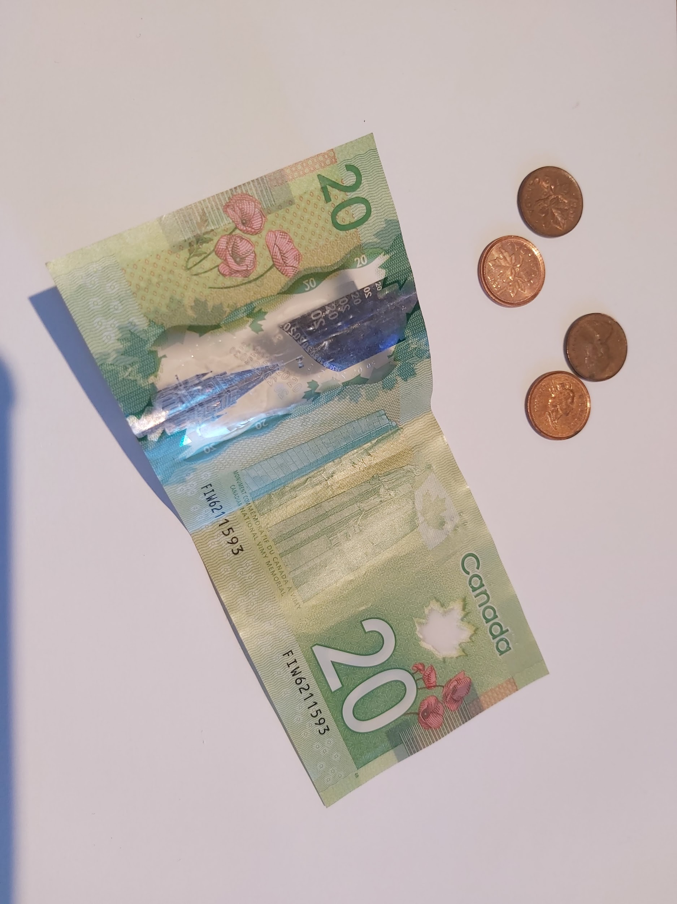 | 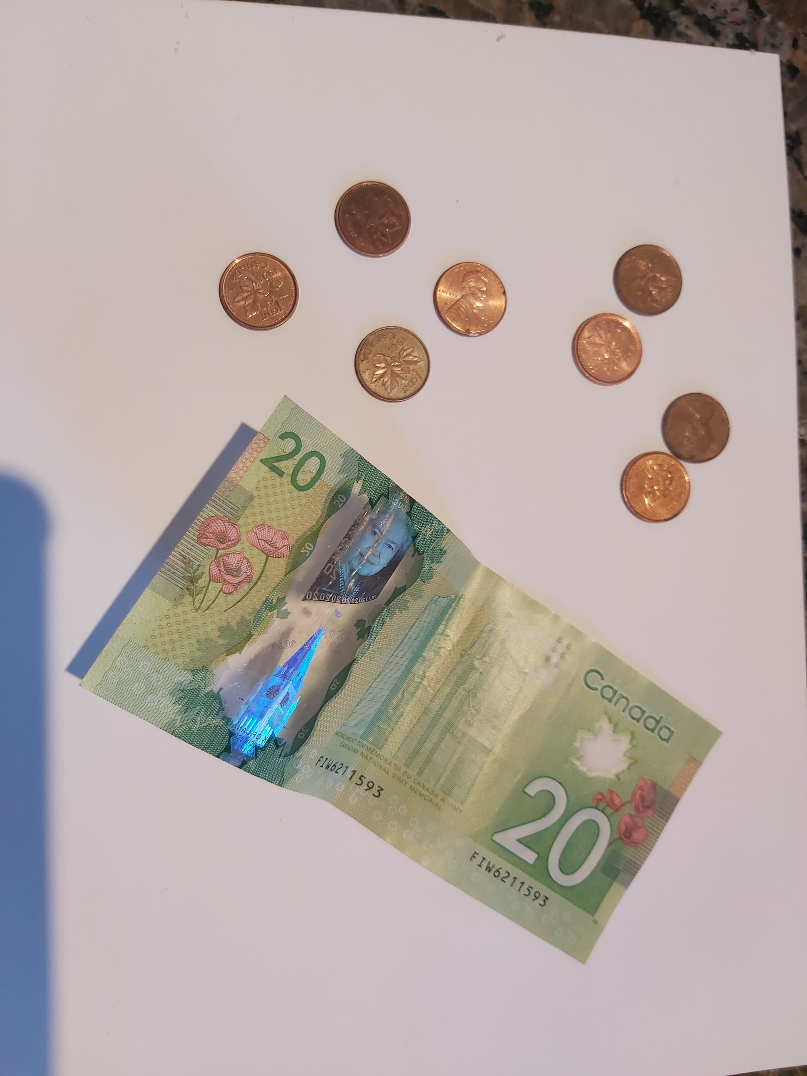
Day 1 | Day 2 | Day 3 | Day 4

Choice #2

Watch the video and make your choice.

Which would you rather have? A million dollars or a penny the first day, then doubled every day for a month?

Create a table or an equation to find the solution?

Challenge your parents. Which one do you think they will choose? Be ready with your explanation.

Choice # 1 Solution

Week 1 | 0.01 | 0.02 | 0.04 | 0.08 | 0.16 | 0.32 | 0.64
Week 2 | 1.28 | 2.56 | 5.12 | 10.24 | 20.48 | 40.96 | 81.92

Option A: $40.00 Option B: $81.92 Peter should choose option B

Choice # 2 Solution can be found on this video and to understand the rule, watch this video.
If a month has 30 days, the pennies will add up to
$5,368,709.12

Exploring Chemical Changes
Information for students
- The following are some signs that a chemical reaction took place:
  - A gas is released
  - There is a change in colour
  - The temperature changes without the need of a heat source (e.g. the mixing of two chemicals makes the container feel hotter or colder)

- List as many examples as possible of chemical reactions. What makes you think they are chemical reactions? Explain.
- Sometimes matter can undergo a change even though it’s not a chemical reaction. Those are called physical changes. Can you give examples of physical changes?
- Demo:
  - (optional) this video is an example of the demo below https://drive.google.com/file/d/1znPxwE8SB4iEdQnn99hxywJCU5kQ4KnP/view?usp=sharing
  - Carefully pour baking soda into a balloon.
  - Pour some vinegar into an empty water bottle.
  - Wrap the open end of the balloon around the bottle’s mouth without spilling the baking soda inside.
  - Place the bottle and balloon combination on a kitchen scale.
  - Take note of the starting weight (or mass)
  - Lift the balloon to allow the baking soda to fall into the bottle without detaching it.

- What do you notice? Make a list of as many observations as possible.
- Draw a before and after picture of the demo.
- Make a list of possible explanations for any changes observed. Here are some sentence starters to help you come up with hypotheses:
  - I think ______ has something to do with _______
  - I think ______ causes _______ to happen.
  - The reason I expect to see this [what I’m seeing] is because [give a cause and effect explanation].

- What has happened to the weight (or mass) of the demo?
- What happens to the weight (mass) if you remove the balloon?
- What types of changes happened - physical or chemical? Give an explanation.
Materials required
- Paper, writing and drawing materials
- An empty water bottle
- Baking soda
- Vinegar
- Kitchen scale
- A balloon
- (optional) Device with Internet access
Information for parents
- Help your child open the link to the video.
- Help your child run the demo, if necessary.
- Read the instructions to your child, if necessary.
- Discuss the questions together.
- (optional) Brief video explanation 1: https://www.youtube.com/watch?v=G4b6zAypaRw
- (optional) Brief video explanation 2: https://www.youtube.com/watch?v=2S6e11NBwiw

Design a Gas Law Demonstration
Instructions for students
Gas laws describe the relationship between two or more properties of a gas. These relationships can be easily illustrated though a demonstration using materials found around the house.

- Click on the link http://tiny.cc/gaslaws for an example of a gas law demonstration that can be done at home.

- Use material found at home to design and carry out a demonstration illustrating one or more of the following gas laws: Charles’ Law, Boyle’s Law, Gay-Lussac’s Law. The demonstration must clearly illustrate the relationship between two properties (i.e.; pressure and temperature, volume and temperature, etc..). Many different examples can be found online.

- To describe your demonstration, you can film your demonstration, take pictures or describe it in writing.

- Make sure to include an explanation of what is happening at the molecular level by making connections to the kinetic theory of gases.

- For more information about gas laws, refer to the Quantum Chemistry Textbook, Section 2.4, p 75-91. The textbook is available online at https://www.iplusinteractif.com/books/63
Materials required
- Various objects (safe) available at home and recycled materials.
- Device with Internet access
- Paper, writing and drawing materials

Information for parents
- Provide your child with a safe workplace and materials that could be used for this activity.
- Ensure that your child is manipulating the material safely.

- Ask your child to show you the demonstration and explain it to you. create and perform a choreography

Kitchen Physics - Measure the Speed of Light with Chocolate!
Information for students
- The speed of light is 299,792,458 metres per second.
- Mathematically, the speed can be determined by the following formula:
c = νλ
Where: c is the speed of light
ν is the frequency
λ is the wavelength
- Using a microwave and chocolate you can measure the speed of light in your kitchen.

Materials
- 1 microwave
- 1 plate suitable for a microwave
- Ruler
- Plain chocolate bar at least 5 inches long

Information for parents
- In this activity, your child will determine the speed of light by heating a chocolate bar in a microwave.
- For an example of the procedure, you can watch the following video.
https://www.youtube.com/watch?v=kpB1wezpJeE

Procedure
- Determine your microwave’s frequency (ν)
  - You can verify the frequency of your microwave on the rating plate or in the appliance’s manual. Standard microwaves have a frequency of 2.45 gigahertz. This means that the microwaves move up and down 2.45 billion times per second.
ν = GHz

  - Convert the frequency of your microwave (ν) into Hz (1GHz = 10⁹Hz)
ν = Hz
- Determine your microwave’s wavelength (λ)
  - Take the turntable out of you microwave (you need the chocolate to stay still when you heat it).
  - Put your chocolate in the middle of a plate and place it in your microwave.
  - Heat the chocolate until it starts to melt in two or three places. This should take about 20-30 seconds.
  - Carefully take the hot plate with the chocolate out of the microwave.
  - Measure the distance (in meters) between the melted spots (from center to center). This represents half of the wavelength (λ).
λ/2 = m
  - Multiply your distance measured (in meters) by two to obtain the wavelength.
λ = m
- Determine the value of the speed of light by applying the mathematical formula and using the calculated values from steps 1 and 2.
c = νλ

c =

- Eat the chocolate.

Energy Drinks and Movement
Information for students

Activity 1:

- Watch the video about energy drinks.

- During supper time, tell your family what you learned about energy drinks.

Activity 2:

- Plan three physical activities you will carry out this week.

- Carry out the physical activities you planned.

- Did you drink water to stay hydrated?

Materials required
Activity 1:
- The video Energy Drink Risks

Information for parents
In the context of the current pandemic, the physical and social environment in which physical activities or active play are carried out must comply with the most recent guidelines issued by the Direction de la santé publique or by any other relevant authority.
Aim of the activity:
- To carefully plan physical activities and think about the planning process afterward

Op Art
Information for students
Do you know what Op Art is? Follow this link to find out: https://www.tate.org.uk/kids/explore/what-is/op-art
Once you have an idea of what Op Art is, you are ready to create your own work of art. All you need is paper, a black marker and 2 or 3 pencil crayons.
Start by drawing a curved line down the paper with a pencil or marker.

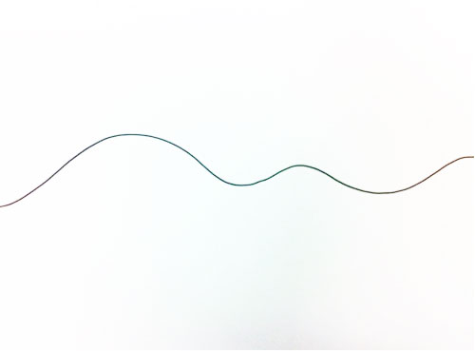

- Add 8 to 10 dots across the line.
- They should be different lengths apart.
- You need a dot close to the edges of your paper.

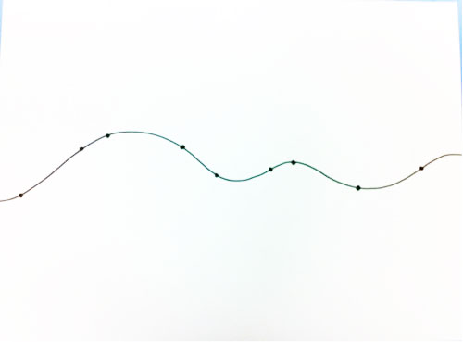

- Start connecting the dots with “jumps”.
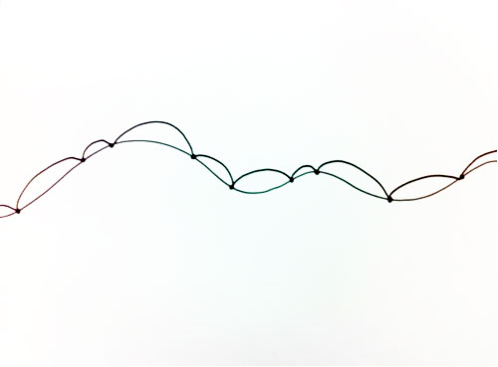

https://kinderart.com/art-lessons/arthistory/op-art-shaded-shapes-lesson/

- The lines will eventually go off the top and bottom of the paper.
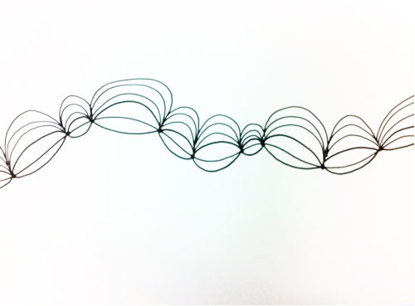
- Draw these “jumps” on either side of the line until you have filled the whole page.

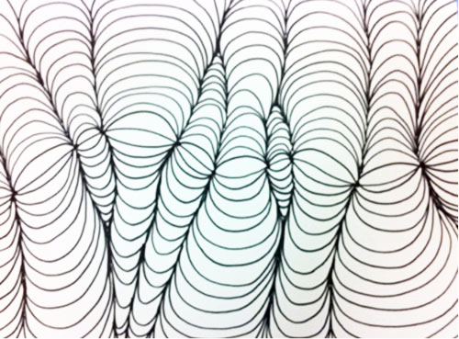

- Choose two or three colours you find go well together. Try to choose colours that contrast well.
- Using pencil crayons, fill in the spaces. Make the corners of each bubble darker by pressing harder and the centers lighter by pushing lightly with your crayon. This creates a shadowing effect.
- Alternate the colours throughout the work.
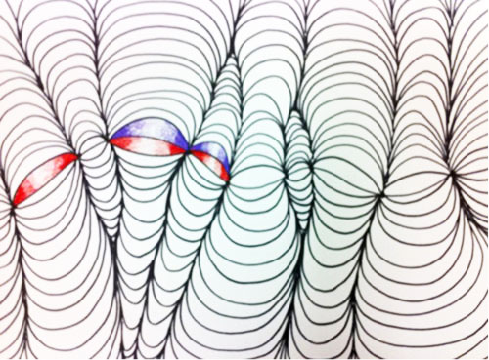

- Continue until the work is complete.

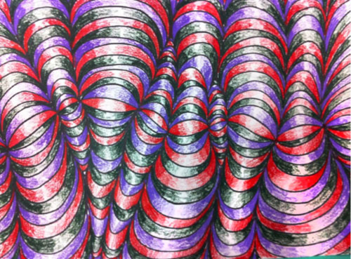

- Here are some YouTube links if you would like to try other Op Art projects: https://www.youtube.com/watch?v=fa10yG5HWXk
https://www.youtube.com/watch?v=KnZQYXPJnXU
https://www.youtube.com/watch?v=9DW4wg2DdwU
Materials required
- Device with Internet access
- Paper, black marker, 2 or 3 coloured pencils

Information for parents
Help your child find the link to the video if necessary
Go over the steps with your child, if necessary.

Ethics Religious Culture
Unavailable

Use a Spreadsheet to Develop a Budget
Information for students
- Making and analyzing a budget can help you keep your spending in check and identify ways to potentially save more money. Spreadsheets are helpful for collecting, organizing, sorting, and storing data, so you can work with and interpret it more easily. In this activity, you will learn to use a spreadsheet to make a budget. Don’t worry, you will be guided with step-by-step videos or transcripts. You can use the fictitious banking data provided, or your own information.
- Option 1 - Online:
  - Access the first video in the “Develop a Budget” lesson on the Applied Digital Skills website:
  - The “Develop a Budget” lesson has 8 videos. Each video will show how to complete a few steps in making a budget using a spreadsheet. There is no need to sign in. Simply watch each video and complete the suggested steps. You can re-watch as many times as you need to and pause as you go. Once you are ready to move on, click the “Next” button at the bottom of the page.
  - The example uses Google Sheets, but the same process can be completed using any spreadsheet program that you have.
- Option 2 - Some Internet Connection
  - If you are able to access an Internet connection some of the time (e.g. drive to a school and connect while remaining in your car), you can download the videos to view them offline. The full download is 510 MB. Use this link to download the videos
  - You will also need the data from the sample bank statement.
  - If you are not able to download the videos, but you have some connectivity from home, you may be interested in accessing the “Develop a Budget” online lesson, but working from the transcripts beneath each video.
- Option 3 - No Internet Connection and/or No Device
  - Use the printed video transcripts that were sent to you to create your budget. Remember that, even if you are using a Chromebook, you can create a Google Sheet in offline mode.
- Option 4 - No Device
  - If you have access to the Internet and can view the videos, use these to guide you in creating a budget on paper.
  - If you have no access to the Internet, use the printed video transcripts that were sent to you to guide you in the creation of a budget on paper.
Materials required
- The “Develop a Budget” lesson materials:
  - Online: The “Develop a Budget” lesson from the Applied Digital Skills website:
https://applieddigitalskills.withgoogle.com/c/middle-and-high-school/en/plan-and-budget/develop-a-budget/develop-a-budget.html
  - Some Connectivity: Downloadable Videos Version: https://storage.googleapis.com/files.cs-first.com/apski/videos/5/allvideos.zip
with the Sample Bank Statement from the lesson: https://script.google.com/macros/s/AKfycbwzBE9adKj44c2ekSNYs1bqA2vfNwthAkHh--miTuSRsNtrkpY/exec
  - No Connectivity: Printed Transcripts and Sample Bank Statement
- A Device with Internet access (optional)
or
A Device with occasional access and the ability to download the videos (optional)
- Google (GSuite or personal) account or other spreadsheet software (can be offline)
or
Paper, writing, and drawing materials
Information for parents
- The goal of this activity is to have the student work with the elements necessary for the creation of a budget and to consider various types of income and expenses, all parts of the Financial Education course. Learning to use a spreadsheet to complete this activity may be a new and interesting twist.
- Note that, while the example given uses Google Sheets, the same activity can be completed using any spreadsheet software.
- Encourage your child to explore creating a spreadsheet with his or her own budget information as they make plans for spending and saving over the next few months.
- If you have always wanted to keep better track of your own budget or to learn how to use a spreadsheet, consider doing this activity yourself and then discussing your experience with your child.

Annexe 1

Video 1: Develop a Budget:

Data is not always collected or stored in a way that makes it easy to interpret.
Spreadsheets are helpful for collecting, organizing, sorting, and storing data, so you can work with and interpret it more easily.
In this activity, you will develop a budget, or a plan for spending and saving.
Using banking data, you will use a spreadsheet to categorize and add together—or sum—data.
Then, you will analyze your budget to identify areas where you could potentially save more money.
Any time you spend money using your debit card to withdraw cash or purchase something at a store or online, the bank takes the money from your checking account.
The transactions, or expenditures, you make automatically update in your online bank account, where you can check all of the debits and credits you accumulate.
Income, or money you have earned and deposited, is called a credit.
Credits usually appear as positive numbers in your bank statement.
Money you have spent is called a Debit, and usually appears as a negative or subtracted number in your bank statement.
In this activity, you will copy and paste data from a simulated checking account.
You will use formulas to calculate total income and expenditures.
Then, you will categorize the expenses to get an idea of what kinds of purchases were made.
Finally, you will use the SUM-IF formula to calculate how much money was spent in each category.
Calculating your total income and expenses gives you the bottom line of your spending.
But totaling categorized expenses gives you an even more complete picture of how you spend your money.
You will create this spreadsheet using a simulated bank account statement, but you can re-use it to keep track of your own spending every month.
To get started, create a new, blank spreadsheet.
Name your sheet Checking Account.
Then, move on to the next video to copy and paste spending data.
Now, it’s your turn: Create a blank spreadsheet.
Name the spreadsheet Checking Account.
Then, move on to the next video.

Video 2: Copy Data and Create a Summary Table

In this video, you will import data from a banking website into your spreadsheet and freeze a set of rows to create a summary table.
Open the simulated banking statement by clicking the link next to this video.
This is a fake bank account statement, but most banking sites display information in similar ways.
Click and drag to select the entire table of data.
Right click or use keyboard commands to copy the table from the website.
When you paste data into a spreadsheet, you also paste the formatting.
To paste the values with no formatting, right click and select “Paste Values Only.”
Next, add space at the top of your spreadsheet for a summary table.
Highlight 10 rows of your spreadsheet.
Right click and insert 10 rows above the data you copied.
Then, freeze these rows so you will always see them as you move around your spreadsheet.
Highlight the 10th row and select “Freeze up to current row.”
Now you have a space at the top of your spreadsheet for your calculations.
In the next video, you will use formulas to calculate your expenditures in this summary table.
Now, it’s your turn: Copy the table from the website and paste it into your spreadsheet.
Create a summary table by adding 10 rows to the top of your spreadsheet and freezing those rows.
Then, move on to the next video.

Video 3: Calculate Total Expenditures

In this video, you will compare how much money was made with how much was spent.
To do this, you will calculate the balance that remains after adding income and subtracting your expenses.
Then, you will create categories for each kind of expenditure, like rent, food, entertainment, and others.
In the summary table, type “Income”.
Beneath it, type “Expenses” and “Balance.”
The balance is the amount of money left after subtracting all expenses.
Next, create formulas to calculate these totals.
In the data you copied, there are separate columns for debits and credits.
Debits are money that has been taken out of an account; credits are money that has been added, or “Income.”
Calculate the total amount of money left in this account using a SUM formula.
Formulas always begin with an equals sign.
In the cell beside “Income,” type “ = ”.
Next, type SUM.
As you begin typing, an autofill menu appears.
Select SUM from the menu.
Select the cells to add together.
In this case, it is all of the cells in column E that are beneath the summary table.
Select column E.
The formula reads “SUM E to E.”
This will add together ALL of the values in Column E, even values in the summary table.
To remove values in the summary table, click in the formula bar.
Change the first cell reference to E12.
Now the formula will add all of the cells in E12 and below.
Close the parentheses in your formula, and press Enter.
The spreadsheet automatically adds the values in the “Credits” column.
Repeat these steps for the “Debits” column.
In the cell beside “Expenses,” type “ = ” and SUM.
Type “D12” “colon” “D” in the formula and close the parentheses.
Check the highlighted column to be sure you are adding the right numbers.
Great!
Press Enter to calculate total expenditures.
Now, create another formula to calculate the “balance,” or money left over after paying all expenses.
In the cell beside “Balance,” Type “ = ” and select the cell with the income calculation.
Type “minus” and select the calculated expenses cell.
Then, press Enter.
The account balance is now calculated in this cell.
Great job!
In the next video, you will categorize expenditures.
Then, you will use SUM-IF formulas to calculate how much money was spent in each category.
Now, it’s your turn: Create cells for Income, Expenses, and Balance.
Beside these, add formulas to calculate the total income, expenses, and balance.
Then, move on to the next video to start categorizing the data.

Video 4: Categorize Expenditures

In this video, you will categorize the data from the simulated bank account in your spreadsheet.
Categorizing helps you determine which costs you can change and which ones are fixed.
It can also help you identify areas where you could spend less and save more.
Take a few minutes to think about how you might categorize your spending.
For example, Gas is a Car expense.
Haircut is another expense, and so on.
Classify each expenditure by typing the category name in each row.
Use any categories you like.
Just make sure that all of the debit charges fit into a category you create.
Once you have labeled all of your expenditures, move on to the next video to start calculating your total expenditures in each category.
Now, it’s your turn: Add columns in your data and summary tables for Categories.
Classify each of your expenditures in your data table.
Then, move on to the next video.

Video 5: Label and Calculate Category Totals

In this video, you will calculate the amount spent in each category from the banking statement simulation.
To do this, you’ll use SUMIF formulas and absolute cell references.
Categorizing expenditures makes it easier to identify what you are spending your money on.
And absolute cell references allow you to copy formulas throughout your spreadsheet.
First, create a “by category” column in your summary table.
Then, calculate the total amount you spent in each category. To do this, you could go through the spreadsheet and manually select all of the cells with “Utilities” values and add them up; then find the “Restaurant” values and sum those, and so on.
But what happens if you move something around?
What about next month when your expenditures change?
Or what if you just have a TON of expenditures?
That’s a lot of work!
The SUMIF formula helps with this.
SUMIF adds all of the values IF they are in a certain category.
Beside “Utilities” in the summary table, type “ = SUMIF.”
You can select “SUMIF” when the autofill menu appears.
There are three parts, or arguments, in a SUMIF formula.
They are separated by commas.
The first is the cell range that contains the category names.
In this case, you listed the categories in Column F, beginning with row 12.
Type F12, colon, F to indicate this range.
Add a comma after the F. The range highlights in your spreadsheet.
Next, add the cell reference that contains the category name.
In this case, select the cell with the word “Utilities,” then type a comma.
Finally, add the sum range, or the range of cells with the values you want to add.
In this case, the values are in the D Column, starting with D12.
Type D12, colon, D and close the parentheses.
Be sure there are commas between each argument in your formula.
Then, press Enter.
The spreadsheet adds all of the expenses labeled “Utilities,” and the total appears in this cell.
Double click on the formula cell.
Be sure the formula references the appropriate cells or range.
Check the math.
Look at the columns you labeled “Utilities,”or whatever category you specified.
Add these costs.
It should match the total in the spreadsheet.
Next, copy the formula to other cells.
Drag the cell handle to extend the formula to the rest of the categories.
Uh oh!
Something isn’t working.
Check the formula bar.
When you changed the cell reference—the middle argument—to E5, the cell range and the sum range both shifted down, too.
Now, instead of including the entire column, they begin on row 14.
What happened?
Typical cell references are relative.
That means they change when a formula is copied to another cell.
Because you changed the cell reference with the name of the category, the spreadsheet assumed that the other cells would also shift down.
To fix this, add an absolute cell reference to the formula.
Absolute references remain constant, even when you copy them to another cell or sheet.
Absolute references are important when you want to reference the same cell or range in multiple formulas.
To create an absolute cell reference, use dollar signs before the column letter and before the row number.
This “locks” the cell reference so that it does not shift with the rest of the formula.
In this case, the cell range AND the sum range remain constant.
Add dollar signs in the cell range before the F and before the 12.
Then, add dollar signs to the sum range, before the D and before the 12.
Now the calculations are correct, and you can drag the cell handle to copy the formula to other categories.
As you build more complex spreadsheets, absolute cell references become even more important.
Adding absolute cell references for cells that will remain constant allows you to quickly and easily copy formulas to other categories.
Now, it’s your turn: Create SUMIF formulas to calculate the total expenditures in one category.
Add absolute references to lock cell references.
Copy the formula to the rest of the categories.
Then, move on to the next video.

Video 6: Use Data Validation to Make Your Spreadsheet More Reliable

In this video, you will add data validation to your “Categories” column.
In computer science, data validation is a process that ensures that a program uses clean, correct, and accurate data
Accuracy is also essential for spreadsheets.
What happens, for example, if you misspell “restaurant” as you are labeling your data entries?
That value would not be added to your total.
One little mistake could throw off several of your calculations!
Use data validation to create a dropdown list right in your spreadsheet.
A dropdown list can save time and ensure accuracy.
Once you have labeled each item in your monthly budget, select the cell range where you classified each entry.
Select “Data” and “Validation.”
The criteria change from “Number” to “List of items.”
The categories you created in each cell are listed here.
“Save” and return to the spreadsheet.
A small arrow appears in the corner of each cell.
Click the arrow.
A dropdown list appears.
Great!
As you add more entries, you can select the category from this list, rather than typing it in every time.
By selecting from the list, you avoid spelling errors that could interfere with your calculations.
You also save a lot of time by not having to type in the category for every entry.
Now, it’s your turn: Create a data validation list to ensure accuracy and save time categorizing your data.
Then, move on to the next video to visualize the expenditures in your spreadsheet.

Video 7: Visualize the Data and Make Decisions

In this video, you will add a chart to your spreadsheet to help you visualize expenditures from the fictitious bank account.
Then, you will make decisions about the expenditures and identify at least one area where you could save money.
You already created a summary table that shows the categories you named and the amount of money you spent in each category.
To create a pie chart from this table, select the category data in the summary sheet.
Then, insert a chart.
Select the pie chart and insert the chart into your spreadsheet.
Select the chart to move and resize it so that it does not cover any data in the spreadsheet.
Experiment with the chart options to make it more legible and to suit your tastes.
Add a title to the chart if you’d like.
You can change the colours and fonts, and even the chart type.
Categorizing your expenses and visualizing them on a chart or graph helps you see spending patterns.
If you spend a lot of money at restaurants, for example, you might decide to eat in more to save money.
If this were your bank account, where could you reduce spending and save more money?
Now, it’s your turn: Highlight the categories and their totals in the summary table and insert a pie chart.
Experiment with chart options.
Evaluate the budget.
Then, move on to the next page to reflect on this activity.

Video 8; Develop a Budget Wrap Up

In this activity, you created a spreadsheet to track and categorize monthly expenditures from a simulated bank account.
You can use a similar spreadsheet to calculate your own expenses.
Costs often add up quicker than you think!
For example, spending a few dollars a day at the vending machines might not seem like much at the time.
But by the end of the month, that could be nearly 100 dollars for snacks!
Maybe you could purchase food for less at the grocery store, then bring your own snacks to save money.
Using a spreadsheet to categorize and account for your spending helps you make better financial decisions.
By being aware of your spending in each category and cutting back on a few expenses, you could save hundreds of dollars a year!
You can copy the spreadsheet you created in this activity and paste in your own banking statement each month.
The spreadsheet will automatically complete the same calculations and create visualizations for you.
Some apps perform similar tasks and return similar information.
By making your own spreadsheet, you have essentially created your own app, where you control the data.
You can name your own categories, sort your spending in ways that work for you, and update the spreadsheet whenever you’d like.
You can even share the spreadsheet with others to collaborate on a project together.
Have confidence that you can create whatever works best for you!

Annexe 2

4/8/2020 https://script.google.com/a/macros/edu.etsb.qc.ca/s/AKfycbwzBE9adKj44c2ekSNYs1bqA2vfNwthAkHh--miTuSRsNtrkpY/exec

Date Type Description Debit Credit
12/1/2016 | Debit | Fast Food | 21.63
12/2/2016 | Debit | Casa Mexicana | 13.84
12/3/2016 | Debit | Rent Payment | 484.21
12/4/2016 | Credit | Birthday Gift |  | 37.63
12/5/2016 | Debit | Online Movie Streaming | 19.74
12/6/2016 | Debit | Clothing Store | 12.16
12/7/2016 | Debit | Haircut | 9.84
12/8/2016 | Deposit | Online Deposit |  | 80.26
12/9/2016 | Debit | Taco Shop | 23.11
12/10/2016 | Debit | University Bookstore | 14.47
12/11/2016 | Deposit | Check Desposit |  | 85.79
12/12/2016 | Debit | Gas | 13.42
12/13/2016 | Debit | Online Purchase | 9.21
12/14/2016 | Debit | Apartment Electricity | 43.16
12/15/2016 | Debit | Oil Change | 56.58
12/16/2016 | Debit | Water Bill | 11.95
12/17/2016 | Debit | Overdraft Fees | 19.95
12/18/2016 | Account Transfer | Workplace Payroll |  | 626.32

https://script.google.com/a/macros/edu.etsb.qc.ca/s/AKfycbwzBE9adKj44c2ekSNYs1bqA2vfNwthAkHh--miTuSRsNtrkpY/exec 1/1

Populations and Pandemics
Information for students
- During your Contemporary World courses, you have likely explored the theme of populations. Some of the topics covered include:
  - Migration flows
  - World populations and demographics
  - Employment policies

- Think about these topics and how the pandemic has led to changes in migration, demographics, and employment. Some questions you may want to ask yourself or discuss with your parents or friends are:
  - What restrictions have been placed in different countries related to migration? How have these impacted your area or even your personal life?
  - How will this pandemic change our world demographics? (Think about who this affects the most.) What countries will be most affected? Why?
  - What impact has the pandemic had on employment? What are Canadian and Quebec government agencies doing to help?
  - How will this pandemic change the way we function in the future? Will we go back to normal?
Materials required
- You may research news broadcasts (https://www.cbc.ca) or interview a parent, or neighbour, using the phone or Facetime of course!
- Other sites you may want to explore: Government of QC-COVID-19 and Government of Canada COVID-19
Information for parents
- Paper and pen, if you want to keep track of the information, but remember the purpose is to be informed, not to produce work. Information for parents.

- Discuss the questions together, perhaps encourage your child to contact a neighbour or family member if they have more questions. Encourage them to discuss with a friend or classmate, if possible.

Make sure that you have the materials required for an activity before you add it to your schedule.

