Then and Now
Information for students
- Our daily routines and activities have changed quickly. Choose a photo that represents an aspect of your life from before March 13, 2020 (interactions with friends, education, daily activities, physical activities) and pair it with a photo that represents a change.
- Use the two photos as a prompt for your writing. This could be a descriptive paragraph, journal entry, poem or any other type of writing.
- Share your photos, writing and thoughts with a family member or friend.

Materials required
- Camera or drawing materials
- Paper or journal
- Writing materials
Information for parents
- Your child can draw as an alternative to taking pictures.
- This activity can be used to start a conversation about recent changes and their impact.
- The best things your child can do are read every day, write every day and talk every day.

Anne Frank
Information for student
Tu connais surement Anne Frank. Cette adolescente d’une autre époque a aussi subi un confinement.
Réfléchis sur tout ce que tu connais déjà sur Anne Frank. Fais une carte conceptuelle avec toutes tes idées. Inspire-toi de l’exemple qui se trouve à la suite de ce plan de travail.
Lis l’article suivant : https://fr.wikimini.org/wiki/Anne_Frank
Ajoute ce que tu as appris en lisant cet article dans ta carte conceptuelle
Regarde la vidéo : https://www.youtube.com/watch?v=hrgsCFAB8Co
Ajoute les nouvelles informations dans ta carte conceptuelle.
Tu peux faire plus de recherche et trouver des extraits du journal d’Anne sur le web.
Écris ton journal pendant quelques jours. Décris comment ta famille vit le confinement imposé par la pandémie. Raconte ce que tu fais, explique ce que tu ne peux plus faire, parle-nous des bons moments, mais aussi des frustrations. Dis comment tu te sens.
Dans un diagramme de Venn, compare ta situation avec celle d’Anne. Tu peux imprimer le diagramme proposé ou le dessiner. Discute de tes constatations avec un ami ou ta famille.

Materials required
- Device with Internet access, printer if possible
- Paper or copy book, writing tools
Information for parents

Read the instructions to your child, if necessary.

Discuss the last point with your child.

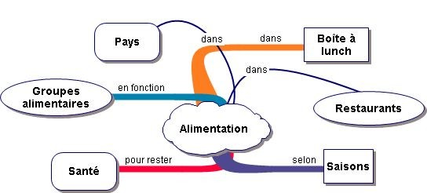
Exemple de carte conceptuelle:

Source: http://france1martineau.canalblog.com/archives/2006/09/26/2763355.html

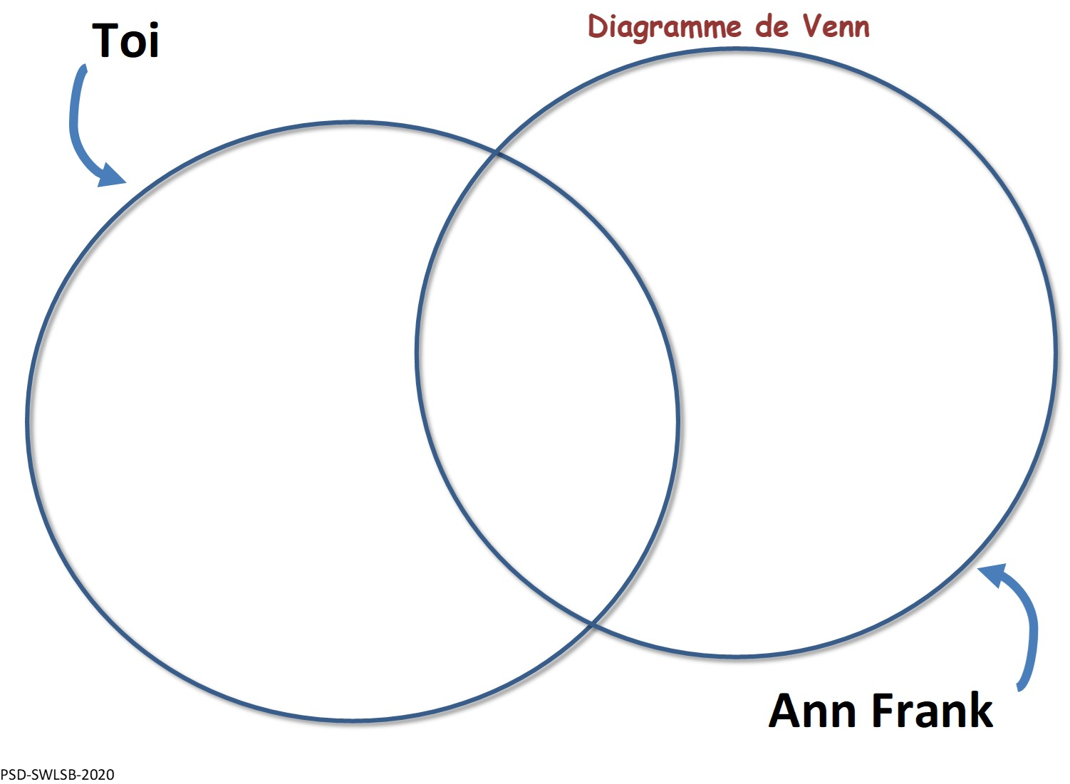

Discover / Rediscover Pi (π)
Information for students
- This activity is to help you discover or rediscover pi (π), the fascinating relationship between the diameter and the circumference of a circle.
- This activity can be done with circular household objects or by using the printed circles attached.
- This video gives you an overview of pi, but is not necessary for the completing the activity. https://www.youtube.com/watch?v=cC0fZ_lkFpQ&t=37s
- As you work, record all measurements in the data chart provided or create your own.
  - Step 1: Record the name of the item in the data chart. For example, Coffee cup.
  - Step 2: Measure the circumference (distance around the outside of the circle) with a string. Lay the string flat on a ruler in order to get the measurement for the circumference. Record the length in the data chart.
  - Step 3: Measure the diameter (largest distance through the centre of the circle from side to side) with a string or ruler. Record the length in the data chart.
  - Step 4: Find the ratio between the circumference and the diameter by dividing the circumference by the diameter.
  - Step 5: Repeat steps 1 to 4 for several different circles.
  - Step 6: What do you notice about the ratios? How close were you to discovering pi (about 3.14). If you were not close, try remeasuring carefully to see if precision can lead to a closer result.
Materials required
- String, measuring tape or ruler
- Calculator
- Circular objects from around your home OR use the printable circles attached
- Writing materials, paper to create a data chart or print the data chart attached
Extension:
- Watch the video below to discover where the terms diameter and circumference came from. https://www.youtube.com/watch?v=DG2GypelzQw
- Now that you have discovered the relationship between the diameter and the circumference of a circle, try the circumference extension activities attached.
Information for parents
- Help your child organize the materials needed.
- Read the instructions to your child if necessary or remind them to use available assistive technologies.
- Help your child measure and record data if needed.
- Encourage them to make links to real life objects like wheels and discuss how the size of the wheel will impact the distance travelled for one turn.

Data Chart
Name of Circular Object | Circumference (Distance around the outside of the object) | Diameter (Distance across the middle of the object at the widest point) | (Circumference ÷ Diameter) (Distance around the object divided by the distance across)
Coffee Cup | 29.8cm | 9.5cm | 3.136

Printable Circles (or use circular objects from your home)
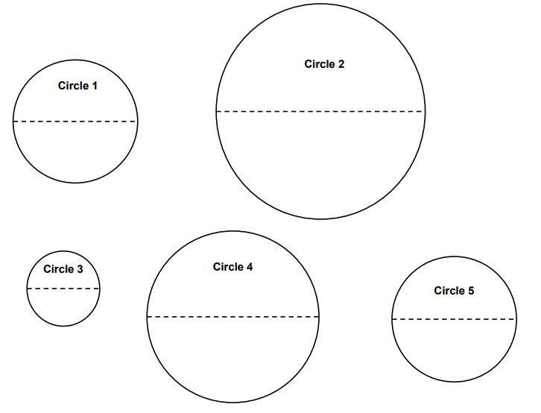

Circumference Extension Activities
Extension Activity 1:

Below is a diagram of a square cardboard pizza box that has a perimeter of 68 cm. The company selling pizzas wants to fit the largest possible pizza in the box. What is the circumference of the largest pizza that can fit into the cardboard box?

Extension Activity 2:
A pizza has a circumference of 25.12 cm. The company selling the pizza wants to package it in the smallest possible square box in order to save money. What would be the dimensions of the smallest box that this pizza would fit into?

Answers:
- The ratio between the circumference and diameter of a circle should be about 3.14 for the activity.
- Answers to the Circumference Extension Activities: #1) 53.38cm #2) 8cm x 8cm.

Sugar Crystals
Instructions for students
There are three types of rocks: metamorphic, sedimentary, and igneous. This week, our focus will be on igneous rock, specifically the production of crystals.
Crystallography is an important part of geology that deals with the formation and internal structure of crystals. Igneous rocks crystallize to form large crystals (inside the earth) or smaller crystals (when they erupt onto the surface).
- Start by reading up on crystals

- Reflect on what you’ve read by answering the following questions:
  - Describe a crystal (touch on its appearance, state and shape).
  - What does a crystal look like at an atomic level?
  - An extrusive igneous rock is formed outside the soil and is made up of fine crystals. During its formation, the atoms that make up the rock didn’t have time to place themselves correctly to form large crystals. Was the cooling of this type of rock fast or slow?
  - An intrusive igneous rock forms inside the soil. So, it cools more slowly. Will the crystals be larger or smaller than those formed outside the soil?
  - Rock candy, also known as sugar candy or sugar rock, is a delicious treat. It is made up of large crystals similar to that of a diamond. During its production, must its growth be slow or fast? Why?

- Now, let’s make your own sugar crystals. Follow the steps as outlined on the video.

- You may wish to extend your learning by asking yourself the following questions:
  - What would happen if I dissolved more sugar? Is there a point where too much sugar might be added?
  - What would happen if I let it sit in the solution for longer than 1 week? (Would there be more crystals? Bigger crystals? Why?)

- Finally, enjoy! Eat the delicious rock candy (or gift it to a family member).
Materials required
- 1 small pot
- Jars or glasses/cups (preferably transparent)
- Sugar (App. 700 grams – 3 cups + a little extra)
- Water (App. 300 mL – 1 cup + a little extra)
- Sticks (any type – chopstick, lollipop, skewer etc.)
- Clothespins (or something similar to hold stick in place)
- Food colouring or coloured/flavoured syrup (optional)

Information for parents
In this activity, children will:
- read up on crystals and make their own by following a very easy recipe.

Parent can:
- allow their child the opportunity of running through a recipe several times (scientific method).

Timely Stamp
Information for students
- These are difficult days and we all miss things and people that were part of our daily lives not so long ago. What do you miss the most? This activity gives you a chance to use words, drawings or both to create a stamp that celebrates these things you miss.
- Make a list or think of the little and big things you miss. This can include people such as family members or friends, places you enjoy going, group events such as sports, etc.
- Start by tracing the outline of your stamp. See the picture below.
- Add pictures and words to illustrate these things you miss. It does not have to be perfect! You can create a beautiful stamp by shading with a pencil in different ways, by using coloured pencils for a colourful stamp, or just by using two or three colors of your choice.
- Do not forget to include “Canada” somewhere in the stamp.
- Ideas for the stamp: friends, family members, sayings, emojis, foods, places, short quotes, inspiring words, etc.
Materials required
- Paper of any size
- Pencil or coloured pencils, pen

Information for parents
- If necessary, discuss things your child misses and focus on celebrating them by talking positively about them.
- The template below does not have to be printed. Students can draw their own stamp outline by using this template as a guide.
- If possible, hang your child’s work of art!

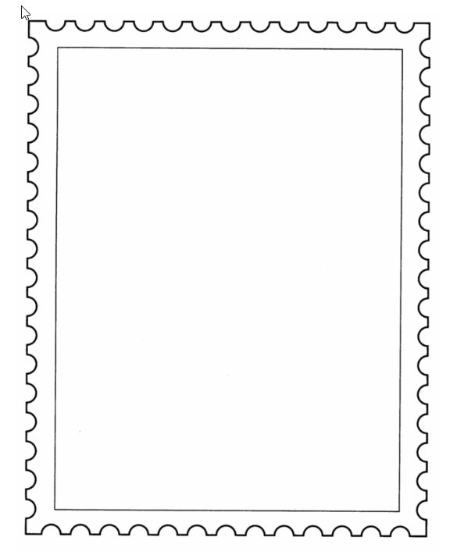

Having an Impact Online
Information for students
- Staying at home means spending lots of time online. Lots of time online means increased chances of seeing something hurtful take place. Take this quiz to see if you know how to react when witnessing cyberbullying. https://impact.mediasmarts.ca/en.

- Now look at these posters offering further suggestions for having a positive impact online: https://impact.mediasmarts.ca/en/teachers, (scroll down to For Teachers posters).
- Extra inspiration 1: Make a list of ways you will commit to having a positive impact online. Create your own posters, using these resources for inspiration.
- Extra inspiration 2: Make a list of ways these suggestions can be transferred into real life situations. Create another poster or adjust the online poster to apply offline as well!
Materials required
- device with Internet access
- paper, writing and drawing materials
Information for parents
- Download the guide for parents: For Parents
https://mediasmarts.ca/sites/mediasmarts/files/guides/navigating_cyberbullying_guide.pdf

The Future of Energy Consumption
Information for students
- Did you know that Canada is a world leader in innovation when it comes to producing the oil and gas we need for our daily energy needs? That’s important because the world needs oil and natural gas, and this demand may increase in the future.
- Go to https://youtu.be/jb6PPOg77H8 (2:40 minutes) to find the video Oil and Gas innovation from Canadian Geographic.
- Enjoy the video!

Questions to consider:
  - What are some uses for the oil and gas developed in Canada?
  - What is the impact of growing energy consumption on the environment?
  - What are some innovations happening in the oil and natural gas industry to reduce the environmental impact?
  - Think about your current energy needs. How has your energy consumption changed in the last month and why? What measures might you take to reduce your energy consumption over the long term? Share your ideas with your family and friends.
- Extension activity: To learn more about the energy produced in Alberta, check out this factbook on Alberta’s energy story from Canadian Geographic’s Energy IQ. Test your knowledge of Alberta’s energy resources!
Materials required
Useful resources, depending on personal preferences and availability:
- writing and drawing materials (paper, pencils, etc.)
- device with Internet access

Information for parents
- Help your child find the link to the video.
- Review the instructions with your child, if necessary.

Reviewing Civilizations
Information for students
- In your History and Citizenship Education course you may have studied various civilizations and societies in Europe and around the world.
- For each of these you discussed economy/trade, religion, political institutions/laws, culture and beliefs.
- Choose one of the aforementioned civilizations and list one item that you can remember for each theme:
  - Economy/industrialization
  - Religion
  - Political Institutions/laws
  - Culture and Beliefs
- Once you have something written for each, compare them with today’s society. Think about what has remained the same and what has changed?
- You can use your memory, your textbook if you have it, or the Internet to help you remember. You can even call a classmate and do it together.
Materials required
Useful resources, depending on personal preferences and availability:

- writing and drawing materials (paper, pencils, etc,)
- Device with Internet access

Information for parents
- You can help your child research the information in their text or on the Internet, or perhaps you can remember items together.

- If necessary, help your child read information they have found and help them make comparisons with today’s society. The main goal is to be able to recognize that while things have changed, some remain the same.

