Epilogue
Information for students
The Present
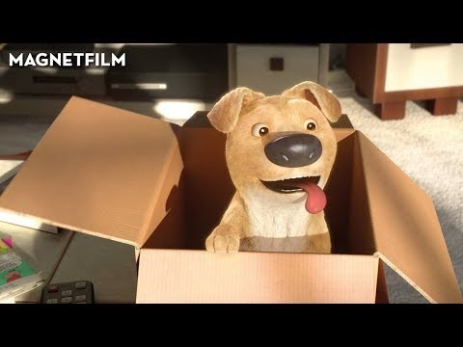
- Watch the short film and then discuss it with your parents or friends online.
- Write an epilogue in the form of a dialogue between the mother and the son.
epilogue or ep·i·log
noun
- a concluding part added to a literary work, as a novel.
- a speech, usually in verse, delivered by one of the actors after the conclusion of a play.
Source: https://www.dictionary.com/browse/epilogue?s=t
Materials required
- Link to the short film (https://www.youtube.com/watch?v=C_nJJHaNmnY)
- Paper and pen
- Phone, tablet or computer
Information for parents
Above all, this activity is designed to be simple! We hope it will appeal to your child whatever their grade level. The best things your child can do are:

- Read every day.
- Write every day.
- Talk every day.

La bonne nouvelle du jour !
Consignes à l’élève
- As-tu lu ou entendu une bonne nouvelle cette semaine ? Quelque chose d’inspirant ? As-tu appris quelque chose d’intéressant ou d’amusant ?
- Cette semaine, appelle quelqu’un que tu connais et parle-lui en français de ce que tu as appris.
- Peut-être qu’une personne de ton entourage parle français ? Sinon, tu peux parler en français avec un ami pendant cinq minutes… ou plus! C’est à vous de décider.
Matériel requis
- Journal, livres, magazines de la maison.
- Site 1 jour1actu (actualités quotidiennes) : https://www.1jour1actu.com.
- Téléphone, médias sociaux.

Information for parents
Activity details
This activity will help students successfully meet the following #MISSIONFLS challenge:
- Mission en équipe – Je discute d’un sujet d’actualité positif qui m’intéresse avec ma famille ou mes amis.

In this activity, students will practise:
- speaking French with no preparation
- developing their vocabulary
- developing their confidence speaking French

Parents could:
- ask for support from someone they know who speaks French
- plan a specific time during the week for the conversation in French to take place
Reference: bit.ly/MissFLSSecCycle1

#MissionFLS - Bonne fête des mères !
Consignes à l’élève
Cette activité t’aidera à compléter la Mission FLS : Je fabrique des cartes de vœux.

Le deuxième dimanche de mai est la fête des mères. C’est la chance de dire à des personnes qui sont importantes pour nous qu’on les aime. Cette semaine, on te propose de faire une carte de souhait pour cet événement.

Voici comment tu peux le faire :
- Pense à ce que tu aimerais dire à ta mère ou à une personne qui est importante pour toi.
- Inspire-toi ! Consulte des sites de cartes de souhaits, de poèmes ou de citations et trouve des mots, des passages que tu aimes.
- Fabrique ta carte en papier ou en ligne et envoie-la !

Matériel requis
Des ressources pour t’inspirer :
- https://www.dromadaire.com/cartes-fete-des-meres
- http://www.iladit.com
- https://www.proverbes-citations.com/citations-par-themes/
- https://www.mon-poeme.fr/poesies-poemes-themes/

Des ressources pour créer ta carte :
- https://www.canva.com/fr_fr/creer/cartes/cartes-de-voeux/
- https://piktochart.com

Mission FLS : https://www.learnquebec.ca/fr/misionsflsc1

The Secret is the Message

Information for students
- This activity will focus on your knowledge of algebra and the order of operations as well as your problem-solving abilities.
- Solve the equations, and see if there is a pattern that exists between the answers you obtained.
- Use the equation table and the substitution cipher provided in Appendix A to write your answers and identify the emerging pattern.
- The answers will lead you to identify the code that will allow you to solve the encrypted message.
- Here is the encrypted message:
“4743118347613707: 7147171171191161027119474111.” 173747030237052371231011143 / 831947

Materials required
- The equations and the encrypted message
- The substitution cipher
- Writing materials, calculator, paper
Information for parents
- Read the instructions to your child, if necessary.

- Your child has the basic mathematical knowledge to solve the equations and the encrypted code, but may require some assistance. Ask them to explain to you what they are doing. It will help them make sense of things without you giving them the answer.

- The answers are provided at the end of this document, but should not be shared with your child at the beginning for obvious reasons. Give them the answers as a last resort. Let your child struggle as much as possible. The satisfaction of “breaking the code” will be their reward! Resilience is an important quality to develop in children.

Appendix A: The Secret is the Message

Introduction
Did you know that cryptology – the science of writing messages in secret form - first appeared in Egypt in 1900 BC. Even historical figures like Julius Caesar, and Mary Queen of Scots used encrypted messages to communicate with their armies and allies. Today, this science is also used to protect digital data. To understand an encrypted message, you need to know how the message was encrypted. This can be done by mixing up or switching existing letters, which creates a cipher. The cipher is the “key” that helps you to understand the encrypted message. This activity will introduce you to a special type of encryption cipher: the substitution cipher.

The challenge? Building a substitution cipher!
- The first thing to do is to find the value of the unknown for equation 1. Write your answer in the Result column on the right.
- Find the unknowns for equations 2 and 3 and write your answers in the Result column on the right.
- Do you see a pattern emerging? What can you say about the resulting numbers? How are they related?
- What do you think the answer to question 4 is? Find the value of the unknown. Were you right? Yes, no?
- Solve equation 5. Does your prediction still work? Confirm it by finding the answer to equation 6.
- If you don’t see the relationship, check your calculations to make sure they are correct. If they are, then focus on your answers. What is the relationship that ties all these numbers together?
- Once you have the pattern, you are ready to complete the substitution cipher from a to z. Start by writing the result for “a” under the “a”, the result for “b” under the “b”, and so on. Use the answers you have calculated and the pattern to complete the rest of the substitution cipher. Note that each letter is coded using at least two digits. This means that single digits are written as 01, 02, etc.
- You are now ready to substitute the letters for the encrypted message. You may need more space, so do this on another page but be careful when rewriting the code.

# | Equation | Result
1 | $$3a – 2 + 4 ( a – 1 ) = 8$$ | a =
2 | $$4b – 7 ( 10 – 2^{2}) + 8b = - 6$$ | b =
3 | $$2 ( 12 – 5c^{2} ) + 3 ( 5c^{2} - 8 ) + 10c = 5 ( 5^{2} – c ) + 15c$$ | c =
4 | $$13 \left( 3d-6 \right)-22=7 \left( 2^{5}+d \right)-100$$ | d =
5 | $$\frac{6 \left(3e-8 \right)-5}{5}=3e-4$$ | e =
6 | $$\frac{5f-9-4f+5}{3}= \frac{7f+3-6f-4}{4}$$ | f =
Substitution Cipher
a | b | c | d | e | f
g | h | i | j | k | l
m | n | o | p | q | r
s | t | u | v | w | x
y | z

Here is the encrypted message once again:
“4743118347613707: 7147171171191161027119474111.” 173747030237052371231011143 / 831947
Here is another encrypted message, which you will try to find by using the same substitution cipher. This message provides you with “the key to success”:
“677305051167137337024307734367730505116767137337531147533711074743477179026197 1761110271379723437119112361020323372371231167. 71191197902619723437119112361 07116723611167714761110205197119112361534771114371230237.” 2947194341028983113737

Discussion
What was the relationship between all the answers? What other similar type of mathematical relationship could have been used? What could be done to make the cipher more complex? Can you create a code for your friends to break?

Interesting Resources
The following online resources may be of interest to those who want to learn more about cryptology. They are also the source of some of the information provided above.
Cryptology Timeline; The Secret Language; Encryption System;

Appendix B: Answer Key

Hints and Solutions for Teachers or Parents
- The pattern to be identified: the answers are all prime numbers.
  - If your child/student is struggling, ask them if the answers are odd numbers? Even numbers? Multiples of two? Multiples of three? Help them focus on the type of number they are seeing. As a last resort, show them this video: Sieve of Eratosthenes.
  - Did they remember that a, b, c, and d must be written as 02, 03, 05, and 07? No prime number ends with 0, so your child/student should notice this. You may tell them that all the letters are represented by a two-digit code, except for Z, which is represented by a three-digit code.

- Substitution Cipher (Solution)

a | b | c | d | e | f
02 | 03 | 05 | 07 | 11 | 13
g | h | i | j | k | l
17 | 19 | 23 | 29 | 31 | 37
m | n | o | p | q | r
41 | 43 | 47 | 53 | 59 | 61
s | t | u | v | w | x
67 | 71 | 73 | 79 | 83 | 89
y | z
97 | 101

- The answer to the first encrypted message, and the only one that needs to be solved, is:
  - “One world: Together at home” Global Citizen / WHO
- The answer to the second encrypted message, for those who want to read words of wisdom:
  - “Successful and unsuccessful people do not vary greatly in their abilities. They vary in their desire to reach their potential.”
John Maxwell

Solar System Model

Information for students
Using objects you find around your home, you are going to build a model of the solar system.
Each planet and dwarf planet will be represented by a scaled object. The space between “planets” will also be scaled appropriately.
If you have internet access, visit https://www.exploratorium.edu/ronh/solar_system/ to determine the dimensions and orbits of your “planets” in the “Solar System Model” section.
If you do not have internet access, please use the measurements in Appendix A to build your model.

Materials required
- Any household items (e.g. bowl, cup, mug, vitamins, golf ball, etc.)
- A measuring tool (e.g. ruler, measuring tape, metre stick, etc.)
- Device with Internet access (optional)
Information for parents
- See the following links for additional information:
  - Exploratorium Observatory
  - If the Moon Were Only One Pixel
  - NASA
  - National Geographic Video

Appendix A: Solar System Measurements

Body | Body Diameter (km) | Scaled Body Diameter (mm) | Orbit Radius (km) | Scaled Orbit Radius (mm)
Sun | 1 391 900 | 750
Mercury | 4 866 | 2.6 | 57 950 000 | 31.225
Venus | 12 106 | 6.5 | 108 110 000 | 58.253
Earth | 12 742 | 6.8 | 149 570 000 | 80.593
Mars | 6 760 | 3.6 | 227 840 000 | 122.767
Jupiter | 142 984 | 77 | 778 140 000 | 419.286
Saturn | 116 438 | 62.7 | 1 427 000 000 | 768.912
Uranus | 46 940 | 25.2 | 2 870 300 000 | 1 546.608
Neptune | 45 432 | 24.4 | 4 499 900 000 | 2 424.689
Pluto* | 2 274 | 1.2 | 5 913 000 000 | 3 186.112

Learn About Vaping and Get Moving!
Information for students
Activity 1: Learn about vaping
- Learn about the mechanics of vaping by watching this video (1 min 8 sec).
- What substance do vaping products contain that is highly addictive?
- The video says that “vaping is not intended for youth and non-smokers.” Who do you think vaping could be a valid option for?
- Discuss what you learned about vaping with a member of your family.

Activity 2: Get moving!
- Look at the diagram containing circuit training exercises to be completed with a soccer ball (available in French only).
- Read the instructions for each step and look up any French words that you do not understand. Find an area where you can set up the circuit. Use chalk or tape to create your own agility ladder.
- Follow the circuit training instructions, performing the ball movements and exercises.
- Using the same circuit set-up, create a new workout routine by changing the exercises. What other ball skills and strength exercises can you include?
Materials required
- A soccer ball or another type of ball
- Chalk or tape

Information for parents
About the activity
Children should:
- learn about vaping
- set-up and carry out the circuit training workout

Parents could:
- discuss what their child has learned about vaping
- participate in the circuit training workout with their child

Tree Silhouettes
Information for students
This is the ideal time of year to notice the beautiful trees that surround us. Before they are
covered with leaves, deciduous tree silhouettes are most visible. This activity can be done outside
or from inside. The challenge is to observe and draw in as much detail as you can at least two
tree silhouettes as you see them from where you are.

Make sure you notice the following: the overall shape of the tree (round, long, V-shaped etc.), the
size of the trunk (long, short, shorter or longer that the rest of the tree), the direction of branches
(going up, going sideways, pointing down, or a combination of these).

No matter the size of your paper, use as much of the space on the page as you can to draw the
tree silhouettes. Draw up to three silhouettes per page.

Start with the general shape of the tree. Sketch this very lightly.

You can also use the steps above to sketch the silhouettes of evergreens such as pine trees.
Don’t forget to add your name and the date to your drawing. Be proud of your work!
Materials required
- Paper or any size
- A hard surface to put your paper on, such as a table or book
- Pencil (not coloured pencils, but you can do colour silhouettes if you wish)

Information for parents
- Observe the different tree shapes visible from your home (inside or outside)
- If you can see more than one tree, draw attention to the differences in their silhouettes: the overall shape of the tree, the sizes, the way branches grow up or sideways.
- Optional: Research what type of tree it could be.
- Optional: Repeat the activity with evergreens.

Be an Upstander
Information for students
- Go the Canadian museum for Human Rights
- What are your human rights?
- Explore stories of real upstanders
- Explore how you would stand up for injustice
Materials required
- device with Internet access
- paper, writing materials

Information for parents
- Help your child find the link to the website
- Read through the activity with your child
- Discuss the questions together

Infographic on a Metropolis
Information for students
- An infographic is a popular way of quickly communicating important facts in a visual way. By using icons and only a little text, you can make dry facts more visually appealing, more interesting to read and easier to understand.
- In this activity, you will learn to create your own infographic to share information about a world metropolis. Begin by choosing a metropolis and learning a bit about it.
  - Choose from Montréal, New York City, Sydney, Cairo or Mexico City.
  - You will find links to some demographic information about the populations of these cities in the materials section below. Pick out some facts that tell the story of this metropolis.
  - You may also conduct your own searches to find out other characteristics about your chosen metropolis.
- Option 1 - Online:
  - Access the first video in the “Design an Infographic in Google Drawings” project on the Applied Digital Skills website. This project consists of 5 video lessons. Each video will show you how to complete a few steps of your infographic using Google Drawings. There is no need to sign in to the Applied Digital Skills website. Watch each video and complete the suggested steps using your chosen metropolis as your topic. You can re-watch as many times as you need to and pause as you go. Once you are ready to move on, click the “Next” button at the bottom of the page.
  - The tutorial uses Google Drawings, but you can use the same principles in any tool that will allow you to insert images and text.
- Option 2 - Occasional access to an Internet connection
  - If you are able to access an Internet connection some of the time (e.g. drive to a school and connect while remaining in your car), you can download the videos to view them offline. The full download is 470 MB. Use this link to download
  - If you are not able to download the videos but you have some connectivity from home, you may be interested in accessing the “Design an Infographic in Google Drawings” but working from the transcripts beneath each video.
- Extensions – Option 1 and 2:
  - If you would like to continue working on your infographic, consider some of the following extensions:
    - Add Shapes and Lines
    - Add Word Art
    - Use Icons to Represent a Number or Statistic
  - Consider an issue that affects this metropolis. Examples include: housing problems, urban sprawl encroaching on agricultural land, population moving to the suburbs, road congestion, waste management, water supply, high population density. Create a section in your infographic for raising awareness about this issue.

- Option 3 - No Internet connection or no device
  - Refer to the printable resources in Appendix 1. These include
    - some demographic information about New York City
    - an example of an infographic.
  - Create a simple poster with a few facts and simple icons to illustrate it.
  - You can use any offline tool that will allow you to combine text and images. Remember that, even if you are using a Chromebook, Google Drawings and Google Slides can be created in offline mode.
  - You can create a paper version of an infographic if you have no device.
Materials required
Useful resources, depending on personal preferences and availability:
- device with Internet access (optional)
or
device with occasional access and the ability to download the videos (optional)
- Google (GSuite or personal) account for Google Drawings or other graphics tool (can be offline)
or
paper, writing, and drawing materials

The “Design an Infographic in Google Drawings” lesson materials:
- online: “Design an Infographic in Google Drawings” lesson from the Applied Digital Skills website
- some Connectivity: Downloadable Videos Version

Useful links to begin your research
- Montréal, Canada
  - Montreal Census Data from Statistics Canada

- New York City, USA
  - NYC Planning from the New York Department of City Planning

- Sydney, Australia
  - Census Data from the Australian Bureau of Statistics

Information for parents
- The goal of this activity is to have the student identify and work with the characteristics of a metropolis.
- You child may need help choosing meaningful data to include in their infographic. It can be helpful to discuss with them the picture they are painting of this metropolis. Let them tell the story through the data. Points of interest include location in the world, population, population density, relative size compared with the country, multi-ethnicity, and urban sprawl
- Note that, while the example given uses Google Drawings, the same activity can be carried out using any tool that allows a combination of icons and text.

Appendix 1
Printable Resources for Students Without an Internet Connection
Here are some interesting facts about the New York City population:
- With a July 2015 population of 8 550 405, New York is the most populous city in the United States, more than twice the size of the second largest city, Los Angeles.
- About 1 in every 38 people living in the United States resides in New York City.
- New York has the highest population density of any major city in the United States, with over 27 000 people per square mile.
- Over 3 million of New York City’s residents are foreign-born; over one quarter arrived in 2000 or later.
- Nearly 2 million New Yorkers are under the age of 18.
- New York City has more people than 40 of the 50 U.S. states.
- New York City comprises over two fifths of New York State’s entire population.
- New York City has grown by over 1 million people since 1990.
- The 2014 median age in New York City was 35.8 years, almost two years lower than the national median of 37.7 years.
- Over one third of the population 25 and over in New York City has a bachelor’s degree or higher, compared with 30 percent nationally.
- There are nearly 400 000 more women than men in New York.
- There is a birth in New York City every 4.4 minutes.
- There is a death in New York City every 9.1 minutes.
- The borough of Brooklyn on its own would be the 4th largest city in the United States; Queens would also rank 4th nationally.
- Approximately two thirds of dwelling units in New York are renter-occupied, over twice the national average.
- The average commute for New Yorkers is just over 40 minutes, about 14 minutes longer than the national average.
- New York City has the largest Chinese population of any city outside of Asia.
- More persons of West Indian ancestry live in New York City than any city outside of the West Indies.
- New York has the largest Puerto Rican population of any city in the world.
- More Dominicans live in New York than any other city in the world, barring Santo Domingo.
- Over 2.4 million Hispanics reside in New York City, more than in any other city in the United States.
- The Black non-Hispanic population of New York City numbered 1.89 million in 2014, more than double the count in any other U.S. city.
- Half of all New Yorkers speak a language other than English at home.
- Over 200 languages are spoken in New York City.
Sample Infographic:
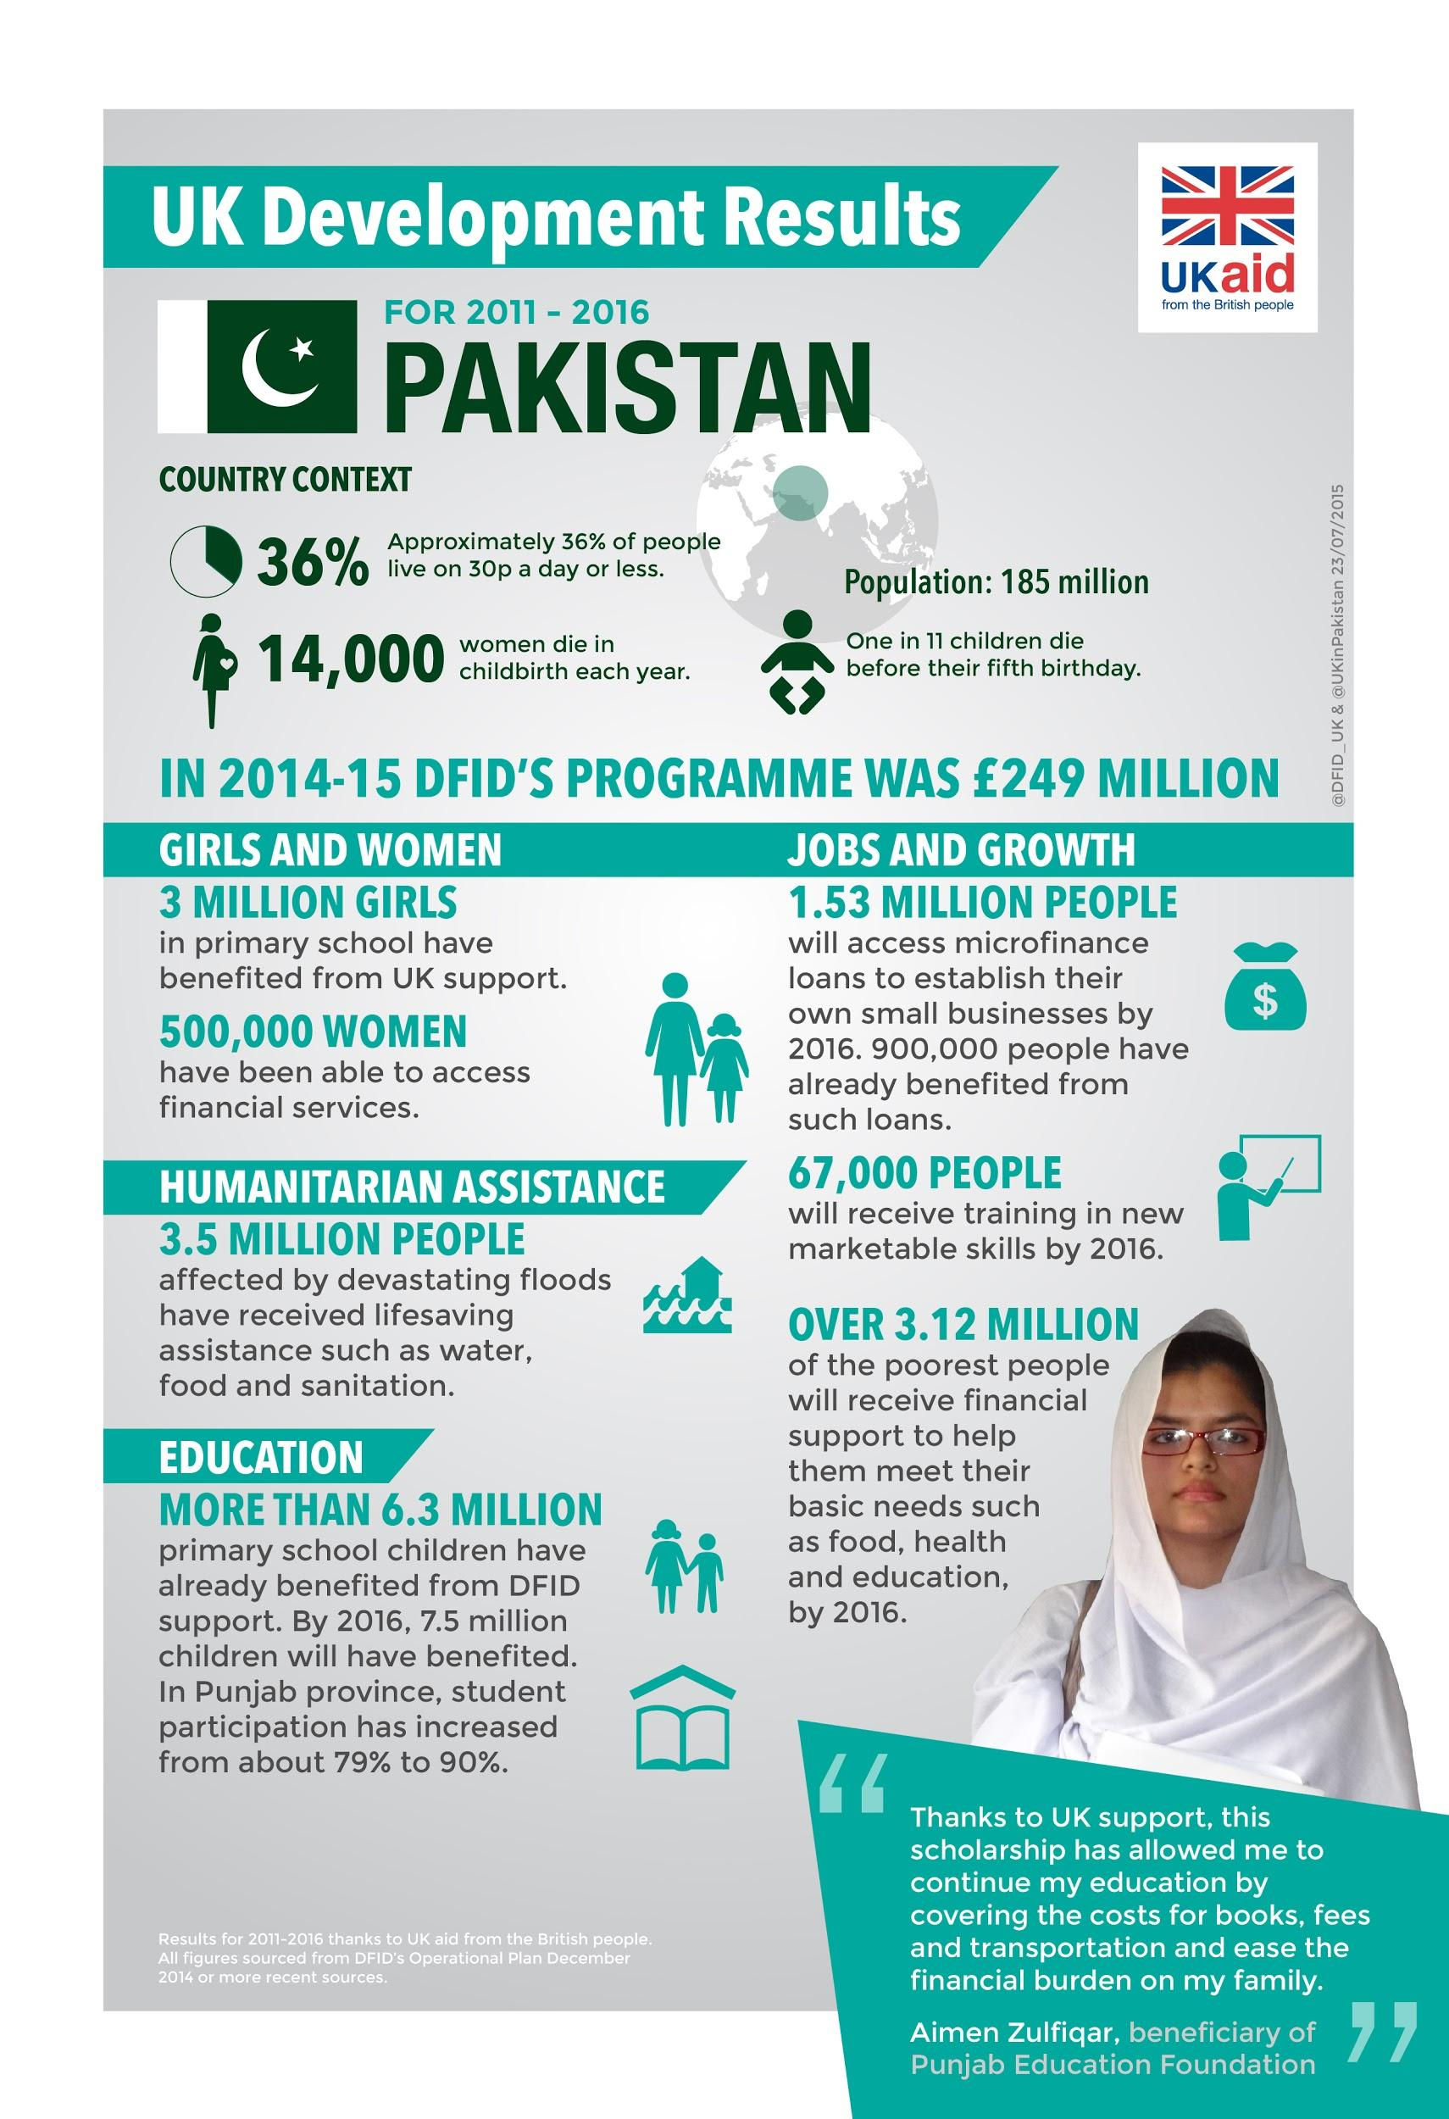
"File:Infographic- Pakistan - 2016 (20570481241).jpg." https://commons.wikimedia.org/wiki/File:Infographic-_Pakistan_-_UK_aid_development_results_for_2011_-_2016_(20570481241).jpg. Accessed 22 Apr. 2020.

Civil Rights and Freedoms
Information for students
- Civil rights and freedoms you may have studied or discussed in your history class include:
  - Right to vote
  - Right to justice
  - Equality before the law
  - Freedom of expression
  - Freedom of Religion
  - Right to marry

- Using the attached chart, identify places around the world today where people do not have these rights and freedoms as well as places where these rights and freedoms were not recognized in the past. Provide an example for each and identify the people affected. Your examples may be specific or general, depending on how much information you can find or what you recall (see examples provided).

- You may remember some examples from your history class, or you may use your textbook or the Internet. Here are a few sites you may want to consult:
  - https://www.nelson.com/common/polisci/rights.html
  - https://ccla.org/education/remote-rights-project/
  - https://www.thecanadianencyclopedia.ca/en/article/civil-liberties
Materials required
Useful resources, depending on personal preferences and availability:
- device with Internet access
- writing and drawing materials
- attached chart
Information for parents
- You can help your child complete the chart and find historical and current examples.
- If necessary, help your child read information they have found and help them make comparisons and identify changes in rights and freedoms.
- Discuss how some rights and freedoms may be granted in one country but not in another.

Civil rights and freedoms | Places in the world today where people do NOT have these rights and freedoms | Places where people did not have these rights and freedoms in the past
Right to vote |  | e.g. In Québec, women were not allowed to vote in provincial elections until 1940. (You don’t need a specific date, simply an example.)
Right to justice
Equality before the law
Freedom of expression
Freedom of Religion
Right to marry | e.g. Some countries do not allow same-sex couples to marry.

1"Planning-Population-NYC Population Facts - DCP - NYC.gov." https://www1.nyc.gov/site/planning/planning-level/nyc-population/population-facts.page. Accessed 22 Apr. 2020.

