Poetry
Information for students
Read the poem “Those Winter Sundays” by Robert Hayden
https://www.poetryfoundation.org/poems/46461/those-winter-sundays

Those Winter Sundays
By Robert Hayden

Sundays too my father got up early
and put his clothes on in the blueblack cold,
then with cracked hands that ached
from labor in the weekday weather made
banked fires blaze. No one ever thanked him.

I’d wake and hear the cold splintering, breaking.
When the rooms were warm, he’d call,
and slowly I would rise and dress,
fearing the chronic angers of that house,

Speaking indifferently to him,
who had driven out the cold
and polished my good shoes as well.
What did I know, what did I know
of love’s austere and lonely offices?

- After your first read of the poem, write your initial thoughts, any questions or areas of confusion. Remember to think of the title, too.
- Read the poem a second time and ponder the following questions. Were your questions answered? Did your initial thoughts change? Do you still have questions? If so, could a discussion with someone else help clarify your understanding?
- Read the poem a third time and ponder the following ideas. This poem reminded me of. . . The poem made me feel. . . The mood of the poem is . . .
- Using only five sentences, write about the ideas the poem has awakened inside of you.
- Share with a friend.
Materials required
- Device with Internet access
- Paper and writing materials
Information for parents
- Read the poem with your child and discuss their answers.
- Discuss a poem that impacted you and why.
- You can also look at song lyrics together.

Une recette à partager
Information for students
Choisis une recette dans un livre, en ligne ou crée ta propre recette originale.
Sur une feuille de papier, note le procédé à l’aide de dessins, de mots clés et de consignes (verbes à l’infinitif) sous forme de « sketchnote ». Pour avoir des idées, cherche en ligne des images de recettes sous forme de « sketchnote ».
Inclus les détails importants tels que les ingrédients, les quantités et les étapes à suivre.
Avant de partager et de déguster ton plat (repas, dessert, bouchée) avec les membres de ta famille, explique-leur comment tu as procédé pour préparer celui-ci.
Réponds à leurs questions s’ils en ont.
Pour aller plus loin : Fais une vidéo de toi en train de cuisiner ton plat. Tu peux ensuite la partager avec des amis ou des membres de ta famille qui n’habitent pas avec toi pour les encourager à essayer cette recette. N’oublie pas d’utiliser des verbes à l’impératif présent pour donner tes consignes.
Materials required
- Papier, crayon, crayons de couleur, livre de recette ou recette en ligne, appareil électronique pour filmer;
- Ingrédients nécessaires pour faire la recette.
Information for parents
Help your child choose a recipe to do, making sure you have the necessary ingredients on hand.

Make sure your child carries out the different steps of the recipe safely (when using a knife, the oven, etc.).

Ask your child questions about the order of the steps to follow.

Build French vocabulary related to the recipe (ingredients, utensils) and to cooking (verbs in the infinitive for the sketchnote, verbs in the present imperative [impératif présent] orally in the video).

Gabriel’s Problem
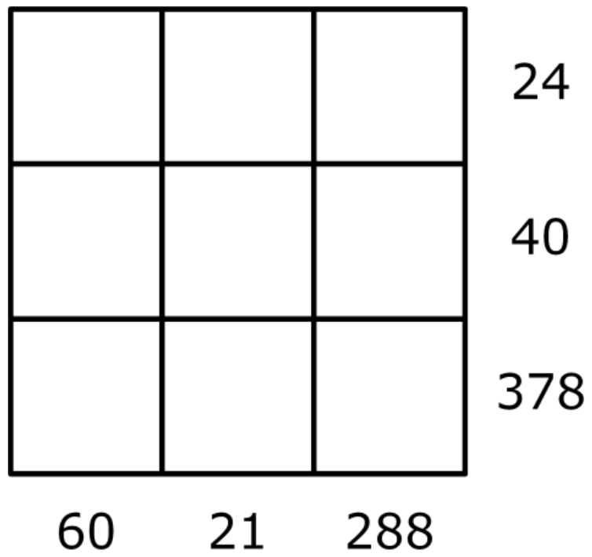
Information for students
- Gabriel wrote the numbers 1 – 9 in a 3x3 grid.
- He multiplied together all the numbers in each row and wrote the resulting product next to that row.
- He also multiplied the numbers in each column together, and wrote the product under that column.
- Gabriel then erased the numbers 1 – 9.
- Can you work out where Gabriel placed the numbers 1 – 9?
Materials required
Please list and describe the materials required
- Paper and pencil
Information for parents
- The purpose of the activity is to use divisibility rules and common factors to complete the grid using the numbers 1 – 9.

- This activity can be completed by a secondary cycle one year one student.

- Enrichment extensions to this problem can be found at https://bit.ly/2XiBfEG

University of Cambridge. (n.d.). Gabriel’s Problem. NRICH. https://nrich.maths.org/11750

Sugar Crystals
Instructions for students
There are three types of rocks: metamorphic, sedimentary, and igneous. This week, our focus will be on igneous rock, specifically the production of crystals.
Crystallography is an important part of geology that deals with the formation and internal structure of crystals. Igneous rocks crystallize to form large crystals (inside the earth) or smaller crystals (when they erupt onto the surface).
- Start by reading up on crystals.

- Reflect on what you’ve read by answering the following questions:
  - Describe a crystal (touch on its appearance, state and shape).
  - What does a crystal look like at an atomic level?
  - An extrusive igneous rock is formed outside the soil and is made up of fine crystals. During its formation, the atoms that make up the rock didn’t have time to place themselves correctly to form large crystals. Was the cooling of this type of rock fast or slow?
  - An intrusive igneous rock forms inside the soil. So, it cools more slowly. Will the crystals be larger or smaller than those formed outside the soil?
  - Rock candy, also known as sugar candy or sugar rock, is a delicious treat. It is made up of large crystals similar to that of a diamond. During its production, must its growth be slow or fast? Why?

- Now, let’s make your own sugar crystals. Follow the steps as outlined on the video.

- You may wish to extend your learning by asking yourself the following questions:
  - What would happen if I dissolved more sugar? Is there a point where too much sugar might be added?
  - What would happen if I let it sit in the solution for longer than 1 week? (Would there be more crystals? Bigger crystals? Why?)

- Finally, enjoy! Eat the delicious rock candy (or gift it to a family member).
Materials required
- 1 small pot
- Jars or glasses/cups (preferably transparent)
- Sugar (App. 700 grams – 3 cups + a little extra)
- Water (App. 300 mL – 1 cup + a little extra)
- Sticks (any type – chopstick, lollipop, skewer etc.)
- Clothespins (or something similar to hold stick in place)
- Food colouring or coloured/flavoured syrup (optional)

Information for parents
In this activity, children will:
- read up on crystals and make their own by following a very easy recipe.

Parent can:
- allow their child the opportunity of running through a recipe several times (scientific method).

Timely Stamp
Information for students
- These are difficult days and we all miss things and people that were part of our daily lives not so long ago. What do you miss the most? This activity gives you a chance to use words, drawings or both to create a stamp that celebrates these things you miss.
- Make a list or think of the little and big things you miss. This can include people such as family members or friends, places you enjoy going, group events such as sports, etc.
- Start by tracing the outline of your stamp. See the picture below.
- Add pictures and words to illustrate these things you miss. It does not have to be perfect! You can create a beautiful stamp by shading with a pencil in different ways, by using coloured pencils for a colourful stamp, or just by using two or three colors of your choice.
- Do not forget to include “Canada” somewhere in the stamp.
- Ideas for the stamp: friends, family members, sayings, emojis, foods, places, short quotes, inspiring words, etc.
Materials required
- Paper of any size
- Pencil or coloured pencils, pen

Information for parents
- If necessary, discuss things your child misses and focus on celebrating them by talking positively about them.
- The template below does not have to be printed. Students can draw their own stamp outline by using this template as a guide.
- If possible, hang your child’s work of art!

Having an Impact Online
Information for students
- Staying at home means spending lots of time online. Lots of time online means increased chances of seeing something hurtful take place. Take this quiz to see if you know how to react when witnessing cyberbullying. https://impact.mediasmarts.ca/en

- Now look at these posters offering further suggestions for having a positive impact online: https://impact.mediasmarts.ca/en/teachers, (scroll down to For Teachers posters).
- Extra inspiration 1: Make a list of ways you will commit to having a positive impact online. Create your own posters, using these resources for inspiration.
- Extra inspiration 2: Make a list of ways these suggestions can be transferred into real life situations. Create another poster or adjust the online poster to apply offline as well!
Materials required
- device with Internet access
- paper, writing and drawing materials
Information for parents
- Download the guide for parents: For Parents
https://mediasmarts.ca/sites/mediasmarts/files/guides/navigating_cyberbullying_guide.pdf

The Future of Energy Consumption
Information for students
- Did you know that Canada is a world leader in innovation when it comes to producing the oil and gas we need for our daily energy needs? That’s important because the world needs oil and natural gas, and this demand may increase in the future.
- Go to https://youtu.be/jb6PPOg77H8 (2:40 minutes) to find the video Oil and Gas innovation from Canadian Geographic.
- Enjoy the video!

Questions to consider:
  - What are some uses for the oil and gas developed in Canada?
  - What is the impact of growing energy consumption on the environment?
  - What are some innovations happening in the oil and natural gas industry to reduce the environmental impact?
  - Think about your current energy needs. How has your energy consumption changed in the last month and why? What measures might you take to reduce your energy consumption over the long term? Share your ideas with your family and friends.
- Extension activity: To learn more about the energy produced in Alberta, check out this factbook on Alberta’s energy story from Canadian Geographic’s Energy IQ. Test your knowledge of Alberta’s energy resources!
Materials required
Useful resources, depending on personal preferences and availability:
- writing and drawing materials (paper, pencils, etc.)
- device with Internet access

Information for parents
- Help your child find the link to the video.
- Review the instructions with your child, if necessary.

Reviewing Civilizations
Information for students
- In your History and Citizenship Education course you may have studied various civilizations and societies in Europe and around the world.
- For each of these you discussed economy/trade, religion, political institutions/laws, culture and beliefs.
- Choose one of the aforementioned civilizations and list one item that you can remember for each theme:
  - Economy/industrialization
  - Religion
  - Political Institutions/laws
  - Culture and Beliefs.
- Once you have something written for each, compare them with today’s society. Think about what has remained the same and what has changed?
- You can use your memory, your textbook if you have it, or the Internet to help you remember. You can even call a classmate and do it together.
Materials required
Useful resources, depending on personal preferences and availability:

- writing and drawing materials (paper, pencils, etc,)
- Device with Internet access

Information for parents
- You can help your child research the information in their text or on the Internet, or perhaps you can remember items together.

- If necessary, help your child read information they have found and help them make comparisons with today’s society. The main goal is to be able to recognize that while things have changed, some remain the same.

