Poetry, Memoir, Narrative – You choose!
Information for students
Strong Emotions

We are all experiencing a wide range of strong emotions these days. Choose a strong emotion (worry, embarrassment, anger, excitement, joy, etc.). Think about the memories you have that connect to the emotion.

You can:
- Write a list poem of the times you experienced this emotion.
- Use ideas connected to the emotion as a story idea.
- Pick a new emotion and start thinking of more ideas.
- Consider which strong emotions generate the most ideas.
- Write a text based on one strong emotion. You can choose to write a memoir, a personal narrative, poetry, or any other text type.
- Write or record your final version of the text. Share it with others.
Materials required
- Paper, pen, phone, tablet or computer.
Information for parents
Above all, this activity is designed to be simple! We hope it will appeal to your child. The best things your child can do are:
- Read every day.
- Write every day.
- Talk every day.

J’apprends, je partage!
Consignes à l’élève
- Lis un article de journal, un livre, un site web, quelque chose qui te plaît.
- Quand tu as terminé ta lecture, parle de ce que tu as appris ou de ce que tu as apprécié à un membre de ta famille ou à un de tes amis en ligne.
Pour aller plus loin…
- Tu peux prendre des notes sur ta lecture pour t’aider à te rappeler des informations les plus importantes et les plus intéressantes. Tu peux aussi écrire une entrée de journal pour réagir à ce que tu as lu et le partager avec tes parents ou tes amis.
Matériel requis
- Journal, livres, revues de la maison.
- Livres et livres audio en ligne: https://www.learnquebec.ca/fr/secondary-french-second-language
Information for parents
About the activity
This activity will help students successfully accomplish the following #MISSIONFLS challenge:
- Mission en équipe - Je lis en français et je parle de ma lecture avec mes proches.

In this activity, students will practise:
- reading for pleasure
- identifying the important elements of a text
- sharing what they have read

Parents could:
- suggest to students a text they might like, or let students choose a text based on their interests
Reference: bit.ly/MissFLSSecCycle1

Mon guide touristique bleu
Consignes à l’élève
Le but de ce guide est de promouvoir l’endroit (village, ville, quartier, etc.) où tu vis.
Lis et consulte quelques-uns des sites proposés sur Allôprof, Le tourisme au Québec.
Visionne ensuite quelques-unes des vidéos que tu trouveras sur le site Ça bouge au Canada : Québec.
Lis le point #4 afin d’obtenir plus d’informations sur ta région Qualification Québec.
Si tu as besoin plus d’informations, consulte quelques-uns des sites suivants. Découvre ce qu’on dit à propos de ta région. Tous ces sites t’aideront pour la rédaction de ton guide touristique bleu :
  - Québec Original ; Québec Métiers D’avenir ; Emploi Québec ; Ministère des affaires municipales et de l’Habitation ; Répertoire Culture et Éducation ; Répertoire du patrimoine culturel du Québec

Tâche – Mon guide touristique bleu - Décrire la région où tu habites. (Production écrite)
  - Tu veux créer un guide touristique de l’endroit où tu habites afin d’encourager le tourisme dans ta région. Indique les formes de tourisme qui existent dans ta région (ex. tourisme balnéaire, tourisme culturel, tourisme d’aventure, tourisme de divertissement, Écotourisme, tourisme sportif). Ton guide touristique peut contenir d’autres informations pertinentes sur ta région. Voici différents projets que nous te proposons cette semaine.
    - Projet 1 - Affiche promotionnelle : illustre ton affiche avec des images de ta région et ajoute des étiquettes de mots pour décrire ce que l’on voit.
    - Projet 2 - Dépliant/brochure : illustre ton dépliant avec des images de ta région et décris en quelques phrases (un paragraphe par image) ce que l’on voit .
  - Pour aller plus loin, décrire la région où tu habites. (production écrite et/ou production orale)
    - Projet 3 - Revue touristique/Magazine : Crée une revue détaillée (descriptif) de ta région. N’oublie pas d’y ajouter une table des matières.
    - Projet 4a - Site web* - Crée un site web. Le but de créer un site web est d’inciter les gens à venir dans ta région. Donne des conseils aux touristes pour des endroits à visiter.
    - Projet 4b - Crée une vidéo promotionnelle ou une série audiovisuelle en utilisant les informations que tu as recueillies. Donne des conseils aux touristes pour des endroits à visiter.
  - Pour aller encore plus loin
    - Partage ton travail sur le Padlet suivant Mon guide touristique bleu. Consigne de partage : indique seulement ton prénom dans ton document et dépose ton travail dans la colonne de ta région

Matériel requis
Mon guide touristique bleu
      - Tout ce dont tu auras besoin pour bricoler et :
        - une affiche en carton ou du papier (pour l’affiche et le dépliant/brochure)
        - un vieil album de photos ; duotang, cartable, etc. (pour la revue/magazine)
        - Des vieilles revues touristiques ; des journaux
      - Si tu préfères faire le tout sous forme numérique, utilise :
        - un logiciel de traitement de texte (Word, Google Doc) ou un site web (Webself, Adobe Spark, MadMagz version gratuite seulement, Flipsnack version gratuite seulement) ; un logiciel de création de diapositives (comme PowerPoint, Sway) ; une application de création de livre (Book Créator)
  - Pour aller plus loin – Site web
      - Si tu décides de faire le site web, utilise Webself, Adobe Spark
      - Si tu décides de faire la vidéo promotionnelle,
        - Vidéo sans ta voix (version gratuite seulement) https://www.makewebvideo.com/fr/templates/popular
        - Vidéo avec ta voix
          - Rédige et vérifie la qualité de ton texte avec Voicebooking https://www.voicebooking.com/fr/generateur-voix-off-gratuit
          - Enregistre ta vidéo sur YouTube (voir guide d’utilisation) ou Screencastify (version gratuite) ou Adobe Spark (voir https://spark.adobe.com/make/video-maker/)

Des conseils comment faire pour la rédaction de tes textes?
  - LEARN – Série comment faire
  - Allôprof - Les textes courants
  - Vérificateur de grammaire https://www.scribens.fr/ OU https://bonpatron.com/fr/
Information for parents
About the activity
Students should:
- understand the main points of short articles (read, seen or heard) on familiar topics
- write simple or complex texts about experiences, events and/or topics of personal interest
- ecognize the main points of a well-structured article on a familiar or current topic
- express ideas and defending opinions accurately

Parents can:
- support your child's comprehension of texts (reading, seeing or hearing)
- help the student to complete their written text (poster, brochure, magazine and/or website)
- engage in a family discussion by explaining why you chose to live in your area compared to another
- (see https://www.macleans.ca/economy/canada-best-communities-quebec-2019/)

Colour Me Integers

Information for students
Solve the operation indicated in each triangle. Then colour each triangle according to the colour key provided (*See 2nd activity on page 2). Hint: Look out for a pattern.

Extension Activity: Once you have finished colouring all the triangles, fill in the table below by indicating the percentage of the triangles that are of each colour.
- Enrichment Activity: In the circle below, use a protractor to draw a circle graph representing the colours used (or show an estimation using a ruler).

Yellow
Blue
Red
Green
Purple
.

Materials required
- A printed copy of the activity sheets
- Paper and pencil (to work out operations)
- Coloured pencils, crayons or markers (yellow, blue, red, green, purple); protractor/ruler
Information for parents
The purpose of this activity is to practice order of operations with integers.
The purpose of the extension activity is to practice ratios.
The purpose of the enrichment activity to construct a circle graph.
This activity can be completed by a secondary cycle one student.

Exploring Habitats
Information for students
- There are two parts to this activity: 1) Identifying habitats in your environment and 2) Designing a habitat for a species
Part 1: Habitat Hunt
- A habitat is the environment in which a species (e.g. a type of plant, animal, or other organism) lives. A habitat provides the resources that a species needs to survive such as food and shelter.
- Observe the environment around your home. Find an example of a habitat and take some time to carefully observe the habitat. Describe the habitat by answering the questions below.
  - What lives in this habitat?
  - What features of the habitat provide what the species needs to survive?
  - What predators, prey, or decomposers might be present in the habitat?
  - How might humans influence this habitat?
  - What other characteristics of the habitat do you notice?
Part 2: Design a Habitat
- The frog population has been decreasing in different parts of the world. Scientists think that two possible causes of this population decrease are climate change and a disease caused by a fungus.
- Habitats can be designed to attract frogs and to support their survival.
- Your challenge is to design a habitat that will attract frogs to a conservation area. You will start off with a flat piece of land in which you can dig holes and to which you can add any living or non-living features.
  - Read about the characteristics and needs of the Green Frog, a frog species that is found in Quebec, in the Appendix.
  - Think about what features you should include so that the frog can survive in the habitat.
What features should be included to give the frogs access to food and water and provide them with shelter and enough space? You can use this habitat planning checklist to help you come up with ideas.
  - Make a sketch of the habitat design. Label the different features.

Materials required
- Paper, writing and drawing materials
- Device with Internet access (optional)
Information for parents
About this activity
Students can try doing this activity on their own.
- In this activity, students will find examples of habitats near their home and design a habitat for a species.
Parents could:
review the instructions with their children, if necessary;
accompany their children on a walk through their neighbourhood to find examples of habitats.

Appendix: The Green Frog
A picture of the green frog is shown below.
Cephas, Rama Clamitans / CC BY-SA 3.0. Taken from https://commons.wikimedia.org/wiki/File:Rana_clamitans_CT2.jpg

Characteristics of Green Frogs

- are found near shallow, permanent bodies of water
- absorb water through their skin
- eat insects and other invertebrates from both land and water, such as slugs, snails, flies, spiders, butterflies and spiders
- hunt by sitting and waiting for prey
- adult frogs are eaten by larger frogs, turtles, snakes, herons, other wading birds, raccoons
- hibernate in the winter, in the mud at the bottom of a pond
- prefer damp, shady areas
- are sensitive to chemical pollutants

Reproduction and Life-Cycle
- The female lays eggs in water. Plants and pond debris can hide the eggs.
- Tadpoles hatch from eggs and live in the water. Tadpoles mainly eat algae.
- Tadpoles undergo metamorphosis and become adult frogs

Skill-related Fitness
Information for students:

Brain Bite

You can think about fitness in two ways - Health-Related Fitness and Skill-Related Fitness. Health related fitness is about your personal fitness level and quality of life - you need a certain level of fitness to carry out every day activities, feel good about yourself and prevent disease. Skill-related fitness is more about performance - the ability to do a movement efficiently and well. If you are getting good at a sport, chances is are you are improving your skill-related fitness. Below are the six components to skill-related fitness. Is there a component that you are particularly skilled at?
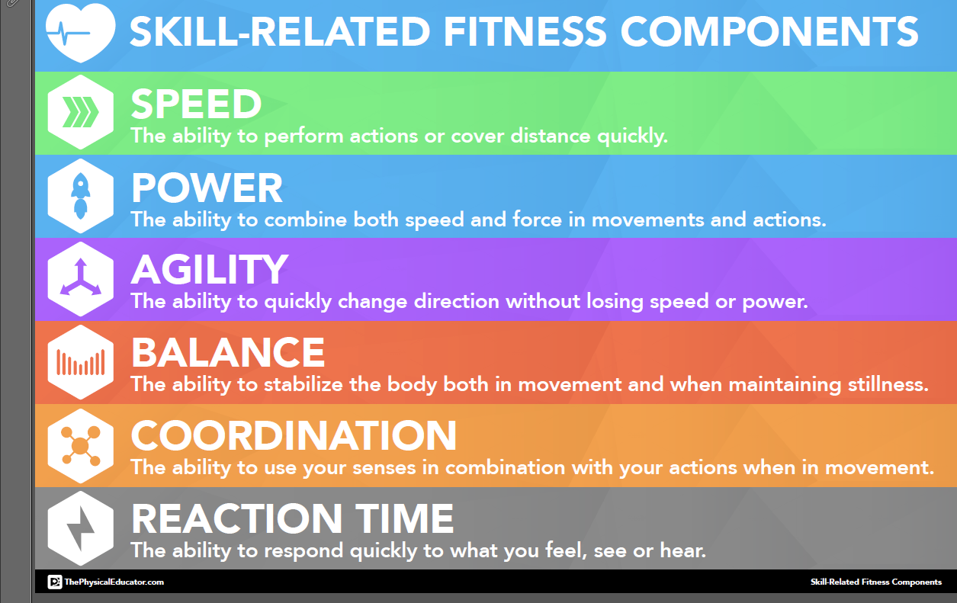

Image Source: The Physical Educator.com
Activity 1 - Speed Stacking

- Watch the speed stacking video and try out some of the activities: Speed stacking Activities
- What did you find easy or difficult? What strategies did you use to help yourself learn?
- What components of skill-related fitness does speed stacking develop?

Activity 2 - Everyday Mindfulness
- Watch this video on everyday Mindfulness:
  - Everyday Mindfulness for Teens

- What are your thoughts on mindfulness? Do you practice it? Do you think it could help you? Discuss with a family member.
Materials required
- Device with Internet access

Information for parents
About the activity
Student should:
- complete the speed stacking activities;
- watch the mindfulness video and reflect.
Parents could:
- support their children in carrying out the activities;
- discuss mindfulness with their child.

Composing a Soundscape
Information for students

- The Merriam-Webster dictionary defines a soundscape as “a mélange of musical and sometimes non-musical sounds”.
- Canadian composer, R. Murray Schafer, defines a soundscape as being “any collection of sounds”, just as “a painting is a collection of visual attractions”.
- In this activity, you will create your own soundscape inspired by the work of R. Murray Schafer.

Instructions

- Look the score in Appendix A. There are eight (8) distinct shapes in your score.
- Brainstorm what each shape could sound like.
- You may use body percussion, vocal effects and any other items found around the house in order to create sound sources for your composition.
- You may compose your piece in whatever order you wish. After all, this is your composition.
- Once you have created sounds for each section of your piece, practice it in order. Feel free to make changes and add to your soundscape.
- You may choose to record the final product or share this with someone at home.

Materials required

- Soundscape score (the visual representation of your “music”) – see Appendix A
- A variety of items which can be used to create sounds (piece of paper, tin foil, water bottle, pencil, etc.). Use your imagination.
- Pencil or pen
- Piece of paper
- Recording device (optional)

Information for parents
- Help your child to gather items which could be used in their soundscape.

- Encourage your child to watch R. Murray Schafer’s National Film Board video, “Listen”,
https://www.youtube.com/watch?v=rOlxuXHWfHw and “The Musical Mind #2: R. Murray Schafer”, https://www.youtube.com/watch?v=4zsYQs2y7vQ

- Encourage your child to share their soundscape with you.

APPENDIX A
Composing a Soundscape
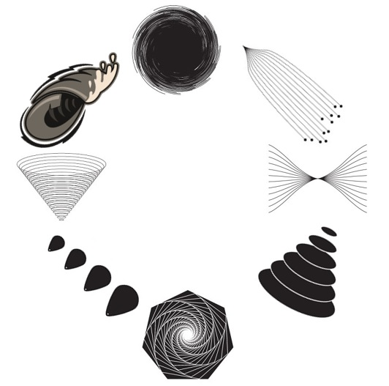

Be an Upstander
Information for students
Go to the Canadian Museum for Human Rights website and ask yourself:
  - What are your human rights?
Explore stories of real Upstanders.
Explore how you would stand up for injustice.
Materials required
- Device with Internet access
- paper, writing materials
Information for parents
Help your child find the link to the website.

Read through the activity with your child.

Discuss the activity question together.

Highlight Tourist Attractions in Your Region
Information for students
- Begin by exploring the following World Tourism Sites Google Earth project, which provides visual access to some important tourist regions from around the world.
  - Consider where each region is located in the world.
  - What makes each region a popular tourist destination?
  - At the end of the tour you will see some arrows showing some of the important flow patterns for tourism. Do these arrows match your expectations?
- Create something that highlights your own region as a tourist destination.
  - You could create a tour in Google Earth like the one you just viewed.
    - You can search for locations and information about them using Google Earth or add your own pins to hidden gems and share the special knowledge of a local resident.
    - If you have your own photos of some locations, you can add those too!
    - The following tutorial videos will show you the basics:
      - Google Earth Tutorial: Intro to Creation Tools
      - Google Earth Tutorial: Adding Features
      - Google Earth Tutorial: Styling Places
  - You could make a short video in the form of a television ad.
    - You can use video clips, but also still images, text and voiceovers.
    - Use any video editing tool that you prefer.
    - You can either use your own photos and videos (if you have them or can go take them) or use images from other sources, with appropriate permissions and credits.
  - You could make a hand-drawn promotional item such as a poster or sketchnote.
    - Be sure to include both text and images.
- Reflect on your creation. Did you consider and include information about the locations of the attractions that you highlight and why someone would want to visit these attractions?
- Share your creation. Send it to your teacher or consider posting it to your town’s Facebook group.
Materials required
- device with Internet access
  - The link to the World Tourism Sites Google Earth Project: https://earth.google.com/web/data=Mj8KPQo7CiExTnJxX3ByOXV5MXZMMXR5elFlMHp6NV93c3dzVkM1eDkSFgoUMDIyODUyQjkwNDEyQjNDNTM1QzE
- options:
  - Google account to create a Google Earth tour
or
  - device for editing video to create an ad
or
  - paper, writing and drawing materials to create a poster or sketchnote
- For students without Internet access: Printed document about the tourist locations around the world.
Information for parents
- Help your child to brainstorm the highlights of your town or region in terms of tourist attractions.
- Consider taking a drive to collect photographs of the attractions if they would be useful additions to the chosen project.
- If your child does not have access to the Internet, they may refer to the printed materials to gain a sense of the tour that was provided. If you have an atlas at home, it could be interesting to explore this as well.

Tour of Important Tourist Destinations

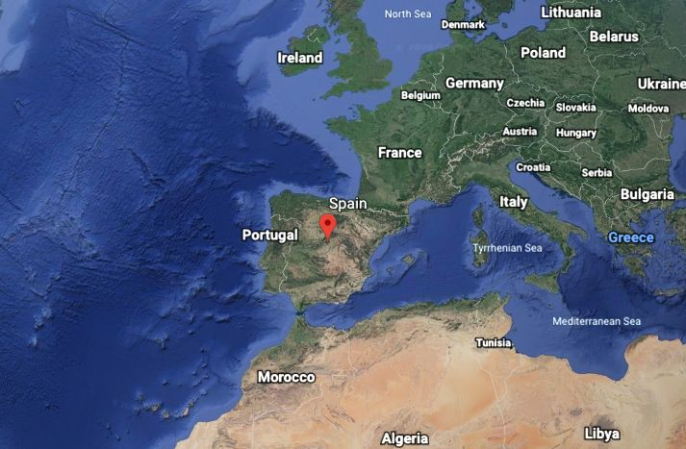
Mediteranean Coast of Spain

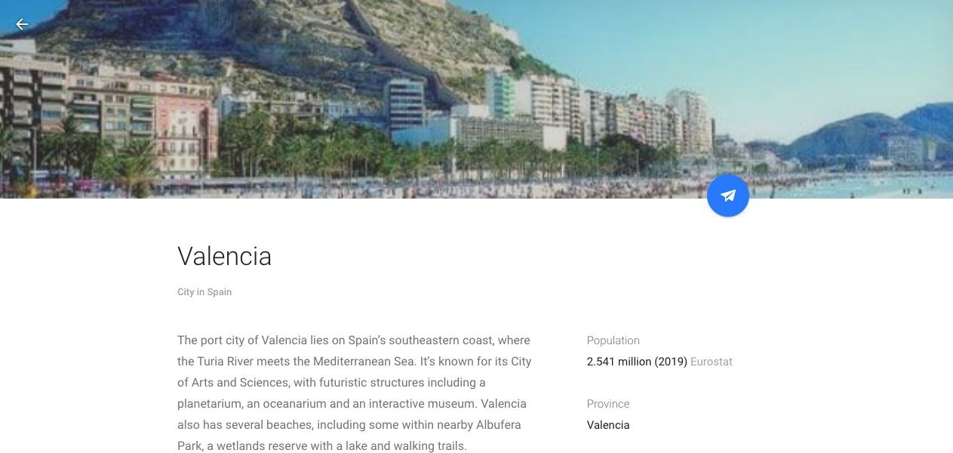
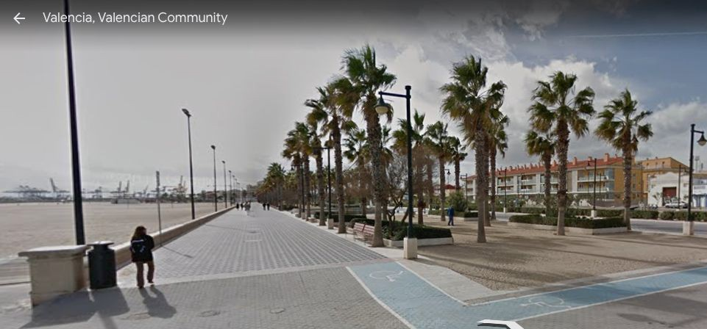

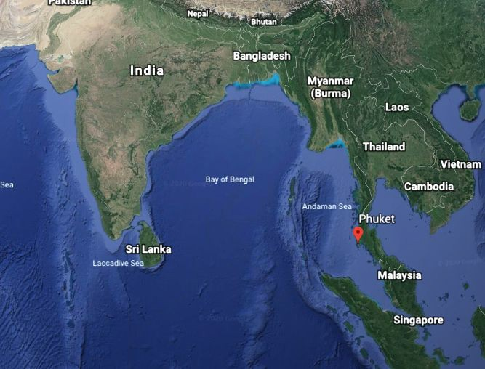
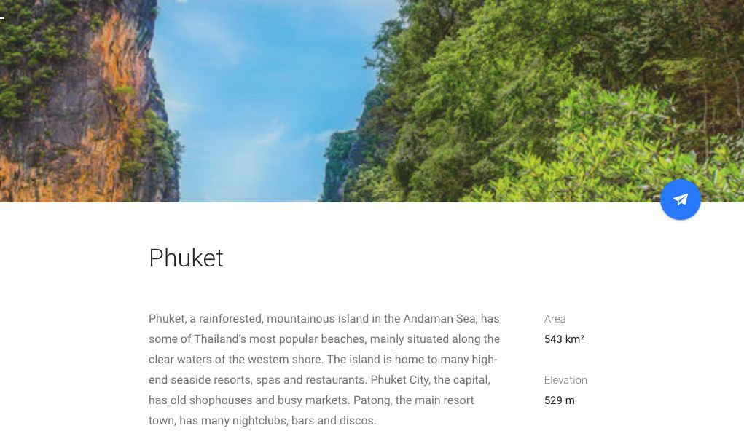
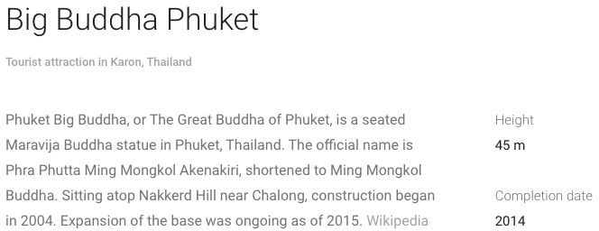
Phuket Region of Thailand

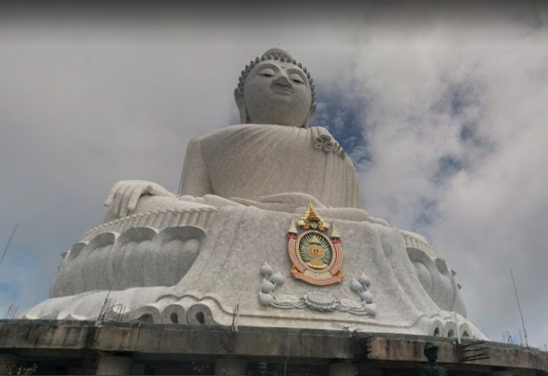

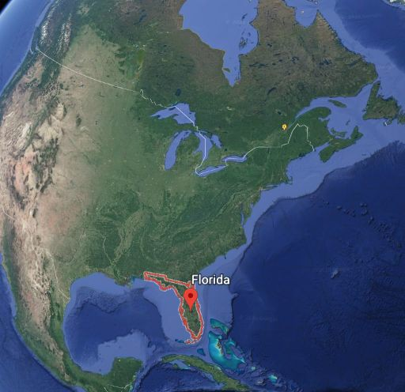
Coast of Florida, Daytona Beach

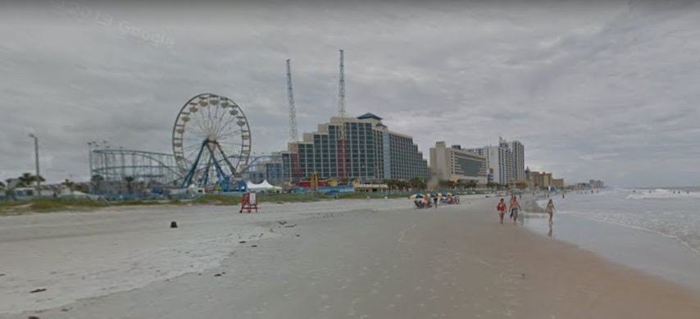

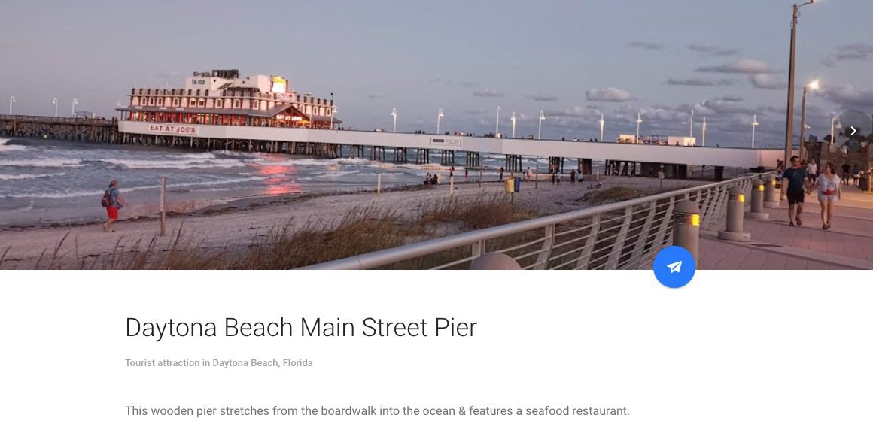

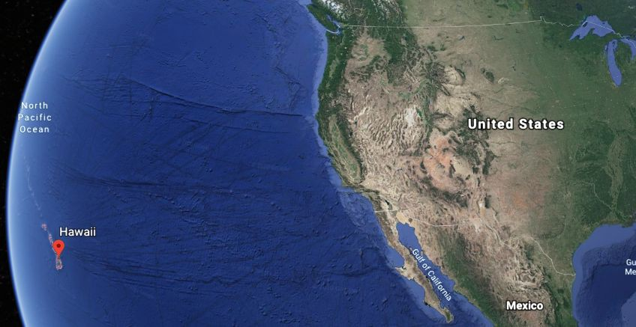
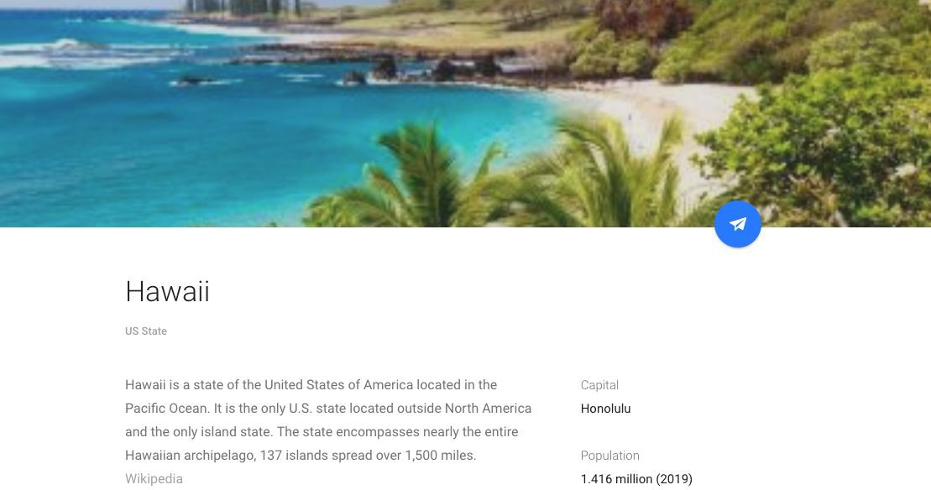
Islands of Hawaii

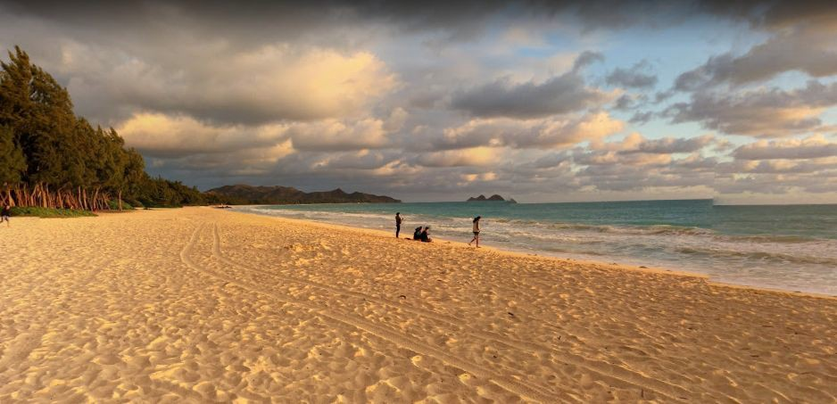

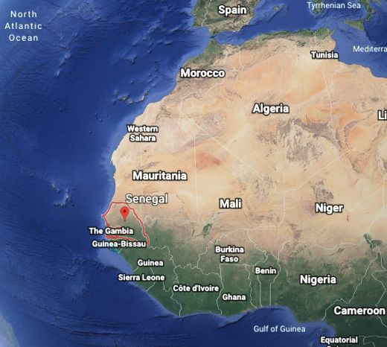
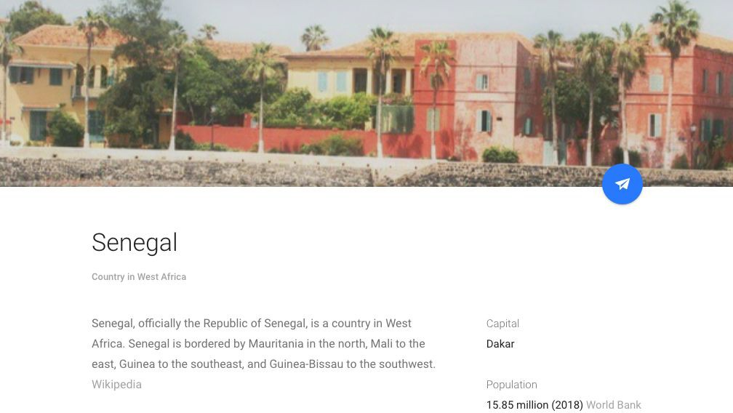
Atlantic Coast of Senegal
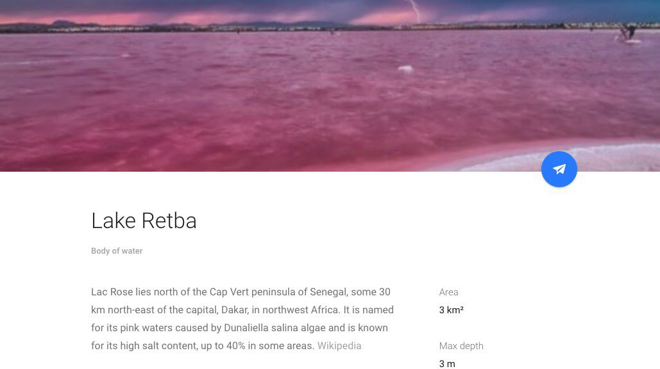
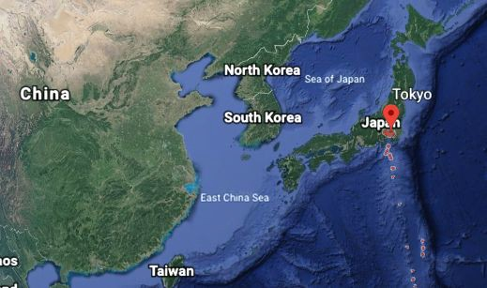
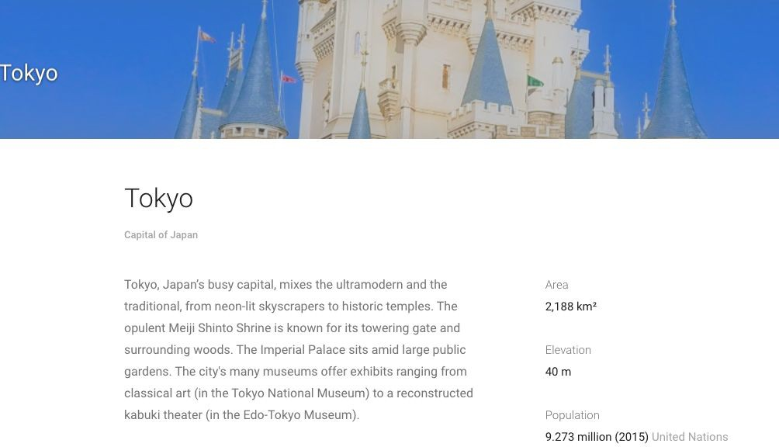
Tokyo, Japan

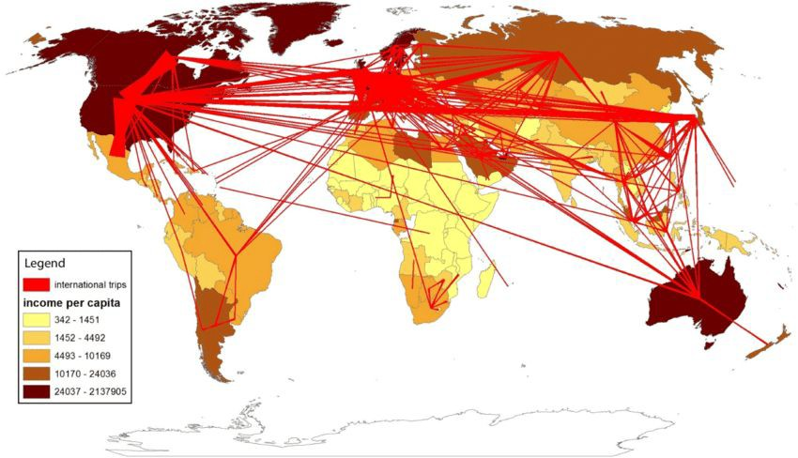
Major Tourist Flow Patterns

Important flows to notice:
- Western Europe to the United States
- Western Europe to South-East Asia
- United States to the Caribbean

Student Led Inquiry of an Important Historical Figure
Information for students
Step 1:

First go to this SITE (Google Arts and Culture)

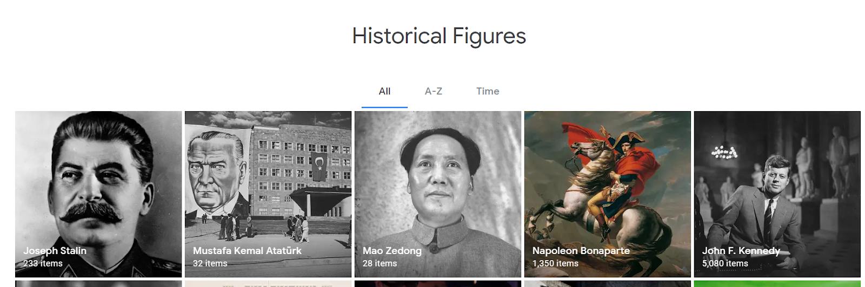

On this site you will now be able to choose a famous historical figure that you would like to learn more about!

Step 2: Explore and Record Notes in a FIELD JOURNAL

Once on the site, choose one of the historical figures to explore.

While you are exploring this virtual tour of your selected historical figure, record your learning, thoughts, and questions in a FIELD JOURNAL.

Here are some prompts, to help set up entries into your field notes:

What do you see?

What do you find interesting? Explain...

What surprises you?

What stood out about your tour experience? Explain…

Step 3 : Question formation

Write down as many questions as you can think of about your historical figure, based on your curiosity.

Questions that I have:

Step 4: Question Selection

Now place a star next to the one question that is your favorite question; the one that you really want to research further.

Step 5: Now, use Google to carry out research and try to find the answer to your question.

My Question:

What I found out:

Materials required
Useful resources, depending on personal preferences and availability:

- writing materials (paper, pencils, etc,)
- Device with Internet access

Information for parents
Your child may benefit from your help with read the instructions
If possible, discuss the journal responses with your child

