Weekly Educational Options from the Ministère
secondary Iv
Week of May 4, 2020
Table of Contents
Where Children Sleep 2
Haïku-iser notre nouvelle réalité… 3
Les caractéristiques des haïkus 5
Exemples de haïkus 6
Dodging Statistics 7
Appendix A – Group Work 9
Appendix B – Formula Sheet 10
Appendix C – Answer Key 11
The Relationship Between the Atmosphere and the Oceans 12
Appendix A: Experiment 14
Percentage of Oxygen in Water 14
Appendix B: Impact of Carbon Dioxide 15
Titre de l’activité 17
Busting some moves! 18
The Many Impacts of COVID-19 (Part 2: Values and social distancing) 19
Creating Canada – The British North America Act 21

English Language Arts

Where Children Sleep
Image source: https://www.jamesmollison.com/where-children-sleep

Information for students
You’ve probably spent a lot of time in your bedroom these last few weeks. This activity asks you to consider what your bedroom says about you. What could an outsider learn about you and your life from viewing a picture of where you sleep?
Go to https://www.jamesmollison.com/where-children-sleep and view the images from James Mollison’s book Where Children Sleep.
Think about what you can learn from someone’s bedroom. Using the visual clues in the photographs on the website, both of the bedrooms and the children themselves, infer what these children’s lives and personalities might be like. How does a bedroom reflect the person who sleeps there? What does someone’s appearance (hair, clothing) tell you? What can’t we tell? Is it always true that a person’s appearance and environment reflect their “real” self?
Choose a child from one of the photos on the website and attempt to write a journal entry from their point of view. Using what you have inferred from the photographs, try and enter their world and their head. Use a first-person point of view to capture what you think you know about them. Where do they live? Who do they live with? What do they do all day? Be as creative as you like.
Share your writing with a friend or family member. Have a competition with them to see who can come up with the most creative and believable backstory to an image.
Optional
For more information on the children in the photographs, you could visit this section of James Mollison’s website https://www.jamesmollison.com/wcs-exhibitions
Materials required
Device with Internet access
Paper and writing materials

Information for parents
Review the instructions with your child, if necessary.
The best things your child can do are: read every day, write every day and talk every day.

French as a Second Language

Haïku-iser notre nouvelle réalité…

Information for students
En guise d’introduction, lis les articles suivants: Les mots de la COVID-19 : exprimer la pandémie et Les bienfaits antistress du haïku.
Prends ensuite le temps de te familiariser avec la structure des haïkus. Voir l’annexe ci-proposée.
Activité 1 : Prends connaissance des vers de 5 et 7 pieds offerts ci-bas (Voir lien : tw-haiku.ac-dijon.fr… content). Associe-les dans l’ordre suivant : un vers de 5 syllabes, un vers de 7 syllabes et un vers de 5 syllabes. Lis les poèmes obtenus. Prends en note ceux qui te plaisent le plus.
Activité 2 : Choisis maintenant les deux premiers vers (vers de 5 et de 7 syllabes) parmi la même sélection, mais compose le troisième vers. Refais l’exercice en tirant au hasard le premier vers mais en écrivant les deux suivants. Fais quelques exercices supplémentaires pour pratiquer.
Activité 3 : Lorsque tu te sens capable, crée tes propres haïkus, mais en insérant des mots tirés de l’article Les mots de la Covid-19 : exprimer la pandémie. Un néologisme (mot nouveau ou sens nouveau) par haïku. Une autre option serait de t’inspirer des photographies présentées sur la galerie de photos ci-proposée (Voir lien : tw-haiku.ac-dijon.fr… galerie-de-photos).
Fais une compilation de tes haïkus (dans un cahier ou en ligne). Tu peux les accompagner d’une photographie ou d’un dessin. À toi de choisir!

Materials required
https://www.lapresse.ca/societe/sante/202004/15/01-5269494-les-mots-de-la-covid-19-exprimer-la-pandemie.php
https://fr.chatelaine.com/societe/entrevues/les-bienfaits-antistress-du-haiku/
http://tw-haiku.ac-dijon.fr/wp-content/uploads/2014/02/annexe2-2015.pdf
http://tw-haiku.ac-dijon.fr/galerie-de-photos/

French as a Second Language

Information for parents
This activity involves sensitivity, calm and a willingness to practise writing poetry. Haïku do not
require any emphasis on rhymes! This activity is stress-free and will make your child proud of
their accomplishments. Everyone can write haïku! It is a fun and fulfilling activity to do on a
daily basis.
Le poème en prose (ne rime pas) | Un tercet (poème écrit en 3 vers)  *I vers = 1 ligne dans un poème
Le 1er vers : 5 syllabes  Le 2e vers : 7 syllabes  Le 3e vers : 5 syllabes  Comment compter les syllabes dans un vers?  Rappel :  https://www.ralentirtravaux.com/lettres  /sequences/sixieme/sequence_2/versification.php | Chaque vers est un « bout » de phrase représentant une idée / une image
Thèmes privilégiés:  La nature, les saisons & le temps | Le lecteur doit identifier la présence d’une émotion à la lecture du haïku
Une forte présence sensorielle (au moins un des 5 sens est sollicité au cours de la lecture du poème) | La présence d’une rupture ou d’une contradiction

French as a Second Language

Les caractéristiques des haïkus

Tableau inspiré par :
http://tw-haiku.ac-dijon.fr/decouvrir-les-haikus-avec-ses-eleves/

Exemples de haïkus

Référence :
https://www.association-francophone-de-haiku.com/exemples-de-haikus/haikus-hiver/billet d’amitié ―
deux tulipes se touchant
les pétales
Ana Drouot
premier son de cloche
dans le boisé de la cour
deux brins de muguet
Céline Lajoie
pluie printanière
son parapluie à mon bras
pleurs silencieux
Christiane Ourliac
entrée principale
du centre pour personnes âgées
lilas en fleurs
Claude Rodrigue
pont solitaire
il s’est trouvé un ami
le vent vagabond
Anne Brousmiche

Mathematics

Dodging Statistics

Information for students
Your school has just wrapped up its intermural dodgeball season (the Marie Curie Dodgeball League).
For your math class, you and your group are asked to present some statistics pertaining to the league this past season.
- Freddie gathered the data on the players who made the All-Star teams, while Joan compiled the data on the rest of the players in the league.
Additionally, your teacher would like you to provide the following information based on this year’s results:
- The linear regression of the games played in relation to the eliminations scored
- How many eliminations should someone who plays 10 and 20 games be expected to get?
- If a new player were to join the league and score 25 eliminations, what percentile would they be in?
- Finally, you need to create a scatterplot with all the data.

Materials required
Appendix A: The statistical information relating to your teammates
Appendix B: Formula sheet with information on determining the regression line and percentile

Information for parents
Read the instructions to your child, if necessary.
Discuss the task together with your child, outlining the steps they need to carry out.
For the regression line, students can use the method they are most comfortable with to determine the equation, as the solutions for Mayer and Median-Median have been included in the answer key (Appendix C).
Once the task is completed, you and your child can go over the task with the answer key provided.
Your child may obtain answers that could be slightly different from the answer key, depending on how they round off their results. Being off by a few tenths is fine. There is no need to worry about inconsistencies in rounding off the results. The important thing is that your child is able to show that they can solve the problem.

Mathematics

Appendix A – Group Work

Freddie’s Stem-and-Leaf Plots
22 Games |  |  | 23 Games |  |  | 24 Games |  |  | 25 Games
1 |  |  | 1 |  |  | 1 |  |  | 1
2 | 2 5 8 |  | 2 | 3 6 8 |  | 2 | 5 5 9 |  | 2 | 7 9
3 | 1 |  | 3 | 3 |  | 3 | 1 |  | 3 | 0 5

Joan’s Table of Values
Games  Played | Eliminations
8 | 10
10 | 11
12 | 12
12 | 16
13 | 15
14 | 15
15 | 16
15 | 17
15 | 19
16 | 18
18 | 25
18 | 22
19 | 23
20 | 18
21 | 15
21 | 26
22 | 29
22 | 25

Mathematics

Appendix B – Formula Sheet

Percentile
Percentile = $\left(\frac{\text{number of data values less than }\text{x} + \frac{\text{number of data values equal to }\text{x}}{\text{2}}}{\text{total number of values}}\right)$ x 100

Regression Line – Median-Median Method
For example: 1) Organize the points on the scatterplot in numerical order
according to the x-axis.
x | y | Median (M)
1 | 10 | M₁ (2, 11)
1 | 12
3 | 9
4 | 15
5 | 15 | M₂ (8, 16)
8 | 16
9 | 18
10 | 19 | M₃ (12, 21)
11 | 22
13 | 20
15 | 25

2) Divide the distribution into three groups. Each group should
have the same number of ordered pairs, if possible. The first and third group need to have the same number of ordered pairs.

3) Find the median of each group.

4) Using the three medians, find the average of both the x- and
y-coordinates to find point P

5) Using the coordinates of M₁ and M₃, find the slope ($\frac{y_{2}-y_{1}}{x_{2}-x_{1}}$).

6) Plug point P into the equation y = ax + b after the slope has

been determined.Regression Line – Mayer Line Method
For example: 1) Organize the points on the scatterplot in numerical order
according to the x-axis.
x | y | Average
1 | 10 | P₁ (2.8, 12.2)
1 | 12
3 | 9
4 | 15
5 | 15
8 | 16 | P₂ (11, 20)
9 | 18
10 | 19
11 | 22
13 | 20
15 | 25

2) Divide the distribution into two groups, as evenly as possible.

3) Determine the average of both the x- and y-coordinates in
each group to find point P₁ and P₂.

4) Using the coordinates of P₁ and P₂, solve for the equation
y = ax + b.

Mathematics

Appendix C – Answer Key

Linear Regression Line (Median-Median Method)
The three medians are (14, 16), (22, 24), and (25, 29)
Point P is (20.33, 23)
The equation of the line is y = 1.18x – 0.99

Linear Regression Line (Mayer Line Method)
The two points are (15.82, 18.06) and (24.35, 27.76)
The equation of the line is y = 1.14x + 0.03

Linear Regression Line (according to Microsoft Excel)
y = 1.12x + 0.5

Eliminations for 10 and 20 games played (using all three equations)
Games | Median-Median | Mayer | Excel
10 | 10.81 | 11.43 | 11.70
20 | 22.61 | 22.83 | 22.90

Percentile Rank
- $\left(\frac{\text{17} + \frac{\text{6}}{\text{2}}}{\text{35}}\right)$ x 100 = 57.142 → 58th percentile

Scatterplot (example)

Science and Technology

The Relationship Between the Atmosphere and the Oceans

Information for students
Essential Question: How is the ocean like sparkling water and why is that a problem?
Since the beginning of the industrial revolution, scientists have been keeping track of the following two things:
- Increases in the average atmospheric temperature
- Increases in the acidity of the oceans
Review or research the following ideas:
- Composition of air
- Greenhouse gases
- Carbonated water
- pH
Conduct the experiment described in Appendix A.
Using the information in Appendix B, reflect on the impact of carbon dioxide.

Materials required
Paper, writing and drawing materials  Bowl of water  Candle  Transparent glass (or graduated measuring cup to measure amounts of water) | Matches or lighter (be careful with fire!)  For the experiment, you may replace the candle and matches with steel wool and vinegar.  Device with Internet access (optional)

Science and Technology

Information for parents
Help your child find the link to the video, if necessary.
Read the instructions to your child, if necessary.
Discuss the questions together.
Brief video explanation: https://www.youtube.com/watch?v=fgBozLCGUHY (optional)

Science and Technology

Appendix A: Experiment

Percentage of Oxygen in Water
Objective: Calculate the percentage of oxygen in the air by burning a candle standing in a bowl of water and observing the amount of water displaced into an inverted glass placed over the candle (see image below).
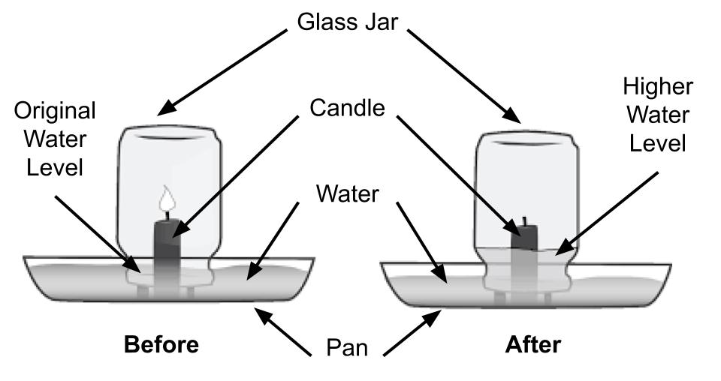
What do you notice? Why is this happening?
Sketch and explain what was in the glass before and then after the experiment. Why is this calculation of the percentage of oxygen in the air not perfectly accurate? Share your thinking with the hashtag #ScienceAtHomeQC-grade10
You may do a similar experiment that does not require burning a candle by replacing it with a piece of steel wool and letting it rust (this also consumes oxygen but takes a few hours - see this link: https://www.youtube.com/watch?v=xQNl2EdteDE). (Optional)

Science and Technology

Appendix B: Impact of Carbon Dioxide
Carbon can be dissolved in water. This can be done artificially, by pumping carbon dioxide gas into a solution, as is done to make carbonated drinks (e.g. soft drinks or sparkling water). However, carbon can also be dissolved in a solution naturally, as is the case in the exchange of carbon between the atmosphere and the hydrosphere. The following chemical equation shows how carbon dioxide interacts with water:
$$H_{2}O+CO_{2}→ H_{2}{CO}_{3}$$
The product of this reaction is called Carbonic Acid. It dissociates in water to form the following ions:
$$H_{2}{CO}_{3}+H_{2}O→{[HCO_{3}]}^{?}+{[H_{3}O]}^{?}$$
What are the missing charges on top of each ion on the right-hand side? What is the name of each ion?
Interpret the following two charts:
Chart 1: Global Annual Temperature
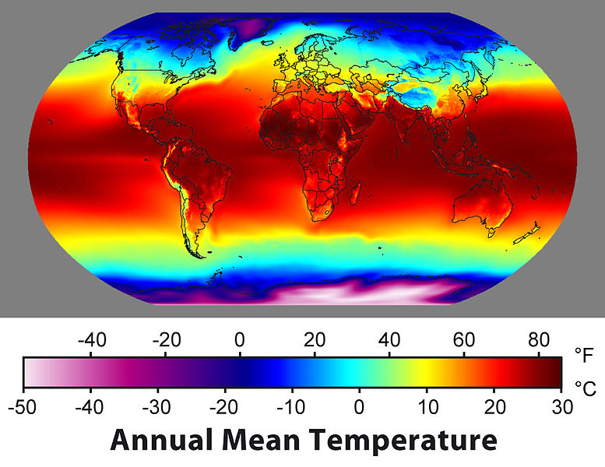

Science and Technology

Chart 2: Change in Acidity
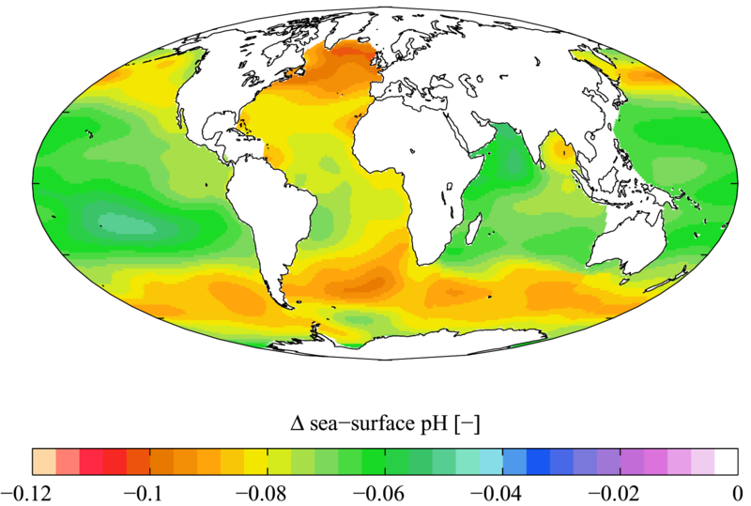

- What parts of the planet are the warmest? Why do you think this is the case?
- What parts of the ocean are becoming more acidic? Why do you think this is the case?
- Based on these two charts, infer how temperature might affect the solubility of carbon dioxide in water. Explain your thinking.
- If greenhouse gases like carbon dioxide warm the average temperature of the planet, what effect will that have on the oceans’ ability to absorb carbon dioxide from the air? Explain your thinking.
- How does a more acidic ocean affect aquatic life? Give as many examples as you can.

Physical Education and Health

Learn About the Cardiovascular System and Get Moving!

Information for students
Activity 1: Learn about the function of your heart during exercise
Watch this video. Speaking to a friend or a family member, can you summarize the function of the cardiovascular system and how it performs that function? Challenge yourself to remember as many details as possible. For example, can you remember how many times your heart beats in a year or how many valves your heart has?
Activity 2: Get moving!
Complete the following training programs on three separate days:
  - Day 1 - Abs Day 2 – Lower body Day 3 – Arms and back
Make sure you select the workout level (number of sets) according to your personal fitness level.
Do not forget that the number of repetitions (reps) is a suggestion only. If you can no longer hold or perform a technique, stop the set and rest.
If you are up for practicing your French and want to explore more activity ideas, visit the Reste Actif! website.
Materials Required
None

Information for parents

About this activity
Children should:
learn about the cardiovascular system
complete the at-home training programs
Parents could:
discuss the circulatory system with their children
join their children in completing one of the proposed training programs

ARTS

Busting some moves!

Information for students
This week, we’ll go beyond building choreographies to trying some dance tutorials and getting inspired by some pop culture dance moves.
Go to https://www.youtube.com/user/DanceTutorialsLIVE. Select one of the choreography videos. Make some space and give it a try.
After having done some of the steps in the videos, reflect on the following questions:
How would you have done it differently? What could be done to make the choreography personal?
Try it out!
Optional: Film yourself to see how it looks if you don’t have a mirror to dance in front of.

Materials required
Device with Internet access

Information for parents
This activity is designed to be simple and build students’ repertoire of dance moves and reflection around their creations.
We hope it will appeal to your child whatever their grade level.

Ethics and Religious Culture

The Many Impacts of COVID-19 (Part 2: Values and social distancing)

Information for students
Read and reflect on the Montreal Gazette article “As usual, Canadians excel at obedience in the COVID-19 era”
Write a short response to the article. Consider the following questions in your response and refer to the values word cloud below if needed: What are some Canadian values that have resulted in a successful obedience to social distancing measures? Why do you think groups of people are disobeying social distancing measures? What values are leading to their disobedience? What does freedom mean to you? What does responsibility mean to you? What consequences has social distancing had on your health, wellbeing, daily life, relationships, etc.?
Inspired by the word cloud of values below, write down your 5 most important values.

Materials required
https://montrealgazette.com/news/local-news/josh-freed-as-usual-canadians-excel-at-obedience-in-the-covid-19-era/
Paper, pen or pencil, tablet or computer for internet access
Image of the values word cloud

Ethics and Religious Culture

Information for parents
Students should
Reflect on the consequences social distancing has had on their lives.
Consider how societal values influence our willingness to abide by rules and regulations.
Reflect on their own personal values
Parents could:
Read the article and discuss it with your child.

History of Québec and Canada

Creating Canada – The British North America Act
The Constitution Act, 1867, originally known as the British North America Act (BNA Act), was the law passed by the British Parliament creating the Dominion of Canada. This document, written over 150 years ago, would become one of the building blocks of the Canada we know today.

Information for students
Click on this link to bring you to an online version of your History textbook, Reflections.qc.ca: 1840 to Our Times: https://www.iplusinteractif.com/books/187/254/3804/67482/235996
You can also use the print version.
Read pages 51-53 to find out about the BNA Act of 1867. If you do not have access to either version of your textbook, consult the historical documents provided below.
Now that you have learned about the BNA Act, do the following activities:
- Identify differences between the maps of Canada in 1867 and today.
- Identify similarities between the political structure during the period of responsible government and at Confederation.
- Establish connections between different areas of responsibility and identify the jurisdiction each one fell under in 1867.

Materials required
Useful resources, depending on personal preferences and availability:
Device with Internet access
Writing materials (paper, pencil, etc.)

Information for parents
Discuss the ideas presented and potential answers with your child.

History of Québec and Canada
- Identify differences between the maps of Canada in 1867 and today.
- To do this activity, you can either use the online maps to help you visualize the differences, or look at the two maps below. (If you use the online versions, select the maps for 1867 and Today.)
Map of Canada, 1867
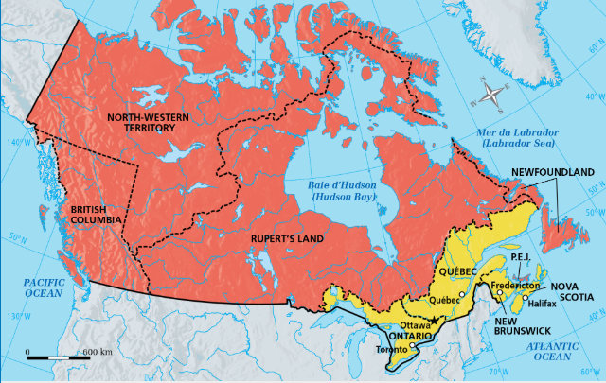

Source: https://platform.cheneliere.ca/myapp/cartes/56a47a58a49a53a85a90a93/56a47a58a49a53a85a90a93/

Map of Canada, today
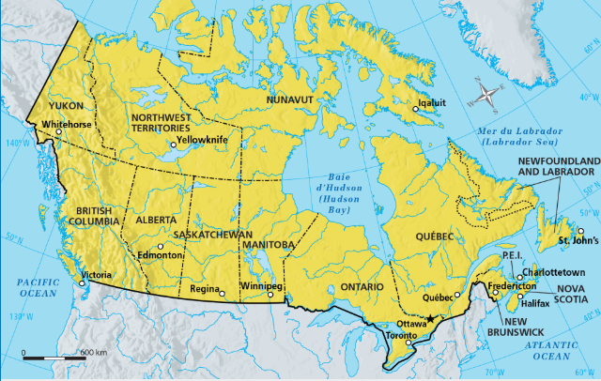

Source: https://platform.cheneliere.ca/myapp/cartes/56a47a58a49a53a85a90a93/56a47a58a49a53a85a90a93/

Differences:

History of Québec and Canada
Identify similarities between the political structure during the period of responsible government and at Confederation.
To do this activity, you can either use this link and go to slide 6 of 7 to help you visualize the similarities, or look at the two charts below:
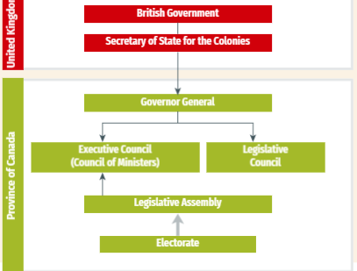
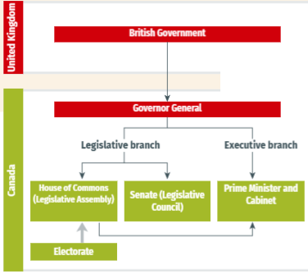
History of Québec and Canada Political structure during responsible government, 1848 Political structure at Confederation, 1867
Source:https://iplusinteractif.com/contenusstatiques/presentations/reflections4/3571_C1_org_1_05_BNAA_1867/index.html
Similarities:

History of Québec and Canada

Establish connections between different areas of responsibility and identify the jurisdiction each one fell under in 1867
Place the following documents in the appropriate boxes.
Document 1
“Upon Confederation [religious] school systems were enshrined in the British North America Act (BNA), 1867. Both Quebec and Ontario were required by section 93 of the BNA Act to safeguard existing educational rights and privileges of the Protestant and Catholic minorities. Thus, separate Catholic schools and school boards were permitted in Ontario. However, neither province had a constitutional requirement to protect its French- or English-speaking minority.”
Laurence K. Shook, 1971
Document 2 Document 3
Farm in New Brunswick, 1867
“The … government's legislative responsibilities for Indians and Inuit derive from section 91(24) of the Constitution Act, 1867 and responsibility was given to the Secretary of State for the Provinces Responsible for Indian Affairs.”

Library and Archives Canada
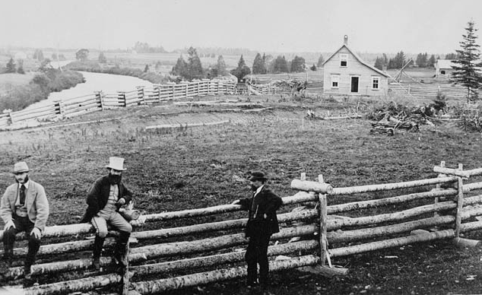

Library and Archives Canada

Federal Jurisdiction | Provincial Jurisdiction | Shared Jurisdiction

History of Québec and Canada

Answer key:
Differences:
- Québec and Ontario are larger today than they were in 1867.
- Prairie provinces like Alberta, Saskatchewan and Manitoba now exist where Rupert’s Land once was.
- British Columbia, PEI and Newfoundland are now provinces of Canada instead of British colonies.
- There are now three Canadian territories on land that used to be the North-Western Territory and Rupert’s Land.
*Other answers are possible.
Similarities:
The British government still had ultimate power.
The Governor General of Canada was still appointed by the British.
The electorate (the people) still voted only for the Legislative Assembly.
*Other answers are possible.

Federal Jurisdiction | Provincial Jurisdiction | Shared Jurisdiction
3 | 1 | 2

Vancouver Bites! Pic of sparkling water taken at Brix restaurant in Vancouver, 2010, JPEG, 1.63MB, Vancouver, Canada, https://commons.wikimedia.org/wiki/File:Sparkling_Water_(4675945072).jpg
Rohde, R.A., Annual Average Temperature Map, 2008, JPEG, 385 KB, https://commons.wikimedia.org/wiki/File:Annual_Average_Temperature_Map.jpg
Plumbago, WOA05 GLODAP del pH AYool, 2009, PNG, 234 KB, https://commons.wikimedia.org/wiki/File:WOA05_GLODAP_del_pH_AYool.png

